

**User Document from SmartDrive Labs**

**Date of Submission:**

21, Oct 2016

**Submitted by:**

Mrs. Vani Sathvik

CEO

[vani@sdlglobe.com](mailto:vani@sdlglobe.com)

[www.sdlglobe.com](http://www.sdlglobe.com)

***CONFIDENTIALITY STATEMENT***

***This document contains proprietary trade secret and confidential information to be used solely for evaluating SDL. Customer, by accepting this document, agrees that neither this document nor the information disclosed herein, nor any part thereof, shall be reproduced or transferred to other documents, or used or disclosed to others for any purpose except as specifically authorized in writing by SDL.***

*Copyright © SMARTDRIVE LABS TECHNOLOGIES INDIA PVT LTD. All rights reserved. All product and company names mentioned herein are trademarks or registered trademarks of their respective companies.*

**Our Location:**

SmartDrive Labs Technologies India Pvt. Ltd.

# 83, 1st floor, 4th Main 8th cross,

AG’s layout, Dollar’s colony, New BEL road

Bangalore – 560 054

Karnataka, India.

STEPS TO ACCESS TRAINZ SCREENS AND REPORTS

* Open URL: [**http://122.166.218.113:8090/Train/index.html**](http://122.166.218.113:8090/Train/index.html)

It will Give you list of menu on left side and Project management screen on right side of the screen like below:

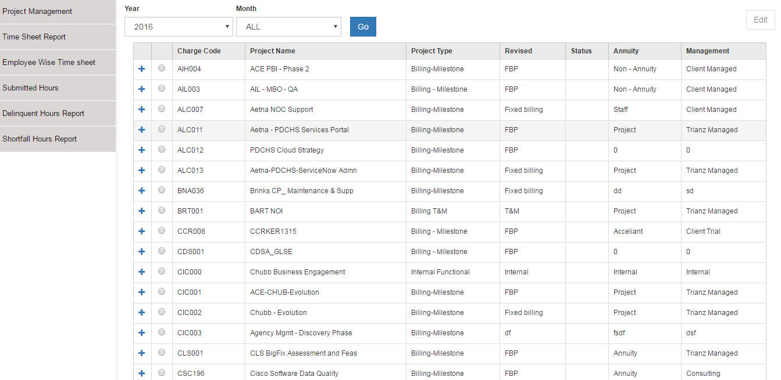

In Project Management Screen,

We have **year Dropdown** and **Month Dropdown** to filter data. Once click on **Go** button the result will change.

There is  Sign before every project. By clicking the same, you can see all Description of that project other than detaild mentioned in table.

and  button at right most of the screen to change Project details .

**Note: EDIT WILL BE DISABLED UNTIL YOU SELECT ANY PROJECT.**

You can change Status, Annuity, Revised and Management of the project and click on **Update** in below screen.

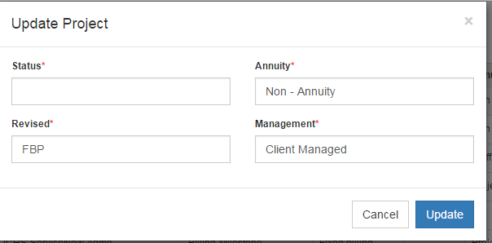

* Click on next item in the menu to see reports.

It will navigate to credentials page.

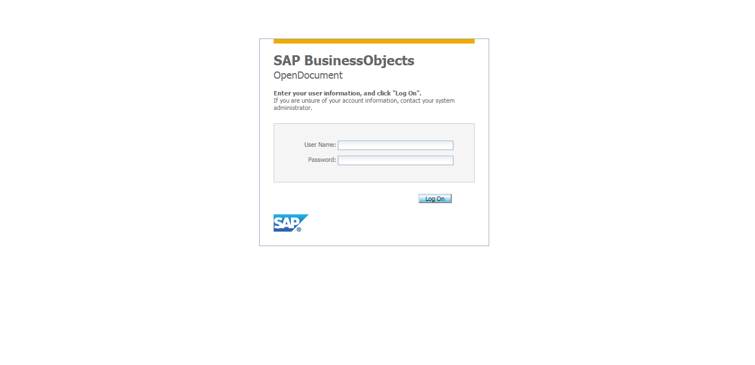

Enter the below login credentials to login:

**Username**: administrator

**Password:** basis123A

**Note**: You can save credentials in your browser. So that it will not ask you for next time.

CONTACT



**Our Location:**

**SmartDrive Labs Technologies India Pvt. Ltd.**

**Our Location:**

SmartDrive Labs Technologies India Pvt. Ltd.

# 83, 1st floor, 4th Main 8th cross,

AG’s layout, Dollar’s colony, New BEL road

Bangalore – 560 054

Karnataka, India.

**Enquires:**

Mrs. Vani Sathvik

[Vani@sdlglobe.com](mailto:Vani@sdlglobe.com)

[www.sdlglobe.com](http://www.sdlglobe.com)