**REQUIREMENT ANALYSIS**

**Module – Exit**

**Client - Aditi**

**Prepared by:**

Mrs. Vani Sathvik

Mr. Vivek

**Date of Submission:**

30th may 2017

[vani@sdlglobe.com](mailto:vani@sdlglobe.com)

[www.sdlglobe.com](http://www.sdlglobe.com)

***CONFIDENTIALITY STATEMENT***

***This document contains proprietary trade secret and confidential information to be used solely for evaluating SDL. Customer, by accepting this document, agrees that neither this document nor the information disclosed herein, nor any part thereof, shall be reproduced or transferred to other documents, or used or disclosed to others for any purpose except as specifically authorized in writing by SDL.***

*Copyright © SMARTDRIVE LABS TECHNOLOGIES INDIA PVT LTD. All rights reserved. All product and company names mentioned herein are trademarks or registered trademarks of their respective companies.*

**Our Location:**

SmartDrive Labs Technologies India Pvt. Ltd.

# 83, 1st floor, 4th Main 8th cross,

AG’s layout, Dollar’s colony, New BEL road

Bangalore – 560 054

Karnataka, India.

EXIT MODULE

**Scenario: 01**

1. Employee will initiate the resignation.
2. Line Manager will conduct a meeting within two days to retain the Employee and send an email notification to him/her, BH and HR.
3. Employee will respond to the e-mail sent by the Line Manager by sending an email response to the Line Manager, BH and HR.

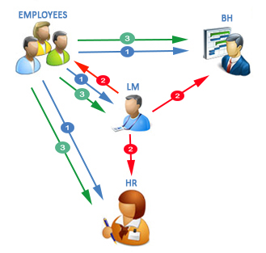

**Scenario: 02-A**

1. Employee will initiate the resignation.
2. Line Manager will conduct a meeting approve his/her resignation and send an email notification to Employee, HR, BH within a span of two days.

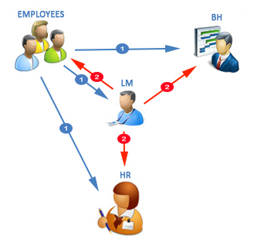

**Scenario: 02-B**

1. After an employee applies for resignation and Line Manager didn’t conduct any meeting within a span of two days.
2. Then the process goes to the BH and HR.

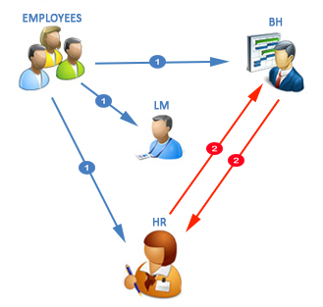

**Exit Process Flow:**

1. HR will send email notifiaction to Employee to answer the Exit intreview Questions and an alert mail to all the department for clearance two days before employee relieving from the company.
2. Employee and Department Managers will response to the alert mail.
3. ISG, Lead, Facility, Finance and HR department will do the clearance.

Note: HR will verify the status of the form and give the direction to the employee if there is any clearance in pending. HR should not be able to give Sign off before all departments have signed off.

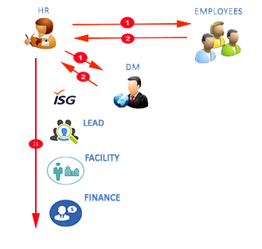

CONTACT



**Our Location:**

**SmartDrive Labs Technologies India Pvt. Ltd.**

**Our Location:**

SmartDrive Labs Technologies India Pvt. Ltd.

# 83, 1st floor, 4th Main 8th cross,

AG’s layout, Dollar’s colony, New BEL road

Bangalore – 560 054

Karnataka, India.

**Enquires:**

Mrs. Vani Sathvik

[Vani@sdlglobe.com](mailto:Vani@sdlglobe.com)

[www.sdlglobe.com](http://www.sdlglobe.com)