Performance Apprasials

**Scenario: 01**

1. Hr will initiate the appraisal process to Employees.

Each quarter weight-age should be hundred percent.

After all quarters, average weight-age should be considered.

There should be five goals in each quarter.

Within five days all appraisal cycles should be completed.

HR will create Appraisal cycle and initiate goal cycle.

1. Employee should fill Objective measurements and Target in appraisal form.

Actual completion and weight-age will be filled by LM.

Appraisal Form

|  |  |  |  |
| --- | --- | --- | --- |
| Objective Measurements(s)/Metric(s) | Target | Actual Completion | Weight-age |
|  | Q1 Q2 Q3 Q4 |  |  |
|  |  |  |  |
|  |  |  |  |

1. Overall Performance Rating (OPR) depends on weight-age.

|  |  |  |  |  |
| --- | --- | --- | --- | --- |
| Outstanding | Exceeds  Expectations | Met  Expectations | Below  Expectations | Does not Meet  Expectations |
| 100 | 90-99 | 80-89 | 60-79 | Less than sixty |

3. LM will send an email to HR.

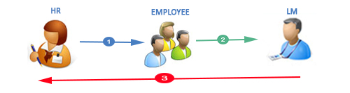

**Scenario: 02**

1. HR willinitiate Hike process after freezing the entire appraisal cycle Q-1, Q-2, Q-3, and Q-4**.**
2. LM will get their respective employees appraisal form. He will fill up the following information.
3. Recommendation on HIKE.

|  |  |  |
| --- | --- | --- |
| Yes | On Hold | No(Reasons for no to be filled) |
|  |  |  |

1. Once submitted by LM,he will send an E-mail and Apprisal application to BH for approval/reject. BH will only approve/Reject the application.
2. Just capture percentage of hike.

HIKE table

|  |  |  |  |  |
| --- | --- | --- | --- | --- |
| Outstanding | Exceeds  Expectations | Meets  Expectations | Just Below  Expectations | Does not meet Expectations |
| 20% | 15%-19.9% | 10%-14.9% | 5%-9.99% | Less than 4.99% |
| 100 | 90-99 | 80 -89 | 60-79 | Less than 60 |

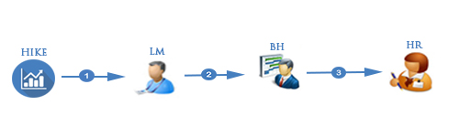

**Scenario: 03**

1. HR willinitiate Promotion process after freezing the entire appraisal cycle Q-1, Q-2, Q-3, and Q-4**.**
2. LM will get their respective employees appraisal form. He will fill up the following information.
3. Recommendation on PROMOTION.

|  |  |  |
| --- | --- | --- |
| Yes | On Hold | No(Reasons for no to be filled) |
|  |  |  |

1. Once submit by LM, Email and Apprisal application will send to BH for approval/ reject. BH will not do any thing. Just approve/Reject
2. Just capture PROMOTION table.

|  |  |  |
| --- | --- | --- |
| Tenture –Min 2 years on the same Role | PMP –Avg2Years->85 | Communications/Leadership Skills-(mangaments observation/testing interviews) |
|  |  |  |

