# StrategistAI: Agentic Product Strategy Workflow
**Built with n8n, OpenAI (GPT-4o), and Perplexity AI**

StrategistAI is an automated multi-agent workflow designed to transform a raw startup idea into a comprehensive product strategy in seconds. It bridges the gap between "Thinking" and "Building."

Key Features
- **Instant TAM Analysis:** Automated market sizing.
- **Competitive Intelligence:** Real-time lookup of industry players.
- **MVP Scoping:** Strategic feature prioritization.
- **6-Month Roadmap:** Bonus feature that generates a GTM (Go-To-Market) timeline.
The Tech Stack
- **Orchestration:** n8n (Agentic Workflows)
- **AI Brain:** OpenAI GPT-4o / Claude 3.5
- **Research API:** Perplexity AI (for live web-searching)
- **Deployment:** Self-hosted / n8n Cloud

## 📊 Sample Agent Output
| Milestone | Focus | Key Deliverable |
| :--- | :--- | :--- |
| **Month 1** | Core Value Prop | MVP Launch (Web) |
| **Month 3** | User Retention | Mobile App (iOS/Android) |
| **Month 6** | Scale | Enterprise API & Integrations |

## 📸 Workflow Preview
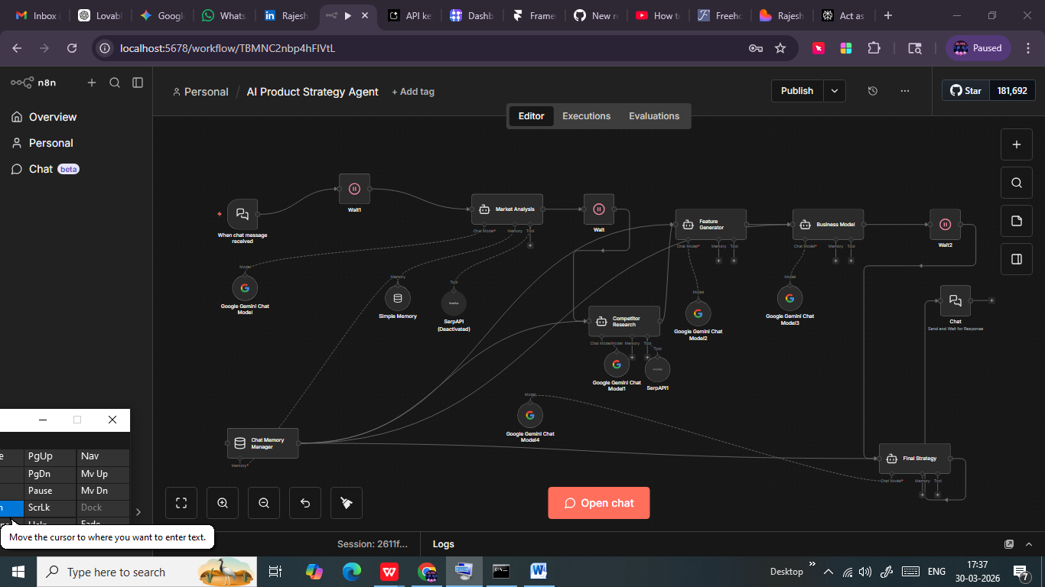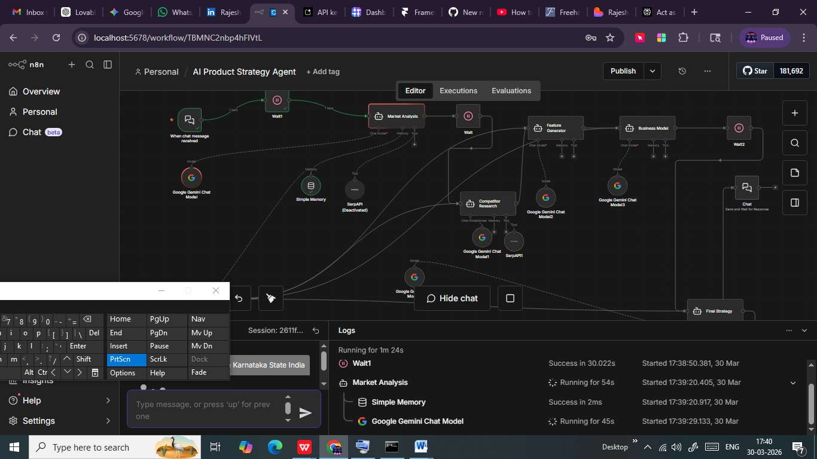
---

About the Author
Rajesh | AI Product Manager**
*8+ Years in Technical Strategy & Human Capital.*
Specializing in building AI-native products for the South Indian tech ecosystem.

