# RAJESH A

SuperSet_Id: 6384182

# WEEK-3

_____________________________________________________________________________

# Lab 3 - Migrations

## Objective

Use EF Core CLI to create and apply migrations.

## Commands

dotnet ef migrations add InitialCreate  
dotnet ef database update

## Screenshot Placeholder

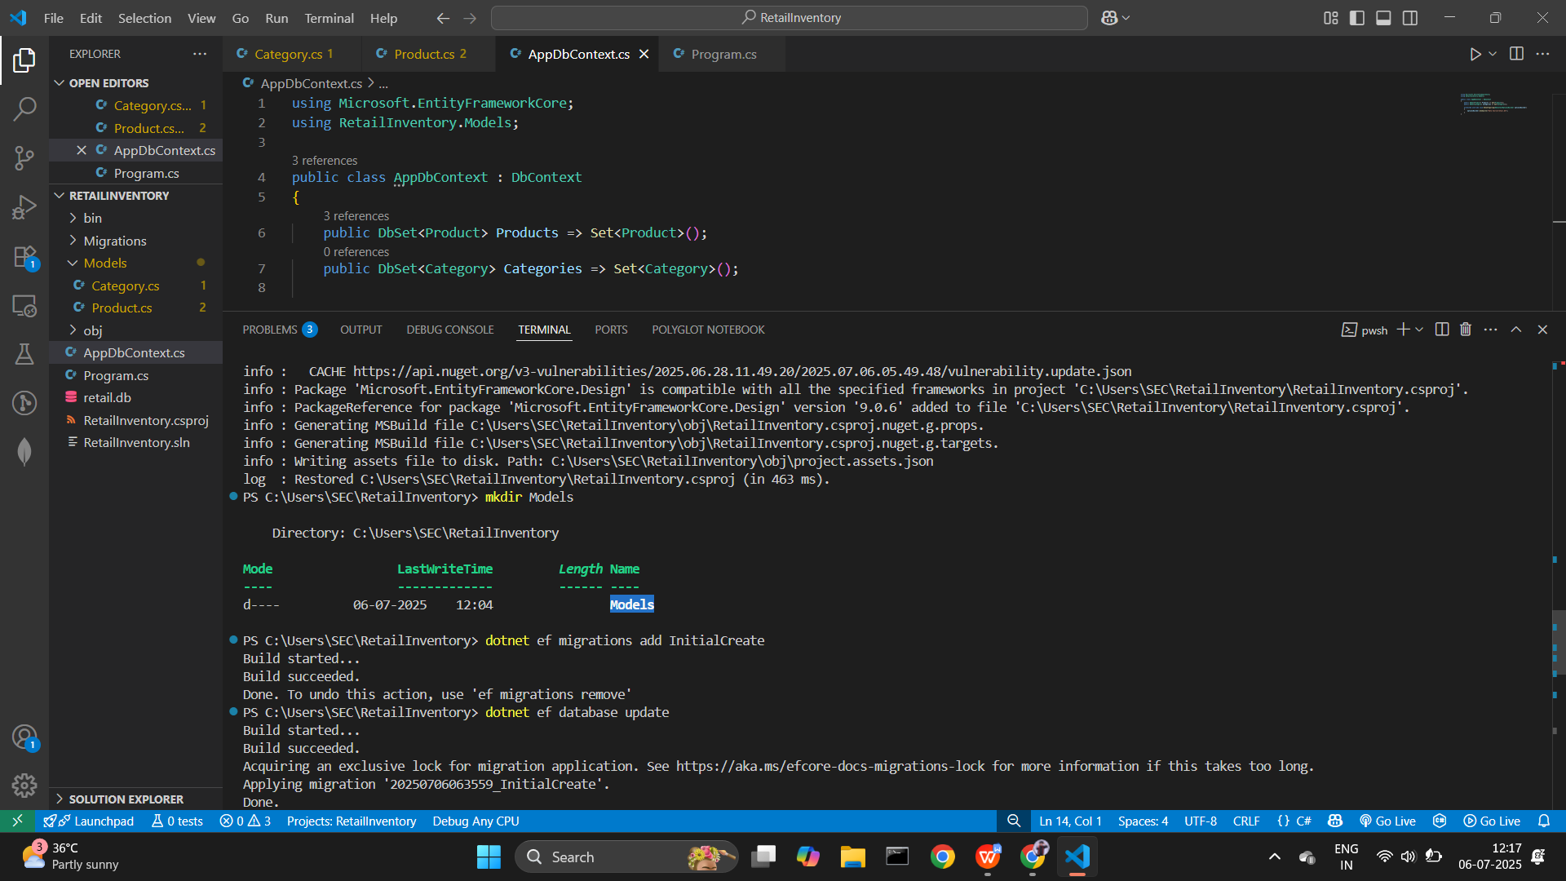

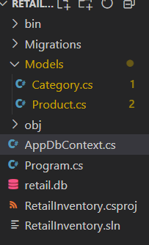

Thank you