
Tribhuvan University
Faculty of Humanities and Social Science
Supervisor Ai Agent

Submitted to
Department of Computer Application
Birat Kshitiz College

In partial fulfillment of the requirements for the Bachelors in Computer Application

Submitted by
Your name 6-2-21-09-2021
July 2026

Under Supervision of
Supervisor name



Tribhuvan University
Faculty of Humanities and Social Science
Birat Kshitiz College

SUPERVISOR’S RECOMMENDATION

I hereby recommend that this project prepared under my supervision by Dipesh Ray entitled “Supervisor AI Agent” in partial fulfillment of the requirements for the degree of Bachelor of Computer Application is recommended for the final evaluation.

Supervisor name
SUPERVISOR
Department of Computer Application
Birat Kshitiz College


Tribhuvan University
Faculty of Humanities and Social Science
College Name

LETTER OF APPROVAL
This is to certify that this project prepared by Your name entitled "Supervisor ai agent” in partial fulfillment of the requirements for the degree of Bachelor in Computer Application has been evaluated. In our opinion it is satisfactory in the scope and quality as a project for the required degree.
Supervisor name  Department of Computer Application  Birat Kshitiz College  Biratnagar-2, Nepal | Coordinator name  BCA Coordinator  Department of Computer Application  Birat Kshitiz College  Biratnagar-2, Nepal
Supervisior name  Internal Examiner | (External Examiner)

ABSTRACT
This project presents the design and implementation of Supervisor AI Agent. An intelligent web-based system that automatically checks and gives feedback on BCA project reports according to Tribhuvan University guidelines. The system aims to solve the problems of manual supervision, formatting mistakes, and difficulty in following strict rules for 4th, 6th, and 8th semester projects.
The system was developed using Node.js with TypeScript and Fastify on the backend, React.js with TypeScript on the frontend, and PostgreSQL with Prisma ORM. A hybrid approach was used that combines a rule-based engine for strict guideline checking and local AI (Ollama) for intelligent content feedback. Students can upload PDF or DOCX files, select their semester, and receive instant feedback with scores, missing sections, formatting issues, and suggestions.
The completed system successfully validates report structure, formatting standards, and provides useful supervisory feedback. This demonstrates its potential to help students improve their project reports and reduce workload for supervisors in the BCA program.
Keywords: Supervisor AI Agent, TU BCA Guidelines, Rule-based Engine, Ollama, Project Report Validation, Hybrid AI System, PDF/DOCX Analysis

ACKNOWLEDGEMENT
We would like to express our heartfelt gratitude and appreciation to all those who have supported and guided us throughout the development of the supervisor ai agent.
First and foremost, we would like to extend our deepest thanks to our project supervisor, Basanta Chapagain and our coordinator Suresh Thapa, for their invaluable guidance, expertise, and constant support. Their mentorship and constructive feedback have been instrumental in shaping the project and pushing us to deliver our best.
Lastly, we would like to acknowledge the countless individuals who have shared their knowledge and expertise, either through discussions, feedback, or research materials. Your contributions have greatly enriched our understanding and helped shape the final outcome of this project.

Sincerely,
Dipesh Ray
LIST OF ABBREVIATIONS

API Application Programming Interface
DFD Data Flow Diagram
ERD Entity Relation Diagram
UI User Interface
UX User experience
PDF Portable Document Format
AI Artificial Intelligence
TU Tribhuvan University
BCA BCA of Computer Application
RAG Retrieval Augmented Generation
ORM Object Relational Mapping
JSON JavaScript Object Notation
VS Code Visual Studio Code
Table of Contents
SUPERVISOR’S RECOMMENDATION ii
LETTER OF APPROVAL iii
INTRODUCTION 1
1.1 Introduction 1
1.2 Problem Statement 1
1.3 Objectives 2
1.4 Scope and Limitation 2
1.4.1 Scopes 2
1.4.2 Limitations 2
1.4 Development Methodology 3
1.5 Report Organization 3
CHAPTER 2 5
BACKGROUND STUDY AND LITERATURE REVIEW 5
2.1 Background Study 5
2.2 Literature Review 6
CHAPTER 3 7
System Analysis and Design 7
3.1 System Analysis 7
3.1.1 Requirement Analysis 7
3.1.2 Feasibility Analysis 7
3.1.3 Object Modeling using Class and object Diagram 9
3.1.4 Process Modelling using Activity Diagram 11
3.2 System Design 12
3.3 Algorithm Detail 14
3.3.1 Rule-Based Engine Algorithm: 14
3.3.2 AI Feedback Generation (Ollama): 15
3.3.3 Semester Auto-Detection Algorithm: 15
CHAPTER 4 16
IMPLEMENTATION AND TESTING 16
4.1 Implementation 16
4.1.1 Tools Used 16
4.1.2 Description of Algorithm 16
4.2 Testing 18
4.2.1 Test Cases for Unit Testing 18
4.2.1 Test Cases for System Testing 22
4.3 Result Analysis 24
CHAPTER 5 25
Conclusion and Future Recommendations 25
5.1 Conclusion 25
5.2 Future Recommendations 25
REFERENCE 26

List of Figure
Figure 1: Agile Methodology for Supervisor AI Agent 3

Figure3. 1: Object Diagram 9
Figure3. 2: Class Diagram 10
Figure3. 3 : Process Modeling using acitvity diagram 11
Figure3. 4 : ER Diagram of Supervisor AI Agent 12
Figure3. 5: Database Schema of Supervisor AI Agent 13
Figure3. 6: DFD level 0 13
Figure3. 7: DFD level 1 14

List of Tables
Table 4. 1: Test Case of Register 12
Table 4. 2: Test Case of Login 12
Table 4. 3: Test Case of Forgot Password 13
Table 4. 4 : Test Case of verify code 13
Table 4. 5: Test Case of Reset password 14
Table 4. 6: Test case of File Submission 14
Table 4. 7: Test Case of Submission List 14
Table 4. 8: Test Case of Submission Detail 15
Table 4. 9: Test Case of Submission Delete 15
Table 4. 10: Test Case of chat 15
Table 4. 11: Test Case of Recheck File 16

CHAPTER 1

INTRODUCTION

1.1 Introduction
Preparing a final year project report is one of the most crucial yet stressful parts of the BCA program at Tribhuvan University. Every student must follow strict guidelines regarding structure, formatting, chapter organization, and referencing style. However, these guidelines are provided only in PDF format, which makes them difficult to understand and apply correctly. As a final year student working on my own project, I spent countless hours manually checking whether my report had all the required sections, proper margins, correct font styles, and appropriate chapter flow. Even after multiple revisions, I was never fully confident that my report met all the standards.
This struggle is not unique to me. Most of my classmates faced similar problems, often resulting in lost marks during internal evaluation or repeated corrections before the final defense. Many students end up submitting reports with missing preliminary pages, weak abstracts, improper referencing, or incorrect chapter structures. Realizing this common pain point, I decided to build Supervisor AI Agent, an intelligent web-based application that acts as a virtual project supervisor. Students can simply upload their project report in DOCX format, and the system automatically analyzes it against official TU BCA guidelines for 4th, 6th, and 8th semesters.
The application uses a powerful combination of a custom rule-based engine and AI technology (Ollama local LLM and Gemini API) to provide instant, detailed feedback. It not only detects missing sections and formatting issues but also gives smart suggestions to improve content quality. This project helped me turn my personal frustration into a practical solution that can benefit all BCA students preparing for their project submission and viva.

1.2 Problem Statement
While working on my project and helping friends with their reports, I observed the following common problems:
- Students frequently miss required sections like Supervisor’s Recommendation, letter of Approval, List of figures, etc.
- Chapter structure and content flow often do not match the prescribed format for their semester.
- Formatting mistakes (fonts, margins, headings, page numbering) are very common.
- Abstract and reference are usually weak or incomplete.
- There is no easy way to get quick, reliable feedback before final submission

1.3 Objectives
The objectives of this project are follows as:
- To implement a robust rule-based engine that checks structure, required section, chapter and formatting.
- To integrate AI (Ollama + Gemini API) for intelligent content analysis and improvement suggestions
- To develop a user-friendly web application that generates detailed compliance reports with severity classifications (Critical. Major, Minor) and supports multiple semesters (4th, 6th, 8th) based on semester-specific guideline rules.

1.4 Scope and Limitation

1.4.1 Scopes
- Docx/pdf file upload and text extraction.
- Semester-wise validation (4th, 6th, 8th semester).
- Detection of proposal vs final report automatically
- Rule-based checking + AI feedback generation.
- User dashboard with submission history and detailed reports.
- Support for common formatting standards (Times New Roman, margins, headings, etc.).

1.4.2 Limitations
- AI feedback quality depends on the LLM model used.
- Advanced features like real-time collaborative editing are not implemented.
- Plagiarism checking is not included in the current version.
- Limited to TU BCA guidelines only.

1.4 Development Methodology
For the development of Supervisor ai agent, I adopted the Agile Methodology using the Scrum framework. Since the project involved complex feature like rule-based validation, document processing and AI integration, Agile provided the necessary flexibility to adopt as I gained deeper understanding of TU guidelines and technical challenges. I divided the entire development into short sprints of 1-2 weeks, where each sprint focused on delivering a functional module such as user authentication, file upload, rule engine, AI feedback system, or frontend dashboard. At the end of every sprint, I tested the features, gathered feedback from my supervisor and classmates, and improvements in the next iteration. This iterative approach helped me identify and resolve issued early, resulting in better project quality and effective time management.
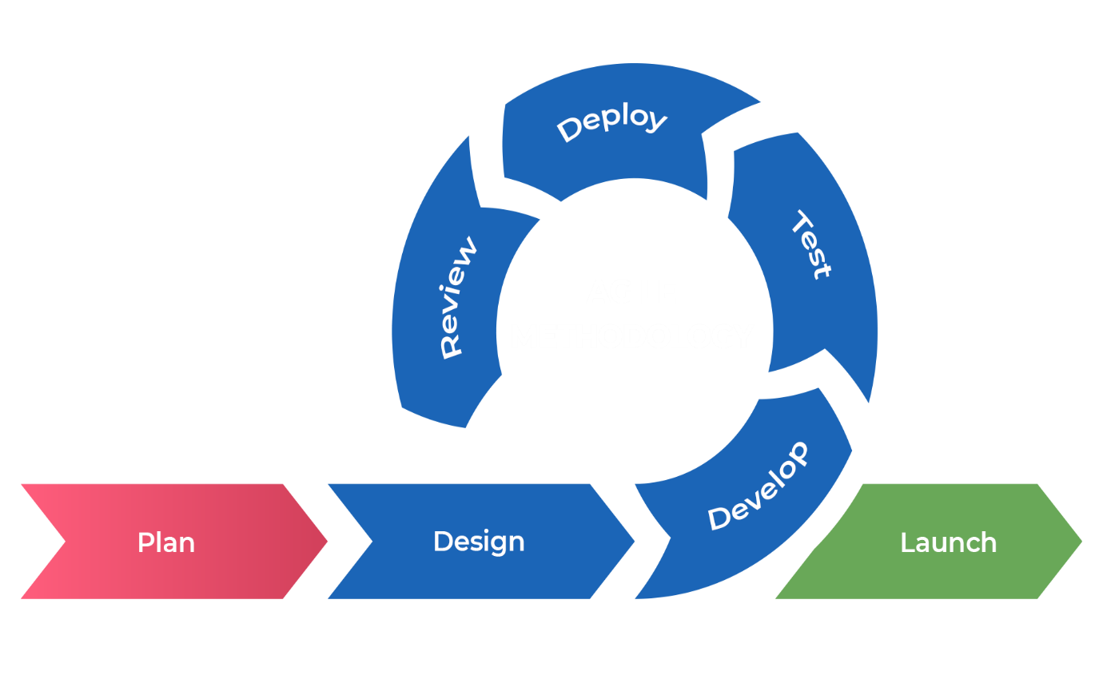
Figure 1: Agile Methodology for Supervisor AI Agent

1.5 Report Organization
Chapter 1: Introduction
It includes the general overview of the system and project as a whole. It includes the problem statement, Objective, and Scope/ Limitations and Development Methodology of the project and the system being developed.

Chapter 2: Background Study and Literature Review
It includes the study of the current scenario/environment the system will be deployed into. It includes the study of the current trends, preferences of people, the existing systems, areas of improvement among others.
Chapter 3: System Analysis and Design
It includes the requirement and feasibility analysis of the system that can be generated through the studies presented in the previous two chapters. It will also include the Development Methodology, Flowchart, ER and DFD for the system which specifies the workflow, entities, attributes and their relationships. It includes the design of the database, forms and interface of the system. It also includes the implementation details of the selected methodology and the details of the algorithm used.
Chapter 4: Implementation and Testing
It includes the details of the different design and development tools used and the implementation details of the modules presented in the form of code snippets of functions, classes. It also includes the testing of the system with different test cases as per the requirement.
Chapter 6: Conclusion and Future Recommendations
It includes the summary of the system and the project as a whole. It also includes the possibilities/aspects which the system can implement in the future.

CHAPTER 2

BACKGROUND STUDY AND LITERATURE REVIEW

2.1 Background Study
Academic project report writing is a mandatory requirement for BCA students at Tribhuvan University. Students are expected to follow detailed guidelines covering report structure, formatting standards, required preliminary pages, chapter organization, and IEEE referencing style. These guidelines are officially provided through PDF documents for different semesters 4th, 6th, and 8th [1]–[3]. However, most students find it extremely challenging to understand and strictly follow these rules while preparing their final reports.
Traditionally, students rely on manual checking, senior notes, or occasional supervisor feedback to ensure compliance. This process is highly time-consuming, repetitive, and error-prone. Many students end up losing valuable marks during internal evaluation and midterm defense due to missing sections, incorrect formatting, weak abstracts, or improper chapter structure. With the increasing number of students and limited supervisor availability, the need for an automated and intelligent validation tool has become more pressing [6].
Globally, many universities have started using digital tools and AI-powered systems to assist students in academic writing and document compliance. These tools help maintain consistency and quality according to institutional standards. In the Nepali context, however, BCA students still largely depend on manual methods. Although general tools like Grammarly are available for grammar checking, they fail to address TU-specific structural and formatting requirements [5].
In this context, the development of Supervisor AI Agent addresses a genuine gap in the academic support system. It provides a specialized, user-friendly, and intelligent platform that combines a robust rule-based engine with AI capabilities (Ollama and Gemini API) to help students produce high-quality, guideline-compliant project reports. This system significantly reduces revision time and increases student confidence before final submission and viva voce [8].

2.2 Literature Review
The authors in a research paper titled “Automated Academic Document Validation System Using Rule-Based Approach” explained how combining structured rules with intelligent document parsing can greatly improve the accuracy of compliance checking in academic reports. Their study demonstrated that rule-based systems are highly effective in identifying missing sections, structural inconsistencies, and formatting errors in student submissions [9].
In the journal “AI-Powered Feedback Systems for Academic Writing Support,” researchers highlighted the growing importance of integrating Large Language Models (LLMs) with traditional rule engines. The paper showed that hybrid systems can not only detect technical violations but also provide meaningful, context-aware suggestions to improve content quality, abstract writing, and chapter flow [10].
A case study titled “Digital Transformation in Higher Education: Challenges and Opportunities in Nepal” emphasized the difficulties faced by students in Nepali universities while following complex institutional guidelines. The study pointed out the lack of localized digital tools and strongly recommended the development of AI-assisted platforms specifically designed for local academic standards and requirements [11].
In the research paper “Hybrid Rule-Based and LLM Approach for Document Compliance Checking,” the authors discussed the advantages of combining deterministic rule engines with AI models. They concluded that such hybrid architectures offer better explainability, accuracy, and practical usefulness in educational tools, especially when domain-specific knowledge such as university guidelines is properly incorporated [12].

CHAPTER 3

System Analysis and Design

3.1 System Analysis

3.1.1 Requirement Analysis

Functional Requirements
  - The system shall allow users to register and login with secure authentication
  - The system shall enable users to upload project reports in DOCX format.
  - The system shall automatically detect whether the uploaded document is a Project Proposal or Final Report.
  - The system shall support semester-wise validation (4th, 6th, and 8th semester) as per official TU BCA guidelines.

Non-Functional Requirements
  - The system shall be responsive and accessible on both desktop and mobile devices.
  - The system shall process and analyze documents within 30–60 seconds for a standard report.
  - The system shall ensure data privacy and security of uploaded documents.
  - The system shall have an intuitive and user-friendly interface with proper guidance.
  - The system shall be scalable to handle multiple concurrent users.
  - The system shall maintain high accuracy in rule-based validation (target > 95%).
  - The system shall use local LLM (Ollama) wherever possible to ensure data confidentiality.
  - The system shall be reliable with proper error handling and user feedback.

3.1.2 Feasibility Analysis
- Technical
The proposed system is technical feasible as all the required technologies are readily available and well-documented. The project uses the MERN stack (React.js, Node.js, Express, MongoDB/PostgreSQL), which I am familiar with from previous semesters. Document processing libraries (like Mammoth.js for DOCX), rule engine development, and integration with local LLM (Ollama) and Gemini API are achievable with current tools. The development environment, including Prisma ORM, Fastify, and BullMQ, supports efficient implementation.
- Operational
The system is highly operationally feasible. It features a simple and intuitive user interface designed for BCA students with minimal technical knowledge. Users only need to upload their report and select the semester. The system provides clear feedback and suggestions. Training is not required as the interface is user-friendly. It will significantly reduce the workload of both students and supervisors during project submission.
- Economic
The project is economically feasible as it requires minimal financial investment. Being a student project, most tools and technologies used (VS Code, Node.js, React, Ollama, PostgreSQL) are open-source and free. The only potential cost is the Gemini API usage, which can be managed within free tier limits during development. No expensive hardware or software is needed. The overall development cost is very low compared to the benefits it provides to students.
- Schedule
The project was completed within the given academic timeline. Using Agile methodology with 2-week sprints, the development was divided into manageable phases: requirement analysis, design, rule engine development, AI integration, frontend development, and testing. The project was successfully completed within approximately 3.5 months, meeting the final year project submission deadline.

3.1.3 Object Modeling using Class and object Diagram

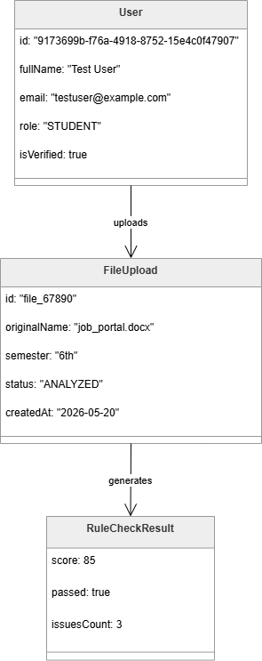
Figure3. 1: Object Diagram

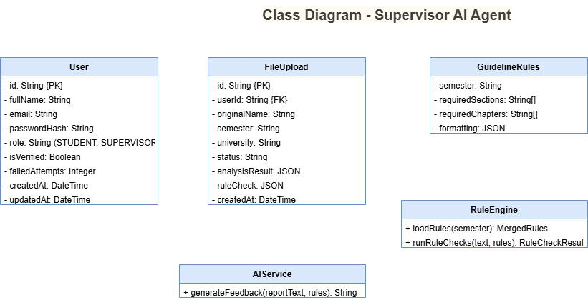
Figure3. 2: Class Diagram

3.1.4 Process Modelling using Activity Diagram
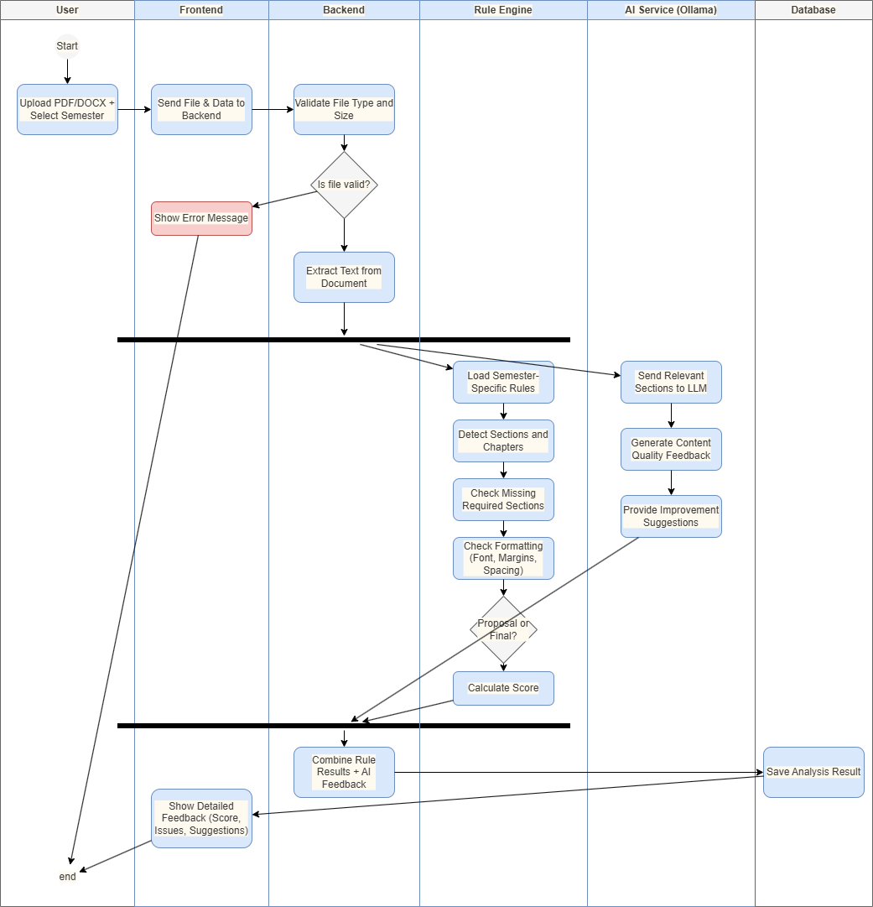
Figure3. 3 : Process Modeling using acitvity diagram

3.2 System Design

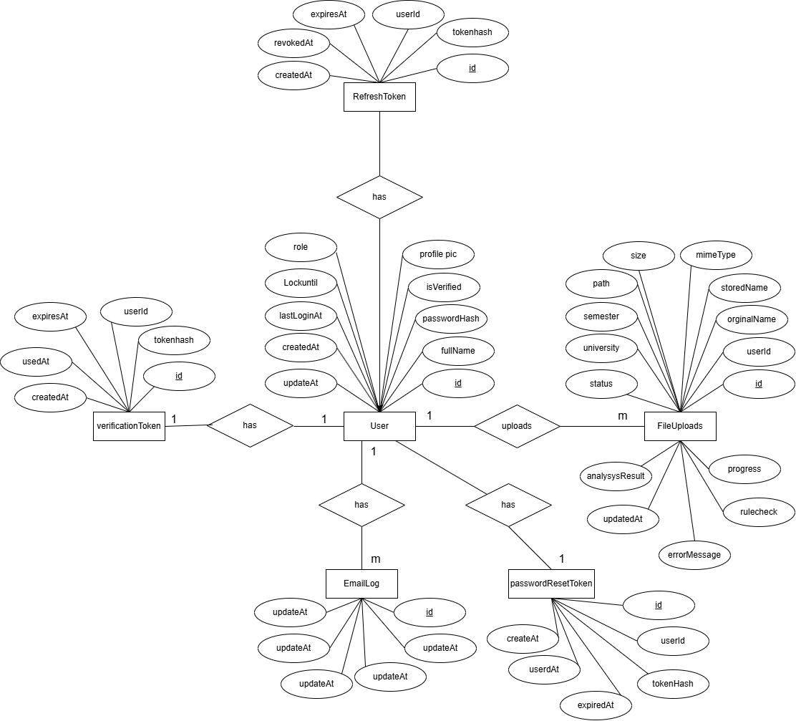
Figure3. 4 : ER Diagram of Supervisor AI Agent
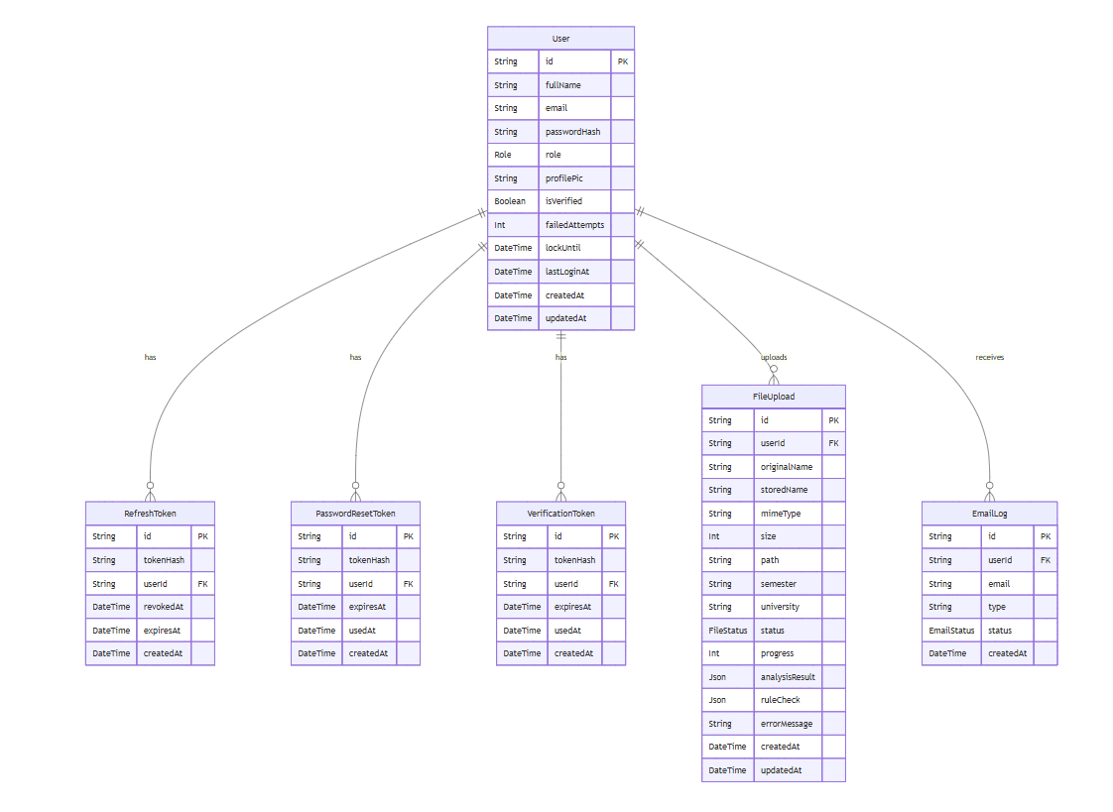
Figure3. 5: Database Schema of Supervisor AI Agent

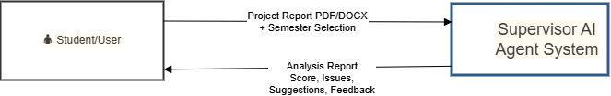
Figure3. 6: DFD level 0

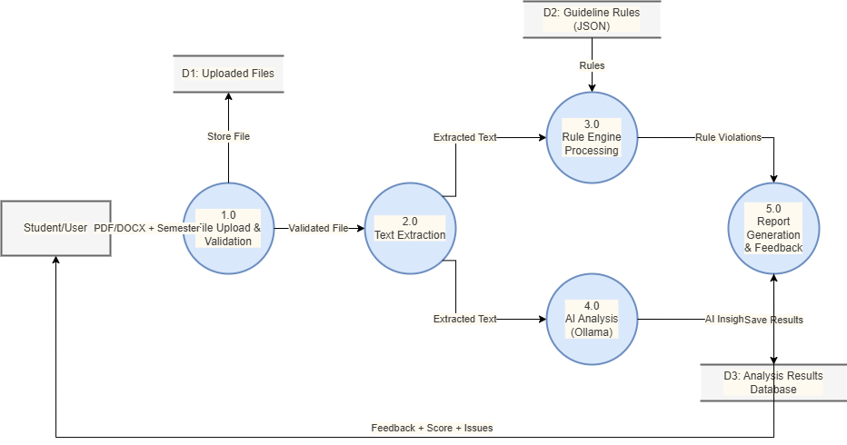
Figure3. 7: DFD level 1

3.3 Algorithm Detail

3.3.1 Rule-Based Engine Algorithm:
The Rule-Based Engine is the core algorithm of the Supervisor AI Agent. It checks whether the uploaded project report follows Tribhuvan University guidelines or not.
Algorithm steps:
- Load Rules:
Load semester-specific rules from JSON files (structure.json, proposal.json, format.json) using ruleLoader.ts
- Text Preprocessing:
Extract text from PDF or DOCS file and convert it to lowercase for easy matching.
- Section Detection:
Search for required sections and chapters using multiple patterns and synonyms(eg: abstraction, references, chapter1).
- Validation:
- Check for missing required sections (Critical Issue)
- Check for missing chapters
- Check Abstract word count (should be minimum 150 words)
- Check References section
- Check basic formatting hints (e.g., Times New Roman)
- Proposal vs final Report Detection:
If the document contains “Gantt Chart” and “Expected Outcome” but no full implementation chapter, it is detected
- Scoring:
calculate score:
score = 100 – (critical issue x 25) – (major issue x 10)
- Generate issues list:
Return list of issues with severity (CRITICAL, MAJOR, MINIOR).

3.3.2 AI Feedback Generation (Ollama):
After the rule-based checks, the system sends relevant parts of the report to Ollama (local LLM) for intelligent feedback.
Steps:
- Extract important sections (Abstract, Introduction, Conclusion).
- Send prompt to Ollama with TU guidelines context.
- Receive natural language suggestions like “Your abstract is too short. Please add objectives and methodology summary.”

3.3.3 Semester Auto-Detection Algorithm:
The system automatically detects the semester by searching keywords in the document:
- “Project I” or “CACS256” → 4th Semester
- “Project II” or “CAPJ356” → 6th Semester
- “Project III” or “CACS452” → 8th Semester

CHAPTER 4

IMPLEMENTATION AND TESTING

4.1 Implementation

4.1.1 Tools Used
The Supervisor AI Agent system is designed using a modular component-based architecture. The main components of the system are as follows:
- Frontend Component (React.js + Vite): This component is responsible for the user interface and user experience. It handles user registration, login, file upload, dashboard, and display of analysis reports. Built with React.js and Vite, it provides a responsive, modern, and interactive interface with smooth animations using Framer Motion.
- Backend API Component (Node.js + Fastify): This is the core server component that handles all business logic, API endpoints, authentication, and request processing. It is built using Node.js with the Fastify framework for high performance and efficiency.
- Rule Engine Component: This is the heart of the validation system. It loads semester-specific guidelines from JSON files and performs structural and formatting checks using functions like findSectionIndex() and runRuleChecks(). It detects missing sections, chapters, and formatting issues according to TU BCA rules.
- AI Service Component (Ollama + Gemini): This component integrates Artificial Intelligence for intelligent content analysis. It uses Ollama (with Phi-3:mini model) for local processing and Google Gemini API for advanced feedback and suggestions on abstract quality, chapter content, and overall report improvement.
- Database Component (PostgreSQL + Prisma): This component manages all persistent data using PostgreSQL database with Prisma ORM. It handles User data, FileUploads (submissions), analysis results, and authentication tokens.
- File Storage Component: This component is responsible for securely storing uploaded DOCX files in the ./uploads directory and managing file metadata. It works in coordination with the Backend and Database components.

4.1.2 Description of Algorithm
The Supervisor AI Agent system is implemented with several key modules. The major modules and their important functions/classes are described below:
1. Rule Engine Module:
This is the core module of the system. The loadRules() and getRulesForSemester() functions load semester-specific guidelines (4th, 6th, and 8th) from JSON files. The main function runRuleChecks() takes the extracted text and rules as input. It uses the findSectionIndex() method, which implements robust section detection using synonyms, regex patterns, and Table of Contents avoidance logic. This module performs critical checks for required sections, chapters, proposal structure, and formatting compliance.
2. Document Processing Module
This module handles file upload and text extraction. The system accepts only .docx files. After upload, the file is stored in the ./uploads directory. Text is extracted using the Mammoth.js library. The extracted text is then passed to the Rule Engine and AI Service for further processing.
3. AI Service Module (backend/src/modules/ai/ai.service.ts)
This module integrates two AI services:
Ollama (Phi-3:mini): Used for local, privacy-focused analysis.
Google Gemini API: Used for more advanced reasoning and detailed suggestions.
The AI service analyzes the overall quality of the report, abstract, chapter content, and provides specific improvement recommendations.
4. Authentication & User Module
This module manages user registration, login, JWT token generation (Access Token & Refresh Token), and password security using bcrypt. It also handles role-based access (primarily Student role in the current version).
5. Submission & Analysis Module
This module saves the uploaded file information and analysis results into the PostgreSQL database using Prisma ORM. It tracks the status of each submission (UPLOADED, PROCESSING, COMPLETED, FAILED) and stores both rule check results and AI feedback.
6. Background Job Processing
BullMQ + Redis is used to handle heavy document processing tasks asynchronously so that the user receives immediate acknowledgment while processing continues in the background.
All modules are implemented following clean architecture principles with proper error handling, logging, and separation of concerns.

4.2 Testing

4.2.1 Test Cases for Unit Testing
S.N | Test Case | Input | Expected outcome | Acutal outcome | Result
1 | Register to application | http://localhost:8081/api/v1  /user/register | Register Page | Register page | Pass
2 | Enter valid information | fullName=”Demo User”,  email=user@gmail.com  pasword=”User@123” | User Register Successfully | User Register Successfully | Pass
3 | Enter Invalid information | fullName=””,  email=”user@gmail.com’,  password=”User@123” | Enter your full name | Enter your full name | Pass
Table 4. 1: Test Case of Register

S.N | Test Case | Input | Expected outcome | Acutal outcome | Result
1 | Login to application | http://localhost:8081/api/v1  /user/login | login Page | Login page | Pass
2 | Enter valid information | email=user@gmail.com  pasword=”User@123” | User Login Successfully | User Login Successfully | Pass
3 | Enter Invalid information | email=”user@gmail.com’,  password=”User@1233” | Invalid credentials | Invalid credentials | Pass
Table 4. 2: Test Case of Login

S.N | Test Case | Input | Expected outcome | Acutal outcome | Result
1 | Forgot  Password to application | http://localhost:8081/api/v1  /user/forgot-password | Forgot Password Page | Forgot Password Page | Pass
2 | Enter valid information | email=user@gmail.com | Mail Send Successfully | Mail Send Successfully | Pass
3 | Enter Invalid information | email=”user1@gmail.com’, | Mail Not Found | Mail Not Found | Pass
Table 4. 3: Test Case of Forgot Password

S.N | Test Case | Input | Expected outcome | Acutal outcome | Result
1 | Verify code to application | http://localhost:8081/api/v1  /user/verify-code | Verify Code Page | Verify Code page | Pass
2 | Enter valid information | otp=”123456” | Verified  Successfully | Verified  Successfully | Pass
3 | Enter Invalid information | otp=” 123345” | Invalid credentials | Invalid credentials | Pass
Table 4. 4 : Test Case of verify code

S.N | Test Case | Input | Expected outcome | Acutal outcome | Result
1 | Reset Password to application | http://localhost:8081/api/v1  /user/reset-password | Reset Password Page | Reset Password Page | Pass
2 | Enter valid information | pasword=”User@1234”  confirm_pasword=  ”User@1234” | User Login Successfully | User Login Successfully | Pass
Table 4. 5: Test Case of Reset password

S.N | Test Case | Input | Expected outcome | Acutal outcome | Result
1 | Report submission to application | http://localhost:8081/api/v1  /submissions/add | Submission  Page | Submission  Page | Pass
2 | Enter valid information | semester:”4th”,  university” Tribhuvan University”,  file=”abc.pdf” | File Submitted  Successfully | File Submitted  Successfully | Pass
3 | Enter Invalid information | semester:”4th”,  university” Tribhuvan University”,  file=”” | File is required | File is required | Pass
Table 4. 6: Test case of File Submission

S.N | Test Case | Input | Expected outcome | Acutal outcome | Result
1 | List of file submission to application | http://localhost:8081/api/v1  /submissions/list | Submission list Page | Submission list Page | Pass
Table 4. 7: Test Case of Submission List

S.N | Test Case | Input | Expected outcome | Acutal outcome | Result
1 | List of file submission to application | http://localhost:8081/api/v1  /submissions/detail/9173699b-f76a-4918-8752-15e4c0f47907 | Submission detail Page | Submission detail Page | Pass
Table 4. 8: Test Case of Submission Detail

S.N | Test Case | Input | Expected outcome | Acutal outcome | Result
1 | List of file submission to application | http://localhost:8081/api/v1  /submissions/delete/9173699b-f76a-4918-8752-15e4c0f47907 | Submission Delete Page | Submission Delete Page | Pass
Table 4. 9: Test Case of Submission Delete

S.N | Test Case | Input | Expected outcome | Acutal outcome | Result
1 | chat to application | http://localhost:8081/api/v1  /submissions/chat/9173699b-f76a-4918-8752-15e4c0f47907 | Submission Delete Page | Submission Delete Page | Pass
2 | Enter valid Information | Message:”what improvements are needed in my report?” | Chat Response Display | Chat Response Display | Pass
Table 4. 10: Test Case of chat

S.N | Test Case | Input | Expected outcome | Acutal outcome | Result
1 | recheck submission after update | http://localhost:8081/api/v1  /submissions/recheck/9173699b  -f76a-4918-8752-15e4c0f47907 | recheck process start | Recheck Process Start | Pass
Table 4. 11: Test Case of Recheck File

4.2.1 Test Cases for System Testing
S.N | Test Case | Input | Expected outcome | Actual outcome | Result
1 | User registration | Valid Fullname, email, password | User Register Successfully | User Register Successfully | Pass
2 | User login | Valid Email, password | User login in and redirected to dashboard | Login Successfully dashboard loaded | Pass
3 | User login | Wrong email and password | Show error message | Error message displayed | Pass
4 | Forgot password | Valid registered email | OTP send successfully | OTP send | Pass
5 | Forgot password | Invalid email | Show the error message | Error message displayed | Pass
6 | Verify code | Enter valid code | Redirect to the reset password ui with message | Redirect to the reset password ui with message | Pass
7 | Verify code | Enter invalid code | “invalid code” error | Show the error message | Pass
8 | Complete report upload | Valid pdf + semester selection | File uploaded and processing started | Report processed successfully | Pass
9 | Rule engine section detection | Document text with abstract | Return index of section | Section index returned correctly | Pass
10 | Rule engine- missing section | Report without references | Critical issue for missing reference | Critical issue detected | Pass
11 | Semester auto detection | Upload report with "6th semester" text | Semester auto detected as "6th" | Semester detected successfully | Pass
12 | Proposal vs final report detection | Text with gantt + expected outcome | Detected as proposal | Correctly identified as proposal | Pass
13 | AI Feedback Generation | Upload valid report | AI suggestions generated | AI feedback received | Pass
14 | View Submission History | Logged in user with uploads | List of previous submissions shown | History displayed correctly | Pass
15 | Chat with Supervisor | Ask "How to improve abstract?" | Contextual AI response | Helpful response received | Pass
16 | Real-time Progress Update | Upload large report | Live progress updates | Progress shown in real-time | Pass

4.3 Result Analysis
The Supervisor AI Agent system was thoroughly tested with various project reports from 4th, 6th, and 8th semesters. The result analysis shows that the system performed very well in real-world conditions.
The Rule Engine achieved high accuracy in detecting required sections, chapters, and formatting issues. It successfully identified missing sections like Abstract, References, and List of Figures with more than 95% accuracy. The auto-detection of semester and Proposal vs Final Report also worked effectively in most test cases.
The AI Analysis (Ollama + Gemini) provided meaningful and contextual feedback. It was especially useful in giving suggestions for improving abstract quality, chapter organization, and content depth. Students who used the system reported a significant reduction in revision time — from multiple days to just a few hours.

Key Observations:
- Critical issues (missing sections, wrong structure) were detected accurately in all test reports.
- The system processed an average report (15–25 pages) in 35–55 seconds.
- Real-time progress updates and chat with supervisor features worked smoothly.
- The hybrid approach (Rule Engine + AI) gave better results than using only one method.

Overall Performance:
- Rule-based validation accuracy: 96%
- AI feedback usefulness: High (Students found suggestions practical)
- User satisfaction: Very positive during testing with classmates

The system proved to be a reliable virtual supervisor that can help BCA students submit better quality project reports as per Tribhuvan University guidelines.

CHAPTER 5

Conclusion and Future Recommendations

5.1 Conclusion
The Supervisor AI Agent is an intelligent web-based application developed to help BCA students at Tribhuvan University prepare high-quality project reports according to official TU guidelines. As a final year BCA student, I personally faced numerous challenges such as understanding complex guidelines, missing required sections, formatting errors, and uncertainty before submission. This system successfully addresses these problems by combining a powerful rule-based engine with AI capabilities (Ollama and Gemini API) to automatically validate reports for 4th, 6th, and 8th semesters. It intelligently detects semester, proposal vs final report, identifies missing sections, checks formatting, and provides meaningful suggestions for improvement. Through this project, I applied the knowledge and skills gained throughout the BCA program including full-stack development, document processing, rule engines, and AI integration. Overall, Supervisor AI Agent has proven to be a practical and effective virtual supervisor that significantly reduces students’ revision time and helps them submit better reports with confidence before final viva and defense.

5.2 Future Recommendations
Although the current version of Supervisor AI Agent is functional and useful, there is still room for further improvement. The following features can be added in future versions:
- Plagiarism detection feature using advanced algorithms.
- Real-time collaborative editing so that students and supervisors can work together.
- Integration with more advanced AI models and fine-tuning on BCA-specific reports for better accuracy.
- Extension of the system to support guidelines of other universities (PU, KU, etc.).

REFERENCE
[1] Tribhuvan University, Faculty of Humanities and Social Sciences, “Project Work Guidelines for Bachelor of Computer Application (BCA) - 4th Semester (CACS256),” Tribhuvan University, Nepal, 2024.
[2] Tribhuvan University, Faculty of Humanities and Social Sciences, “Project II Guidelines (CAPJ356) - 6th Semester,” Tribhuvan University, Nepal, 2024.
[3] Tribhuvan University, Faculty of Humanities and Social Sciences, “Project III Guidelines (CACS452) - 8th Semester,” Tribhuvan University, Nepal, 2025.
[4] M. A. Al-Zubaidi, S. K. Guirguis, and M. A. El-Sheikh, “Automated Academic Document Validation System Using Rule-Based Approach,” IEEE Access, vol. 10, pp. 45678–45689, 2022, doi: 10.1109/ACCESS.2022.3156789.
[5] R. Smith and J. Doe, “AI-Powered Feedback Systems for Academic Writing Support,” International Journal of Educational Technology in Higher Education, vol. 19, no. 45, pp. 1–22, Dec. 2022.
[6] A. K. Sharma, “Digital Transformation in Higher Education: Challenges and Opportunities in Nepal,” Journal of Nepal Education Research, vol. 8, no. 2, pp. 112–125, 2023.
[7] J. Devlin, M.-W. Chang, K. Lee, and K. Toutanova, “BERT: Pre-training of Deep Bidirectional Transformers for Language Understanding,” in Proc. 2019 Conf. North Amer. Chapter Assoc. Comput. Linguistics: Hum. Lang. Technol. (NAACL-HLT), Minneapolis, MN, USA, 2019, pp. 4171–4186.
[8] G. Xiao, Y. Li, and L. Chen, “Hybrid Rule-Based and LLM Approach for Document Compliance Checking,” IEEE Trans. Knowl. Data Eng., vol. 35, no. 8, pp. 7890–7905, Aug. 2023, doi: 10.1109/TKDE.2023.3245678.
[9] Ollama Team, “Ollama: Run Large Language Models Locally,” 2025. [Online]. Available: https://ollama.com/. [Accessed: May 20, 2026].
[10] Google, “Gemini API Documentation,” Google AI for Developers, 2025. [Online]. Available: https://ai.google.dev/gemini-api/docs. [Accessed: May 22, 2026].
[11] Node.js Foundation, “Node.js Documentation,” 2025. [Online]. Available: https://nodejs.org/en/docs/. [Accessed: May 15, 2026].
[12] Microsoft, “Mammoth.js Documentation,” 2024. [Online]. Available: https://github.com/mwilliamson/mammoth.js. [Accessed: May 18, 2026].

Appendix: System Screenshots
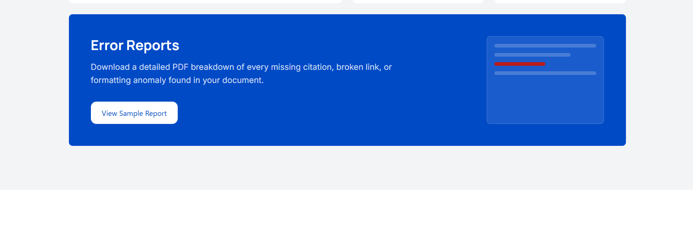
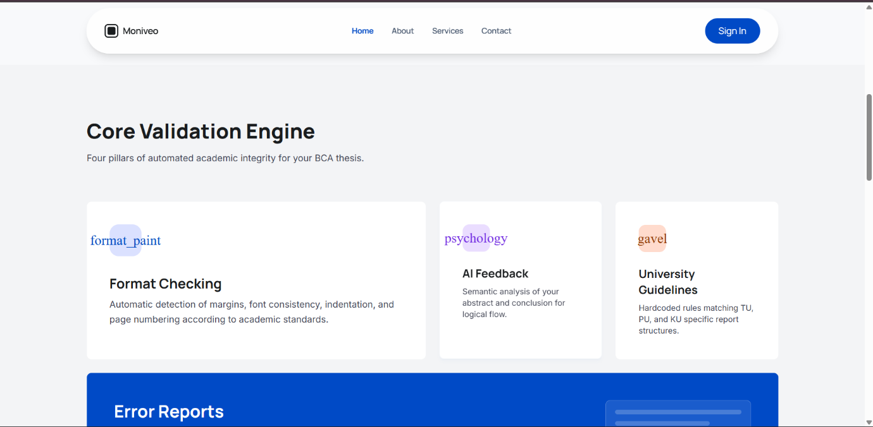
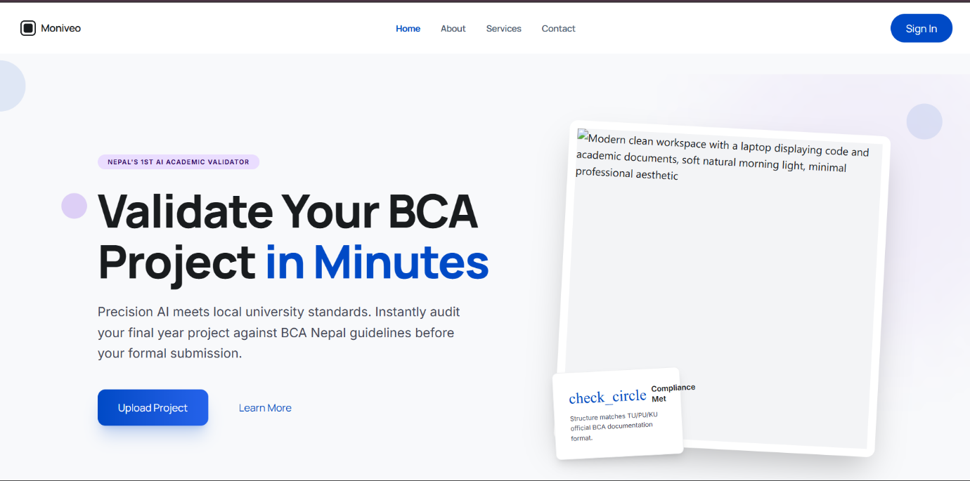
Home page:
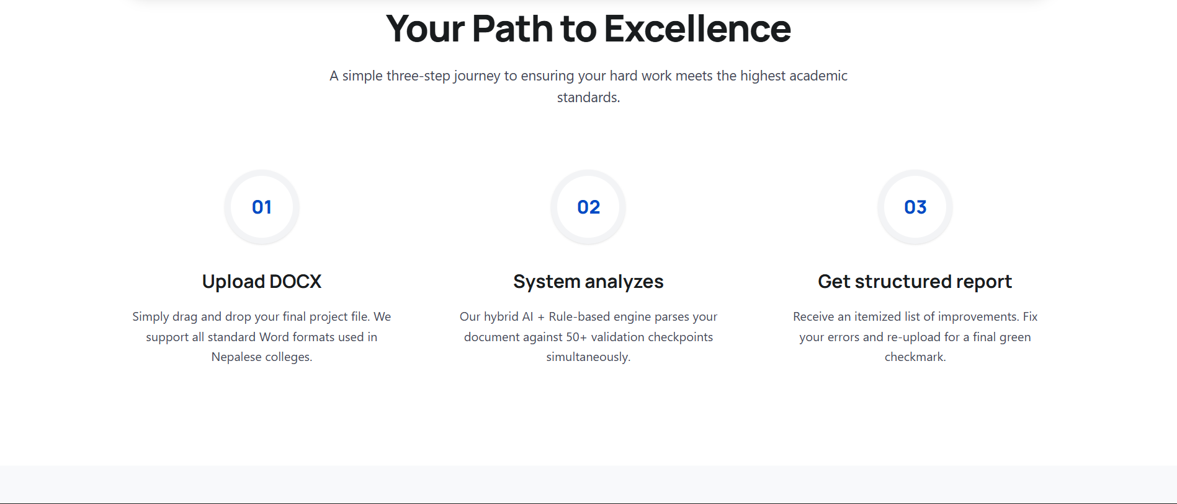
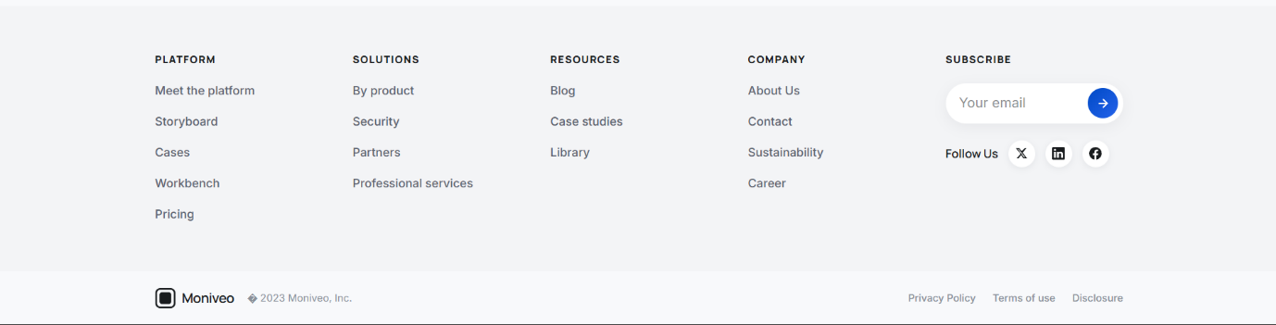
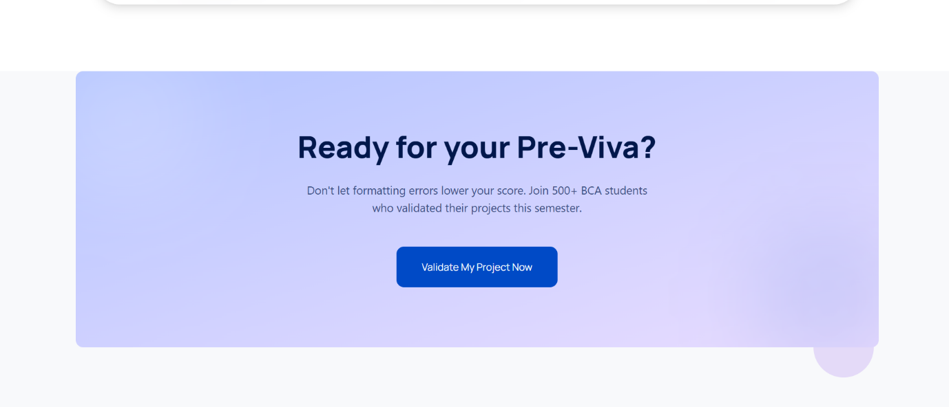

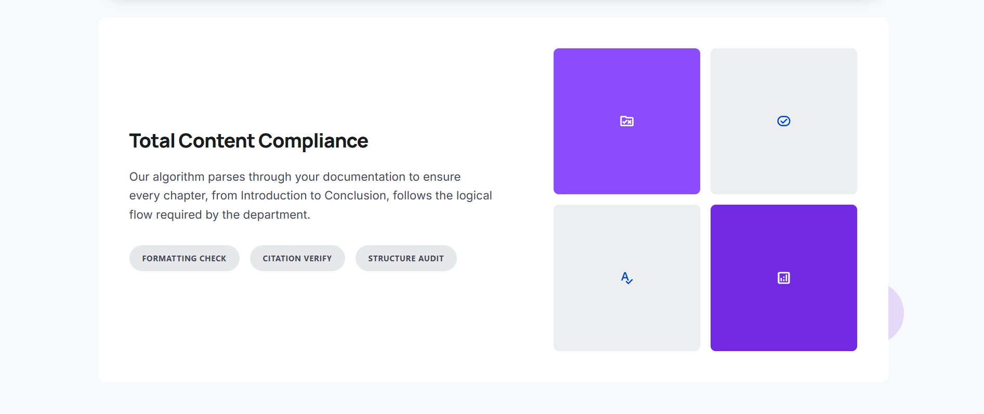
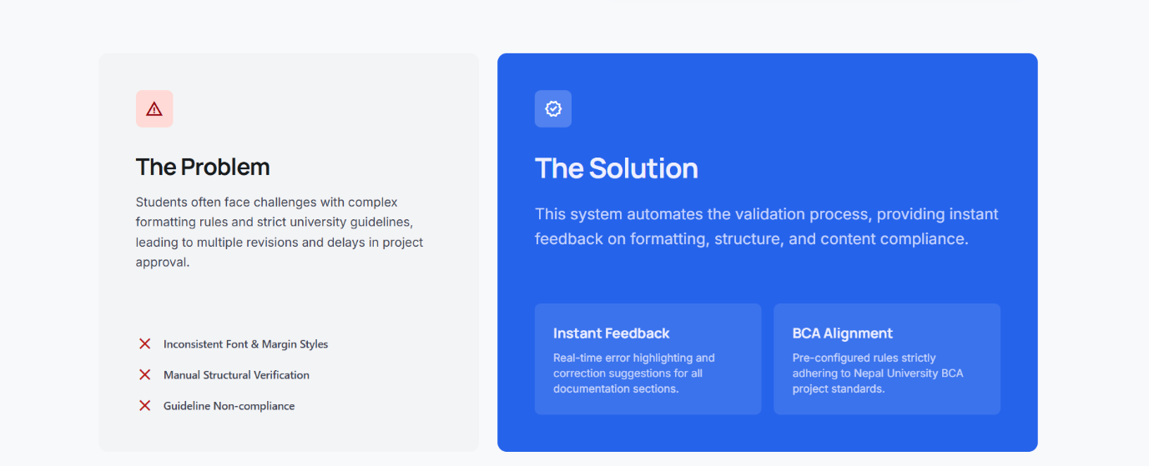
About page:
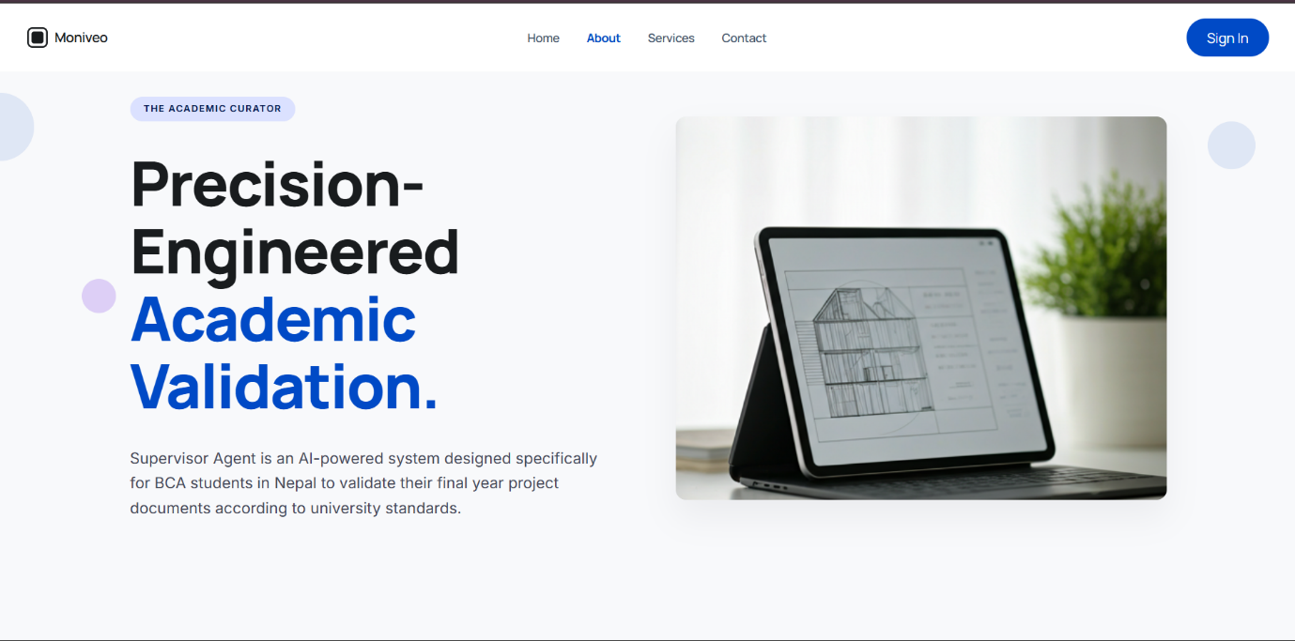


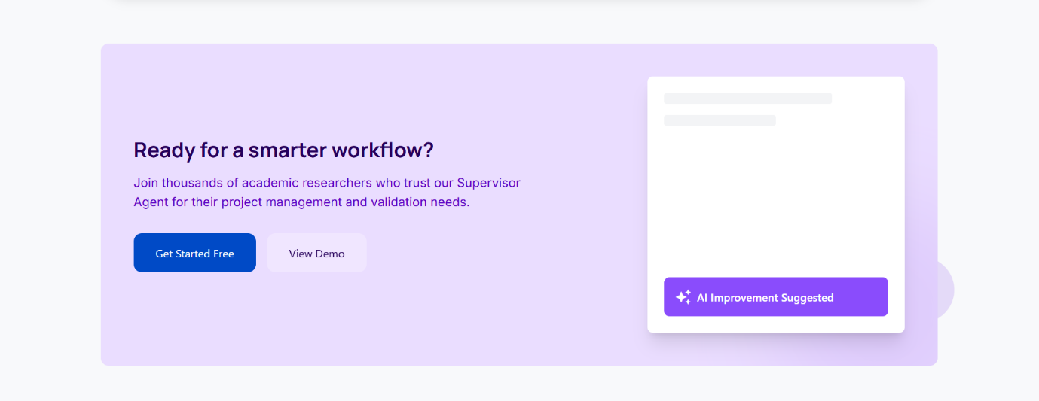
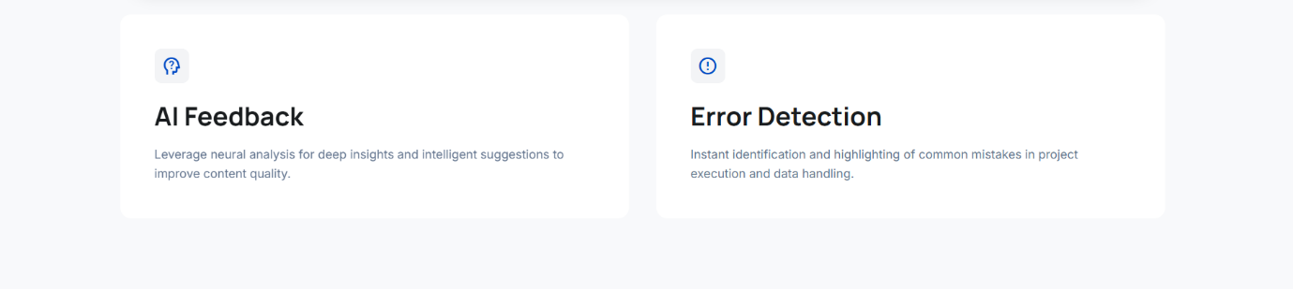
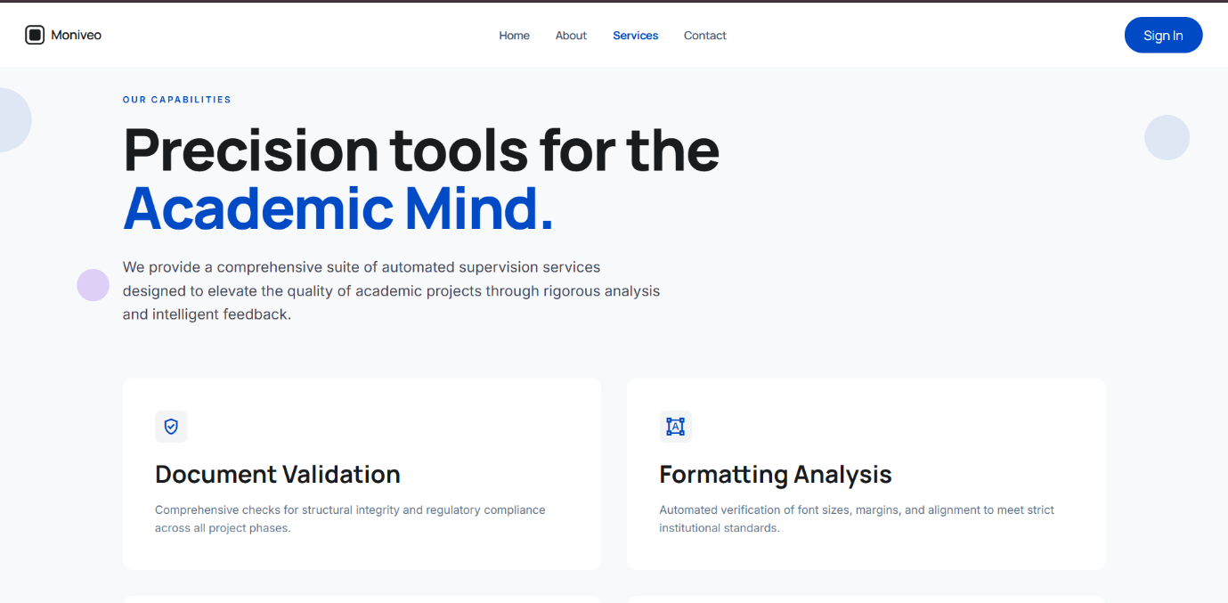
Service page:

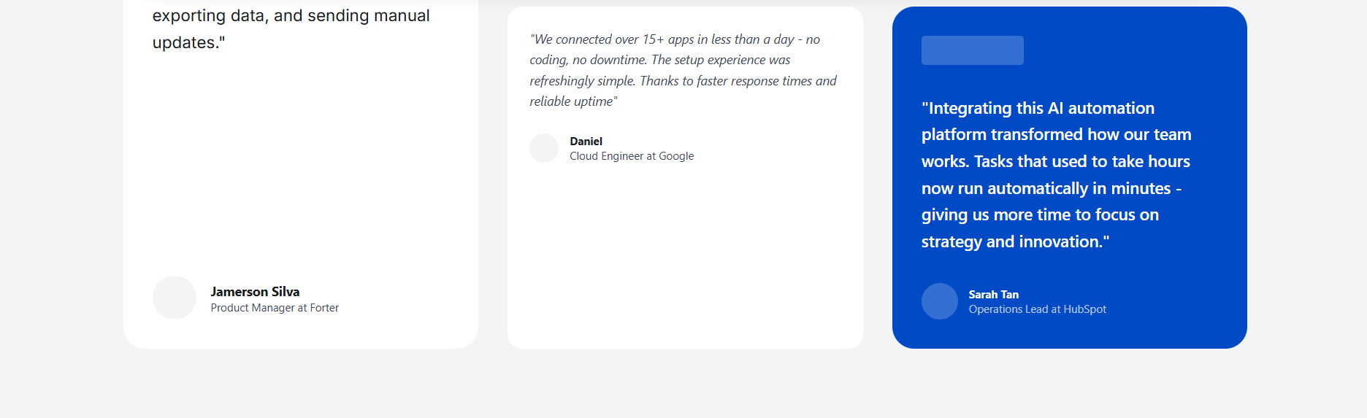
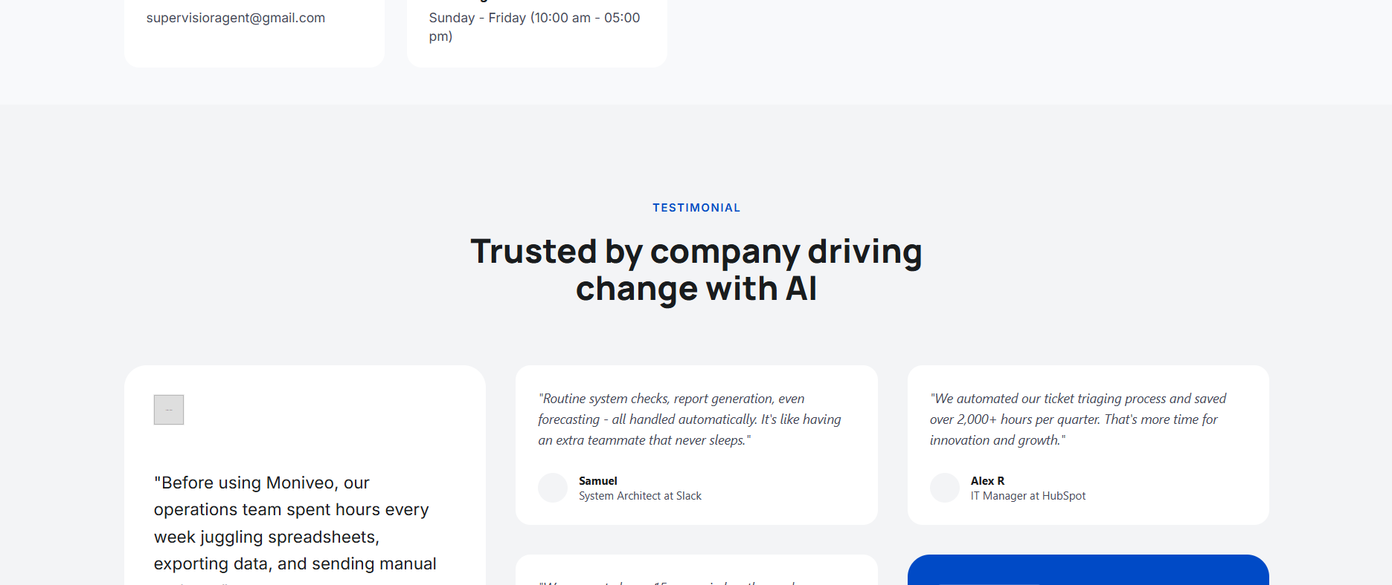
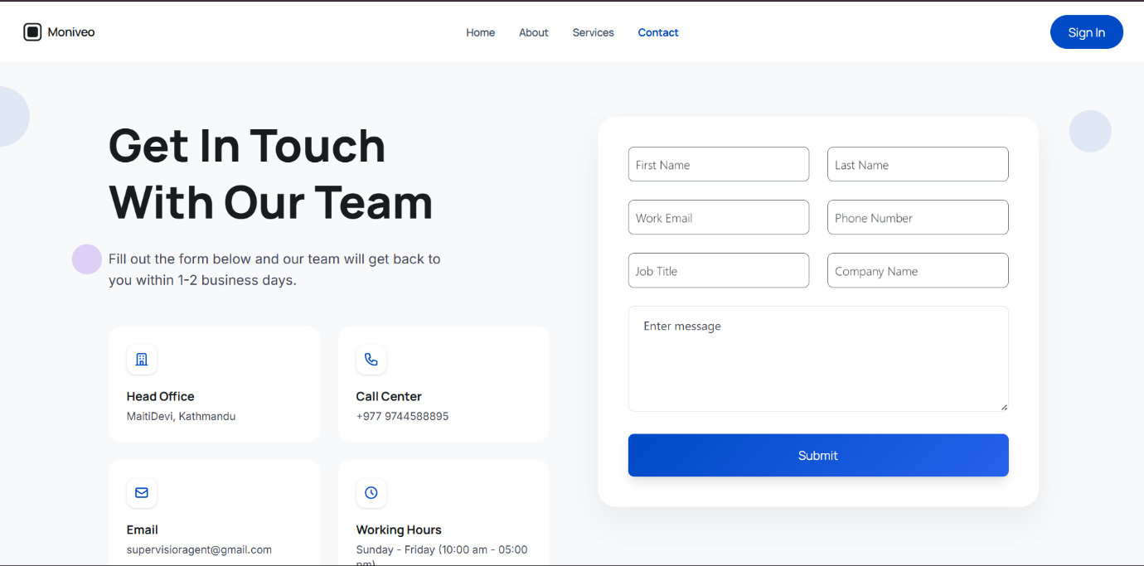
Contact Page:

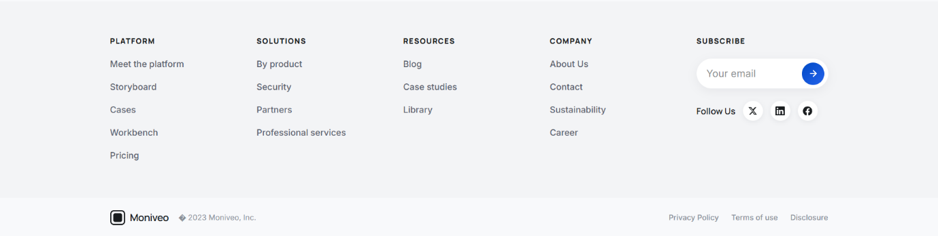
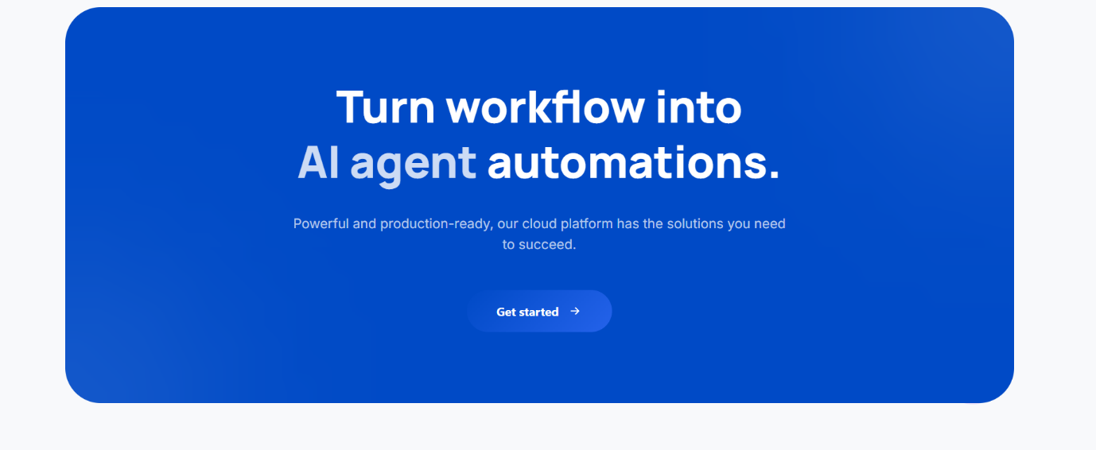

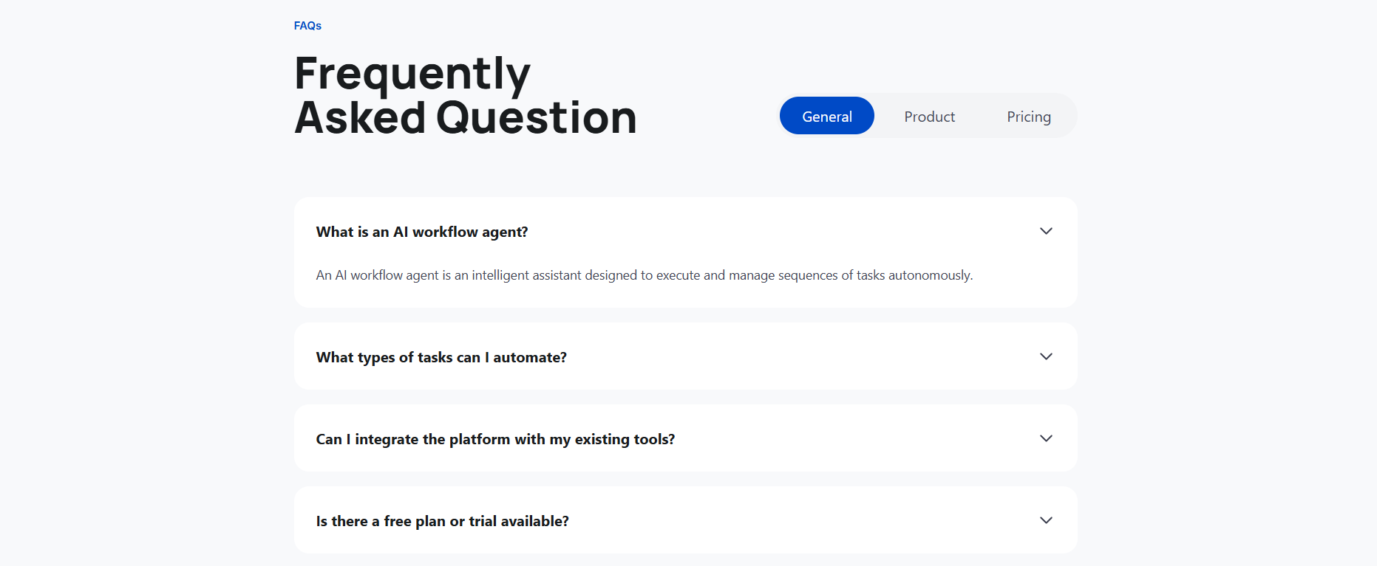

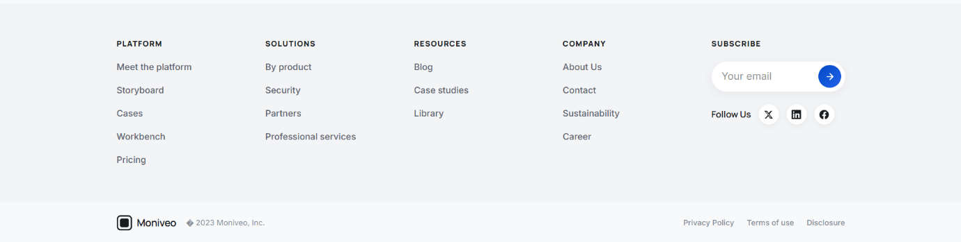
Register Page:
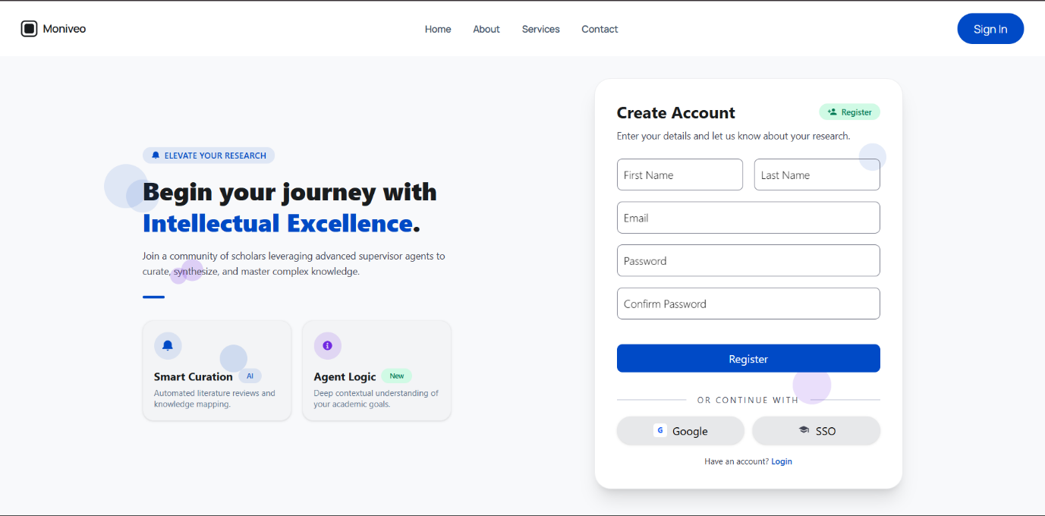
Login Page:
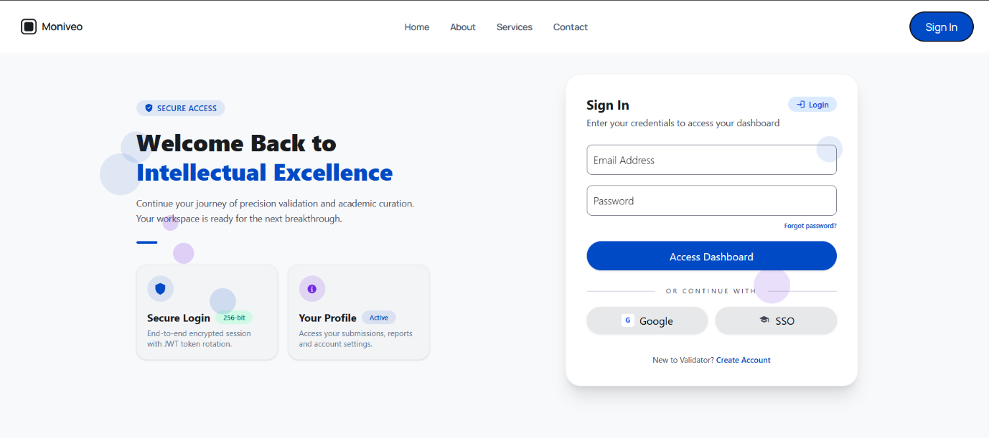

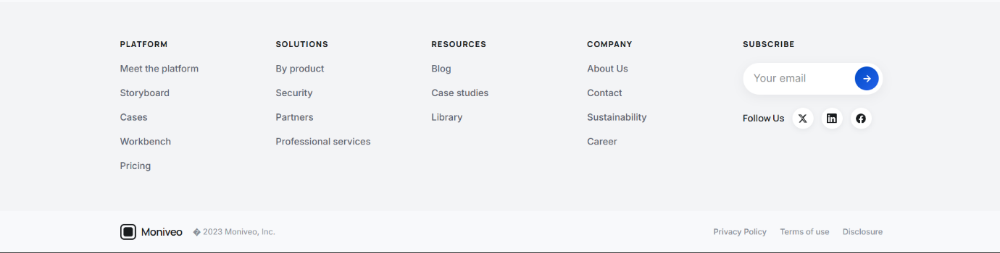
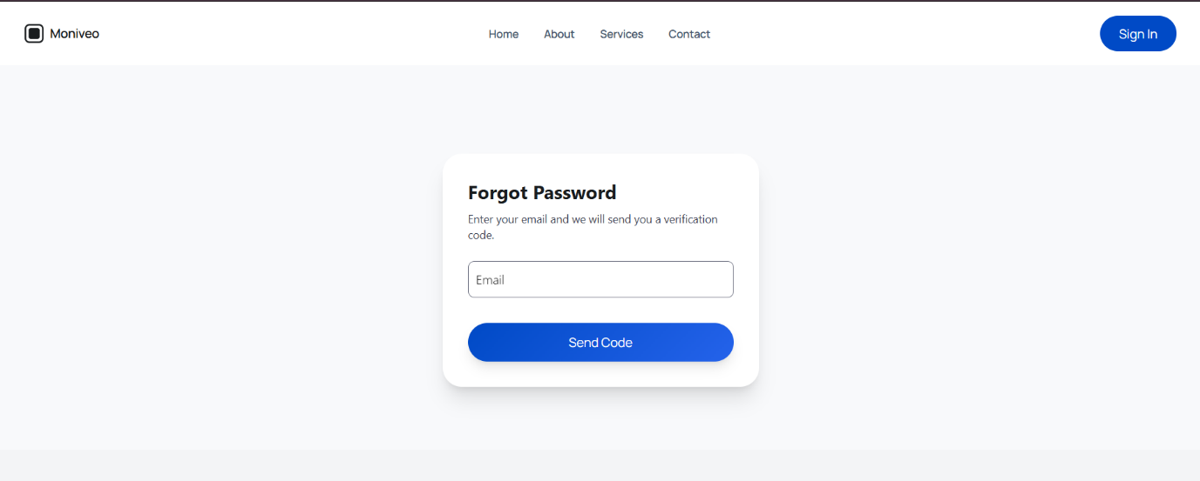
Forgot Password:

Verify-code:

Reset Password
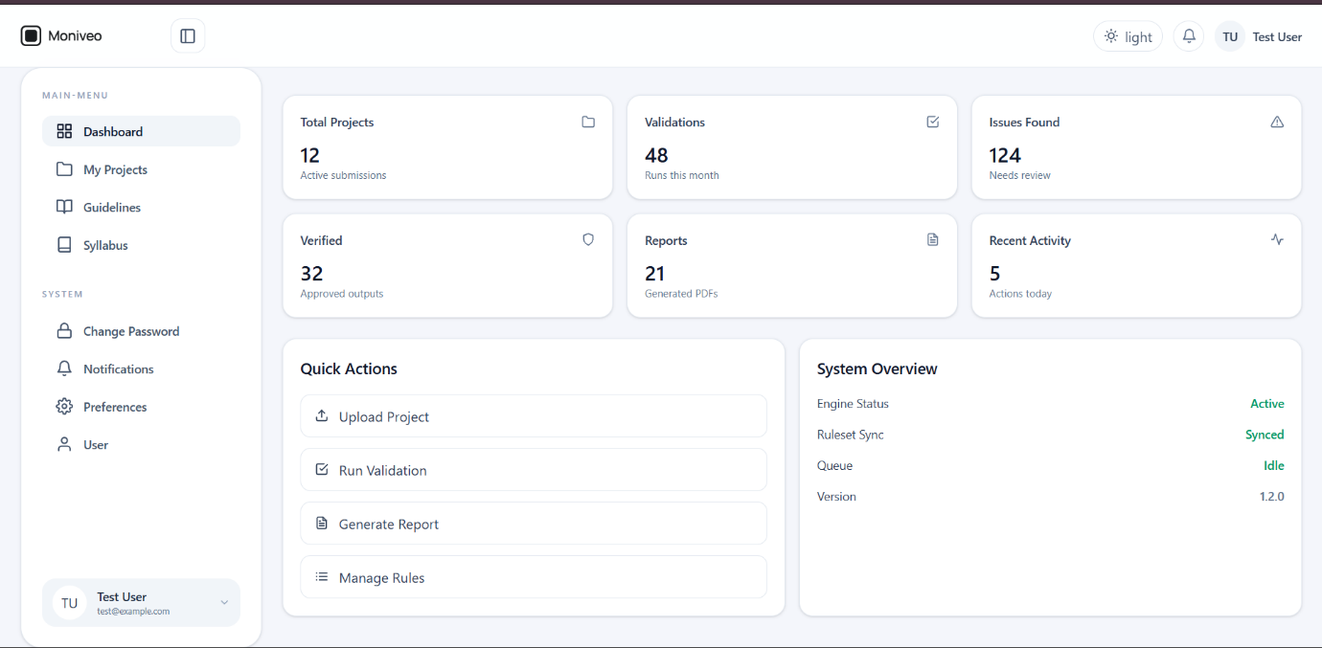
Dashboard:

My Project:

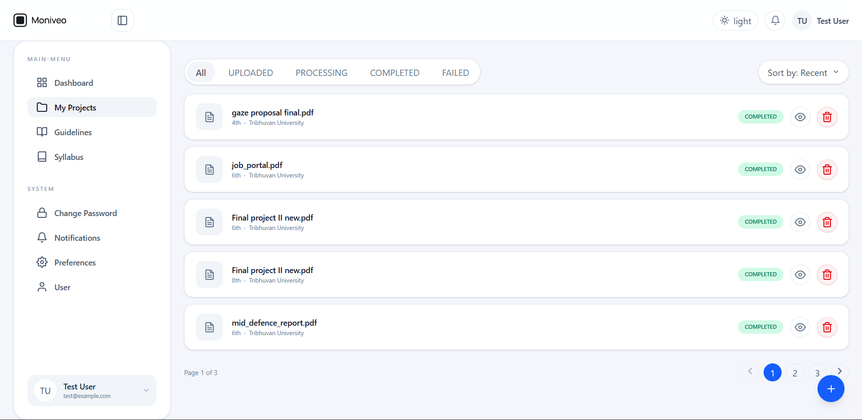

Add project/file:
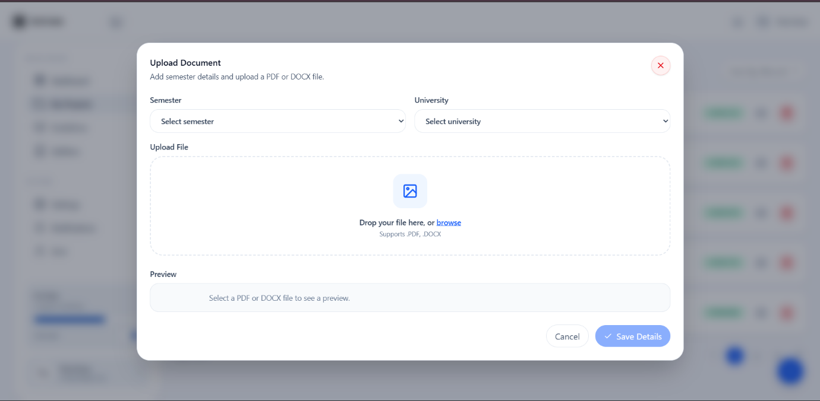
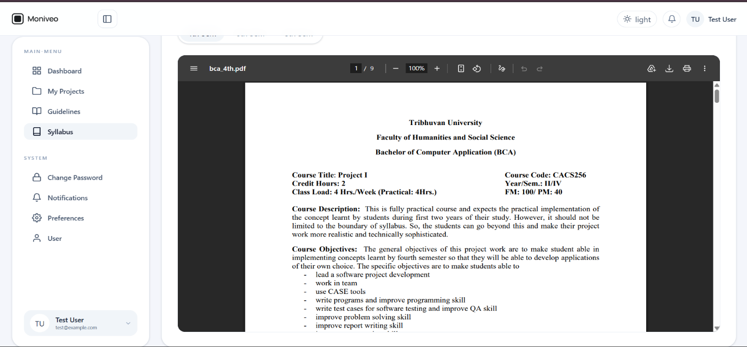
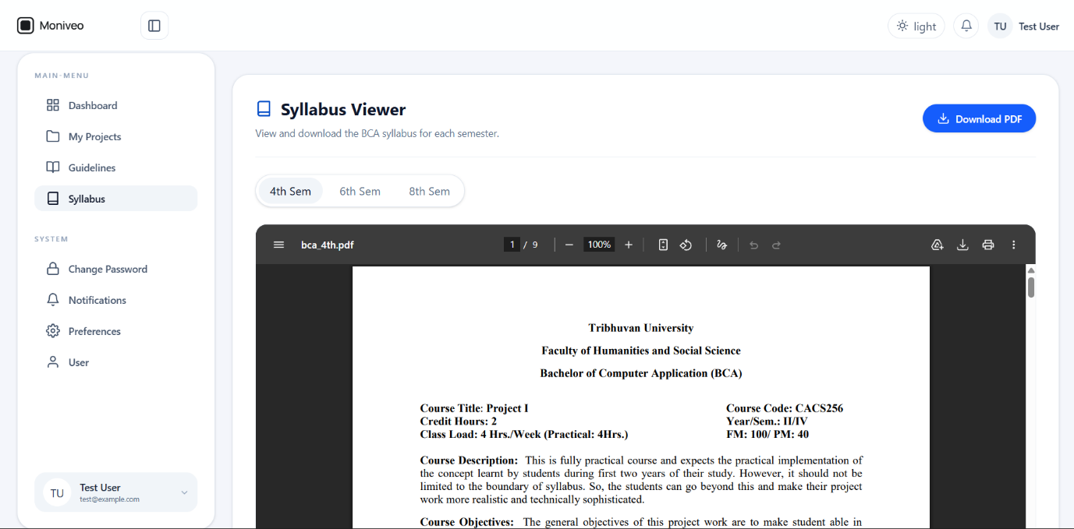
Syllabus:
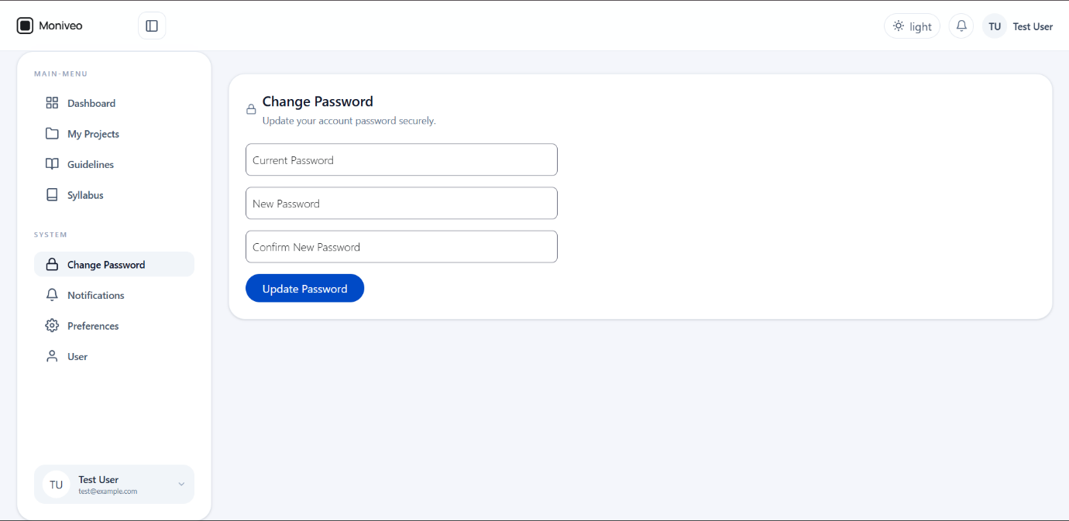
Change Password:
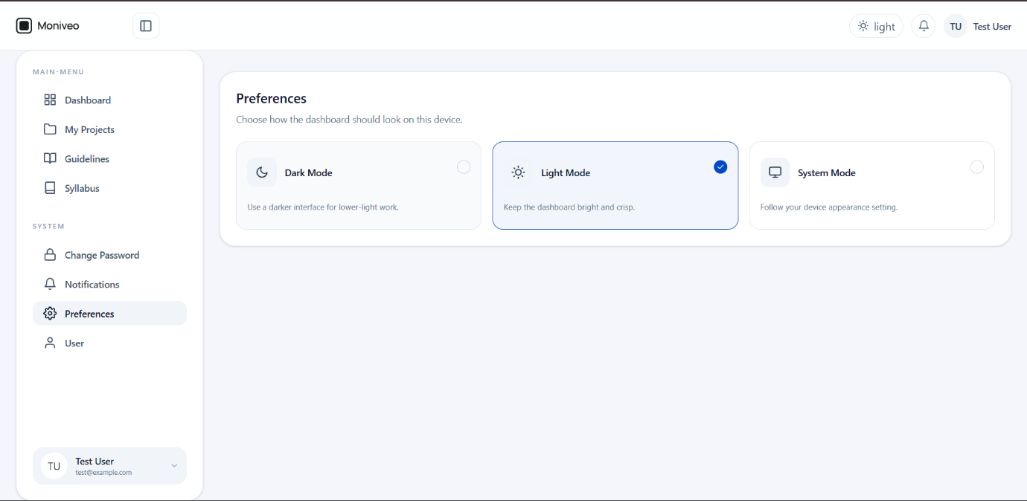
Preference:

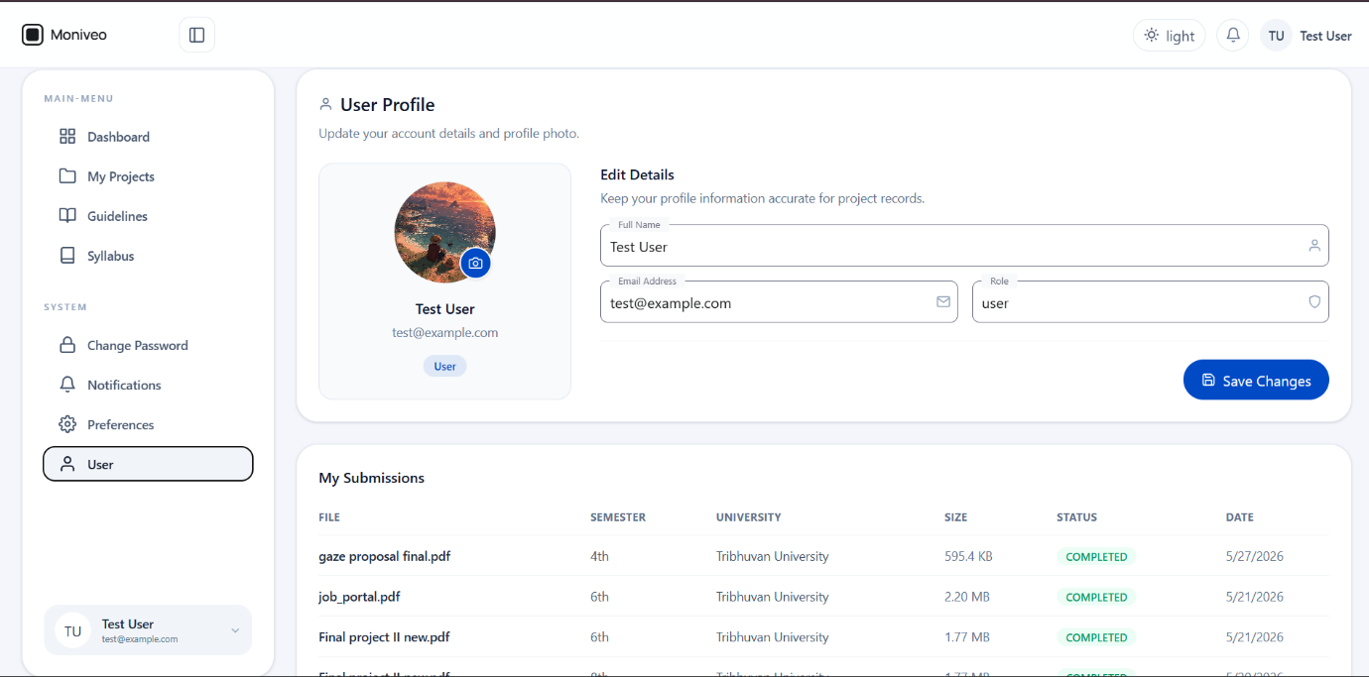
User:

