Issue Description: When velocity is rebooted, or sometimes when velocity is too cold (not accessed for long time), some of the search –collection’s crawler service is being stopped and that should be brought up, so that the Document Import and further edits can work seamlessly.
Step1: Copy the ResumeCrawler.ps1 and vivisimo_instances_config.xml in any drive in any available machine which is able to reach the velocity servers. [Typically, it would be nice to place this files under the ‘bin’ folder in the velocity installed path]
Step2: Edit the vivisimo_instances_config.xml file and make sure correct velocity server details are provided. If there are more than one velocity servers present in the environment, register all those velocity servers in this xml
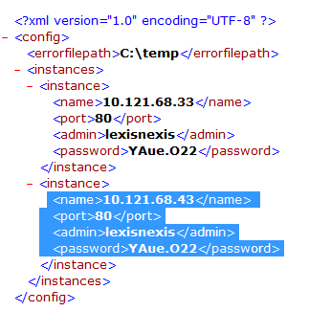
Step3: Open ‘cmd’ exe in Administrator mode (Right click and choose ‘Run as Administrator’)
Step4: Move to the path where the script file is available.
Eg: C:\Windows\System32> cd D:\Tools\VelocityPatch

Step5: Run the command ‘powershell’ in the window
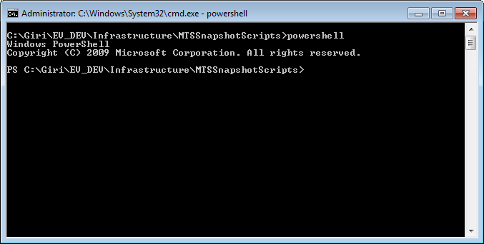

Step6: Run the command ‘Set-ExecutionPolicy unrestricted’ in the cwindow

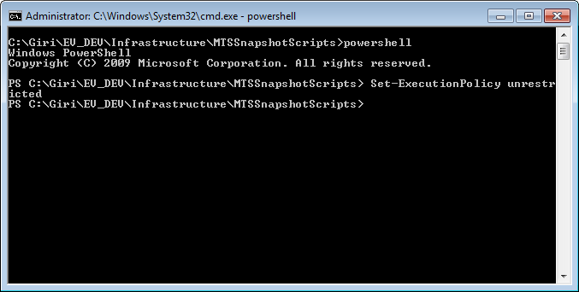

Step7: Run the command to kick off the script file to resume the crawlers which are in stopped state across all the velocity servers registered. Please make sure the full path of the vivisimo_instances_config.xml file for the parameter –config is appropriate

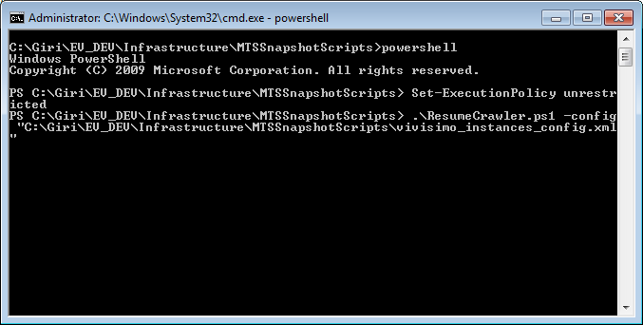
Step8: Watch out for any error or information log in the file named ‘CrawlerLog.txt’ under ‘C:\temp’.

