DSA
DSA stands for Data Structures and Algorithms. Way we store and organize data is know as Data Structures.
What is Algorithm?
Algorithm is nothing but following step by step to complete certain procedure and achieve expected outcome.
Linear Time Complexity – Big O or O(N)
Logarithmic Time Complexity – O(log N)
Constant Time Complexity – O(1)
O(log N) – Find a card in sorted cards
O(N) – Find card in random cards
O(N²) time complexity
O(N³) time complexity
O(2ˆn) time complexity

O(N!) – factorial time complexity

Why use Big O for time complexity and space complexity?
O = Order of
Big O – Upper bound – Order of Growth rate

public class BigOExamples{
public static int getFirstElement(int [] arr){
return arr[0];
}
}
O/p:- O(1)

public static int binarySearch(int [] arr, int target){
int left=0, right=arr.length-1;
while(left<=right){
int mid=(left+right)/2;
if(arr[mid] == target) return mid;
else if (arr[mid]<target) left=mid+1;
else right=mid-1;
}
return -1;
}
O(log n)

public static int linearSearch(int [] arr, int target){
for(int i=0;i<arr.length;i++){
if(arr[i]==target) return I;
}
return -1;
}
O(n)

public static void mergeSort(int [] arr, int left, int right){
if(left<right){
int mid=(left+right)/2;
mergeSort(arr,left,mid);
mergeSort(arr,mid+1,right);
merge(arr, left, mid, right);
}
}
private static void merge(int [] arr, int left, int mid, int right){
int n1=mid-left+1;
int n2=right-mid;
int[] L=new int[n1];
int[] R=new int[n2];

for(int i=0;i<n1;i++) L[i]=arr[left+i];
for(int j=0;j<n2;j++) R[j]=arr[mid=1=j];

int i=0,j=0, k=left;
while(i<n1 && j<n2){
if(L[i]<=R[j]) arr[k++]=L[i++];
else arr[k++]=R[j++];
}
while(i<n1) arr[k++]=L[i++];
while(j<n2) arr[k++]=R[j++];
}
O(n log n)

public static void printPairs(int [] arr){
for(int i=0;i<arr.length; i++){
for(int j=0;j<arr.length;j++){
System.out.println(arr[i] +”, “ + arr[j]);
}
}
}
O(n*n) = O(n²)

public static void printTriplets(int [] arr){
for(int i=0;i<arr.length;i++){
for(int j=0;j<arr.length;j++){
for(int k=0;k<arr.length;k+=){
System.out.println(arr[i]+ “, “ +arr[j]+”, “+arr[k]);
}
}
}
}
O(n³)

public static int fib(int n){
if(n<=1) return n;
return fib(n-1) + fib(n-2);
}

public static void permute(String str, String ans){
if(str.length()==0){
System.out.println(ans);
}
for(int i=0;i<str.length();i++){
char ch=str.charAt(i);
String rest=str.substring (0,i) +str.substring(i+1);
permute(rest, ans+ch);
}
}

Big O Comparison Table:-
Complexity | n=10 | n=100 | n=1000
O(1) | 1 | 1 | 1
O(log n) | 3.32 | 6.64 | 9.97
O(n) | 10 | 100 | 1000
O(n log n) | 33.22 | 664.39 | 9965.78
O(n²) | 100 | 10,000 | 1,000,000
O(n³) | 1,000 | 1,000,000 | 1,000,000,000
O(2^{n}) | 1,024 | ∼1.27*10³⁰ | ̃∼1.07*10³⁰¹

Classification of Data Structures:-
Linear
- Array
- Linked List
- Stack
- Queue
Non – Linear
- Graph
- Tree
Hash based
- Hash map
- Hashset

Linear Data Structure:- In this all elements are sequential. one after another.
- Array:- fixed size linear data structure. In memory we allocate fixed size block where we can enter elements where we can remove elements. All the elements are going to be accessed by the index position of that particular element.
- Linked List:- here we don’t have fixed size. It is dynamic data structure. we have head of linked list, tail of linked list. Very first element has element and has address of next element. tail element points to null variable or null pointer and that’s where the linked list ends. linked list grow and shrink in the size depending on how many elements are there and it can happen dynamically.
- Stack:- Last In first out data structure.
- Queue:- First In First Out.
Non – linear Data structure:- don’t have any sort of sequential line or property we need to follow. They follow some kind hierarchical or networking related data structure. It is dynamic in nature can grow and shrink based on data.
- graph:- graph basically have two things nodes and edges. These nodes and edges have some sort of connection between them. some places both have edges or some places one has edge. There can be connected and non connected graphs. very heavily used in Social networking, maps.
- trees:- tree has root variable which is the entry point and can have children who has their own children. all elements at the bottom level these are referred to leaf node all elements above leaf are going to be the parents of subsequent level. Root node is parent. all nodes are connected.
Hash based:- we have some sort of hash that defines every single element currently present in hash map or hash set in very quick manner. we can identify and pick elements easily.
- Hash map:- we have key value pairs. No duplicates.
- Hash set:- No duplicates.
hashmap vs hashset
Feature | HashMap | HashSet

Purpose | Stores key–value pairs | Stores unique elements (no duplicates)

Implements | Map interface | Set interface

Underlying Structure | Uses hash table for mapping keys to values | Internally uses a HashMap (with dummy values)

Example Use Case | Storing user IDs mapped to user names | Storing unique user IDs

======================================================================
Array:-
Introduction to Arrays:- Arrays is continuous block of memory that is currently stored inside your computer. In arrays we can store int, Boolean. Restriction in array is fixed size. everything in array is defined by index position. we can fetch any index position value in constant time. computer knows that what is going to be the memory size for each blocks. computer knows starting position of this memory location.
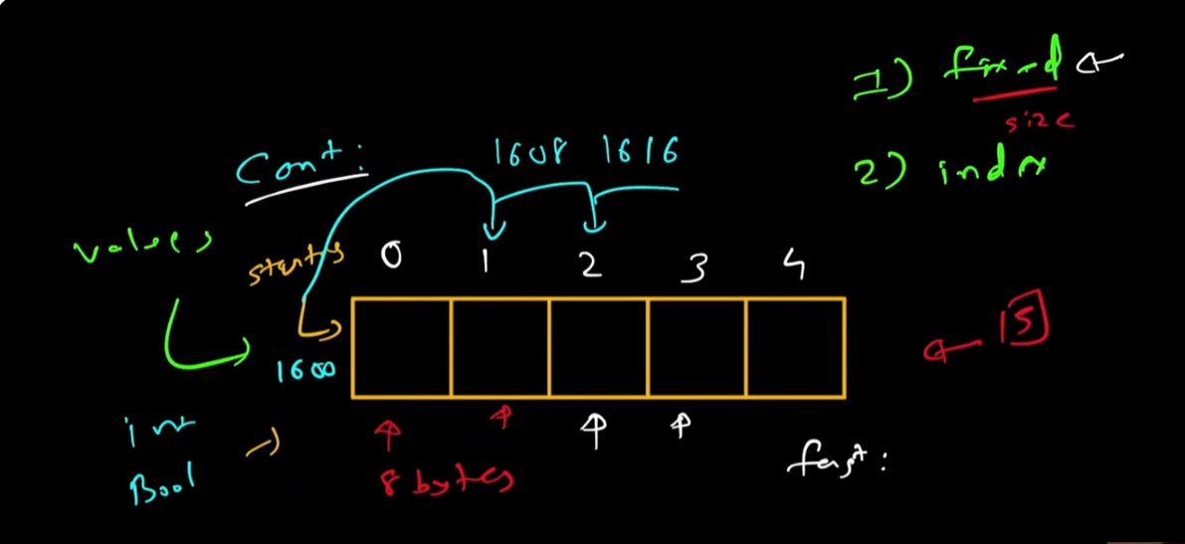
Time Complexity Array Operations:-
Accessing: O(1)
Insertion: O(1) / O(n)
worst case can be O(n).
Delete: O(n)/O(1)
Traverse: O(n)
Search: IF not sorted and random values you can do linear search O(n). Or binary search if sorted O(log n).
Update: O(1)
Benefits and Limitations of Array:
Benefits | Limitations
Random Access O(1) | Fixed Size
Cache friendly | O(n) – insert, delete
Ease of sorting | Inefficient for frequent modifications
Implementing other Data Structures

When to use Array:
- Implement other Data Structures
- caching, tabulation, memorization
- keep track of visited nodes
- mathametical
- coding patters – 2 pointers, sliding window technique, fast and slow pointer
Multi-Dimensional Arrays:-
1D, 2D, 3D, 4D Array
======================================================================
Two Sum:- Leetcode 1(Easy)
Given an array of integers nums and an integer target, return indices of the two numbers such that they add up to target.
You may assume that each input would have exactly one solution, and you may not use the same element twice.
You can return the answer in any order.
nums:[15,7,2,11] target :9
if we see 7+2=9 so we can return either [1,2] or [2,1]
Brute force: every single character worst case we might have to go all of them so O(n²)
[15,7,2,11] 9-7=2 we find if there is 2 in array or not
[2,7,11,15] <-sorted 9-2=7 we can use binary search take half of array and check based on 7 if greater than 7 eliminate. O(n log n) + log n=O(n log n)
=====================
we can use Additional Data Structure. we can use Hash map.
[1,7,3,2] target=9
Hash map has key and value
9-1 =8 is there 8 in array or not
9-7 = 2
9-3 = 6
9-2 = 7
1 | 0
7 | 1
3 | 2

as 7 is already there so [3,1] or [1,3]
Time complexity = O(n)
Space complexity = O(n)
Coding Approach:-
class Solution {
public int [] twoSum(int [] nums, int target){
Map<Integer, Integer> map=new HashMap<>();
for (int i=0;i<nums.length;i++)
{
int complement = target-nums[i];
if(map.containsKey(complement)){
return new int [] {map.get (complement), i};
}
map.put (nums [i], i);
}
return null;
}
}
full solution:
import java.util.HashMap;
class Main {
public int [] twoSum(int [] nums, int target){
HashMap<Integer, Integer> map=new HashMap<>();

for (int i=0;i<nums.length;i++)
{

int complement = target-nums[i];

if(map.containsKey(complement)){
return new int [] {map.get (complement), i};
}
map.put (nums [i], i);

}
return null;
}
public static void main(String[] args) {
Main m=new Main();
int[] result = m.twoSum(new int[]{1, 7, 2, 15}, 9);
if(result != null){
System.out.println(result[0] + " , " + result[1]);
} else {
System.out.println("No pair found");
}

}
}

