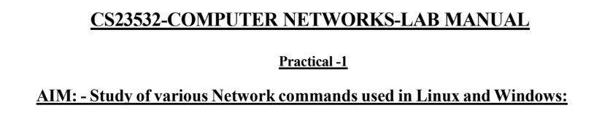
Windows commands
C:\Users\rajeshganesh>hostname
RajeshGanesh

C:\Users\rajeshganesh>ipconfig /all

Windows IP Configuration

Host Name . . . . . . . . . . . . : RajeshGanesh
Primary Dns Suffix . . . . . . . :
Node Type . . . . . . . . . . . . : Mixed
IP Routing Enabled. . . . . . . . : No
WINS Proxy Enabled. . . . . . . . : No

Ethernet adapter Ethernet 2:

Connection-specific DNS Suffix . :
Description . . . . . . . . . . . : VirtualBox Host-Only Ethernet Adapter
Physical Address. . . . . . . . . : 0A-00-27-00-00-0E
DHCP Enabled. . . . . . . . . . . : No
Autoconfiguration Enabled . . . . : Yes
Link-local IPv6 Address . . . . . : fe80::aa4a:775:1de1:1757%14(Preferred)
IPv4 Address. . . . . . . . . . . : 192.168.56.1(Preferred)
Subnet Mask . . . . . . . . . . . : 255.255.255.0
Default Gateway . . . . . . . . . :
DHCPv6 IAID . . . . . . . . . . . : 118095911
DHCPv6 Client DUID. . . . . . . . : 00-01-00-01-2D-79-FD-43-2C-58-B9-DE-5F-5F NetBIOS over Tcpip. . . . . . . . : Enabled

Wireless LAN adapter Local Area Connection* 1:

Media State . . . . . . . . . . . : Media disconnected
Connection-specific DNS Suffix . :
Description . . . . . . . . . . . : Microsoft Wi-Fi Direct Virtual Adapter
Physical Address. . . . . . . . . : F8-FE-5E-3A-70-56
DHCP Enabled. . . . . . . . . . . : Yes
Autoconfiguration Enabled . . . . : Yes

Wireless LAN adapter Local Area Connection* 2:

Media State . . . . . . . . . . . : Media disconnected
Connection-specific DNS Suffix . :
Description . . . . . . . . . . . : Microsoft Wi-Fi Direct Virtual Adapter #2
Physical Address. . . . . . . . . : FA-FE-5E-3A-70-55
DHCP Enabled. . . . . . . . . . . : No
Autoconfiguration Enabled . . . . : Yes

Wireless LAN adapter Wi-Fi:

Connection-specific DNS Suffix . :
Description . . . . . . . . . . . : Intel(R) Wi-Fi 6E AX211 160MHz
Physical Address. . . . . . . . . : F8-FE-5E-3A-70-55
DHCP Enabled. . . . . . . . . . . : Yes
Autoconfiguration Enabled . . . . : Yes
Link-local IPv6 Address . . . . . : fe80::b810:29c9:55e9:3a65%17(Preferred)
IPv4 Address. . . . . . . . . . . : 10.83.96.83(Preferred)
Subnet Mask . . . . . . . . . . . : 255.255.255.0
Lease Obtained. . . . . . . . . . : 26 August 2026 14:38:14
Lease Expires . . . . . . . . . . : 26 August 2026 15:38:11
Default Gateway . . . . . . . . . : 10.83.96.20
DHCP Server . . . . . . . . . . . : 10.83.96.20
DHCPv6 IAID . . . . . . . . . . . : 167312990
DHCPv6 Client DUID. . . . . . . . : 00-01-00-01-2D-79-FD-43-2C-58-B9-DE-5F-5F
DNS Servers . . . . . . . . . . . : 10.83.96.20
NetBIOS over Tcpip. . . . . . . . : Enabled

Ethernet adapter Bluetooth Network Connection:

Media State . . . . . . . . . . . : Media disconnected
Connection-specific DNS Suffix . :
Description . . . . . . . . . . . : Bluetooth Device (Personal Area Network)
Physical Address. . . . . . . . . : F8-FE-5E-3A-70-59
DHCP Enabled. . . . . . . . . . . : Yes
Autoconfiguration Enabled . . . . : Yes

Ethernet adapter Ethernet:

Media State . . . . . . . . . . . : Media disconnected
Connection-specific DNS Suffix . :
Description . . . . . . . . . . . : Realtek Gaming GbE Family Controller
Physical Address. . . . . . . . . : 2C-58-B9-DE-5F-5F
DHCP Enabled. . . . . . . . . . . : Yes
Autoconfiguration Enabled . . . . : Yes

C:\Users\rajeshganesh>arp -a

Interface: 192.168.56.1 --- 0xe
Internet Address Physical Address Type
192.168.56.255 ff-ff-ff-ff-ff-ff static
224.0.0.22 01-00-5e-00-00-16 static
224.0.0.251 01-00-5e-00-00-fb static
224.0.0.252 01-00-5e-00-00-fc static
239.255.255.250 01-00-5e-7f-ff-fa static
255.255.255.255 ff-ff-ff-ff-ff-ff static

Interface: 10.83.96.83 --- 0x11
Internet Address Physical Address Type
10.83.96.20 4e-ec-85-ec-ff-15 dynamic
10.83.96.255 ff-ff-ff-ff-ff-ff static
224.0.0.22 01-00-5e-00-00-16 static
224.0.0.251 01-00-5e-00-00-fb static
224.0.0.252 01-00-5e-00-00-fc static
239.255.255.250 01-00-5e-7f-ff-fa static
255.255.255.255 ff-ff-ff-ff-ff-ff static

C:\Users\rajeshganesh>netstat -r
===========================================================================
Interface List
14...0a 00 27 00 00 0e ......VirtualBox Host-Only Ethernet Adapter
11...f8 fe 5e 3a 70 56 ......Microsoft Wi-Fi Direct Virtual Adapter
4...fa fe 5e 3a 70 55 ......Microsoft Wi-Fi Direct Virtual Adapter #2
17...f8 fe 5e 3a 70 55 ......Intel(R) Wi-Fi 6E AX211 160MHz
19...f8 fe 5e 3a 70 59 ......Bluetooth Device (Personal Area Network)
2...2c 58 b9 de 5f 5f ......Realtek Gaming GbE Family Controller
1...........................Software Loopback Interface 1
===========================================================================

IPv4 Route Table
===========================================================================
Active Routes:
Network Destination Netmask Gateway Interface Metric
0.0.0.0 0.0.0.0 10.83.96.20 10.83.96.83 35
10.83.96.0 255.255.255.0 On-link 10.83.96.83 291
10.83.96.83 255.255.255.255 On-link 10.83.96.83 291
10.83.96.255 255.255.255.255 On-link 10.83.96.83 291
127.0.0.0 255.0.0.0 On-link 127.0.0.1 331
127.0.0.1 255.255.255.255 On-link 127.0.0.1 331
127.255.255.255 255.255.255.255 On-link 127.0.0.1 331
192.168.56.0 255.255.255.0 On-link 192.168.56.1 281
192.168.56.1 255.255.255.255 On-link 192.168.56.1 281
192.168.56.255 255.255.255.255 On-link 192.168.56.1 281
224.0.0.0 240.0.0.0 On-link 127.0.0.1 331
224.0.0.0 240.0.0.0 On-link 192.168.56.1 281
224.0.0.0 240.0.0.0 On-link 10.83.96.83 291
255.255.255.255 255.255.255.255 On-link 127.0.0.1 331
255.255.255.255 255.255.255.255 On-link 192.168.56.1 281
255.255.255.255 255.255.255.255 On-link 10.83.96.83 291
===========================================================================
Persistent Routes:
None

IPv6 Route Table
===========================================================================
Active Routes:
If Metric Network Destination Gateway
1 331 ::1/128 On-link
14 281 fe80::/64 On-link
17 291 fe80::/64 On-link
14 281 fe80::aa4a:775:1de1:1757/128
On-link
17 291 fe80::b810:29c9:55e9:3a65/128
On-link
1 331 ff00::/8 On-link
14 281 ff00::/8 On-link
17 291 ff00::/8 On-link
===========================================================================
Persistent Routes:
None

C:\Users\rajeshganesh>nslookup www.google.com
Server: UnKnown
Address: 10.83.96.20

Non-authoritative answer:
Name: www.google.com
Addresses: 2001:4860:482d:7700::
2001:4860:4826:7700::
2001:4860:4828:7700::
2001:4860:482b:7700::
2001:4860:4827:7700::
2001:4860:4829:7700::
2001:4860:482a:7700::
2001:4860:482c:7700::
142.251.152.119
142.251.156.119
142.251.154.119
142.251.151.119
142.251.153.119
142.251.157.119
142.251.150.119 142.251.155.119

C:\Users\rajeshganesh>ping google.com

Pinging google.com [142.251.43.46] with 32 bytes of data: Reply from 142.251.43.46: bytes=32 time=14ms TTL=114
Reply from 142.251.43.46: bytes=32 time=233ms TTL=114
Reply from 142.251.43.46: bytes=32 time=59ms TTL=114
Reply from 142.251.43.46: bytes=32 time=328ms TTL=114

Ping statistics for 142.251.43.46:
Packets: Sent = 4, Received = 4, Lost = 0 (0% loss),
Approximate round trip times in milli-seconds:
Minimum = 14ms, Maximum = 328ms, Average = 158ms

C:\Users\rajeshganesh>route print
===========================================================================
Interface List
14...0a 00 27 00 00 0e ......VirtualBox Host-Only Ethernet Adapter
11...f8 fe 5e 3a 70 56 ......Microsoft Wi-Fi Direct Virtual Adapter
4...fa fe 5e 3a 70 55 ......Microsoft Wi-Fi Direct Virtual Adapter #2
17...f8 fe 5e 3a 70 55 ......Intel(R) Wi-Fi 6E AX211 160MHz
19...f8 fe 5e 3a 70 59 ......Bluetooth Device (Personal Area Network)
2...2c 58 b9 de 5f 5f ......Realtek Gaming GbE Family Controller
1...........................Software Loopback Interface 1
===========================================================================

IPv4 Route Table
===========================================================================
Active Routes:
Network Destination Netmask Gateway Interface Metric
0.0.0.0 0.0.0.0 10.83.96.20 10.83.96.83 35
10.83.96.0 255.255.255.0 On-link 10.83.96.83 291
10.83.96.83 255.255.255.255 On-link 10.83.96.83 291
10.83.96.255 255.255.255.255 On-link 10.83.96.83 291 127.0.0.0 255.0.0.0 On-link 127.0.0.1 331
127.0.0.1 255.255.255.255 On-link 127.0.0.1 331
127.255.255.255 255.255.255.255 On-link 127.0.0.1 331
192.168.56.0 255.255.255.0 On-link 192.168.56.1 281
192.168.56.1 255.255.255.255 On-link 192.168.56.1 281
192.168.56.255 255.255.255.255 On-link 192.168.56.1 281
224.0.0.0 240.0.0.0 On-link 127.0.0.1 331
224.0.0.0 240.0.0.0 On-link 192.168.56.1 281
224.0.0.0 240.0.0.0 On-link 10.83.96.83 291
255.255.255.255 255.255.255.255 On-link 127.0.0.1 331
255.255.255.255 255.255.255.255 On-link 192.168.56.1 281
255.255.255.255 255.255.255.255 On-link 10.83.96.83 291
===========================================================================
Persistent Routes:
None

IPv6 Route Table
===========================================================================
Active Routes:
If Metric Network Destination Gateway
1 331 ::1/128 On-link
14 281 fe80::/64 On-link
17 291 fe80::/64 On-link
14 281 fe80::aa4a:775:1de1:1757/128
On-link
17 291 fe80::b810:29c9:55e9:3a65/128
On-link
1 331 ff00::/8 On-link
14 281 ff00::/8 On-link
17 291 ff00::/8 On-link
===========================================================================
Persistent Routes:
None

C:\Users\rajeshganesh>tracert google.com

Linux commands
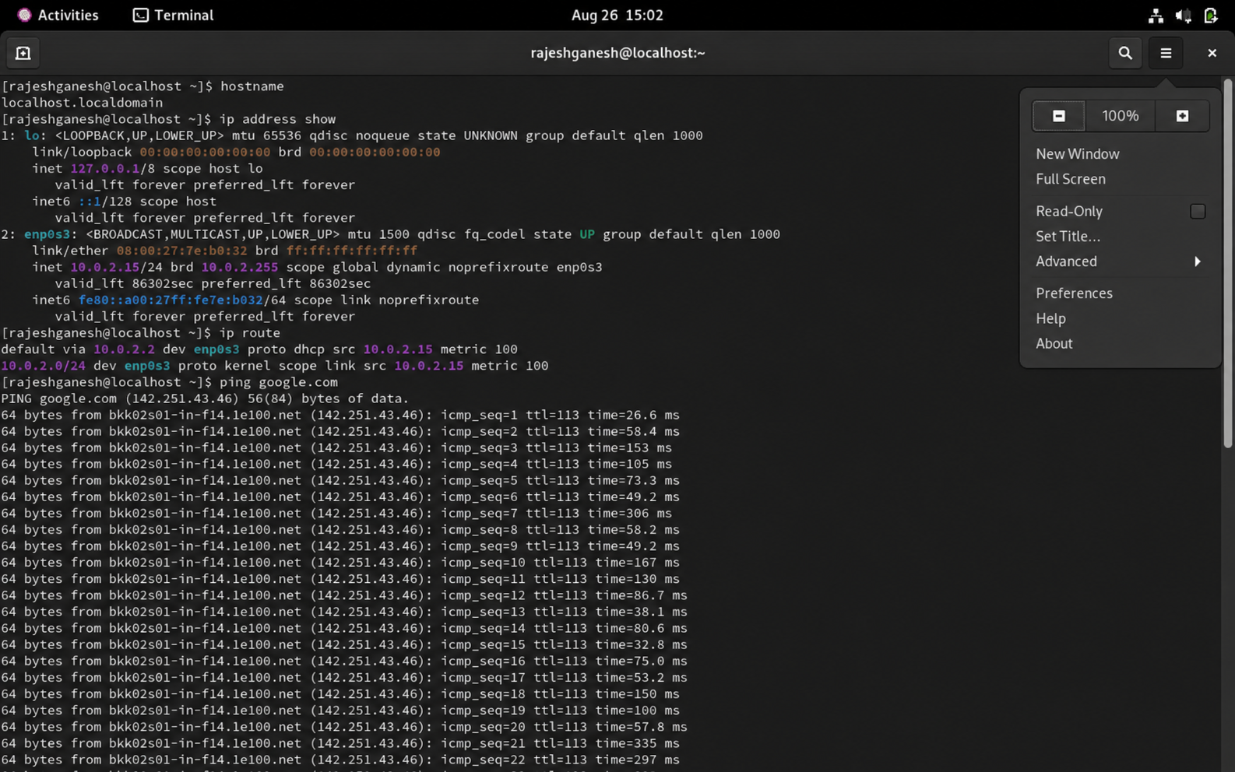

Student observation answers
- Command used to check reachability: ping
- Command used to find hops: tracert in Windows / traceroute in Linux
- Command to display IP configuration: ipconfig in Windows / ip address in Linux
- Command to display TCP port status: netstat
- Command to modify IP configuration in Linux: ip address / ip route

