# WORKING OF PROJECT MANAGER APPLICATION

## 1. Default landing page on launching the host URL: VIEW TASK page

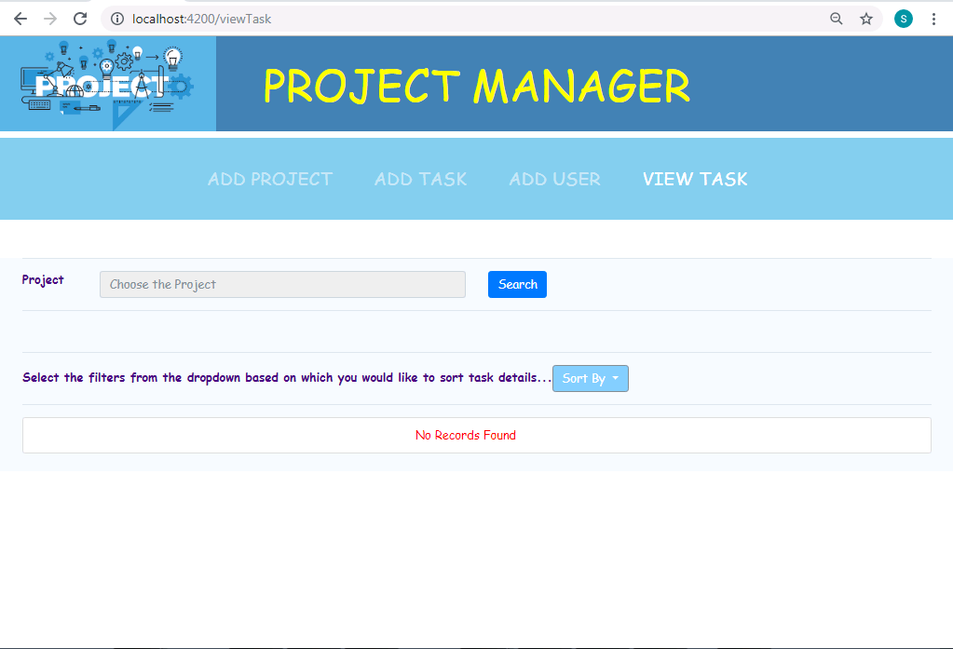

## 2. Adding User Details

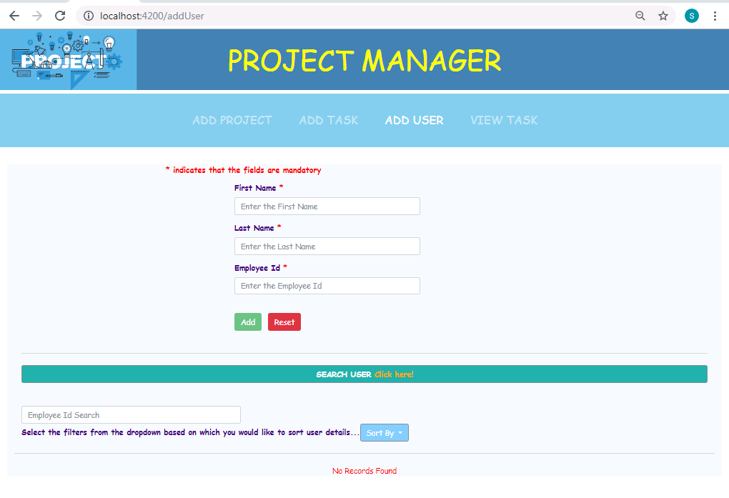

* User can enter First Name, Last Name and Employee ID (all are mandatory). If field validations are passed, a message pops up saying successful registration as seen below and the User details get added.

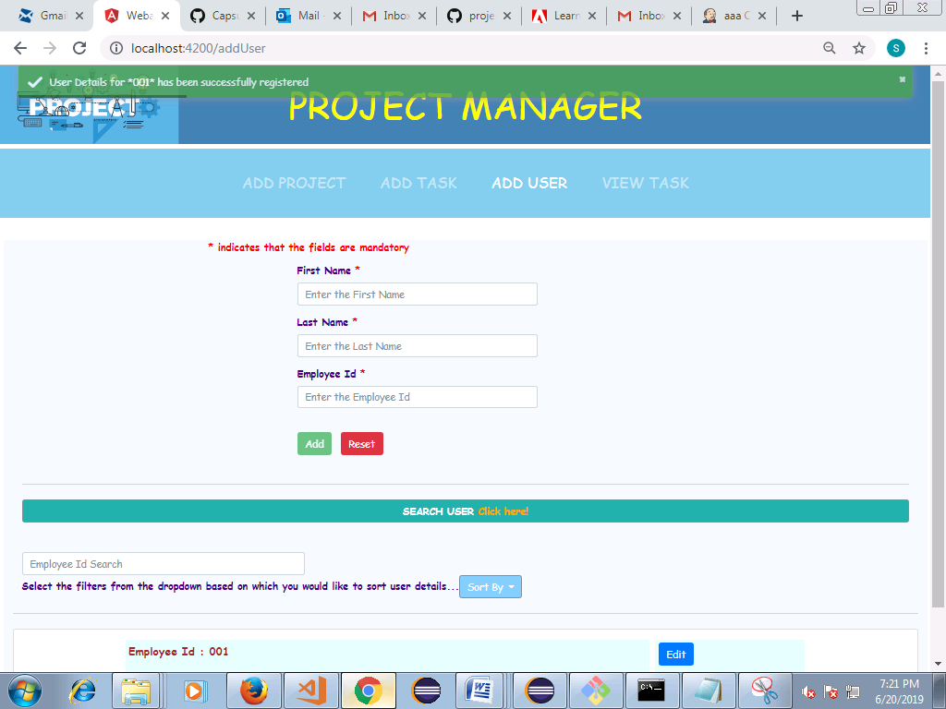

* Appropriate basic field validations are handled as below for each fields.

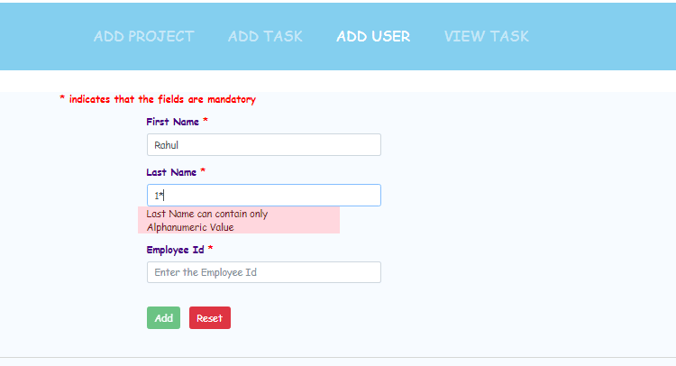

* As and when new users are added, the data gets added in the bottom of the page.

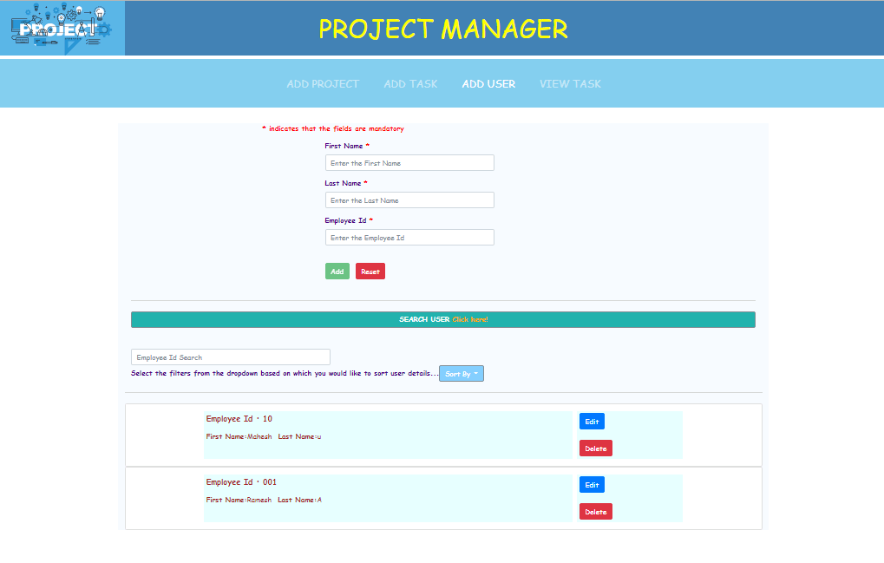

* The user can click on ‘Search User’ button to search the user available in the user list based on First Name, Last Name or Employee ID.

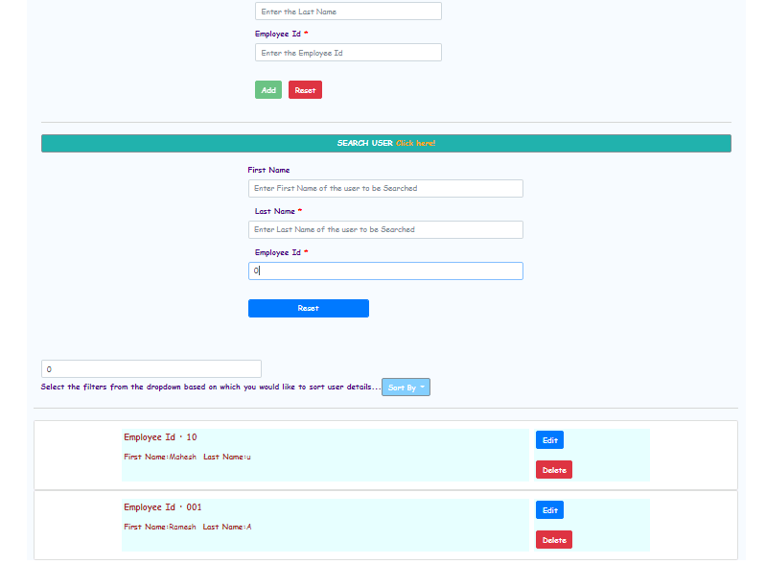

* The user can sort the records based on the last name, first name and employee ID. Also, the user details added can be added or edited from the list.

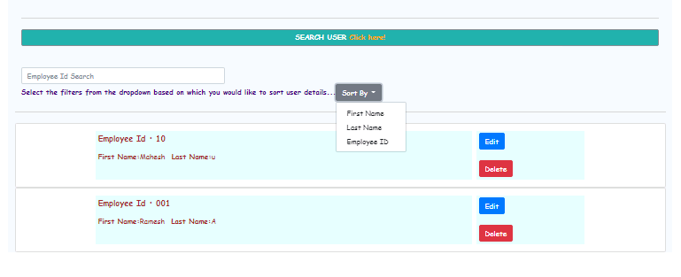

* On clicking Edit, the user info can be edited. Once edited, click on Update to see the updated details.

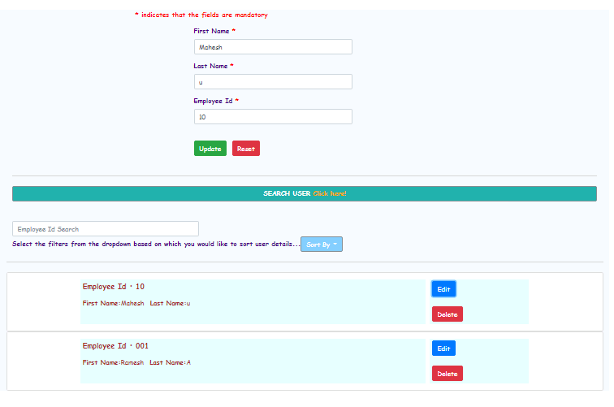

## 3. Adding Project Details

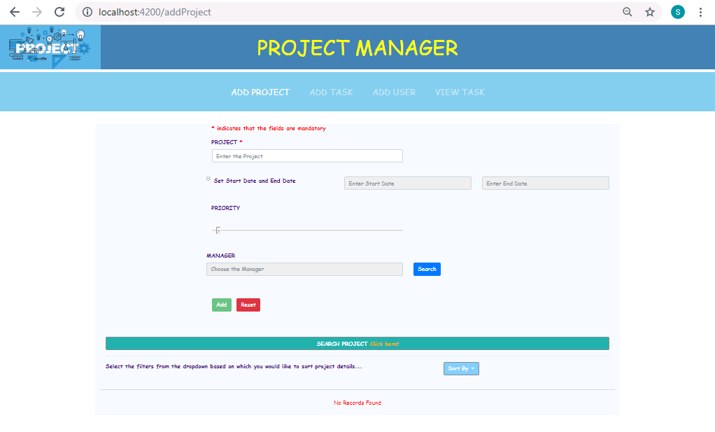

* User can enter the project details like Project Name, Start End Date and Priority.

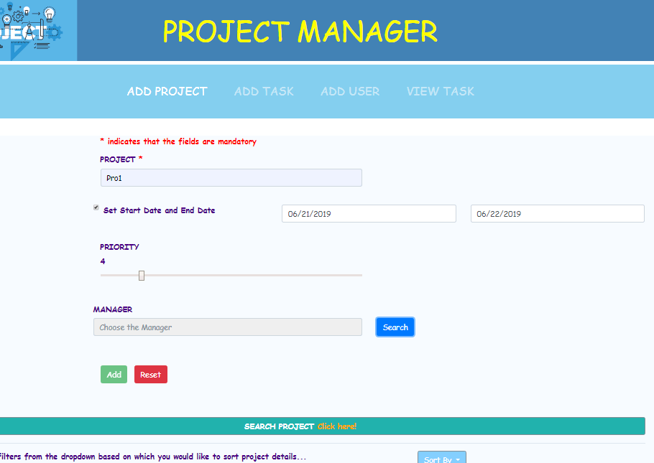

* On clicking on Search button across Manger option, the user can search the manager from user list by clicking on Search.

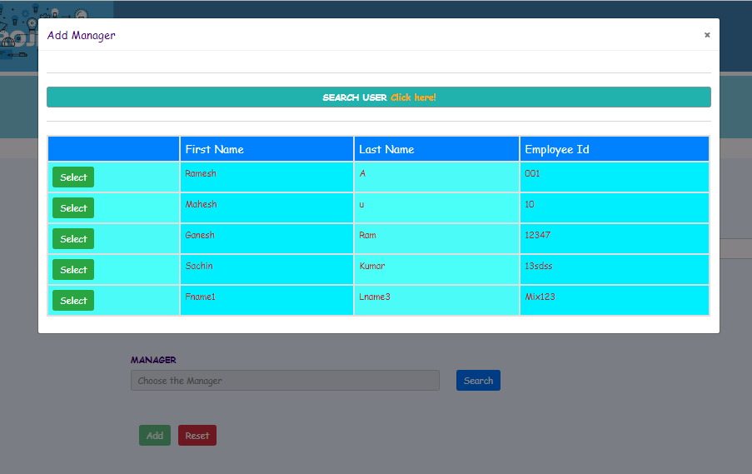

* Click on "Search User" to specifically search from the list of users and click on Select to add the user as manager.

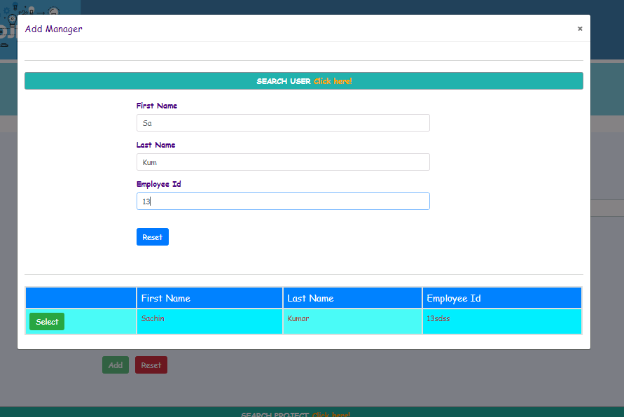

* The user can click on reset to cancel the specific search. All the list of users will be displayed.
* Similar to adding Users, Projects can be added and list of Projects can be sorted based on the fields selected for sorting.

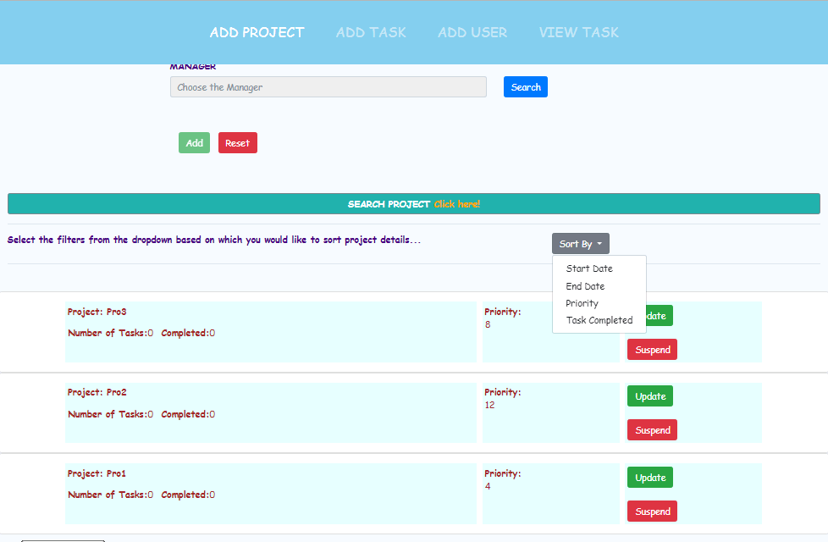

* The user can suspend the project or Update the project info.
* Also, the projects can be searched adding suitable search filters by clicking on SEARCH PROJECT.

## 4. Adding Task Details

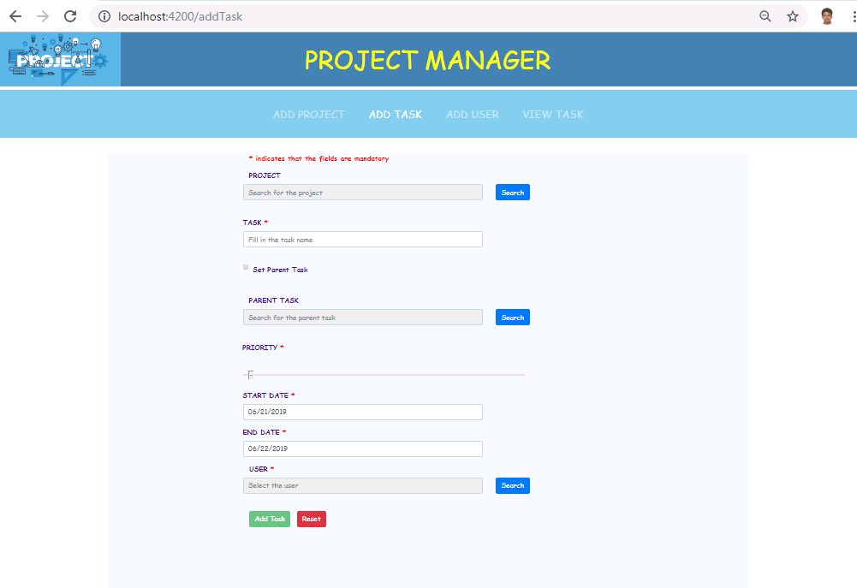

* User can click on Search under Project section to select a project from project list.

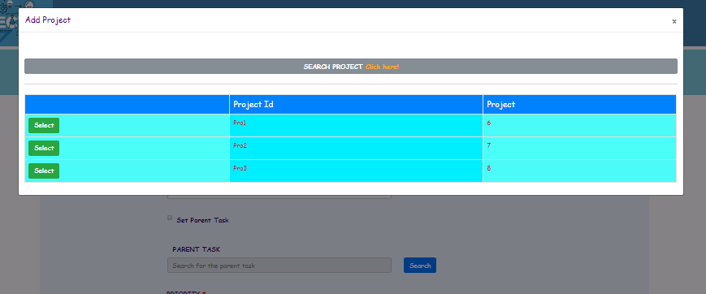

* If the user intends to set the current task as Parent task, check the Set Parent Task. Add Task button will be enabled freezing all other options to edit below.

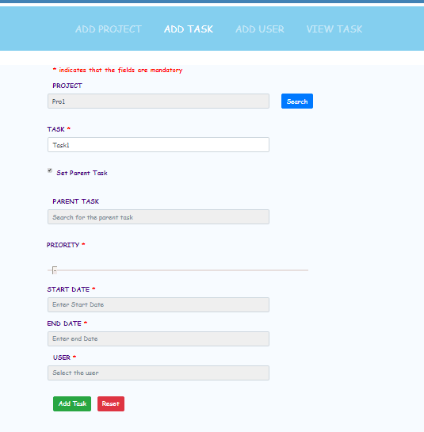

* Otherwise, the user can enter other mandatory fields to add Tasks.
* Appropriate basic field validations are handled.
* If a parent task is registered, and if the Search button across Parent Task label is selected the parent task from the list can be selected to set Parent Task for the new task that is being added.
* The Search button across User Label is available when the current task is not a parent task. On clicking, a list of users added will be available, to whom the task will be/should be assigned.
* If any user is tried to be deleted, there is a validation to check if there is any project associated with that user. Only if there is no project associated the user will be successfully deleted. Otherwise, a suitable error message is displayed.

## 5. Viewing the Task Details

* The tasks added will be available in VIEW TASK tab.

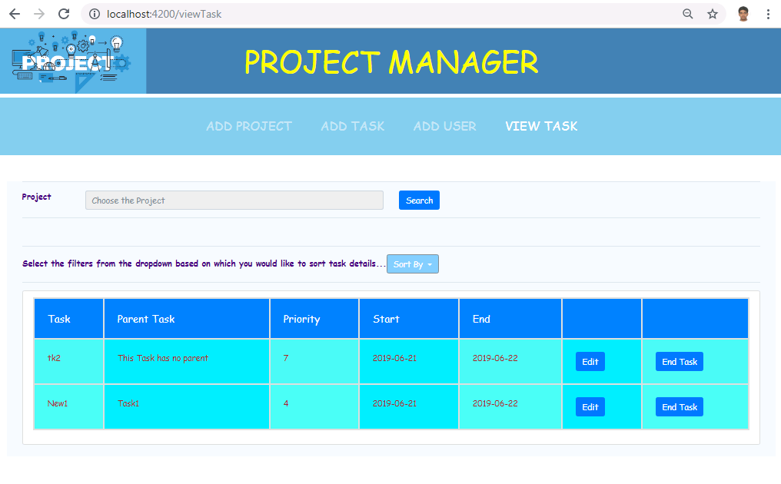

* The user can search for a project by clicking on Search option in project. Based on the project selected from the list appropriate task list will be filtered out.

