Where Hindsight Recall Fits in My Agent's Request Path
How TOM runs memory recall alongside parsing, and why only some handlers use what comes back
If you add memory to an agent with several front ends, you have to decide where recall lives. Put it in each interface and you write it three times. Put it in the model prompt and you pay for it on every request, whether it matters or not.
TOM has a Tkinter desktop app, a CLI and voice input. I put Hindsight agent memory in the shared agent core, started it in parallel with parsing, and let each handler decide whether to use the result.

One core, three front doors
tom_desktop_app.py is the Tkinter UI. main.py is the CLI. Voice has a conversation mode and an action mode. They differ in how they show results, but task requests from all three end up in TomAgent.execute_task() in agent.py. Action-like voice requests are handed straight to it.
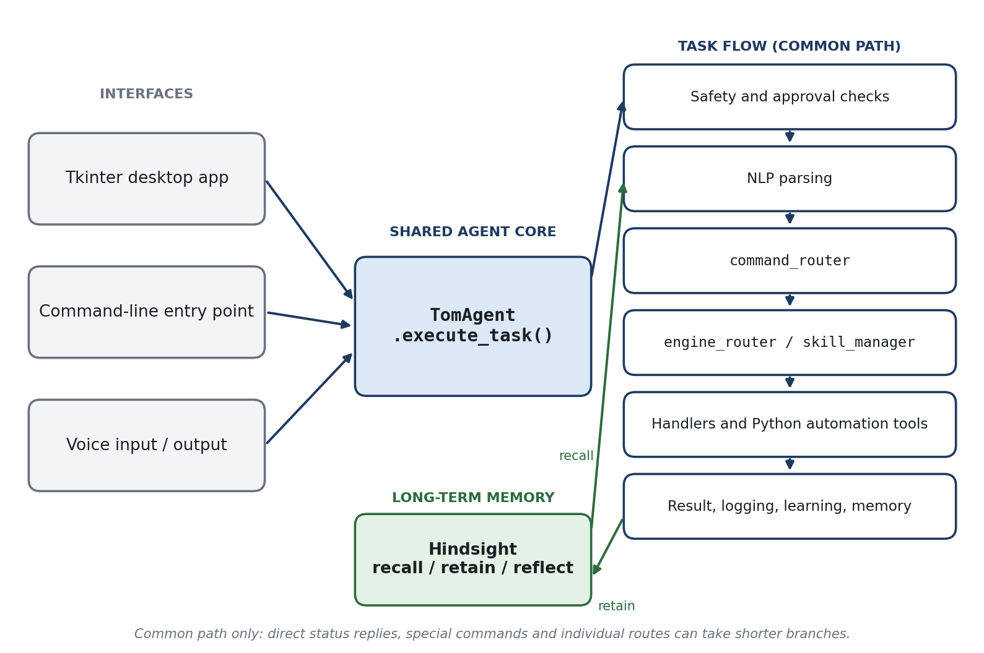
Figure 1: The common path through the shared agent core. Direct status replies and special commands take shorter branches.
Because they share a core, they share a memory bank. A preference stored through one interface is available to the others, since the bank ID is a property of the install.
The interfaces still own what only they can do. The desktop app installs a dialog as the approval provider (approval_manager.provider = self._ask_approval), because a GUI has no console to read a yes or no from. The core asks for approval the same way everywhere; each front end decides how to ask. It also prints the memory status line into the chat at startup, for example Long-term memory: ONLINE — Hindsight Cloud, bank 'tom-...', so I always know whether memory is on before I rely on it.

The request path
execute_task() starts with a safety check. Then, if memory is available, it launches recall as a background task and awaits parsing, so the two overlap:
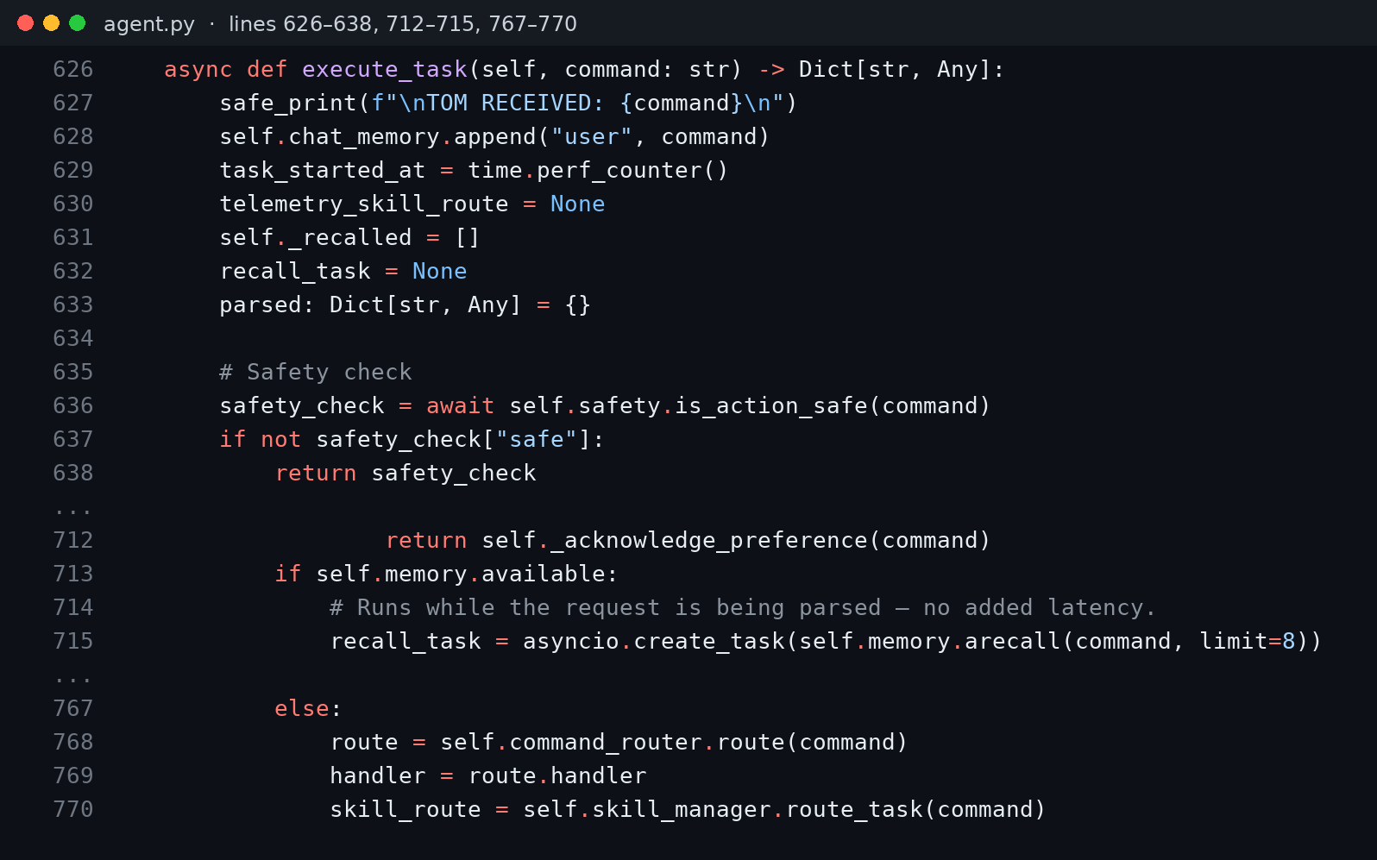
Figure 2: execute_task(): the safety gate, the recall task started alongside parsing, and command and skill routing (agent.py).
Recall is time-boxed. arecall() wraps the call in a timeout slightly longer than the client's, so a slow memory server can delay a task by a bounded amount and never hangs it.
After parsing, three routers take over:
- command_router classifies the request and attaches metadata, such as whether it needs approval.
- engine_router matches specialized engines with conservative regular expressions.
- skill_manager checks for a local skill when nothing more specific applies.

Where recalled memory actually goes
This is the part I want to be honest about. The general recall (limit=8) fills self._recalled. Handlers that draft emails or documents call _build_memory_context() and fold the hits into their prompts. Voice mode does the same with limit=5.
Most other handlers never read it. File organization does its own, narrower recall: a file-specific query, filtered to preference and correction tags, parsed into rules. I did not want a pile of recalled sentences in every prompt. Some requests benefit from memory, some are harmed by extra context, and the handler knows which.

Opting a handler in
Adding memory to a handler is one line plus a decision about the prompt:
memory_context = self._build_memory_context(command)
_build_memory_context() combines long-term recall with other context sources into a block of text. The handler then places that block in its own prompt, wherever it belongs. There is no global prompt injection to reason about, and a handler that never calls it never sees memory. Setting HINDSIGHT_ENABLED=0 switches the whole layer off, and the status line says so.
That shape is what I would reuse for any agent that sits behind several channels. A support agent answering over chat, email and phone, or an accounts-payable agent fed from a mailbox and a shared folder, needs one memory bank behind one core, not one per channel.

Before and after
Same request, "organize my downloads," first with no stored preferences, then after one correction and a reworded request:
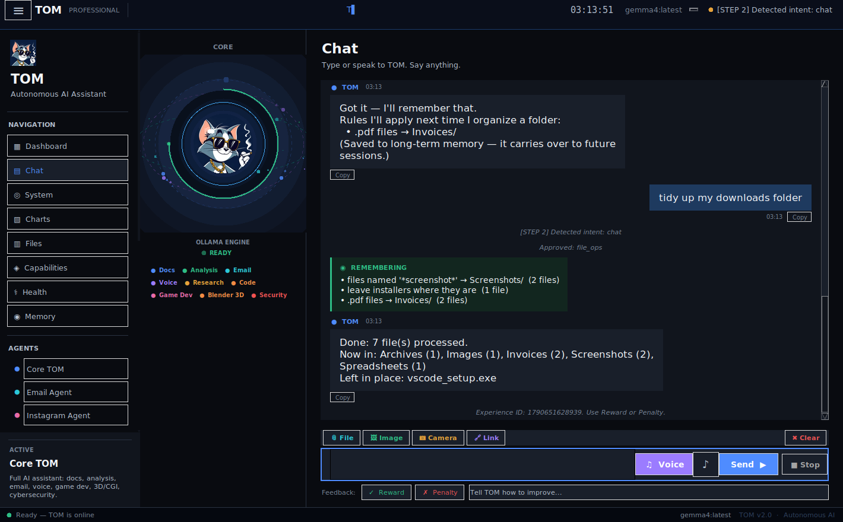
Figure 3: A later request in different words. The "Remembering" card lists the memory TOM used. Captured against a sandbox folder with an in-memory test client standing in for Hindsight.
The first plan sent PDFs to Documents/. The second sent them to Invoices/. The card exists because I did not want memory to be invisible: if TOM used a rule, it says so.

Failure handling
Memory is optional by design. The wrapper catches missing packages, bad configuration and client errors. A failed recall returns an empty list. A failed retain goes to a local journal and a pending queue, and the queue is retried after the next successful retain or recall. With Hindsight down, TOM still organizes files. It just falls back to defaults.

What did not work as I hoped
There are two recall paths, and that duplication is a cost. A general one feeds prompts, and a specialized one feeds the file planner. They can disagree if the bank is inconsistent. I accepted that because merging them would mean either bloating prompts or losing the tag filters.
Rules from memory also apply only to handlers that consult them. Adding a new handler does not give it memory for free; you have to call recall on purpose.

Takeaways
- Put recall in the shared core. Interfaces stay thin, and memory follows the user across them.
- Overlap recall with parsing. Recall becomes a parallel step instead of a serial one.
- Let handlers opt in. Not every request wants memory in its prompt.
- Show what memory did. A visible card builds more trust than a better prompt.
- Time-box everything. A memory layer should never be the reason a task hangs.
For the mechanics of recall and retain, see the Hindsight documentation. Vectorize's page on what agent memory is is a good primer, and the code lives in the TOM repository.

