Hindsight Made My File Agent Stop Misfiling Invoices
One correction, a recalled rule, and an approval step: how TOM learned where my invoices go
Every finance team has some version of this problem: PDFs arrive, and someone has to remember that vendor invoices go in one place and everything else goes in another. I wanted an agent that learns that routing from a single correction instead of a settings screen.
TOM is a local desktop agent that takes plain-language tasks. File organization is the smallest useful version of the invoice problem, so it is where I tested whether Hindsight agent memory changes behavior. It does, and the change is easy to see.

The problem in concrete terms
I ask: "organize my downloads." TOM's file engine groups by extension. PDFs go to Documents/, screenshots to Images/, .exe and .msi files to Installers/. That is a sensible default for nobody in particular.
For me, it puts an AWS invoice and an electricity bill next to a resume. That is the mistake I want fixed once.
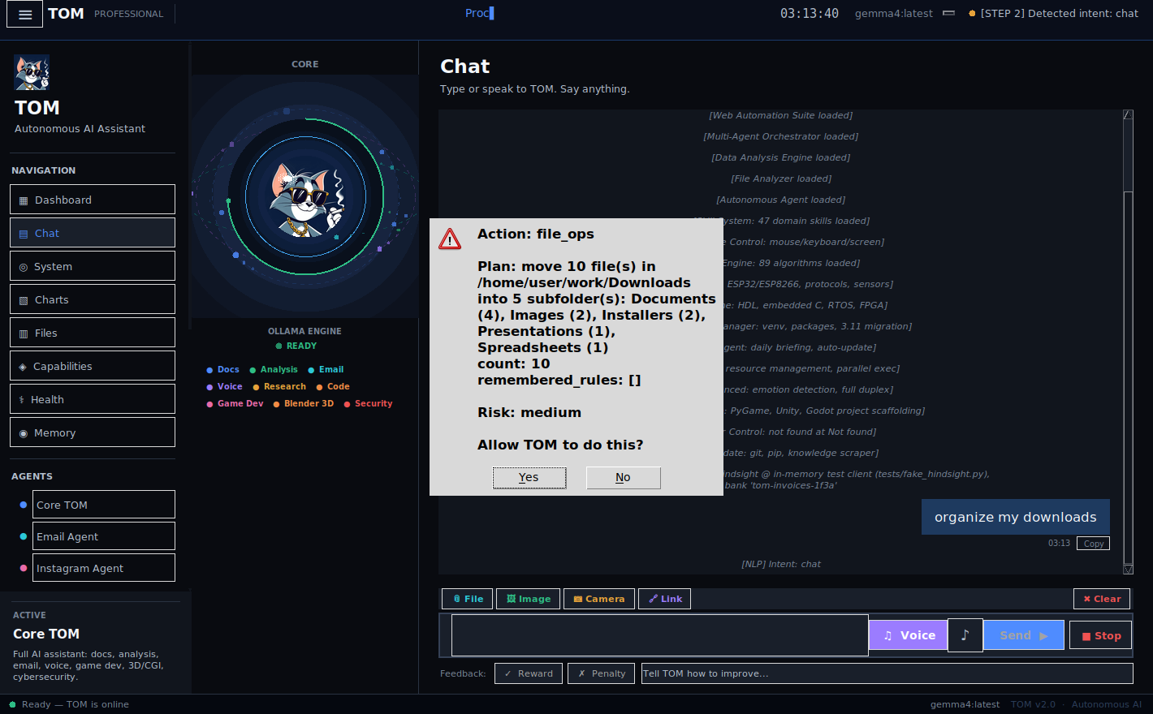
Figure 1: The first plan, before any correction. remembered_rules: [] in the approval dialog. Captured against a sandbox folder with an in-memory test client standing in for Hindsight.

The flow, end to end
- I make a request. execute_task() runs a safety check, then routes it. engine_router.detect() matches "organize/tidy" plus "folder/downloads" and returns the fileops key.
- _run_fileops() asks the agent for remembered folder rules before it plans anything.
- The planner builds a list of moves. It moves nothing.
- An approval request shows the plan, the move count and the remembered rules.
- Only after I approve does execute_plan() move the files.
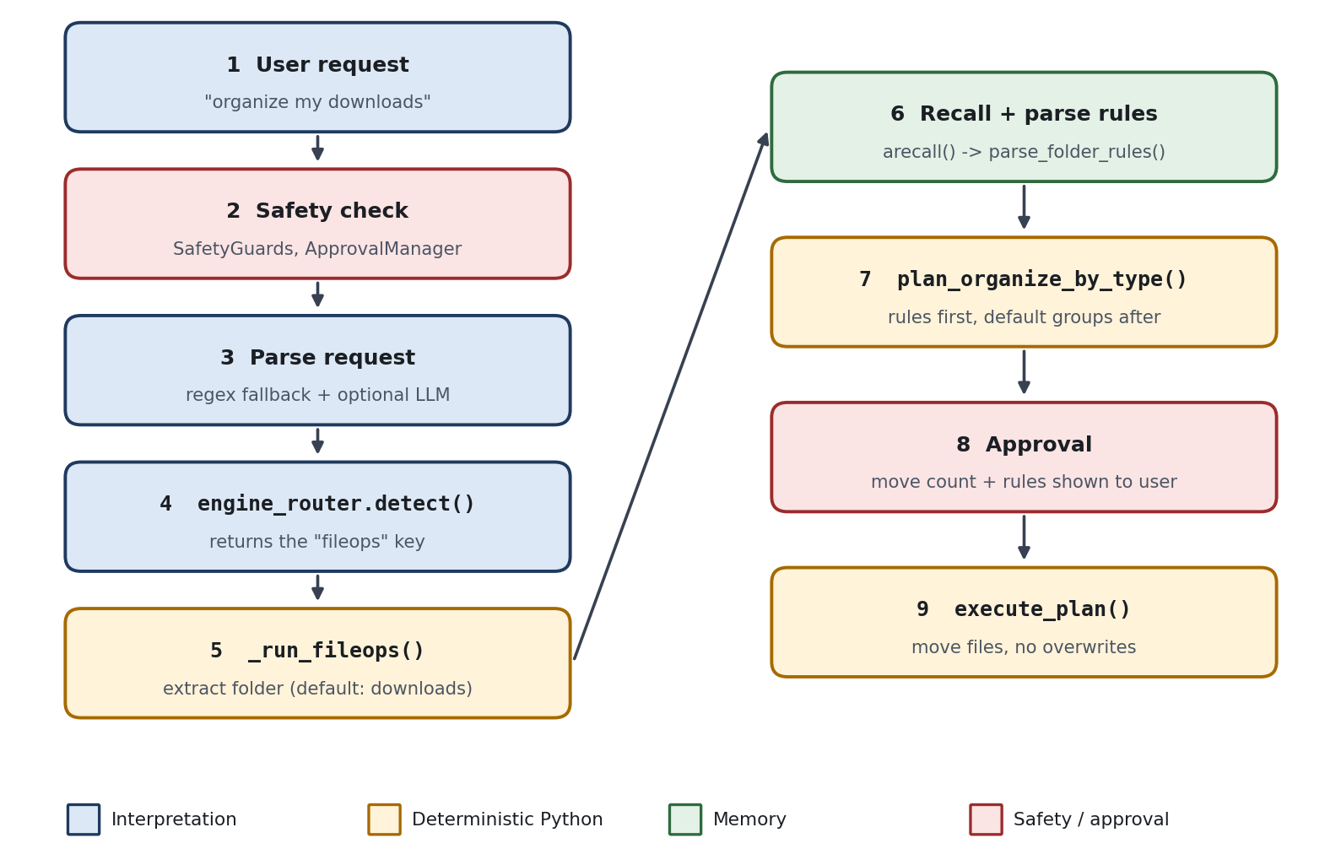
Figure 2: The request path. Recall (step 6) happens before planning; approval (step 8) happens before any move.
The order is deliberate. Memory can change what TOM proposes, but it cannot skip the approval step. A remembered rule is a reason to propose a move, not permission to make one.

The correction
I typed one sentence:
No — PDFs always go in Invoices, not Documents.
TOM recognized it as a preference, stored it in Hindsight tagged preference, file_organization and correction, and answered with the rule it extracted.
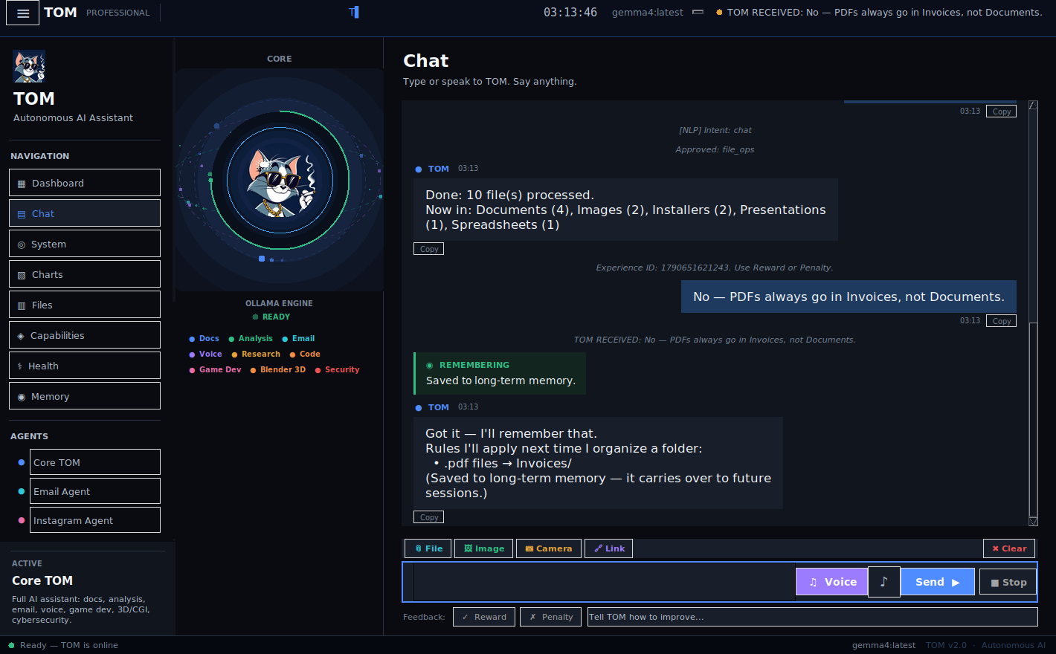
Figure 3: The correction and TOM's acknowledgment. The correction is stored; it does not trigger a file move by itself.

The payoff
Later I added new files and used different words: "tidy up my downloads folder." The file engine called remembered_folder_rules(), which recalls preference and correction memories, parses them into FolderRule objects, and hands them to the planner. The approval dialog listed the rule before I clicked Yes.
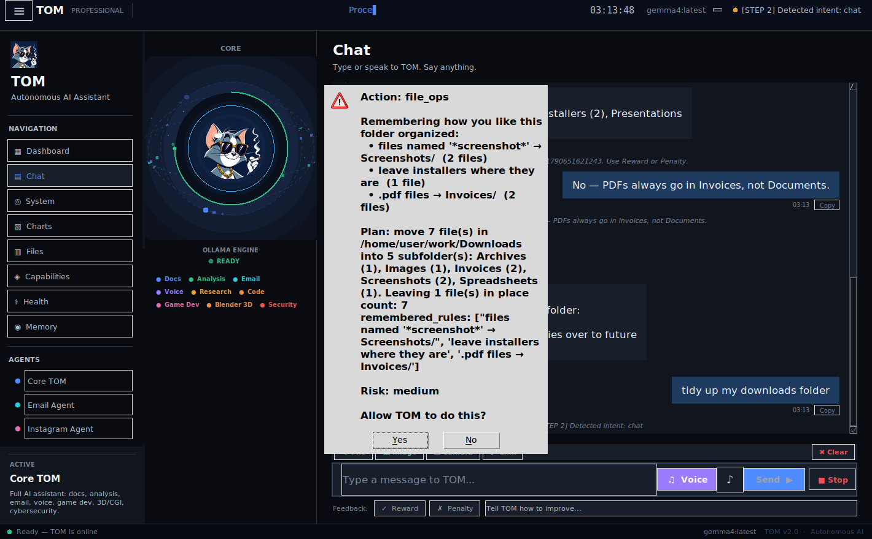
Figure 4: The second plan. The remembered rules appear in the approval request itself.
The result:
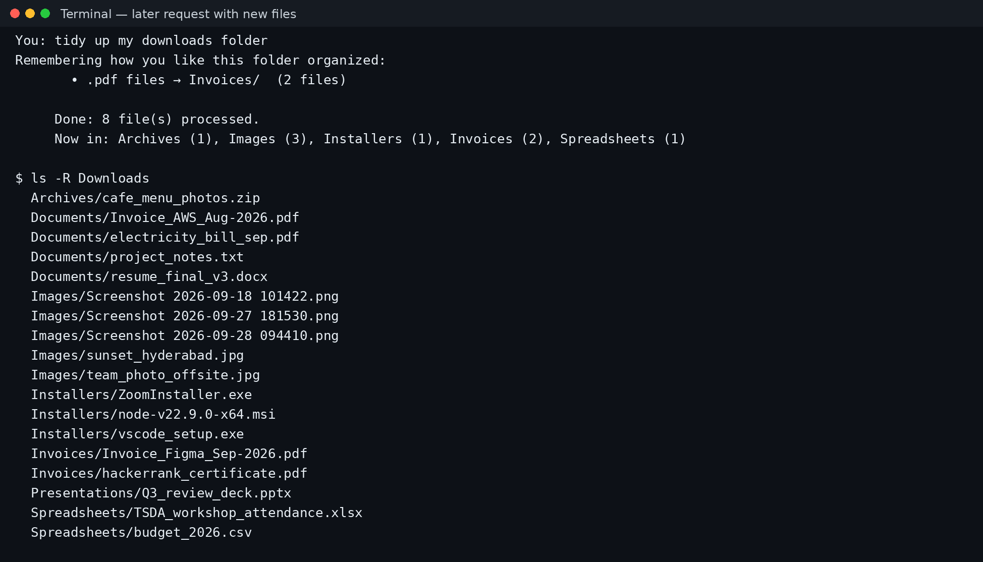
Figure 5: After the second request. The two new PDFs are in Invoices/; the earlier PDFs stay in Documents/.
Two things to notice. The new invoices went where I said. And the earlier PDFs did not move, because the planner only looks at files directly inside the target folder. That is a fair reading of "tidy up this folder," but it means old files need their own request.

Adding history
One correction is a thin test. To see what a longer relationship looks like, I seeded the same memory bank with earlier preferences using seed_history.py: screenshots go to Screenshots/, installers stay where they are, plus email and slide-deck style preferences. That history is synthetic and backdated; it is not weeks of real use.
Then I added another batch of files and asked again in different words. The "Remembering" card listed three rules instead of one.
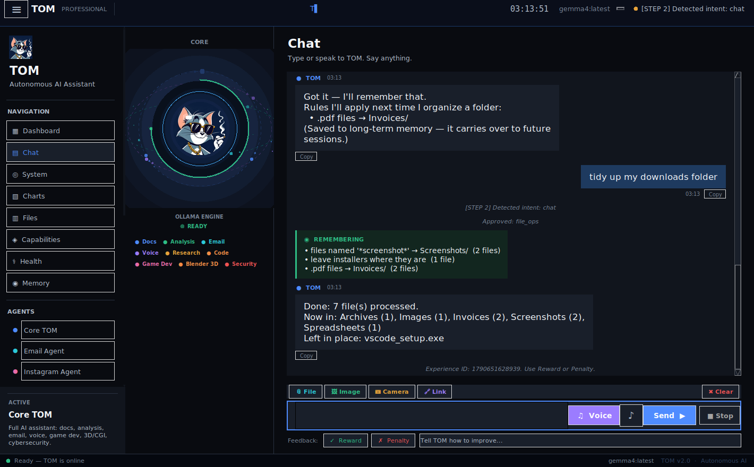
Figure 6: With three stored preferences: screenshots to Screenshots/, PDFs to Invoices/, and the installer left in place. Captured against a sandbox folder with an in-memory test client standing in for Hindsight.
That is the learning curve I care about: request one is generic, request two follows one correction, request three follows several, and I never restated any of them.

The code that matters
rules, memory_note = await agent_ref.remembered_folder_rules(command)
plan = ops.plan_organize_by_type(folder, rules=rules)
Inside the planner, user rules are checked first and default groups second, so the correction wins over the default without any special case.

Where it gets wrong
Rules match by extension. In my second run, hackerrank_certificate.pdf also went to Invoices/, because it is a PDF and I had said "PDFs." A real invoice workflow needs finer rules. The parser already handles that wording: a test feeds it "From now on put invoice PDFs into Finance/2026" and gets back a filename rule, files named '*invoice*' → Finance/2026/. I have not run that variant through the full agent, so I can't tell you how it behaves on messy filenames.
Execution is careful about collisions. execute_plan() skips a source that is no longer a file, creates the destination folder, and adds a numeric suffix rather than overwrite a file that already exists.

What I would keep
- Approval before side effects. Memory that can move files without asking is a bug waiting to happen.
- Show the rules you applied. The "Remembering" card and the approval dialog let me see what memory did.
- Start with one correction. Hindsight made "learn it once" cheap enough to be the whole interface.
In an accounts-payable setting, the equivalent correction is "invoices from this vendor go to this ledger folder." The hard parts are the same as here: capturing the correction once, remembering it across sessions, and making the agent show its work before it acts. Hindsight handled the remembering for me. The vendor-specific parsing is still mine to write.
The pattern is the same one an accounts-payable agent needs: learn where each kind of document goes, then apply it before asking. The Hindsight documentation has the retain and recall APIs, what agent memory is explains the idea, and the full code is in the TOM repository.

