Why My Agent's Hindsight Memory Isn't a Chat Log
What TOM retains, what it recalls, and how one stored correction turns into a different file plan
My agent filed my electricity bill and my AWS invoice in Documents/, next to a resume and a text file of project notes. No amount of chat history was going to fix that, because the mistake wasn't a lack of context. It was a default that didn't match how I work.
That is the difference I care about between a transcript and memory. A transcript records what was said. Memory has to be retrievable later, for a specific task, in a form the agent can act on. I built that layer in TOM, a local Python desktop agent, on top of Hindsight agent memory.

Where Hindsight sits
TOM has a Tkinter desktop app, a CLI and voice input, and all of them hand task requests to one TomAgent. Hindsight is reached through a single wrapper, tools/hindsight_memory.py. It builds a hindsight_client.Hindsight client lazily, so the agent still starts if the package or the key is missing.
You can point it at Hindsight Cloud with an API key, or at a self-hosted server with HINDSIGHT_BASE_URL. The bank ID is stable per install: HINDSIGHT_BANK_ID if set, otherwise a random tom-... ID saved under tom_brain/hindsight/. On first use the wrapper creates the bank with a short mission that tells Hindsight what to learn about this user and to prefer the most recent instruction when two conflict. That last clause matters. If I say PDFs go to Invoices today and Bills next month, I want the newer one to win.
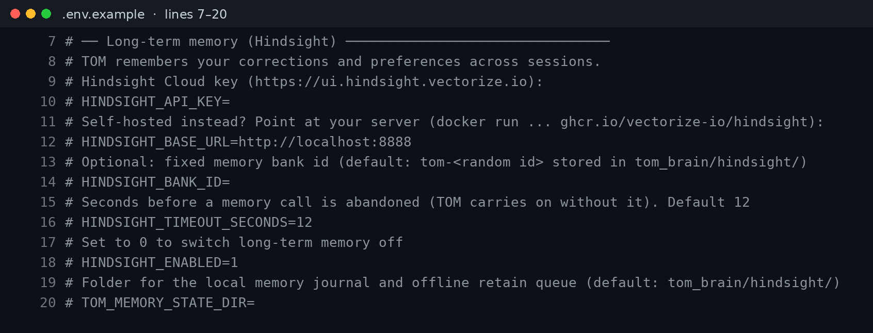
Figure 1: The Hindsight settings in .env.example. Every value is commented out by default.
The Hindsight documentation covers the client calls; the wrapper adds a 12 second timeout, two attempts, and a local journal.

What I retain
I retain two kinds of records, and they are tagged differently so recall can filter them.
Preferences and corrections. When I say "No, PDFs always go in Invoices, not Documents," _retain_preference() stores the correction together with the request it corrects and TOM's previous reply. It tags the record preference, a category such as file_organization, and correction when it is one. My exact words go into metadata.
# simplified from agent.py
tags = [TAG_PREFERENCE, category] + ([TAG_CORRECTION] if correction else [])
self.memory.retain(content, tags=tags, index_now=True,
metadata={"user_words": command[:400], "category": category})
index_now=True asks Hindsight to finish extracting facts before the call returns, so a correction is recallable on the very next request.
Task outcomes. After a task, _retain_outcome() stores what I asked, how TOM handled it, the status, and any rules it applied, tagged task. Those are cheap to write and give the bank a history of what worked.
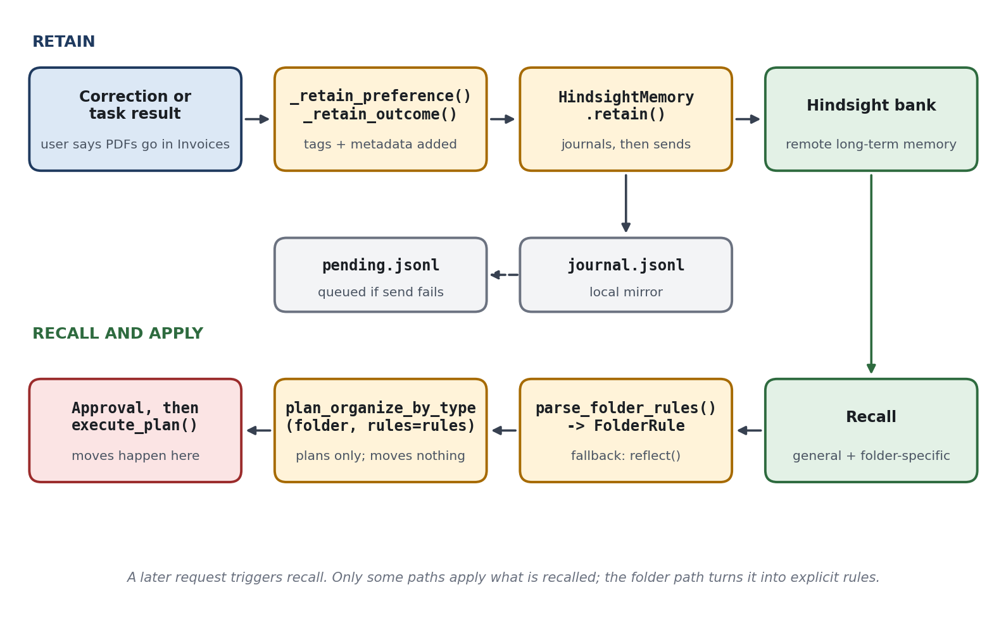
Figure 2: The memory lifecycle: retain with tags, recall later, and turn the result into a rule.

What I recall
There are two recall paths. For ordinary requests, execute_task() starts a general recall as a background task while the NLP parser runs, so it adds no serial step. Handlers that draft emails or documents fold the hits into their prompts through _build_memory_context(). Voice mode does the same with a smaller limit.
File organization gets its own path, remembered_folder_rules(). It asks a file-specific question, filters to preference and correction tags, and returns up to 12 hits. If Hindsight returns facts but the text parser finds no rule, it falls back to reflect() with a JSON schema and asks for structured rules.
reflect() also powers a plain question: "what have you learned about me?" returns a grouped summary of what is in the bank.

Making memory inspectable
Retaining facts you can't look at is uncomfortable. TOM has a Memory view with a Recall box and a "What have you learned?" button. Recall shows the stored facts behind a behavior, and "Recently stored" lists the latest items from the local journal.
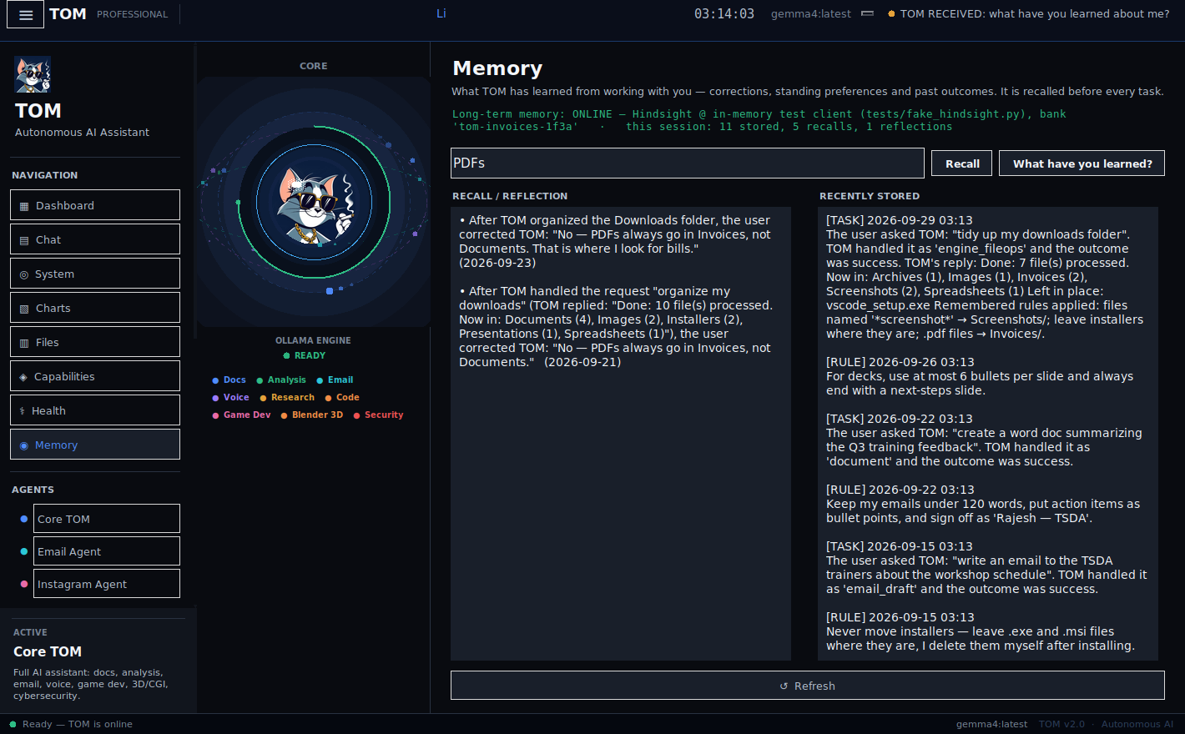
Figure 3: The Memory view after searching "PDFs": the stored corrections on the left, recent items on the right. Captured with an in-memory test client standing in for Hindsight.
Retained content is capped at 4,000 characters, and context and metadata values at 200 each, so a runaway reply can't bloat the bank.

Before and after
Same folder, same agent, one correction in between.
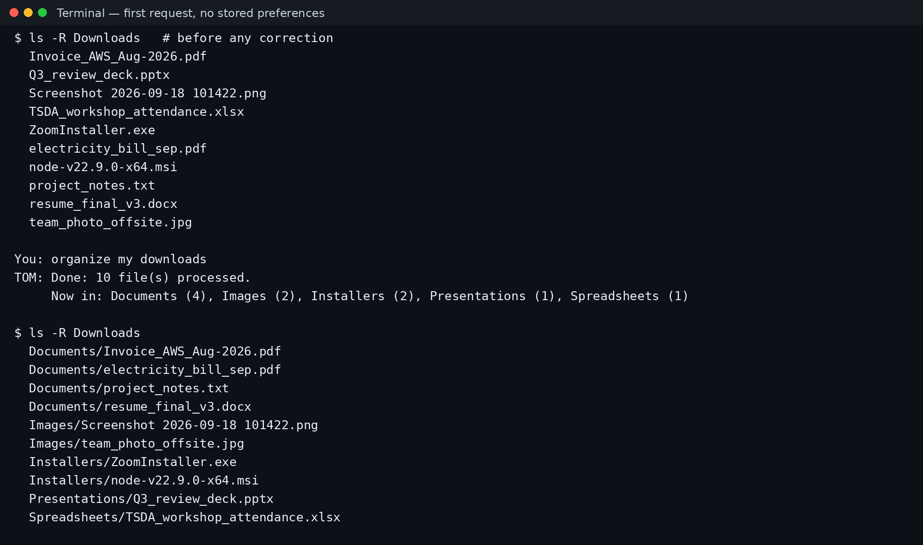
Figure 4: First request, nothing stored. Both PDFs land in Documents/.
After the correction, I added new files and reworded the request. TOM recalled the rule, showed it in a "Remembering" card, and asked for approval before moving anything.
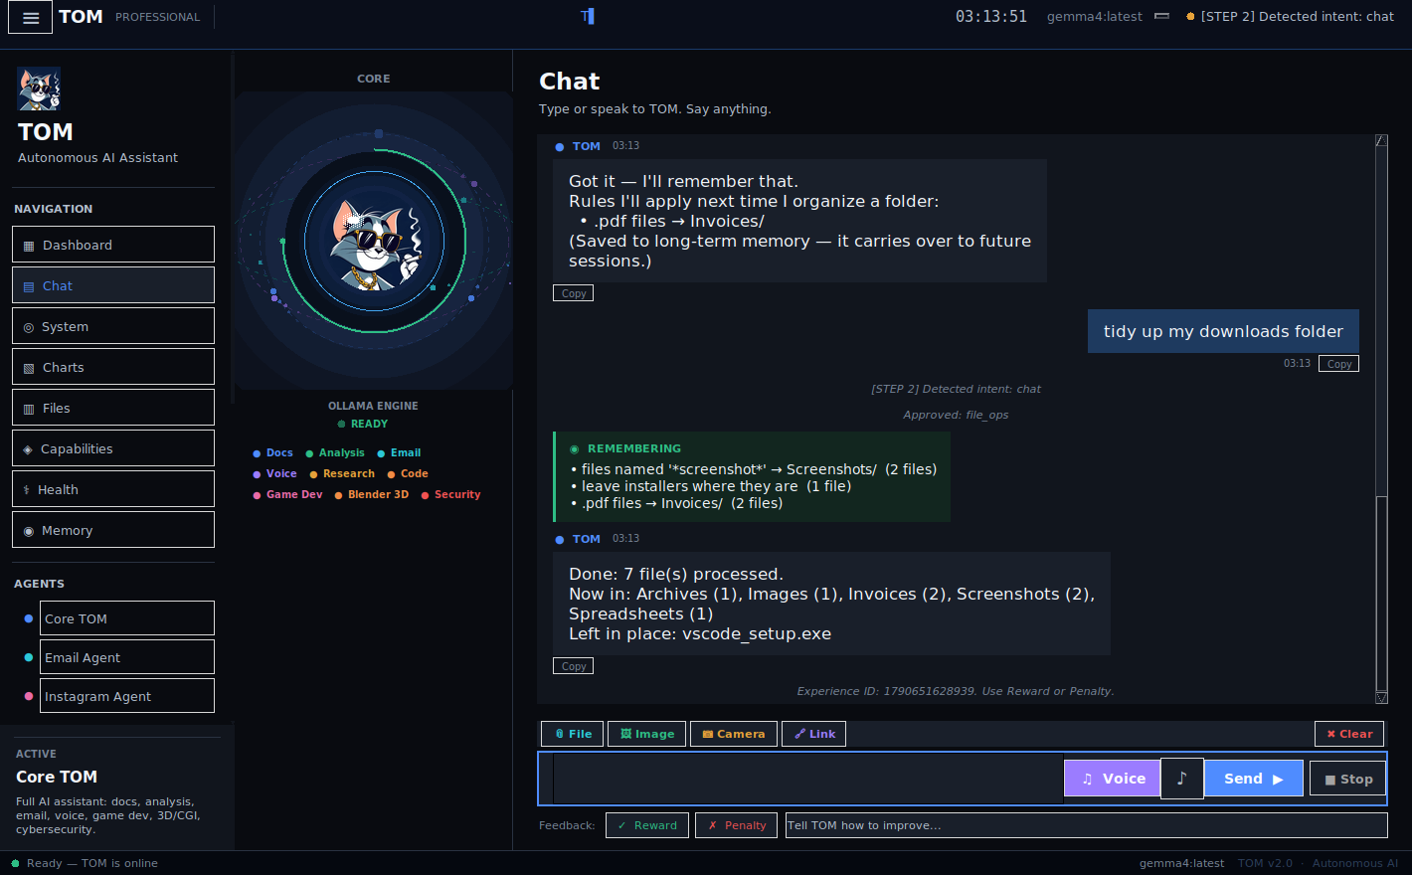
Figure 5: A later request in different words. The card lists the rule TOM used. Captured against a sandbox folder with an in-memory test client standing in for Hindsight.
The plan is built by ordinary Python. Hindsight decides what I prefer; the code decides where each file goes.

What I would tell you before you copy this
- Store tagged facts, not transcripts. A small, stable tag set (preference, correction, task) is what makes filtered recall possible.
- Write the correction with its context. "Not Documents" means nothing without the reply it corrects.
- Turn recalled text into a constrained object. Mine becomes a FolderRule before it can touch a file.
- Don't treat the local journal as proof of storage. It mirrors what I retained. It does not confirm Hindsight accepted it.
- Know the limits. Only handlers that call recall benefit from memory, and rules match by extension, so a PDF that isn't an invoice still follows the PDF rule.
I don't fine-tune anything. The model is unchanged; the behavior changes because the right fact comes back at the right time. If you want the background, Vectorize has a good explanation of what agent memory is, and the code is in the TOM repository.

