I Turned Hindsight Memories Into Deterministic Folder Rules
Why TOM parses recalled text into a small rule object before it lets memory touch a file
The easy way to use agent memory is to paste whatever comes back into a prompt and hope. I tried to avoid that for anything that moves files. Recalled text is a claim about what I want. A file move is a side effect. I wanted a hard boundary between the two.
The boundary in TOM is a 5-field dataclass called FolderRule. Here is how a memory stored in Hindsight agent memory becomes one, and why that made the behavior easier to trust.

The default that needs overriding
tools/file_ops.py groups files by extension: .pdf and .docx to Documents, images to Images, .exe and .msi to Installers. With no rules, the planner checks each file directly inside the folder and picks its group. It builds a plan and moves nothing.

From correction to stored fact
When I say "No — PDFs always go in Invoices, not Documents," _retain_preference() stores it in Hindsight with tags and my exact words in metadata:
tags = [TAG_PREFERENCE, category] + ([TAG_CORRECTION] if correction else [])

Recall, then parse
When I later ask TOM to tidy a folder, remembered_folder_rules() runs a file-specific query, restricted to those two tags:
hits = await self.memory.arecall(query, tags=[TAG_PREFERENCE, TAG_CORRECTION],
limit=12, budget="mid")
It also reads the original wording from a local journal, because Hindsight returns extracted facts in the third person ("the user corrected TOM...") and my own sentence parses more reliably. Both feed parse_folder_rules() in tools/memory_rules.py, which uses regular expressions to find file types, destinations and "leave in place" instructions.
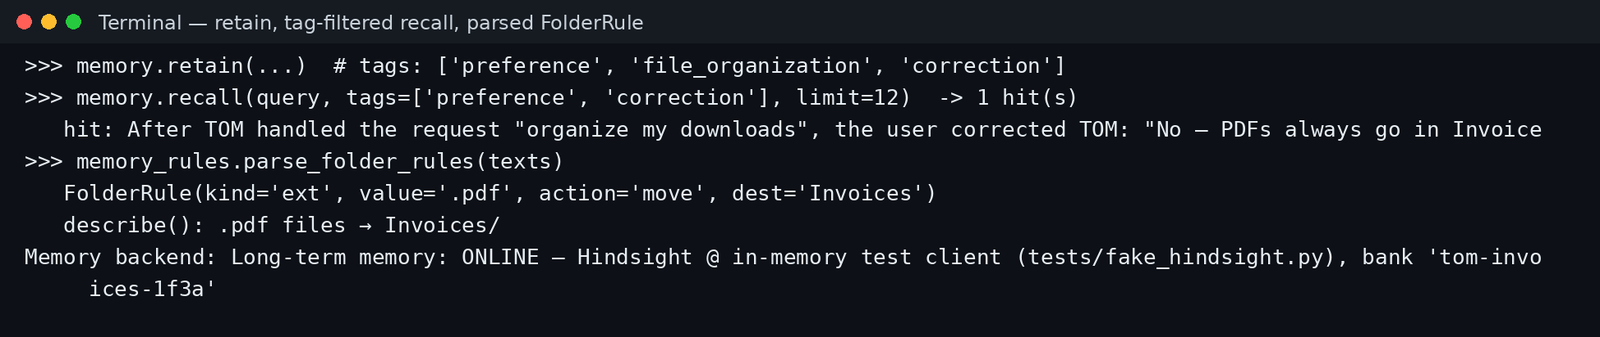
Figure 1: A stored correction, a tag-filtered recall with one hit, and the parsed rule. Captured with an in-memory test client standing in for Hindsight.
The result is a FolderRule:
FolderRule(kind="ext", value=".pdf", action="move", dest="Invoices")
A rule can match by extension, by group, or by a fragment of the filename, and its action is either move or skip. That is enough to express "PDFs to Invoices," "screenshots to Screenshots," and "never move installers."
The parser is tested against real phrasings, each with its expected output:
- "always put PDFs in Invoices, not Documents" gives .pdf files → Invoices/
- "Never move installers — leave .exe files where they are" gives leave installers where they are
- "Screenshots should go into a folder called Screenshots" gives files named '*screenshot*' → Screenshots/
- "From now on put invoice PDFs into Finance/2026" gives files named '*invoice*' → Finance/2026/
- "keep my emails short" gives no rule at all, and neither does a third-person sentence about a past move
That last pair matters. A parser that returns nothing on unrelated text is the reason I trust the ones it does return.
If Hindsight returns facts but nothing parses, the agent asks reflect() for structured rules against a JSON schema and validates the result before use. If that yields nothing, the planner uses its defaults.

Rules first, defaults second
The planner checks rules before groups. A matching skip leaves the file where it is; a matching move supplies the destination; otherwise the default applies.
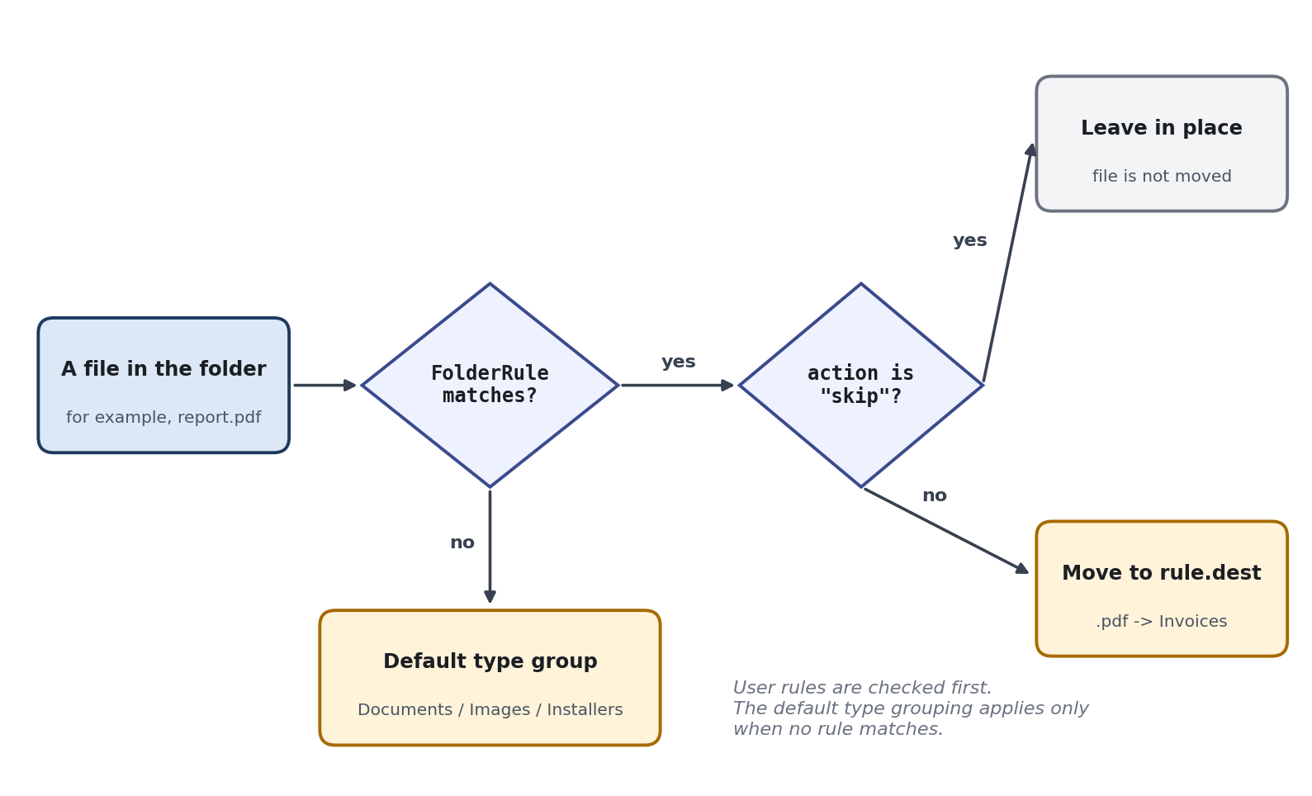
Figure 2: The precedence in plan_organize_by_type().
No language model decides where a file goes at planning time. The same rules and the same folder always produce the same plan, which is what makes it testable.

Executing the plan
execute_plan() is deliberately dull. For each planned move it checks that the source is still a file, creates the destination folder, and adds a numeric suffix instead of overwriting an existing name. It returns how many files it moved and how many it skipped. The same rules also feed the by-year planner, so a preference is not tied to one grouping mode.

Approval sits after the rule
The engine passes the plan to ApprovalManager with the move count and the rules applied. If I decline, it returns a cancelled result. If the approval system is missing, it returns a dry run.
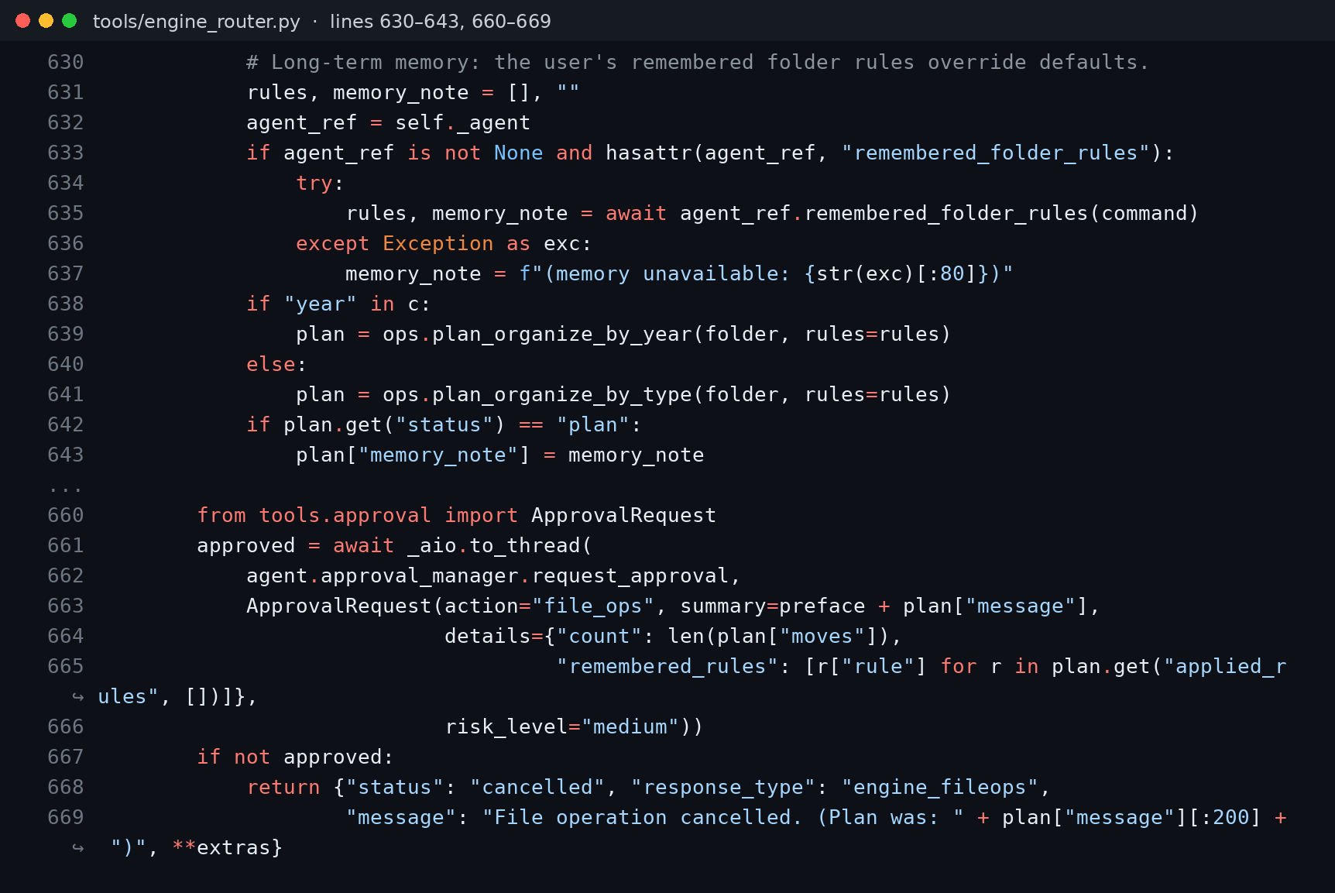
Figure 3: _run_fileops(): recall, plan, then request_approval with the rules in the details (engine_router.py).

Before and after
With one stored correction, I added new files and reworded the request:
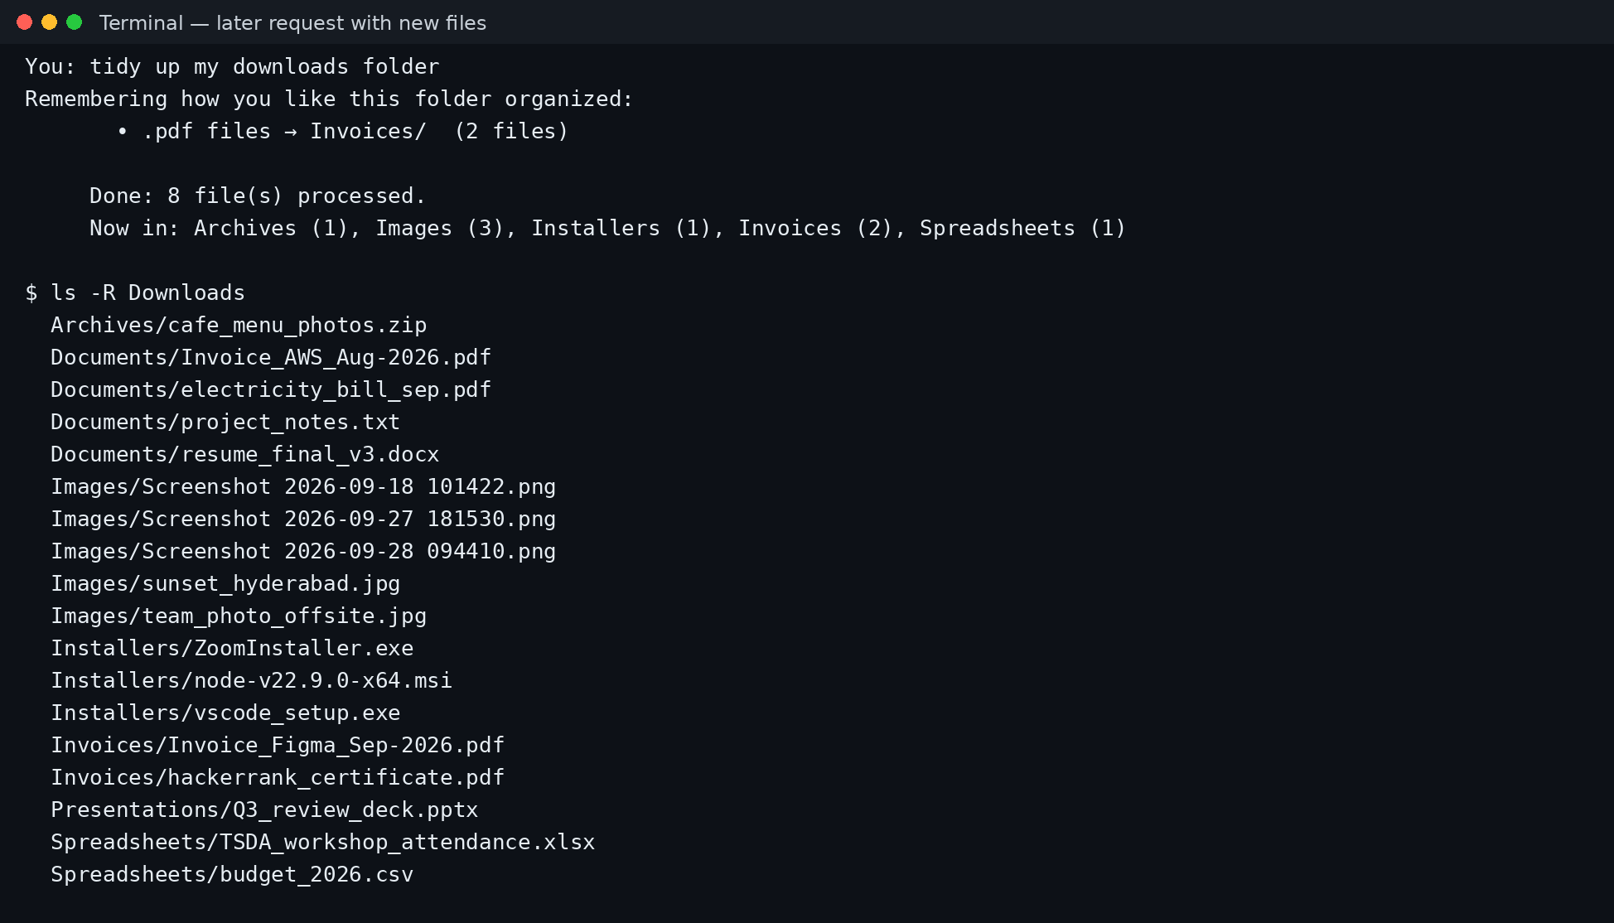
Figure 4: The new PDFs land in Invoices/. The earlier PDFs stay in Documents/ because the planner only looks at files directly in the folder.
Before the correction: PDFs go to Documents/. After: PDFs go to Invoices/. Everything else follows the defaults, because my correction says nothing about images or archives.

What went wrong
The rule is only as precise as the sentence. "PDFs" became .pdf, so a certificate PDF also went to Invoices/. Regex parsing of natural language is also brittle: a phrasing the patterns don't cover produces no rule, and I fall back to reflect(). There is also an ordering question I have not settled. Inside the planner, the first rule in the list that matches a file wins, and the list order follows the order of the recalled text. If two stored preferences both match one file, the result depends on that order, not on which instruction is newer. Hindsight's bank mission asks it to prefer recent instructions, but my parser doesn't enforce that on its own. I chose the fail-toward-defaults trade-off on purpose. A missed rule means TOM uses defaults, which is annoying but safe. A wrong rule could misfile documents.

Lessons
- Parse memory into a constrained type before acting on it. Free text is fine for prompts, not for file paths.
- Keep precedence in one place. Rules first, defaults second, and nowhere else.
- Test the deterministic part. test_organizer_applies_rules runs without any model or network.
- Fail toward defaults. When memory is missing or unparseable, do the boring thing.
Hindsight keeps the memory across sessions; ordinary code keeps it safe. The Hindsight documentation covers recall and reflect, what agent memory is gives the background, and the code is in the TOM repository.

