How I Made My Agent's Hindsight Memory Fail Safe
Journals, retry queues and an in-memory test client: how TOM keeps working when the memory service is slow, missing or offline
An agent with long-term memory has a new way to fail: the memory layer goes away. The network drops, the key is wrong, or the server is slow. I wanted TOM to lose its preferences for a while, not stop doing its job.
This is how TOM's Hindsight agent memory wrapper behaves when things go wrong, how I test it without a live service, and the bug I found while writing this.

The rules
Three rules shaped tools/hindsight_memory.py:
- Never lose a correction the user typed.
- Never let a recall failure raise into a task.
- Never hang a task waiting on memory.
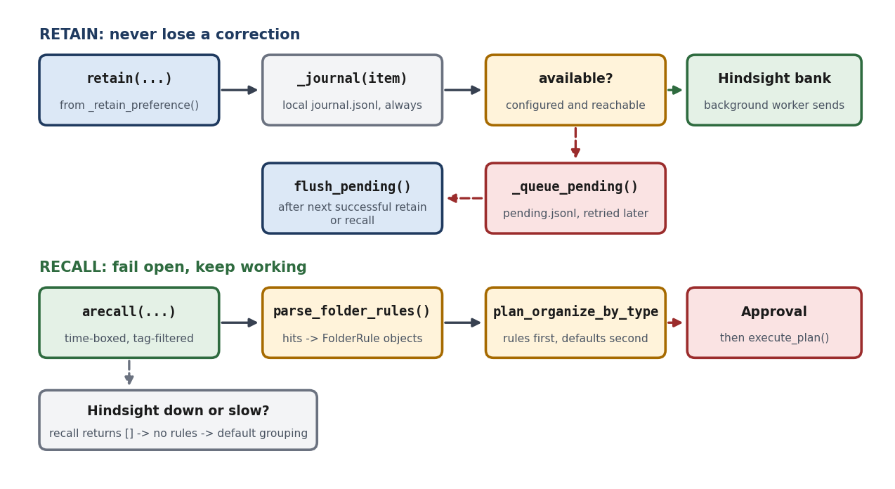
Figure 1: Retain and recall failure paths. Retain journals first; recall fails open.

Retain: journal first
retain() writes to a local journal.jsonl before it does anything else. Then it checks whether the client is available. If not, it appends the item to pending.jsonl and returns False. Otherwise it puts the item on a background queue, and a worker sends it to Hindsight.
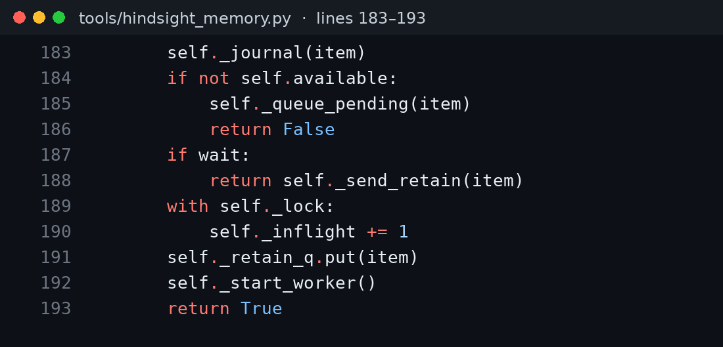
Figure 2: retain() journals first, then queues or sends (hindsight_memory.py).
The journal is a mirror for the UI and for recovery. It is not proof that Hindsight stored anything, and I do not describe it that way.

Recall: fail open
Recall catches every exception, records last_error, and returns an empty list. The async wrapper adds a hard timeout. A caller that gets no hits proceeds without them.
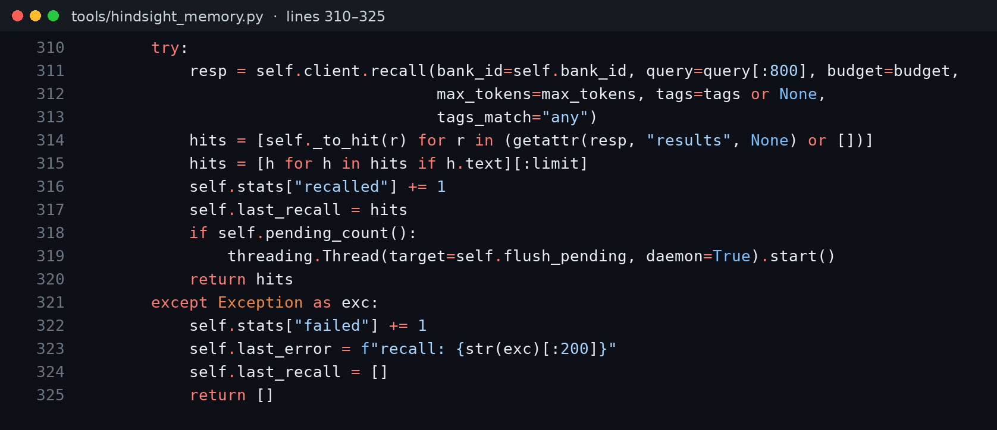
Figure 3: recall() fails open, and a successful recall triggers a flush of pending retains.
For the file planner, no hits means no rules, so the defaults apply. The behavior that memory added disappears; the feature does not.

Running with no configuration at all
The wrapper also has to behave when Hindsight was never set up. With no HINDSIGHT_API_KEY and no HINDSIGHT_BASE_URL, test_unconfigured_memory_is_safe asserts that the memory reports itself unavailable, that its status line names the missing variable, that recall returns [], that reflect() returns ok: False, and that a retain is journaled and queued so it can sync once configuration appears. The status line has three states: OFF (HINDSIGHT_ENABLED=0), OFFLINE with the reason, and ONLINE with the endpoint, bank ID and queued count. It is printed into the chat at startup, so a degraded memory is never silent.
The same tolerance shows up elsewhere. While capturing screenshots for these articles, my sandbox had no local Ollama server, so the embedding calls behind TOM's separate document search failed and were logged as warnings. The file organizer still ran to completion.

Testing without a service
I do not want tests that need an account. tests/fake_hindsight.py is a small in-memory client that supports create_bank, retain, recall, reflect and list_memories. It ranks recall results by word overlap with the query, and it can be switched into a failing mode. That makes it good for integration tests and useless as evidence about production recall quality. I keep those two claims apart.
client = FakeHindsight(fail=True)
mem.retain("never move installers", tags=[TAG_PREFERENCE], wait=True) # False
assert mem.pending_count() == 1
assert mem.recall("installers") == [] # degrades, never raises
client.fail = False
assert mem.flush_pending() == 1
That is test_offline_retains_queue_and_flush_later. Another test, test_correction_changes_next_run, runs a full session: organize with defaults, store a correction, add new files, reword the request, and assert the PDFs land in Invoices/. All 28 tests in tests/test_hindsight_memory.py pass in about seven seconds with no network.
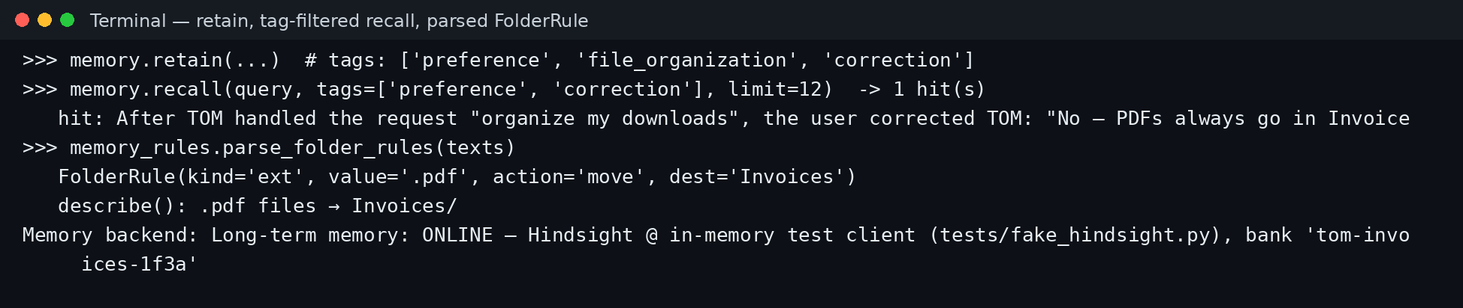
Figure 4: A retain, a tag-filtered recall and the parsed rule, run against the in-memory test client.

The bug I found
Writing this, I re-read flush_pending(). It reads the pending file, deletes it, then sends items one by one:
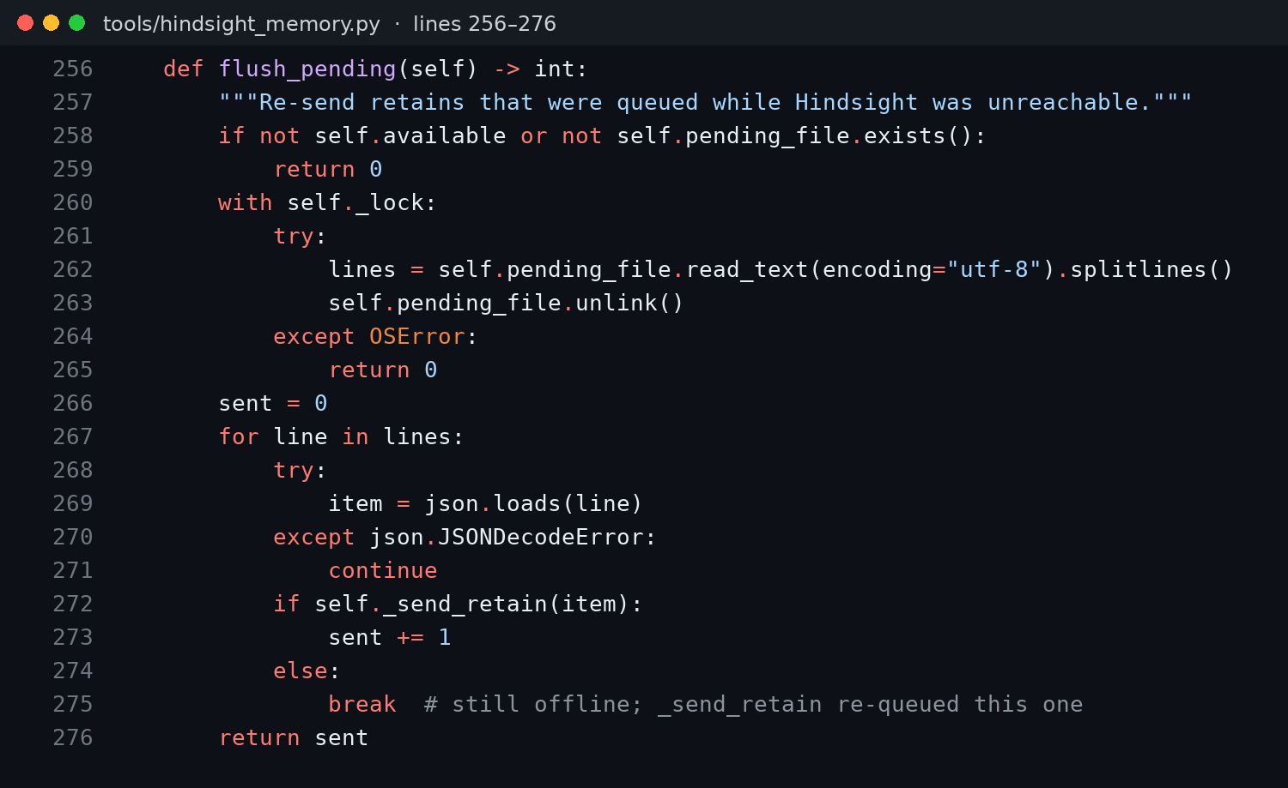
Figure 5: flush_pending(). When one send fails, the loop stops.
When a send fails, _send_retain re-queues that one item, and the loop breaks. Everything after it in the batch was already deleted from disk and is not re-queued. The journal still has them, but the retry path forgets them. I reproduced it with the test client: three failed retains left three items pending, and one flush that failed on the first send left one.
The fix is small: on failure, write the failed item and all remaining items back to the pending file. I have not made that change yet, so I am documenting it here instead of implying the queue is airtight. It is exactly the kind of thing a happy-path test doesn't catch.

Before and after
With Hindsight reachable, one stored correction sends new PDFs to Invoices/. With it unreachable, the identical request falls back to Documents/, with no crash and no error dialog, and the status line says why. When the service returns and the queue flushes, the rule is back. The cost of an outage is a worse plan that I still get to approve, not a broken agent.

Lessons
- Journal before you send. The user's words should exist locally the moment they are typed.
- Fail open on recall, loudly on retain. A missing memory is a degraded answer; a lost correction is a bug.
- Keep a test client, and label it. It proves integration, not recall quality.
- Re-read your retry code. Queues look simple until a batch fails halfway.
The Hindsight documentation describes the API surface this wrapper sits on, what agent memory is gives the background, and the code is in the TOM repository.

