Backend

1. Create folder d:> cd project
2. Create backend folder in project folder D:/project/>mkdir backend
3. Create and Activate a Virtual Environment

**For On macOS/Linux**

Create : python3 -m venv venv

Activate : source venv/bin/activate

**On Windows**

Create : python3 -m venv venv

Activate : venv\Scripts\activate

1. Install Dependencies  
   pip install django djangorestframework djangorestframework-simplejwt
2. **Create Django Project**

django-admin startproject Ecommproject

D:/project/backend> django-admin startproject Ecommproject

1. **Create Django Application**

D:/project/backend/ Ecommproject > python manage.py startapp app

D:/project/backend/ Ecommproject > python manage.py startapp products

D:/project/backend/ Ecommproject >python manage.py startapp orders

1. **Settings:**

INSTALLED_APPS =

[

# Default Django apps...

# Third-party apps

'rest_framework',

'corsheaders',

'rest_framework_simplejwt',

'app',

'products',

'orders',

]

add the following configurations for DRF and Simple JWT.

REST_FRAMEWORK = {

'DEFAULT_AUTHENTICATION_CLASSES': ( 'rest_framework_simplejwt.authentication.JWTAuthentication',

),

'DEFAULT_PERMISSION_CLASSES':

( 'rest_framework.permissions.IsAuthenticated', )

}

from datetime import timedelta

SIMPLE_JWT =

{ 'ACCESS_TOKEN_LIFETIME': timedelta(minutes=5),

'REFRESH_TOKEN_LIFETIME': timedelta(days=1),

'ROTATE_REFRESH_TOKENS': False,

'BLACKLIST_AFTER_ROTATION': False,

'UPDATE_LAST_LOGIN': False,

}

For development (allows all origins):

CORS_ALLOW_ALL_ORIGINS = True

For production (recommended):

CORS_ALLOWED_ORIGINS = [

"https://example.com",

"https://sub.example.com",

"http://localhost:3000",

# Your frontend's development URL

]

1. Run the server

D:/project/backend/ Ecommproject >python manage.py run server

Frontend

1. Download and Install the Nodejs application
2. 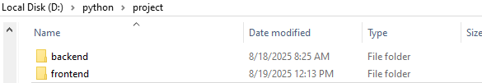Create Frontend Folder In Project Folder
3. Go to command prompt and select the frontend path
4. D:/project/Frontend> npm create vite@latest . (. (dot) for same folder)
5. And choose -> React option
6. Next choose -> Javascript option
7. After some time it installed required packages
8. To Install the tailwind please follow the https://tailwindcss.com/docs/installation/using-vite
9. And then install the required axios, react-router-dom, D:/project/Frontend> npm install axios react-router-dom react-icons
10. For run D:/project/Frontend> npm run dev

API calls

1. Register API call

<http://127.0.0.1:8000/api/auth/register/>

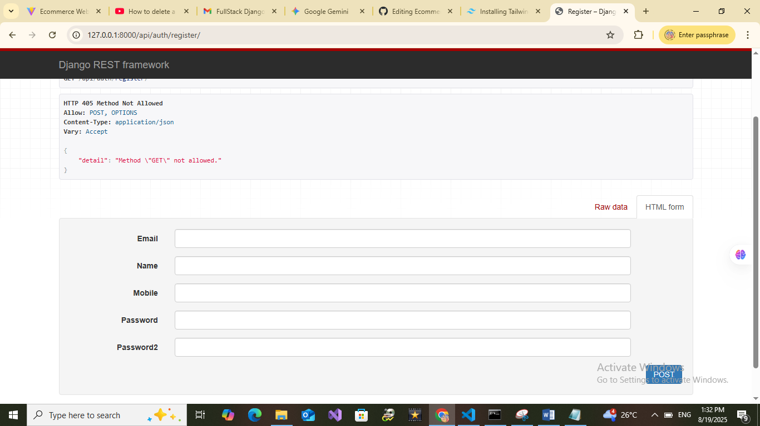

1. Login API call

<http://127.0.0.1:8000/api/auth/login/>

after logged in you will get access and refresh token

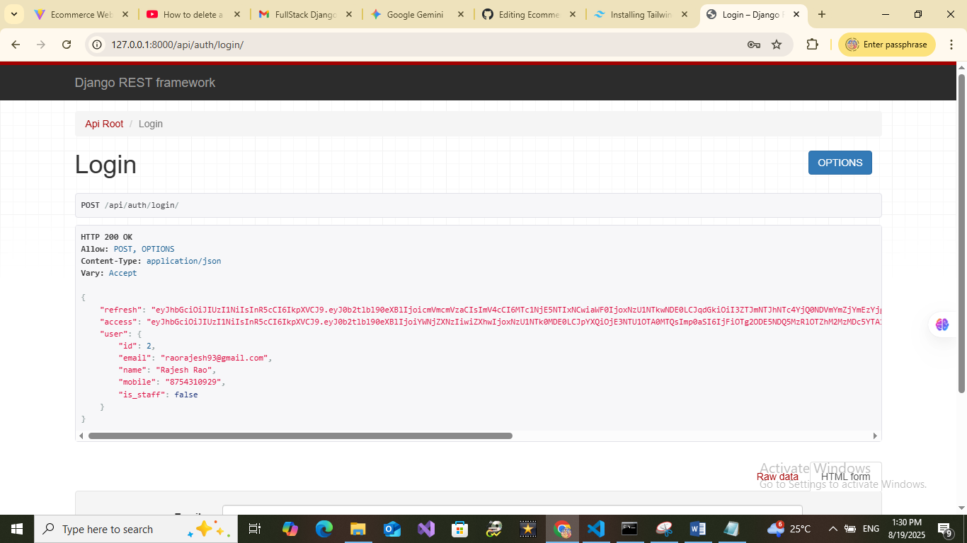

1. 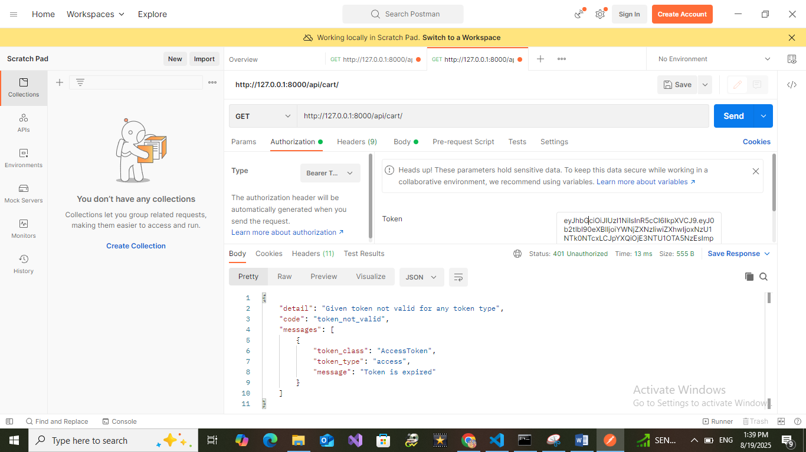After getting the token just paste it in the place of authentication token box
2. 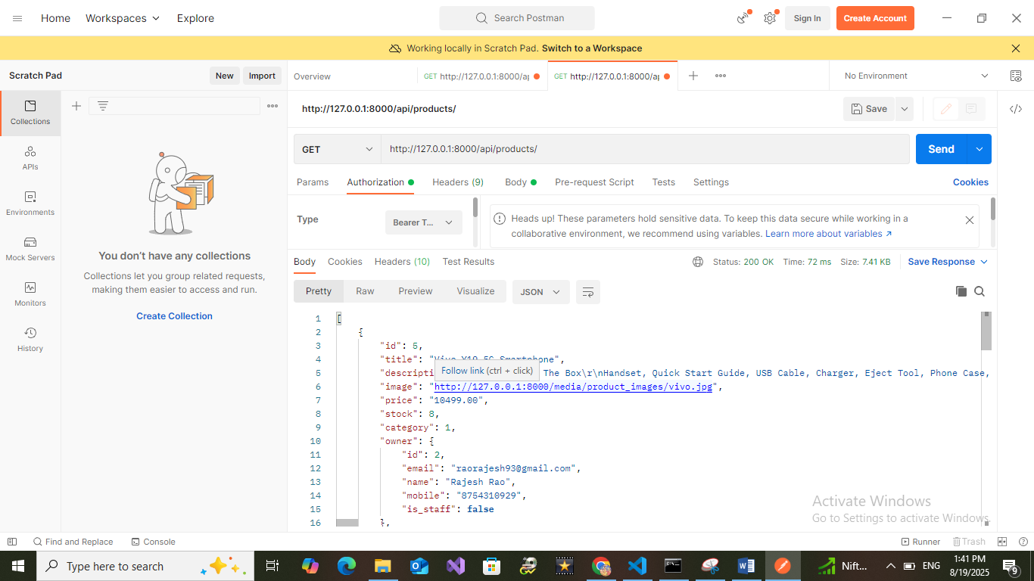 Products API : http://127.0.0.1:8000/api/products/
3. <http://127.0.0.1:8000/api/my-products/>

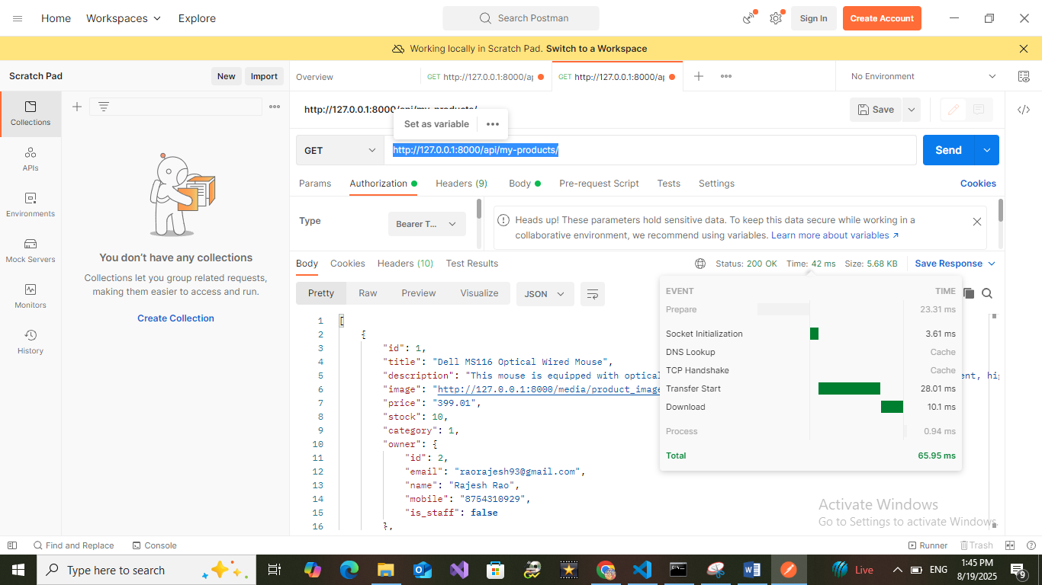

1. Orders API : <http://127.0.0.1:8000/api/orders/>

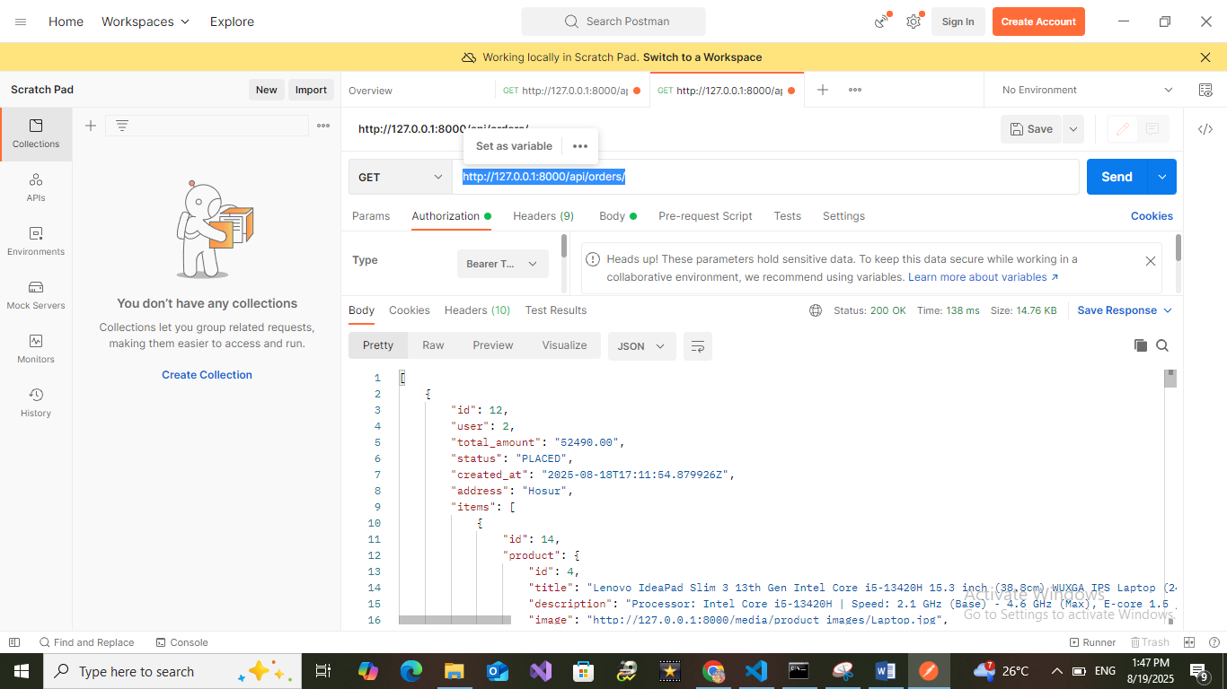

1. 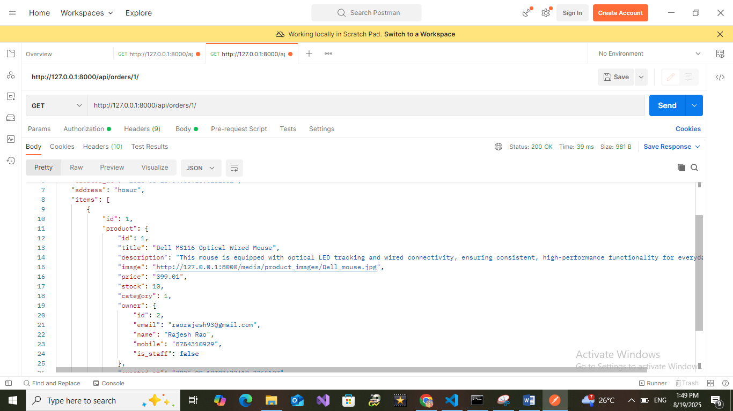Detail Order API : http://127.0.0.1:8000/api/orders/1/

Administrator

1. Category API http://127.0.0.1:8000/api/admin/categories/

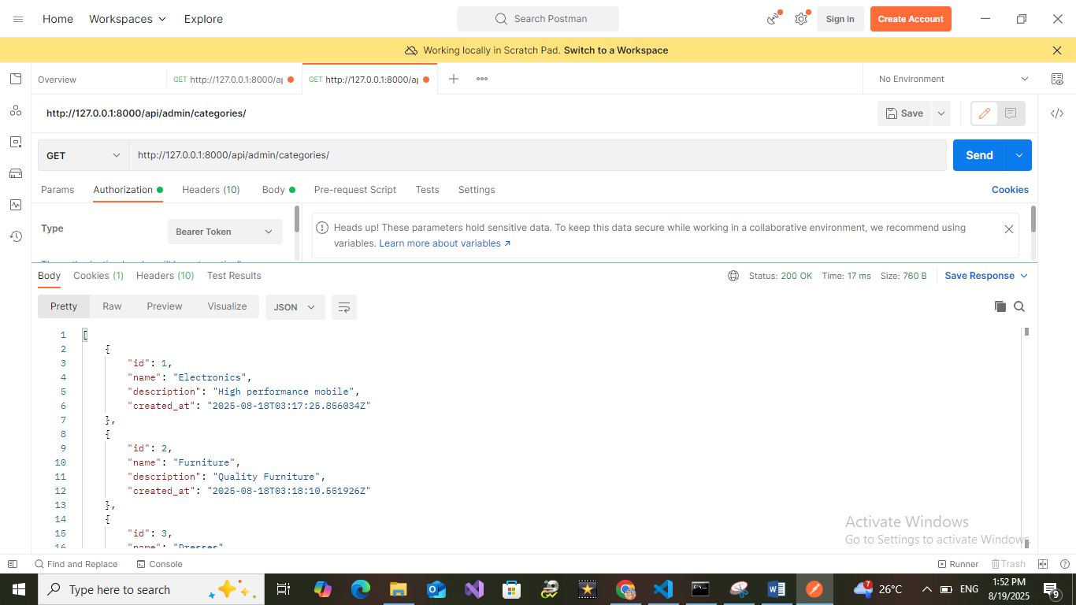

1. 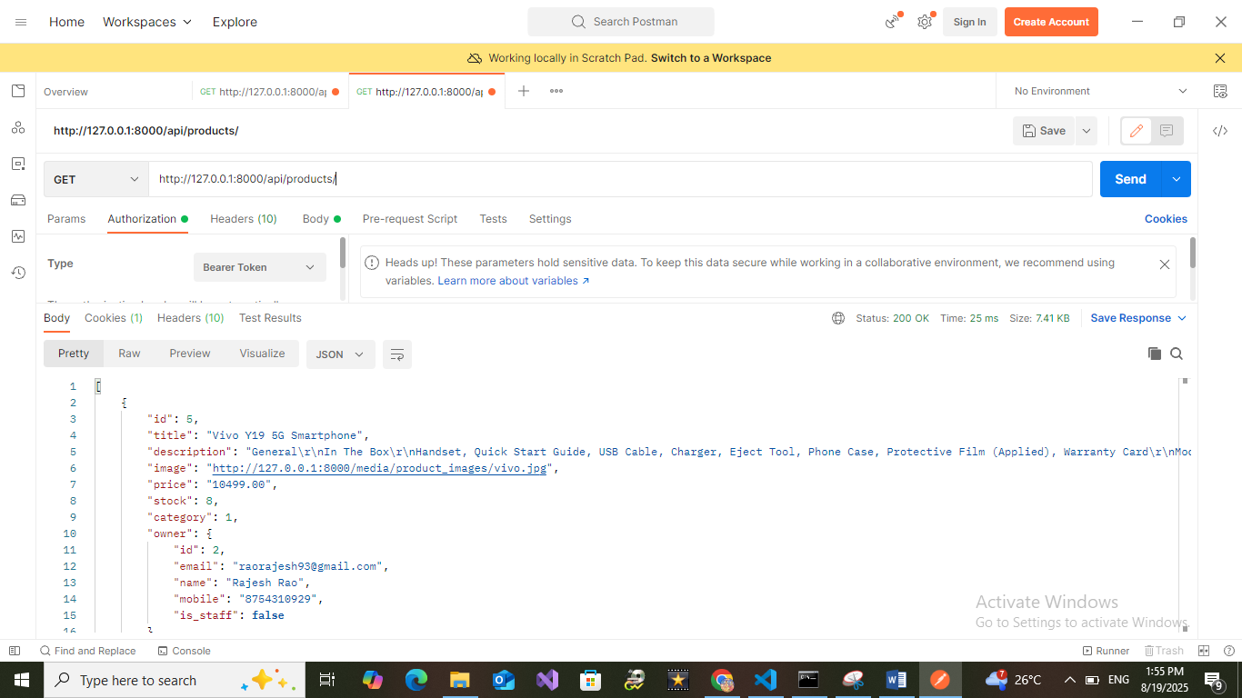Product API http://127.0.0.1:8000/api/products/
2. 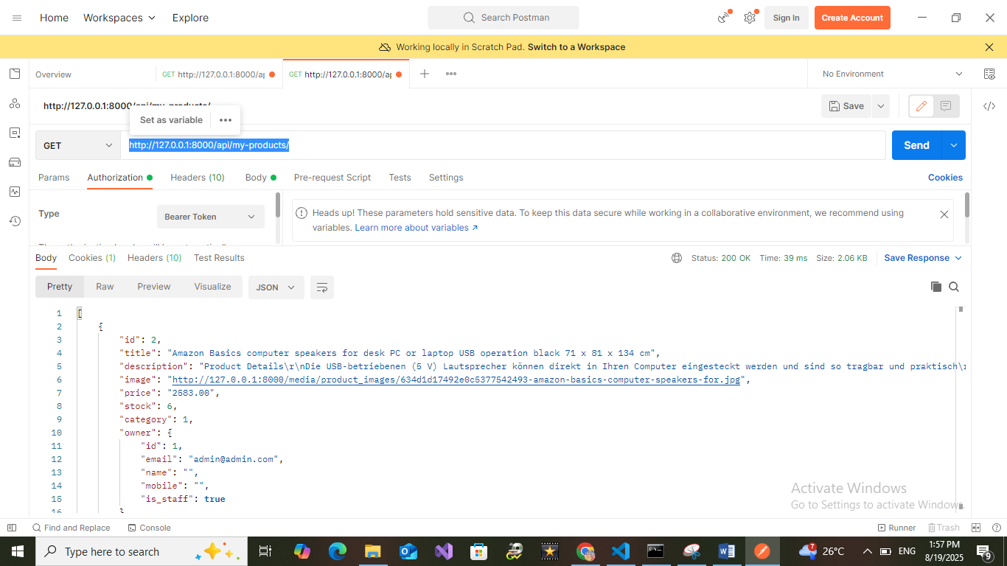Admin Product API http://127.0.0.1:8000/api/my-products/

Frontend

Login Page

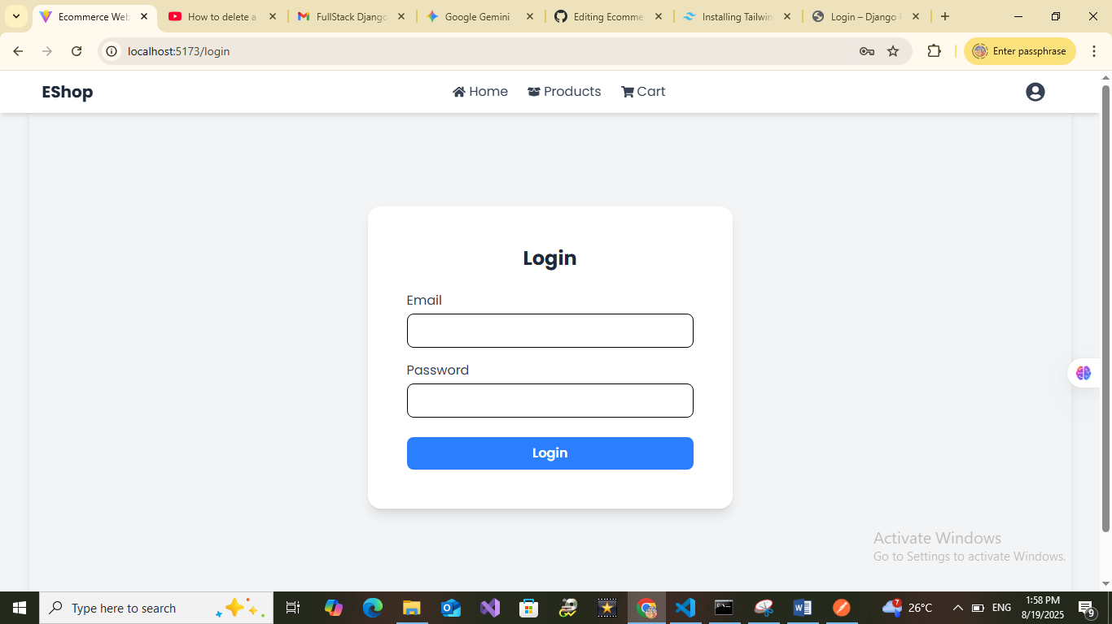

Register Page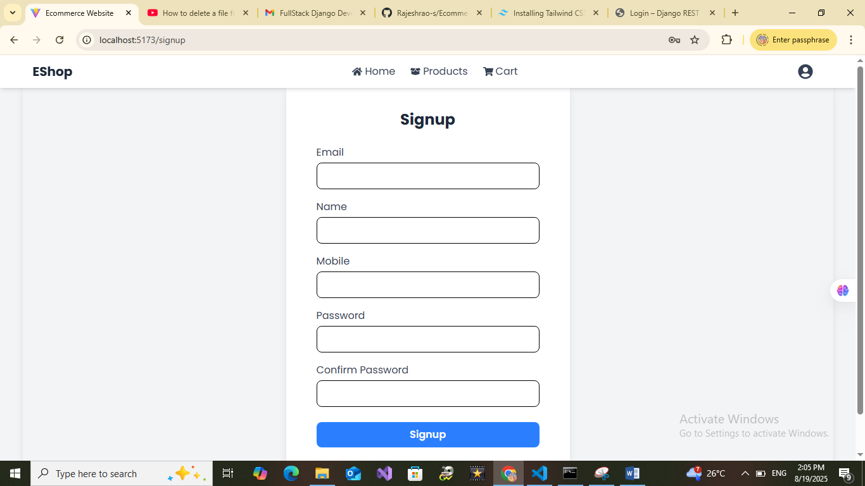

Admin

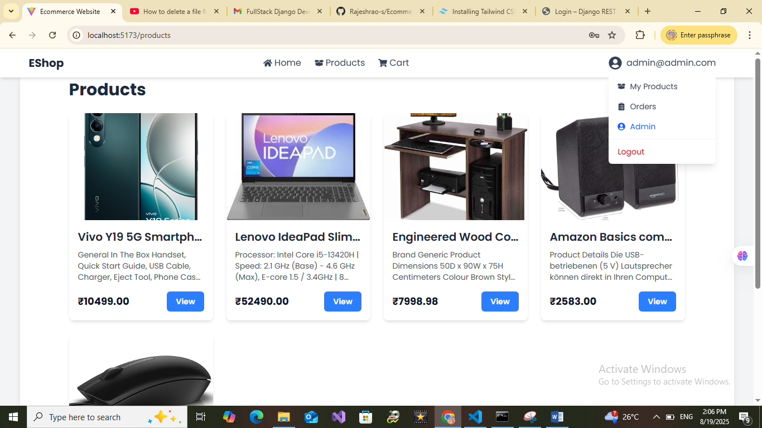

Admin Products

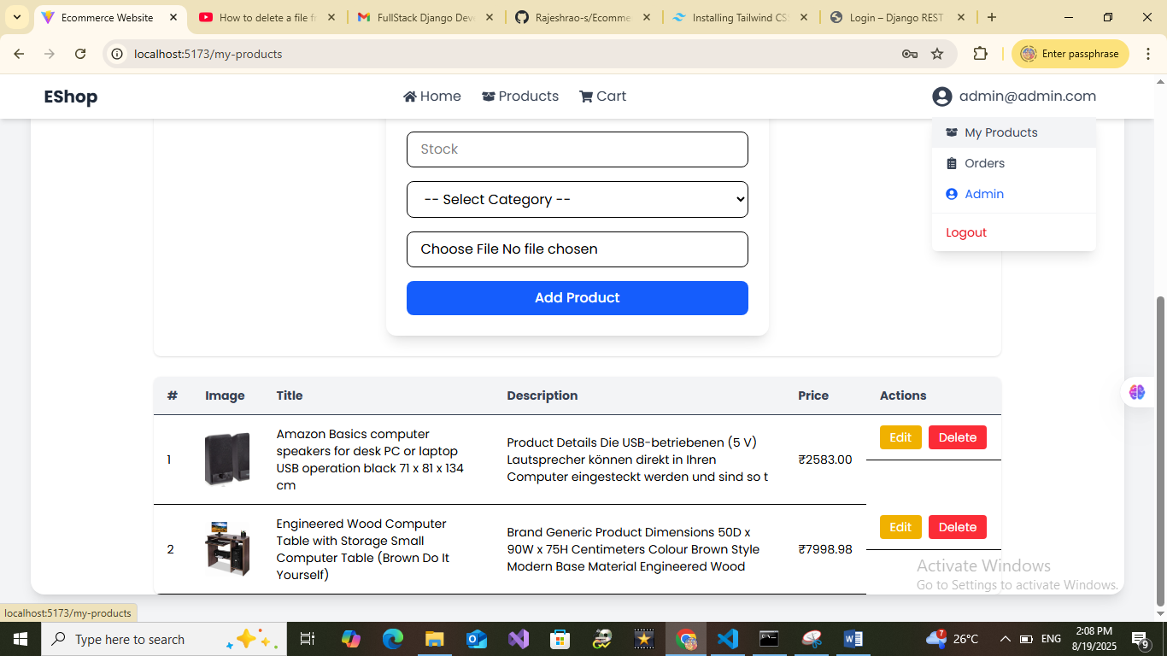

Over all Orders

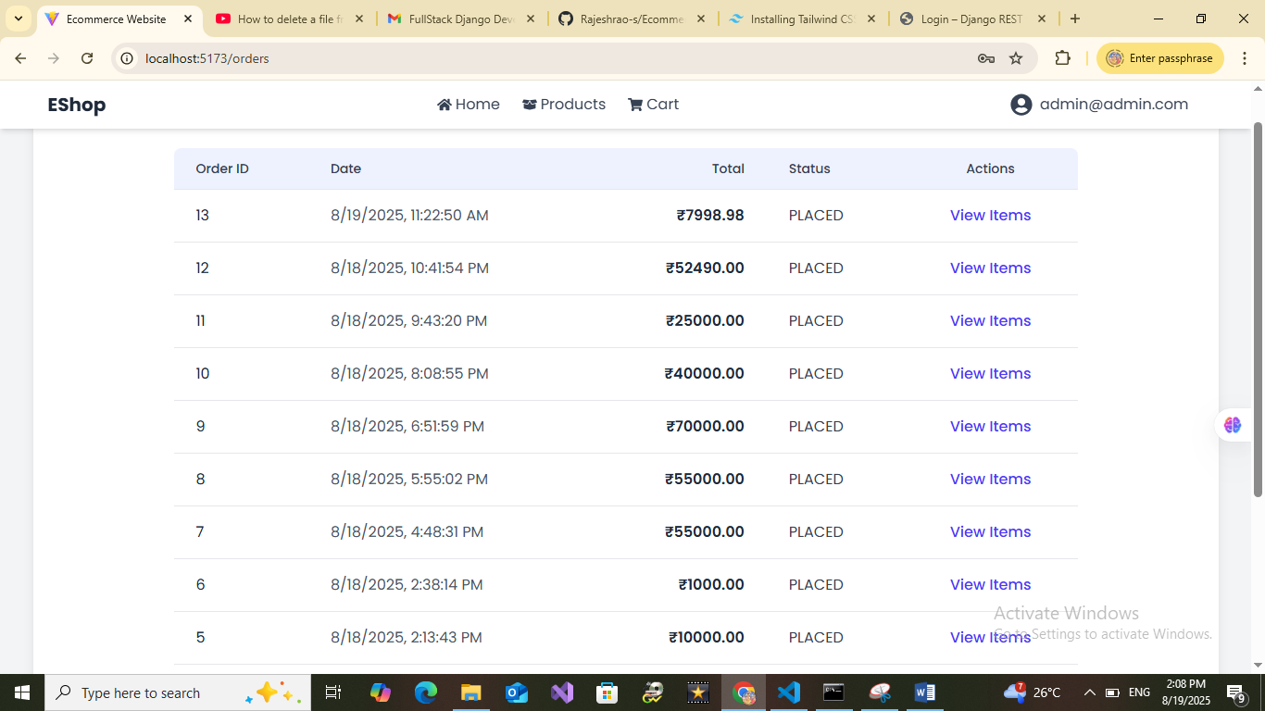

Category Management

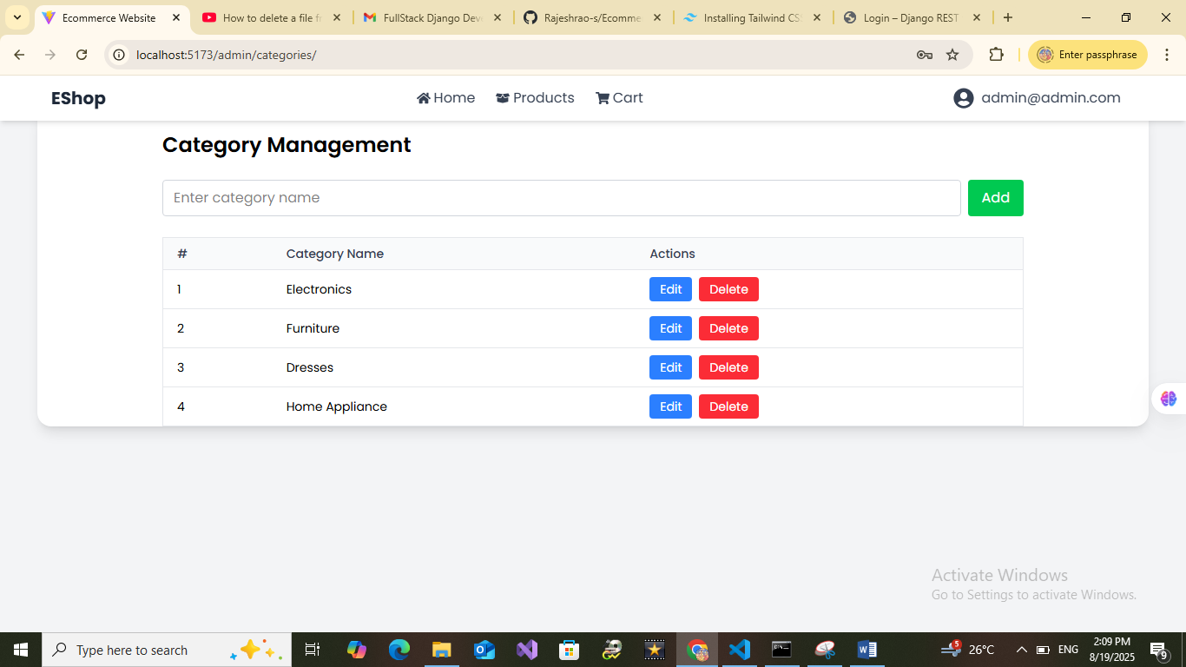

User

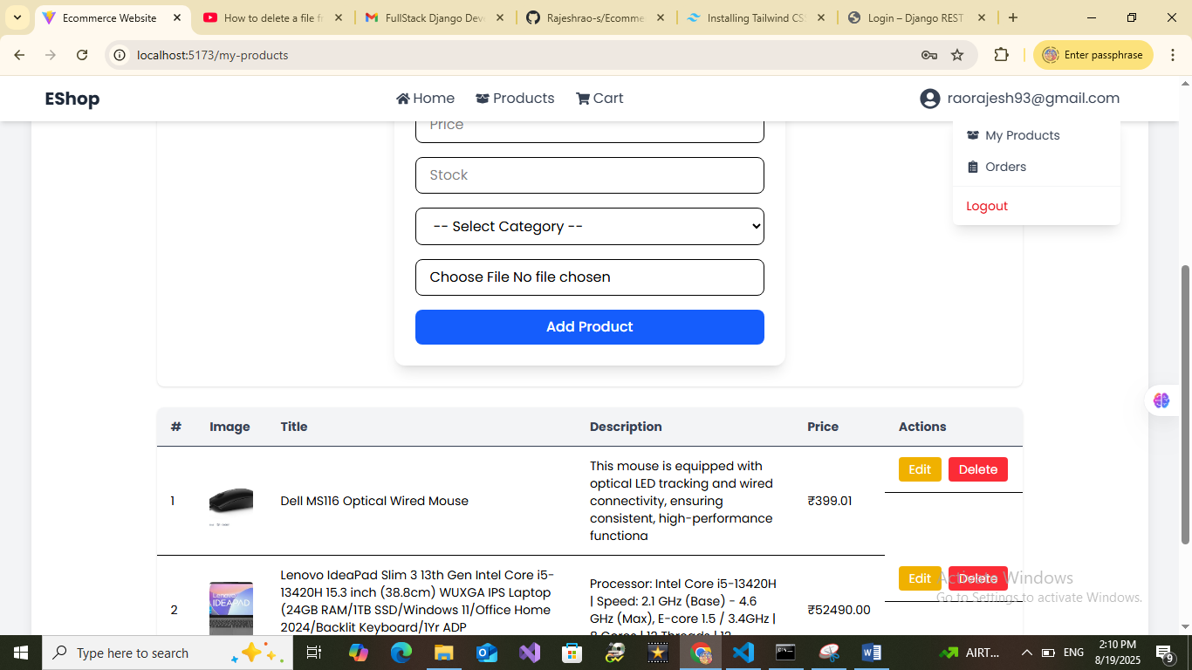

Orders

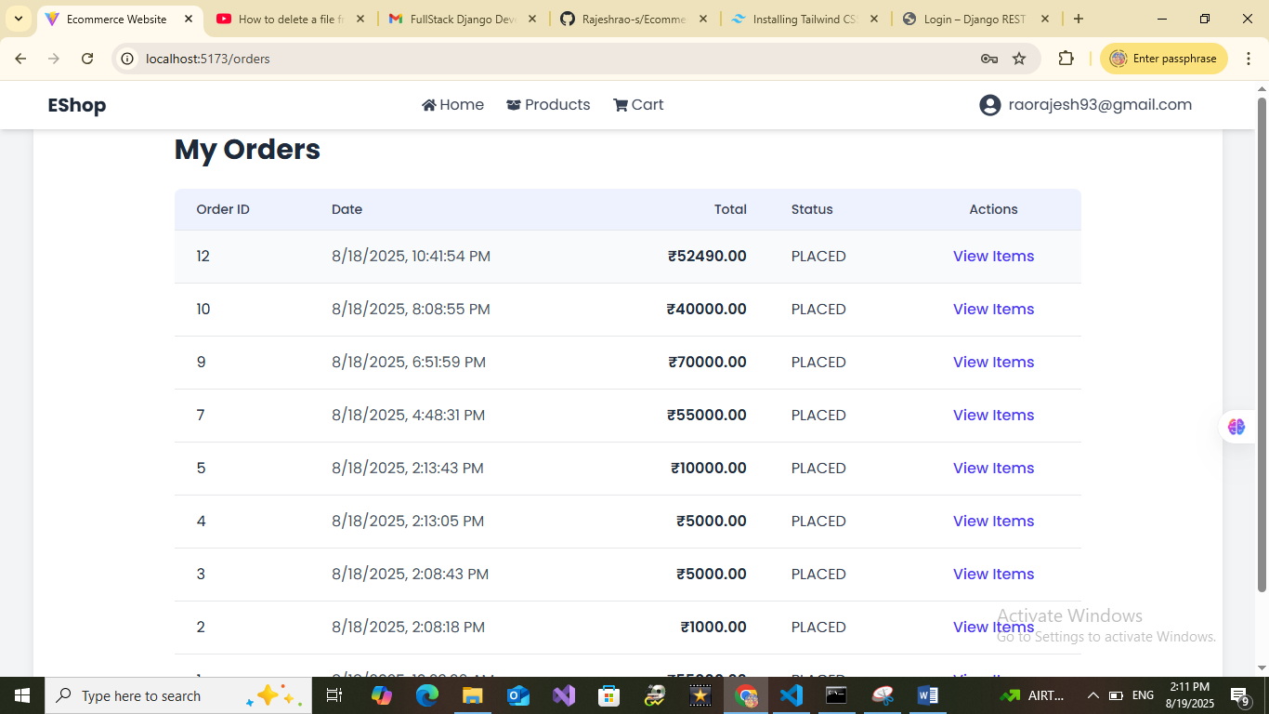

Product Page

