PROJECT REPORT
ON
PEERLEARN
SUBMITTED TO


HIMACHAL PRADESH UNIVERSITY, SHIMLA
FOR THE PARTIAL FULFILLMENT FOR THE
AWARD OF THE DEGREE OF

BACHELOR OF COMPUTER APPLICATIONS

(2023-2026)

UNDER THE GUIDANCE OF: SUBMITTED BY:
ASST. PROF. SHILPA SHARMA Manjeet Singh
University Roll No. 6231030040

DRONACHARYA POST GRADUATE COLLEGE OF
EDUCATION RAIT, KANGRA

COLLEGE CERTIFICATE

This is to certify that the project work entitled “PEERLEARN”, submitted by Manjeet Singh, has been completed in partial fulfilment of the requirements for the award of the degree of Bachelor of Computer Applications (BCA) under Himachal Pradesh University, for the academic session 2023–2026. The work embodies the original efforts of the candidate and has been carried out under proper guidance and supervision.

Date: ____________________

Signature of the Principal

SUPERVISOR CERTIFICATE

This is to certify that the project work titled “PEERLEARN”, submitted by Manjeet Singh, has been successfully completed under the supervision of Mrs. Shilpa Sharma (Assistant Professor) in partial fulfilment of the requirements for the award of the degree of Bachelor of Computer Applications (BCA) under Himachal Pradesh University, for the academic session 2023–2026.

Date: ____________________

Signature of Supervisor

STUDENT’S DECLARATION

This is to certify that work, which is being presented in the project entitled “PEERLEARN”, submitted by undersigned student of BCA degree is a record of our own work carried out by as under guidance and supervision of the project guide. In case the project work, or any part of it, is found to be copied or quoted without reference, I shall be solely held accountable for the repercussions arising there from.

Date: _________________

Signature of Student

ACKNOWLEDGEMENT

It gives me a great pleasure to present my project of BCA (6th Semester) undertaken at Dronacharya PG College of Education, Rait.
Project development is not an easy task; it requires cooperation and support from many individuals. I would like to express my sincere gratitude to all those who have directly or indirectly helped me in the successful completion of this project.
First of all, I would like to express my heartfelt thanks to Mr. Rajesh Rana (HOD), BCA Department, Dronacharya PG College of Education, Rait, for providing me with this valuable opportunity.
I would also like to extend my sincere thanks to my project guide, Mrs. ShilpaSharma (Assistant Professor), for her constant guidance, support, and encouragement throughout the development of my project titled “PEERLEARN”. Her valuable suggestions and practical insights into this computerized system greatly helped me in completing this project successfully.

INDEX

S.NO | TOPIC | PAGE.NO
1. | Project Introduction | 8
2. | Objectives of the Project | 9
3. | Scope of the project | 10
4. | System development life cycle | 11-14
5. | Software Requirement specification | 15-17
6. | System Software and Hardware tool | 18
7. | Feasibility study | 19-21
8. | Modules and their description | 22-23
9. | System Design (DFD) | 24-25
10. | E-R Diagram | 26-27
11. | Database Dictionary | 28
12. | Coding and Output screens | 29-39
13. | Testing | 40-54
14. | Implementation | 55
15. | Maintenance | 56
16. | Conclusion | 57
17. | Future Scope | 58
18. | References | 59

ABSTRACT

The PeerLearn platform is a web-based peer-to-peer learning system designed to enable collaborative knowledge sharing among college students. The primary goal of the system is to bridge the gap between learners and mentors within the same academic environment by creating a structured and interactive platform for skill development.
In today’s digital learning landscape, students often depend on fragmented resources such as YouTube tutorials or expensive online courses. These approaches lack structured guidance, personalized mentorship, and a clear learning roadmap. As a result, students frequently struggle with confusion, inconsistency, and inefficiency in skill acquisition.
Peer Learn addresses these challenges by providing a platform where students can both learn and teach. Users can create and join learning sessions, collaborate on projects, share resources, and communicate with peers. The system promotes a community-driven learning environment where knowledge exchange becomes more practical and efficient.
The platform is developed using modern technologies including React.js and Tailwind CSS for the frontend, Node.js and Express.js for the backend, and PostgreSQL as the database system. It implements secure authentication using JWT-based access and refresh tokens, along with role-based authorization and data validation mechanisms.
Additionally, the system incorporates important backend engineering concepts such as database normalization, transaction handling, and concurrency control, ensuring data consistency and reliability in real-world scenarios.
PeerLearn not only enhances the learning experience for students but also allows mentors to strengthen their own understanding by teaching others. The platform fosters a collaborative ecosystem that encourages growth, interaction, and continuous improvement.
Future enhancements may include real-time communication features, AI-based recommendations, and improved user interface design to further elevate the platform’s capabilities.

INTRODUCTION

In recent years, the demand for technical skills such as web development, application development, data structures, and programming languages has increased significantly among college students. However, the availability of structured and guided learning resources remains limited, especially for students who rely on free or self-paced learning platforms.
Most students depend on online platforms like YouTube or paid courses to acquire new skills. While these platforms provide valuable content, they suffer from several limitations:
- Lack of structured learning paths
- Scattered and unorganized content
- Absence of personalized mentorship
- High cost of premium courses
- Difficulty in deciding what to learn and what to avoid
Due to these challenges, students often face confusion, waste time, and fail to build strong conceptual understanding.
The PeerLearn platform is designed to overcome these limitations by introducing a peer-to-peer learning model within the college ecosystem. Instead of relying solely on external resources, students can learn directly from their peers who have already acquired specific skills.
The platform allows users to:
- Create and join learning sessions
- Share knowledge and resources
- Collaborate on projects
- Interact with other learners and mentors
- Build a structured learning roadmap

OBJECTIVES OF THE PROJECT

The primary objectives of the PeerLearn platform are as follows:
- To develop a peer-to-peer learning platform that enables students to share knowledge and learn collaboratively
- To provide a structured learning environment that eliminates confusion caused by scattered resources
- To implement a secure authentication system using JWT-based access and refresh tokens
- To enable users to create, manage, and participate in learning sessions
- To allow students to collaborate on projects and build teams
- To design a system that supports resource sharing, including notes and study materials
- To implement a review and rating system for evaluating sessions and mentors
- To ensure data integrity through database normalization and transaction management
- To handle concurrent operations efficiently using concurrency control mechanisms
- To build a responsive and user-friendly interface using modern frontend technologies
- To create a scalable architecture that supports future enhancements such as real-time communication and AI-based recommendations

SCOPE OF THE PROJECT

The scope of the PEERLEARN project defines the boundaries within which the system operates.

In Scope
- User registration and authentication
- Secure login using JWT tokens (access and refresh tokens)
- Creation and management of learning sessions
- Viewing and enrolling in available sessions
- Collaboration features including project creation and team formation
- Resource sharing (uploading and accessing learning materials)
- Review and rating system for sessions and mentors
- Leaderboard system based on activity, ratings, and session participation
- Messaging system (basic message storage-based communication)
- Database operations including normalization, transactions, and concurrency handling

Out of Scope
    - Real-time messaging using WebSocket
    - Video conferencing integration
    - Advanced UI animations and Apple-style design system

AI-based personalized learning recommendations

Advanced UI animations and Apple-style design system

PeerLearn is positioned as a community-driven educational platform, not a replacement for formal education or professional courses. It acts as a supplementary learning tool that enhances peer interaction and practical knowledge sharing.

SYSTEM DEVELOPMENT LIFE CYCLE (SDLC)

The development of the PeerLearn platform follows a structured approach based on the System Development Life Cycle (SDLC). SDLC provides a systematic framework that ensures the application is designed, developed, tested, and deployed in a disciplined and efficient manner.
The adoption of SDLC helps in:
- Reducing development risks
- Improving system quality
- Ensuring scalability and maintainability
- Managing complexity in a structured way
For the PeerLearn system, a phased SDLC approach has been adopted, consisting of the following stages:

PHASES OF SOFTWARE DEVELOPMENT LIFE CYCLE (SDLC)

- Requirement Analysis
This is the most critical phase where the foundation of the system is defined.
In this phase:
- The core problem was identified: lack of structured peer-based learning
- User requirements were analysed based on real student experiences
- Functional requirements such as authentication, session creation, and collaboration were defined
- Non-functional requirements such as performance, scalability, and security were also considered
A major focus was placed on designing a system that is:
- User-centric
- Scalable
- Secure

- System Design
In this phase, the overall architecture of the system was planned.
Key design decisions include:
- Adoption of modular backend architecture (MVC pattern)
- Separation of concerns:
  - Routes → handle API endpoints
  - Controllers → business logic
  - Models → database schema
- Database design using PostgreSQL with normalized schema
- Designing entities such as:
  - Users
  - Sessions
  - Enrollments
  - Teams
  - Resources
  - Reviews
- Creation of system-level workflows such as:
  - Authentication flow
  - Session booking flow
  - Collaboration workflow
The design phase ensures that the system is:
- Maintainable
- Extensible
- Efficient in handling real-world use cases
- Implementation
In this phase, the actual development of the system takes place.
The PeerLearn system is implemented using:
- Frontend: React.js + Tailwind CSS
- Backend: Node.js + Express.js
- Database: PostgreSQL
Key implementation highlights:
- JWT-based authentication system with:
  - Access Tokens
  - Refresh Tokens
- Secure password handling
- API development using REST principles
- Implementation of:
  - CRUD operations
  - Data validation
  - Error handling
- Backend concepts implemented:
  - Database normalization
  - Transactions (ACID properties)
  - Concurrency handling

- Testing
Testing ensures that the system works correctly under different scenarios.
Types of testing performed:
- Unit Testing → Individual APIs tested
- Integration Testing → Modules tested together
- Manual Testing → UI and workflows tested
Tools used:
- Postman (API testing)
- AI-assisted debugging
Special focus areas:
- Authentication flow
- Session booking logic
- Transaction consistency
- Error handling
- Deployment
The system is deployed using Replit, allowing users to access the platform via a web interface.
Deployment considerations include:
- Environment configuration
- API accessibility
- Database connectivity
6. Maintenance
After deployment, the system requires continuous monitoring and improvement.
Maintenance activities include:
- Bug fixes
- Performance optimization
- Feature enhancements
- Security updates
Future maintenance will include:
- Real-time messaging
- UI improvements
- Advanced features

Software Requirement Specification (SRS)

The Software Requirement Specification (SRS) defines the functional and non-functional requirements of the PeerLearn system. It serves as a blueprint for system development and ensures alignment between user expectations and system implementation.

Functional Requirements

🔹 Authentication & Authorization
- The system shall allow users to register with unique credentials
- The system shall authenticate users using JWT-based authentication
- The system shall implement:
  - Access tokens (short-lived)
  - Refresh tokens (long-lived)
- The system shall securely store passwords using hashing techniques
- The system shall authorize users based on roles and permissions

🔹 Session Management
- Users shall be able to create learning sessions
- Users shall define:
  - Session title
  - Description
  - Date and time
  - Google Meet link
  - Tags
- Users shall be able to:
  - View sessions
  - Join sessions
  - Delete sessions

🔹 Enrollment System
- Users shall be able to enroll in sessions
- The system shall check availability before confirming enrollment
- The system shall handle booking transactions safely

🔹 Collaboration Module
Users shall be able to:
  - Create projects
  - Send join requests
  - Accept or reject requests
  - Build teams

🔹 Resource Management
- Users shall upload resources
- Users shall access shared learning materials

🔹 Review System
- Users shall submit ratings and feedback
- The system shall store and display reviews

🔹 Messaging System
- Users shall send messages to each other
- Messages shall be stored in the database (non-real-time)

🔹 Leader board System
- The system shall rank users based on:
  - Activity
  - Ratings
  - Session participation

Non-Functional Requirements

🔹 Performance
- The system should respond within acceptable latency
- Efficient database queries must be used

🔹 Security
- JWT authentication must be implemented
- Sensitive data must be encrypted
- Tokens must be securely stored

🔹 Scalability
- The system should support future enhancements
- Modular design should allow easy extension

🔹 Usability
- The UI should be simple and intuitive
- Navigation should be user-friendly

🔹 Reliability
- Transactions must ensure data consistency
- System should handle concurrent requests safely

System Software and Hardware Tools

- Hardware Requirements
Minimum Requirements:
- Processor: Intel i3 or equivalent
- RAM: 4GB
- Storage: 1GB free space
- Internet Connection
Recommended Requirements:
- Processor: Intel i5 or higher
- RAM: 8GB
- SSD storage
- Stable internet

SOFTWARE REQUIREMENTS
- Operating System: Windows / Linux / macOS
- Frontend: React.js, Tailwind CSS
- Backend: Node.js, Express.js
- Database: PostgreSQL
- Tools: Postman, Replit, Git

FEASIBILITY STUDY

A feasibility study investigates whether a proposed system is practical, sustainable, and profitable. It evaluates the viability of the hospital management system based on business model, market needs, location, cost, and financing.
The main objective of a feasibility study is to determine whether the proposed system is feasible or not. Without analyzing the advantages and limitations of the project, it is not possible to proceed further. Therefore, the feasibility study is one of the most important steps in system development.

TYPES OF FEASIBILITY STUDY:

- Technical Feasibility
The The PeerLearn system is technically feasible as it is built using widely adopted and robust technologies such as:
- Node.js and Express.js for backend development
- React.js and Tailwind CSS for frontend
- PostgreSQL for relational database management
These technologies provide:
- High performance and scalability
- Strong community support
- Flexibility for future enhancements
Additionally, advanced backend concepts such as:
- JWT-based authentication
- Database normalization
- Transaction management (ACID compliance)
- Concurrency handling
have been successfully implemented, demonstrating the technical viability of the system.

- Operational Feasibility
The system is designed to be user-friendly and intuitive.
- Simple UI for session creation and joining
- Easy navigation across modules
- Minimal technical knowledge required for usage
Students can easily:
- Register and log in
- Join sessions
- Collaborate with peers
Thus, the system is operationally feasible for its target audience.

- Economic Feasibility
The system is economically feasible because:
- It uses open-source technologies
- No licensing cost is involved
- Development tools like Postman, Replit, and Git are free
This makes the project cost-effective and suitable for academic implementation.

- Schedule Feasibility
The project was developed within an academic timeline by following structured SDLC phases.
- Requirement gathering → Design → Implementation → Testing
The use of modern frameworks helped accelerate development.

- Legal Feasibility
The system complies with legal considerations:
- No copyrighted content is used
- User data is handled securely
- No violation of privacy laws

- Social Feasibility
PeerLearn promotes:
- Knowledge sharing
- Collaboration
- Skill development
It contributes positively to the student community by building a learning ecosystem.
.

Modules and Their Description
The PeerLearn system is divided into multiple functional modules, each responsible for a specific set of operations. This modular approach improves maintainability, scalability, and clarity of system design.

🔹 1. Authentication Module
The Authentication Module manages user registration, login, token generation, and secure access control. It verifies user credentials, issues JWT access and refresh tokens, and protects restricted routes through authorization middleware.

🔹 2. Session Management Module
The Session Management Module allows users to create, update, view, and delete learning sessions. Users can define session details such as topic, description, schedule, tags, and meeting link.

🔹 3. Enrollment Module
The Enrollment Module handles session booking and participation requests. It checks seat availability, processes enrollments using transactional logic, and ensures that duplicate or invalid bookings are prevented.

🔹 4. Collaboration Module
The Collaboration Module enables students to create projects, build teams, and send join requests. It supports approval workflows where project owners can accept or reject participation requests.

🔹 5. Resource Management Module
The Resource Management Module allows users to upload, store, and access learning materials such as notes, documents, and references. It promotes easy knowledge sharing within the student community.

🔹 6. Review and Rating Module
The Review and Rating Module collects feedback after sessions or collaborations. Users can submit ratings and written reviews, helping maintain quality standards and improving trust within the platform.

🔹 7. Messaging Module
The Messaging Module provides basic communication between users through stored messages. It enables learners and mentors to interact directly, discuss topics, and coordinate activities within the platform.

🔹 8. Leader board Module
The Leaderboard Module ranks users based on participation, session activity, and received ratings. It encourages healthy competition, motivates contribution, and highlights active mentors and learners.

SYSTEM DESIGN
System design is the process of defining the architecture, components, modules, interfaces, and data for a system to satisfy specified requirements. It essentially provides a blueprint for how the system will be built and how its parts will interact.
Data Flow Diagram (DFD):
The Data Flow Diagram (DFD) represents how data moves through the PEERLEARN system. It shows the interaction between different entities, processes, and data storage components
The DFD helps in understanding how user input is processed by the system and how the output is generated and displayed.

DFD Level 0 Diagram-

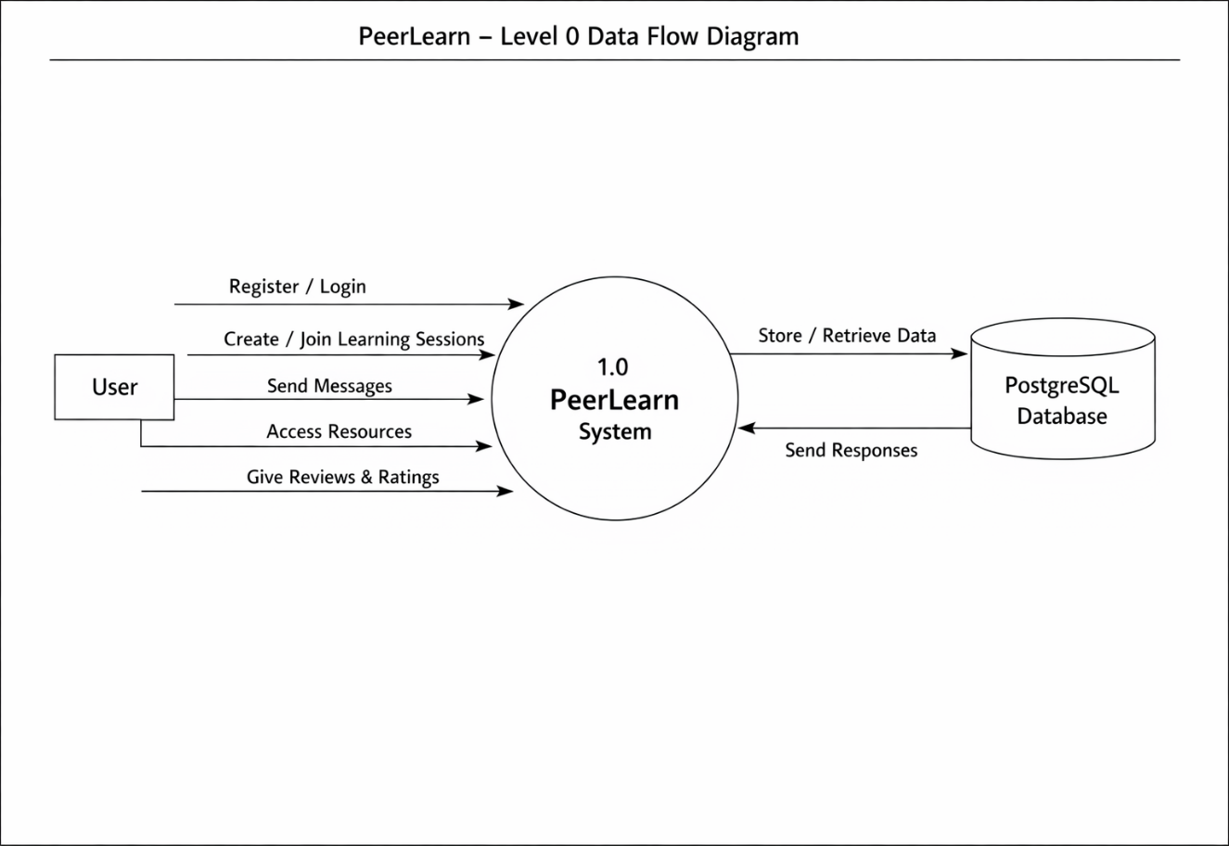

DFD Level 1 Diagram-

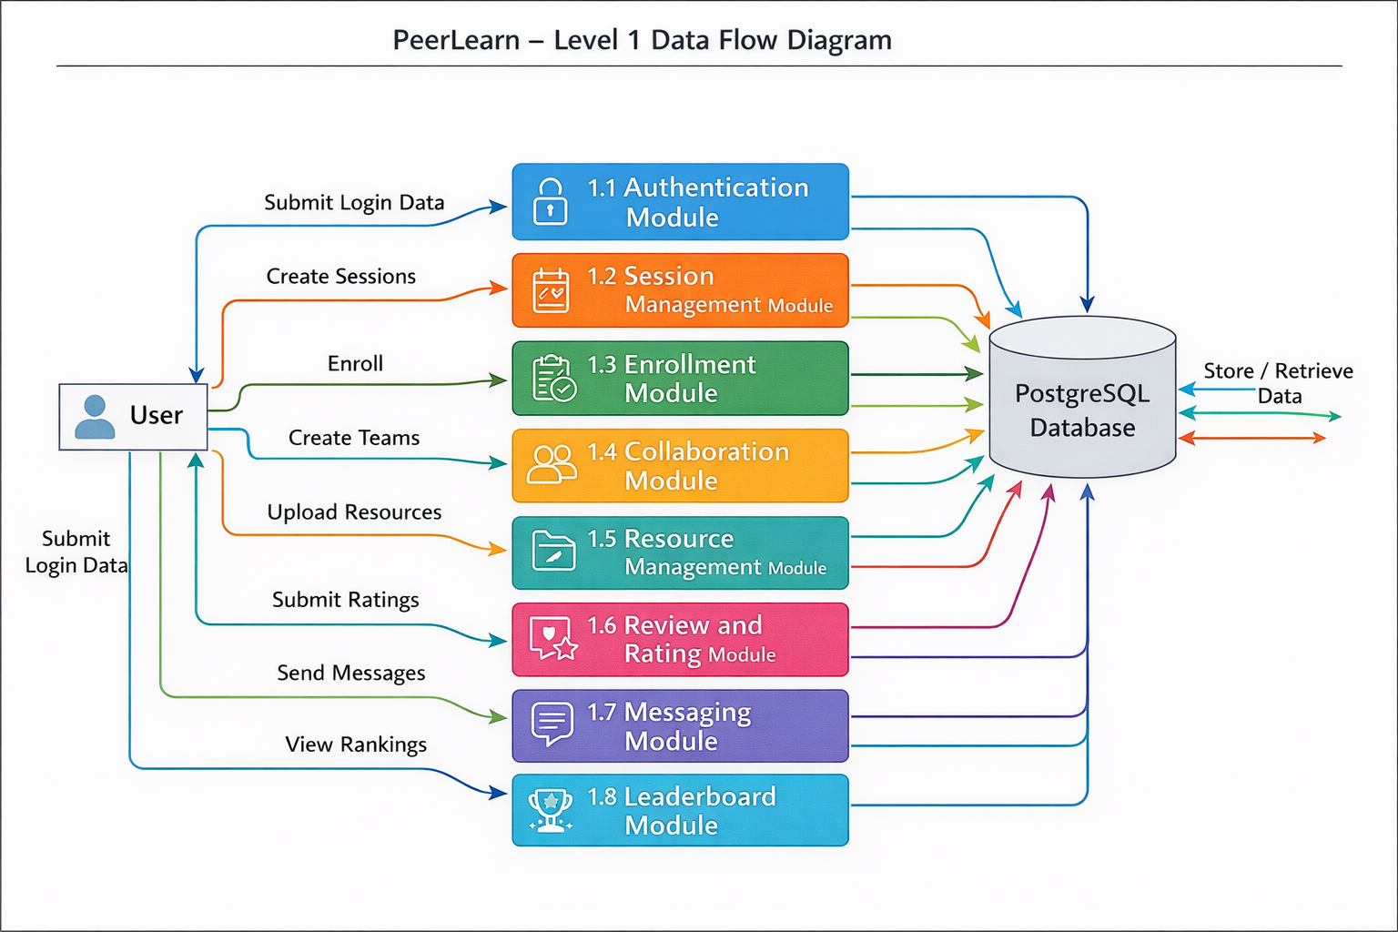

Entity Relationship Diagram (ER)

The Entity Relationship (E-R) Diagram represents the logical structure of the database used in the PEERLEARN system. It shows how different entities are related to each other and how data is stored and managed within the system.
The E-R diagram helps in designing the database efficiently by defining entities, their attributes, and relationships.

Main entities:
- User
- Session
- Enrollment
- Team
- Resource
- Review
- Tokens
Relationships:
- User creates sessions
- User enrolls in sessions
- User joins teams
- User uploads resources
- User gives reviews

ER-Diagram

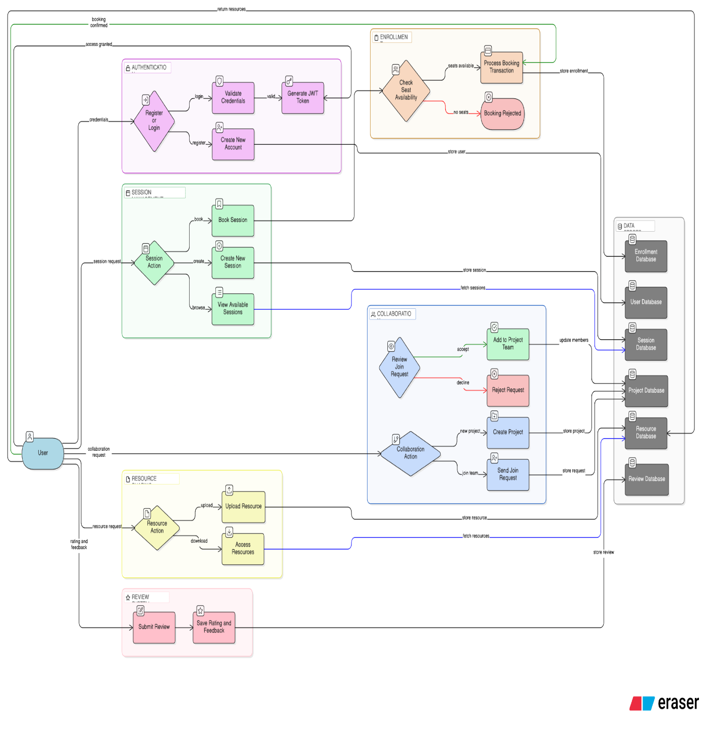

DATABASE DICTIONARY

A Data Dictionary is a centralized repository that contains a detailed description of all data used in the system. It defines data elements, their meaning, type, and relationship with other data.
It helps in improving documentation, maintaining consistency, and enhancing communication between developers and users. A data dictionary is an important part of database design as it ensures proper understanding of all database components.

Database Type: SQLite

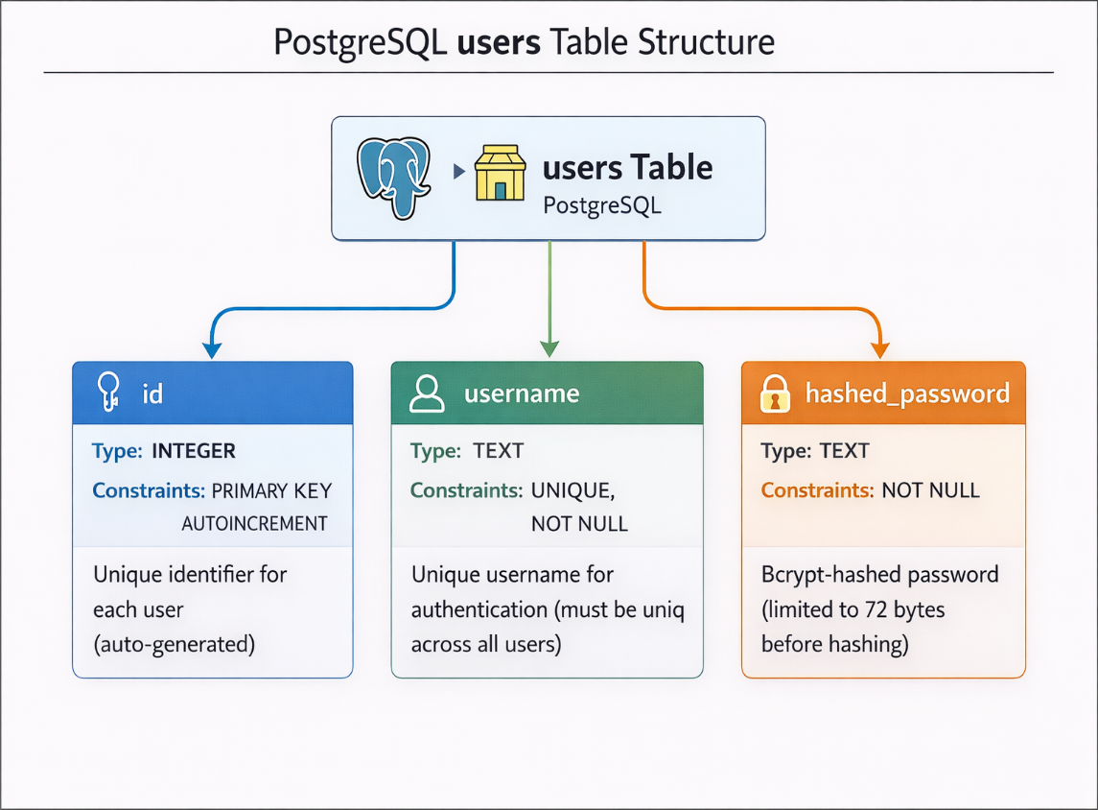

CODE SNIPPET AND OUTPUT WINDOW
This section presents sample code snippets and output windows to demonstrate the working of the system.

Authentication: -

const services=require("../services/auth.service")

exports.createUser=async(req,res)=>{
try{
const {name,email,password,role}=req.body
const result=await services.register(name,email,password,role)
res.status(201).json(
{success:true,
message:"user created successfuly",
data:result
}
)
}
catch(err){
res.status(400).json({
success:false,
message:err.message
})
}
}

exports.loginUser=async(req,res)=>{
try{
const {email,password}=req.body
const result= await services.login(email,password,req.ip,req.headers["user-agent"])
res.cookie("refreshToken",result.refreshToken,{
httpOnly:true,
secure:false,//true in producttion later
sameSite:'strict',
maxAge:7*24*60*60*1000
})
res.status(200).json({
success:true,
message:"user logedin successfully",
data:result.accessToken

})

}
catch(err){
res.status(400).json({
success:false,
message:err.message
})
}
}

exports.refreshToken=async(req,res)=>{
try{
const result= await services.refreshTokenApi(req.cookies?.refreshToken)
res.cookie("refreshToken",result.refreshToken,{
httpOnly:true,
secure:false,//true in producttion later
sameSite:'strict',
maxAge:7*24*60*60*1000
})
res.status(200).json({
success:true,
message:"New access token generatedy",
data:result.accessToken

})
}
catch(err){
res.status(400).json({
success:false,
message:err.message
})
}
}

exports.logout = async (req, res) => {
try {
const refreshToken = req.cookies?.refreshToken;

await services.logoutUser(refreshToken, req.user.id);

res.clearCookie("refreshToken");

return res.json({
success: true,
message: "Logged out successfully"
});

} catch (err) {
return res.status(400).json({
success: false,
message: err.message
});
}
};

Schema: -
generator client {
provider = "prisma-client-js"
}

datasource db {
provider = "postgresql"
url = env("DATABASE_URL")
}
enum SessionStatus {
SCHEDULED
COMPLETED
CANCELLED
}

enum SessionType {
ONE_TO_ONE
GROUP
}

enum Role{
LEARNER
MENTOR
}
enum EnrollmentStatus{
ACTIVE
CANCELLED
}
// User model
model User{
id Int @id @default(autoincrement())
name String
email String @unique
password String
role Role @default(LEARNER)
bio String?
skills String[]
token Token[]
sessions Session[]
createdAt DateTime @default(now())
enrollments Enrollment[]
reviewsGiven Review[] @relation("UserReviews")
reviewsReceived Review[] @relation("MentorReviews")
@@index([createdAt])
@@index([role])
}

model Token{
id Int @id @default(autoincrement())
userId Int
token String @unique
device String?
ip String?
isRevoked Boolean @default(false)
user User @relation(fields: [userId],references: [id], onDelete: Cascade)
createdAt DateTime @default(now())
@@index([userId])
}

model Session{
id Int @id @default(autoincrement())
mentorId Int
mentor User @relation(fields: [mentorId],references: [id])
title String
description String?
thumbnail String?
startTime DateTime
endTime DateTime
maxSeats Int
bookedSeats Int @default(0)
status SessionStatus @default(SCHEDULED)
meetingLink String?
price Float @default(0)
isPublic Boolean @default(true)
skills String[]
type SessionType

createdAt DateTime @default(now())
updatedAt DateTime @updatedAt
enrollment Enrollment[]
reviews Review[]
@@index([startTime])
@@index([mentorId])
}

model Enrollment {
id Int @id @default(autoincrement())
userId Int
sessionId Int
user User @relation(fields: [userId],references: [id])
session Session @relation(fields: [sessionId],references: [id])

status EnrollmentStatus @default(ACTIVE)
joinedAt DateTime @default(now())

@@unique([userId,sessionId])
@@index([sessionId])
@@index([userId])

}

model Review{
id Int @id @default(autoincrement())
userId Int
mentorId Int
sessionId Int

user User @relation("MentorReviews",fields: [userId],references: [id])
mentor User @relation("UserReviews",fields: [mentorId],references: [id])
session Session @relation(fields: [sessionId],references: [id])

rating Int
comment String?
createdAt DateTime @default(now())

@@unique([userId,sessionId])
@@index([mentorId])
}

Folder structure of project in GitHub:
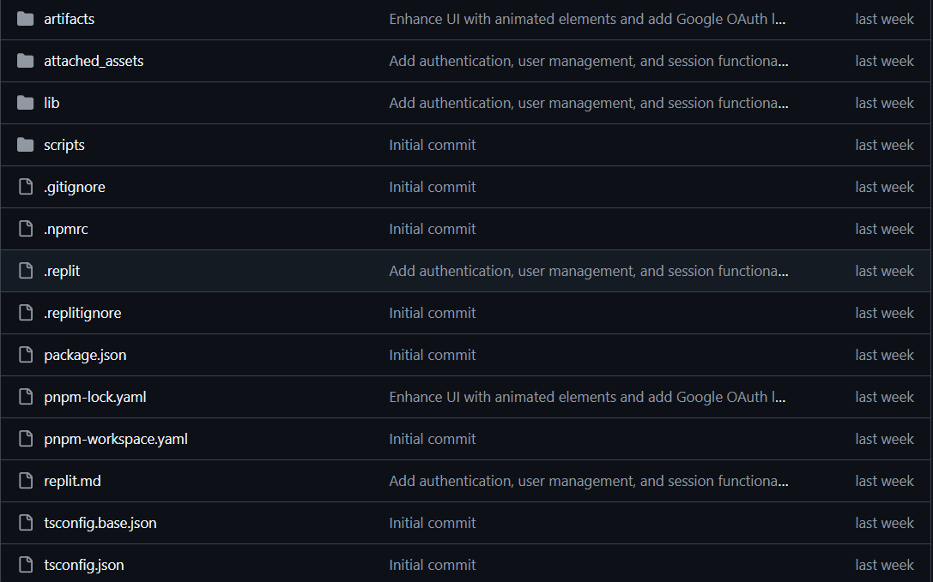

Database –

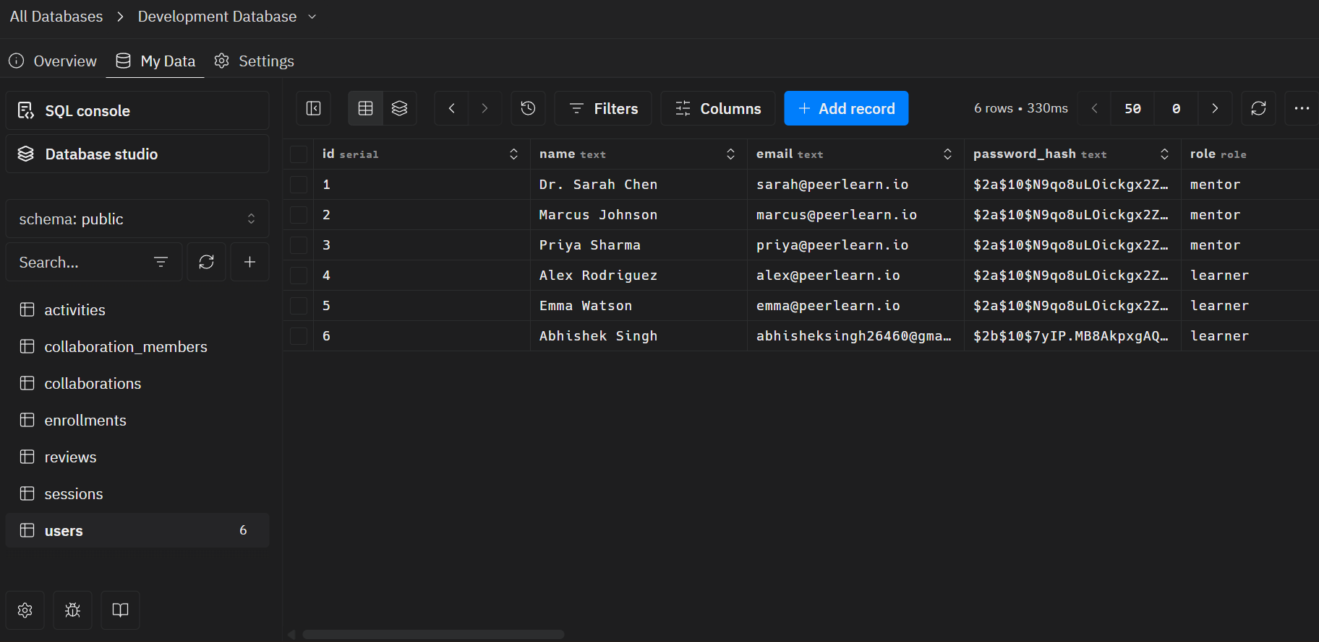

API snippet:
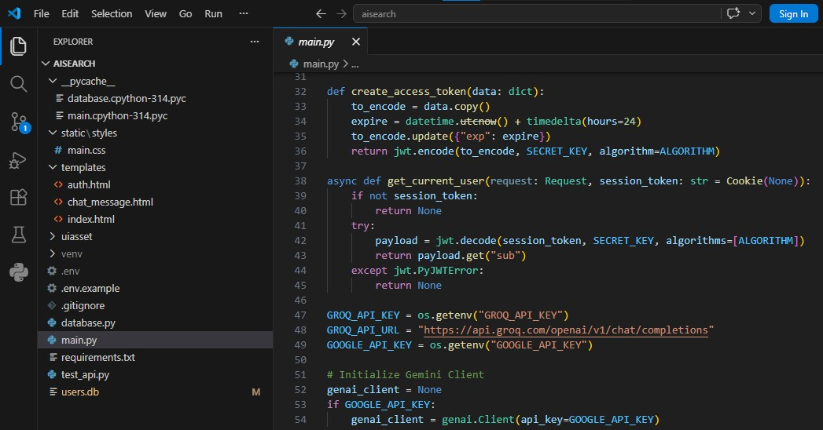

LOGIN PAGE:
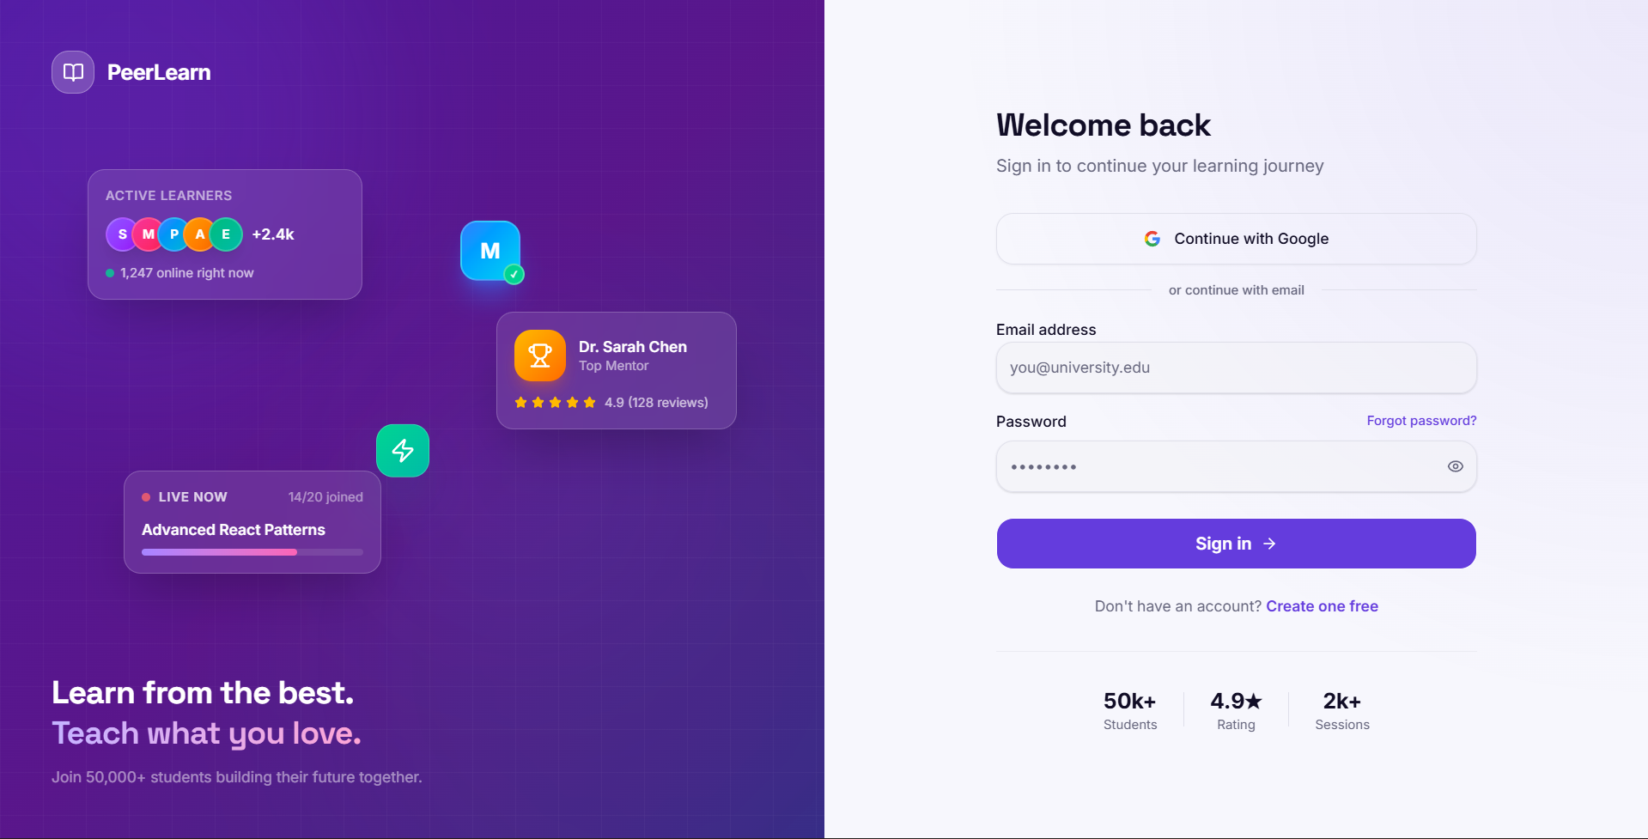

Landing Page:
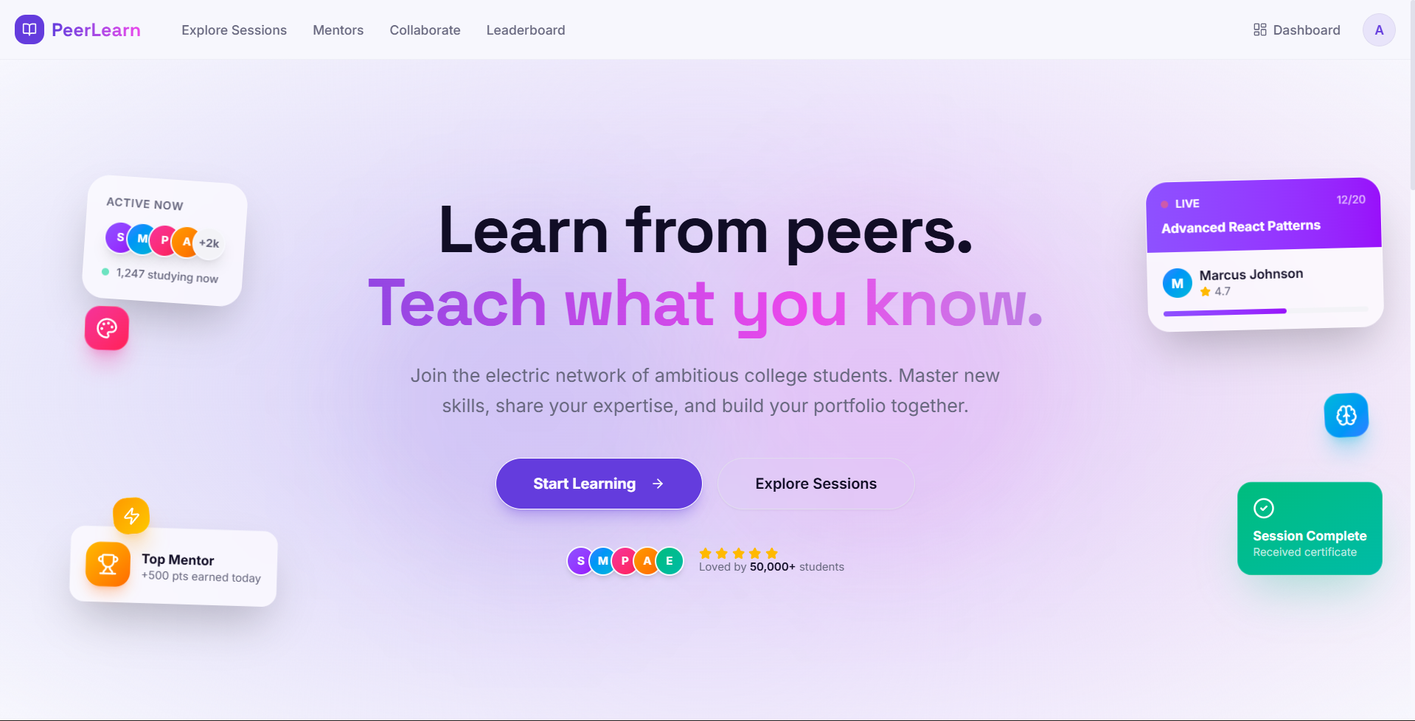

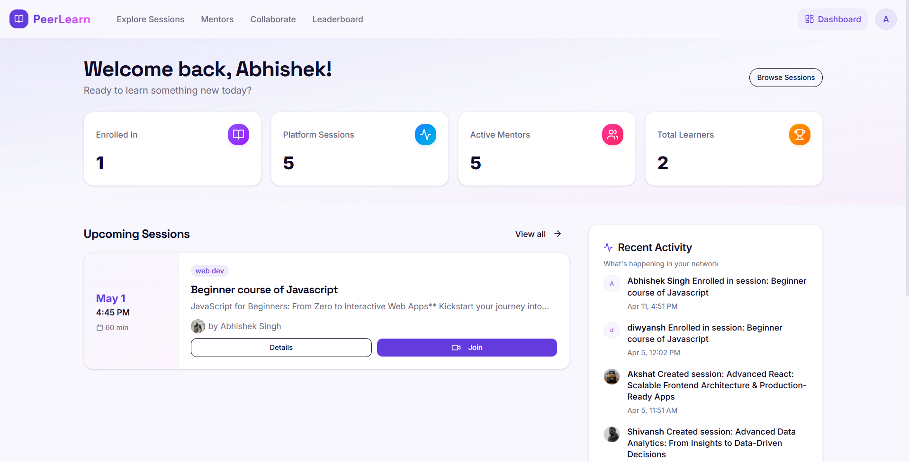

Testing



SEO AUDIT REPORT
https://motion-learning--abhisheksing813.replit.app/

overview: -
The objective of this audit report is to highlight the SEO potential of your website. I have analyzed the website and found that it could not rank on the top page of Google for multiple keywords organically. We’ve highlighted the area of work here that can bring more organic traffic.

SEO Score:-
I have thoroughly analyzed your website (https://motion-learning--abhisheksing813.replit.app/) and assessed its overall SEO performance.

The current SEO score is 55 (Shown in the image below), reflecting the site's strengths and areas that need improvement. This score is based on a detailed evaluation of all key SEO components essential for visibility, user experience, and search rankings.

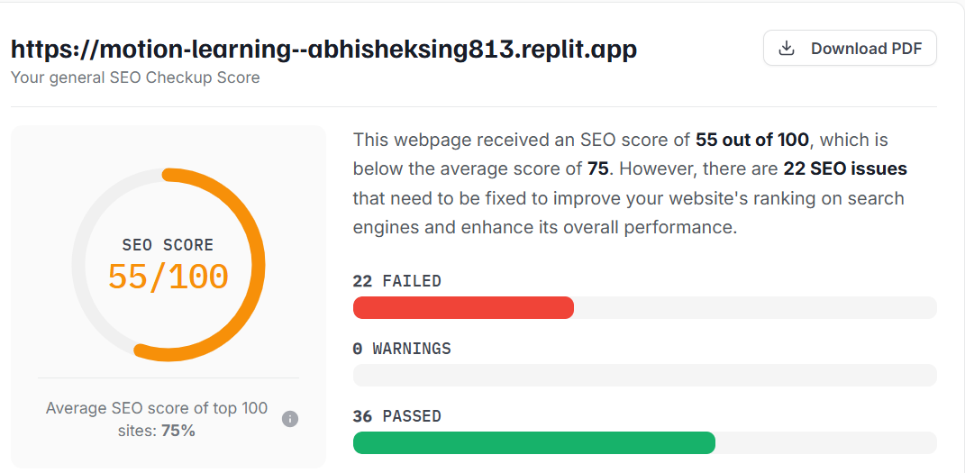

I have examined several aspects of your page during the audit process. They all play an important role in how well your page is able to meet your business goals.

TECHNICAL SEO:-
Crawlability: Passed

Determines whether search engine bots can access and read the content of your site. If pages are blocked or hidden, they won’t appear in search results. Pages must have the correct meta tags (e.g. noindex) and not be blocked in robots.txt.

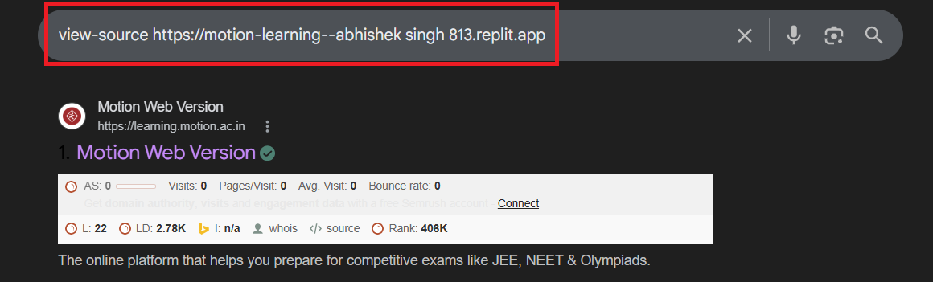

Observation:
I’ve analyzed that your website is not using “no index tag” which prevents indexing.

Recommendation:
Not Require.

Indexability: Passed

Checks if crawled pages are indexing in the search engines.

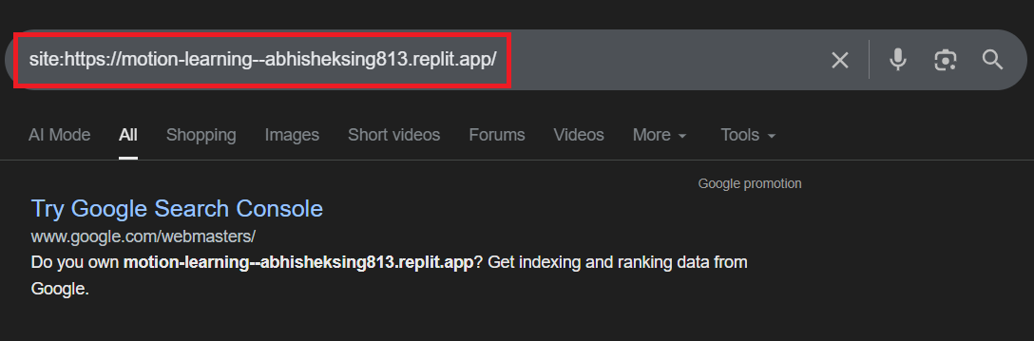

Observation:
Website pages are not indexed by Google, limiting their visibility in search results.
Recommendation:
Ensure proper indexing by submitting pages through Google Search Console and resolving technical issues like sitemap, robots.txt and noindex tags.

Robots.txt:Passed

A file that tells search engines which parts of your site they are allowed or disallowed to crawl. Critical for controlling access to duplicate or private content.

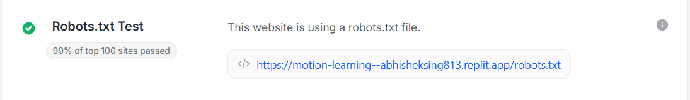
Observation:
robots.txt file is not missing, which may lead to improper crawling and indexing by Google.

Recommendation:
Create and configure a robots.txt file to guide search engine bots on which pages to crawl or restrict.

XML Sitemap: Failed
A structured list of all important URLs on your website, submitted to search engines to guide their indexing.

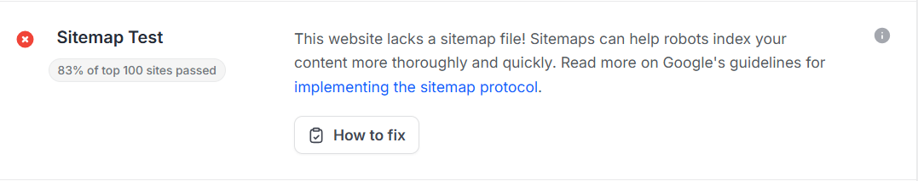

Observation:
We have checked the tool and found that the sitemap does not exists for the website.

Recommendation:
Create and submit a sitemap.xml file to improve website crawlability and search engine optimization (SEO)

Canonical Tags: passed
HTML Tags that point to the “main” version of a page to avoid duplicate content issue when similar pages exist.

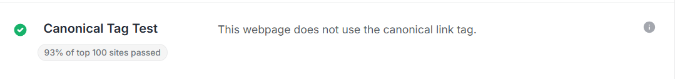
Observation: -
I have checked the tool and website’s source code and found that your website is using canonical tag.

Recommendation: -
Not require
Redirects: Passed
301 redirects are permanent and pass SEO value; 302 are temporary and generally don't. They help maintain link equity during URL changes or migrations.

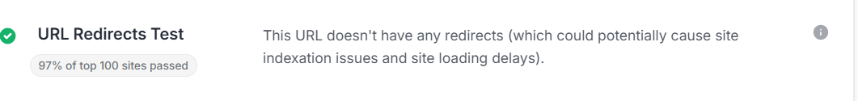

Observation:
This URL doesn’t have and redirects (which could potentially cause site indexation issues and site loading delays).

Recommendation:
Not require
HTTPS/SSL Certificate: Passed

A secure protocol (HTTPS) encrypts data between browser and server. It’s a trust signal for users and a confirmed Google ranking factor.

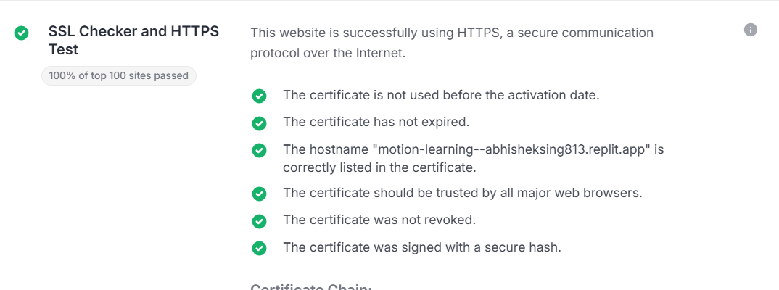

Observation:
Your website is SSL certified, which means it uses a secure HTTPs connection-this not only protects user data but also positively impacts SEO.

Recommendation:
Not required.

Site Speed / Core Web Vitals: Passed

Core Web Vitals are Google’s page speed metrics: LCP (load time), FID (interactivity), and CLS (visual stability), impacting user experience and SEO rankings.
Mobile Performance:
Mobile performance is vital for SEO, as Google prioritizes mobile-friendly, fast-loading sites. Poor responsiveness increases bounce rates and hurts rankings. Optimizing mobile speed and usability boosts both user experience and search visibility.
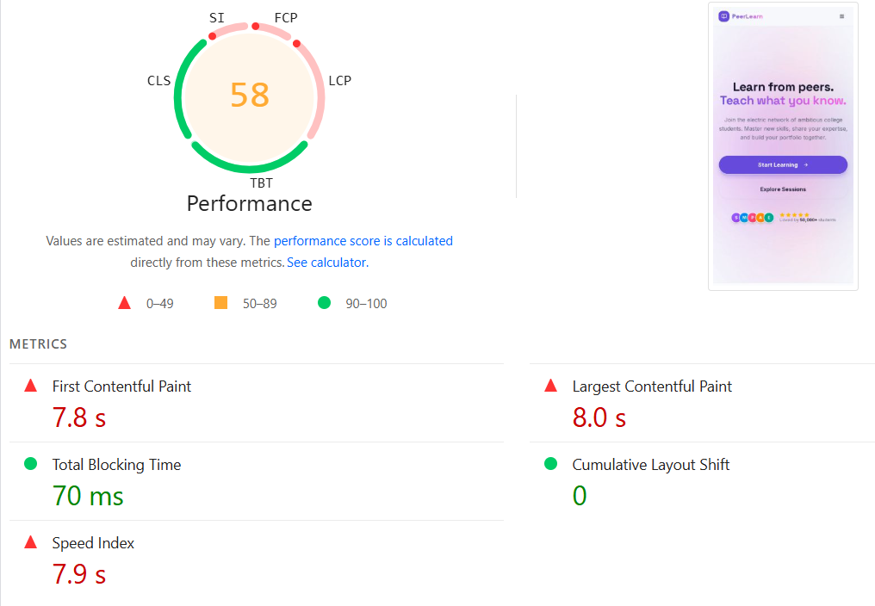

Desktop Performance:
Desktop performance impacts SEO by affecting user experience and rankings. A fast, well- structured site reduces bounce rates and supports strong visibility. Optimizing speed and navigation is key for engagement and search success.

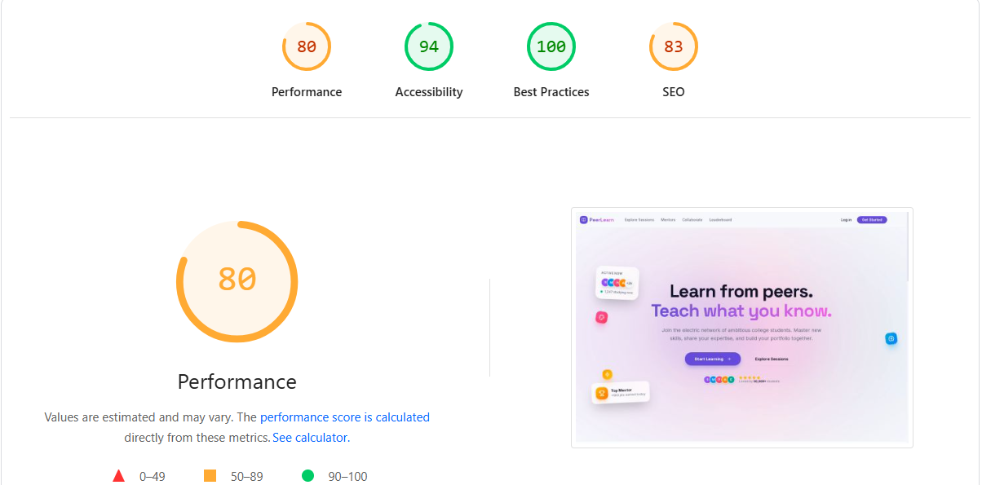

Observation:
I tested your website using performance analysis tools and found that the mobile speed score is 58/100, while the desktop speed score is 80/100. Both scores fall within the average performance range.

Recommendation:
Not required.

Favicon Test: Failed

Favicon is the small icon that appears in a browser tab next to a website’s title. It enhances brand recognition and improves user experience, indirectly supporting SEO through trust and professionalism.

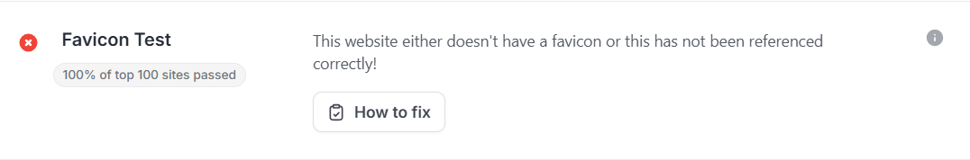

Observation:
Favicon is missing, which reduces brand visibility and recognition in browser tabs and search results on Google.

Recommendation:
Add a favicon to the website to enhance branding and improve user experience across browsers and devices.

On-Page SEO
Meta Titles: Passed
The clickable headline in search results. It should include a target keyword and be within 50–60 characters.

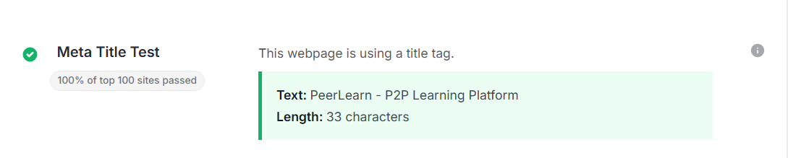

Observation:
Meta title is present but too short (29 characters), which may limit keyword visibility on Google.

Recommendation:
Optimize the meta title length (50–60 characters) with relevant keywords to improve visibility and click-through rate.

Meta Descriptions: Failed
Brief summaries (up to 160 characters) are shown under the title tag in SERPs.
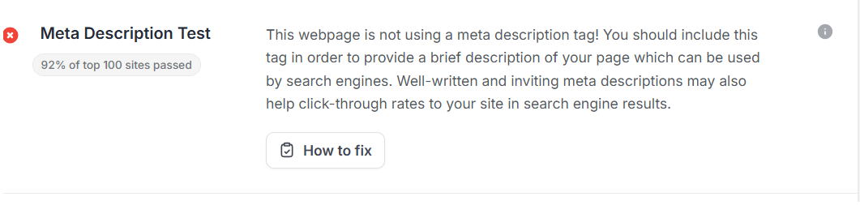

Observation:
I found that your website does not have the meta description.

Recommendation:
Add a compelling and informative meta description to each page, ideally within the 150 to 160-character limit.

Header Tags (H1, H2, etc.):
Used to organize content hierarchically. The H1 should be used once per page, usually for the main topic, with H2s for subtopics.

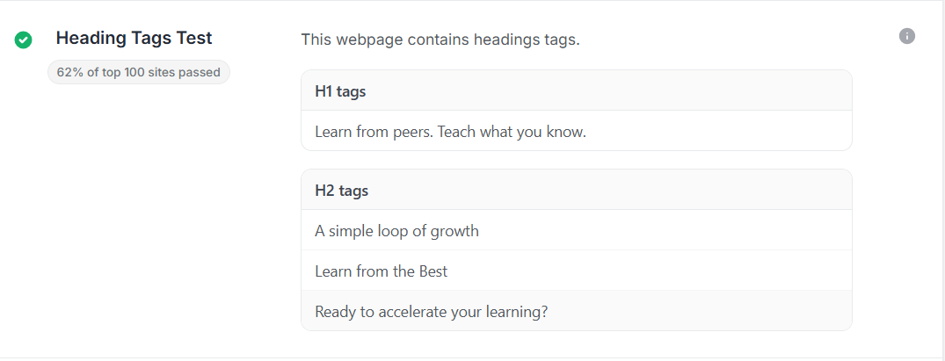

Observation:
I’ve studied the Heading tags of the webpages and it is according to the ideal standards.

Recommendation:
Not required.

Image Optimization (ALT Tags): Passed

Describes the content of an image for screen readers and display when images don’t load. In SEO, they improve image accessibility and help search engines understand and index visual content.


Observation:

I found all the images on your website have image alt tags.

Recommendation:

Not Required.

URL Structure: Passed
SEO-friendly URLs are short, include keywords, and use hyphens instead of underscores. Clean URLs are easier to index and share.

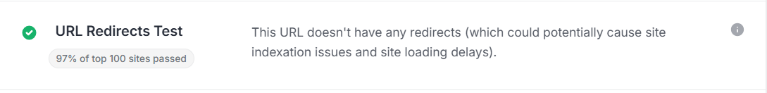

Observation:
I’ve reviewed the website and found that all URLs are SEO- friendly, with clean, readable structures that include relevant keywords and avoid unnecessary parameters.

Recommendation:
Not required.

Content SEO
Content amount: Passed
Content amount refers to the volume of text or media on a webpage. In SEO, sufficient and relevant content helps search engines understand page context and improves chances of ranking for target keywords.

Observation:
I’ve observed that the website has a low content volume (103 words), which is acceptable as it appears to be a newly developed website.

Recommendation:
Not Required.

Content Quality / AI Content: Failed
AI-generated content can negative impact on a website’s SEO if it's low-quality, spammy, or lacks originality. Search engines like Google prioritize helpful, people-first content, so AI content must be reviewed, fact-checked, and edited to ensure it adds real value to users.

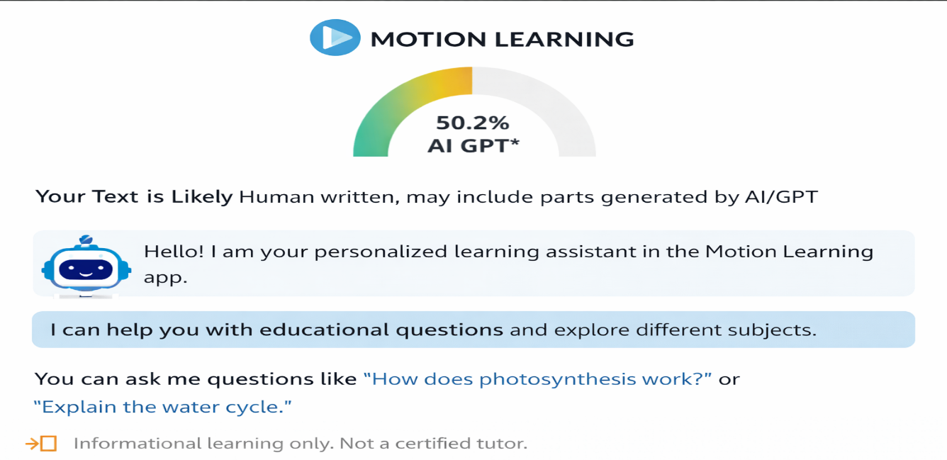

Implementation

The implementation phase of the PeerLearn platform focused on converting the planned system design into a fully functional web application. The project was developed using a modern full-stack architecture where the frontend, backend, and database layers were integrated in a structured manner. Each layer was designed to handle specific responsibilities, ensuring maintainability and scalability.
The frontend of the system was developed using React.js with Tailwind CSS. React was used to build reusable user interface components and manage dynamic state changes efficiently. Tailwind CSS helped in designing a responsive and clean user interface with faster styling and consistent layouts. The desktop-based interface was designed to make navigation simple for users such as students, learners, and mentors.
The backend was implemented using Node.js and Express.js. Express provided a lightweight and flexible framework for building RESTful APIs. The backend layer manages business logic, request handling, authentication workflows, validation, and communication with the database. A modular structure was followed by separating routes, controllers, and models, which improved readability and future maintenance.
The database layer was implemented using PostgreSQL, a powerful relational database system. Different entities such as users, sessions, enrollments, teams, resources, reviews, and tokens were designed as structured tables with proper relationships. Normalization techniques were applied to reduce redundancy and improve consistency.
One of the most important implementation areas was the authentication system. Secure login and protected routes were implemented using JWT-based access tokens and refresh tokens. This token-based mechanism allowed secure session management while maintaining a scalable stateless architecture.
Advanced backend concepts were also implemented during development. Database transactions were used in critical operations such as enrollments to ensure atomicity and consistency. Concurrency-related logic was considered to avoid conflicting actions when multiple users interact with the same data simultaneously.
Testing and debugging were continuously performed during implementation using tools such as Postman and AI-assisted debugging methods. APIs were tested for expected outputs, error responses, and route security.

MAINTENANCE

Maintenance is an essential phase in the software life cycle because no system remains static after deployment. Once a platform is used by real users, new requirements, bugs, and optimization opportunities naturally emerge. For PeerLearn, maintenance ensures that the system remains functional, secure, and relevant over time.
The first aspect of maintenance is corrective maintenance, which focuses on identifying and fixing errors discovered after deployment. These may include API issues, validation bugs, database inconsistencies, or user interface problems. Timely resolution of such issues helps maintain user trust and system reliability.
The second aspect is adaptive maintenance, where the system is modified to remain compatible with changing technologies or environments. For example, updates in browser behavior, hosting platforms, package versions, or database drivers may require adjustments in the application codebase.
Another important area is perfective maintenance, which focuses on improving performance and usability. As more users join the platform, database queries may need optimization, frontend responsiveness may need enhancement, and workflows may need simplification based on user feedback.
Security maintenance is also critical. Since PeerLearn uses authentication tokens and stores user-related data, regular security updates are necessary. Token expiration policies, dependency patching, input sanitization, and access control checks must be reviewed periodically to reduce vulnerabilities.
Future maintenance may also involve adding new modules such as real-time messaging, live sessions, advanced analytics, and AI-powered recommendations. Because the system was built using a modular architecture, these enhancements can be integrated more efficiently.
In summary, maintenance is not only about fixing defects but also about continuously improving the platform so that it can grow with user needs and technological changes.

CONCLUSION

The PeerLearn project successfully demonstrates how technology can be used to solve practical learning challenges faced by students in modern academic environments. Many students want to learn valuable technical skills such as development, programming, design, and problem solving, but they often struggle due to unstructured resources, lack of mentorship, and absence of a proper roadmap. PeerLearn addresses these problems through a collaborative peer-to-peer model.
The platform creates an ecosystem where students can both learn and teach. Learners receive guidance, structured sessions, and access to shared resources, while mentors strengthen their own understanding by teaching others. This dual-benefit model makes the platform more sustainable and community-driven.
From a technical perspective, the project also reflects strong software engineering practices. It combines a modern frontend using React.js, a scalable backend using Node.js and Express.js, and a robust relational database using PostgreSQL. Important backend concepts such as authentication, authorization, normalization, transactions, and concurrency handling were applied during development.
Another major achievement of the project is its modular system design. Features such as session management, collaboration, reviews, messaging, and leaderboards were organized into independent modules, improving maintainability and future scalability.
The project was also a valuable learning experience for the developer. It required not only coding skills but also problem-solving, debugging, architectural thinking, and understanding of real-world backend systems. Challenges faced during development helped strengthen practical knowledge and confidence.
In conclusion, PeerLearn is more than just an academic project. It is a meaningful solution with real-world relevance that can positively impact student communities by promoting mentorship, collaboration, and continuous learning.

FUTURE SCOPE
The current version of PeerLearn provides a strong foundation for peer-based learning, but there are many opportunities for future enhancement. As user needs grow and technology evolves, the platform can be expanded into a more advanced and intelligent learning ecosystem.
One of the most important future improvements is the implementation of real-time communication. Currently, the messaging system uses stored messages. By integrating technologies such as WebSockets or Socket.io, users could experience instant messaging, live notifications, and faster collaboration.
Another valuable enhancement would be the addition of live classes or video sessions directly inside the platform. Instead of relying only on external meeting links, users could host sessions natively through integrated video communication features.
The platform can also benefit from AI-powered recommendations. Machine learning models could suggest mentors, sessions, learning paths, or resources based on user interests, activity, and skill goals. This would create a more personalized learning experience.
A dedicated mobile application for Android and iOS could significantly improve accessibility. Many students prefer learning through smartphones, so a mobile version would increase user engagement and convenience.
The user interface can also be upgraded with more advanced design systems, smoother animations, and premium user experience concepts inspired by modern product companies. This would make the platform more attractive and professional.
Additional features may include:
- Skill verification badges
- Progress tracking dashboards
- Certificate generation after sessions
- Community discussion forums
- Search and filtering improvements
- Admin analytics panel
- Multi-language support

REFERENCES
- Node.js Official Documentation – Runtime environment for backend development.
https://nodejs.org/
- Express.js Official Documentation – Web framework used for REST API development.
https://expressjs.com/
- React Official Documentation – Frontend library used for building user interfaces.
https://react.dev/
- Tailwind CSS Official Documentation – Utility-first CSS framework used for styling.
https://tailwindcss.com/
- PostgreSQL Official Documentation – Relational database management system used in the project.
https://www.postgresql.org/docs/
- JSON Web Token (JWT) Documentation – Token-based authentication mechanism.
https://jwt.io/
- MDN Web Docs – Reference for JavaScript, HTTP, and web development concepts.
https://developer.mozilla.org/
- Postman Documentation – API testing and development tool.
https://learning.postman.com/
- Replit Documentation – Deployment and cloud coding platform.
https://docs.replit.com/
- Software Engineering Concepts and Database Management System textbooks used for academic reference.

