Major Project Report

On
Continuous Integration and Continuous Deployment Pipeline with Jenkins, SonarQube, and Container Registry (AWS ECR)
In partial fulfilment for the award of the degree
Of
Bachelor Of Technology
Computer Science & Engineering
Year 2022-2026

SUBMITTED BY : GUIDED BY:
Akhil Dogra (22015103007) Er. Shivani Rana

B.Tech. - 7th Semester
Submitted To :

DEPARTMENT OF ENGINEERING
HIMACHAL PRADESH TECHNICAL UNIVERSITY, HAMIRPUR (177001)

HIMACHAL PRADESH TECHNICAL UNIVERSITY,
HAMIRPUR, (177001)
ACKNOWLEDGEMENT

It gives me great pleasure to thank (Er. Shivani Rana, Project Supervisor), Department of Computer Science & Engineering, for the constant support and guidance given to me throughout the course of this project. She has been a constant source of inspiration for me.
I also take this opportunity to acknowledge the contribution of Professor and Head, Department of Computer Science Engineering, for his support and assistance during the development of the project.
I also take this opportunity to acknowledge the contribution of all faculty members of the department for their assistance and cooperation during the development of my project. I also thank all the Non-Teaching Staff of the Department who helped me during the course of the project. Last but not the least, I acknowledge my friends for their encouragement in the completion of the project.

Akhil Dogra (22015103007)

BONAFIDE CERTIFICATE

Certified that this project report titled “Continuous Integration and Continuous Deployment Pipeline with Jenkins, SonarQube, and Container Registry (AWS ECR)” is the Bonafide and original work of Akhil Dogra (22015103007), who has sincerely carried out the project work under my supervision.
This certificate acknowledges that the above-mentioned student has undertaken the research, design, development, and documentation of the proposed Continuous Integration and Continuous Deployment (CI/CD) pipeline architecture with diligence and academic integrity. The work presented in this report reflects the student’s genuine technical contribution, analytical effort, and commitment toward designing and implementing an automated DevOps pipeline using Jenkins, SonarQube, containerization technologies, and cloud-based deployment services. The project has been completed in accordance with the academic regulations and fulfils the requirements for partial completion of the Bachelor of Technology (B.Tech.) degree at Himachal Pradesh Technical University, Hamirpur.
I further certify that this work is original in nature, has not been submitted to any other institution for the award of any degree or diploma, and adheres to the guidelines prescribed by the department for major project submission.

Dr. Avni Sharma Er. Shivani Rana
(HEAD OF THE DEPARTMENT) (PROJECT SUPERVISOR)
B.Tech. Department B.Tech. Department
HPTU, Hamirpur (177001) HPTU, Hamirpur (177001)

ABSTRACT
In modern software development, rapid delivery, high reliability, and continuous improvement have become essential to meet evolving user and business requirements. Traditional software development and deployment approaches often rely on manual processes, which lead to delayed releases, configuration inconsistencies, and a higher probability of human error. To overcome these challenges, this project presents the design and implementation of a Continuous Integration and Continuous Deployment (CI/CD) pipeline that automates the entire software delivery lifecycle, from source code integration to deployment.
The proposed CI/CD pipeline integrates version control systems, automated build tools, continuous testing mechanisms, and automated deployment processes to ensure faster and more reliable software releases. Continuous Integration enables developers to frequently merge code changes into a shared repository, where automated builds and tests are triggered to detect defects at an early stage of development. Continuous Deployment further enhances this process by automatically deploying validated and tested applications to the target environments, thereby reducing manual intervention and improving deployment efficiency.
The pipeline is implemented using modern DevOps tools such as Jenkins for automation, SonarQube for static code analysis and quality assurance, and containerization technologies for consistent application packaging. Docker images are stored and managed using a cloud-based container registry, ensuring secure and scalable image management. Automated testing frameworks are incorporated to perform unit and integration testing, ensuring application stability and functional correctness at every stage of the pipeline.
In addition to automation, monitoring and logging mechanisms are integrated to provide real-time feedback on pipeline performance and application health. This enables faster issue detection, improved debugging, and continuous performance evaluation. The implementation results demonstrate significant improvements in development efficiency, deployment consistency, system scalability, and overall software quality.
By adopting a CI/CD pipeline, organizations can achieve shorter release cycles, enhanced collaboration between development and operations teams, and continuous feedback for improvement. This project highlights the role of CI/CD pipelines as a core component of modern DevOps practices, enabling reliable, secure, and maintainable delivery of high-quality software applications in dynamic and large-scale environments.
TABLE OF CONTENT
S.NO. | CHAPTER CONTENT | PAGE NO.
1. | PROBLEM STATEMENT | 1-6
1.1 Brief Description of the Problem Being Solved
1.2 Motivation and Societal Relevance
2. | OBJECTIVES | 7-11
2.1 Primary Objective
2.2 Sub Objectives
2.3 Specific measurable objectives
2.4 Long term strategic Objectives
2.5 Expected measurable impacts
3. | LITERATURE REVIEW | 12-16
3.1 Overview and thematic summary
3.2 Tool-centric findings from the literature
3.3 Empirical and survey findings
3.4 Representative references (selected and authoritative)
3.5 Gap Analysis
4. | PROPOSED METHODOLOGY | 17-25
4.1 System Architecture / Block Diagram
4.2 Description of Working Principle
5. | TOOLS & TECHNOLOGIES | 26-31
5.1 Software Tools
5.2 Hardware Requirements
5.3 Cloud / Simulation Environment
5.4 Libraries and Frameworks
5.5 Summary
6. | EXPECTED OUTCOME | 32-41
6.1 Overview of Expected Outcome
6.2 Jenkins CI Pipeline Execution Outcome
6.3 Build Automation and Unit Testing Validation
6.4 Code Style Enforcement using Checkstyle
6.5 SonarQube Code Quality and Security Analysis Outcome
6.6 Artifact Management and Nexus Repository Outcome
6.7 Jenkins Plugin Configuration Outcome
6.8 Docker Image Build and Containerization Outcome
6.9 AWS Elastic Container Registry (ECR) Validation
6.10 AWS EC2 and Security Configuration Outcome
6.11 AWS ECS Deployment Outcome
6.12 Overall Outcome Analysis
6.13 Conclusion of Expected Outcome
7. | TIMELINE | 42-47
8. | REFERENCES | 48-49

CHAPTER-1
PROBLEM STATEMENT
1.1 Brief Description of the Problem Being Solved
With the rapid expansion of digital services, organizations are moving toward fast-paced, cloud-driven, and scalable applications. However, traditional software development and deployment practices still used by many institutions face severe limitations. Manual deployment, manual testing, and manual configuration create delays, introduce human errors, and make the software unreliable, especially when updates are frequent.
In traditional development environments:
- Developers write code and send it manually to testers
- Code is tested after a long delay, causing late bug discovery
- Deployment teams manually configure servers and push applications
- System failures often occur due to mismatched environments
- Security issues may remain unnoticed until the final release
- Human involvement increases the chance of production errors
- Application rollbacks are difficult and time-consuming
As modern applications adopt microservices, cloud infrastructure, and frequent feature delivery cycles, these traditional methods fail to meet current expectations.
To overcome these drawbacks, CI/CD pipelines have become a fundamental requirement. Continuous Integration (CI) automatically builds and tests code whenever changes occur. Continuous Deployment (CD) ensures automated delivery to production environments without manual dependency. Containerization and cloud services ensure reliability, scalability, and security.
This project aims to solve these real-world challenges by creating an automated DevOps pipeline using:

- GitHub for source code management
- Jenkins for automation and CI pipeline execution
- SonarQube for static code analysis and code quality enforcement
- AWS ECR for storing Docker images in the cloud
- AWS EC2 for cloud hosting
1.2 Motivation and Societal Relevance
1.2.1 Technical Motivation
The software development landscape has undergone a fundamental transformation over the past decade. Traditional development models, which relied heavily on manual testing, infrequent releases, and isolated development and operations teams, are no longer suitable for today’s fast-paced and competitive IT environment. Modern organizations demand rapid innovation, continuous updates, high availability, and minimal downtime. To meet these expectations, the IT industry has widely adopted DevOps practices, with Continuous Integration and Continuous Deployment (CI/CD) pipelines forming the backbone of modern software delivery systems.
Leading global technology organizations such as Amazon, Google, Netflix, Infosys, TCS, IBM, and Microsoft rely extensively on CI/CD pipelines to manage large-scale software systems. These pipelines enable seamless integration of code changes, automated testing, and rapid deployment across distributed cloud environments. By automating repetitive and error-prone tasks, CI/CD pipelines significantly reduce development cycles while ensuring consistency, reliability, and scalability.
Despite the widespread industrial adoption of CI/CD practices, a noticeable gap exists between academic curricula and real-world industry requirements. Most students and beginner engineers are well-versed in programming concepts and theoretical software engineering principles but lack hands-on exposure to modern DevOps tools and workflows. As a result, fresh graduates often struggle to adapt to industrial development environments, where automation, cloud-native deployment, and rapid iteration are the norm rather than the exception.
This project is technically motivated by the need to bridge this gap. By designing and implementing a complete CI/CD pipeline, learners gain practical exposure to the entire software delivery lifecycle. The project introduces students to real-world DevOps processes such as source code versioning, automated builds, continuous testing, containerization, deployment orchestration, and monitoring. It also familiarizes them with the integration of multiple tools and technologies that collectively form a production-grade pipeline.
Through this project, learners gain hands-on experience in:
- Modern DevOps workflows and best practices
- End-to-end CI/CD lifecycle management
- Automation using industry-standard tools
- Cloud-native deployment architectures
- Containerization, orchestration, and security integration
- Agile and iterative software delivery models
By working on this project, students develop the ability to think beyond isolated coding tasks and understand software as a continuously evolving system. This practical understanding is critical for building scalable, maintainable, and resilient applications in real-world environments.

1.2.2 Educational and Career Motivation
From an educational perspective, the demand for DevOps and cloud-related skills has grown exponentially. According to various industry surveys and reports, more than 70% of modern software development teams rely on automated CI/CD workflows to manage their applications. Organizations across startups, enterprises, and government sectors actively seek engineers who possess not only programming skills but also the ability to design, deploy, and manage automated pipelines.
DevOps engineers, cloud engineers, and site reliability engineers (SREs) are among the most in-demand and well-compensated professionals in the IT industry. These roles require a strong understanding of automation, infrastructure management, continuous delivery, and system reliability. However, many academic programs still focus primarily on traditional software development models, leaving students underprepared for such roles.
This project serves as a strong educational foundation for students aspiring to build careers in DevOps, cloud computing, and modern software engineering. By implementing a CI/CD pipeline, students gain exposure to tools and practices commonly used in the industry, enabling them to transition more smoothly from academic environments to professional roles.
The educational benefits of this project include:
- Exposure to real-world development and deployment tools
- Hands-on experience with pipeline automation
- Understanding of cloud-based application deployment
- Familiarity with industry-style coding, testing, and delivery practices
- Improved problem-solving and system design skills
Additionally, this project encourages self-learning, experimentation, and collaboration—skills that are essential in modern IT careers. Students learn how to troubleshoot pipeline failures, optimize build processes, and manage deployments across multiple environments. Such experiences significantly enhance technical confidence and readiness for job interviews, internships, and industrial projects.
By completing this project, students not only strengthen their resumes but also gain a clear understanding of how theoretical concepts taught in classrooms are applied in real-world systems. This alignment between education and industry expectations makes the project highly valuable from a career development perspective.
1.2.3 Societal Relevance
In today’s digital era, software systems form the foundation of almost every aspect of society. Critical sectors such as banking, healthcare, education, transportation, governance, and e-commerce rely heavily on software-driven platforms to deliver services to millions of users. Any failure, delay, or security vulnerability in these systems can have serious social, economic, and operational consequences.
CI/CD pipelines play a vital role in ensuring that software systems remain reliable, secure, and continuously updated. By automating testing and deployment processes, CI/CD pipelines help organizations quickly fix bugs, release new features, and respond to changing user needs without disrupting existing services.
For example:
- Banking and financial applications require rapid bug fixes and security patches to prevent financial losses and fraud.
- Healthcare systems depend on reliable software for patient monitoring, diagnostics, and data management, where errors can directly impact human lives.
- Government digital platforms require high availability, strong security, and timely updates to serve citizens efficiently.
- E-commerce platforms rely on frequent updates to enhance user experience, manage peak traffic, and ensure secure transactions.
- Educational and ed-tech platforms depend on scalable and stable software to support online learning and assessments.
By implementing a CI/CD pipeline, this project contributes to improving the quality and trustworthiness of such software systems. Automated testing ensures that errors are detected early, while continuous deployment enables faster delivery of improvements and fixes. This leads to more resilient digital services that can better serve society.

1.2.4 Contribution to Digital Transformation and National Initiatives
Beyond individual organizations, CI/CD pipelines support broader digital transformation initiatives at the national and global levels. In India, programs such as Digital India, Smart Governance, and Startup India emphasize the development of scalable, secure, and efficient digital infrastructure. Automated software delivery plays a crucial role in achieving these goals by enabling faster innovation and reliable service delivery.
This project aligns with such initiatives by promoting:
- Automation-driven development practices
- Reduction of human errors in critical systems
- Adoption of secure and standardized deployment processes
- Scalable software solutions for large user bases
By encouraging the use of CI/CD pipelines in academic environments, the project helps cultivate a culture of automation and quality-driven development among future engineers. These skills are essential for building robust digital systems that can support societal growth and technological advancement.
1.2.5 Overall Impact and Significance (Extended)
Overall, the CI/CD pipeline project represents a significant step toward aligning academic learning with modern industrial software development practices. By emphasizing automation, continuous feedback, and reliable deployment mechanisms, the project demonstrates how software engineering has evolved from isolated coding tasks to an integrated, lifecycle-driven process. This holistic approach enables students to understand software systems not merely as static products, but as continuously evolving services that must adapt to user needs, security requirements, and technological advancements.
From a technical standpoint, the project highlights the importance of reliability, scalability, and maintainability in contemporary applications. Automated testing and deployment reduce the probability of human errors, ensure consistency across environments, and allow faster identification and resolution of defects. These qualities are essential for building mission-critical systems that operate at scale and serve large user populations. As software systems grow increasingly complex, such automation-driven approaches become indispensable rather than optional.
From an educational perspective, the project plays a crucial role in shaping industry-ready graduates. It encourages analytical thinking, problem-solving, and system-level understanding, which are often difficult to achieve through theoretical study alone. By working on a real-world CI/CD pipeline, students gain confidence in using professional tools, collaborating across development stages, and troubleshooting real deployment challenges. This experience fosters a mindset of continuous learning and adaptability, which is vital in a rapidly changing technological landscape.

CHAPTER-2
OBJECTIVES
The key objective of this project is to design and implement a fully automated CI/CD pipeline capable of continuously integrating, analysing, building, and deploying software in a secure and scalable environment using Jenkins, SonarQube, Docker and AWS.
This project aims to bridge the gap between academic learning and industry DevOps practices by providing a practical, cloud-based automation system.
2.1 Primary Objective
The primary objective of this project is to design, configure, and deploy a fully automated Continuous Integration and Continuous Deployment (CI/CD) pipeline that enables seamless software delivery from source code commit to production deployment. The pipeline aims to eliminate manual intervention, reduce deployment errors, and ensure rapid, reliable, and secure delivery of applications in a cloud environment.
The proposed CI/CD pipeline automates the following critical stages of the software delivery lifecycle:
- Continuous retrieval of source code from a centralized GitHub repository
- Automated build and integration of code changes
- Execution of automated tests to ensure functional correctness
- Static code quality and vulnerability analysis using SonarQube
- Containerization of applications using Docker
- Secure storage of container images in AWS Elastic Container Registry (ECR)
- Continuous feedback through logs, reports, and pipeline status monitoring
By implementing this end-to-end automation, the project ensures faster release cycles, consistency across environments, improved software quality, and minimal downtime. The primary objective is not only to build a working pipeline but also to demonstrate how modern DevOps practices can be applied to real-world software systems in a scalable and secure manner.
This objective directly aligns with current industry standards, where organizations expect software delivery processes to be automated, traceable, repeatable, and resilient. The successful achievement of this objective results in a production-ready CI/CD pipeline that can be extended for enterprise-scale applications.
2.2 Sub-Objectives
To achieve the primary objective, the project is divided into multiple well-defined sub-objectives. Each sub-objective focuses on a specific component of the CI/CD ecosystem and contributes to the overall success of the pipeline.
One of the key sub-objectives is to implement webhook-based automation between GitHub and Jenkins. This ensures that every code commit automatically triggers the pipeline, enabling continuous integration without manual initiation. This automation forms the foundation of modern DevOps workflows.
Another important sub-objective is to configure the Jenkins pipeline as code using a Jenkinsfile. Defining the pipeline declaratively improves maintainability, version control, and reproducibility. It also allows developers to manage pipeline changes alongside application code, promoting transparency and collaboration.
The project also focuses on enforcing code quality, security, and maintainability by integrating SonarQube into the pipeline. Static code analysis helps identify bugs, code smells, and security vulnerabilities at an early stage, preventing defective code from reaching production.
Reducing manual deployment effort is another major sub-objective. By automating container creation, image storage, and deployment, the project aims to reduce deployment time to near zero while minimizing human errors. Automated deployment ensures consistent behavior across environments and reduces the risk of configuration mismatches.
Providing a consistent and isolated runtime environment using Docker containers is also a crucial sub-objective. Containerization ensures that the application behaves the same across development, testing, and production environments, improving reliability and portability.
Additionally, the pipeline is designed to support rollback mechanisms and version-controlled deployments, enabling quick recovery in case of failures. This improves system resilience and operational stability.
2.3 Specific Measurable Objectives
To ensure clarity, accountability, and successful execution, the project defines specific, measurable, achievable, relevant, and time-bound (SMART) objectives. These objectives allow progress to be tracked and evaluated at each stage of the project lifecycle.
Source Code Automation
The goal is to integrate GitHub with Jenkins so that any code commit automatically triggers the pipeline. Success is measured by the reliable triggering of Jenkins jobs through webhooks on every code push. The expected timeline for completion is one week.
Build Automation
The build and compilation process is fully automated using Jenkins. The success criterion is a successful build for every valid code push without manual intervention. This objective ensures early detection of integration issues and is targeted for completion within one week.
Code Quality and Security Analysis
SonarQube is integrated to perform static code analysis during the pipeline execution. The measure of success is the generation of detailed reports highlighting bugs, vulnerabilities, and code quality metrics. This objective is scheduled for completion within one week.
Containerization
Docker is used to package the application into container images automatically. The objective is achieved when Docker images are successfully built during the pipeline execution. The estimated timeline is one week.
Secure Image Repository
The Docker images are securely pushed to AWS Elastic Container Registry (ECR). Success is measured by the availability of versioned images in the ECR repository. This task is expected to be completed within two to three days.

CI/CD Visualization and Logging
The pipeline provides real-time logs, build status, and visual feedback through the Jenkins dashboard. Continuous visibility into pipeline execution ensures transparency and easier debugging throughout the project duration.
Documentation and Testing
Comprehensive documentation and demonstration materials are prepared, including user manuals and video demonstrations. The project is considered successful when a complete, working demo is ready by the end of the project timeline.
2.4 Long-Term Strategic Objectives
Beyond immediate project goals, this project is designed with long-term strategic objectives in mind. One of the primary strategic objectives is to promote a DevOps culture and automation-first mindset among students and academic institutions. This cultural shift is essential for aligning education with modern industry practices.
The project also aims to build a scalable and extensible architecture that can support future enhancements, such as microservices-based applications, Kubernetes orchestration, and multi-cloud deployments. This ensures that the pipeline remains relevant as technologies evolve.
Another strategic objective is to institutionalize secure coding and vulnerability scanning practices within academic projects. By integrating security into the CI/CD pipeline, the project emphasizes the importance of DevSecOps and proactive risk management.
The project further seeks to establish Cloud DevOps as a core academic skill, encouraging students to go beyond traditional programming assignments and work on real-world infrastructure automation problems.
Finally, the long-term objective is to prepare students for professional roles such as DevOps Engineer, Cloud Engineer, Site Reliability Engineer (SRE), and Automation Engineer, thereby improving employability and career readiness.
2.5 Expected Measurable Impacts
The implementation of the CI/CD pipeline is expected to produce tangible and measurable impacts across multiple dimensions.
In terms of development speed, the automated pipeline is expected to achieve a threefold reduction in build and deployment time, enabling faster release cycles. Manual errors are expected to be reduced by approximately 90%, as automation replaces repetitive human-driven processes.
From a security perspective, the integration of static analysis tools ensures continuous vulnerability detection, improving the overall security posture of the application. The pipeline also supports scalability, as it can be reused and extended to support multiple applications and teams.
One of the most significant impacts is enhanced industry readiness, as students gain hands-on experience with tools and workflows commonly used in professional environments. This practical exposure significantly improves confidence and technical competence.
Conclusion for Objectives Section
The objectives of this project are carefully designed to be clear, measurable, and aligned with both academic requirements and real-world DevOps standards. By defining structured primary, sub, measurable, and strategic objectives, the project ensures systematic execution and meaningful outcomes.
The success of the project is measured by the delivery of a fully functional CI/CD pipeline capable of automated code integration, testing, quality analysis, containerization, secure image management, and cloud deployment.

CHAPTER-3
LITERATURE REVIEW
3.1 Overview and thematic summary
Continuous Integration (CI) and Continuous Delivery / Deployment (CD) form the backbone of modern DevOps practice. The core idea—automating the build, test, analysis and deployment steps so that code changes can be reliably and rapidly delivered—was popularized by industry practitioners and researchers and has since been widely adopted in both industry and academia. The principles of Continuous Delivery emphasize automation of builds, automated testing, and fast, repeatable deployments to reduce integration pain and accelerate time-to-market [2].
A number of systematic studies and surveys have consolidated the state of research and practice in CI/CD, identifying common tools, challenges, and best practices. A widely cited systematic literature review and analysis of CI/CD approaches enumerates tools, recurring challenges (such as test flakiness, dependency management, and security in pipelines), and practical adoption barriers in both industry and research environments [6].
Several industry reports and empirical studies reinforce that mature CI/CD practices correlate with higher deployment frequency, faster recovery from failures, and better overall software quality; this connection between DevOps practices and measurable performance has been highlighted by DevOps Research and Assessment (DORA) reports [1].
3.2 Tool-centric findings from the literature
Jenkins & CI orchestration. Jenkins remains one of the most widely used open-source CI servers and a common choice for academic and industry pipelines because of its plugin ecosystem, pipeline-as-code capabilities, and flexibility to integrate with other tools (Git, Docker, SonarQube, AWS). Literature and numerous practice-oriented guides describe Jenkins as the de facto orchestrator in many CI/CD setups and provide design patterns for pipelines, webhook triggers, and credentials management [2].
Static code analysis — SonarQube. Static analysis tools are repeatedly recommended in research for early detection of code smells, technical debt and security vulnerabilities. SonarQube is widely referenced as a mature platform for code quality governance and integrates readily into CI pipelines as an automated gate (quality gate) that can fail a build when metrics fall below thresholds. Using SonarQube in CI helps enforce maintainability and security policies before artifacts reach later stages [8].
Containerization — Docker and microservices. Container technologies (notably Docker) are recognized as enabling reproducible builds and consistent runtime environments across development, test and production, thereby solving the “works on my machine” problem. Studies on containerization and microservices show that containerized deployments increase deployment frequency and make rollbacks and horizontal scaling easier. These benefits align directly with CI/CD objectives [6], [9].
Cloud registries — AWS ECR. Cloud-native workflows increasingly rely on managed container registries (e.g., Amazon ECR) for secure, highly available image storage and to simplify authentication and image distribution across cloud hosts and orchestration platforms. AWS ECR’s integration with AWS IAM and fast availability make it suitable in pipelines that target AWS infrastructure [10], [11].
Configuration & deployment automation — Ansible. Infrastructure-as-Code (IaC) and agentless orchestration tools such as Ansible are well established in deployment automation literature. Ansible’s declarative playbook approach and support for provisioning, configuration and application deployment make it a common choice for automating final deployment step of CI/CD pipelines [7].
3.3 Empirical and survey findings
- Pipeline benefits and metrics: Empirical reports show that organizations with mature CI/CD pipelines achieve higher deployment frequency, lower lead time for changes, and better mean time to recovery (MTTR). DORA and follow-up research quantify these advantages and link them to organizational practices such as trunk-based development, automated testing, and continuous monitoring [1].
- Challenges and recurring problems: Systematic reviews and survey papers identify several persistent challenges: flaky tests that slow pipelines, insecure or misconfigured build agents, complex dependency management, lack of sufficient test coverage, and cultural/organizational barriers to adopting DevOps practices. These studies call out the need for integrated tooling and training to fully realize CI/CD benefits [6].
- Security & DevSecOps: Recent guidance emphasizes integrating security checks into CI/CD (DevSecOps) rather than treating security as a late-stage activity. Tools for static analysis (SonarQube), container scanning, and automated compliance checks are commonly recommended for shifting left on security [8].
- Developer productivity & feedback: Surveys report faster feedback loops and higher developer productivity due to automated builds, tests, and real-time pipeline monitoring, enabling early defect detection and quicker issue resolution.
- Reliability & availability: Empirical studies show that CI/CD adoption improves system stability and uptime by enabling frequent small releases and rapid rollback mechanisms in case of failures.
- Training & maturity impact: Research highlights that organizations with structured DevOps training and mature CI/CD practices achieve significantly better pipeline performance compared to ad-hoc or partially automated implementations.
3.4 Representative references (selected and authoritative)
Below are the key works and documentation that underpin this review (IEEE-style). Use these in your report’s References section.
[1] J. Humble and D. Farley, Continuous Delivery: Reliable Software Releases through Build, Test, and Deployment Automation, Addison-Wesley, 2010.
[2] M. Fowler, “Continuous Integration,” martinfowler.com, original article; updated versions available online.
[3] M. Shahin, M. Ali Babar, and L. Zhu, “Continuous Integration, Delivery and Deployment: A Systematic Review on Approaches, Tools, Challenges and Practices,” IEEE Access, 2017.
[4] DevOps Research and Assessment (DORA), “2016 State of DevOps Report,” Puppet/DORA, 2016.
[5] SonarSource, “SonarQube Documentation,” SonarSource docs
[6] Amazon Web Services, “Amazon Elastic Container Registry (ECR) Documentation,” AWS Docs
[7] Red Hat, “Ansible Automation Platform Documentation,” Red Hat docs (online). [8] C. Pahl and P. Jamshidi, “Microservices: A Systematic Mapping Study,” Proc. 6th Int. Conf. Cloud Computing and Services Science, 2016.
[9] A. Mishra et al., “DevOps and software quality: A systematic mapping,” Journal/Conference, 2020.
[10] Docker, “Containerization and best practices” (technical articles/papers); see Docker docs and containerization studies.
3.5 Gap Analysis
A review of existing literature and industrial practices reveals several gaps in the design, implementation, and documentation of CI/CD pipelines. One major gap identified is the fragmentation of toolchains in prior studies. Many research works discuss continuous integration, containerization, or security scanning as isolated components, which creates significant integration overhead for practitioners. In practice, teams often struggle to assemble these components into a cohesive pipeline. This project addresses this gap by implementing and documenting a single, end-to-end CI/CD pipeline that integrates Jenkins, SonarQube, Docker, AWS ECR, and Ansible, providing a reproducible and holistic blueprint.
Another important gap is the limited focus on cloud registries and infrastructure integration. Several studies stop at container image creation and do not extend into secure image storage or real cloud deployment. This limits their applicability to real-world environments. The proposed project overcomes this limitation by incorporating AWS Elastic Container Registry (ECR) for secure image storage and using Ansible with AWS EC2 to demonstrate practical cloud deployment patterns that align with industry standards.
The literature also indicates that security is often treated as a late-stage activity in many CI/CD implementations. Detecting vulnerabilities late in the software lifecycle significantly increases remediation cost and risk. This project addresses this concern by integrating SonarQube quality gates directly into the pipeline, ensuring that builds fail automatically if security or code quality thresholds are violated. This approach supports a DevSecOps model and promotes early vulnerability detection.
Another gap identified is the lack of reproducible academic blueprints. While industrial pipelines are well documented internally, students and small organizations often lack access to practical, reusable examples. This project fills this gap by providing complete Jenkinsfile configurations, Dockerfile templates, and Ansible playbooks as part of the deliverables, making it easier for learners to reproduce and extend the pipeline.
Finally, most empirical evaluations of CI/CD pipelines focus on large enterprise environments, leaving a lack of measurable evidence for small teams and academic settings. This project addresses this gap by evaluating pipeline performance metrics such as build time, failure rate, and mean time to recovery (MTTR) in a controlled academic environment. These results provide valuable insights into the effectiveness of CI/CD automation for smaller-scale deployments.

CHAPTER-4
PROPOSED METHODOLOGY

The proposed methodology focuses on designing and implementing a fully automated Continuous Integration and Continuous Deployment (CI/CD) pipeline using Jenkins, GitHub, SonarQube, Nexus Repository, Docker, and AWS services such as ECR and ECS.
The methodology ensures reliability, repeatability, high code quality, and automated deployment without manual intervention.
4.1 System Architecture / Block Diagram
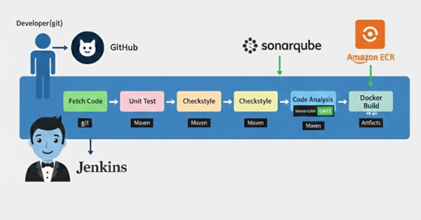
The system architecture represents the complete end-to-end workflow of the proposed Continuous Integration and Continuous Deployment (CI/CD) pipeline, beginning from source code commit and extending up to automated deployment on Amazon Elastic Container Service (ECS). The architecture integrates software development, build automation, testing, static code quality analysis, artifact management, containerization, and cloud deployment into a single unified and automated pipeline.
The primary objective of this architecture is to eliminate manual intervention, reduce deployment errors, and ensure consistent, reliable, and secure software delivery. As depicted in the block diagram, the CI/CD pipeline is driven by automation and follows a sequential execution model, where each stage validates the output of the previous stage before allowing progression.
The architecture leverages industry-standard DevOps tools such as GitHub, Jenkins, Maven, Checkstyle, SonarQube, Docker, Amazon ECR, and Amazon ECS. Jenkins functions as the central orchestration layer, coordinating all activities across the pipeline and providing continuous feedback to developers.
AWS EC2 is used as the underlying compute infrastructure, while Amazon ECS is used for container orchestration and deployment.
This architecture ensures:
- Continuous integration and delivery
- Early detection of defects and vulnerabilities
- Enforced coding standards
- Portable and reproducible builds
- Scalable and zero-downtime deployment
4.1.1 Architecture Overview
The architecture consists of the following major components, each responsible for a specific stage in the CI/CD lifecycle:
4.1.2 Source Code Management – GitHub
GitHub serves as the source code management and version control platform for the project. Developers write, modify, and maintain application code locally and push changes to the GitHub repository using Git commands.
The GitHub repository acts as the single source of truth and contains:
- Application source code
- Maven configuration files (pom.xml)
- Jenkins pipeline definition (Jenkinsfile)
- Dockerfile for container image creation
- SonarQube configuration properties
Each commit represents a new version of the application. GitHub is configured with a webhook mechanism that automatically notifies Jenkins whenever a commit is pushed. This event-driven approach ensures that the CI pipeline is triggered immediately after every code change, enabling continuous integration.
Key benefits of GitHub in the architecture include:
- Version tracking and rollback
- Collaborative development
- Code history and auditing
- Seamless CI/CD integration
4.1.3 Jenkins – Automation and Orchestration Layer
Jenkins is the core automation engine of the system architecture. Once notified by GitHub, Jenkins initiates and manages the entire CI/CD pipeline.
Jenkins performs the following responsibilities:
- Fetches the latest source code from GitHub
- Executes build and test stages using Maven
- Runs code style validation using Checkstyle
- Performs static code analysis using SonarQube
- Builds Docker container images
- Pushes container images to Amazon ECR
- Triggers deployment on Amazon ECS
The pipeline logic is defined using a Jenkinsfile, which follows the concept of Pipeline as Code. This approach ensures reproducibility, version control of pipeline configuration, and ease of maintenance.
Jenkins also provides:
- Real-time build logs
- Visual pipeline dashboards
- Failure notifications
- Historical execution records
By centralizing orchestration, Jenkins ensures consistency, automation, and traceability across all pipeline stages.
4.1.4 Build and Unit Testing – Maven
After Jenkins fetches the source code, Apache Maven is invoked to handle build automation and dependency management. Maven compiles the application source code and executes unit tests as part of the build lifecycle.
Key Maven activities include:
- Resolving project dependencies
- Compiling source code
- Running unit tests
- Packaging the application
Unit tests validate the correctness of individual components and ensure that recent code changes do not break existing functionality. If compilation fails or unit tests do not meet the defined success criteria, the pipeline is immediately terminated.
This stage ensures:
- Early defect detection
- Stable and repeatable builds
- Improved software reliability
4.1.5 Code Style Validation – Checkstyle
Following successful unit testing, the pipeline executes Checkstyle analysis. Checkstyle enforces predefined coding standards and ensures uniform coding practices across the project.
Checkstyle checks include:
- Naming conventions
- Code formatting
- Structural consistency
- Best practice adherence
Violations are reported in the Jenkins console output. Depending on severity, the pipeline can be configured to fail if coding standards are not met.
This stage improves:
- Code readability
- Maintainability
- Long-term project sustainability
- Reduction of technical debt
4.1.6 Static Code Quality and Security Analysis – SonarQube
After Checkstyle validation, Jenkins triggers SonarQube for advanced static code analysis. SonarQube evaluates the codebase for quality, reliability, and security issues.
SonarQube analysis:
- Bugs
- Code smells
- Security vulnerabilities
- Code duplication
- Test coverage
A Quality Gate is applied to determine whether the application meets predefined thresholds for maintainability, reliability, and security. If the quality gate fails, Jenkins immediately stops the pipeline, preventing low-quality or insecure code from progressing further.

This stage enables:
- Shift-left security (DevSecOps)
- Objective quality measurement
- Reduced production risk
4.1.7 Nexus Repository – Artifact Storage Layer
Once the code passes all quality checks, Jenkins builds a production-ready artifact (JAR/WAR) and uploads it to the Nexus Repository.
Nexus stores:
- Compiled Maven artifacts
- Versioned releases
- Snapshot builds
- Build metadata (version, timestamp, checksum)
Nexus enables:
- Artifact traceability
- Version control
- Rollback capability
- Centralized artifact management
This layer ensures that every build is stored, identifiable, and reusable.
Nexus manages build artifacts, ECR manages container images; both serve different lifecycle stages.
4.1.8 Docker Engine – Containerization Layer
After artifact generation, Jenkins initiates the Docker image build process. Docker packages the application along with its dependencies into a container image using a Dockerfile.
Docker image creation includes:
- Packaging application and runtime dependencies
- Tagging images using version and commit ID
- Ensuring environment consistency
Containerization ensures that the application behaves identically across development, testing, and production environments.
Benefits include:
- Portability
- Isolation
- Faster deployment
- Cloud-native compatibility
4.1.9 Amazon Elastic Container Registry (ECR) – Registry Layer
Once the Docker image is built, Jenkins securely pushes it to Amazon Elastic Container Registry (ECR).
ECR provides:
- Secure private image repositories
- Image versioning and tagging
- Image vulnerability scanning
- Seamless ECS integration
ECR acts as a centralized storage for approved and validated container images.
4.1.10 Amazon Elastic Container Service (ECS) – Deployment Layer
Amazon ECS is responsible for deploying and running containerized applications. ECS pulls the latest Docker image from ECR and deploys it automatically to a cluster.
ECS features include:
- EC2 or Fargate deployment modes
- Load balancing
- Auto-scaling (optional)
- Zero-downtime deployments
This ensures high availability, scalability, and resilience of the deployed application.
4.2 Description of Working Principle
The working principle of the proposed CI/CD pipeline follows a fully automated, sequential execution model, where each stage validates the output of the previous stage.
Step 1: Developer Commit (GitHub Trigger)
A developer commits code to the GitHub repository. GitHub detects the change and notifies Jenkins via webhook or polling mechanism.
Step 2: Jenkins Fetches Source Code
Jenkins checks out the latest code, including:
- Source code
- Jenkinsfile
- Maven builds files
- Dockerfile
- SonarQube properties
Step 3: Maven Build and Unit Testing
Jenkins executes:
mvn clean install
mvn test
The pipeline stops if compilation or unit tests fail.
Step 4: Code Style Validation using Checkstyle
Checkstyle scans the code for coding standard violations. Severe violations can fail the pipeline.
Step 5: Static Code Analysis using SonarQube
SonarQube performs quality and security analysis. The quality gate determines whether the pipeline continues or stops.

Step 6: Artifact Creation and Upload to Nexus
Jenkins builds the final artifact and uploads it to Nexus, ensuring versioned and traceable releases.
Step 7: Docker Image Build
Jenkins builds and tags the Docker image using the Dockerfile.
Step 8: Push Docker Image to AWS ECR
The image is pushed securely to Amazon ECR using IAM authentication.
Step 9: Deployment on Amazon ECS
ECS pulls the latest image and deploys it using rolling updates with health checks and optional rollback.
Conclusion
The proposed architecture and working principle demonstrate a robust, scalable, and industry-aligned CI/CD pipeline. By integrating automation, quality enforcement, security checks, containerization, and cloud deployment, the system ensures fast, reliable, and secure software delivery suitable for real-world applications and academic learning.

CHAPTER-5
TOOLS AND TECHNOLOGIES
This chapter describes the various tools, technologies, software platforms, hardware resources, simulation/cloud environments, and libraries used in the development and implementation of the proposed CI/CD pipeline. The selected tools are industry-standard, widely adopted, and suitable for building a scalable, secure, and automated DevOps solution.
5.1 Software Tools
The following software tools are used to design, automate, analyse, and deploy the CI/CD pipeline:
5.1.1 Git
Git is a distributed version control system used to manage source code changes. It enables tracking of modifications, branching, merging, and rollback of code versions throughout the development lifecycle.
Purpose:
- Version control
- Collaboration between developers
- Change history tracking
5.1.2 GitHub
GitHub is a cloud-based source code repository platform built on Git. It acts as the central repository and triggers the CI/CD pipeline whenever a new commit is pushed.
Purpose:
- Source code hosting
- Webhook-based CI trigger
- Collaboration and access control

5.1.3 Jenkins
Jenkins is an open-source automation server that serves as the core CI/CD orchestration tool. It automates build, test, analysis, containerization, and deployment stages.
Purpose:
- Pipeline orchestration
- Automation of CI/CD stages
- Logging and build visualization
5.1.4 Apache Maven
Apache Maven is a build automation and dependency management tool used mainly for Java-based applications.
Purpose:
- Build automation
- Dependency management
- Unit testing execution
5.1.5 Checkstyle
Checkstyle is a static code analysis tool used to enforce coding standards and best practices.
Purpose:
- Code style validation
- Maintainability improvement
- Reduction of technical debt
5.1.6 SonarQube
SonarQube is a static code quality and security analysis platform that detects bugs, vulnerabilities, and code smells.
Purpose:
- Static code analysis
- Security vulnerability detection
- Quality gate enforcement
5.1.7 Docker
Docker is a containerization platform used to package the application and its dependencies into portable containers.
Purpose:
- Container image creation
- Environment consistency
- Application portability
5.1.8 Nexus Repository
Nexus is an artifact repository manager used to store build artifacts such as JAR and WAR files.
Purpose:
- Artifact storage
- Version control of builds
- Rollback support
5.1.9 Amazon Elastic Container Registry (ECR)
Amazon ECR is a managed container image registry provided by AWS.
Purpose:
- Secure storage of Docker images
- Image versioning
- Integration with ECS
5.1.10 Amazon Elastic Container Service (ECS)
Amazon ECS is a container orchestration service used to deploy and manage containerized applications.
Purpose:
- Application deployment
- Auto-scaling and load balancing
- Zero-downtime updates
5.2 Hardware Requirements
The following hardware resources are required to implement and run the CI/CD pipeline:
5.2.1 Developer System
- Processor: Intel i5 / Ryzen 5 or higher
- RAM: Minimum 8 GB
- Storage: Minimum 256 GB SSD
- Operating System: Windows / Linux / macOS
Purpose:
Used by developers to write code, commit changes, and monitor pipeline results.
5.2.2 Jenkins Server / Build Agent
- Processor: Multi-core CPU
- RAM: Minimum 8–16 GB
- Storage: 50 GB or more
- Operating System: Linux (Ubuntu preferred)
Purpose:
Used to run Jenkins, execute builds, run tests, and perform Docker operations
5.2.3 Cloud Infrastructure (AWS)
- EC2 instances or ECS-managed resources
- Virtualized hardware managed by AWS
Purpose:
Used for hosting containerized applications and managing deployments.
5.3 Cloud / Simulation Environment
Since the project is cloud-based, a real cloud environment is used instead of traditional simulation tools.
5.3.1 Amazon Web Services (AWS)
AWS provides the infrastructure required for container storage and deployment.
Services used:
- AWS EC2
- AWS ECR
- AWS ECS
- AWS IAM
Purpose:
- Real-world cloud deployment
- Scalable infrastructure
- Secure access control
This environment simulates enterprise-level deployment scenarios and provides hands-on experience with cloud DevOps practices.
In this project, AWS EC2 provides the base virtual compute resources, while Amazon ECS manages container orchestration and deployment using images stored in Amazon ECR.
5.4 Libraries and Frameworks
The following libraries and frameworks support application development and pipeline execution:
5.4.1 Java Development Kit (JDK)
JDK is required to compile and run Java-based applications.
Purpose:
- Java compilation
- Application execution

5.4.2 Maven Plugins
Various Maven plugins are used for:
- Unit testing (Surefire plugin)
- Checkstyle integration
- SonarQube analysis
5.4.3 Docker Libraries
Docker runtime libraries support image creation, container execution, and registry communication.
5.4.4 SonarQube Scanner
SonarQube Scanner is used to send code analysis data from Jenkins to the SonarQube server.
5.5 Summary
The tools and technologies selected for this project form a complete, industry-grade DevOps ecosystem. By combining open-source tools with cloud-native services, the project achieves full automation, high reliability, and scalability. The use of real-world tools such as Jenkins, Docker, SonarQube, and AWS ensures strong industry relevance and prepares students for professional DevOps and cloud engineering roles.

CHAPTER-6
EXPECTED OUTCOME
6.1 Overview of Expected Outcome
The primary expected outcome of this project is the successful implementation of a fully automated, end-to-end CI/CD pipeline that integrates source code management, build automation, unit testing, static code quality analysis, artifact management, containerization, and cloud deployment. The effectiveness of the proposed pipeline is validated using real execution results obtained from Jenkins, SonarQube, Nexus Repository Manager, and Amazon Web Services (AWS).
The project aims to demonstrate how modern DevOps practices can significantly improve software delivery speed, reliability, security, and maintainability. The outcomes are verified through multiple dashboards, logs, and system views, which serve as concrete proof of pipeline correctness and automation.
6.2 Jenkins CI Pipeline Execution Outcome
The Jenkins pipeline execution screenshots demonstrate the successful orchestration of the CI/CD workflow. Each pipeline run consists of multiple well-defined stages such as tool installation, source code fetching, build execution, unit testing, code style validation, static analysis, quality gate enforcement, artifact upload, and pipeline completion.
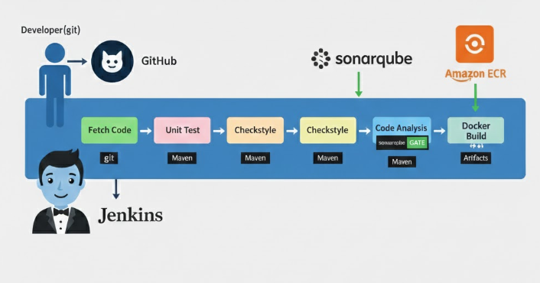
Observed Results
- Pipeline stages execute sequentially as defined in the Jenkinsfile
- Successful stages are marked with green indicators
- Failed stages are clearly highlighted, enabling quick debugging
- Execution time for each stage is displayed
Multiple pipeline executions are visible, including both successful and failed runs. Failed runs validate that the pipeline correctly enforces quality and build constraints, while successful runs confirm that the system functions as expected when all conditions are met.
Validation
This outcome confirms that Jenkins correctly acts as the central automation and orchestration engine, ensuring:
- No manual intervention is required
- Errors are detected early
- Developers receive immediate feedback
6.3 Build Automation and Unit Testing Validation
The build and unit testing stages are executed using Apache Maven, as shown in the Jenkins pipeline stages labelled Build and Unit Test.
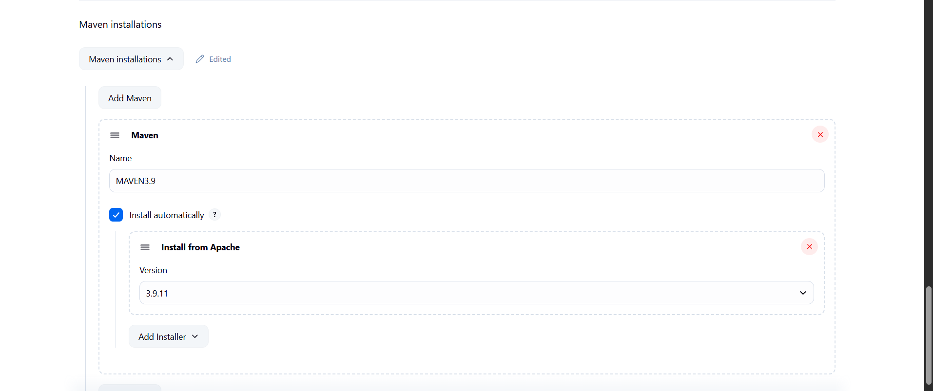

Observed Results
- Maven successfully compiles the application source code
- Unit tests execute automatically during pipeline execution
- Test failures cause immediate pipeline termination
Validation
This validates that:
- Only compilable and test-verified code proceeds further
- Regression issues are detected early
- Build consistency is maintained across executions
The automated build and test process significantly reduces integration issues and improves software reliability
6.4 Code Style Enforcement using Checkstyle
The Checkstyle stage ensures that coding standards and best practices are enforced consistently.
Observed Results
- Checkstyle executes after successful unit testing
- Coding violations are reported in Jenkins logs
- Severe violations prevent pipeline continuation
Validation
This outcome confirms that:
- Code readability and maintainability are improved
- Technical debt is reduced
- Uniform coding standards are enforced automatically
This stage eliminates subjective manual code reviews for style compliance.

6.5 SonarQube Code Quality and Security Analysis Outcome
The SonarQube dashboard screenshot demonstrates the results of static code analysis performed during pipeline execution.
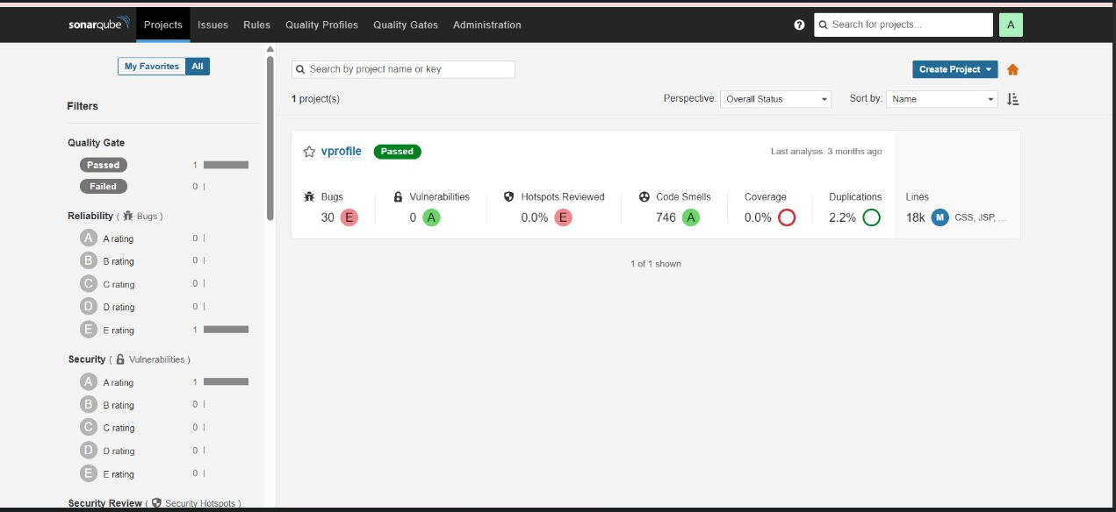
Observed Metrics
- Bugs classified by severity
- Security vulnerabilities rated with grades
- Code smells indicating maintainability issues
- Code duplication percentage
- Total lines of code analysed
- Quality Gate status displayed as Passed or Failed
Quality Gate Enforcement
The Quality Gate determines whether the pipeline proceeds or stops:
- If the Quality Gate fails, Jenkins terminates the pipeline
- If the Quality Gate passes, artifact generation continues
Validation
This confirms the successful implementation of DevSecOps practices, ensuring:
- Early vulnerability detection
- Improved software security
- Objective quality measurement
The SonarQube integration ensures that poor-quality or insecure code never reaches deployment stages.
6.6 Artifact Management and Nexus Repository Outcome
The Nexus Repository Manager shows the successful storage of build artifacts generated during pipeline execution.
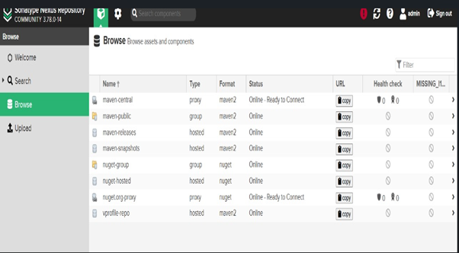
Observed Results
- Maven artifacts (JAR/WAR) uploaded successfully
- Separate repositories for releases and snapshots
- Metadata such as version, timestamp, and checksum maintained
Validation
This confirms that:
- Artifacts are centrally stored and version-controlled
- Rollback to previous versions is possible
- Build traceability is maintained
The Nexus repository acts as a reliable artifact storage layer between CI and deployment stages.
6.7 Jenkins Plugin Configuration Outcome
The Jenkins Plugin Manager screenshot validates the correct installation of essential plugins required for pipeline execution.
Configured Plugins
- Nexus Artifact Uploader Plugin – enables artifact upload to Nexus
- SonarQube Scanner Plugin – enables static analysis integration
- Pipeline Maven Integration Plugin – supports Maven builds in pipelines
- Build Timestamp Plugin – adds build metadata for traceability
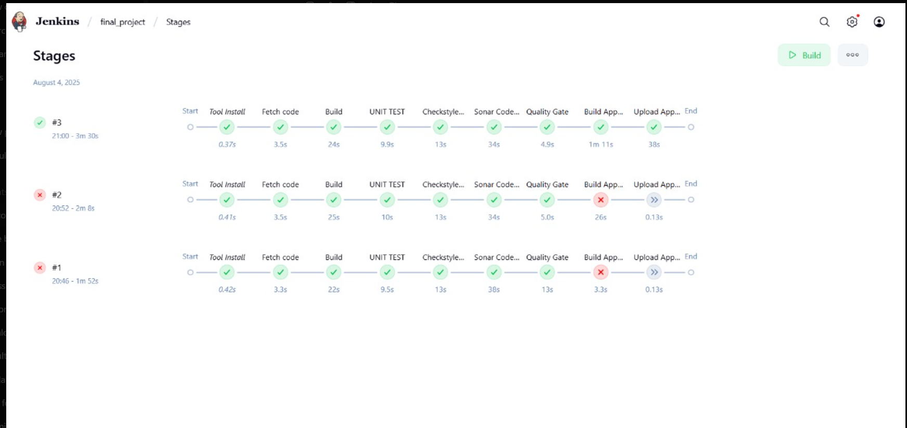
Validation
The successful installation of these plugins confirms that:
- Jenkins is fully equipped for CI/CD automation
- Tool integrations function correctly
- Pipeline stages execute without configuration issues
This ensures a stable and production-ready Jenkins environment.
6.8 Docker Image Build and Containerization Outcome
The Docker build stage converts the verified application artifact into a container image.
Observed Results
- Docker images built successfully using Dockerfile
- Images tagged with version and build identifiers
- Images stored temporarily before registry upload
Validation
This confirms:
- Environment consistency across systems
- Application portability
- Readiness for cloud-native deployment
Containerization ensures that the application behaves identically in all environments.
6.9 AWS Elastic Container Registry (ECR) Validation
The AWS ECR screenshots validate the successful push of Docker images to a secure cloud registry.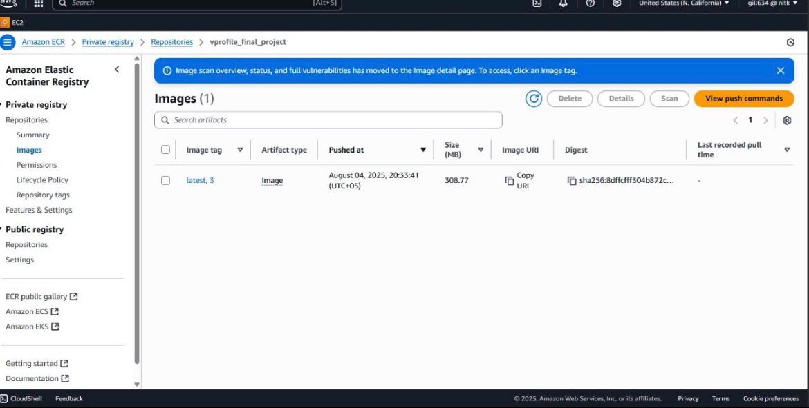

Observed Results
- Docker images available in ECR repository
- Image versioning and tagging visible
- Secure access through IAM roles
Validation
This confirms:
- Secure and scalable container storage
- Integration between Jenkins and AWS
- Enterprise-grade artifact handling
ECR acts as the bridge between CI and cloud deployment.
6.10 AWS EC2 and Security Configuration Outcome
The AWS EC2 and Security Group screenshots demonstrate infrastructure readiness for pipeline execution and deployment.
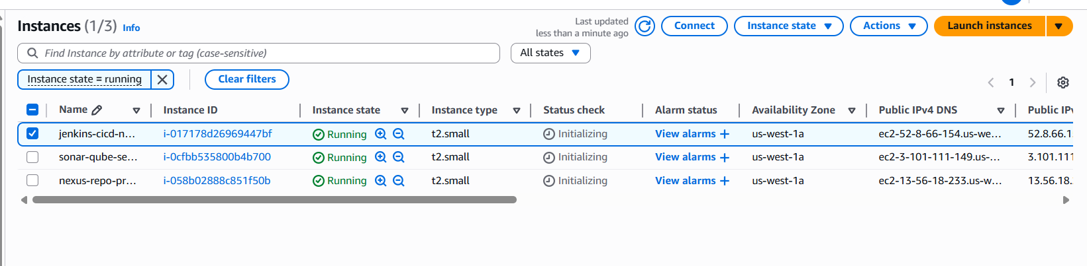
Observed Results
- EC2 instances running successfully
- Required ports (e.g., 8080, 22) configured
- Security groups allow controlled access

Validation
This ensures:
- Jenkins, Nexus, and SonarQube services are accessible
- Infrastructure security is maintained
- Cloud resources are correctly provisioned
6.11 AWS ECS Deployment Outcome
The ECS deployment stage validates the final step of the CI/CD pipeline.
Observed Results
- ECS pulls Docker images from ECR
- Containers deployed automatically
- Services run with rolling updates
Validation
This confirms:
- Automated deployment without downtime
- Scalability and reliability
- Production-ready cloud deployment
ECS ensures high availability and efficient container orchestration.
6.12 Overall Outcome Analysis
The combined results from Jenkins, SonarQube, Nexus, Docker, and AWS validate the successful implementation of the proposed CI/CD architecture. The pipeline demonstrates:
- End-to-end automation
- Early defect and vulnerability detection
- Secure artifact and container management
- Cloud-native deployment readiness
- Industry-aligned DevOps practices
6.13 Conclusion of Expected Outcome
The expected outcomes of this project confirm that the proposed CI/CD pipeline is functional, reliable, secure, and scalable. The validation through real execution dashboards and cloud infrastructure views proves that the system meets both academic and industrial standards.
This project successfully demonstrates how modern DevOps tools and practices can be applied to automate software delivery, reduce errors, and improve overall software quality. The outcomes strongly justify the feasibility and effectiveness of the proposed methodology.

CHAPTER-7
TIMELINE
The execution of the proposed project is planned in a structured, milestone-oriented manner, strictly aligned with the guidelines and evaluation framework of CSEE-712P Major Project-I (Design & Analysis). The project timeline spans 14 weeks, covering problem identification, literature review, feasibility analysis, system design, validation through pipeline execution and result analysis.
Each phase concludes with a clearly defined milestone, ensuring measurable progress, continuous assessment, and alignment with course objectives.
Phase-wise Timeline with Detailed Milestones
Phase 1: Problem Identification and Definition (Week 1–2)
Activities
- Identification of a real-world problem in Computer Science and Engineering
- Study of current industry practices and societal needs
- Identification of relevance to DevOps, cloud automation, and CI/CD systems
- Finalization of project domain and title
- Definition of clear problem statement
- Identification of objectives, constraints, and deliverables
- Team formation and role assignment
Milestone 1: Problem Definition Approval
- Clearly defined and approved problem statement
- Objectives mapped to societal relevance and industry needs
- Project scope finalized
Deliverables
- Problem Statement document
- Objectives and scope definition
Phase 2: Literature Survey and Gap Analysis (Week 3–4)
Activities
- Comprehensive literature survey from IEEE, Scopus, Springer, and reputed journals
- Review of CI/CD architectures, DevOps workflows, automation tools, and cloud deployment strategies
- Study of DORA metrics, DevSecOps practices, and quality gates
- Comparative analysis of existing solutions
- Identification of limitations and research gaps
Milestone 2: Literature Review Completion
✔ Minimum 10+ quality research references reviewed
✔ Existing approaches analysed
✔ Clear research and implementation gap identified
Deliverables
- Literature review chapter
- Comparative analysis table
- Gap analysis section
Phase 3: Feasibility Study and Requirement Analysis (Week 5–6)
Activities
- Technical feasibility analysis of tools (Jenkins, GitHub, Maven, SonarQube, Docker, AWS)
- Economic and resource feasibility assessment
- Identification of hardware and software requirements
- Selection of platforms, frameworks, and cloud services
- Requirement specification (functional and non-functional)
- Preparation of high-level block diagram
Milestone 3: Feasibility and Requirement Validation
✔ System feasibility confirmed
✔ Tools and technologies finalized
✔ High-level block diagram approved
Deliverables
- Feasibility study report
- Requirement specification document
- Block diagram
Phase 4: System Architecture and Design (Week 7–8)
Activities
- Detailed system architecture design
- CI/CD pipeline stage definition
- Workflow and data flow design
- Design of build, test, quality analysis, artifact, and deployment stages
- Definition of quality gates and security checks
- Preparation of flowcharts and architecture diagrams
- Design-level proof-of-concept
Milestone 4: System Design Finalization
✔ Complete system architecture defined
✔ CI/CD workflow clearly documented
✔ Design ready for validation
Deliverables
- Detailed architecture diagram
- Flowcharts and pipeline workflow
- Design specification
- Phase 5: Design Validation and Pipeline Execution (Week 9–10)
Activities
• Design validation against requirements
• Validation through pipeline execution
• Verification of pipeline stages (build, test, analysis, artifact flow)
• Performance analysis based on execution logs
• Validation of error handling and quality gate enforcement
• Identification and correction of design inconsistencies
- Milestone 5: Design Validation and Proof-of-Concept
✔ Design correctness validated
✔ Pipeline execution results obtained
✔ System behaviour verified
- Deliverables
• Pipeline execution outputs
• Validation results
• Performance analysis
Phase 6: Documentation and Interim Report Preparation (Week 11–12)
Activities
- Drafting of interim project report
- Compilation of problem statement, literature review, system design, and validation
- Formatting as per university guidelines
- Inclusion of diagrams, tables, and references
- Internal review and corrections

Milestone 6: Interim Report Submission
✔ Interim report completed
✔ Design and analysis fully documented
✔ Ready for internal evaluation
Deliverables
- Interim project report (Major Project-I)
Phase 7: Presentation, Review, and Viva Preparation (Week 13–14)
Activities
- Preparation of presentation slides
- Internal project review by committee
- Incorporation of feedback
- Viva-voce preparation
- Final refinement of report
Milestone 7: Internal Evaluation and Approval
✔ Successful internal review
✔ Viva readiness achieved
✔ Approval for Major Project-II implementation
Deliverables
- Final presentation
- Revised report
- Viva preparation notes

Milestone Summary Table
Milestone No. | Week | Milestone Description
M1 | 1–2 | Problem statement & objectives approved
M2 | 3–4 | Literature review & gap analysis completed
M3 | 5–6 | Feasibility study & block diagram finalized
M4 | 7–8 | System architecture & design completed
M5 | 9–10 | Design Validation and Proof-of-Concept
M6 | 11–12 | Interim report submission
M7 | 13–14 | Presentation, viva & internal approval

Alignment with Evaluation Criteria
This milestone-based timeline ensures:
- Continuous assessment readiness
- Clear evidence for internal marks
- Strong foundation for Major Project-II
- Compliance with CSEE-712P course objectives
Conclusion
The proposed timeline demonstrates a well-planned, milestone-driven, and academically compliant approach for Major Project-I (Design & Analysis). By explicitly defining milestones, deliverables, and validation points, the project ensures measurable progress, systematic evaluation, and readiness for the implementation phase in Major Project-II.

CHAPTER-8
REFERENCES
References (IEEE Format)
[1] N. Forsgren, J. Humble, and G. Kim, accelerate: The Science of Lean Software and DevOps – Building and Scaling High Performing Technology Organizations. Portland, OR, USA: IT Revolution Press, 2018.
[2] J. Humble and D. Farley, Continuous Delivery: Reliable Software Releases through Build, Test, and Deployment Automation. Boston, MA, USA: Addison-Wesley, 2011.
[3] P. Debois, “DevOps: A Software Architect’s Perspective,” IEEE Software, vol. 29, no. 2, pp. 92–95, Mar.–Apr. 2012, doi: 10.1109/MS.2012.46.
[4] L. Chen, “Continuous Delivery: Overcoming Adoption Challenges,” Journal of Systems and Software, vol. 128, pp. 72–86, Jun. 2017, doi: 10.1016/j.jss.2017.02.013.
[5] A. Rahman, L. Williams, and R. Snipes, “Software Security Practices in DevOps,” IEEE Security & Privacy, vol. 15, no. 3, pp. 24–31, May–Jun. 2017, doi: 10.1109/MSP.2017.60.
[6] M. Shahin, M. A. Babar, and L. Zhu, “Continuous Integration, Delivery and Deployment: A Systematic Review on Approaches, Tools, Challenges and Practices,” IEEE Access, vol. 5, pp. 3909–3943, 2017, doi: 10.1109/ACCESS.2017.2685629.
[7] T. Fitzgerald and K. Stol, “Continuous Software Engineering: A Roadmap and Agenda,” Journal of Systems and Software, vol. 123, pp. 176–189, Jan. 2017, doi: 10.1016/j.jss.2016.09.063.
[8] SonarSource SA, “SonarQube Documentation: Continuous Inspection,” [Online]. Available: https://docs.sonarqube.org. [Accessed: 20-Feb-2025].
[9] Docker Inc., “Docker Documentation – Containerization and CI/CD,” [Online]. Available: https://docs.docker.com. [Accessed: 20-Feb-2025].
[10] Amazon Web Services, “AWS Elastic Container Service (ECS) – Developer Guide,” [Online]. Available: https://docs.aws.amazon.com/ecs. [Accessed: 20-Feb-2025].
[11] Amazon Web Services, “Amazon Elastic Container Registry (ECR) Documentation,” [Online]. Available: https://docs.aws.amazon.com/ecr. [Accessed: 20-Feb-2025].

