**B.Tech in Aeronautical Engineering** Graduated, 2020

**Education**

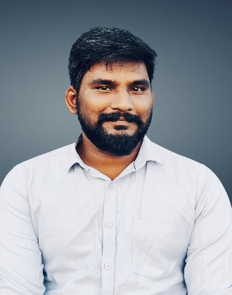

**Rajesh.P**



No:1, Mettu street,



Vadatharam,Thiruvampattu (PO),



Gingee, Villupuram,



Pincode



-



645204.



rajesh.cs225@gmail.com



9789338733



Hindustan institute of technology Marks 61% Chennai.

**+2** Graduated, 2015

RR Cambridge Matric Hr. Sec School Marks 67% Kallakurichi

**10th** Graduated, 2013

RR Cambridge Matric Hr. Sec School Marks 90.2% Kallakurichi

 **Workshop**

• Participated one day workshop on Composite materials.

 **Co-Curricular Activities**

• Actively participated in volunteering the college & department cultural and technical programmes.

 **Academic Project**

• Completed a project titled, Design and fabrication of composite UAV.

 **Work Experience**

* + - 6 months of experience as a Product Consultant in Linz Technologies.

* + - Currently working as a System Administrator (System Engineer) in TCS.

* **Headship Skills**
  + - Ability to delegate
    - Strong team player
    - Good decision maker
    - Ability to handle a critical situation

* **Skills** 
  + - Reliable and Responsible
    - Adaptable to all the environment
    - Ability to work under pressure
    - Self motivator

 **Respite Pursuit**

* + - Cooking
    - Travelling
    - Listening songs
    - Playing cricket

 **Languages**

* + - Tamil
    - English

 **Personal Details**

Father’s Name : Mr. J. Panneer Marital Status : Single

Birthday : December 26, 1997 Nationality : Indian

Gender : Male

**Declaration**

I do hereby confirm that the above particulars given by me is true to the best of my knowledge and belief. I shall render my duties honestly and enthusiastically if I am appointed. Hoping to hear back from you.

DATE : _____________________

PLACE: RAJESH.P