**Cucumber-Selenium Solution**

**(Maven project->Integrated with GitHub)**

**Scenario**: Adding products to wish list and viewing Wish list products to fetch price.

4 Static products from Home page been added into wish list.

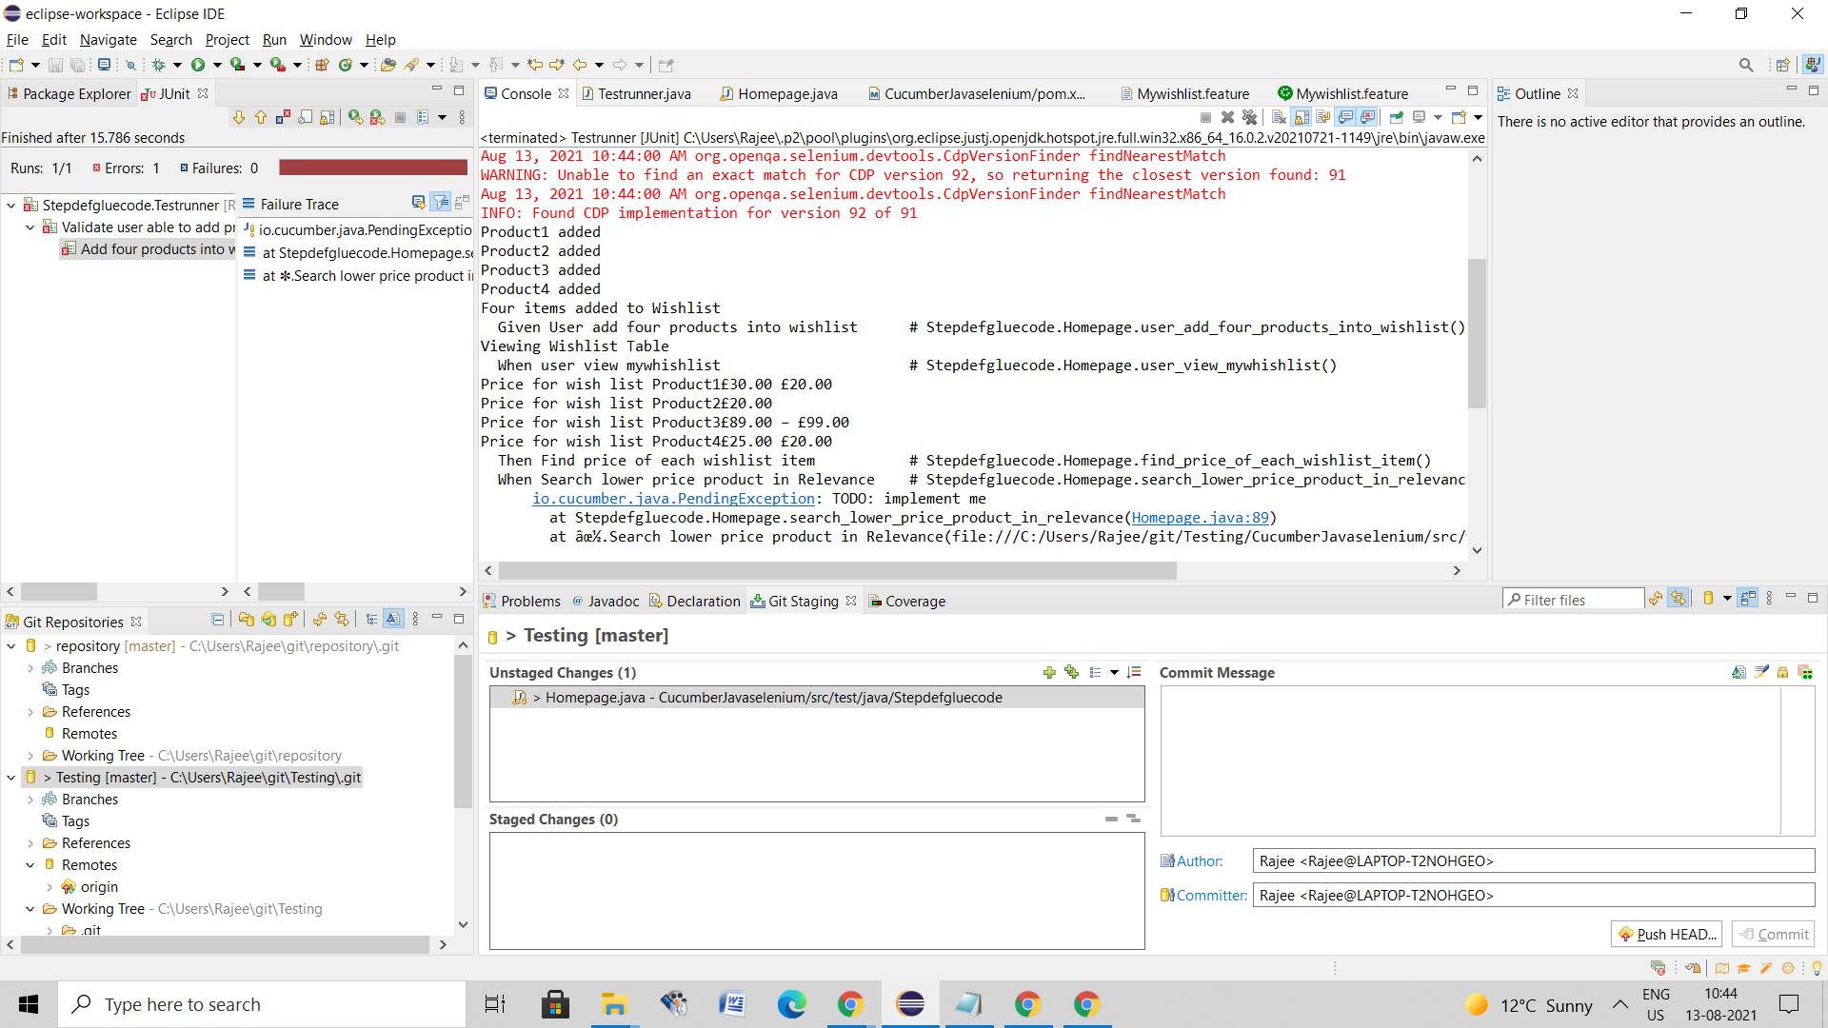

New WebDriver-Chrome opening

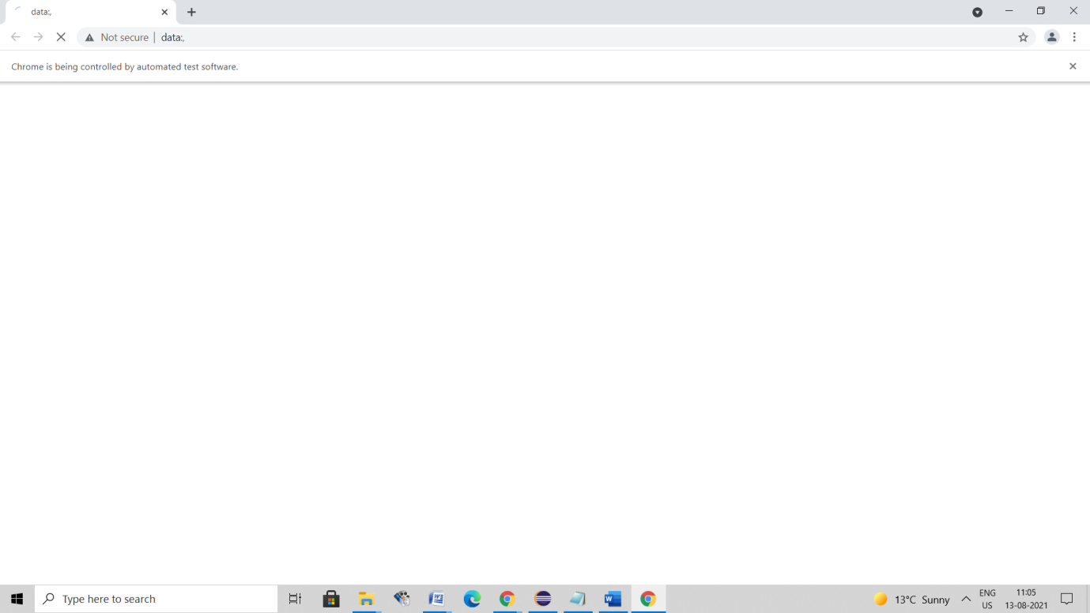

First 4 products added to Wishlist

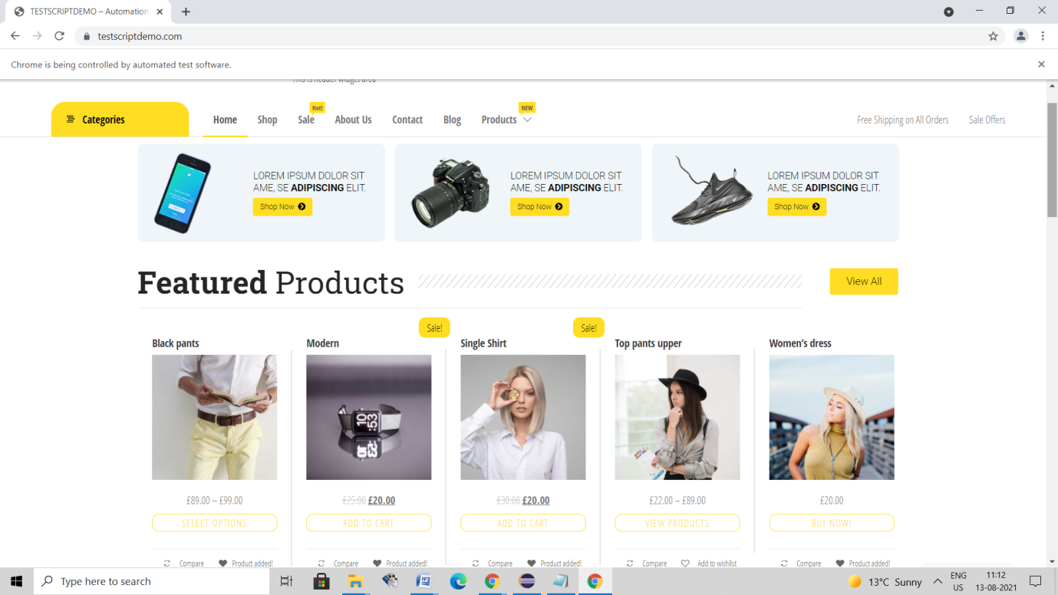

View Wishlist for Price list

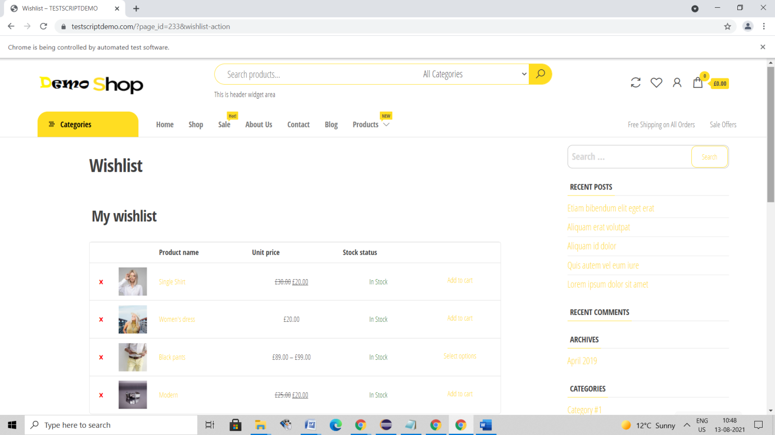

**Scenario**: Sorting Low price to High Price using Sorting list available in Page.

Navigation made like: Categories->Clothing->Default Sorting->Sort by Price: Low to High

****There is no explicit comparison logic used. However observed Lowest price product appearing first in Default Sorting. Hence Default sorting will be reverted again in steps and first low price product added to cart.

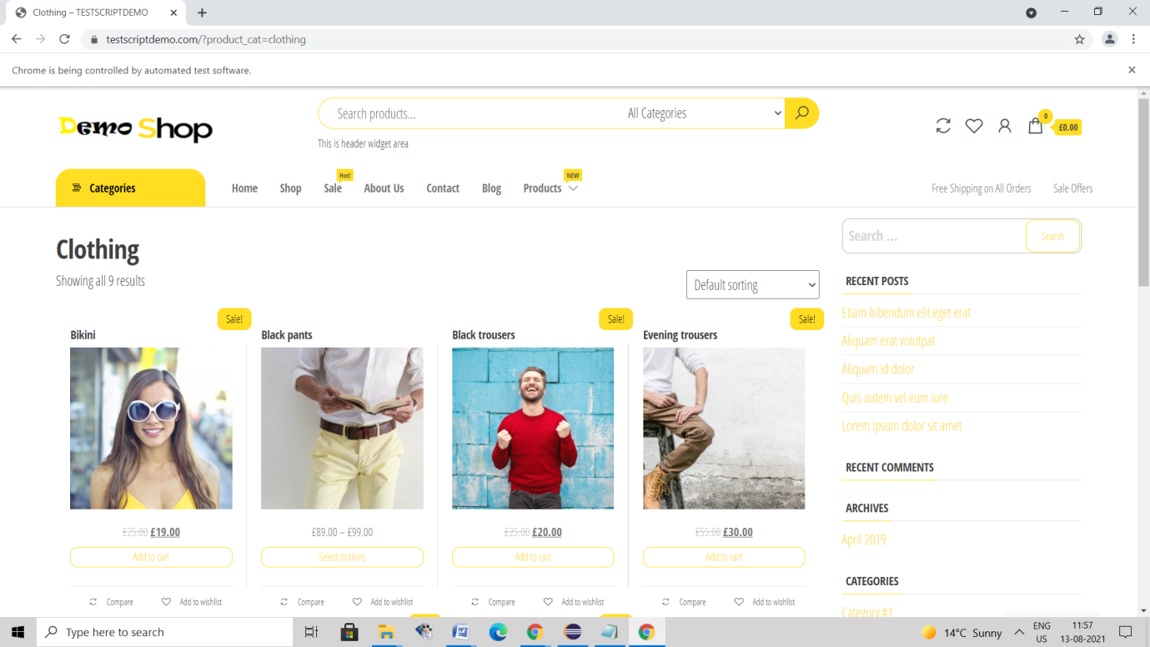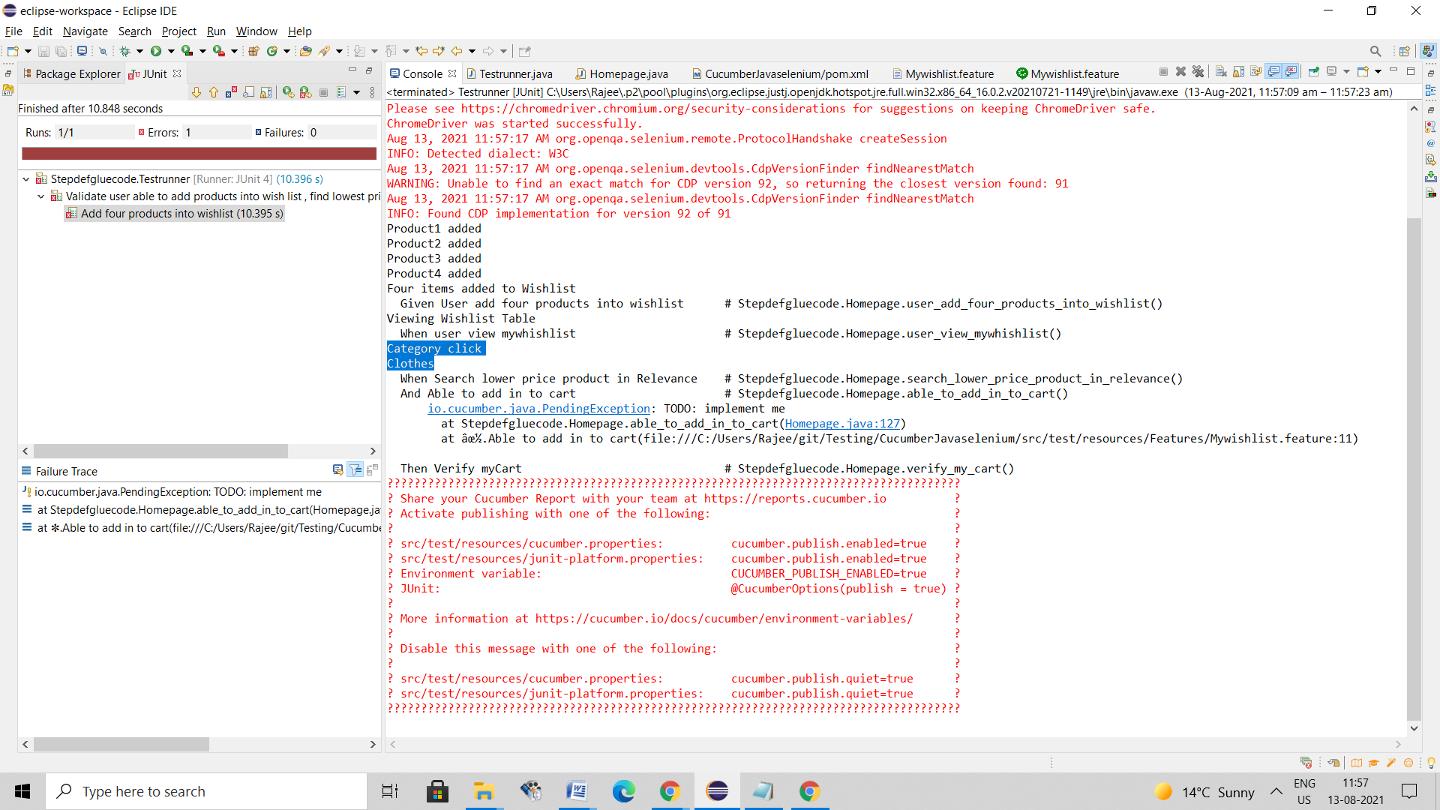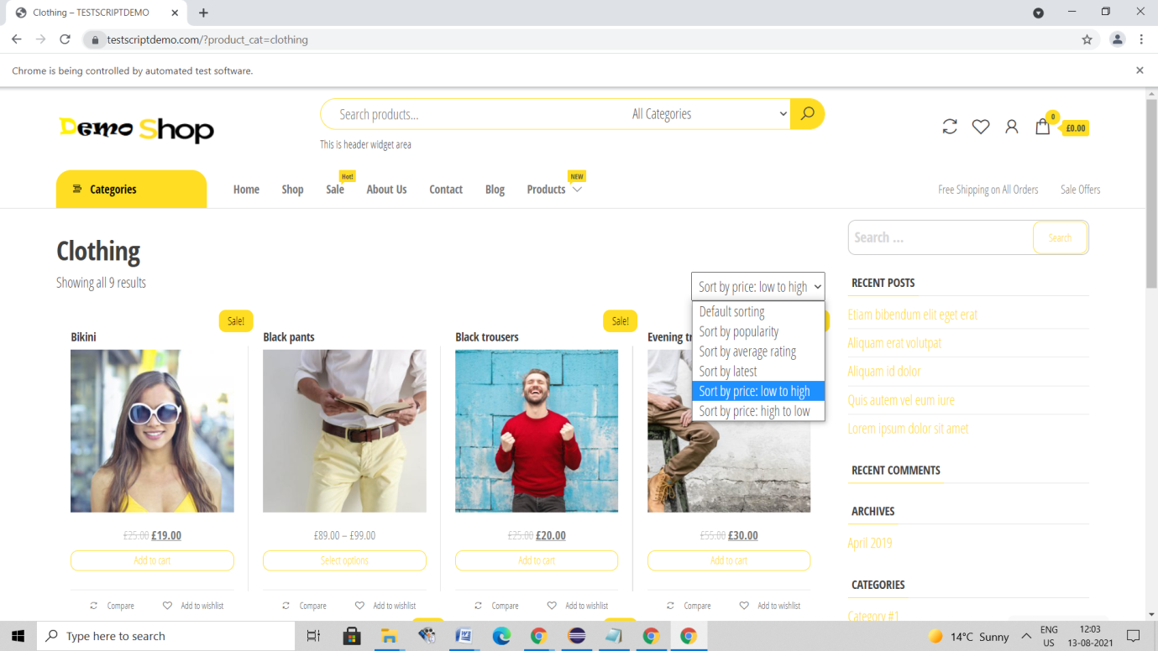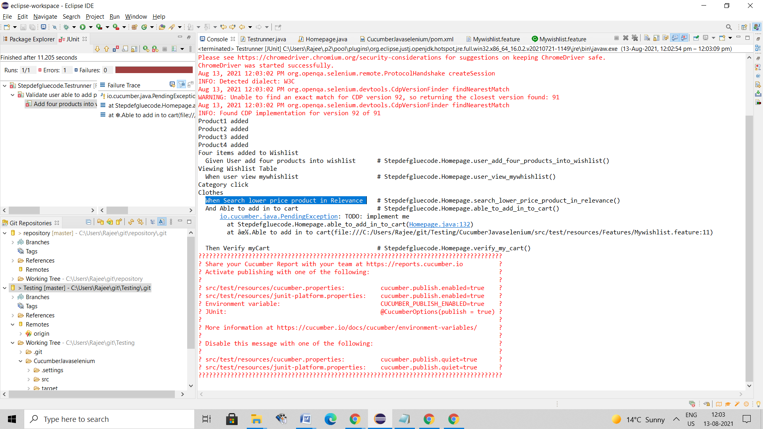

Final Execution with All values populated in Console. Output available in html format at Target folder.

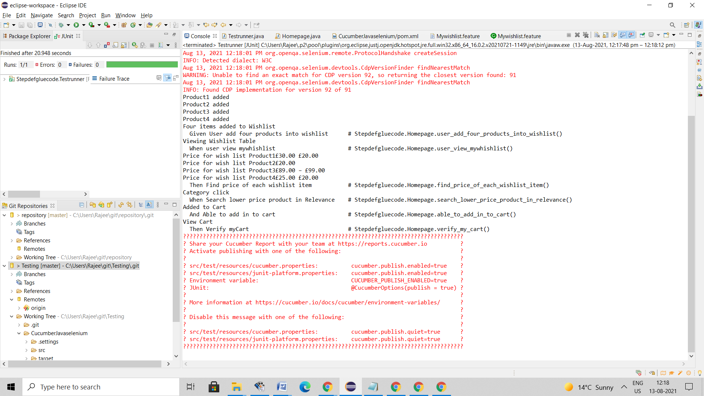

User Viewing Cart with lowest price product added