s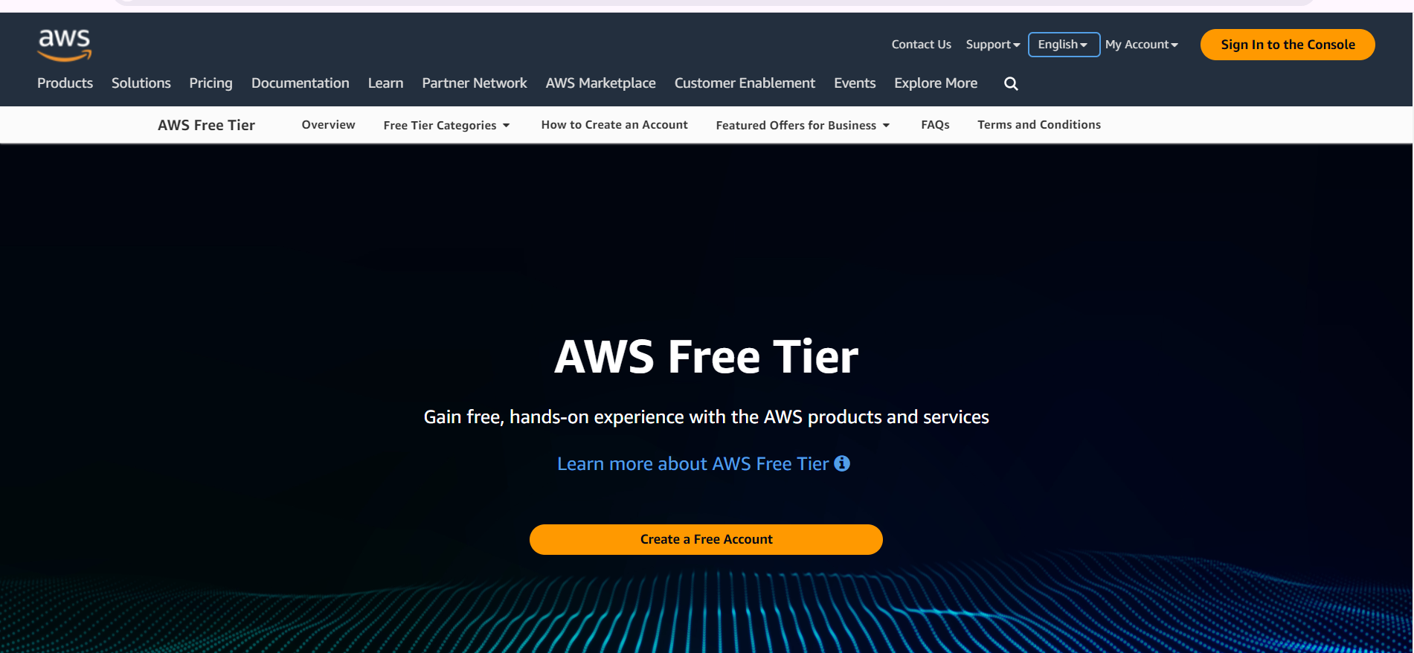

**After login**

**Select ec2**

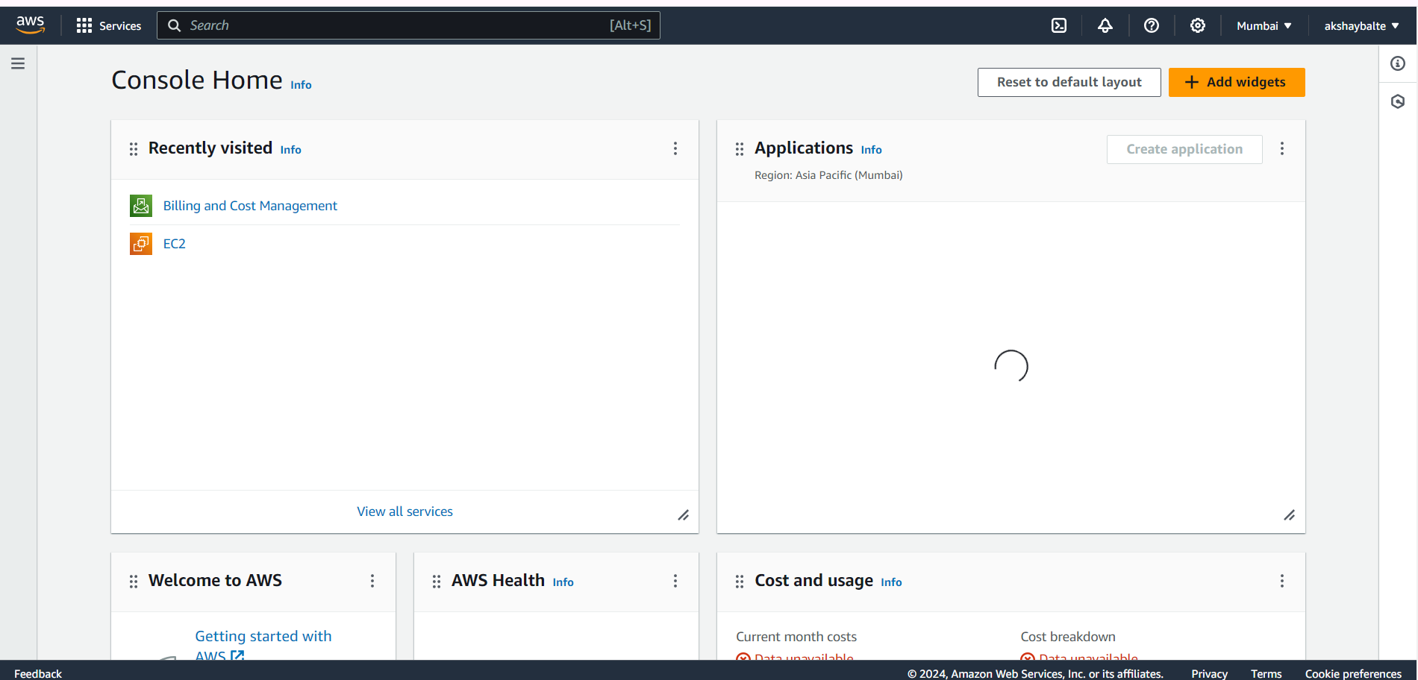



***Select instance***

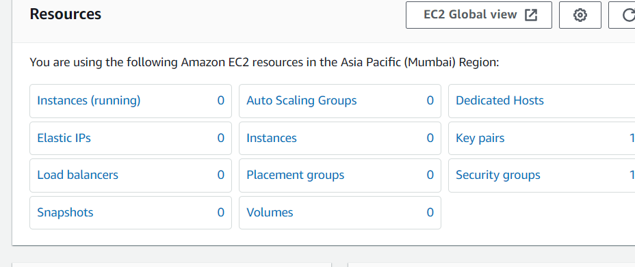



**Launch instance**

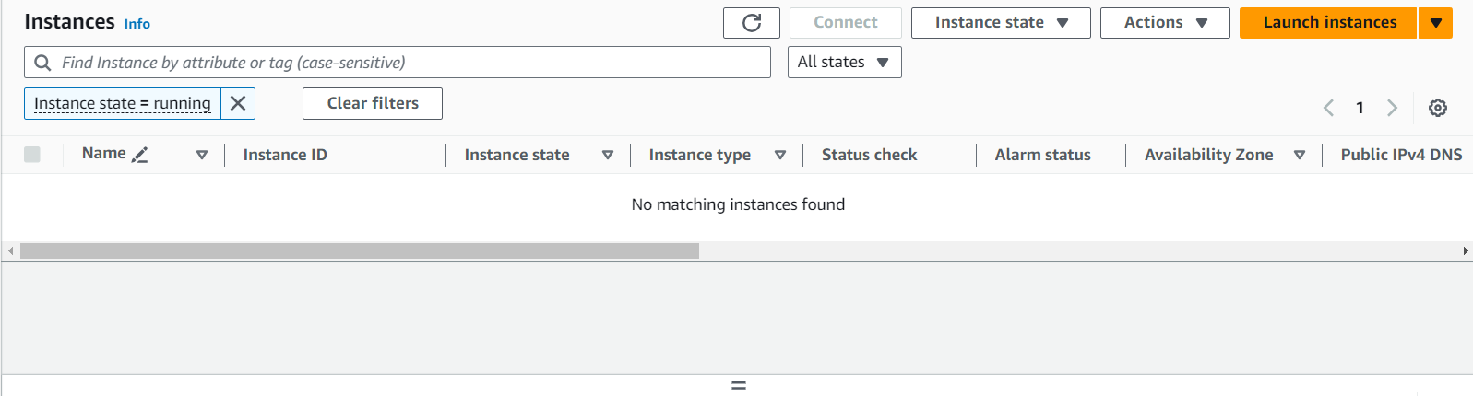



**Give a name**

**And select ubuntu**

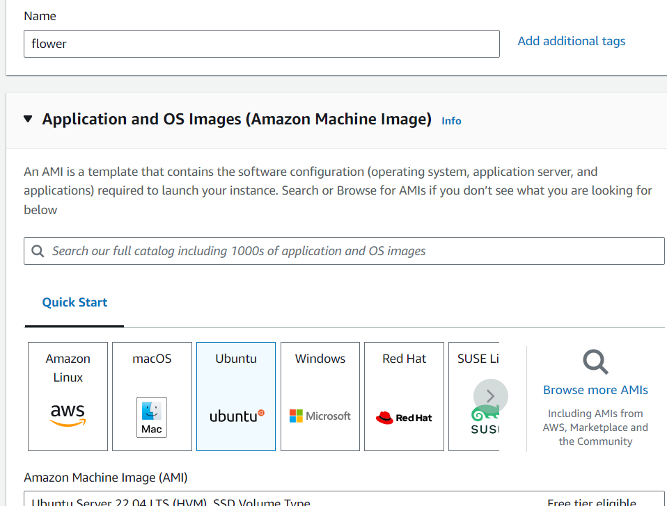

**Select key pair**

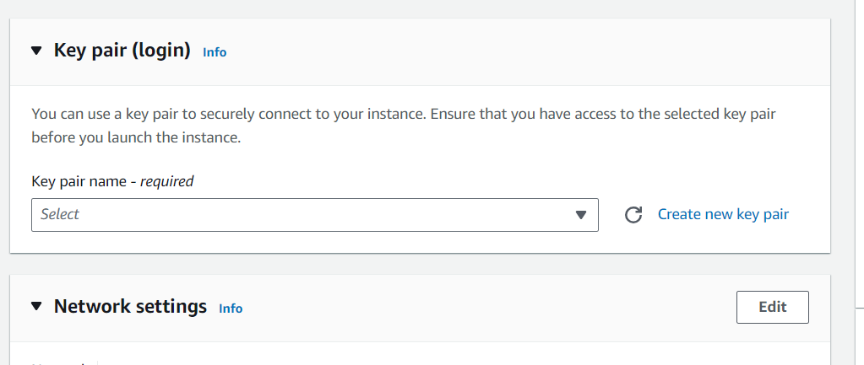

**Give a name to key pair**

**And**

**Select ppk file**

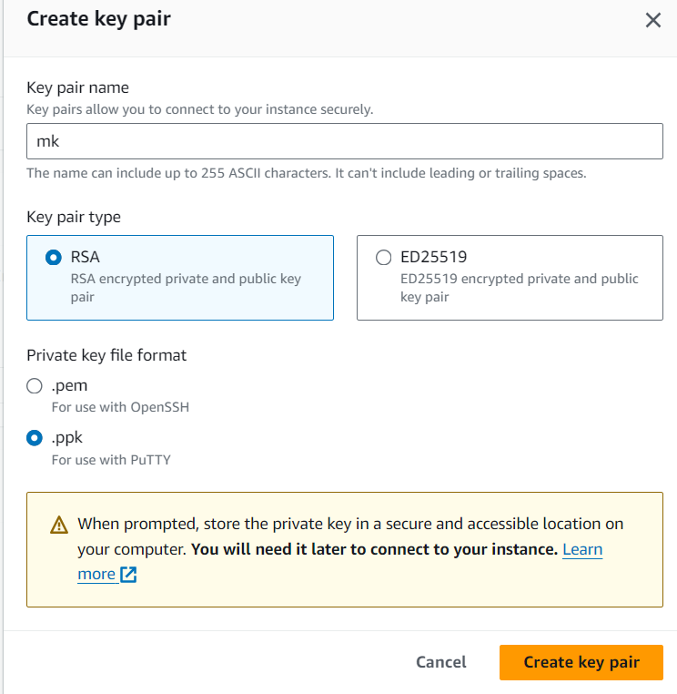

**Now launch instance**

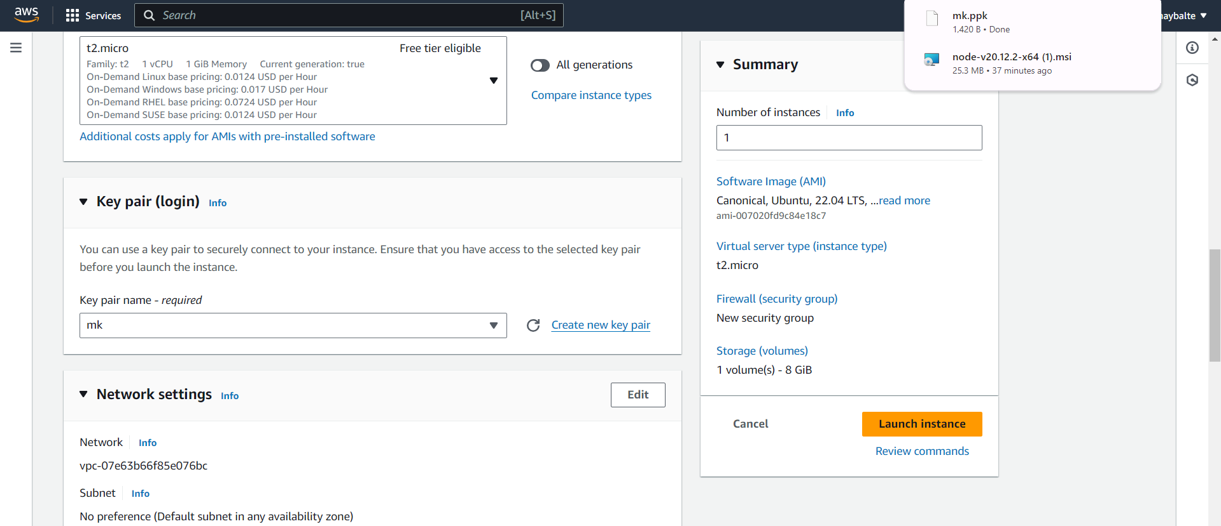

**After launch we run using two way**

**1.cconnect using aws**

**But when server is down then use putty**

**2. putty**

**Select instance and select connect**

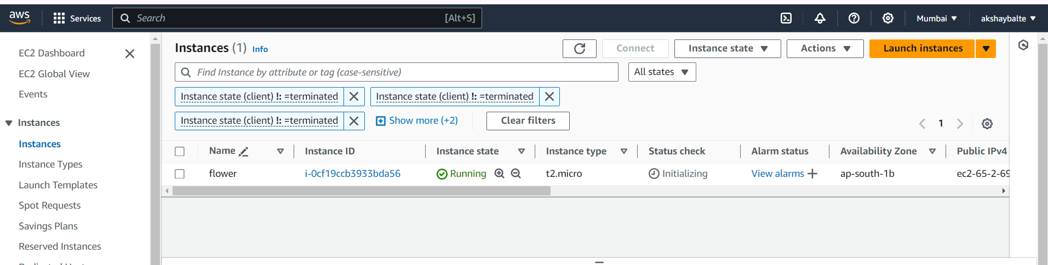

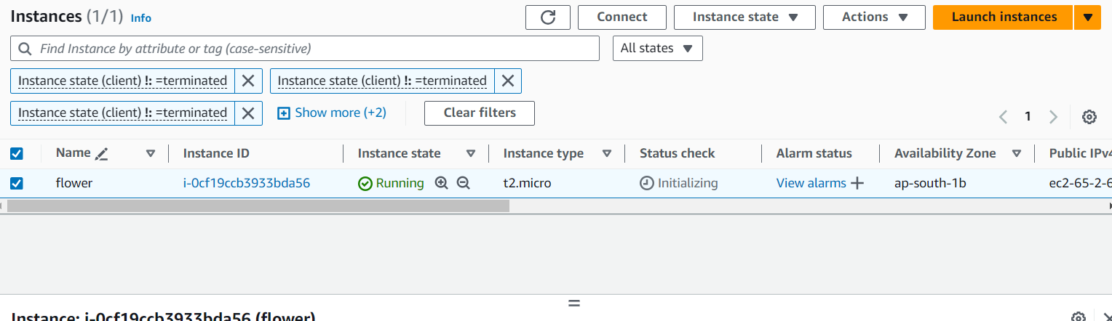

**Select connect**

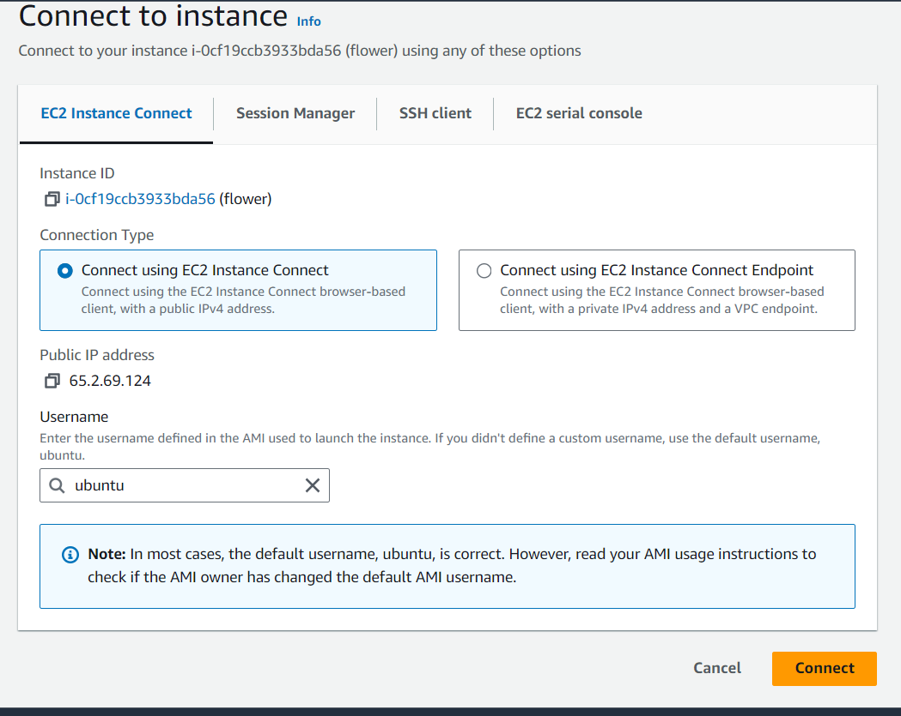

**New terminal is open linux**

1. **Sudo apt update**
2. **Sudo apt install nodejs**
3. **Sudo apt install npm**
4. **Node -v**
5. **Git -v**
6. **Mkdir name**
7. **Cd name**
8. **Git clone url**
9. **Cd filename**
10. **Npm install**
11. **node filename.js**

Open linux terminal



**Then update sercurity**

**Select instance**

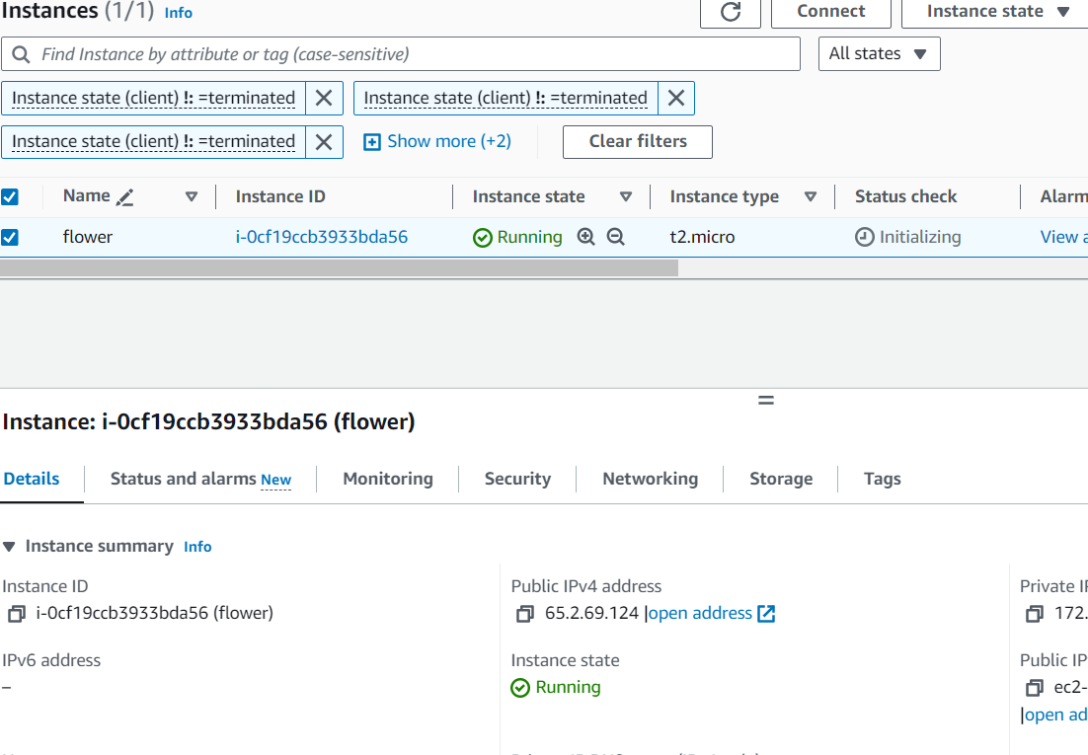



Select

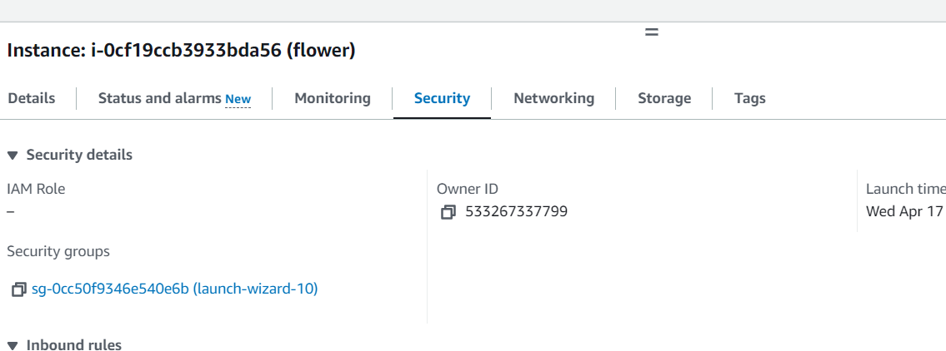



**Select edit inbound rule**

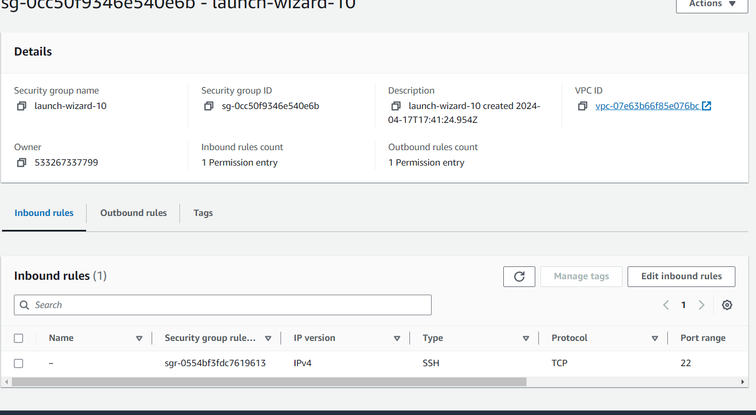



**Inbound rule add new rule**

**Add all traffic in it**

**And anywhere ipv4**

**And then save rule**

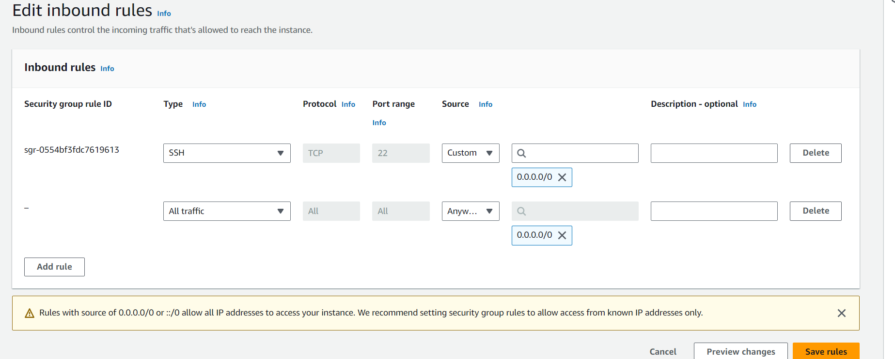

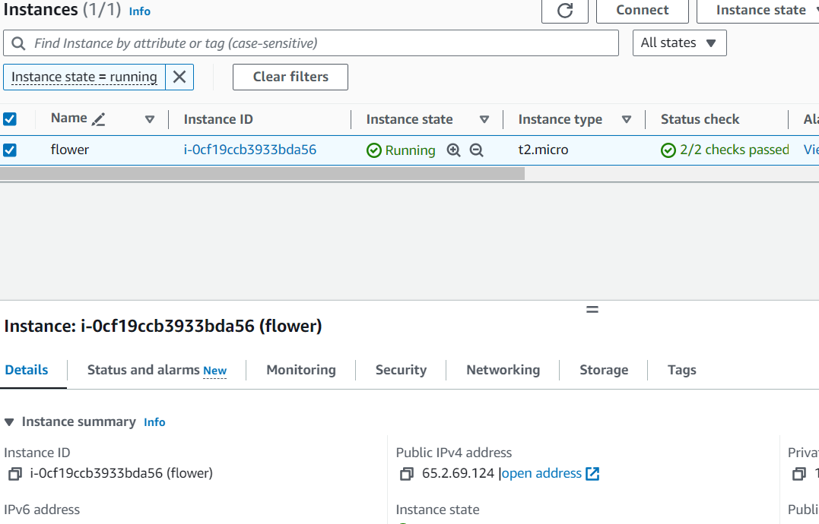

<http://65.2.69.124:8000>

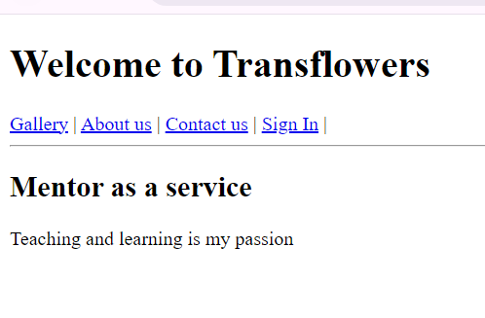

**Using putty**

**Give hostname as ip address in it**

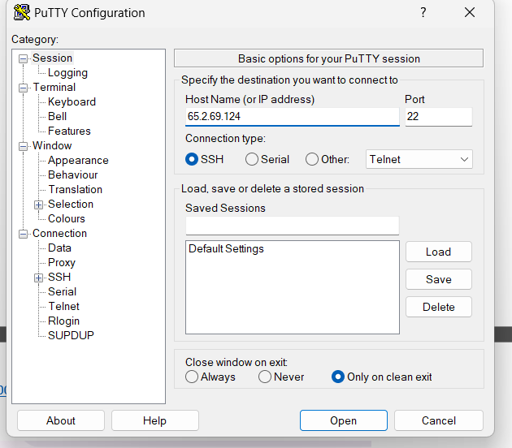



**Select data and add ubuntu in auto login**

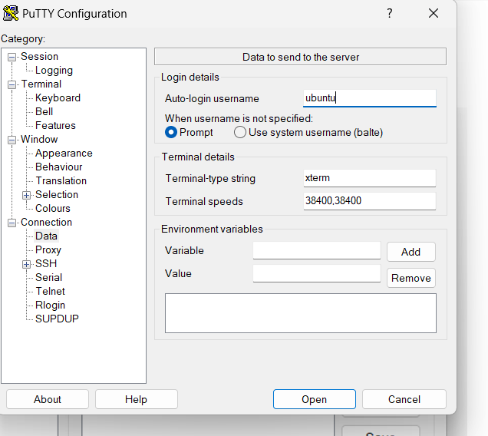



**Then select on ssh and then auth**

**On that auth – credentials**

**And browes the key and put on it**

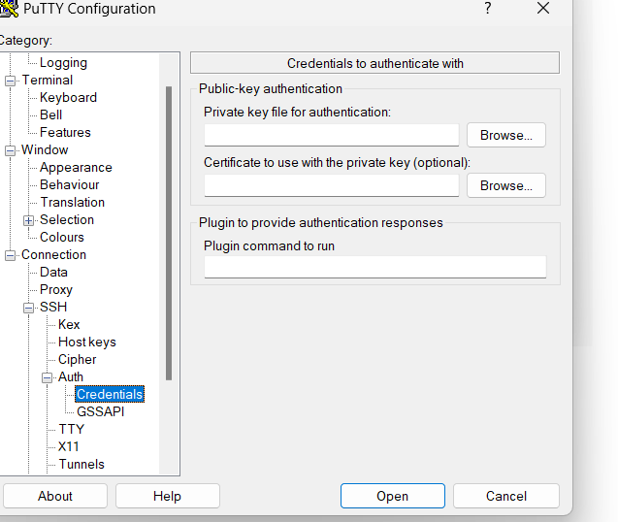



**It open and linux shell**

**Then add this command in it**

1. **sudo update**
2. **sudo apt install nodejs**
3. **sudo apt install npm**
4. **mkdir demo**
5. **cd demo**
6. **git clone url**
7. **ls**
8. **cd file**
9. **npm install**
10. **node server.js**