**PERSONAL BLOG ON IBM CLOUD STATIC WEB APPS**

**PHASE 3 PROJECT:**

Designing and developing a static travel blog website involves several steps:

1. Planning and Research:

* Determine the purpose and goals of your travel blog.
* Identify your target audience and niche.
* Research competitors and popular travel blogs for inspiration.

2. Choose a Domain and Hosting:

* Select a domain name that reflects your blog's theme.
* Choose a reliable web hosting provider.

3. Select a Website Builder or Framework:

* You can use a static site generator like Jekyll or a website builder like Wix.
* Choose a template or theme that suits your travel blog style.

4. Content Creation:

* Create high-quality content, including articles, photos, and videos.
* Organize your content into categories or topics.

5. Design and Layout:

* Customize the template to match your brand and style.
* Ensure your website is mobile-responsive.
* Create a user-friendly navigation structure.

6. SEO Optimization:

* Optimize your content for search engines by using relevant keywords.
* Set up meta titles and descriptions for each page.
* Create an XML sitemap.

7. Add Social Media Integration:

* Include social media sharing buttons.
* Display your social media profiles.

8. Implement Contact and About Page:

* Create an "About" page to introduce yourself.
* Add a contact page for reader inquiries.

9. Performance Optimization:

* Compress images and optimize page loading speed.
* Minimize code and use a Content Delivery Network (CDN) if needed.

10. Security Measures:

* Install an SSL certificate to secure your website.
* Regularly update your website software.

11. Testing:

* Test your website across different browsers and devices.
* Ensure all links are working correctly.

12. Launch Your Website:

* Point your domain to your hosting server.
* Make your website live for the public to access.

13. Content Management:

* Update your blog with new content regularly.
* Engage with your audience through comments and social media.

14. Backup and Maintenance:

* Regularly back up your website.
* Keep your plugins and themes up to date.

15. Monitor and Analyse:

* Use analytics tools to track website traffic and user behaviour.
* Adjust your content and strategy based on the data.

16. Promotion:

* Share your blog posts on social media.
* Collaborate with other travel bloggers or websites.

WEBSITE LAYOUT:

CSS CODE:

css

body, h1, h2, p {

margin: 1;

padding: 0.5;

}

header {

background-color: #333;

color: blue;

text-align: center;

}

header h1 {

font-size: 2rem;

}

header nav ul {

list-style: none;

}

header nav ul li {

display:inline;

margin: 0 5px;

}

header nav a {

text-decoration: none;

color: #fff;

}

.hero {

text-align: center;

padding: 0rem 2;

background-image: url("hero-background.jpg");

background-size: cover;

background-position:center;

color: black;

}

.blog-posts {

display: flex;

flex-wrap: wrap;

justify-content: space-around;

margin: 2rem;

}

.blog-posts article {

width: 45%;

margin: 0.5rem;

padding: 1rem;

}

footer {

background-color: #333;

color: #fff;

text-align: center;

}

HTML CODE:

<!DOCTYPE html>

<html lang="en">

<head>

<meta charset="UTF-8">

<meta name="viewport" content="width=device-width, initial-scale=1.0">

<link rel="stylesheet" href="abc.css">

<title>My Travel Blog</title>

</head>

<body>

<header>

<h1>My Travel Blog</h1>

<nav>

<ul>

<li><a href="index.html">Home</a></li>

<li><a href="about.html">About</a></li>

<li><a href="contact.html">Contact</a></li>

</ul>

</nav>

</header>

<section class="hero">

<h2>Welcome to My Travel Blog</h2>

<p>Explore the world with our travel .</p>

</section>

<section class="blog-posts">

<article>

<img src="C:\Users\ELCOT\Desktop\explore the world.jpg" width="400px" length="100px" alt="Travel Image 1">

<br><br><br><br>

<h3>Discovering Paradise in Bali</h3>

<p>Bali's stunning landscapes.</p>

</article>

<article>

<img src="C:\Users\ELCOT\Desktop\bali.jpg" width="500px" length="100px" alt="Travel Image 2">

<h3>Exploring the Streets of Tokyo</h3>

<p>Experience the culture and cuisine of Tokyo.</p>

</article>

<!-- Add more articles for other blog posts -->

</section>

<footer>

<p>&copy; 2023 My Travel Blog</p>

</footer>

</body>

</html>

OUTPUT:

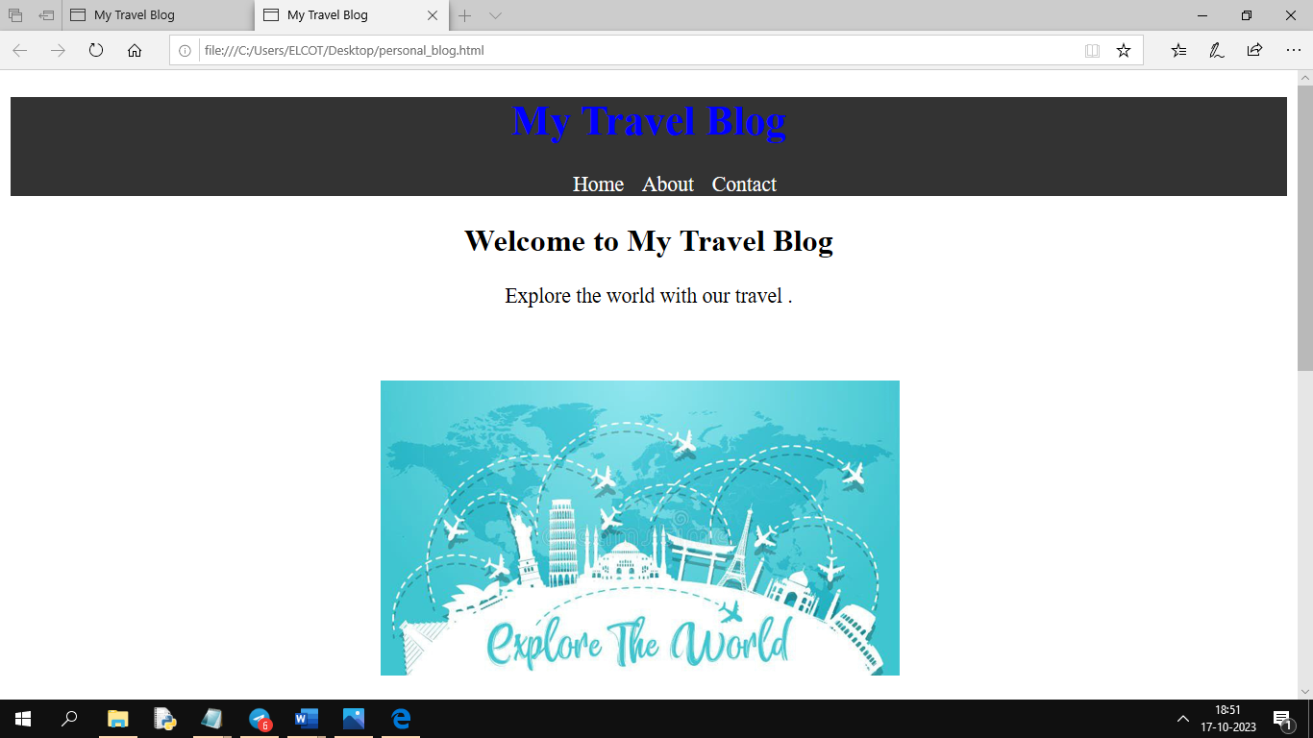

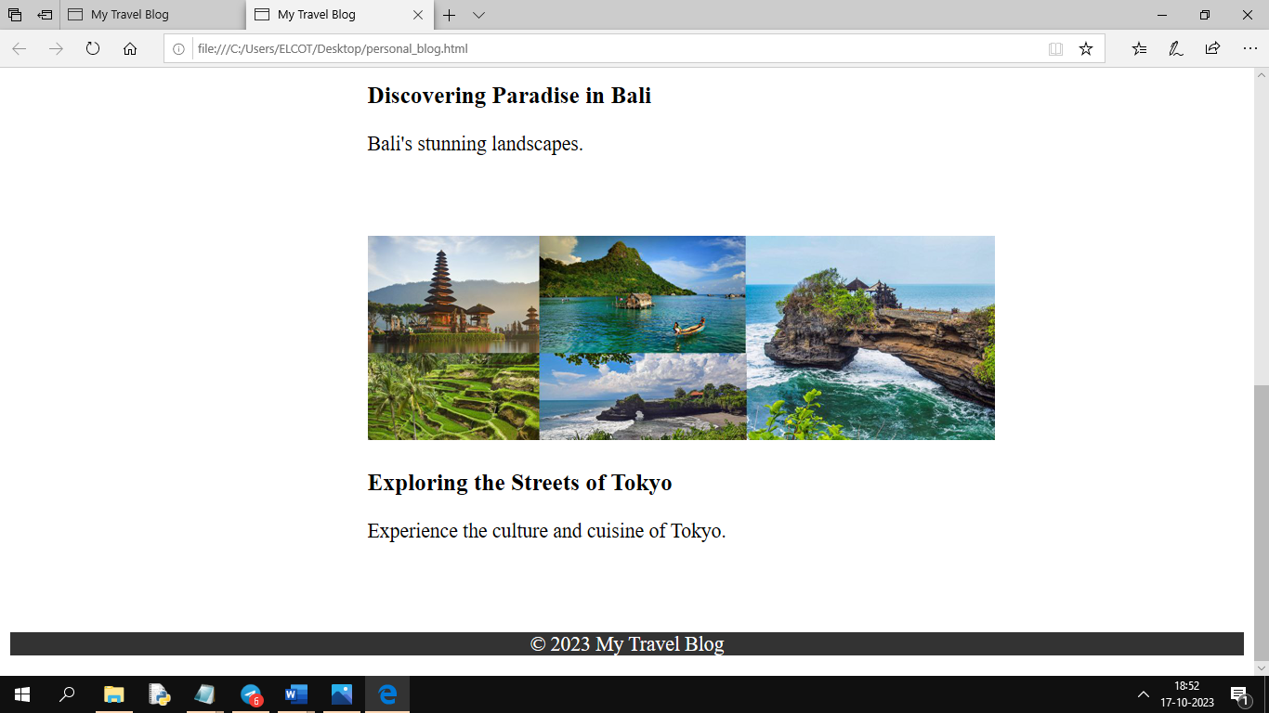

To create engaging travel content, you can start by choosing a captivating destination or travel experience. Then, combine it with stunning photos and a compelling story:

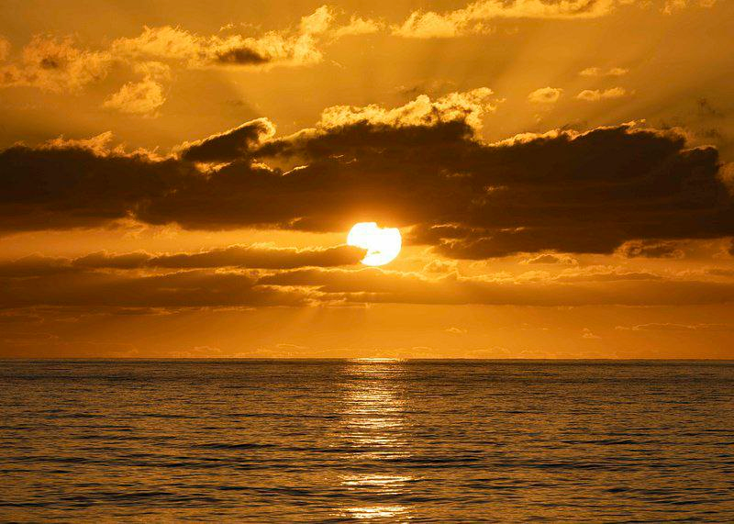

As the sun dipped below the horizon, casting a warm, golden glow over the pristine waters of the Aegean Sea, I found myself utterly entranced by the magic of Santorini. This island, with its iconic white-washed buildings and crystal-clear waters, had long been on my travel bucket list.

From exploring the charming streets of Oia to savoring delectable Greek cuisine at a seaside taverna, every moment in Santorini was a testament to its beauty and charm. And that sunset... well, it was nothing short of legendary.

Wandering through the labyrinthine streets of Oia, I stumbled upon hidden treasures at every turn. The whitewashed buildings, adorned with vibrant blue domes, seemed straight out of a postcard.

The culinary adventures in Santorini were a delight for the senses. From fresh seafood to succulent souvlaki, the flavors of Greece danced on my palate with each bite.

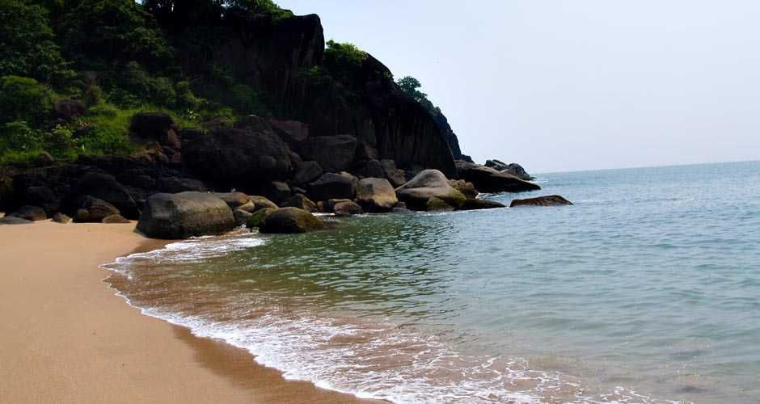

As I ventured off the beaten path, I discovered a secret beach spot, away from the crowds. The tranquil cove, with its pristine waters, felt like a well-guarded secret that I had stumbled upon.

Santorini, with its beauty, culture, and cuisine, had left an indelible mark on my heart. This journey was a reminder that sometimes, the most extraordinary experiences are found in the most unexpected places.

**Presented by,**

K.Rajeshwari

V.Janani

S.Anushka