REACT.JS

**1)CRICKET APP**

### Project Structure

cricketapp/

├── src/

│ ├── components/

│ │ ├── ListofPlayers.jsx

│ │ └── IndianPlayers.jsx

│ ├── App.jsx

│ └── main.jsx

├── index.html

└── package.json

### Step-by-Step Implementation

#### 1. ListofPlayers.jsx

import React from 'react';

const ListofPlayers = () => {

const players = [

{ name: 'Virat Kohli', score: 98 },

{ name: 'Rohit Sharma', score: 88 },

{ name: 'KL Rahul', score: 65 },

{ name: 'Shubman Gill', score: 72 },

{ name: 'Shreyas Iyer', score: 68 },

{ name: 'Ravindra Jadeja', score: 45 },

{ name: 'Hardik Pandya', score: 82 },

{ name: 'R. Ashwin', score: 60 },

{ name: 'Mohammed Shami', score: 50 },

{ name: 'Jasprit Bumrah', score: 90 },

{ name: 'Ishan Kishan', score: 66 }

];

const lowScorers = players.filter(player => player.score < 70);

return (

<div>

<h2>All Players:</h2>

<ul>

{players.map((player, index) => (

<li key={index}>{player.name} - {player.score}</li>

))}

</ul>

<h3>Players with score below 70:</h3>

<ul>

{lowScorers.map((player, index) => (

<li key={index}>{player.name} - {player.score}</li>

))}

</ul>

</div>

);

};

export default ListofPlayers;

#### 2. IndianPlayers.jsx

import React from 'react';

const IndianPlayers = () => {

const allPlayers = [

'Virat', 'Rohit', 'Rahul', 'Gill', 'Iyer', 'Jadeja',

'Hardik', 'Ashwin', 'Shami', 'Bumrah', 'Ishan'

];

const oddTeam = allPlayers.filter((_, index) => index % 2 !== 0);

const evenTeam = allPlayers.filter((_, index) => index % 2 === 0);

const [v1, v2, ...restEven] = evenTeam;

const [o1, o2, ...restOdd] = oddTeam;

const T20Players = ['Surya', 'Rinku', 'Arshdeep'];

const RanjiPlayers = ['Pujara', 'Rahane', 'Saha'];

const mergedPlayers = [...T20Players, ...RanjiPlayers];

return (

<div>

<h2>Odd Team Players:</h2>

<ul>

{[o1, o2, ...restOdd].map((player, index) => (

<li key={index}>{player}</li>

))}

</ul>

<h2>Even Team Players:</h2>

<ul>

{[v1, v2, ...restEven].map((player, index) => (

<li key={index}>{player}</li>

))}

</ul>

<h2>Merged Players (T20 + Ranji):</h2>

<ul>

{mergedPlayers.map((player, index) => (

<li key={index}>{player}</li>

))}

</ul>

</div>

);

};

export default IndianPlayers;

#### 3. App.jsx

import React from 'react';

import ListofPlayers from './components/ListofPlayers';

import IndianPlayers from './components/IndianPlayers';

const App = () => {

const flag = true; // Change this to false to see the other component

return (

<div>

<h1>🏏 Cricket App</h1>

{flag ? <ListofPlayers /> : <IndianPlayers />}

</div>

);

};

export default App;

#### 4. main.jsx

import React from 'react';

import ReactDOM from 'react-dom/client';

import App from './App';

ReactDOM.createRoot(document.getElementById('root')).render(

<React.StrictMode>

<App />

</React.StrictMode>

);

#### 5. index.html (basic Vite setup or similar)

<!DOCTYPE html>

<html lang="en">

<head>

<meta charset="UTF-8" />

<title>Cricket App</title>

</head>

<body>

<div id="root"></div>

</body>

</html>

### How to Run

npm create vite@latest cricketapp --template react

cd cricketapp

npm install

npm run dev

## OUTPUT:

## When flag = true

### Displays: ListofPlayers component

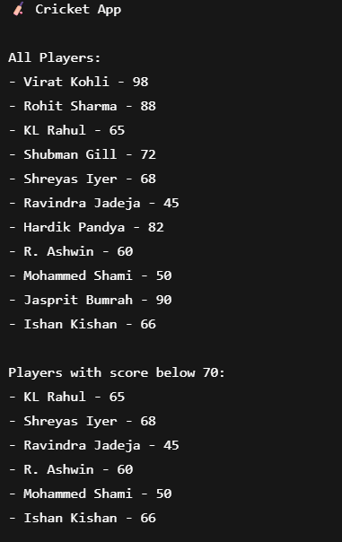

## When flag = false

### Displays: IndianPlayers component

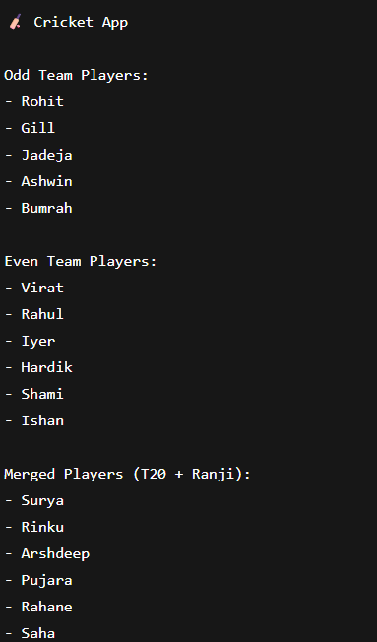

1. **OFFICE SPACE RENTAL APP**

## File Structure (Basic React App)

officespacerentalapp/

├── src/

│ ├── App.jsx

│ └── main.jsx

├── index.html

└── package.json

### App.jsx

import React from 'react';

const App = () => {

// JSX element: Heading

const heading = <h1>🏢 Office Space Rental App</h1>;

// Office list

const officeSpaces = [

{

name: 'Sunset Tower',

rent: 55000,

address: '123 Palm Street, Los Angeles',

image: 'https://via.placeholder.com/300x200?text=Sunset+Tower'

},

{

name: 'Downtown Hub',

rent: 75000,

address: '789 Metro Ave, New York',

image: 'https://via.placeholder.com/300x200?text=Downtown+Hub'

},

{

name: 'Green Valley Tech Park',

rent: 60000,

address: '456 Silicon Road, San Jose',

image: 'https://via.placeholder.com/300x200?text=Green+Valley'

}

];

return (

<div style={{ fontFamily: 'Arial', padding: '20px' }}>

{heading}

{officeSpaces.map((office, index) => (

<div key={index} style={{ border: '1px solid #ddd', padding: '10px', marginBottom: '20px' }}>

{/* JSX Attribute: Image */}

<img src={office.image} alt={office.name} style={{ width: '100%', height: '200px', objectFit: 'cover' }} />

{/* JSX Object Rendering */}

<h2>{office.name}</h2>

<p>

Rent:

<span

style={{

color: office.rent > 60000 ? 'green' : 'red',

fontWeight: 'bold',

marginLeft: '5px'

}}

>

₹{office.rent.toLocaleString()}

</span>

</p>

<p>Address: {office.address}</p>

</div>

))}

</div>

);

};

export default App;

### main.jsx

import React from 'react';

import ReactDOM from 'react-dom/client';

import App from './App';

ReactDOM.createRoot(document.getElementById('root')).render(

<React.StrictMode>

<App />

</React.StrictMode>

);

### index.html (Basic)

<!DOCTYPE html>

<html lang="en">

<head>

<meta charset="UTF-8" />

<title>Office Space Rental App</title>

</head>

<body>

<div id="root"></div>

</body>

</html>

## Output

Office Space Rental App

Sunset Tower

Rent: ₹55,000

Address: 123 Palm Street, Los Angeles

Downtown Hub

Rent: ₹75,000

Address: 789 Metro Ave, New York

Green Valley Tech Park

Rent: ₹60,000

Address: 456 Silicon Road, San Jose

### How to Run:

npm create vite@latest officespacerentalapp --template react

cd officespacerentalapp

npm install

npm run dev

**3)CURRENCY CONVERTOR**

### 📁 Project Structure

eventexamplesapp/

├── src/

│ ├── App.jsx

│ ├── CurrencyConvertor.jsx

│ └── main.jsx

├── index.html

└── package.json

### App.jsx

import React, { useState } from 'react';

import CurrencyConvertor from './CurrencyConvertor';

const App = () => {

const [counter, setCounter] = useState(0);

// Multiple functions handler

const handleIncrease = () => {

increment();

sayHello();

};

const increment = () => {

setCounter(prev => prev + 1);

};

const sayHello = () => {

console.log("Hello! This is a static message.");

alert("Hello! This is a static message.");

};

const decrement = () => {

setCounter(prev => prev - 1);

};

// Say welcome handler

const sayWelcome = (message) => {

alert(`Message: ${message}`);

};

// Synthetic event handler

const onPress = (event) => {

console.log("I was clicked");

alert("I was clicked");

};

return (

<div style={{ padding: '20px', fontFamily: 'Arial' }}>

<h1>🎉 Event Examples App</h1>

<h2>Counter: {counter}</h2>

<button onClick={handleIncrease}>Increment</button>

<button onClick={decrement}>Decrement</button>

<hr />

<button onClick={() => sayWelcome("Welcome to Event App!")}>Say Welcome</button>

<hr />

<button onClick={onPress}>Click Me (OnPress)</button>

<hr />

<CurrencyConvertor />

</div>

);

};

export default App;

### CurrencyConvertor.jsx

import React, { useState } from 'react';

const CurrencyConvertor = () => {

const [rupees, setRupees] = useState('');

const [euros, setEuros] = useState('');

const handleSubmit = () => {

const rupeeAmount = parseFloat(rupees);

if (!isNaN(rupeeAmount)) {

const euroValue = (rupeeAmount / 90).toFixed(2); // 1 Euro ≈ ₹90

setEuros(euroValue);

} else {

alert("Please enter a valid number");

}

};

return (

<div>

<h2>💱 Currency Converter (INR → EUR)</h2>

<input

type="text"

placeholder="Enter amount in ₹"

value={rupees}

onChange={(e) => setRupees(e.target.value)}

/>

<button onClick={handleSubmit}>Convert</button>

{euros && (

<p>Converted Amount: €{euros}</p>

)}

</div>

);

};

export default CurrencyConvertor;

**main.jsx**

import React from 'react';

import ReactDOM from 'react-dom/client';

import App from './App';

ReactDOM.createRoot(document.getElementById('root')).render(

<React.StrictMode>

<App />

</React.StrictMode>

);

### index.html

<!DOCTYPE html>

<html lang="en">

<head>

<meta charset="UTF-8" />

<title>Event Examples App</title>

</head>

<body>

<div id="root"></div>

</body>

</html>

## OUTPUT

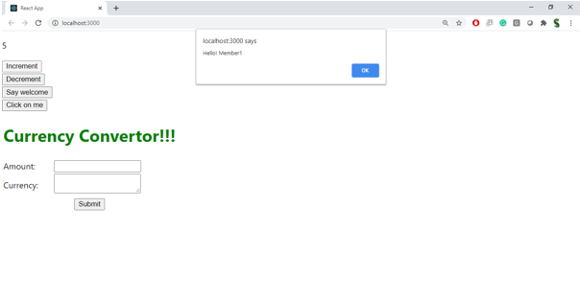

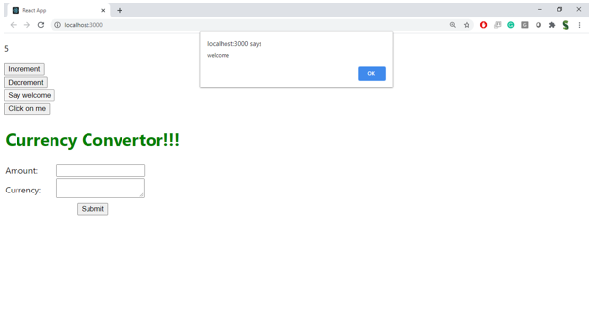

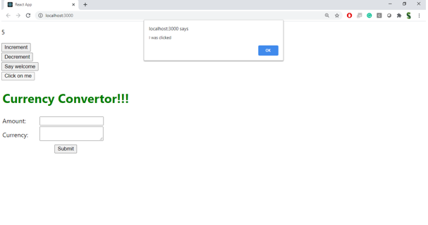

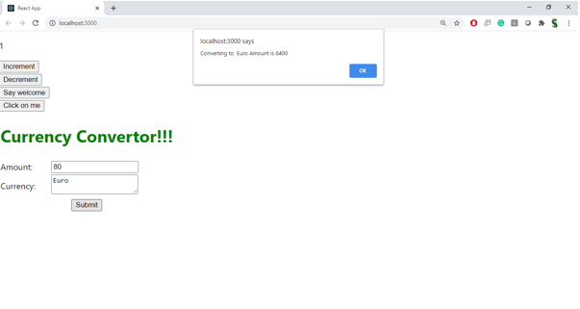

## 4)TICKET BOOKING SYSTEM

## Folder Structure

ticketbookingapp/

├── src/

│ ├── App.jsx

│ ├── components/

│ │ ├── GuestPage.jsx

│ │ └── UserPage.jsx

│ └── main.jsx

├── index.html

└── package.json

## App.jsx

import React, { useState } from 'react';

import GuestPage from './components/GuestPage';

import UserPage from './components/UserPage';

const App = () => {

const [isLoggedIn, setIsLoggedIn] = useState(false);

const handleLogin = () => {

setIsLoggedIn(true);

};

const handleLogout = () => {

setIsLoggedIn(false);

};

return (

<div style={{ padding: '20px', fontFamily: 'Arial' }}>

<h1>✈️ Ticket Booking App</h1>

{isLoggedIn ? (

<>

<UserPage />

<button onClick={handleLogout} style={{ marginTop: '20px' }}>Logout</button>

</>

) : (

<>

<GuestPage />

<button onClick={handleLogin} style={{ marginTop: '20px' }}>Login</button>

</>

)}

</div>

);

};

export default App;

## components/GuestPage.jsx

import React from 'react';

const GuestPage = () => {

const flights = [

{ flightNo: 'AI101', destination: 'New Delhi', time: '10:00 AM' },

{ flightNo: 'EK202', destination: 'Dubai', time: '2:30 PM' },

{ flightNo: 'BA303', destination: 'London', time: '6:45 PM' }

];

return (

<div>

<h2>Welcome, Guest 👋</h2>

<p>Please log in to book tickets. Here are available flights:</p>

<ul>

{flights.map((flight, index) => (

<li key={index}>

✈️ {flight.flightNo} - {flight.destination} at {flight.time}

</li>

))}

</ul>

</div>

);

};

export default GuestPage;

## components/UserPage.jsx

import React from 'react';

const UserPage = () => {

const flights = [

{ flightNo: 'AI101', destination: 'New Delhi', time: '10:00 AM' },

{ flightNo: 'EK202', destination: 'Dubai', time: '2:30 PM' },

{ flightNo: 'BA303', destination: 'London', time: '6:45 PM' }

];

const handleBooking = (flightNo) => {

alert(`Ticket booked for flight ${flightNo}`);

};

return (

<div>

<h2>Welcome, User ✅</h2>

<p>You can now book tickets:</p>

<ul>

{flights.map((flight, index) => (

<li key={index}>

✈️ {flight.flightNo} - {flight.destination} at {flight.time}

<button onClick={() => handleBooking(flight.flightNo)} style={{ marginLeft: '10px' }}>

Book Ticket

</button>

</li>

))}

</ul>

</div>

OUTPUT

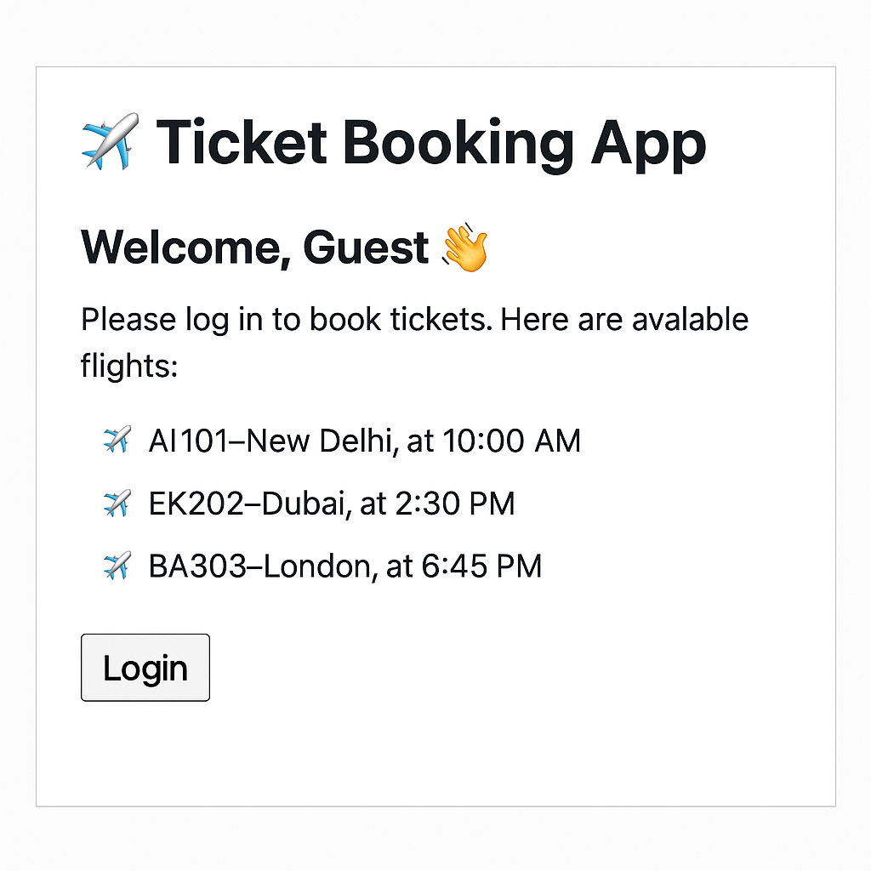

1. **BLOGGER APP**

## Project Structure:

bloggerapp/

├── src/

│ ├── App.jsx

│ ├── components/

│ │ ├── BookDetails.jsx

│ │ ├── BlogDetails.jsx

│ │ └── CourseDetails.jsx

│ └── main.jsx

├── index.html

└── package.json

### App.jsx

import React, { useState } from 'react';

import BookDetails from './components/BookDetails';

import BlogDetails from './components/BlogDetails';

import CourseDetails from './components/CourseDetails';

const App = () => {

const [activeComponent, setActiveComponent] = useState('book'); // default view

// 1. if-else

const renderWithIfElse = () => {

if (activeComponent === 'book') {

return <BookDetails />;

} else if (activeComponent === 'blog') {

return <BlogDetails />;

} else {

return <CourseDetails />;

}

};

// 2. Switch case rendering

const renderWithSwitch = () => {

switch (activeComponent) {

case 'book':

return <BookDetails />;

case 'blog':

return <BlogDetails />;

case 'course':

return <CourseDetails />;

default:

return <p>Component not found</p>;

}

};

return (

<div style={{ padding: '20px', fontFamily: 'Arial' }}>

<h1>📝 Blogger App</h1>

<div style={{ marginBottom: '20px' }}>

<button onClick={() => setActiveComponent('book')}>Book</button>

<button onClick={() => setActiveComponent('blog')}>Blog</button>

<button onClick={() => setActiveComponent('course')}>Course</button>

</div>

{/* Conditional rendering techniques */}

<h2>1. Using If-Else</h2>

{renderWithIfElse()}

<hr />

<h2>2. Using Ternary Operator</h2>

{

activeComponent === 'book' ? (

<BookDetails />

) : activeComponent === 'blog' ? (

<BlogDetails />

) : (

<CourseDetails />

)

}

<hr />

<h2>3. Using Logical AND (&&)</h2>

{activeComponent === 'book' && <BookDetails />}

{activeComponent === 'blog' && <BlogDetails />}

{activeComponent === 'course' && <CourseDetails />}

<hr />

<h2>4. Using Switch Statement</h2>

{renderWithSwitch()}

</div>

);

};

export default App;

### components/BookDetails.jsx

import React from 'react';

const BookDetails = () => {

return (

<div>

<h3>📚 Book Details</h3>

<p>Title: React Essentials</p>

<p>Author: Dan Abramov</p>

</div>

);

};

export default BookDetails;

### components/BlogDetails.jsx

import React from 'react';

const BlogDetails = () => {

return (

<div>

<h3>✍️ Blog Details</h3>

<p>Title: Understanding React Hooks</p>

<p>By: Jane Doe</p>

</div>

);

};

export default BlogDetails;

### components/CourseDetails.jsx

import React from 'react';

const CourseDetails = () => {

return (

<div>

<h3>🎓 Course Details</h3>

<p>Course: Full Stack Development</p>

<p>Duration: 12 Weeks</p>

</div>

);

};

export default CourseDetails;

### main.jsx

import React from 'react';

import ReactDOM from 'react-dom/client';

import App from './App';

ReactDOM.createRoot(document.getElementById('root')).render(

<React.StrictMode>

<App />

</React.StrictMode>

);

### To Run:

npm create vite@latest bloggerapp --template react

cd bloggerapp

npm install

npm run dev

OUTPUT

