SQL (Structured Query Language)
- SQL stands for Structured Query Language.
- SQL is pronounced as "sequel" by some, while "S-Q-L" by others.
- SQL stands for Structured Query Language. It is a standardised programming language used to manage and manipulate relational databases.
- SQL allows users to perform operations such as querying, updating, inserting, and deleting data within a database.
- Originally developed in the 1970s by IBM.

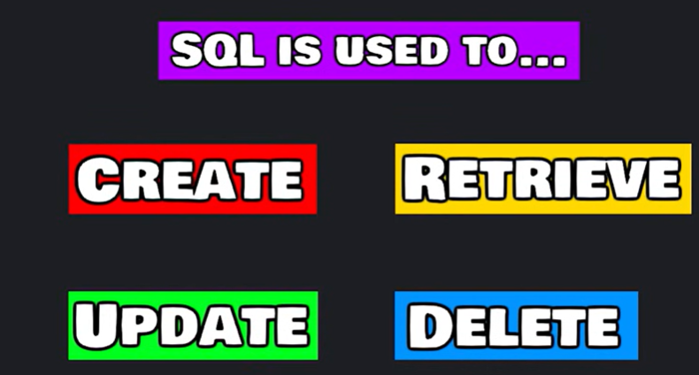

Managing streaming data like transactions, bill statements, and records in a relational database, tables is easier than paper, pen and paragraphs.
Handling data in tables and electronics is an easier way.
Generally, 2 types of databases:
- Relational
- Non-Relational
Relational Database (RDBMS):
A relational database stores data in tables with rows and columns, and relationships between tables are defined using keys.
Key Features
- Uses structured tables
- Follows a fixed schema
- Supports SQL (Structured Query Language)
- Maintains relationships using primary keys and foreign keys
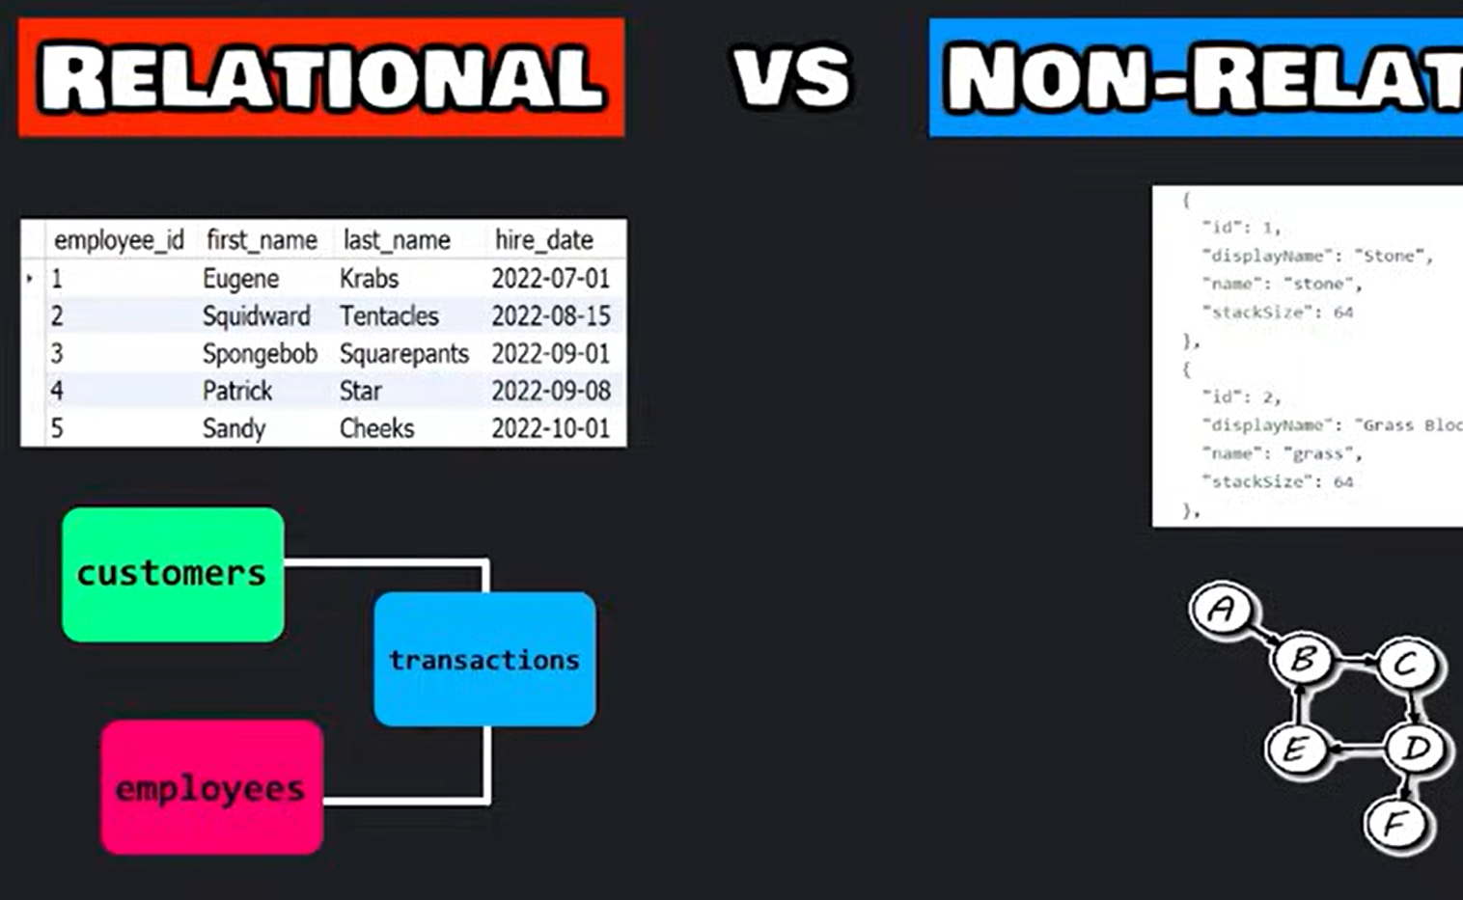
Example
Student_ID | Name | Department
1 | John | IT
2 | Alice | CSE

Popular Relational Databases
- MySQL
- Oracle Database
- PostgreSQL
- Microsoft SQL Server
Real-Time Example
A banking system uses a relational database to store:
- Customer details
- Account information
- Transactions
All tables are connected through relationships.

Non-Relational Database (NoSQL):
A non-relational database stores data in flexible formats such as documents, key-value pairs, graphs, or collections instead of tables.
Key Features
- Flexible schema
- Handles large volumes of unstructured data
- Faster for big data and real-time applications
- Does not always require SQL
Example (Document Format)
{
"name": "John",
"department": "IT",
"skills": ["Python", "SQL"]
}
Popular Non-Relational Databases
- MongoDB
- Cassandra
- Redis
- Firebase
Real-Time Example
A social media application uses non-relational databases to store:
- Posts
- Comments
- Images
- User activity logs
because the data structure changes frequently.



Difference between Relational Database and Non-Relational Database:
Relational Database | Non-Relational Database
Stores data in tables | Stores data in flexible formats
Fixed schema | Dynamic schema
Uses SQL | Uses NoSQL methods
Best for structured data | Best for unstructured/big data
Example: MySQL | Example: MongoDB

Database Management System:
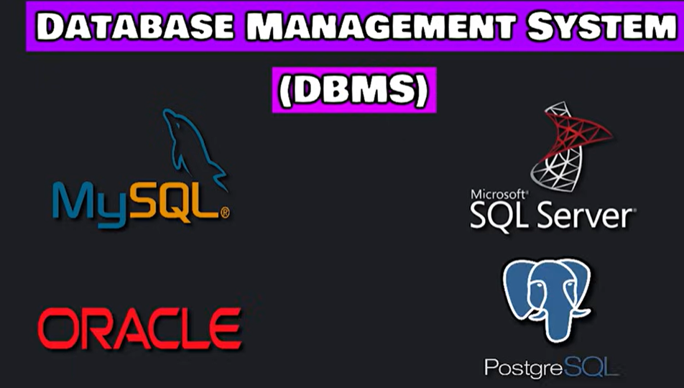
A DBMS is software used to store, manage, retrieve, and organise data efficiently.
What is DBMS?
A Database Management System (DBMS) acts as an interface between:
- the user/application
- and the database
It helps in:
- Creating databases
- Storing data
- Updating records
- Retrieving information
- Managing security and backup
1. MySQL

Definition
MySQL is an open-source relational database management system that uses SQL.

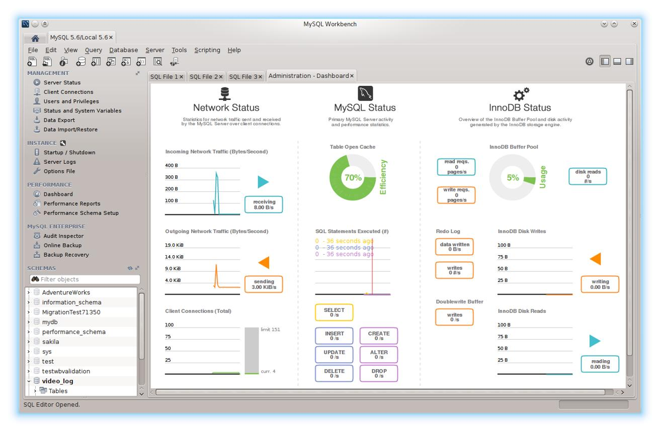
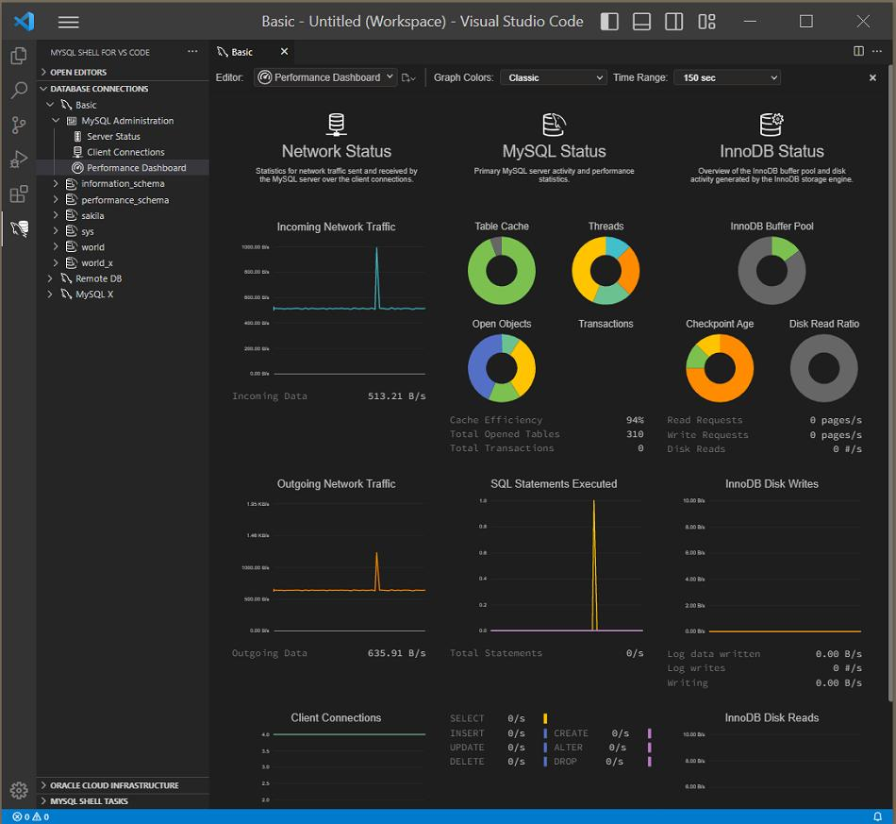
Features
- Fast and easy to use
- Stores data in tables
- Widely used for web applications
- Supports SQL queries
Real-Time Example
Used in:
- Websites
- E-commerce applications
- Student management systems
Example Query
SELECT * FROM students;

2. Oracle Database
Definition
Oracle Database is a powerful enterprise-level relational DBMS developed by Oracle Corporation.
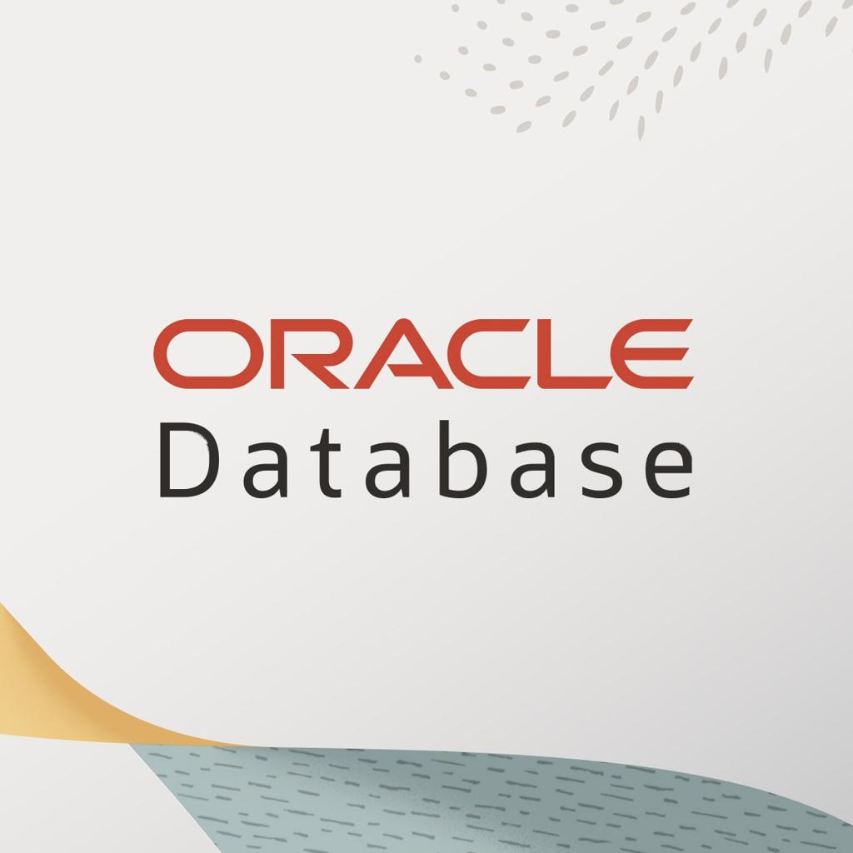
Features
- Highly secure
- Handles very large databases
- Supports advanced transactions
- Used in large organizations

Real-Time Example
Used in:
- Banking systems
- Government organizations
- Large enterprises

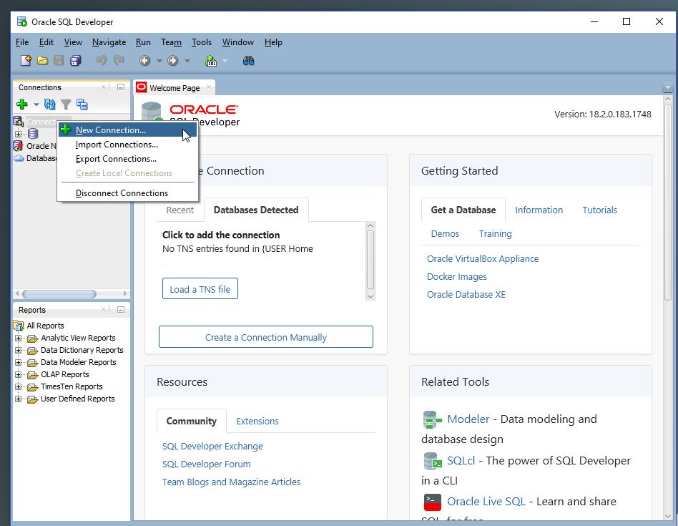
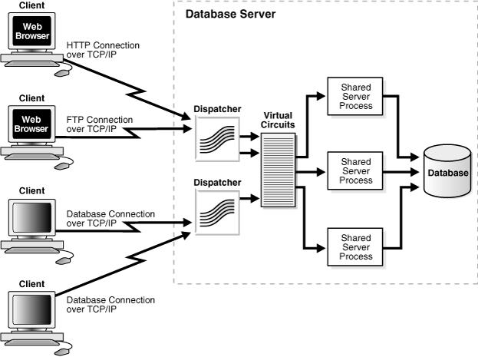
3. Microsoft SQL Server
Definition
Microsoft SQL Server is a relational DBMS developed by Microsoft.
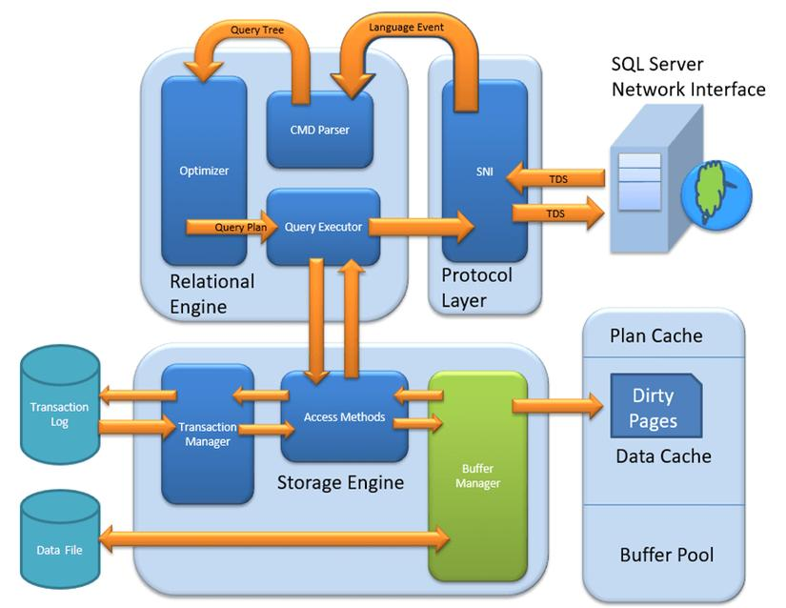
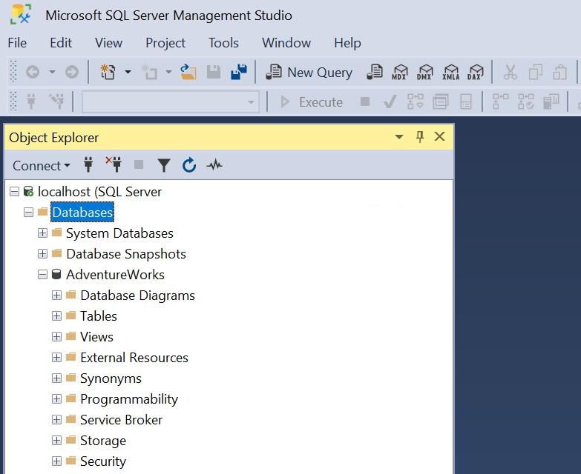
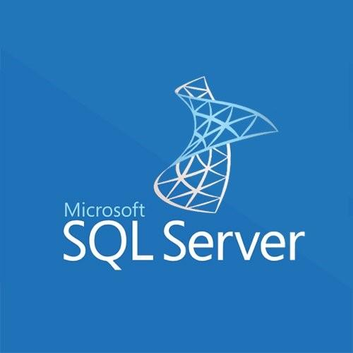
Features
- Works well with Windows applications
- Supports data analysis and reporting
- Strong security features
- User-friendly tools
Real-Time Example
Used in:
- Business applications
- ERP systems
- Corporate software
4. PostgreSQL
Definition
PostgreSQL is an advanced open-source relational database system.
Features
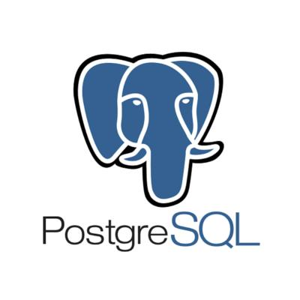
- Highly reliable
- Supports complex queries
- Good for large-scale applications
- Extensible and customizable
Real-Time Example
Used in:
- Data analytics platforms
- GIS applications
- Enterprise software
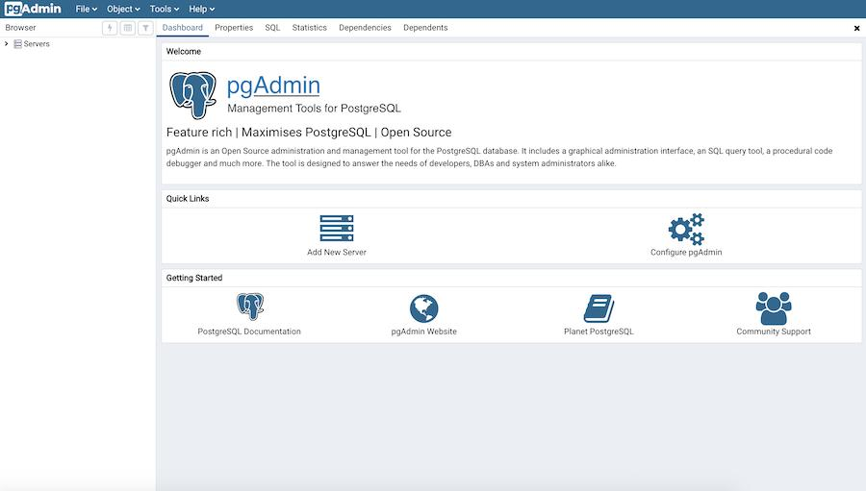
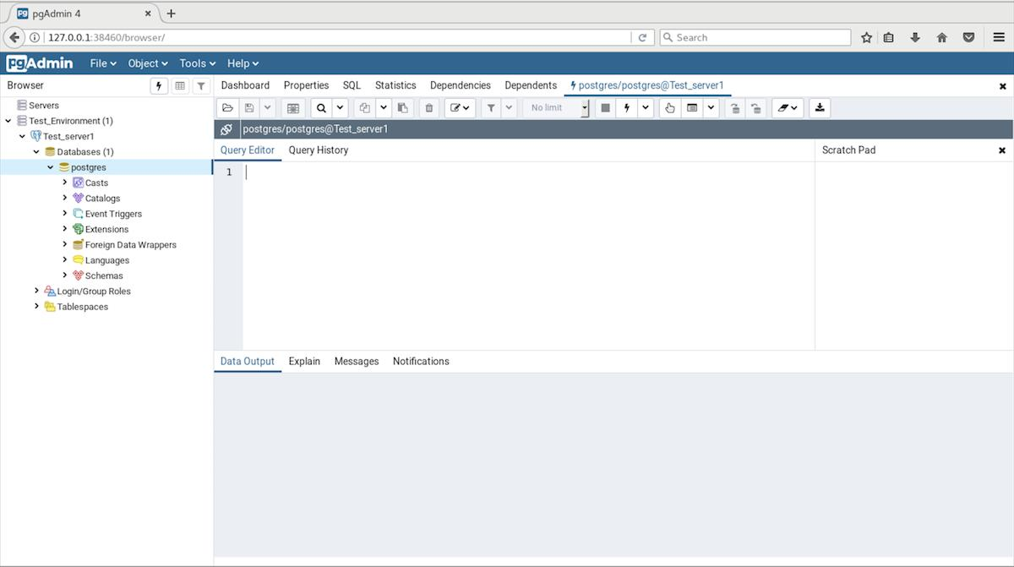
Simple Summary Table
DBMS | Developed By | Type | Common Use
MySQL | Oracle Corporation | Relational | Websites & Web Apps
Oracle Database | Oracle Corporation | Relational | Banking & Enterprises
Microsoft SQL Server | Microsoft | Relational | Business Applications
PostgreSQL | Open Source Community | Relational | Analytics & Large Applications

