Project report on

**EMPLOYEE ATTENDENCE AND PAYROLL SYSYTEM**

**Submitted in partial fulfillment of the requirements for the award of the degree**

Of

**BACHELOR OF TECHNOLOGY**

In

**COMPUTER SCIENCE AND ENGINEERING(ARTIFICIAL**

**INTELLIGENCE AND MACHINE LEARNING)**



**Department of Computer Science and Engineering**

**(Artificial Intelligence and Machine learning)**

**BVRIT HYDERABAD College of Engineering for Women**

(Approved by AICTE, New Delhi and Affiliated to JNTUH, Hyderabad)

(Accredited by NBA – EEE, ECE, CSE and IT and NAAC with A grade) Bachupally, Hyderabad – 500090

2023-24

**CERTIFICATE**

This is to certify that the Technical Report titled “**EMPLOYEE ATTENDENCE AND PAYROLL SYSYTEM**” is being submitted by Team 11&12 of the II B.Tech Computer Science and Engineering, (Academic year 2023- 2024) during the II semester B.Tech in CSE(AI&ML)

|  |  |
| --- | --- |
| **Mrs.V.Asha**  **Assistant Professor,**  Department of  Computer Science  And Engineering | **DONE BY:**  Megana-22WH1A6603  Devika-22WH1A6611  Indu- 22WH1A6619  Bhavya-22WH1A6624  Kritika-22WH1A6625  Jahnvi-22WH1A6640  Prasanna-22WH1A6643  Gayathri-22WH1A6656  Sushma-23WH5A6606  Rajeshwari-23WH1A6607 |

(AI&ML)

**INDEX**

|  |  |  |
| --- | --- | --- |
| **S.NO** | **TOPIC** | **Page.No** |
| **1.** | **Introduction** |  |
| **2.** | **Abstract** |  |
| **3.** | **Requirements** |  |
| **4.** | **Entity Representation Model** |  |
| **5.** | **Code Implementation** |  |
| **6.** | **Queries** |  |
| **7.** | **Testing And Results** |  |

**INTRODUCTION**

In today's competitive business environment, efficient management of employee attendance and payroll is crucial for organizational success. Companies need a robust system to track employee work hours, manage leave requests, accurately calculate payroll, and ensure compliance with tax regulations. A well-designed Employee Attendance and Payroll System not only streamlines administrative processes but also enhances productivity and employee satisfaction by providing transparent and timely payroll management.

**ABSTRACT**

This project proposes the development of an Employee Attendance and Payroll System, designed to facilitate comprehensive management of employee-related data. The system encompasses several core functionalities, including attendance tracking, work hour calculations, leave request management, payroll computations, tax deductions, and maintenance of employee information. The database-driven system aims to automate and simplify the administrative tasks associated with human resource management, ensuring accuracy and efficiency in payroll processing and attendance monitoring.

The system will feature a relational database with interconnected tables for employees, departments, attendance records, leave requests, payroll details, and tax information. Key functionalities include recording employee check-in and check-out times, calculating total hours worked, handling various types of leave requests, generating payroll based on worked hours and predefined salary rates, and applying tax deductions to compute net pay. The system will also support detailed reporting capabilities, allowing administrators to generate insights into attendance patterns, payroll expenses, and leave utilization.

By integrating these functionalities into a unified system, the proposed solution aims to reduce manual errors, enhance data accuracy, and improve overall administrative efficiency. This project will ultimately contribute to better resource management and compliance with legal and financial regulations, providing a reliable tool for organizations to manage their human resources effectively.

The system will feature a relational database with interconnected tables for employees, departments, attendance records, leave requests, payroll details, and tax information. Key functionalities include recording employee check-in and check-out times, calculating total hours worked, handling various types of leave requests, generating payroll based on worked hours and predefined salary rates, and applying tax deductions to compute net pay. The system will also support detailed reporting capabilities, allowing administrators to generate insights into attendance patterns, payroll expenses, and leave utilization.

By integrating these functionalities into a unified system, the proposed solution aims to reduce manual errors, enhance data accuracy, and improve overall administrative efficiency. This project will ultimately contribute to better resource management and compliance with legal and financial regulations, providing a reliable tool for organizations to manage their human resources effectively.

**TECHNICAL REQUIREMENTS:**

1. Database Management System (DBMS):

* Use a relational DBMS such as MySQL, PostgreSQL, or SQL Server.
* Ensure the DBMS supports ACID (Atomicity, Consistency, Isolation, Durability) properties for reliable transactions.

1. Perform thorough testing, including unit tests, integration tests, and end-to-end tests.

**Entity Representation Model**

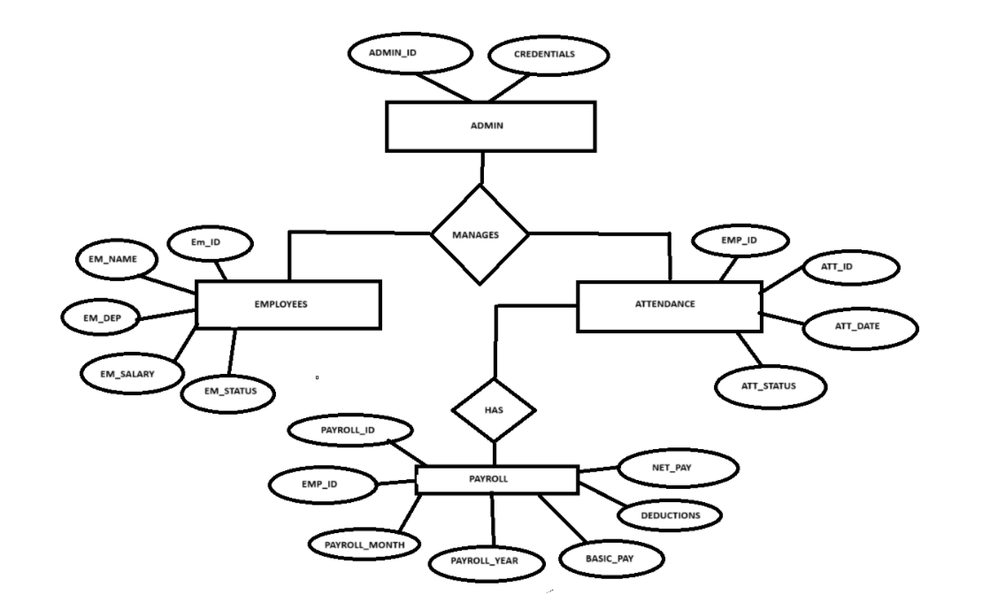

CODE IMPLEMENTATION

* **Create database if not exists**

CREATE DATABASE IF NOT EXISTS employee_management_system;

--Use the database

USE employee_management_system;

* **Employees table**

CREATE TABLE IF NOT EXISTS employees (

employee_id INT PRIMARY KEY AUTO_INCREMENT,

employee_name VARCHAR(100) NOT NULL,

employee_department VARCHAR(100),

employee_salary DECIMAL(10, 2),

employee_status VARCHAR(20));

* **Inserting data into Employees table**

INSERT INTO employees (employee_name, employee_department, employee_salary, employee_status)

VALUES ('Sushma', 'IT', 50000.00, 'active'), ('Rajeshwari', 'HR', 450

00.00, 'active'), ('Indu', 'Finance', 55000.00, 'active'), ('Jahnvi', 'Marke

ting', 48000.00, 'active'), ('Devika', 'IT', 51000.00, 'active'), ('Prasanna', 'Finance', 56000.00, 'active');

* **Attendance table**

CREATE TABLE IF NOT EXISTS attendance (

attendance_id INT PRIMARY KEY AUTO_INCREMENT,

employee_id INT,

attendance_date DATE,

attendance_status VARCHAR(20),

FOREIGN KEY (employee_id) REFERENCES employees(employee_id));

INSERT INTO attendance (employee_id, attendance_date, attendance_status)

VALUES (1, '2024-06-15', 'present'),

(2, '2024-06-15', 'present'),

(3, '2024-06-15', 'absent'),

(4, '2024-06-15', 'present'),

(5, '2024-06-15', 'present'),

(6, '2024-06-15', 'absent');

CREATE TABLE IF NOT EXISTS payroll (

payroll_id INT PRIMARY KEY AUTO_INCREMENT,

employee_id INT,

payroll_month INT,

payroll_year INT,

basic_pay DECIMAL(10, 2),

deductions DECIMAL(10, 2),

net_pay DECIMAL(10, 2),

FOREIGN KEY (employee_id) REFERENCES employees(employee_id));

* **Inserting data into Payroll table**

INSERT INTO payroll (employee_id, payroll_month, payroll_year, basic_pay, deductions, net_pay)

VALUES (1, 6, 2024, 5000.00, 500.00, 4500.00),

(2, 6, 2024, 4500.00, 400.00, 4100.00),

(3, 6, 2024, 5500.00, 600.00, 4900.00),

(4, 6, 2024, 4800.00, 450.00, 4350.00),

(5, 6, 2024, 5100.00, 480.00, 4620.00),

(6, 6, 2024, 5600.00, 700.00, 4900.00);

* **Updating Employee Details**

UPDATE employees

SET employee_salary = 52000.00

WHERE employee_id = 1;

-- Deleting an Employee (soft delete)

UPDATE employees

SET employee_status = 'resigned'

WHERE employee_id = 3;

* **Fetching Employee Attendance for a Date Range**

SELECT e.employee_name, a.attendance_date, a.attendance_status

FROM employees e

JOIN attendance a ON e.employee_id = a.employee_id

WHERE a.attendance_date BE-- Calculating Total Payroll for a Month

SELECT e.employee_name, p.payroll_month, p.payroll_year, p.net_pay

FROM employees e

JOIN payroll p ON e.employee_id = p.employee_id

WHERE p.payroll_month = 6 AND p.payroll_year = 2024;TWEEN '2024-06-01' AND '2024-06-30';

Aggregate Functions

* **Calculating Total Payroll for a Month**

SELECT e.employee_name, p.payroll_month, p.payroll_year, p.net_pay

FROM employees e

JOIN payroll p ON e.employee_id = p.employee_id

WHERE p.payroll_month = 6 AND p.payroll_year = 2024;

* **Generating Monthly Attendance Report**

SELECT e.employee_name, COUNT(a.attendance_id) AS days_present

FROM employees e

LEFT JOIN attendance a ON e.employee_id = a.employee_id

WHERE a.attendance_status = 'present'

GROUP BY e.employee_id;

* **Calculating Average Salary by Department**

SELECT employee_department, AVG(employee_salary) AS avg_salary

FROM employees

GROUP BY employee_department;

* **Regular Expressions**

-- Finding Employees with Highest Deductions

SELECT e.employee_name, p.deductions

FROM employees e

JOIN payroll p ON e.employee_id = p.employee_id

ORDER BY p.deductions DESC

LIMIT 10;

-- Views

-- Example View: Employees with Active Status

CREATE VIEW active_employees AS

SELECT *

FROM employees

WHERE employee_status = 'active';

-- Example View: Employees and Their Payroll Information

CREATE VIEW employee_payroll_info AS

SELECT e.employee_name, p.payroll_month, p.payroll_year, p.net_pay

FROM employees e

JOIN payroll p ON e.employee_id = p.employee_id;

-- Deleting Attendance Records Older than a Year

DELETE FROM attendance

WHERE attendance_date < DATE_SUB(CURDATE(), INTERVAL 1 YEAR);

**Queries**

1: Create a new table to store department details

CREATE TABLE IF NOT EXISTS departments (

department_id INT PRIMARY KEY AUTO_INCREMENT,

department_name VARCHAR(100) NOT NULL,

department_head VARCHAR(100));

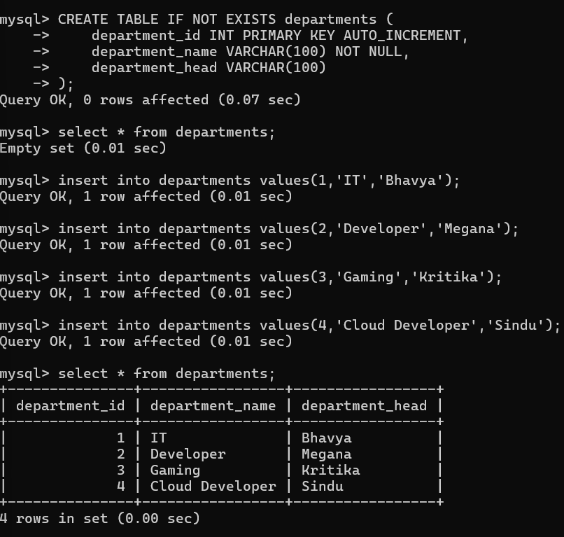

2: Add a unique constraint to the department_name column in the departments table

ALTER TABLE departments

ADD CONSTRAINT unique_department_name UNIQUE (department_name);

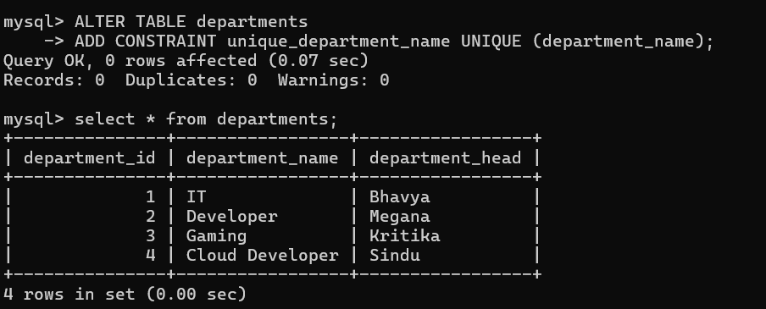

3: Rename the payroll table to employee_payroll

ALTER TABLE payroll RENAME TO employee_payroll;

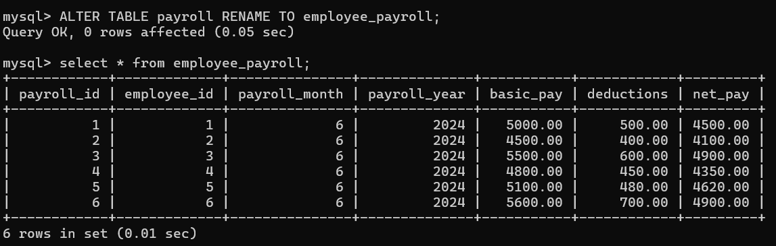

4: Add a column to the attendance table to store remarks

ALTER TABLE attendance ADD COLUMN remarks VARCHAR(255);

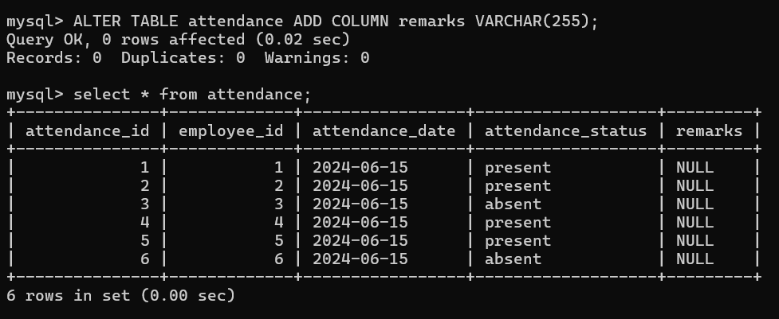

5: Drop the remarks column from the attendance table

ALTER TABLE attendance DROP COLUMN remarks;

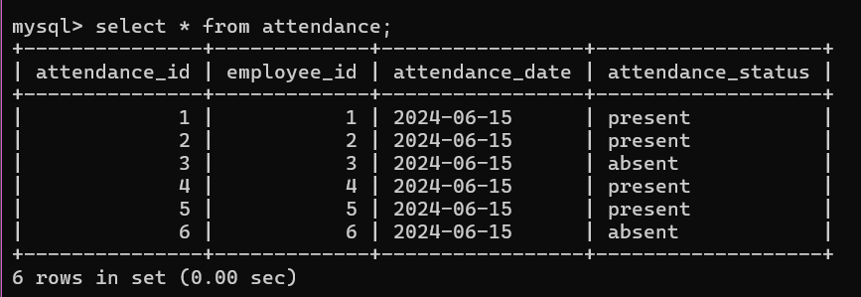

6: Insert a new department into the departments table

INSERT INTO departments (department_name, department_head)

VALUES ('Legal', 'Laura Johnson');

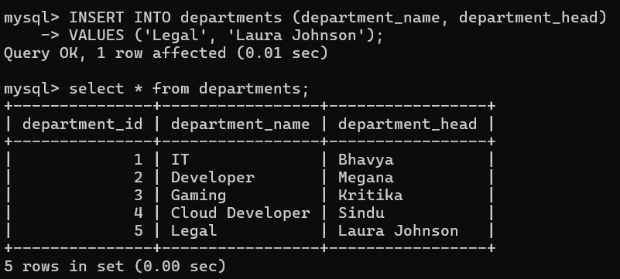

7: Update the department head for the IT department

UPDATE departments

SET department_head = 'Mark Spencer'

WHERE department_name = 'IT';

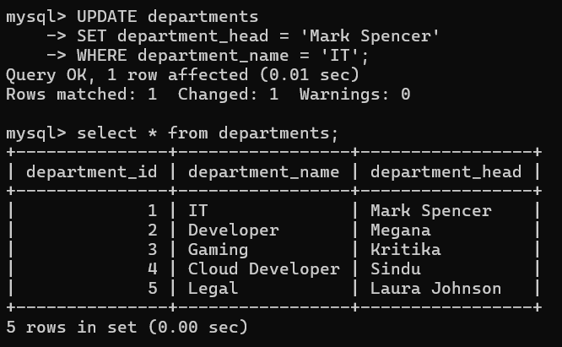

8: Delete a department from the departments table

DELETE FROM departments

WHERE department_name = 'Marketing';

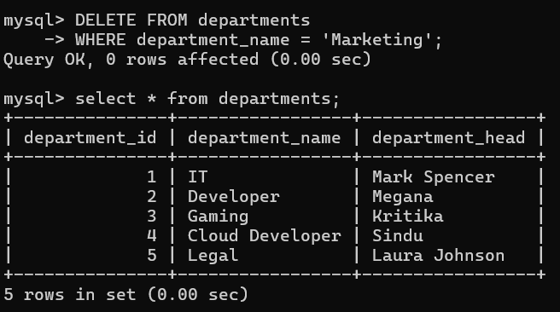

9: Soft delete an employee by setting their status to 'inactive'

UPDATE employees

SET employee_status = 'inactive'

WHERE employee_id = 6;

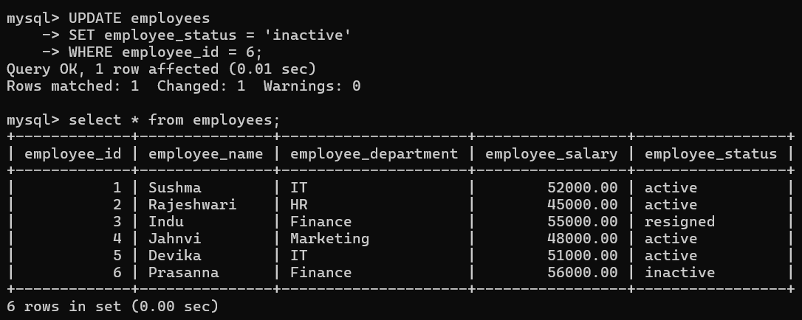

10: Bulk insert multiple employees into the employees table

INSERT INTO employees (employee_name, employee_department, employee_salary, employee_status)

VALUES

('Emma Watson', 'IT', 58000.00, 'active'),

('Liam Neeson', 'HR', 48000.00, 'active'),

('Olivia Brown', 'Finance', 62000.00, 'active');

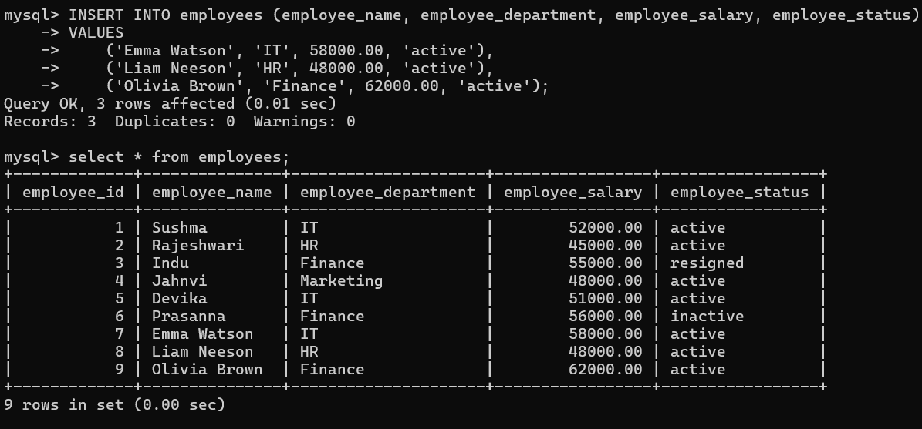

11: Fetch all employees along with their department head

SELECT e.employee_name, e.employee_department, d.department_head

FROM employees e

JOIN departments d ON e.employee_department = d.department_name;

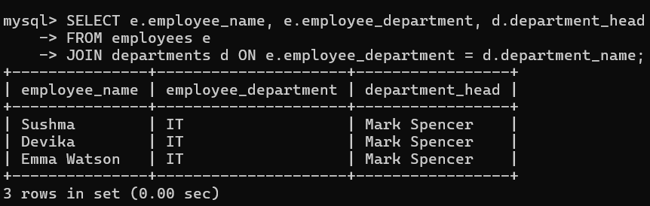

12: Fetch employees along with their attendance status for a specific date

SELECT e.employee_name, a.attendance_date, a.attendance_status

FROM employees e

JOIN attendance a ON e.employee_id = a.employee_id

WHERE a.attendance_date = '2024-06-15';

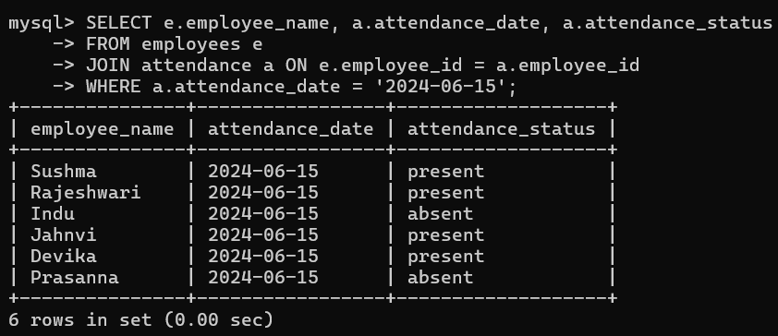

13: Create a view to show employees who are in the IT department

CREATE VIEW it_employees AS

SELECT employee_id, employee_name, employee_salary

FROM employees

WHERE employee_department = 'IT';

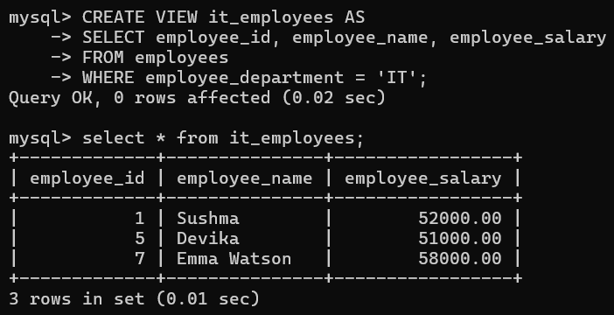

14: Create a view to display the payroll details of employees with a net pay above 4500

CREATE VIEW high_earning_employees AS

SELECT e.employee_name, p.net_pay

FROM employees e

JOIN employee_payroll p ON e.employee_id = p.employee_id

WHERE p.net_pay > 4500.00;

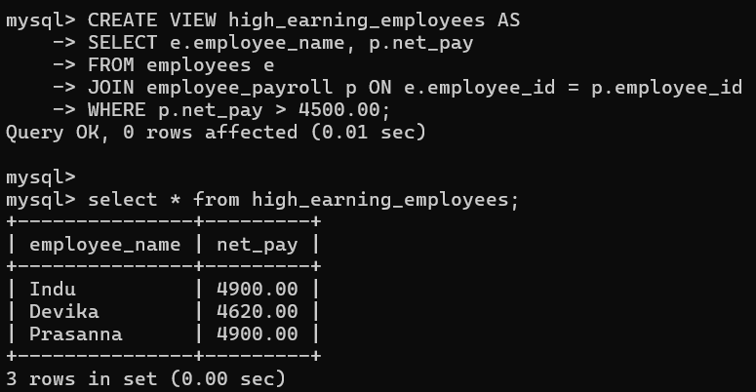

15: Calculate the total number of employees in each department

SELECT employee_department, COUNT(employee_id) AS total_employees

FROM employees

GROUP BY employee_department;

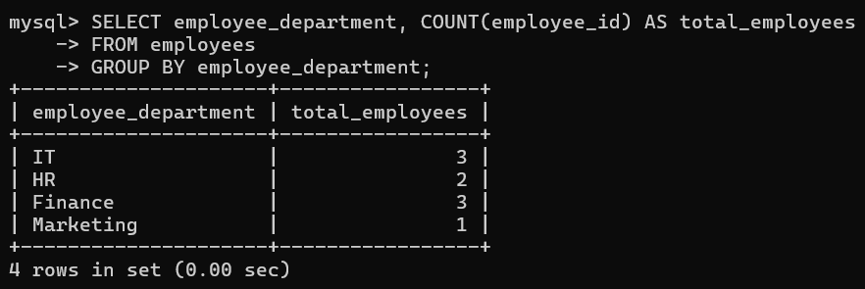

16: Calculate the minimum salary in each department

SELECT employee_department, MIN(employee_salary) AS minimum_salary

FROM employees

GROUP BY employee_department;

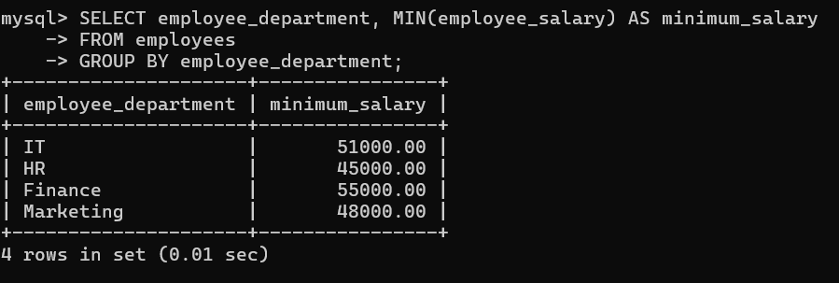

17: Calculate the maximum salary in each department

SELECT employee_department, MAX(employee_salary) AS maximum_salary

FROM employees

GROUP BY employee_department;

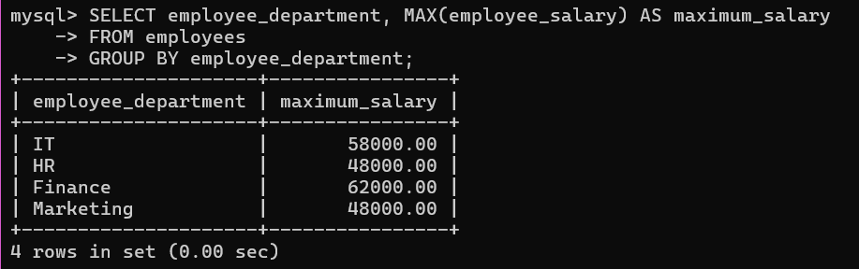

18: Calculate the sum of salaries for the HR department

SELECT SUM(employee_salary) AS total_hr_salaries

FROM employees

WHERE employee_department = 'HR';

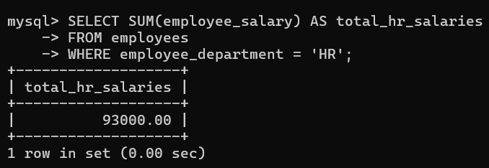

19: Find employees whose names contain 'a' followed by any character and then 'n'

SELECT employee_name

FROM employees

WHERE employee_name REGEXP 'a.n';

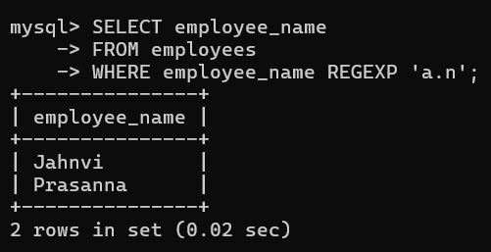

20: Find employees whose names contain exactly five characters

SELECT employee_name

FROM employees

WHERE employee_name REGEXP '^.{5}$';

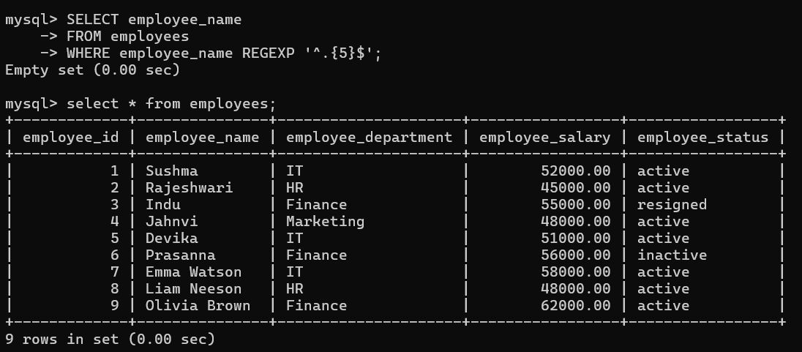

**TESTING & RESULTS:**

**Here the Outputs of Code implementation**

