Program for insertion sort and selection sort

1) Insertion Sort
#include <stdio.h>
#include <stdlib.h>
void insertion(int arr[], int n);
int main()
{
int arr[20], n, i;
printf("Enter no of elements: ");
scanf("%d", &n);
printf("Enter elements: ");
for (i = 0; i < n; i++)
{
scanf("%d", &arr[i]);
}
insertion(arr, n);
printf("\nThe Sorted array: ");
for (i = 0; i < n; i++)
{
printf("%d\t", arr[i]);
}
return 0;
}
void insertion(int arr[], int n)
{
int i, j, temp, k = 0, s = 0;
for (i = 1; i < n; i++)
{
k++;
temp = arr[i];
j = i - 1;
while (j >= 0 && arr[j] > temp)
{
s++;
arr[j + 1] = arr[j];
j--;
}
arr[j + 1] = temp;
}
printf("\nNo of Iterations %d", k);
printf("\nNo of Comparisons %d", s);
}

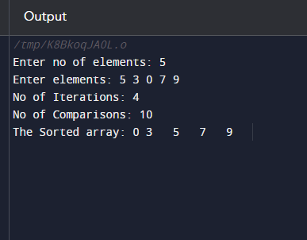

2) Selection Sort
#include <stdio.h>
#include <stdlib.h>
void selection(int arr[], int n)
{
int i, j, min, temp,k=0,s=0;
for (i = 0; i < n - 1; i++)
{
k++;
min = i;
for (j = i + 1; j < n; j++)
{
s++;
if (arr[j] < arr[min])
{
temp = arr[j];
arr[j] = arr[i];
arr[i] = temp;
}
}
}
printf("No of Iterations: %d",k);
printf("\nNo of Comparisons: %d",s);
}
void main()
{
int arr[20], n, i;
printf("Enter no of elements: ");
scanf("%d", &n);
printf("Enter elements: ");
for (i = 0; i < n; i++)
{
scanf("%d", &arr[i]);
}
selection(arr, n);
printf("\nThe Sorted array: ");
for (i = 0; i < n; i++)
{
printf("%d\t", arr[i]);
}
}

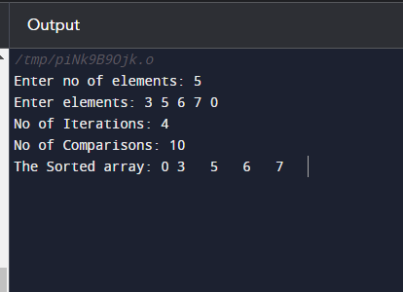

Conclusion:
Insertion sort is more efficient than Selection sort. As you can see, we have given the same numbers as input for both the algorithms, but insertion sort has sorted the array efficiently with a smaller number of comparisons. Insertion sort only scans as many elements as it needs in order to place the i+1th element. But in selection sort, you must scan all the remaining elements in order to find the i+1th element.

