Write a program to implement the Knuth Morris Pratt (KMP) algorithm.

Aim: Given a (short) pattern and a (long) text, both strings, determine whether the pattern appears somewhere in the text.

Program Execution

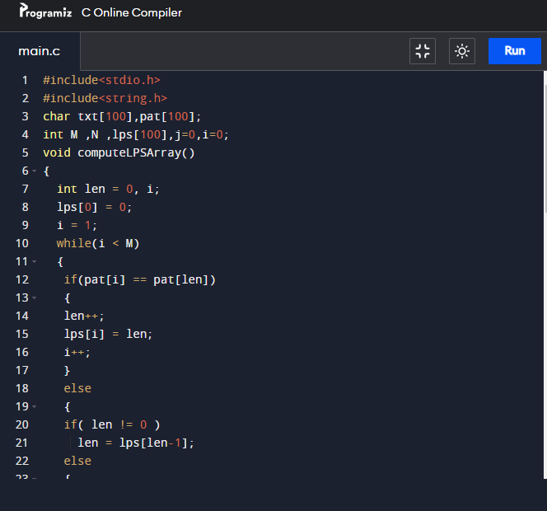
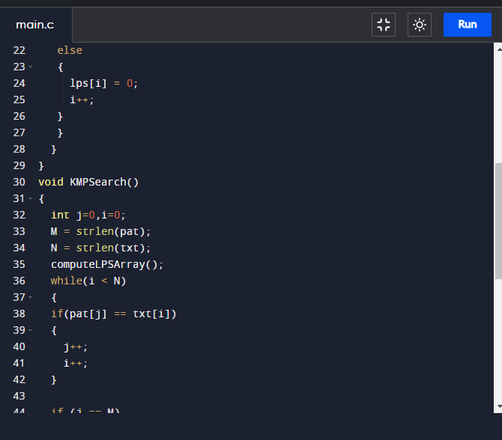
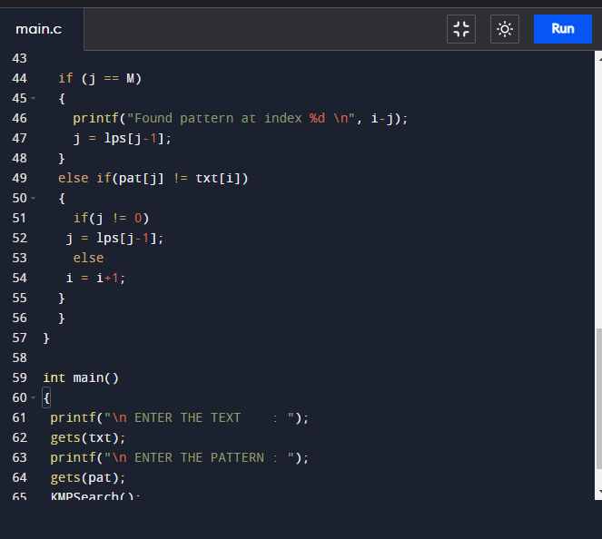
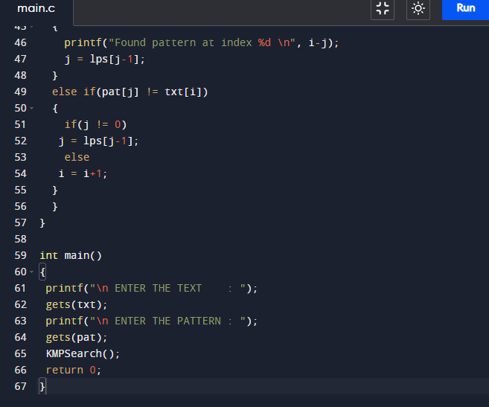
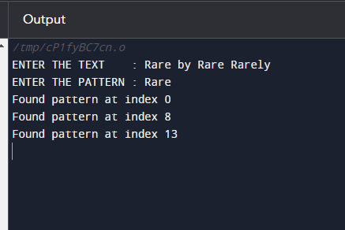

Conclusion:
The running time of Knuth-Morris-Pratt algorithm is proportional to the time needed to read the characters in text and pattern. In other words, the worst-case running time of the algorithm is O(m + n) and it requires O(m) extra space.

