Write a program to compare Quick Sort and Merge Sort.
Problem Statement: - Doing the comparative analysis of Quick Sort and Merge Sort on the basis of comparisons required for sorting list of large value of n.
Program
Quick Sort
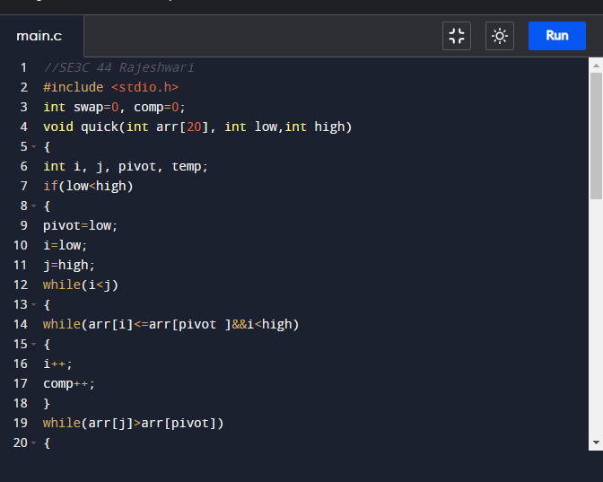
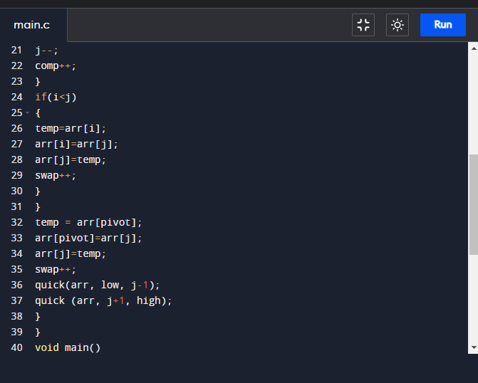
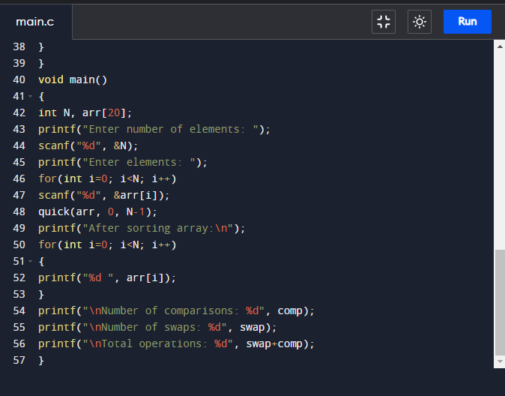
//SE3C 44 Rajeshwari
#include <stdio.h>
int swap=0, comp=0;
void quick(int arr[20], int low, int high)
{
int i, j, pivot, temp;
if(low<high)
{
pivot=low;
i=low;
j=high;
while(i<j)
{
while(arr[i]<=arr[pivot ]&&i<high)
{
i++;
comp++;
}
while(arr[j]>arr [pivot])
{
j--;
comp++;
}
if(i<j)
{
temp=arr[i];
arr[i]-arr[j];
arr[j]=temp;
swap++;
}
}
temp=arr[pivot];
arr[pivot]=arr[j];
arr[j]=temp;
swap++;
quick(arr, low, j-1);
quick (arr, j+1, high);
}
}
void main()
{
int N, arr[20];
printf("Enter number of elements: ");
scanf("%d", &N);
printf("Enter elements: ");
for(int i=0; i<N; i++)
scanf("%d", &arr[i]);
quick(arr, 0, N-1);
printf("After sorting array: \n");
for(int i=0; i<N; i++)
{
printf("%d ", arr[i]);
}
printf("\nNumber of comparisons: %d", comp);
printf("\nNumber of swaps: %d", swap);
printf("\nTotal operations: %d", swap+comp);
}
Output
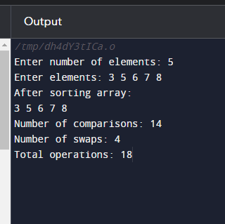
Merge Sort
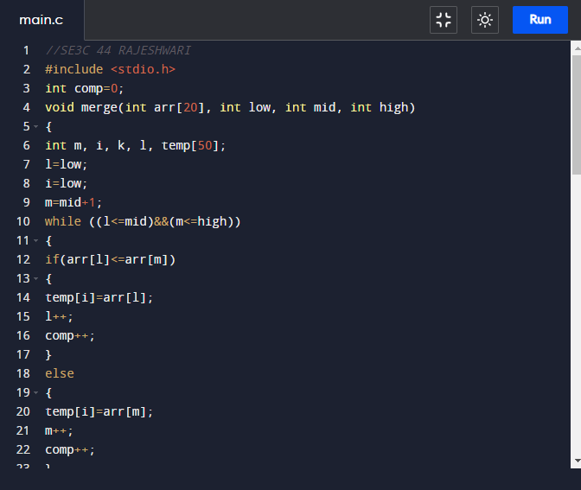
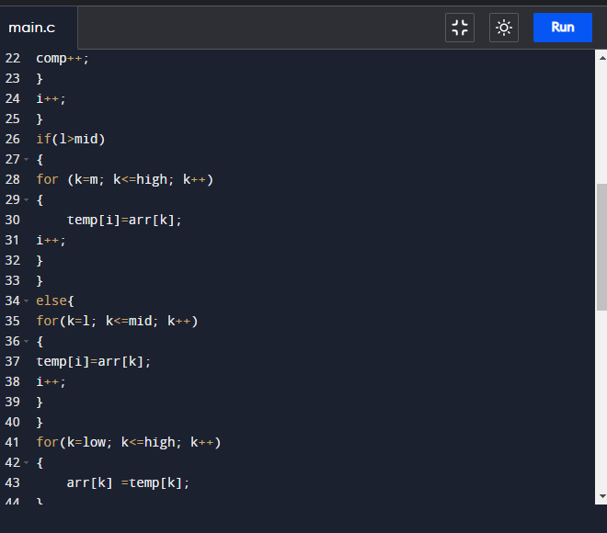
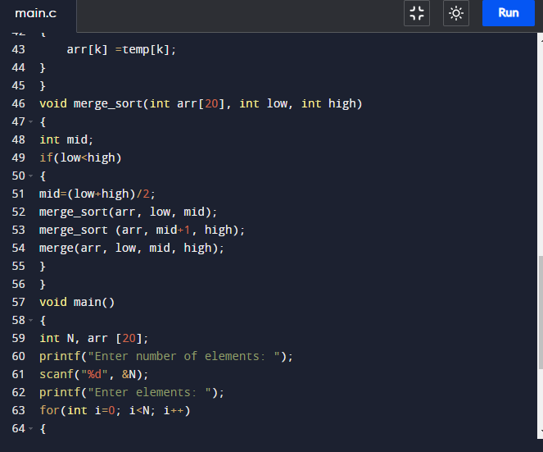
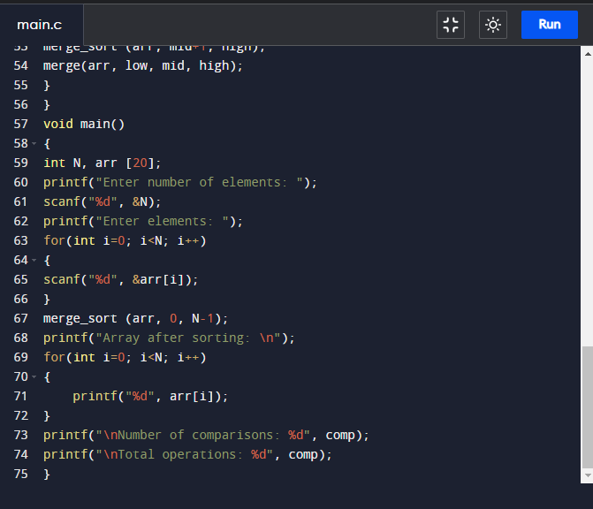
#include <stdio.h>
int comp=0;
void merge(int arr[20], int low, int mid, int high)
{
int m, i, k, l, temp[50];
l=low;
i=low;
m=mid+1;
while ((l<=mid)&&(m<=high))
{
if(arr[l]<=arr[m])
{
temp[i]=arr[l];
l++;
comp++;
}
else
{
temp[i]=arr[m];
m++;
comp++;
}
i++;
}
if(l>mid)
{
for (k=m; k<=high; k++)
{
temp[i]=arr[k];
i++;
}
}
else{
for (k=l; k<=mid; k++)
{
temp[i]=arr[k];
i++;
}
}
for(k=low; k<=high; k++)
{
arr[k] =temp[k];
}
}
void merge_sort(int arr[20], int low, int high)
{
int mid;
if(low<high)
{
mid=(low+high)/2;
merge_sort(arr, low, mid);
merge_sort (arr, mid+1, high);
merge(arr, low, mid, high);
}
}
void main()
{
int N, arr [20];
printf("Enter number of elements: ");
scanf("%d", &N);
printf("Enter elements: ");
for (int i=0; i<N; i++)
{
scanf("%d", &arr[i]);
}
merge_sort (arr, 0, N-1);
printf("Array after sorting: \n");
for (int i=0; i<N; i++)
{
printf("%d", arr[i]);
}
printf("\nNumber of comparisons: %d", comp);
printf("\nTotal operations: %d", comp);
}
Output
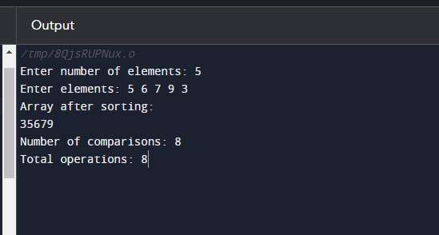
CONCLUSION
After implementing both the methods, we observe that, quick sort does not require additional array space, while merge sort requires temporary array for merging sorted sub arrays. Thus we have successfully implemented or studied Quick Sort and Merge Sort will not be accepted.

