Write a program to solve Fractional Knapsack problem using Greedy method.
Problem Statement: - To obtain the filling of Knapsack that maximizes the total profit earned.
Program
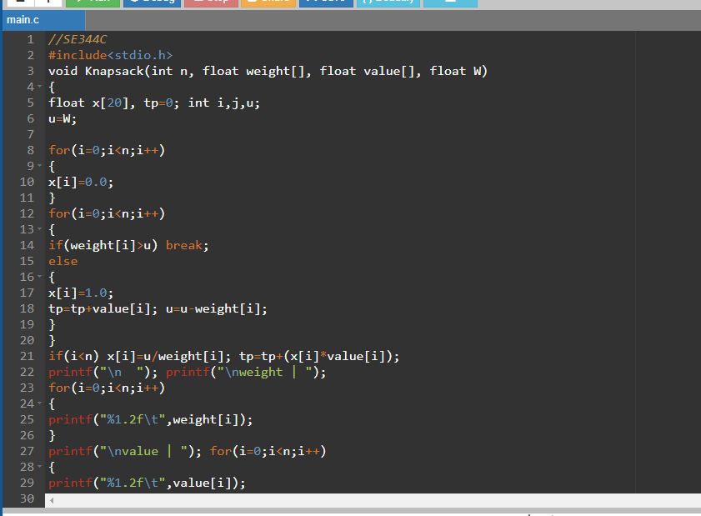
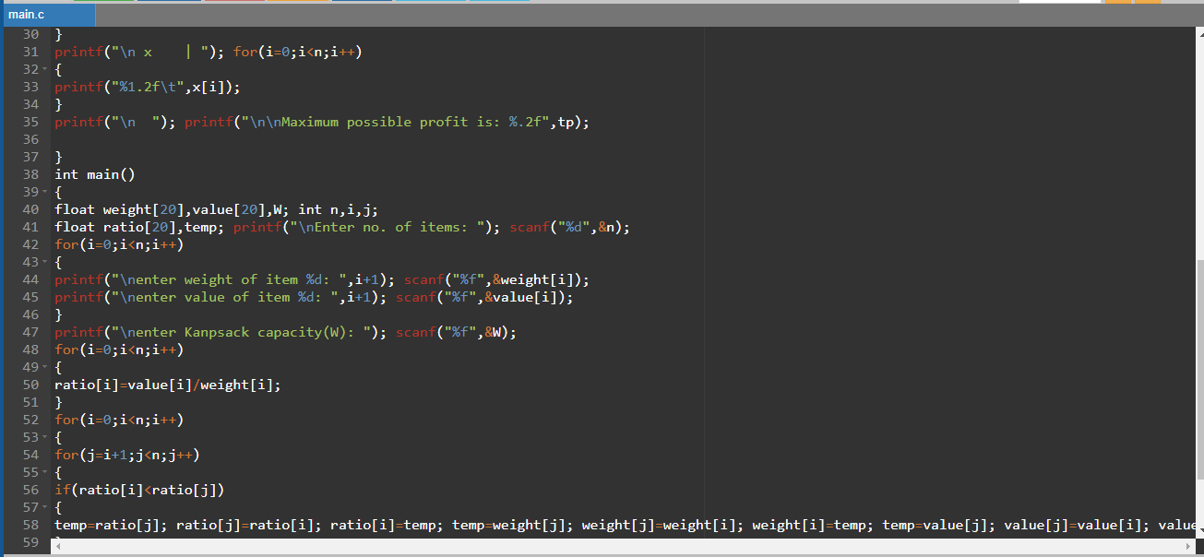
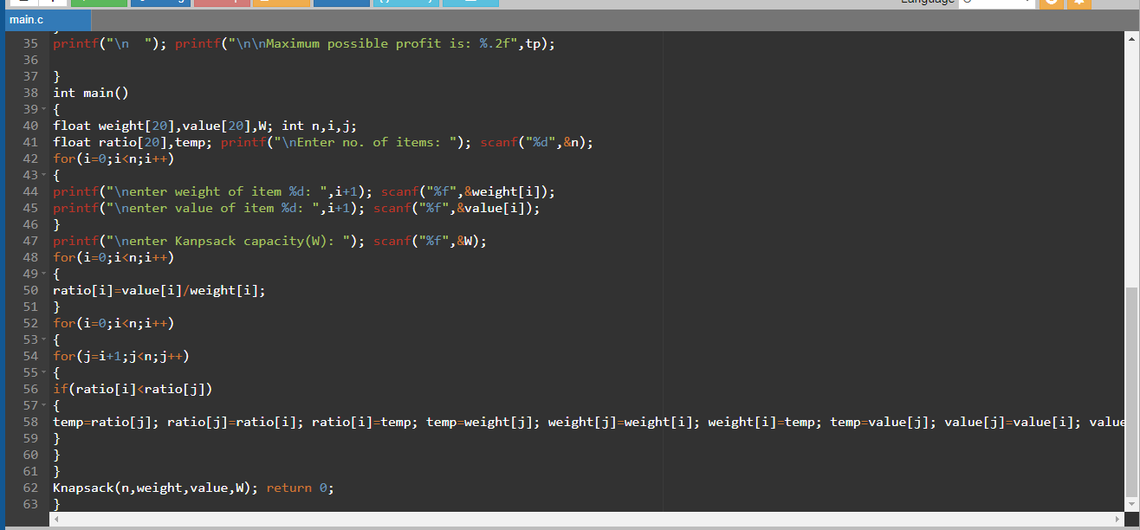
//SE344C
#include<stdio.h>
void Knapsack(int n, float weight[], float value[], float W)
{
float x[20], tp=0; int i,j,u;
u=W;

for(i=0;i<n;i++)
{
x[i]=0.0;
}
for(i=0;i<n;i++)
{
if(weight[i]>u) break;
else
{
x[i]=1.0;
tp=tp+value[i]; u=u-weight[i];
}
}
if(i<n) x[i]=u/weight[i]; tp=tp+(x[i]*value[i]);
printf("\n "); printf("\nweight | ");
for(i=0;i<n;i++)
{
printf("%1.2f\t",weight[i]);
}
printf("\nvalue | "); for(i=0;i<n;i++)
{
printf("%1.2f\t",value[i]);
}
printf("\n x | "); for(i=0;i<n;i++)
{
printf("%1.2f\t",x[i]);
}
printf("\n "); printf("\n\nMaximum possible profit is: %.2f",tp);

}
int main()
{
float weight[20],value[20],W; int n,i,j;
float ratio[20],temp; printf("\nEnter no. of items: "); scanf("%d",&n);
for(i=0;i<n;i++)
{
printf("\nenter weight of item %d: ",i+1); scanf("%f",&weight[i]);
printf("\nenter value of item %d: ",i+1); scanf("%f",&value[i]);
}
printf("\nenter Kanpsack capacity(W): "); scanf("%f",&W);
for(i=0;i<n;i++)
{
ratio[i]=value[i]/weight[i];
}
for(i=0;i<n;i++)
{
for(j=i+1;j<n;j++)
{
if(ratio[i]<ratio[j])
{
temp=ratio[j]; ratio[j]=ratio[i]; ratio[i]=temp; temp=weight[j]; weight[j]=weight[i]; weight[i]=temp; temp=value[j]; value[j]=value[i]; value[i]=temp;
}
}
}
Knapsack(n,weight,value,W); return 0;
}
Output
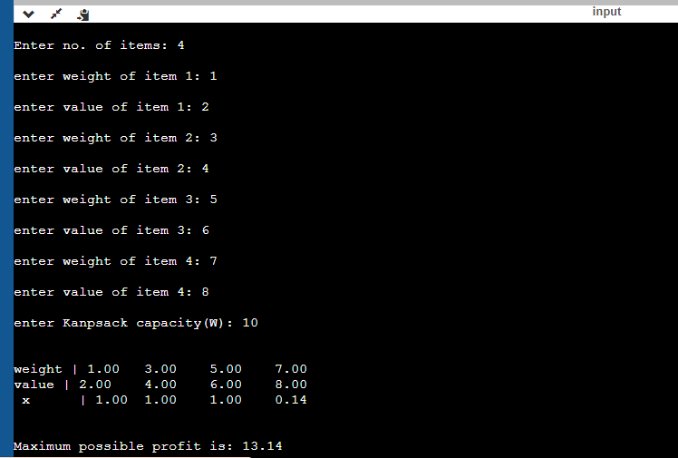
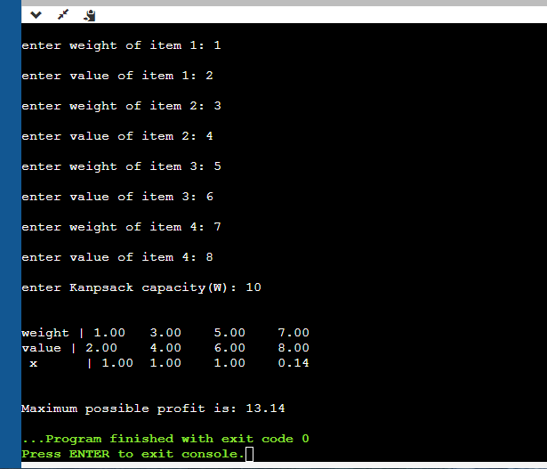
Conclusion:

Fractional Knapsack is a greedy method which is used to efficiently store elements with maximum possible profit. It obeys greedy method

