Write a program to compare Kruskal and Prims algorithm by finding Minimum Cost Spanning Tree (MCST).

Problem Statement: Doing the comparative analysis of Kruskal & Prims algorithm by finding out Minimum Cost Spanning Tree.

Kruskal Algorithm

//SE3C 44

#include <stdio.h>

#include <conio.h>

#include <stdlib.h>

int i,j,k,a,b,u,v,n,ne=1;

int min,mincost=0,cost[9][9],parent[9]; int find(int);

int uni(int,int);

void main()

{

printf("\n\tImplementation of Kruskal's Algorithm\n");

printf("\nEnter the no. of vertices:");

scanf("%d",&n);

printf("\nEnter the cost adjacency matrix:\n");

for(i=1;i<=n;i++)

{

for(j=1;j<=n;j++)

{

scanf("%d",&cost[i][j]);

if(cost[i][j]==0)

cost[i][j]=999;

}

}

printf("The edges of Minimum Cost Spanning Tree are\n");

while(ne < n)

{

for(i=1,min=999;i<=n;i++)

{

for(j=1;j <= n;j++)

{

if(cost[i][j] < min)

{

min=cost[i][j];

a=u=i;

b=v=j;

}

}

}

u=find(u);

v=find(v);

if(uni(u,v))

{

printf("%d edge (%d,%d) =%d\n",ne++,a,b,min);

mincost +=min;

}

cost[a][b]=cost[b][a]=999;

}

printf("\n\tMinimum cost = %d\n",mincost);

getch();

}

int find(int i)

{

while(parent[i]) i=parent[i];

return i;

}

int uni(int i,int j)

{

if(i!=j)

{

parent[j]=i; return 1;

}

return 0;

}

OUTPUT

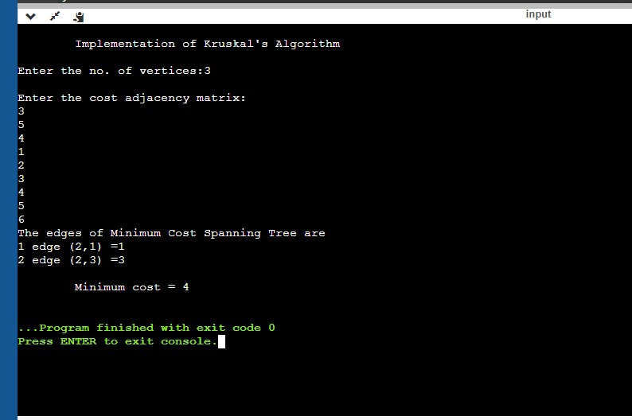

Prims Algorithm

//SE3C 44

#include <stdlib.h>

#include <stdio.h>

int main()

{

int cost[10][10],visited[10]={0},i,j,n,no_e=1,min,a,b,min_cost=0;

printf(" Implementation of Prims Algorithm \n ");

printf("Enter number of nodes ");

scanf("%d",&n);

printf("Enter cost in form of adjacency matrix\n");

//input graph

for(i=1;i<=n;i++)

{

for(j=1;j<=n;j++)

{

scanf("%d",&cost[i][j]);

// cost is 0 then initialize it by maximum value

if(cost[i][j]==0)

cost[i][j]=1000;

}

}

// logic for finding minimum cost spanning tree

visited[1]=1; // visited first node

while(no_e<n)

{

min=1000;

// in each cycle find minimum cost

for(i=1;i<=n;i++)

{

for(j=1;j<=n;j++)

{

if(cost[i][j]<min)

{

if(visited[i]!=0)

{

min=cost[i][j];

a=i;

b=j;

}

}

}

}

//if node is not visited

if(visited[b]==0)

{

printf("\n%d to %d cost=%d",a,b,min);

min_cost=min_cost+min;

no_e++;

}

visited[b]=1;

// initialize with maximum value you can also use any other value

cost[a][b]=cost[b][a]=1000;

}

printf("\nminimum cost is %d",min_cost);

return 0;

}

OUTPUT

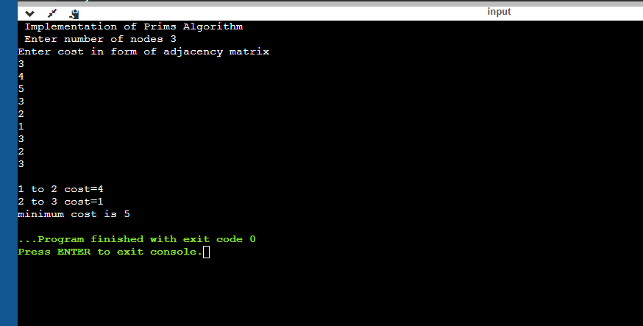

Conclusion: Prim's algorithm is significantly faster in the limit when you've got a really dense graph with many more edges than vertices. Kruskal performs better in typical situations (sparse graphs) because it uses simpler data structures.

