Write a program to find Single Source Shortest Path in a directed graph.

Problem Statement: Finding Single Source Shortest Path in a directed graph with Negative edge lengths using Bellman Ford Algorithm.

Program:

//SE3C 44
#include <stdio.h>

#include <stdlib.h>

#include <string.h>

#include <limits.h>

struct Edge

{

// This structure is equal to an edge. Edge contains two end points. These edges are directed edges so they

//contain source and destination and some weight. These 3 are elements in this structure

int source, destination, weight;

};

// a structure to represent a connected, directed and weighted graph

struct Graph

{

int V, E;

// V is number of vertices and E is number of edges

struct Edge* edge;

// This structure contain another structure which we already created edge.

};

struct Graph* createGraph(int V, int E)

{

struct Graph* graph = (struct Graph*) malloc( sizeof(struct Graph));

//Allocating space to structure graph

graph->V = V; //assigning values to structure elements that taken form user.

graph->E = E;

graph->edge = (struct Edge*) malloc( graph->E * sizeof( struct Edge ) );

//Creating "Edge" type structures inside "Graph" structure, the number of edge type structures are equal to number

of edges

return graph;

}

void FinalSolution(int dist[], int n)

{

// This function prints the final solution

printf("\nVertex\tDistance from Source Vertex\n");

int i;

for (i = 0; i < n; ++i){

printf("%d \t\t %d\n", i, dist[i]);

}

}

void BellmanFord(struct Graph* graph, int source)

{

int V = graph->V;

int E = graph->E;

int StoreDistance[V];

int i,j;

// This is initial step that we know , we initialize all distance to infinity except source.

// We assign source distance as 0(zero)

for (i = 0; i < V; i++)

StoreDistance[i] = INT_MAX;

StoreDistance[source] = 0;

//The shortest path of graph that contain V vertices, never contain "V-1" edges. So we do here "V-1" relaxations

for (i = 1; i <= V-1; i++)

{

for (j = 0; j < E; j++)

{

int u = graph->edge[j].source;

int v = graph->edge[j].destination;

int weight = graph->edge[j].weight;

if (StoreDistance[u] + weight < StoreDistance[v])

StoreDistance[v] = StoreDistance[u] + weight;

}

}

// Actually upto now shortest path found. But BellmanFord checks for negative edge cycle. In this step we check

for that

// shortest distances if graph doesn't contain negative weight cycle.

// If we get a shorter path, then there is a negative edge cycle.

for (i = 0; i < E; i++)

{

int u = graph->edge[i].source;

int v = graph->edge[i].destination;

int weight = graph->edge[i].weight;

if (StoreDistance[u] + weight < StoreDistance[v])

printf("This graph contains negative edge cycle\n");

}

FinalSolution(StoreDistance, V);

return;

}

int main()

{

int V,E,S; //V = no.of Vertices, E = no.of Edges, S is source vertex

printf("Enter number of vertices in graph\n");

scanf("%d",&V);

printf("Enter number of edges in graph\n");

scanf("%d",&E);

printf("Enter your source vertex number\n");

scanf("%d",&S);

struct Graph* graph = createGraph(V, E); //calling the function to allocate space to these many vertices and

edges

int i;

for(i=0;i<E;i++){

printf("\nEnter edge %d properties Source, destination, weight respectively\n",i+1);

scanf("%d",&graph->edge[i].source);

scanf("%d",&graph->edge[i].destination);

scanf("%d",&graph->edge[i].weight);

}

BellmanFord(graph, S);

//passing created graph and source vertex to BellmanFord Algorithm function

return 0;

}

OUTPUT

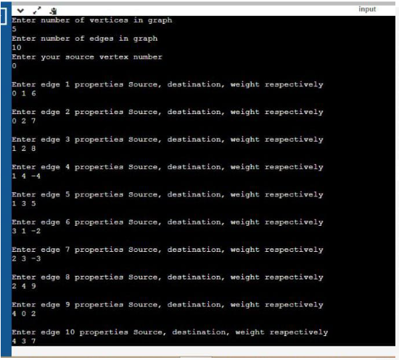

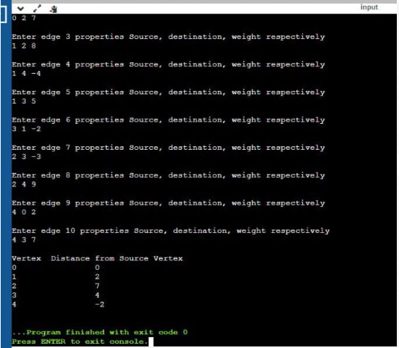

Conclusion: Single Source Shortest Path problem using Bellman Ford Algorithm implemented to find the shortest path from a source vertex to all remaining vertices in the directed graph.

