DIGITAL CONSULTANCY SERVICE PORTAL FOR NIVAS CONSTRUCTIONS

A PROJECT REPORT
(22ITP61-Project Work I) Submitted by
SHREYAA J
(23ITR151)

ROSHAN THIRUMOORTHY (23ITR137)

in partial fulfilment of the requirements for the award of the degree
of

BACHELOR OF TECHNOLOGY IN
INFORMATION TECHNOLOGY

DEPARTMENT OF INFORMATION TECHNOLOGY


(Autonomous)

PERUNDURAI ERODE – 638 060

MARCH 2026

BONAFIDE CERTIFICATE

This is to certify that the Project report entitled Digital Consultancy Service Portal for Nivas Constructions is the Bonafide record of project work done by Shreyaa J (23ITR151) and Roshan Thirumoorthy (23ITR137) in partial fulfilment of the requirements for the award of the Degree of Bachelor of Technology in INFORMATION TECHNOLOGY of Anna University Chennai during the year 2025 - 2026.

SUPERVISOR HEAD OF THE DEPARTMENT
Date: (Signature with seal)

Submitted for the end semester viva voce examination held on .

INTERNAL EXAMINER EXTERNAL EXAMINER
ii

DECLARATION

We affirm that the Project Report titled Digital Consultancy Service Portal for Nivas Constructions being submitted in partial fulfilment of the requirements for the award of Bachelor of Technology is the original work carried out by us. It has not formed the part of any other project report or dissertation on the basis of which a degree or award was conferred on an earlier occasion on this or any other candidate.

Shreyaa J (23ITR151)

Roshan Thirumoorthy
(23ITR137)

Date:

I certify that the declaration made by the above candidates is true to the best of my knowledge.

Date: Name and Signature of the Supervisor with seal
iii

ACKNOWLEDGEMENT

First and foremost, we acknowledge the abundant grace and presence of Almighty throughout different phases of the project and its successful completion.

We express our gratefulness to Correspondent Thiru. E. R. K. Krishnan, M.Com. and all the trust members of Kongu Vellalar Institute of Technology Trust for providing all the necessary facilities to complete the project successfully.

We express our deep sense of gratitude to our beloved Principal Dr.R.Parameshwaran M.E.,Ph.D., for providing us an opportunity to complete the project.

We express our gratitude to Dr. S. Anandamurugan M.E.,Ph.D., Head of the Department, Department of Information Technology for his valuable suggestions.

We are thankful to our respected Project Coordinators Dr.E.M.Roopa Devi M.E,Ph.D., Ms.S.Sujitha M.Tech a n d G . S a s i k al a M.E., for their valuable guidance and support.

We are highly indebted to Mr.D.VijayAnand MCA.,M.E, Department of Information Technology for his valuable supervision and advice for the fruitful completion of the project.

We are thankful to the faculty members of the Department of Information Technology for their valuable guidance and support.

We are obliged to thank Mr. V.Palanisamy, Owner of Nivas Constructions for supporting us through the various development phases of the project with atmost trust.
iv

v

ABSTRACT

A web-based consultancy application was developed for Nivas Constructions to enhance and digitize their construction consultancy services. The platform provides an online environment where users can explore various consultancy services related to construction and easily submit their consultation requests. By implementing this digital solution, the system bridges the gap between traditional offline consultation methods and modern online service platforms.

The application offers a simple and user-friendly interface that allows clients to access professional guidance conveniently. Users can browse available services, learn about the expertise offered by the company, and communicate their requirements through the platform. This improves accessibility and allows customers to connect with the consultancy services anytime and from anywhere.

The system also includes an administrative dashboard that enables administrators to manage consultancy services, monitor client inquiries, and maintain overall system functionality efficiently. This feature helps the company organize client interactions, track service requests, and improve operational efficiency.

Overall, the consultancy platform developed for Nivas Constructions demonstrates how digital technology can modernize traditional consultancy services. By combining an intuitive interface with effective management tools, the system improves customer engagement while creating opportunities for future expansion and digital growth.

TABLE OF CONTENTS
vi

CHAPTER No. TITLE PAGE No.

ABSTRACT | v
LIST OF FIGURES | viii
LIST OF ABBREVIATIONS | ix
1 INTRODUCTION | 1
1.1 OVERVIEW | 1
1.2 OBJECTIVE | 2
2 SYSTEM SPECIFICATION | 3
2.1 HARDWARE REQUIREMENTS | 3
2.2 SOFTWARE REQUIREMENTS | 3
2.3 SOFTWARE DESCRIPTION | 4
2.3.1 Visual Studio Code | 4
2.3.2 NodeJS | 5
2.3.3 MongoDB | 6
2.3.4 React | 7
3 SYSTEM DESIGN | 8
3.1 USE CASE DIAGRAM | 8
3.2 CLASS DIAGRAM | 9
3.3 SEQUENCE DIAGRAM | 10
3.4 ACTIVITY DIAGRAM | 11
3.5 DATABASE DESIGN | 12

  - MODULES DESCRIPTION 14
vii
    - User Authentication Module 14
    - Service Management Module 14
    - Project Management Module 14
    - Admin Dashboard Module 15
    - User Dashboard Module 15
    - Email Module 15
- TESTING 16
  - SYSTEM TESTING 16
  - UNIT TESTING 16
  - MODULE TESTING 17
  - INTEGRATION TESTING 17
  - VALIDATION TESTING 17
- RESULTS & DISCUSSIONS 19
- CONCLUSION 23
APPENDIX 1- CODING 24
APPENDIX 2- SNAPSHOTS 41
REFERENCES 49
MAPPING OF SDG GOALS 53

LIST OF FIGURES
viii

FIGURE No. | FIGURE NAME | PAGE No.
3.1 | USE CASE DIAGRAM | 8
3.2 | CLASS DIAGRAM | 9
3.3 | SEQUENCE DIAGRAM | 10
3.4 | ACTIVITY DIAGRAM | 11
5.1 | LANDING PAGE | 20
5.2 | ADMIN LOGIN PAGE | 21
5.3 | ADMIN DASHBOARD | 21
5.4 | PROJECTS AND SERVICES PAGE | 22
A2.1 | LANDING PAGE | 41
A2.2 | ABOUT PAGE | 41
A2.3 | SERVICES PAGE | 42
A2.4 | PROJECTS PAGE | 42
A2.5 | CONTACT US | 43
A2.6 | FOOTER | 43
A2.7 | ADMIN LOGIN PAGE | 44
A2.8 | ADMIN DASHBOARD | 44
A2.9 | ADD SERVICE | 45
A2.10 | ADD PROJECT | 45
A2.11 | ENQUIRY PAGE | 46
A2.12 | ENQUIRY DETAILS | 46
A2.13 | REPLY MAIL | 47
A2.14 | APPLYING FILTERS TO ENQUIRIES | 47
A2.15 | APPLYING FILTERS TO PROJECTS | 48
A2.16 | RESPONSE FOR FORM FILLING | 48

ix

LIST OF ABBREVIATIONS

S.NO | ABBREVIATIONS | EXPANSIONS
01 | DOM | Document Object Model
02 | JS | JavaScript
03 | UI | User Interface
04 | API | Application Programming Interface
05 | RAM | Random Access Memory
06 | Gen | Generation
07 | DB | Database
08 | JSON | JavaScript Object Notation
09 | HTTP | Hyper Text Transfer Protocol
10 | UML | Unified Modeling Language
11 | JWT | JSON Web Token

x

LIST OF TABLES

S.NO | TABLE NAME | PAGE NO
01 | Users | 13
02 | Services | 13
03 | Enquiries | 13
04 | Projects | 14
05 | Admin | 14

CHAPTER 1 INTRODUCTION
  - OVERVIEW

The rapid growth of digital technology and widespread internet access has completely changed the way businesses connect with their customers. Today, having an online presence is no longer optional—it’s essential. Businesses need to offer easy, accessible, and efficient services to stay competitive. This is especially important in the construction industry, where clear communication and proper consultancy play a key role in project success. Using digital platforms can simplify many complex processes and improve the overall quality of service.This project is focused on developing a web-based consultancy application for Nivas Constructions. The main goal is to make their consultancy services more organized, accessible, and user-friendly. Through this platform, clients can explore different services such as architectural planning, cost estimation, project management, and design guidance. The system is designed in a simple and intuitive way so that users can easily find the information they need and make better decisions without confusion.

A major advantage of this application is how it improves communication between clients and consultants. Instead of relying on phone calls or physical visits, users can directly submit their queries and request consultations online. This makes the process faster and more convenient for both parties. It also ensures that all interactions are properly recorded, making it easier to track and manage client requests. Additionally, users can receive updates on their inquiries, which helps build trust and keeps them informed throughout the process.Security and future growth are also taken into consideration. The platform can include secure login systems to protect user information and maintain privacy. It is also designed to be scalable, meaning new features like appointment booking, online payments, live chat support, or even a mobile app can be added later as the business grows.

OBJECTIVE

    - The primary objective of this project is to develop a web-based consultancy application for Nivas Constructions that makes it easier for clients to access construction-related consultancy services online. Instead of relying on traditional methods like phone calls or in-person visits, the platform aims to provide a simple and efficient way for users to connect with experts and get the guidance they need from anywhere.

    - Another important goal is to design a user-friendly and intuitive interface that ensures a smooth experience for all users, even those with minimal technical knowledge. The application will allow users to easily browse available consultancy services, understand what each service offers, and submit their inquiries without confusion. By keeping the design simple and clear, the platform ensures that users can quickly find information and seek professional advice conveniently.

    - The project also focuses on building an effective administrative system that helps manage the platform efficiently. Administrators will be able to add, update, or remove services, view and respond to client inquiries, and monitor overall system activities. This centralized control reduces manual effort, improves response time, and ensures that the platform runs smoothly at all times.

    - In addition to these core objectives, the system aims to improve communication between clients and consultants, reduce delays, and maintain proper records of all interactions. This not only enhances service quality but also helps in better decision- making and future improvements.

    - Overall, the objective of this project is to create a reliable, efficient, and scalable digital solution that improves customer experience, simplifies service management, and supports the growth of Nivas Constructions in a modern, technology-driven environment.

CHAPTER 2 SYSTEM SPECIFICATION

  - HARDWARE REQUIREMENTS

Processor : Intel Pentium

Processor Speed : 250MHz to 667MHz

RAM : 4GB RAM

Hard Disk : 256GB

SOFTWARE REQUIREMENTS

Platform : Visual Studio Code

Server-Side Script : NodeJS

Operating System : Windows, macOS, or Linux

Backend : MongoDB

Library : React

SOFTWARE DESCRIPTION

Visual Studio Code

Visual Studio Code is a versatile and user-friendly code editor widely used by developers across the world. It supports a wide range of programming languages and frameworks, including JavaScript, React, and Node.js, making it highly suitable for full- stack development. For this project, VS Code provides an efficient environment for writing, editing, and debugging both server-side code using Node.js and client-side code using React.js. One of the key advantages of Visual Studio Code is its built-in terminal, which allows developers to run commands, install packages, and manage the project without switching between multiple tools. Its powerful debugging features help identify and fix errors quickly, improving code quality and reducing development time. Additionally, the editor offers a rich ecosystem of extensions that support features like code formatting, linting, version control integration, and intelligent code suggestions. The customizable interface and settings enable developers to tailor the workspace according to their preferences, which enhances comfort and productivity during development. Overall, Visual Studio Code plays a crucial role in simplifying the development process, improving efficiency, and ensuring a smooth workflow throughout the lifecycle of the project.

ES6+ React/Redux/React-Native:
ES6 React/Redux/React-Native snippets provide code templates designed to simplify and accelerate the development process for building applications with React, Redux, and React Native. These snippets utilize the powerful features introduced in ES6, allowing developers to quickly scaffold common patterns like React components, Redux actions, reducers, and React Native components. By incorporating ES6 syntax, such as arrow functions, destructuring, template literals, and modules, these snippets make it easier to write clean and concise code. With ES6 snippets, developers can efficiently generate standardized code structures that promote consistency and reduce the chance of errors, cutting down on boilerplate code. This collection of snippets supports the creation of both web applications in React and cross-platform mobile applications in React Native, while simplifying state management in Redux. Whether developing user interfaces, managing state, or working on cross-platform features, these ES6 snippets help developers stay focused on creating features and solving problems instead of repeating boilerplate setup.

NodeJS

Node.js is a powerful server-side JavaScript runtime environment commonly used for building scalable and efficient web applications. In our project, Node.js serves as the server- side scripting language, handling tasks such as routing, handling HTTP requests, and interacting with the MongoDB database.. With its vast ecosystem of libraries and frameworks, Node.js allows for rapid development and deployment of server-side applications. Additionally, its compatibility with Visual Studio Code provides a seamless development experience, enabling developers to write, test, and debug server- side code effectively within a unified environment. Overall, Node.js plays a crucial role in this project by powering the backend infrastructure and facilitating the seamless integration of frontend and backend components.

Bcryptjs
Bcryptjs is a library used for hashing passwords in JavaScript. It provides a secure way to hash passwords before storing them in a database or comparing them during authentication processes. By using bcryptjs, developers can ensure that user passwords are encrypted and protected against common security threats like brute force attacks and rainbow table attacks.

Express

Express is a minimalist web application framework for Node.js. It provides a robust set of features for building web servers and APIs, including routing, middleware support, template engines, and HTTP utilities. With its simple and flexible design, Express enables developers to quickly create scalable and maintainable web applications
.

Jsonwebtoken

JSON Web Token is an open standard (RFC 7519) that defines a compact and self- contained way for securely transmitting information between parties as a JSON object. JWTs are commonly used for authentication and authorization in web applications. The jsonwebtoken library provides utilities for generating, parsing, and verifying JWTs, making it easy to implement token-based authentication and authorization systems.

MongoDB
MongoDB is a flexible and scalable NoSQL database platform that is well suited for managing the data requirements of the consultancy web application developed for Nivas Constructions. With MongoDB’s document-oriented architecture, the system can efficiently store and manage different types of data such as user information, consultancy service details, client inquiries, and administrative records. Its schema-less structure allows the application to handle dynamic and evolving data models, which is beneficial for managing various consultancy services and client interactions within the platform.For this project, MongoDB’s scalability plays an important role as it can efficiently handle increasing amounts of user data and service requests while maintaining optimal performance. This ensures that the consultancy platform remains responsive even as the number of users and inquiries grows. MongoDB’s powerful query capabilities and indexing features enable fast retrieval of information such as user profiles, consultancy service details, and client requests, which improves the overall efficiency and user experience of the system.Additionally, MongoDB supports high availability and reliable data management, helping the platform remain stable and accessible. By providing a secure, flexible, and scalable database solution, MongoDB plays a vital role in supporting the functionality of the Nivas Constructions consultancy application, ensuring efficient data storage, smooth system performance, and the ability to support future enhancements.

React

React is a popular JavaScript library used to build interactive and responsive user interfaces. In the consultancy web application developed for Nivas Constructions, React helps create a dynamic frontend where users can easily explore consultancy services, submit inquiries, and interact with the platform. Its component-based architecture allows the application to be divided into reusable parts such as service pages, forms, and navigation components, making the system easier to develop and maintain. React also improves application performance through its virtual DOM, which updates only the necessary parts of the interface instead of reloading the entire page. This ensures faster rendering and a smooth user experience. By enabling efficient communication with backend APIs, React helps display data such as services and client requests dynamically, making the platform responsive, scalable, and user-friendly.

axios:

Axios is a promise-based HTTP client for making HTTP requests in browser- based and Node.js applications. It provides a simple and intuitive API for performing asynchronous HTTP requests, handling request and response data, and intercepting request and response lifecycle events. Axios supports features like request and response interception, request cancellation, automatic JSON data parsing, and more, making it a popular choice for handling AJAX requests in JavaScript applications.

react-navigation:

react-navigation is a popular routing and navigation library specifically designed for React Native applications. It enables smooth and intuitive navigation between screens using stacks, tabs, and drawer navigators. The library handles navigation history, parameter passing, and screen transitions efficiently across both Android and iOS platforms. It provides a customizable and scalable solution for managing complex navigation flows in mobile apps, ensuring a seamless user experience and structured app architecture.

React Router DOM:

React Router DOM is a standard routing library used in React applications to manage navigation between different pages. It enables the creation of multiple routes such as home, services, contact, and dashboard pages without reloading the entire website. This improves the user experience by providing smooth navigation and better organization of the application structure.

Bootstrap / CSS Framework:

Bootstrap is a widely used front-end framework that helps design responsive and visually appealing web interfaces. It provides pre-designed components such as buttons, forms, navigation bars, and layouts. g Bootstrap in this consultancy application improves the overall design, responsiveness, and user experience across different devices.
Usin

React Toastify:
React Toastify is a library used to display notifications in React applications. It allows developers to show success, error, or warning messages in a simple and visually appealing way. In this project, React Toastify helps notify users about actions such as successful form submissions, login status, or error messages, improving the overall user experience.

CHAPTER 3 SYSTEM DESIGN
  - USE CASE DESIGN
A use case diagram is a dynamic or behavior diagram in UML (Unified Modelling Language). Use case diagrams model the functionality of a system using actors and use cases. Use cases are a set of actions and functions that the system needs to perform. A "system" is something being developed or operated, here is a website. The "actors" are people or entities operating under defined roles within the system as shown below in Figure 3.1.
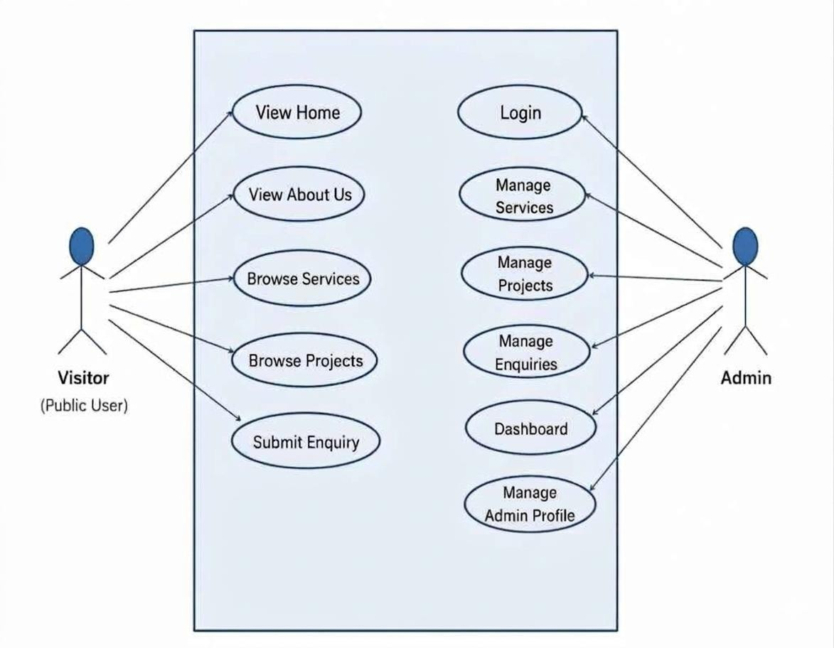

Fig 3.1 Use Case Diagram

CLASS DIAGRAM
A class diagram is a static structure diagram in UML (Unified Modeling Language) that illustrates the structure of a system by showing the classes of the system, their attributes, methods, and relationships between them as shown in Figure 3.2. Classes represent the blueprint for objects, encapsulating data and behavior. Attributes are the data members of a class, while methods represent the operations that can be performed on the class's objects.

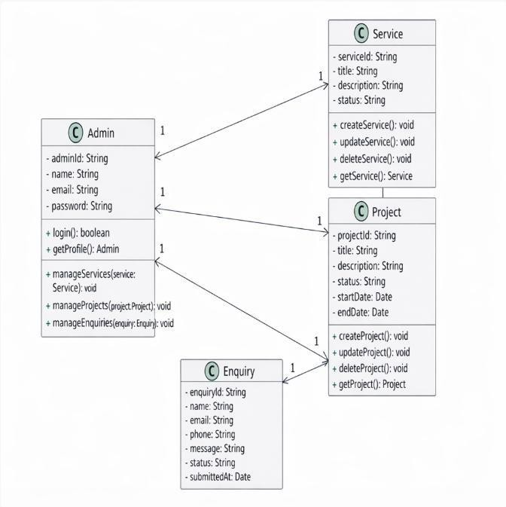
Fig 3.2 Class Diagram

SEQUENCE DIAGRAM
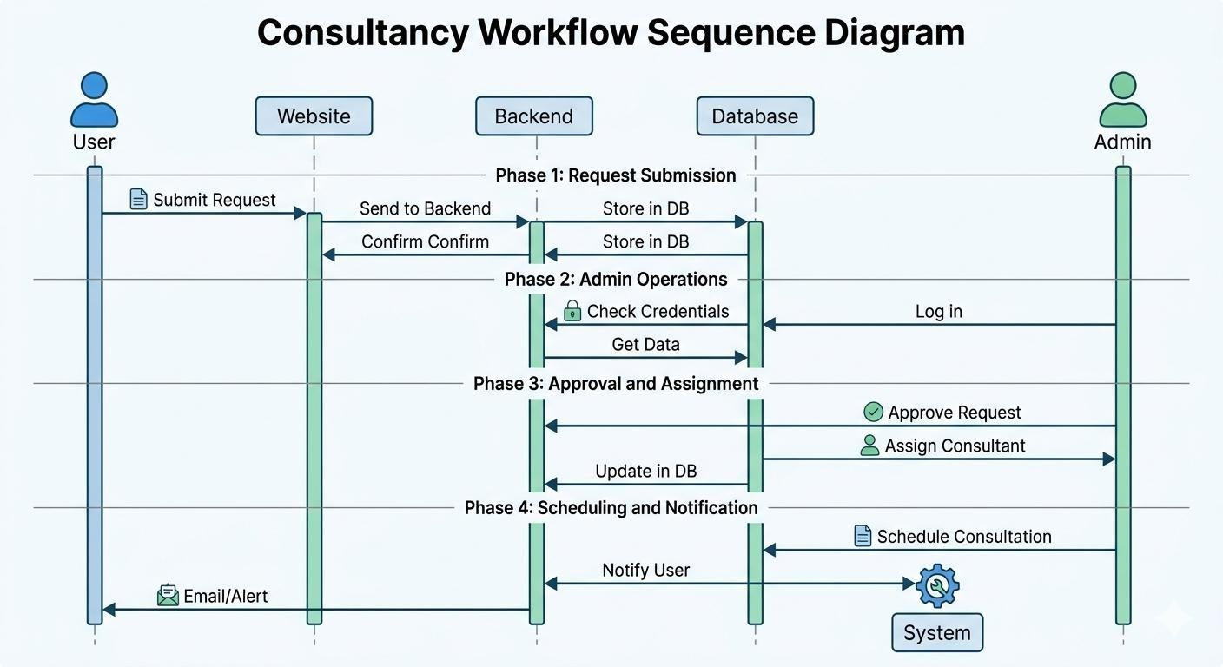
A sequence diagram is a form of interaction diagram which shows objects as lifelines running down the page, with their interactions over time represented as messages drawn as arrows from the source lifeline to the target lifeline. Sequence diagrams are good at showing which objects communicate with which other objects and what messages trigger those communications as shown below in Figure 3.3. Sequence diagrams are not intended for showing complex procedural logic.
Reply to query
View the query

Fig 3.3 Sequence Diagram

3.4. ACTIVITY DIAGRAM
In UML, the activity diagram is used to demonstrate the flow of control within the system rather than the implementation. It models the concurrent and sequential activities. The activity diagram helps in envisioning the workflow from one activity to another. It put emphasis on the condition of flow and the order in which it occurs. The flow can be sequential, branched or concurrent and to deal with such kinds of flows, the activity diagram has come up with a fork, join, etc. as shown in the Figure 3.4 below.
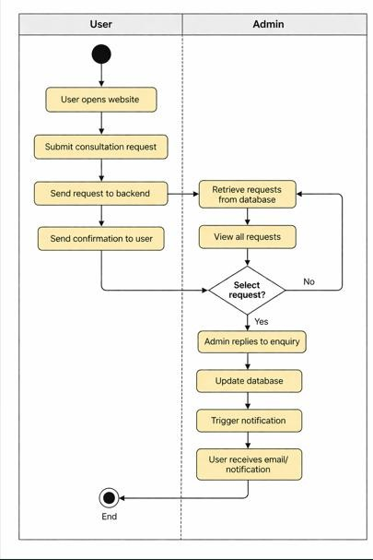

Fig 3.4 Activity Diagram

DATABASE DESIGN

User Schema:
const mongoose = require("mongoose");
const UserSchema = new mongoose.Schema({ name: String,
email: String, phone: String, password: String, role: {
type: String,
enum: ["user", "admin"], default: "user"
},
createdAt: { type: Date,
default: Date.now
}
});

Service Schema:
const ServiceSchema = new mongoose.Schema({ serviceName: String,
description: String, category: String, price: Number, createdAt: {
type: Date, default: Date.now
}
});

Project Schema:
const ProjectSchema = new mongoose.Schema({ projectTitle: String,
description: String, location: String, clientName: String, completionDate: Date, projectImage: String, category: String, createdAt: {
type: Date, default: Date.now
}
});

Request Schema:

const ConsultationSchema = new mongoose.Schema({ userId: {
type: mongoose.Schema.Types.ObjectId, ref: "User"
},
serviceId: {
type: mongoose.Schema.Types.ObjectId, ref: "Service"
},
message: String, status: {
type: String, default: "Pending"
},
createdAt: { type: Date,
default: Date.now
}
});

const Consultation = mongoose.model("Consultation", ConsultationSchema);

MODULES DESCRIPTION

User Authentication Module

User authentication module is responsible for handling the administrator login and ensuring that only authorized users can access the system’s backend. While anyone can visit and browse the website without signing up, access to the admin dashboard is restricted for security reasons. Only administrators with valid credentials, such as email and password, are allowed to log in. When an admin tries to log in, the system checks the entered details with the information stored in the database. If the credentials are correct, access is granted; otherwise, the system prevents entry, ensuring that unauthorized users cannot access sensitive features. This helps protect important data and maintain the integrity of the application.Once logged in, the administrator can manage consultancy services, view and respond to client inquiries, and update website content as needed. The module also follows secure practices for handling passwords and sensitive information, reducing the risk of data breaches.Overall, this module plays an important role in keeping the system secure while allowing administrators to efficiently manage and control the platform’s operations.

Service Management Module

The service management module enables administrators to easily manage the consultancy services offered by Nivas Constructions. Through the admin dashboard, they can add new services, update existing ones, or remove services that are no longer needed. Each service includes important details such as the service name, description, category, and other relevant information, making it easier for users to understand what is being offered. Whenever the administrator makes any changes, those updates are immediately reflected on the website, ensuring that users always see the most up-to-date information. The system handles these operations smoothly using backend APIs developed with Node.js and Express.js, which manage all the create, read, update, and delete (CRUD) actions. Meanwhile, MongoDB is used to store and organize the service data efficiently. Overall, this module simplifies service management for administrators and ensures that the platform remains accurate, dynamic, and easy to maintain.

Project Management Module

The project module handles the management of construction projects completed by Nivas Constructions. Through the admin dashboard, administrators can easily add new projects, update existing details, or remove projects when needed. Each project includes key information such as the project title, description, location, completion details, and images that highlight the company’s work. The module also allows visitors to browse these completed projects on the website. This helps potential clients get a clear idea of the company’s experience, quality of work, and the types of projects they have handled in the past.All the project information is securely stored in MongoDB, ensuring organized and reliable data management. The backend, built using Node.js and Express.js, takes care of all operations like adding, viewing, updating, and deleting project data. Any changes made by the administrator are reflected instantly on the website, keeping the content accurate and up to date.Overall, this module helps showcase the company’s portfolio effectively while making it easy for administrators to manage project details.

Admin Dashboard Module

The admin dashboard module serves as the central control panel for managing the Nivas Constructions consultancy web application. It provides administrators with a single, organized interface where they can monitor and manage all key activities of the system. Through the dashboard, admins can easily view client inquiries, manage consultancy services, and update project details without any complexity.The dashboard is designed to present information in a clear and structured way, making it easier for administrators to keep track of user interactions and overall system activity. It also offers quick access to important features, such as adding or editing services and reviewing consultation requests, which helps save time and improve efficiency.Overall, this module simplifies system management by bringing all essential controls into one place, allowing administrators to maintain and operate the platform smoothly and effectively.

User Dashboard Module

The user dashboard module provides a personalized space for users once they access the Nivas Constructions consultancy platform. It is designed to make the overall experience simple and convenient, allowing users to easily explore available consultancy services, submit their requests, and keep track of the status of their inquiries in one place.Through the dashboard, users can also manage their basic profile information and review any requests they have submitted earlier. All the important details are presented in a clear and organized manner, making it easy for users to navigate and use the platform without confusion. Overall, this module helps users stay informed about their consultation activities while providing a smooth and user-friendly experience throughout their interaction with the system.

Email Module

The email module handles all communication between users and Nivas Constructions through the consultancy web application. Whenever a user submits an inquiry or contact request on the website, the system automatically sends the details to the company via email. This ensures that administrators are quickly informed about new client requests without any delay.By automating this process, the module makes communication faster and more organized. It allows the company to review and respond to client inquiries efficiently, without missing any important messages.Overall, this module plays an important role in keeping the communication smooth and timely, helping both users and administrators stay connected through the platform.

CHAPTER 4 TESTING

SYSTEM TESTING
System testing is carried out to make sure that the entire application works properly as a complete system. In the Nivas Constructions consultancy web application, this testing focused on all the main features, such as browsing consultancy services, viewing project details, submitting inquiries through contact forms, and using the admin dashboard to manage services and projects. Each part of the system was tested under different conditions to ensure that everything works together smoothly without any issues.Special attention was given to the user experience, making sure that visitors can easily navigate the website, explore services, and submit their requests without confusion or errors. The testing also checked whether the user interface is responsive across different devices, and whether the frontend and backend communicate correctly using Node.js and Express.js. In addition, it verified that data is properly stored and retrieved from MongoDB.Overall, the main goal of system testing was to ensure that the application runs reliably and provides a smooth and user-friendly experience for both users and administrators of Nivas Constructions.

UNIT TESTING
Unit testing is the first stage of testing, where individual parts of the application are checked separately to make sure they work correctly. In the Nivas Constructions consultancy web application, unit testing was carried out on both the frontend and backend to ensure that each component functions as expected.On the frontend, React components such as service display sections, contact forms, navigation menus, and input fields were tested to confirm that they load properly and respond correctly to user actions. Form validations and user input handling were also verified to ensure that the data entered by users is accurate and properly submitted.On the backend, testing focused on Node.js functions that handle inquiries, manage consultancy services, and perform database operations using MongoDB. By testing these functions individually, it was easier to identify and fix errors early in the development process.

MODULE TESTING
Module testing was carried out to check how well each part of the Nivas Constructions consultancy web application works on its own. In this stage, every module was treated as a separate unit and tested to ensure that its features function correctly and consistently.For instance, the User Module was tested to verify login and authentication processes. The Service Module was checked to ensure that services can be added, updated, and displayed properly. The Project Module was tested to confirm that project details are managed correctly. Similarly, the Contact or Inquiry Module was tested to make sure that user inquiries are successfully submitted and stored in the database.By testing each module individually, it became easier to identify and fix issues early. This approach ensured that data handling, system flow, and overall functionality of each module were working properly before combining them into the complete system.

INTEGRATION TESTING
Integration testing was carried out to ensure that all the different parts of the Nivas Constructions consultancy web application work well together. The focus was on checking how modules like user authentication, service browsing, project display, contact inquiries, and the admin dashboard interact with each other when combined. For example, when a user submits an inquiry through the contact form, the system was tested to make sure that the data is correctly sent to the backend and stored in the MongoDB database. The communication between the React frontend and the Node.js and Express.js backend was also carefully checked to ensure that API requests work properly and errors are handled correctly.In addition, the connection between the application and the MongoDB database was tested to confirm that data can be stored and retrieved without any issues. Overall, integration testing helped ensure smooth coordination between different modules and provided a seamless and reliable experience for both users and administrators.

VALIDATION TESTING
Validation testing was carried out to make sure that the Nivas Constructions consultancy web application meets all its required functionalities and performs well in real- world use. The application was checked against its main goals, such as allowing users to easily browse consultancy services, view project details, submit inquiries through contact forms, and enabling administrators to manage everything efficiently through the dashboard.Special attention was given to form validations to ensure that users enter correct and complete information while submitting inquiries or contact requests. Different situations, such as missing details, invalid inputs, and how the system responds to errors, were tested to ensure proper handling. The application was also tested on different screen sizes to confirm that it remains responsive and user-friendly across devices.Overall, this testing phase helped confirm that the system works as expected under practical conditions and meets both technical requirements and user expectations, providing a reliable and smooth experience for users and administrators of Nivas Constructions.

CHAPTER 5 RESULTS AND DISCUSSION
The consultancy web application developed for Nivas Constructions provides a modern and efficient way for the company to showcase its services and completed projects to potential clients. Through this platform, users can easily explore available consultancy services, view project details, and submit inquiries using a simple and user-friendly interface. By bringing these processes online, the application reduces the need for traditional communication methods and makes it much easier for clients to connect with the company.The system is built using modern web technologies such as React for the frontend, Node.js and Express.js for the backend, and MongoDB for data storage.
The technologies work together to ensure smooth communication, efficient data handling, and reliable storage of important information like services, project details, and user inquiries. The inclusion of an admin dashboard further improves the system by allowing administrators to manage services, update project information, and handle client requests efficiently from a single place.To ensure the application works effectively, thorough testing was carried out under different conditions.
The platform was checked for functionality, responsiveness, and data accuracy to make sure users can navigate the system easily without any issues. Proper validation, fast response times, and smooth interaction between different parts of the system were also verified.Overall, this project shows how digital solutions can improve traditional consultancy services and make business operations more efficient. It strengthens the online presence of Nivas Constructions, improves communication with clients, and provides a strong foundation for future enhancements such as online appointment booking, advanced service features, and better customer interaction tools.


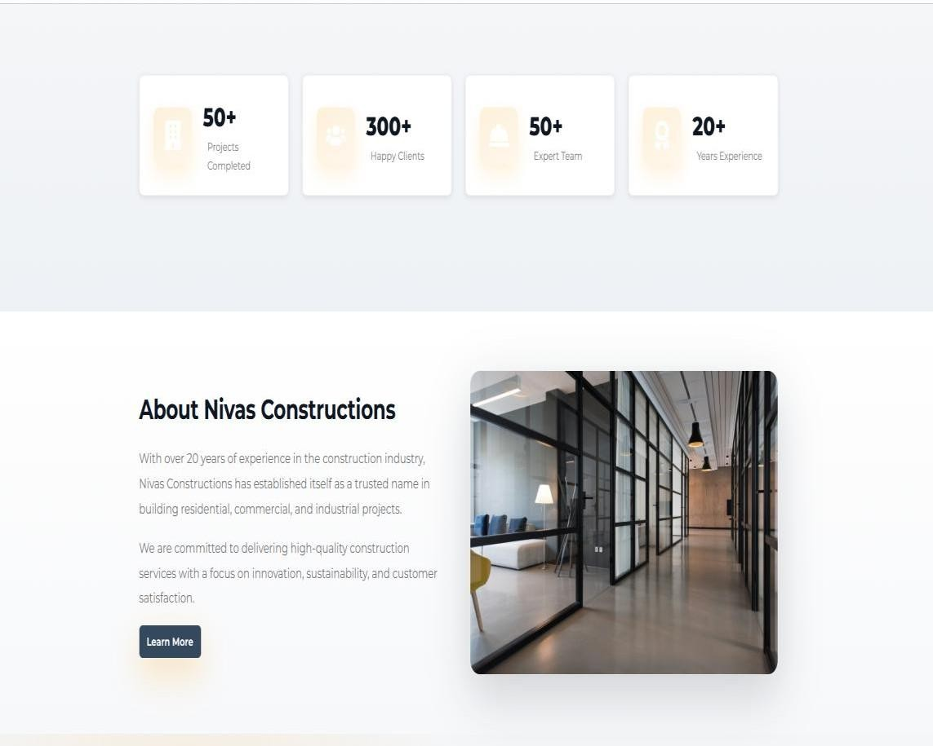

Figure 5.1 Landing Page
The landing page is the main entry point of the website where users can view an overview of
Nivas Constructions, explore consultancy services, and navigate to other sections.

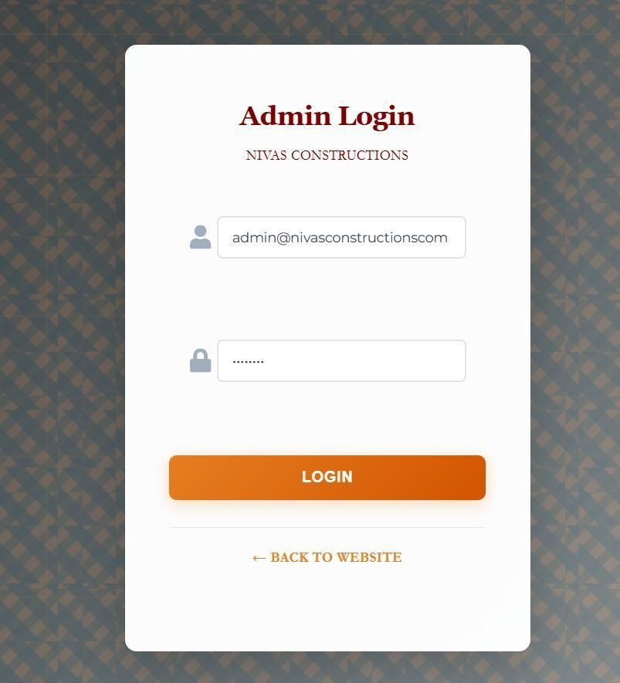

Figure 5.2 Admin LoginPage
The Admin Login Page allows authorized administrators to securely log in to the system and access the dashboard to manage services, projects, and client inquiries.
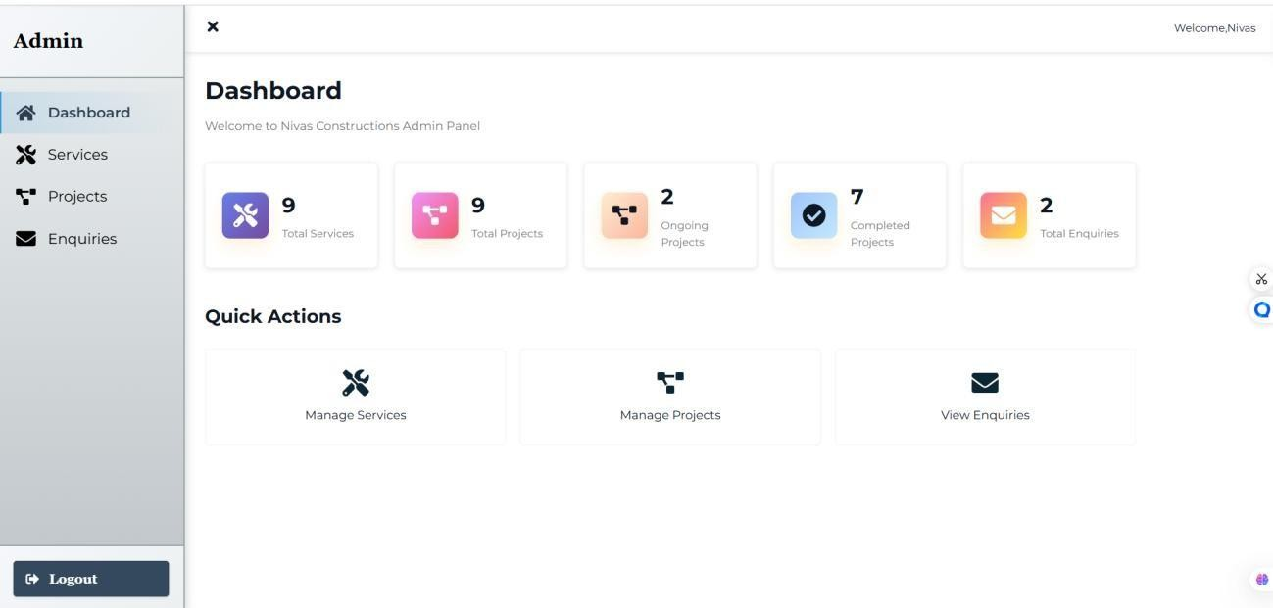

Figure 5.3 Admin Dashboard
The Admin Dashboard provides administrators with a centralized interface to manage consultancy services, update project details, and monitor client inquiries efficiently.

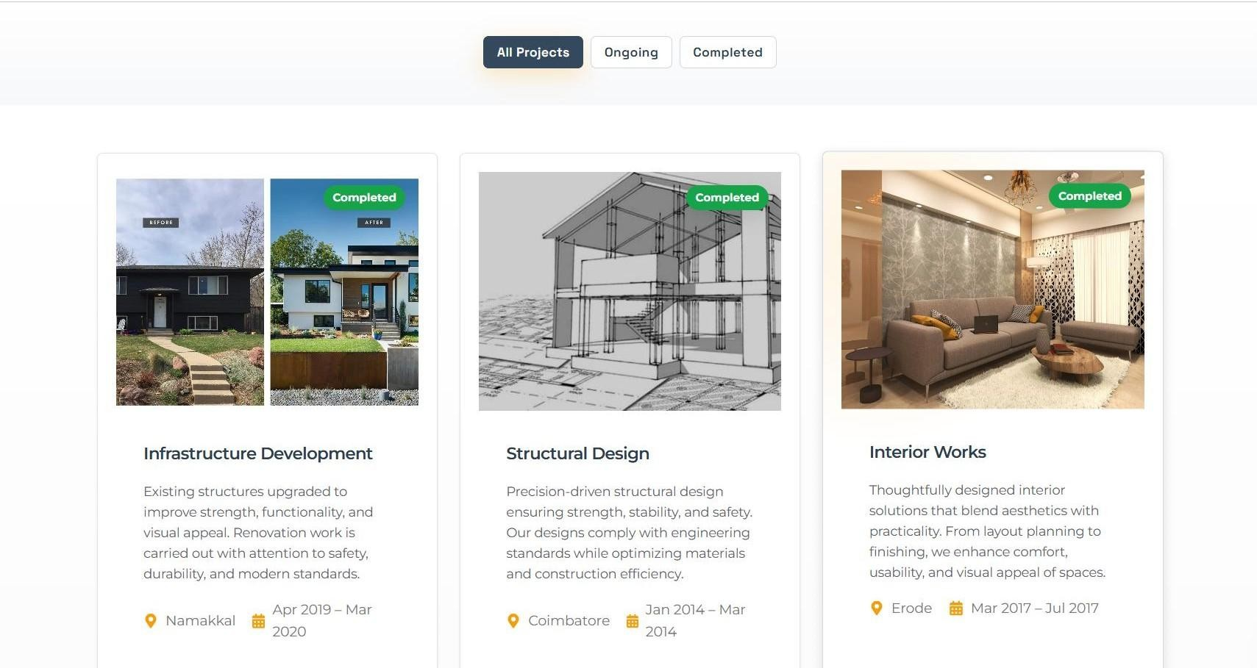
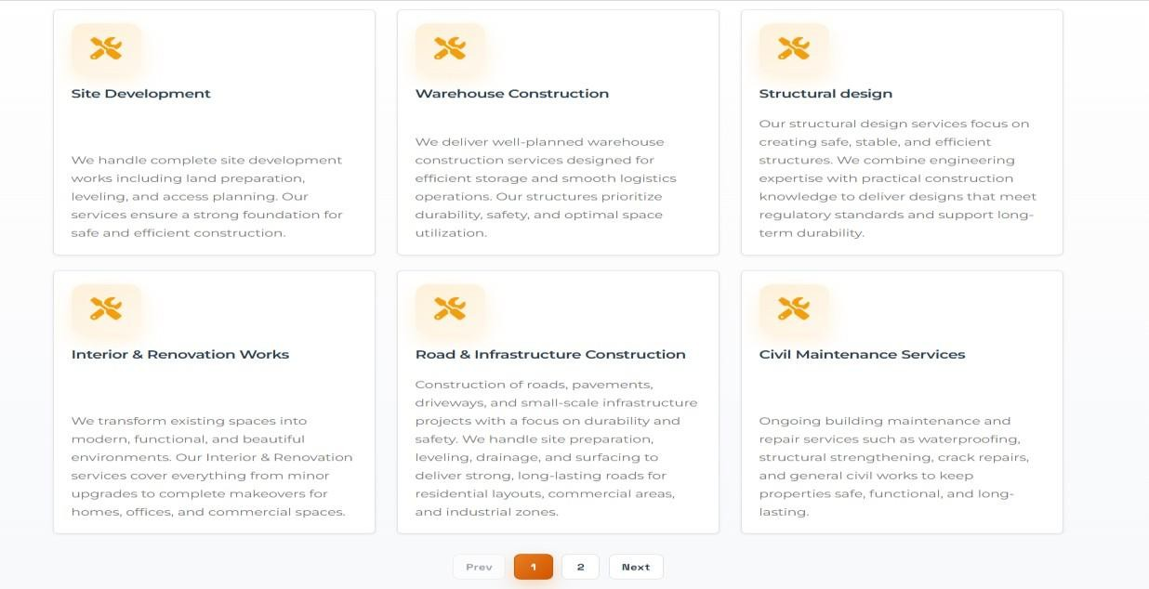

Figure 5.4 Projects & ServicePage
The Projects & Service Page displays the projects completed , ongoing and services offered by Nivas constructions.

CHAPTER 6 CONCLUSION AND FUTURE WORK
The consultancy web application developed for Nivas Constructions successfully achieves
its goal of providing a modern and efficient digital platform to showcase the company’s consultancy services and completed construction projects. By using technologies such as React for the frontend, Node.js and Express.js for the backend, and MongoDB for database management, the system ensures smooth performance, reliable functionality, and efficient handling of data. The website allows users to easily browse available services, view detailed project information, and submit inquiries through a simple and user-friendly interface. At the same time, the admin dashboard enables administrators to manage services, update project details, and monitor client inquiries in an organized and efficient manner.

This system significantly improves the company’s online presence and simplifies communication between the organization and its clients. It reduces manual effort in handling inquiries and maintaining service information, while ensuring that all data is properly stored and easily accessible. The platform provides a structured and intuitive experience for users, making it easier for them to interact with the company and understand the services offered. Overall, it bridges the gap between traditional consultancy methods and modern digital solutions, helping Nivas Constructions reach a wider audience and build stronger client relationships.

Looking ahead, there are several opportunities to further enhance the system and improve its capabilities. Features such as online appointment scheduling can make the consultation process more convenient for users, while secure payment integration can support paid consultancy services. Real-time chat functionality can enable instant communication between clients and the company, improving responsiveness and customer satisfaction. In addition, advanced analytics can be used to track user behavior and provide insights for better decision-making.

Further improvements such as multi-language support can make the platform accessible to a broader audience, while enhanced project galleries with images and detailed descriptions can better showcase the company’s work. Improvements in mobile responsiveness can also ensure a smooth experience across all devices.

APPENDIX 1 CODING

App.js :
import React from 'react';
import { BrowserRouter as Router, Routes, Route, Navigate } from 'react-router-dom'; import ProtectedRoute from './utils/ProtectedRoute';
import './styles/App.css';
import Home from './pages/public/Home'; import About from './pages/public/About'; import Services from './pages/public/Services'; import Projects from './pages/public/Projects'; import Contact from './pages/public/Contact';
import AdminLogin from './pages/admin/AdminLogin'; import Dashboard from './pages/admin/Dashboard';
import AdminServices from './pages/admin/AdminServices'; import AdminProjects from './pages/admin/AdminProjects'; import AdminEnquiries from './pages/admin/AdminEnquiries'; function App() {
return (
<Router>
<Routes>
{/* Public Routes */}
<Route path="/" element={<Home />} />
<Route path="/about" element={<About />} />
<Route path="/services" element={<Services />} />
<Route path="/projects" element={<Projects />} />
<Route path="/contact" element={<Contact />} />
{/* Admin Routes */}
<Route path="/admin/login" element={<AdminLogin />} />
<Route path="/admin/dashboard" element={
<ProtectedRoute>

<Dashboard />
</ProtectedRoute>
}
/>
<Route path="/admin/services" element={
<ProtectedRoute>
<AdminServices />
</ProtectedRoute>
}
/>
<Route path="/admin/projects" element={
<ProtectedRoute>
<AdminProjects />
</ProtectedRoute>
}
/>
<Route path="/admin/enquiries" element={
<ProtectedRoute>
<AdminEnquiries />
</ProtectedRoute>
}
/>
{/* Redirect /admin to /admin/dashboard */}
<Route path="/admin" element={<Navigate to="/admin/dashboard" replace />} />
{/* 404 Route */}
<Route path="*" element={<Navigate to="/" replace />} />
</Routes>
</Router>
);

}
export default App;

server.js:
require('dotenv').config();
const express = require('express'); const cors = require('cors');
const connectDB = require('./config/db');
const authRoutes = require('./routes/authRoutes'); const serviceRoutes = require('./routes/serviceRoutes'); const projectRoutes = require('./routes/projectRoutes');
const enquiryRoutes = require('./routes/enquiryRoutes');

const app = express(); connectDB();
const allowedOrigins = process.env.NODE_ENV === 'production'
? [process.env.FRONTEND_URL || 'https://nivas-constructions.vercel.app']
: ['http://localhost:3000', 'http://localhost:5000'];

const corsOptions = { origin: allowedOrigins, credentials: true,
methods: ['GET', 'POST', 'PUT', 'DELETE', 'OPTIONS'],
allowedHeaders: ['Content-Type', 'Authorization']
};

app.use(cors(corsOptions)); app.use(express.json({ limit: '50mb' }));
app.use(express.urlencoded({ limit: '50mb', extended: true }));

app.use('/api/auth', authRoutes); app.use('/api/services', serviceRoutes); app.use('/api/projects', projectRoutes); app.use('/api/enquiries', enquiryRoutes);

app.get('/', (req, res) => { res.json({
message: 'Nivas Constructions API', status: 'Active',
version: '1.0.0'
});
});
app.use((err, req, res, next) => { console.error(err.stack);

res.status(500).json({ success: false,
message: 'Something went wrong!',
error: process.env.NODE_ENV === 'development' ? err.message : undefined
});
});
app.use((req, res) => { res.status(404).json({ success: false,
message: 'Route not found'
});
});

const PORT = process.env.PORT || 5000; app.listen(PORT, () => {
console.log(`Server running in ${process.env.NODE_ENV || 'development'} mode on port
${PORT}`);
});

ApiServices.js :
import api from './api'; export const authService = {
login: async (credentials) => {

const response = await api.post('/auth/login', credentials); if (response.data.token) {
localStorage.setItem('token', response.data.token); localStorage.setItem('admin', JSON.stringify(response.data.admin));
}

return response.data;

},

logout: () => { localStorage.removeItem('token'); localStorage.removeItem('admin');
},

getProfile: async () => {

const response = await api.get('/auth/profile'); return response.data;
},

isAuthenticated: () => {

return !!localStorage.getItem('token');

},

getAdmin: () => {

const admin = localStorage.getItem('admin'); return admin ? JSON.parse(admin) : null;
}
};

export const serviceService = { getAll: async () => {
const response = await api.get('/services?limit=1000'); return response.data;
},
getAllAdmin: async () => {

const response = await api.get('/services/admin/all?limit=1000'); return response.data;
},

getById: async (id) => {

const response = await api.get(`/services/${id}`); return response.data;
},

create: async (data) => {

const response = await api.post('/services', data);

return response.data;

},

update: async (id, data) => {

const response = await api.put(`/services/${id}`, data); return response.data;
},

delete: async (id) => {

const response = await api.delete(`/services/${id}`); return response.data;
}

};

export const projectService = { getAll: async (status) => {
const params = status ? `?status=${status}&limit=1000` : '?limit=1000'; const response = await api.get(`/projects${params}`);
return response.data;

},
getAllAdmin: async () => {

const response = await api.get('/projects/admin/all?limit=1000'); return response.data;
},

getById: async (id) => {

const response = await api.get(`/projects/${id}`); return response.data;
},

create: async (data) => {

const response = await api.post('/projects', data);

return response.data;

},

update: async (id, data) => {

const response = await api.put(`/projects/${id}`, data); return response.data;
},

delete: async (id) => {

const response = await api.delete(`/projects/${id}`); return response.data;
}

};

export const enquiryService = { getAll: async (status) => {
const params = status ? `?status=${status}` : '';

const response = await api.get(`/enquiries${params}`); return response.data;
},
getById: async (id) => {

const response = await api.get(`/enquiries/${id}`); return response.data;
},

create: async (data) => {

const response = await api.post('/enquiries', data); return response.data;
},

update: async (id, data) => {

const response = await api.put(`/enquiries/${id}`, data);

return response.data;

},

delete: async (id) => {

const response = await api.delete(`/enquiries/${id}`); return response.data;
},

sendReply: async (id, reply) => {

const response = await api.post(`/enquiries/${id}/reply`, { reply }); return response.data;
},

getStats: async () => {

const response = await api.get('/enquiries/stats'); return response.data;
}};

Home.js :
import React from 'react';

import Layoutfrom'../../components/public/Layout'; import { Link } from 'react-router-dom';
import { FaHardHat, FaBuilding, FaUsers, FaAward } from 'react-icons/fa'; import '../../styles/Home.css';
const Home= () => { return (
<Layout>

<div className="home">
<sectionclassName="heroparallax-hero" style={{backgroundImage:
`url('https://www.constructionworld.in/assets/uploads/13a98c40261296c534a4868124aecf91.jpg')`}}>

<div className="hero-overlay">

<div className="container">

<div className="hero-grid">

<divclassName="hero-leftrevealslide-up" style={{animationDelay: '120ms'}}>

<div className="glass-panel">

<h1><b>Building Your Dreams Into Reality</b></h1>

<p className="lead"><b>Design · Build · Deliver — Professional construction services with a focus on quality, safety and timely delivery.</b></p>

{/* <divclassName="hero-buttons">

<Linkto="/projects" className="btnbtn-primary">View Projects</Link>

<Linkto="/contact" className="btnbtn-secondary">Request Quote</Link>

</div>*/}

</div>

</div>

<divclassName="hero-rightreveal zoom-in stagger-2">

<div className="hero-image">

<img alt="constructionsite"
src="https://www.constructionworld.in/assets/uploads/13a98c40261296c534a4868124aecf91.jpg"

/>

<div className="brand-badge">

<h3>Nivas Constructions</h3>

<p><b>Quality • Safety • Trust</b></p>

</div>

</div>

</div>

</div>

</div>

</div>

</section>

<div className="hero-wave">

<svgviewBox="00 1440 64" preserveAspectRatio="none" xmlns="http://www.w3.org/2000/svg"><path
d="M0 32c120 0 240-24 360-24s240 24 360 24 240-24 360-24 240 24 360 24v32H0z" fill="var(--
white)"/></svg>

</div>

<section className="stats-section">

<div className="container">

<div className="stats-grid">
<divclassName="stat-cardreveal slide-up stagger-1">

<div className="stat-icon"><FaBuilding /></div>

<div>

<div className="stat-number">50+</div>

<div className="stat-meta">Projects Completed</div>

</div>

</div>

<divclassName="stat-cardreveal slide-up stagger-2">

<div className="stat-icon"><FaUsers /></div>

<div>
<div className="stat-number">300+</div>

<div className="stat-meta">Happy Clients</div>

</div>

</div>

<divclassName="stat-cardreveal slide-up stagger-3">

<div className="stat-icon"><FaHardHat /></div>

<div>

<div className="stat-number">50+</div>

<div className="stat-meta">Expert Team</div>

</div>

</div>


<divclassName="stat-cardreveal slide-up stagger-4">
<div className="stat-icon"><FaAward /></div>

<div>
<div className="stat-number">20+</div>

<div className="stat-meta">Years Experience</div>

</div>

</div>

</div>

</div>

</section>

<section className="about-preview">
<div className="container">

<div className="about-preview-content">

<div className="about-text">
<h2>About Nivas Constructions</h2>

<p>

With over 20 years of experience in the construction industry, Nivas Constructions hasestablished itself as a trusted name in building residential, commercial, and industrial projects.
</p>

<p>

We are committed to delivering high-quality construction services with a focus on innovation, sustainability, and customer satisfaction.
</p>

<Linkto="/about" className="btnbtn-primary">Learn More</Link>

</div>

<divclassName="about-imagerevealzoom-in stagger-2">

<imgalt="project preview" src="https://images.unsplash.com/photo-1497366754035- f200968a6e72?ixlib=rb-4.0.3&auto=format&fit=crop&w=1200&q=80" />

</div>

</div>

</div>
</section>

{/* Why Choose Us */}

<section className="why-choose">

<div className="container">

<h2>Why Choose Us</h2>

<div className="features-grid">

<div className="feature-card">

<h3>Quality Assurance</h3>
<p>We maintain the highest standards of quality in every project we undertake.</p>

</div>
<div className="feature-card">

<h3>Timely Delivery</h3>

<p>Werespect deadlines and ensure projects are completed on time.</p>

</div>

<div className="feature-card">

<h3>Expert Team</h3>

<p>Our experiencedprofessionals bring expertise to every project.</p>

</div>

<div className="feature-card">

<h3>Competitive Pricing</h3>

<p>Qualityconstruction services at affordable andtransparent prices.</p>

</div>

</div>

</div>

</section>

{/* Featured Projects */}

<section className="featured-projects">

<div className="container">

<h2>Featured Projects</h2>

<p className="sub">Selected projects showcasingour quality and attention to detail</p>

<div className="projects-grid">

<divclassName="project-cardreveal slide-up stagger-1">

<div className="project-media"><img alt="project 1" src="https://images.unsplash.com/photo- 1504307651254-35680f356dfd?ixlib=rb-4.0.3&auto=format&fit=crop&w=1200&q=80"/></div>

<div className="project-body">

<h3>Road Construction</h3>
<p>Professional road infrastructure withsuperiormaterials andengineering.</p>

<Linkto="/projects" className="btnbtn-secondary">View Project</Link>
</div>

</div>

<divclassName="project-cardreveal slide-up stagger-2">

<div className="project-media"><img alt="project 2" src="https://images.unsplash.com/photo- 1505693416388-ac5ce068fe85?ixlib=rb-4.0.3&auto=format&fit=crop&w=1200&q=80"/></div>

<div className="project-body">

<h3>Commercial Office Fitout</h3>

<p>Efficient layouts and durable materials tailored for businesses.</p>

<Linkto="/projects" className="btnbtn-secondary">View Project</Link>

</div>

</div>

<divclassName="project-cardreveal slide-up stagger-3">

<div className="project-media"><img alt="project 3" src="https://images.unsplash.com/photo- 1531834685032-c34bf0d84c77?ixlib=rb-4.0.3&auto=format&fit=crop&w=1200&q=80"/></div>

<div className="project-body">

<h3>Industrial Warehouse</h3>

<p>Robust construction focused on efficiency and longevity.</p>

<Linkto="/projects" className="btnbtn-secondary">View Project</Link>
</div>

</div>

</div>

</div>

</section>

<section className="cta-section">

<div className="container">

<h2>Ready to Start Your Project?</h2>
<p>Contact us today for a free consultation and quote</p>

<Linkto="/contact" className="btnbtn-primary">Contact Us</Link>
</div>

</section>

</div>

</Layout>

);};

export default Home;

Auth.js
constjwt =require('jsonwebtoken');

const Admin =require('../models/Admin');

const authMiddleware = async (req, res, next) => {

try { const token = req.header('Authorization')?.replace('Bearer ', ''); if (!token) {
returnres.status(401).json({ success: false,
message: 'No authentication token, access denied'

});}


const decoded=jwt.verify(token, process.env.JWT_SECRET); const admin= await Admin.findById(decoded.id).select('-password'); if (!admin) {
returnres.status(401).json({ success: false,
message: 'Admin not found, token invalid'

});}

req.admin=admin; next();
} catch (error) {

console.error('Authmiddleware error:', error); res.status(401).json({
success: false,

message: 'Token is not valid'

});}

};

module.exports = authMiddleware;

APPENDIX 2

SNAPSHOTS
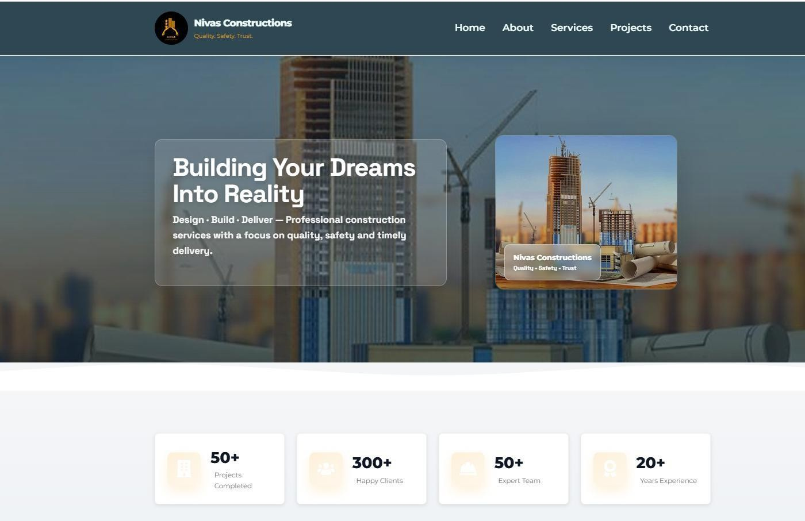
Fig. A2.1 Landing page
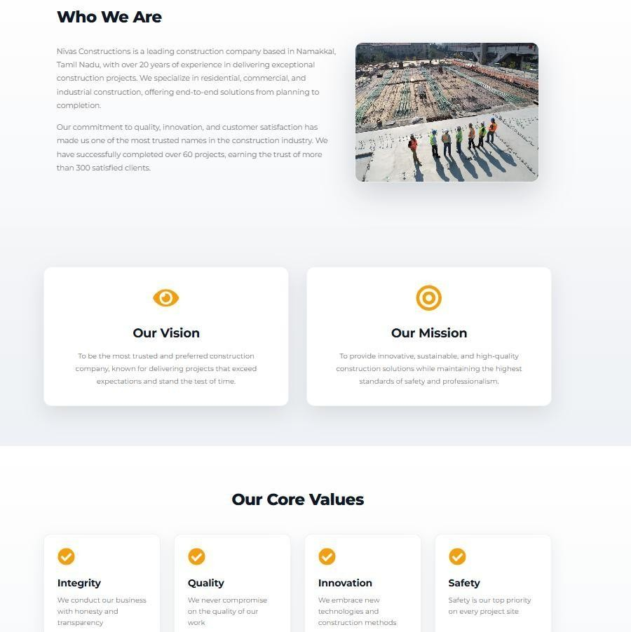

Fig. A2.2 About us Page

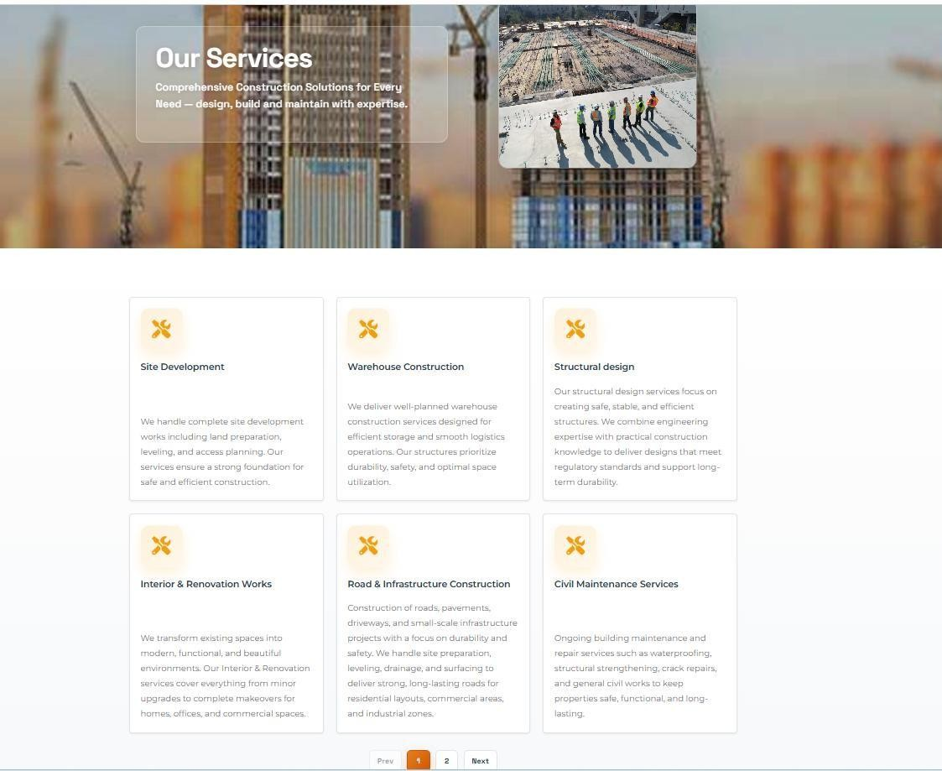
Fig. A2.3 Services Page

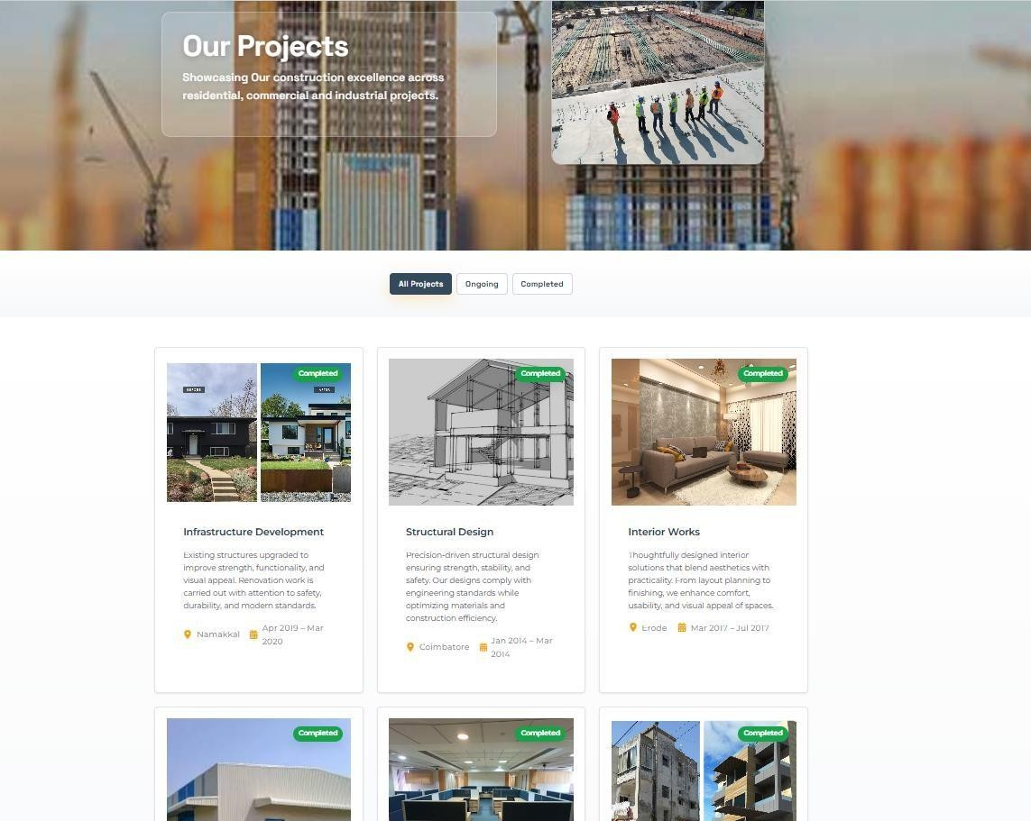
Fig. A2.4 Projects Page

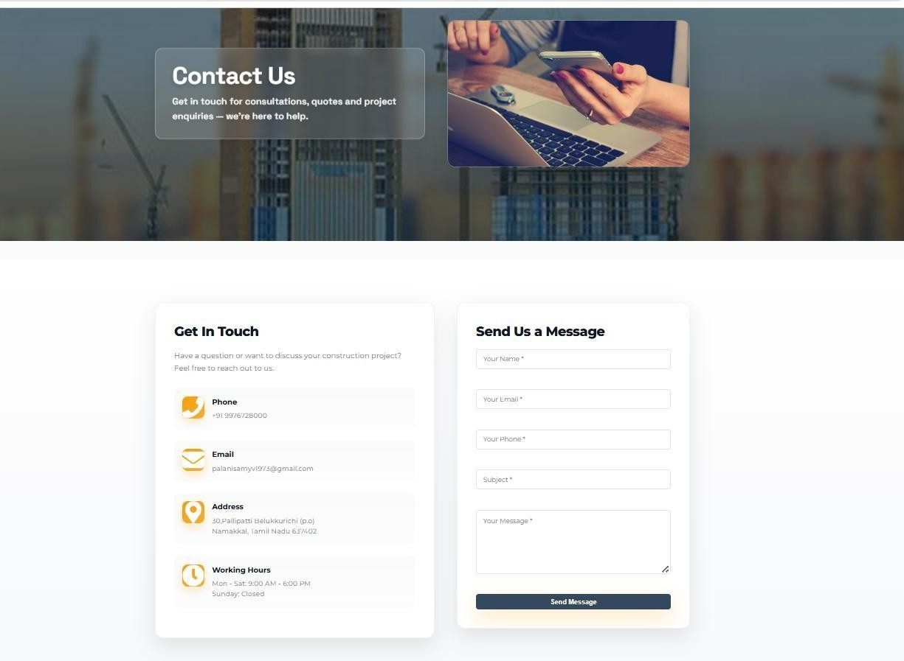

Fig. A2.5 Contact Us Page

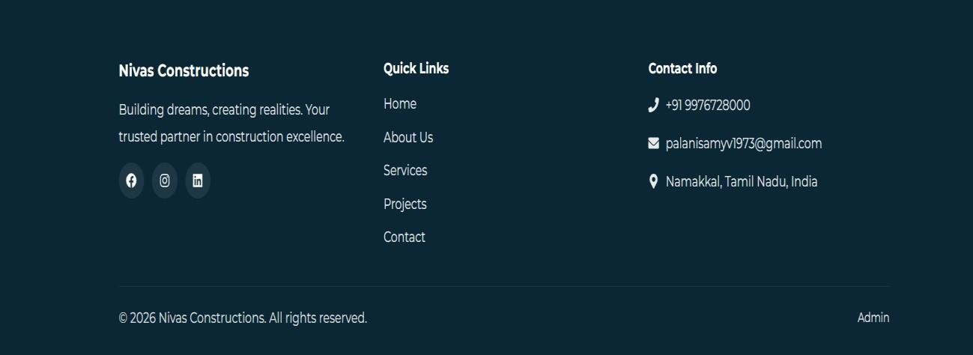

Fig. A2.6 Footer

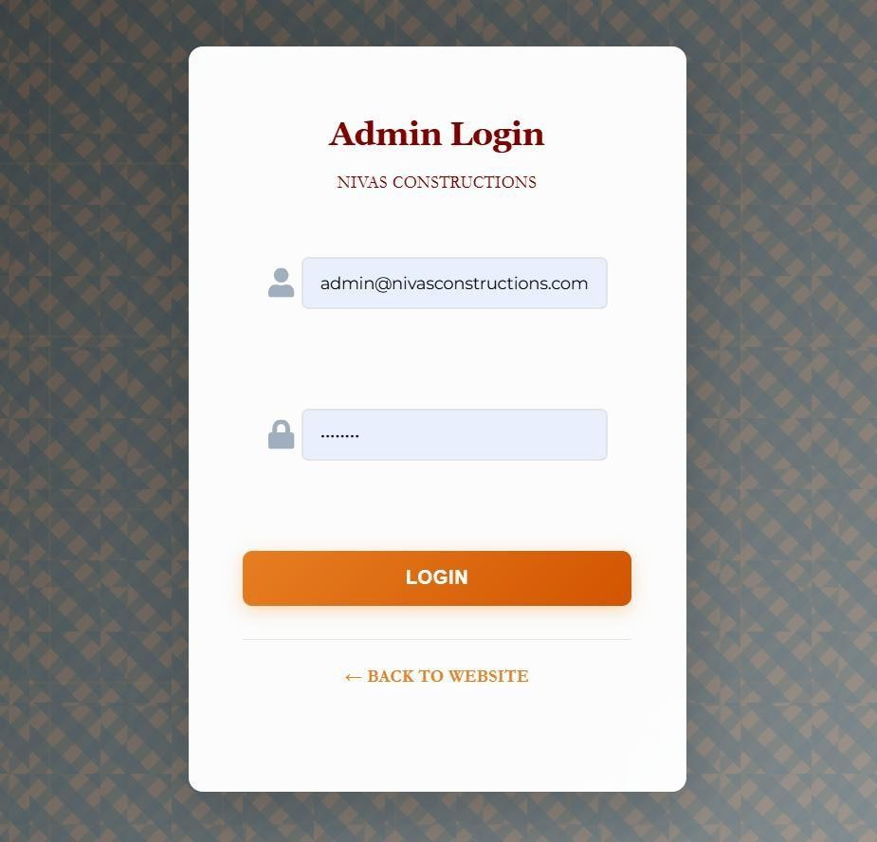
Fig. A2.7 Admin Login Page
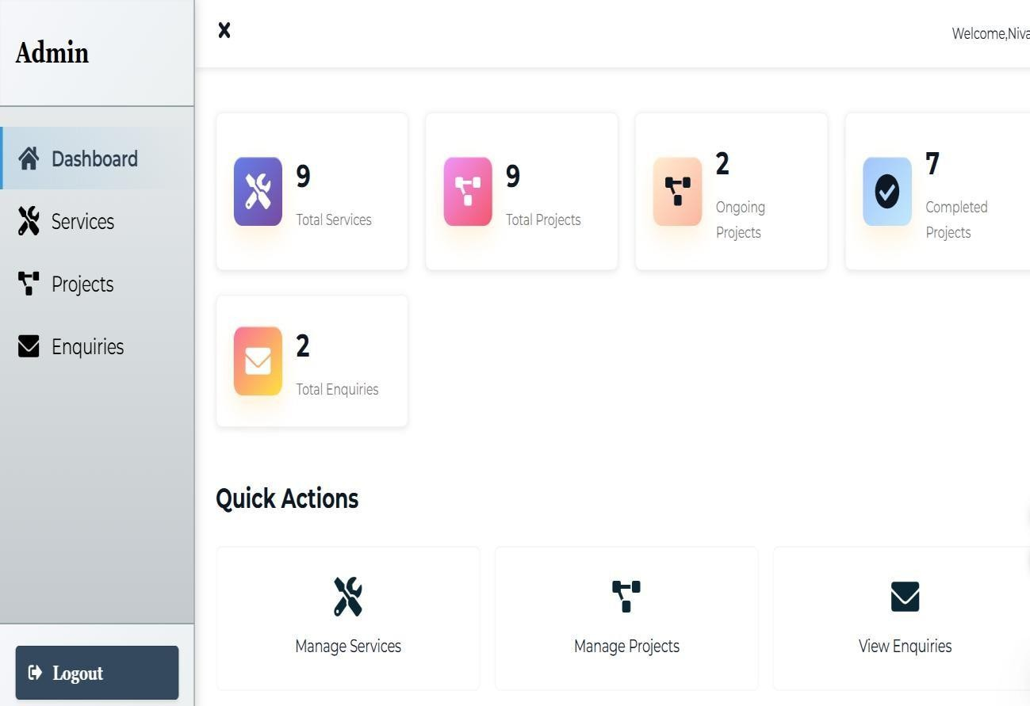

Fig. A2.8 Admin Dashboard

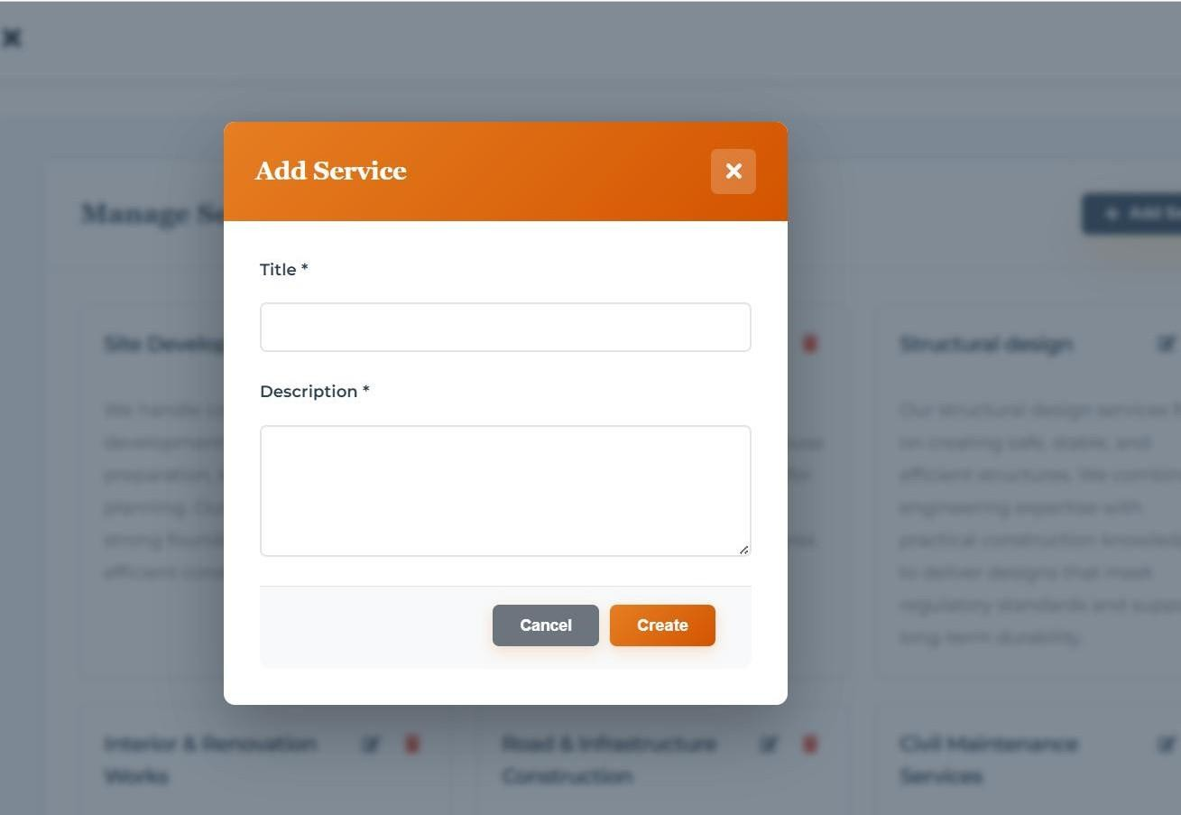

Fig. A2.9 Add Service Page
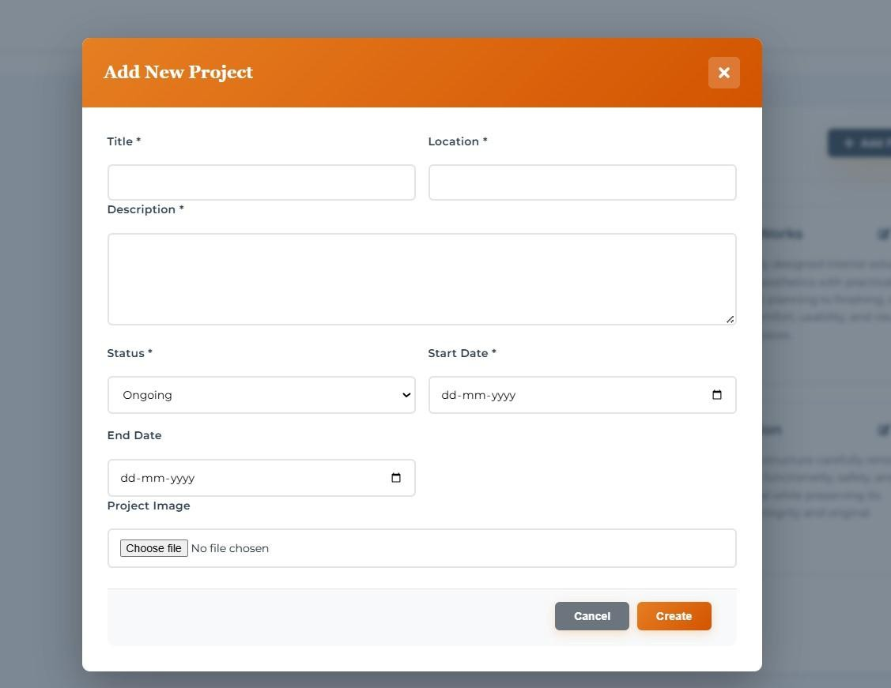

Fig. A2.10 Add Project Page

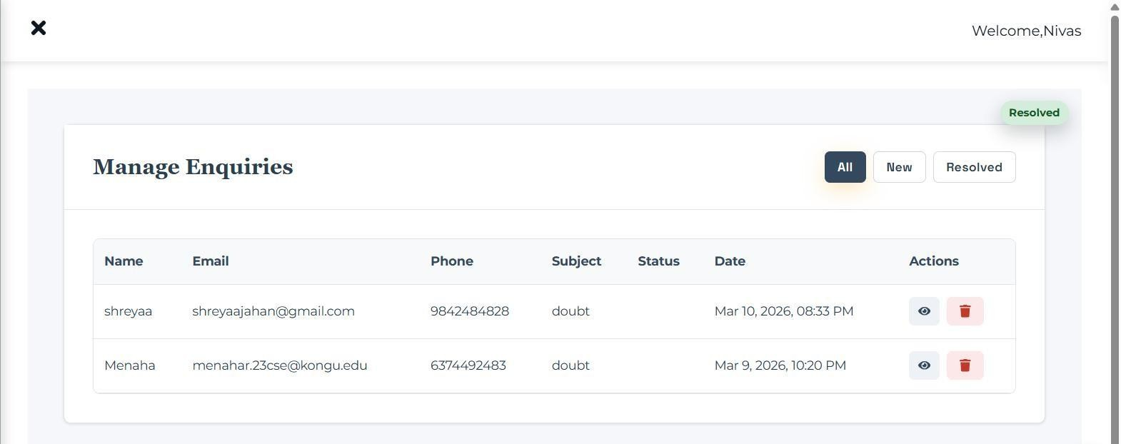

Fig. A2.11 Enquiries Page
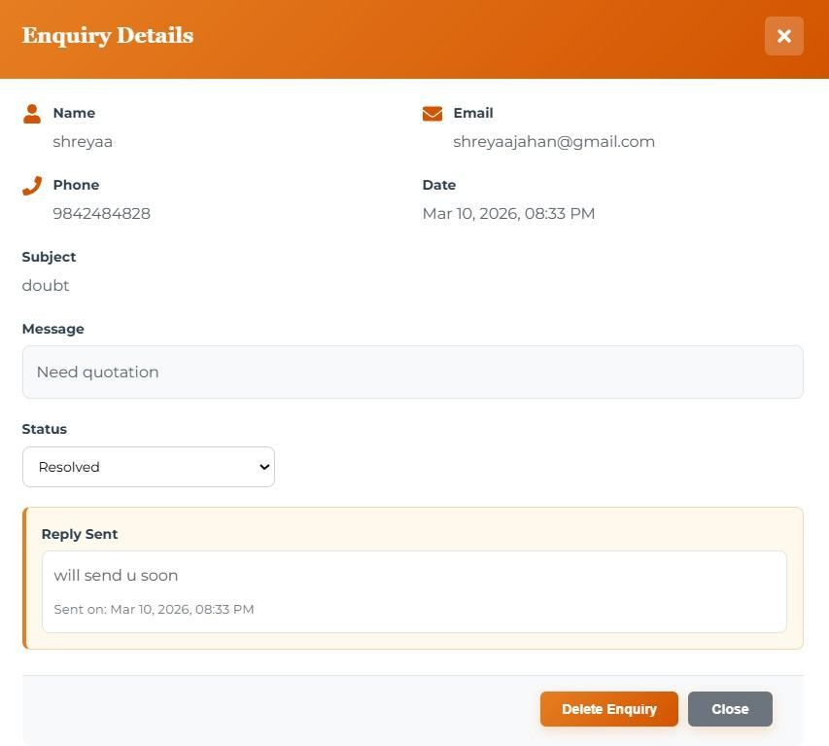

Fig. A2.12 Enquiry Details

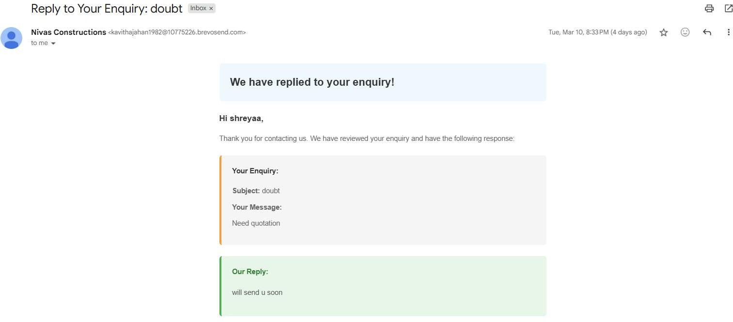

Fig. A2.13 Reply Mail
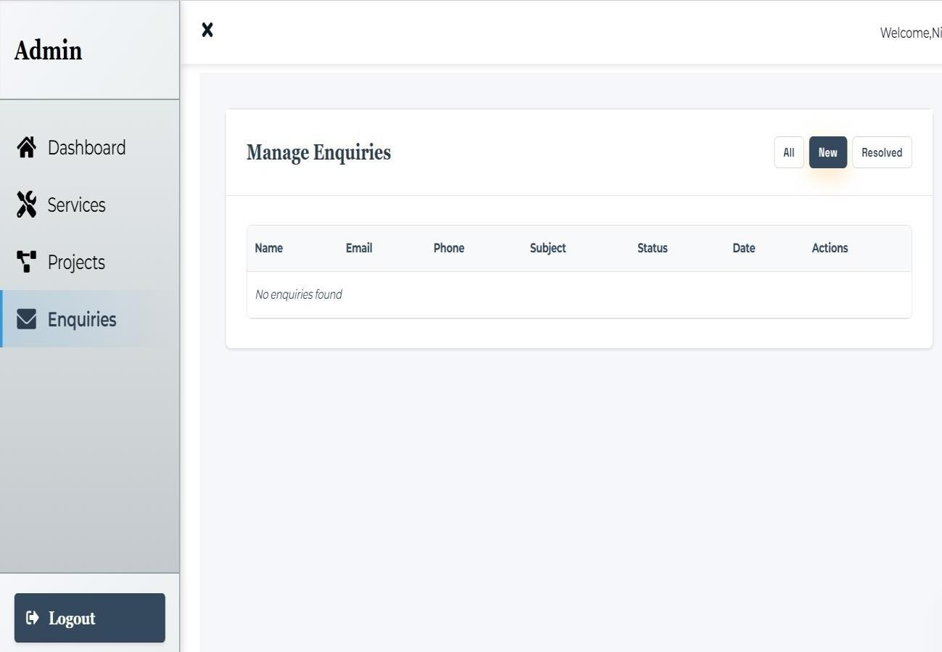

Fig. A2.14 Applying Filters to Enquiries

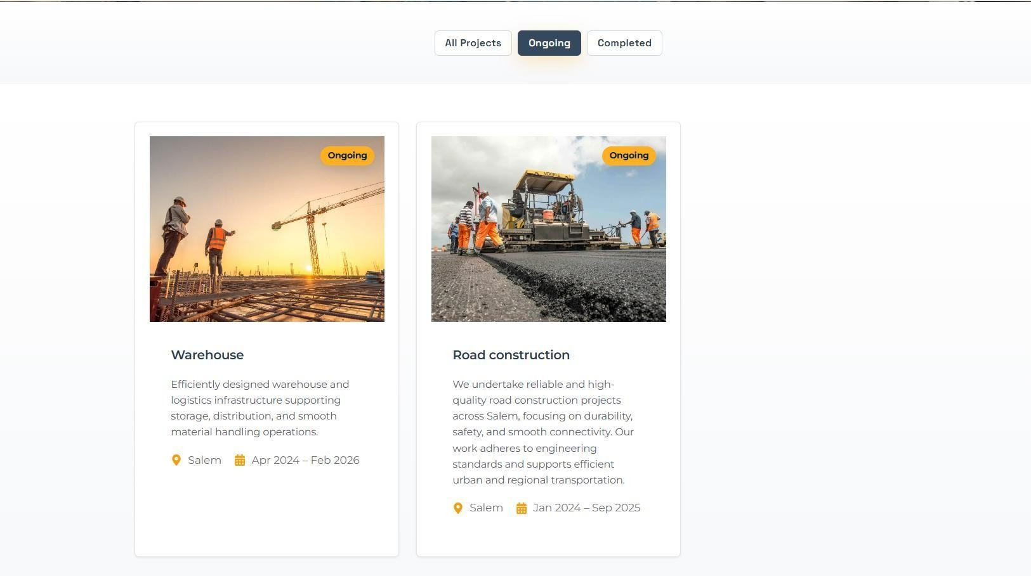

Fig. A2.15 Applying Filters to Projects Page
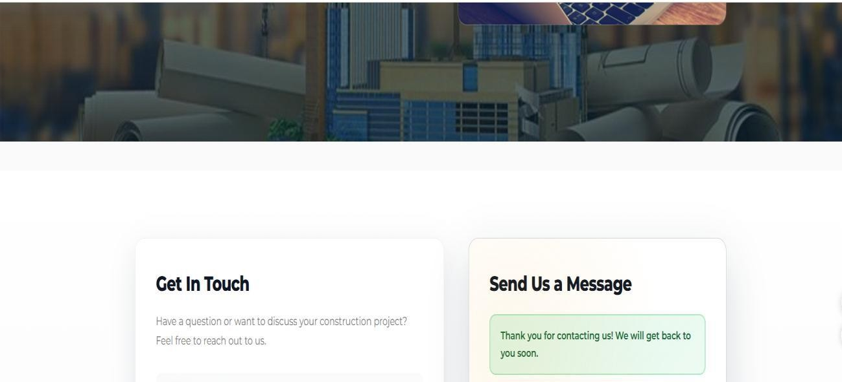

Fig. A2.16 Response for form filling

REFERENCES

- React Documentation -Meta (Facebook), https://reactnative.dev/docs/

- Node.js Documentation – OpenJS Foundation, https://nodejs.org/en/docs

- Express.js Guide – Express.js Official Site, https://expressjs.com/

- MongoDB Manual – MongoDB Inc., https://www.mongodb.com/docs/manual/

Github Link:

https://github.com/shreyaajahan/consultancy

https://github.com/roshantmr/consultancy

Live Demo:

https://consultancy-gamma-flax.vercel.app/

Deployment Platforms:

Vercel – https://vercel.com/docs

Render – https://render.com/docs

APPROVAL LETTER FROM THE COMPANY
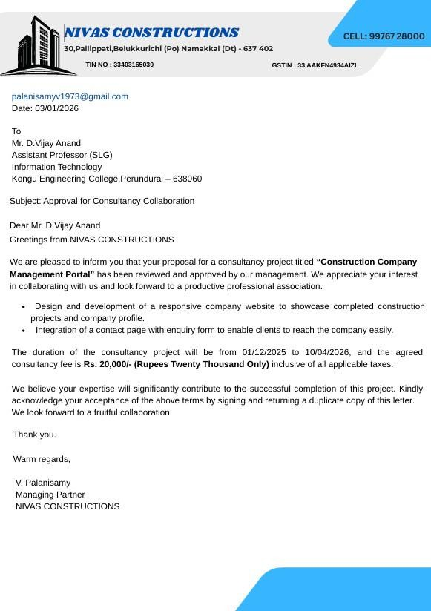

COMPLETION LETTER FROM THE COMPANY
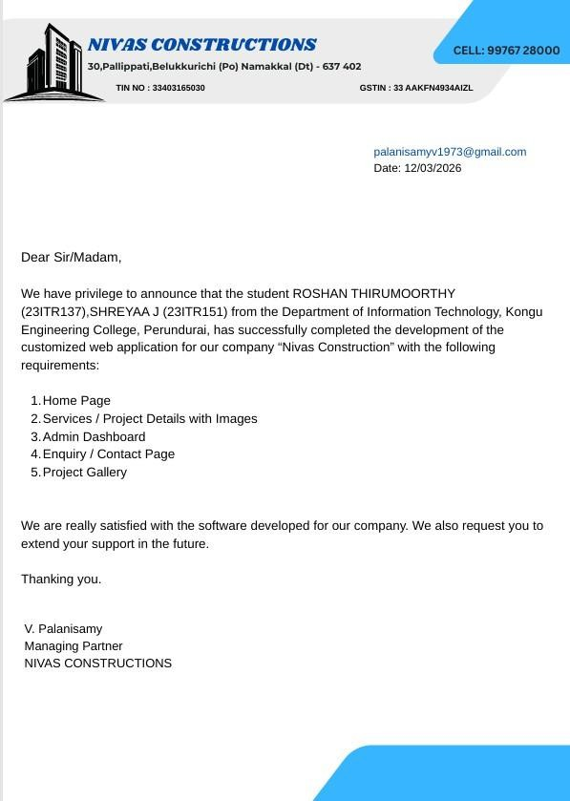

RECEIPT FROM THE COMPANY
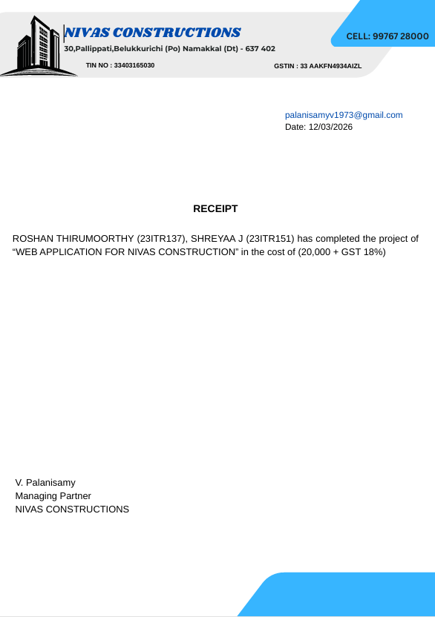

MAPPING OF SDG TO PROJECT WORK – I

Sustainable Development Goals (SDGs) are a set of global goals established by the United Nations to promote sustainable development and improve the quality of life for people around the world. They focus on important areas such as economic growth, environmental protection, innovation, education, and social equality. By integrating sustainable practices and technologies, different sectors—including digital platforms like e-commerce—can contribute to achieving these goals and creating a better and more sustainable future for society.

SDG 9 – Industry, Innovation and Infrastructure

This project aligns with Sustainable Development Goal 9 (Industry, Innovation, and Infrastructure) by introducing digital innovation into the traditional consultancy and construction services sector. The Nivas Constructions consultancy web application modernizes the way consultancy services are presented and accessed by providing an online platform where users can explore services, view completed projects, and submit inquiries easily. By transforming traditional consultation methods into a digital platform, the project promotes technological adoption and improves accessibility to professional services.

Additionally, the system strengthens business operations by providing an admin dashboard for managing consultancy services, project details, and client inquiries efficiently. These digital features help reduce manual communication processes, improve service management, and enhance client engagement. By integrating modern web technologies into the consultancy process, the project contributes to improving digital infrastructure and encourages innovation within the construction and consultancy industry, supporting the key objectives of Sustainable Development Goal 9.

