1. What Are Programming Languages?
- A programming language is a formal system that lets humans tell computers what to do.
- Computers understand machine code (binary: 0s and 1s), which is hard for humans — so languages help bridge that gap.

2. Types of Programming Languages (Paradigms)

🟢 a. Procedural Languages
- Code is written as a sequence of procedures / functions.
- Focus on:
  - Step-by-step instructions
  - Modular functions
- Example idea: Do A → Then B → Then C.

🟢 b. Functional Languages
- Based on mathematical functions.
- Avoid changing state and mutating data.
- Works well for operations where data doesn’t change a lot (like in ML/AI tasks).

🟢 c. Object-Oriented Languages
- Objects combine data + behavior.
- Key idea:
  - Code and its related data are bundled together
  - Objects interact through methods
- Helps with:
  - Code reuse
  - Easier debugging
  - Better structure

🟠 Multiple Paradigms
- A language can belong to multiple types:
  - Python can be procedural + object-oriented + functional style.
  - Java supports both procedural and object-oriented styles.

3. Static vs Dynamic Languages

🟡 Static Languages
- Type checking at compile time.
- Errors (like type mismatches) are identified before running.
- Variables must be declared with data types.
- Less risk at runtime.

🟡 Dynamic Languages
- Type checking happens while running.
- Program might compile, but errors can appear only when running.
- Easier syntax (less grammar), faster to write — but can crash at runtime.

Static vs Dynamic Quick Comparison
Feature | Static | Dynamic
Type Checks | Compile time | Runtime
Error Detection | Early | May appear at run
Control | Strong | Flexible
Syntax | Verbose | Simpler

4. How Memory Works
Memory is where program data is stored while it runs.

🟢 a. Stack Memory
- Stores local variables and function data.
- Fast, limited space.
- Controlled by program structure:
  - When a function starts → space allocated.
  - When it ends → freed automatically.

🟢 b. Heap Memory
- Used for objects and data created dynamically.
- Larger but slower than stack.
- Not automatically freed — sometimes requires special cleanup.

🟢 Reference Variables vs Primitives
- Primitives (like int, float, boolean) are stored in stack.
- Objects are stored in heap, and stack holds a reference to them.

int a = 10;
The value 10 is stored in the stack.
Object x = new Object();
The object is created in the heap, and the stack stores only the reference to that object.

Multiple References to the Same Object
Two variables can point to the same object.
If you modify the object using one variable, the change will be reflected when accessing the object through the other variable as well.
Example:
b = a
If b changes the object, a will also see the change because both point to the same object.

Garbage Collection
Garbage collection is an automatic memory management system used in languages like Java and Python.
When an object has no references pointing to it, it becomes eligible for garbage collection.
Unreferenced memory, meaning memory with no pointer or reference pointing to it, is automatically cleaned up to prevent memory leaks.

1. What Is the Flow of a Program?
- The flow of a program refers to the order in which statements are executed from start to finish. Programs follow a logical sequence to perform tasks.
- Understanding flow helps you visualize algorithms before writing actual code.

2. Why Visualize Program Flow?
Before writing code, programmers often outline the logic using tools that show how a program works:

⭕ a. Flowcharts
- A flowchart is a visual diagram representing an algorithm or program logic using symbols and arrows.
- It helps you see the steps and decisions clearly.
Common Flowchart Symbols:
Symbol | Represents
Oval / Terminator | Start or End of a program
Rectangle / Process | A step or operation
Parallelogram / I/O | Input or output process
Diamond / Decision | Choice or branching (e.g., yes/no)
Arrow | Direction of flow
👉 Flowcharts make it easy to visualize the movement of the program from one step to another — especially when decisions or loops are involved.

⭕ b. Pseudocode
- Pseudocode is a textual representation of an algorithm written in simple, structured English that resembles code but isn’t tied to any programming language.
- It describes what needs to be done, but not how to write it in specific syntax (like Java, Python, etc.).
✨ Think of pseudocode as a bridge between plain English logic and real code.

3. Differences: Flowchart vs Pseudocode
Feature | Flowchart | Pseudocode
Format | Visual diagram | Text description
Detail | Good for visualizing decisions | Good for precise step-by-step logic
Change | Harder to update (redraw) | Easier to modify
Use | Great for explaining logic flow | Great for translating to code later
💡 Both tools are used in the planning phase before writing actual code.

4. How Flowcharts Work
Flowcharts show the sequence and decision paths:
- Start with an oval indicating the start.
- Draw arrows to show the flow.
- Add rectangles for every step (e.g., “Input age”).
- Use diamonds for decisions (e.g., “Is age >= 18?”).
- Continue arrows to the next step or end.
The flow generally goes top to bottom or left to right.

5. How to Write Pseudocode
- Use plain English to describe steps.
- Write logic as a sequence of actions.
- No strict syntax rules, but structure should make reading easy.
Example (conceptual for leap-year logic):
START
INPUT year
IF (year divisible by 4)
PRINT "Leap year"
ELSE
PRINT "Not leap year"
END
This describes logic without real code syntax.

6. When to Use These Tools
✅ Flowcharts
- When you want a visual understanding of program decisions.
- Great for planning large logical flows.
✅ Pseudocode
- When you want clear, step-by-step instructions before coding.
- Useful for writing logic that can later translate directly into code.
Together, these help programmers think first — code later.

1. What Is Java?
- Java is a general-purpose, high-level programming language designed to be platform-independent.
- Java code is compiled to bytecode, which runs on the Java Virtual Machine (JVM). This makes Java write once, run anywhere (WORA).
- The architecture involves:
  - Java Source Code (.java)
  - Java Compiler (javac) → generates bytecode (.class)
  - JVM → executes the bytecode on any platform.

2. How Java Works
- You write Java code in a .java file.
- The compiler (javac) compiles it into bytecode.
- The JVM loads the bytecode and executes it.
- This means the same bytecode can run on Windows, Linux, macOS, etc., as long as a JVM is present.

3. Setting Up Java (Installation)
To write and run Java programs, you need:

🟢 a. JDK (Java Development Kit)
- Contains tools to compile and run Java programs (javac, java).

🟢 b. PATH Environment Variable
- After installing JDK, you must add javac and java to your system PATH so they can run from the command line.

🟢 c. Text Editor / IDE
- You can write Java code in any editor (VS Code, Notepad++) or an IDE (IntelliJ, Eclipse).

4. Your First Java Program

📝 Hello World Example
public class Main {
public static void main(String[] args) {
System.out.println("Hello World");
}
}
✔ public class Main — Defines a class named Main.
✔ public static void main(String[] args) — The entry point that the JVM calls first.
✔ System.out.println() — Prints text to the console.
How to run this:
- Save file as Main.java.
- Compile: javac Main.java.
- Run: java Main.

5. Java Syntax Basics

🟡 Classes
- Java is object-oriented, so code lives inside classes.

🟡 Methods
- A method is a function inside a class — like main() above.

🟡 Statements
- A statement ends with a semicolon ;.

🟡 Curly Braces {}
- Used to group code blocks (methods, loops, classes).

6. Input and Output (I/O)

🟢 Printing Output
- System.out.println("text"); — prints text + newline.
- System.out.print("text"); — prints text without newline.

🟢 Taking Input
- Java uses the Scanner class for input:
import java.util.Scanner;

Scanner sc = new Scanner(System.in);
int num = sc.nextInt();
String name = sc.next();
- import java.util.Scanner; lets you use Scanner.

7. Debugging Basics
- Compile errors — caught when compiling (javac).
- Runtime errors — happen while the program runs.
- Learn to read error messages and correct typos or logic mistakes.

8. Java Data Types (Fundamentals)
Java divides data types into:

🟡 Primitive Types
- int — integers
- float, double — decimals
- char — single character
- boolean — true/false
✔ These represent actual values and have fixed sizes.

🟡 Reference Types
- Objects like Strings and arrays — not primitives.

9. Conditionals & Loops (Introduced Later)
This video sets up the stage for the next video on if-else, loops, switch — but it may briefly mention:
- if, else if, else — decision making.
- for, while loops — repeated actions.
These will be covered in subsequent lectures.

10. Key Java Concepts to Remember
✔ Java programs always start from main() method.
✔ Everything in Java must be inside a class.
✔ Java is platform-independent due to bytecode and JVM.
✔ Java syntax is strict — semicolons and curly braces matter.

1. Input and Output (I/O) in Java
Java uses classes from the java.util package to handle input and output.

🟢 a. Printing Output
You can output text and values to the console using:
✔ System.out.println(value);
- Prints the value followed by a newline.
✔ System.out.print(value);
- Prints the value without a newline.
✔ System.out.printf(format, args…);
- Allows formatted output (like spacing and place-holders).
Examples:
System.out.println("Hello World!");
System.out.print("Enter number: ");
System.out.printf("You entered: %d", 10);

🟢 b. Taking User Input
Java uses the Scanner class for reading input from the keyboard.

📍 Step-by-Step Scanner Setup
- Import the Scanner class
import java.util.Scanner;
- Create a Scanner object
Scanner sc = new Scanner(System.in);
- Read values using appropriate methods
- nextInt() – Reads an integer
- nextFloat() – Reads a float
- nextDouble() – Reads a double
- next() – Reads single word (String)
- nextLine() – Reads entire line (String)
Example:
Scanner sc = new Scanner(System.in);
System.out.print("Enter age: ");
int age = sc.nextInt();
System.out.println("Your age is " + age);
🔹 Note: Always close the Scanner if not needed later:
sc.close();

2. Data Types in Java
Data types define what kind of data a variable can store. Java has two main groups:

🟡 a. Primitive Data Types
These store actual values and are fast & efficient.
Data Type | Size | Description
byte | 1 byte | Small integers
short | 2 bytes | Short range integers
int | 4 bytes | Standard integer
long | 8 bytes | Large integers
float | 4 bytes | Decimal with less precision
double | 8 bytes | Decimal with more precision
char | 2 bytes | Single Unicode character
boolean | 1 bit | true or false
Examples:
int x = 10;
double d = 3.14;
char ch = 'A';
boolean flag = true;

🟡 b. Reference (Non-Primitive) Data Types
These refer to objects and not actual value directly. Examples:
- String
- Arrays
- Classes / Interfaces

3. Type Conversion and Type Casting
Java stores data in variables of specific types. Sometimes you need to convert between types.

⚡ a. Widening (Automatic Conversion)
- Smaller type → larger type
- Happens automatically
Example:
int a = 10;
double b = a; // int promoted to double

⚡ b. Narrowing (Explicit Casting)
- Larger type → smaller type
- Must be forced by the programmer
Example:
double d = 9.78;
int x = (int) d; // 9.78 → 9

4. Debugging Basics
Debugging means finding and fixing errors in code.

a. Common Error Types
- Compile-time errors
- Happens when code doesn’t follow syntax rules
- Caught when you run javac
- Example: missing ;, wrong keyword
- Runtime errors
- Happens while the program runs
- Example: dividing by zero, invalid input
- Logical errors
- Program runs but gives wrong result
- Hardest to catch because no crash happens

🛠️ b. How to Debug
✔ Read the error message carefully
✔ Check line number mentioned by the compiler
✔ Fix spelling, syntax, and type mismatch
✔ Test step by step
✔ Use print lines to inspect variable values
For complex code, use a debugger in an IDE like VS Code, Eclipse, or IntelliJ.

5. Example Java Program (I/O + Data Types)
Here’s a typical example combining input, variables, and output:
import java.util.Scanner;

public class Main {
public static void main(String[] args) {
Scanner sc = new Scanner(System.in);

System.out.print("Enter your name: ");
String name = sc.nextLine();

System.out.print("Enter your age: ");
int age = sc.nextInt();

System.out.println("Name: " + name);
System.out.println("Age: " + age);

sc.close();
}
}
✔ Reads a name and age
✔ Prints them back to user
✔ Shows use of Scanner and output methods

🔹 Types of Access Modifiers
There are 4 main access modifiers in Java:
- public
  - Accessible from anywhere in the program (no restrictions).
  - Used for the main method so the JVM can call it from outside the class.
- private
  - Accessible only within the same class.
  - Not visible outside that class.
- protected
  - Accessible within the same package AND in subclasses in other packages.
- default (no keyword)
  - If you don’t write any modifier, Java uses default (also known as package-private).
  - Accessible only within the same package.

🔑 2. Explain Every Word in public static void main(String[] args)
Each word has a role:
Keyword | Meaning
public | Access modifier — method is visible everywhere (needed for JVM to call it).
static | JVM can call main without creating an object of the class.
void | The method does not return any value.
main | Name of the method the JVM looks for as the starting point.
String[] args | An array of strings that stores arguments passed via command line.

Type promotion rules

🔹 What is Type Promotion?
Type promotion is the process by which Java automatically converts smaller data types into larger data types during expressions (especially arithmetic operations) to prevent data loss.
Java follows strict rules for this.

🔹 Why Type Promotion Exists
- To avoid data loss
- To make arithmetic operations safe and predictable
- To ensure consistency across platforms

Rule 1: byte, short, char → int
In any arithmetic operation, byte, short, and char are automatically promoted to int.
Example1:
byte a = 10;
byte b = 20;
// byte c = a + b; ❌ ERROR
int c = a + b; // OK
example2:
char ch = 'a'; // ASCII value = 97
int x = ch + 1; // 97 + 1 = 98
System.out.println(x);

Rule 2: Mixed Data Types → Largest Type Wins
If operands are of different data types, Java promotes everything to the largest data type involved.

Promotion Order (Ascending)
byte → short → char → int → long → float → double

int a = 10;
double b = 5.5;

double result = a + b; // int → double

🔹 Rule 3: Integer Division Gives Integer Result
If both operands are integers, the result is an integer — even if assigned to a float or double.

Example
int a = 5;
int b = 2;

double c = a / b; // 5 / 2 = 2 (not 2.5)
System.out.println(c); // 2.0

🔹 Rule 4: Explicit Casting Required for Narrowing
When assigning a larger type to a smaller type, Java does not do it automatically.

Example
int a = 257;
byte b = (byte) a;
System.out.println(b);
✔ Output:
1
📌 Reason:
- byte range = -128 to 127
- 257 % 256 = 1

🔹 Rule 5: Float Literals Are double by Default
By default:
- 10.5 → double
- float needs f or F

Example
float f = 10.5f; // ✅
float f2 = 10.5; // ❌ ERROR

🔹 Rule 6: Long Literals Need L
Integer literals are int by default.

Example
long l = 10000000000L; // ✅
long l2 = 10000000000; // ❌ ERROR

🔹 Rule 7: Expression Result Depends on Operands, Not Variable Type
Java decides the result type before assignment.

Example
byte a = 10;
byte b = 20;
byte c = (byte)(a + b); // manual cast required
📌 (a + b) becomes int, not byte.

🔹 Rule 8: Boolean Is NOT Promoted
❌ boolean does not participate in type promotion.
boolean flag = true;
// int x = flag + 1; ❌ ERROR

🔹 Common Interview Traps ⚠️

Trap 1
byte b = 50;
b = b * 2; // ❌ ERROR
✔ Correct:
b = (byte)(b * 2);

Trap 2
System.out.println('a' + 'b');
✔ Output:
195
Because:
- 'a' = 97
- 'b' = 98

📘 Java Flow Control: Conditionals & Loops
In Java, flow control statements let you control how your program executes — whether to make decisions or repeat actions.

✅ 1. Conditional Statements (Decision Making)
Conditional statements let a program choose a path based on a condition (true/false).

🔹 a. if Statement
Syntax:
if (condition) {
// code runs if condition is true
}
Example:
if (age >= 18) {
System.out.println("You are an adult.");
}
✔ Executes block only if condition is true.

🔹 b. if‐else Statement
This gives an alternate path if the condition is false.
Syntax:
if (condition) {
// if true
} else {
// if false
}
Example:
if (marks >= 40) {
System.out.println("Pass");
} else {
System.out.println("Fail");
}
✔ Exactly two paths — true or false.

🔹 c. else if Ladder (Multiple Conditions)
When you need to check more than two conditions:
if (x > y) {
// first
} else if (x == y) {
// second
} else {
// last
}
Example:
if (score >= 90) {
System.out.println("A grade");
} else if (score >= 80) {
System.out.println("B grade");
} else {
System.out.println("C grade");
}
✔ Checks conditions from top to bottom; first true block executes.

🔹 d. Nested if
You can put one if inside another.
if (x > 0) {
if (y > 0) {
System.out.println("Both positive");
}
}
✔ Useful when decisions depend on earlier conditions.

✅ 2. switch Statement
The switch case is an alternative to multiple if-else.

🧠 Situation:
- When you compare one variable against many possible values.

Syntax:
switch (variable) {
case value1:
// code
break;
case value2:
// code
break;
default:
// fallback code
}
Example:
switch(day) {
case 1:
System.out.println("Monday");
break;
case 2:
System.out.println("Tuesday");
break;
default:
System.out.println("Other day");
}
✔ break prevents “fall through” to the next case.
✔ default is like else — runs if no case matches.

🧝‍♂️ 3. Loops (Repetition Structures)
Loops let you repeat a block of code multiple times.

🔹 a. for Loop
Used when you know how many times you want to repeat.
Syntax:
for (initialization; condition; update) {
// repeated code
}
Example:
for (int i = 0; i < 5; i++) {
System.out.println(i);
}
✔ Runs while condition is true; runs known number of times.

🔹 b. while Loop
Used when you want to continue as long as a condition is true.
Syntax:
while (condition) {
// loop body
}
Example:
int i = 0;
while (i < 5) {
System.out.println(i);
i++;
}
✔ Checks condition before each loop.

🔹 c. do‐while Loop
Similar to while, but executes loop body at least once before checking condition.
Syntax:
do {
// loop body
} while (condition);
Example:
int n = 0;
do {
System.out.println(n);
n++;
} while (n < 5);
✔ Body runs first, then condition checked.

✨ 4. Break & Continue
(Not always covered, but often explained in these lessons)

🔹 break
Stops the loop completely.
Example:
for (int i = 0; i < 10; i++) {
if (i == 5)
break; // loop stops at 5
}

🔹 continue
Skips the current iteration and goes to the next.
for (int i = 0; i < 5; i++) {
if (i == 2)
continue; // skips printing 2
System.out.println(i);
}

🧠 5. Example: Basic Calculator Using Control Statements
In the video, the instructor builds a simple calculator program using conditionals and loops.

🧾 Pseudocode (Concept):
Input choice from user
if (choice == 1) add two numbers
else if (choice == 2) subtract
else if (choice == 3) multiply
else if (choice == 4) divide
else print "invalid"
✔ Combines user choice with decision making.

🗂 6. Recap – When to Use What
Task | Best Structure
Do IF one condition | if
Two outcomes | if-else
Many options | else if or switch
Known number of repeats | for
Repeat until condition false | while
Run at least once | do-while

Using Scanner (Most Common)
Java does not have a direct nextChar() method, so we read a string and take its first character.
Example:
Scanner sc = new Scanner(System.in);
char ch = sc.next().charAt(0);
Explanation:
- next() reads a word
- charAt(0) gets the first character

Java Switch Statements
Java’s switch is a control structure used to compare a value against multiple possibilities more cleanly than many if-else checks.

1. When to Use switch
Use switch when you have one variable that you want to compare against many constant values.
It’s cleaner and easier to read than many if-else if statements when comparing one value repeatedly.

2. Basic switch Syntax
switch (expression) {
case value1:
// code
break;
case value2:
// code
break;
default:
// fallback
break;
}
✔ The expression result is tested against each case.
✔ When a match is found, executing starts at that case.
✔ break exits the switch.

❗ 3. What Happens Without break
If you omit break, execution will continue into the next cases — this is called fall-through.
Example:
switch(num) {
case 1:
System.out.println("One");
case 2:
System.out.println("Two");
}
If num == 1, it prints:
One
Two
because no break stops it from falling into case 2.

🔹 4. default Block
default runs if none of the cases match.
It’s like the else of a switch.
Example:
switch(day) {
case 1: …
default:
System.out.println("Invalid day");
}
If day isn’t any listed case, default executes.

🪜 5. Nested switch Statements
You can put a switch inside another switch.
This helps when decisions have multiple layers.
Example:
switch(mainChoice) {
case 1:
switch(subChoice) {
case 1: …
break;
}
break;
}
Nested switches let you split options into organized groups.

6. What Types Work with switch
Before Java 7, switch only worked with:
✔ int, byte, short, char, enum.
Since Java 7, it also supports:
✔ String values.
This makes switch useful for menu options based on text too.

✔ 7. switch with Strings
switch (name) {
case "Raj":
…
break;
case "Sara":
…
break;
}
Here switch compares String values — not object references.

🆚 8. == vs equals() for Strings
Java has two ways to compare strings — and they behave differently:

🔹 == checks reference equality
✔ == tells whether both variables point to the exact same object in memory.
Example:
String a = new String("hello");
String b = new String("hello");
System.out.println(a == b); // false
Even though the text is the same, a and b are different objects, so == gives false.

🔹 equals() checks content equality
✔ equals() compares the actual characters inside the string.
Example:
String a = new String("hello");
String b = new String("hello");
System.out.println(a.equals(b)); // true
Since both strings have the same characters, equals() returns true.
So:
✔ Use equals() to check whether two strings mean the same thing.
✔ Use == to check whether two references are the same object.

⚠️ 9. Why equals() Matters
Because in Java:
✔ String variables hold references to objects,
not the characters directly.
So:
== compares where the object is, not what it says.
equals() compares what the string says.
This is a very common interview point, and using == when you mean .equals() is a frequent bug among beginners.

10. Example: Price Menu (Switch with Numbers)
int choice = sc.nextInt();
switch(choice) {
case 1:
System.out.println("Add");
break;
case 2:
System.out.println("Subtract");
break;
default:
System.out.println("Invalid choice");
}
✔ Each case handles one specific option.
✔ default gives fallback for invalid input.

11. Example: Day Names (Switch with String)
switch(dayName) {
case "Mon":
System.out.println("Monday");
break;
…
default:
System.out.println("Unknown day");
}
✔ The compiled code uses .equals() behind the scenes to check String values in switch.

Enhanced Switch Syntax

🔹 1. Arrow Syntax (->)
No break needed ❌
No fall-through ❌
int day = 1;

switch (day) {
case 1 -> System.out.println("Monday");
case 2 -> System.out.println("Tuesday");
default -> System.out.println("Invalid day");
}
✔ Cleaner
✔ Safer
✔ Easier to read

🔹 2. Multiple Values in One Case
You can combine cases with commas.
int day = 6;

switch (day) {
case 1, 2, 3, 4, 5 -> System.out.println("Weekday");
case 6, 7 -> System.out.println("Weekend");
}
❌ Not possible cleanly in old switch
✅ Very easy in enhanced switch

🔹 3. Switch as an Expression (Returns a Value)
Enhanced switch can return a value directly.
int day = 2;

String result = switch (day) {
case 1 -> "Monday";
case 2 -> "Tuesday";
case 3 -> "Wednesday";
default -> "Invalid day";
};

System.out.println(result);
This is a big upgrade — old switch could not do this directly.

🔹 4. yield Keyword (When Block Has Multiple Statements)
If your case has more than one statement, use yield.
int marks = 85;

String grade = switch (marks / 10) {
case 9, 10 -> "A";
case 8 -> {
System.out.println("Good job");
yield "B";
}
case 7 -> "C";
default -> "Fail";
};

Benefit of not putting a break condition

switch (day) {
case 1:
case 2:
case 3:
case 4:
case 5:
System.out.println("Weekday");
break;

case 6:
case 7:
System.out.println("Weekend");
break;
}

Passing Arguments in Java

Primitive vs Non-Primitive (Reference Types)
Key truth (must remember):
Java is ALWAYS pass-by-value
But what the value is differs for primitives and objects.

🔹 1. Passing Primitive Data Types

What is passed?
✔ The actual value is copied
✔ A new copy is created for the method

Memory behavior
- Original variable → unchanged
- Method works on its own copy

✅ Example (Primitive)
public class Main {

static void change(int x) {
x = 100;
}

public static void main(String[] args) {
int a = 10;
change(a);
System.out.println(a);
}
}

Output
10

Explanation
- a = 10
- change(a) passes value 10
- x gets its own copy
- Changing x does NOT affect a
✔ Primitive arguments are safe from modification

🔹 2. Passing Non-Primitive (Objects / Arrays)

What is passed?
✔ A copy of the reference (address) is passed
❌ NOT a copy of the object itself

Memory behavior
- Both variables point to same object in heap
- Changing object → reflected everywhere

✅ Example (Array)
public class Main {

static void change(int[] arr) {
arr[0] = 99;
}

public static void main(String[] args) {
int[] nums = {1, 2, 3};
change(nums);
System.out.println(nums[0]);
}
}

Output
99

Explanation
- nums holds a reference to array in heap
- change(nums) passes a copy of reference
- arr and nums → same heap object
- Modifying array affects original
✔ Object’s internal data can be changed

📘 Functions / Methods in Java
This video teaches everything about methods (also called functions) in Java — how they work, how to define them, how parameters are passed, scopes, overloading, and more.

1. What Is a Method?
A method is a block of code that performs a specific task and can be reused wherever needed in your program.
✔ Helps avoid repeating code
✔ Makes code modular & organized
✔ Breaks large problems into smaller sub-problems

2. Why Do We Use Methods?
- To reuse logic without rewriting it
- To break programs into logical pieces
- To make code readable and maintainable
- To allow testing of individual parts easily

3. Method Syntax
returnType methodName(parameters) {
// method body
}
Parts
✔ returnType: type of value the method gives back (or void if nothing).
✔ methodName: identifier for the method.
✔ parameters: values passed into the method (optional).
✔ {…}: contains the method logic.

4. Calling a Method
methodName(arguments);
When you call the method, the program jumps to its logic and executes it.

5. Example: Simple Method
public static void greet() {
System.out.println("Hello!");
}
✔ This method prints “Hello!” when called.
Call it with:
greet();

6. Methods with Parameters
Methods often take inputs to work with.
Example:
public static void printSum(int a, int b) {
System.out.println(a + b);
}
Call:
printSum(5, 3); // Output: 8
✔ a and b are parameters.

7. Return Values
If a method returns a value, declare a return type other than void.
Example:
public static int add(int x, int y) {
return x + y;
}
Call:
int sum = add(4, 6); // sum = 10
✔ You must use return to send back a value.

8. Returning Different Types
Methods can return any type: strings, ints, booleans, etc.
Example:
public static String getGreeting() {
return "Hi!";
}
Call:
System.out.println(getGreeting());

9. Pass By Value in Java
Java always passes copies of values into methods — called pass by value.
- For primitive types, the value is copied.
- For objects, a copy of the reference is passed.
Example:
public static void change(int x) {
x = 99;
}
Calling change(a) will not change the original a.

10. Swap Example – Why It Doesn’t Work
Beginners often try:
swap(a, b);
But since Java passes copies, the original values don’t change.

11. Scope of Variables
Scope defines where a variable can be accessed.

📍 Types of Scope:
✔ Method Scope – variable exists inside a method only
✔ Block Scope – variable exists inside { } block
✔ Loop Scope – inside loops only
If a variable is declared inside a method/block, you cannot use it outside.

12. Shadowing
If a local variable has the same name as a variable outside it, the local one overrides the outer one inside its scope.
Example:
int a = 10;

public static void fun() {
int a = 20; // shadows outside 'a'
}
✔ This is called variable shadowing.

13. Method Overloading
You can create multiple methods with the same name as long as their parameter lists differ.
Example:
static int sum(int a, int b) { … }
static double sum(double a, double b) { … }
static int sum(int a, int b, int c) { … }
✔ The compiler chooses the right version based on input.

14. Rules of Overloading
✔ Must differ in number or type of parameters
✔ Return type alone cannot overload
✔ You can overload with different orders of arguments

15. Varargs (Variable Arguments)
Use ... when you want a method to accept any number of arguments.
Example:
public static int sum(int... nums) {
int total = 0;
for(int n : nums) total += n;
return total;
}
Call:
sum(1,2,3,4); // 10
✔ Helpful when the exact count is unknown.

16. Return Without Value
If a method returns void, you can’t return a value from it.
Example:
public static void sayHi() {
return; // okay with no value
}
❌ return 5; is invalid since method is void.

17. Example Programs from the Video
The video demonstrates several useful programs:

➤ Sum of Two Numbers
public static int add(int a, int b) {
return a + b;
}
Called inside main.

➤ Greeting with Methods
public static String greet(String name) {
return "Welcome " + name;
}
✔ Returns string.

➤ Prime Number Method
Checks if a number is prime using a separate method.

➤ Armstrong Number Program
Uses methods to check conditions modularly.

Variable Arguments (Varargs) in Java

🔹 What Are Variable Arguments?
Variable arguments (varargs) allow a method to accept zero or more arguments of the same type.
Instead of writing multiple overloaded methods, one varargs method can handle all cases.
Introduced in Java 5.

🔹 Syntax of Varargs
methodName(dataType... variableName)

Example
static int sum(int... nums) {
int total = 0;
for (int n : nums) {
total += n;
}
return total;
}

🔹 Calling a Varargs Method
You can pass any number of arguments (including none):
sum(); // 0
sum(5); // 5
sum(1, 2, 3); // 6
sum(10, 20, 30, 40);// 100
✔ All calls are valid
✔ No need to overload methods

🔹 How Varargs Work Internally (VERY IMPORTANT)
Internally, varargs are treated as arrays.
This:
sum(1, 2, 3);
Is converted by the compiler to:
sum(new int[]{1, 2, 3});
That’s why you can loop over varargs using for-each.

🔹 Varargs with Other Parameters
Varargs can be mixed with normal parameters — but varargs must be LAST.

✅ Correct
static void greet(String name, int... marks) { }

❌ Wrong
static void greet(int... marks, String name) { } // ERROR
Reason: Java wouldn’t know where varargs end.

🔹 Only ONE Varargs Allowed
A method can have only one varargs parameter.

❌ Invalid
static void test(int... a, int... b) { } // ERROR

🔹 Varargs vs Method Overloading
Without varargs:
sum(int a)
sum(int a, int b)
sum(int a, int b, int c)
With varargs:
sum(int... nums)
✔ Cleaner
✔ Less code
✔ Easier maintenance

🔹 Varargs with Different Data Types
Varargs are type-specific.
static void print(String... names) { }
static void print(int... nums) { }
You cannot mix types in one varargs list.
❌ sum(1, "two", 3) → ERROR

🔹 Passing an Array to Varargs
You can pass an existing array directly.
int[] arr = {1, 2, 3, 4};
sum(arr);
✔ Works perfectly

🔹 Varargs and Method Overloading (Tricky)
If both normal and varargs methods exist, Java chooses the most specific one.
static void show(int a) {
System.out.println("Single int");
}

static void show(int... a) {
System.out.println("Varargs");
}

show(5); // "Single int"
Exact match wins over varargs.

🔹 Zero Arguments Case
Calling varargs with no arguments is allowed.
sum(); // nums.length == 0
You must handle this case inside your method if needed.

🔹 Common Mistakes ⚠️

❌ Assuming Varargs is Dynamic Type
Varargs type is fixed at compile time.

❌ Placing Varargs Not at End
method(int... a, int b) // ERROR

❌ Modifying Varargs Array Carelessly
Varargs is an array — modifying it affects the local copy.

🔹 When to Use Varargs
✔ When number of arguments is unknown
✔ Utility methods (sum, max, min)
✔ Logging methods
✔ Formatting methods (printf uses varargs)

🔹 When NOT to Use Varargs
❌ When arguments have different meanings
❌ When performance is extremely critical (array creation overhead)

🔹 Interview / Exam One-Liners
- Varargs internally use arrays
- Only one varargs allowed per method
- Varargs must be the last parameter
- Varargs improve readability and reduce overloading
- Exact match beats varargs in method resolution

Java Arrays
Arrays are one of the most fundamental data structures in Java — used to store multiple values of the same type in a single variable.

1. What Is an Array?
- An array is a collection of elements of the same data type.
- It stores multiple values using one variable name and index positions.
Example:
int[] numbers;
✔ This declares a variable capable of referencing an integer array.

2. Creating (Declaring) an Array
You can declare and initialize arrays in two ways:

🟡 Method 1 — Declaration + Memory Allocation
int[] arr = new int[5];
✔ Creates an int array capable of holding 5 integers.
✔ All elements default to 0 initially.

🟡 Method 2 — Declaration + Initialization Inline
int[] arr = {10, 20, 30};
✔ Creates an array of size 3 with those values.

🔢 3. Array Indexing
- Array elements are accessed using indexes starting from 0.
- For an array of size n, valid indices are 0 to n-1.
Example:
arr[0] = 15;
System.out.println(arr[2]);

4. Default Values in Arrays
When an array is created but not initialized manually:
Data Type | Default Value
int | 0
float | 0.0
boolean | false
char | '\u0000' (null character)
Reference types (e.g., String) | null

🔄 5. Looping Through Arrays
Arrays are often processed using loops.

Example with for loop
for (int i = 0; i < arr.length; i++) {
System.out.println(arr[i]);
}
✔ arr.length gives the number of elements.

Example with for-each loop
for (int num : arr) {
System.out.println(num);
}
✔ Cleaner way to iterate through entire array.

6. Memory Behavior
- Arrays are objects in Java — even primitive arrays.
- The variable holds a reference to the array stored in heap memory.
So:
int[] arr = new int[5];
✔ arr stores a reference, not the actual data.

⚠️ 7. Array Length
- Use .length with arrays (no parentheses).
- Example:
System.out.println(arr.length);
✔ Gives the number of elements.

8. Common Array Operations
You can do many things with arrays:

🔹 Assign values
arr[0] = 100;

🔹 Access value
int x = arr[2];

🔹 Update value
arr[3] = arr[3] + 10;

🔹 Print entire array
System.out.println(Arrays.toString(arr));
✔ Requires import java.util.Arrays;.

📊 9. Arrays Are Fixed Size
Once created, Java arrays cannot grow or shrink.
Example:
int[] arr2 = new int[10];
✔ You can change elements — not size.

10. Multidimensional Arrays
Arrays can have more than one dimension.

2D Array Example
int[][] matrix = new int[3][3];
Iteration:
for (int i = 0; i < matrix.length; i++) {
for (int j = 0; j < matrix[i].length; j++) {
System.out.print(matrix[i][j] + " ");
}
System.out.println();
}
✔ Useful for grids, matrices, etc.

11. ArrayList Intro (if covered)
If the video also introduces ArrayList, here’s the core idea:
- ArrayList is a dynamic array — it can grow and shrink automatically.
- It’s part of java.util package.
Example:
ArrayList<Integer> list = new ArrayList<>();
list.add(10);
list.add(20);
✔ No fixed size
✔ Provides useful methods like .add(), .remove(), .size(), .get().

12. Array vs ArrayList
Feature | Array | ArrayList
Size | Fixed | Dynamic
Type | Supports primitives | Only objects
Performance | Faster for primitives | Slight overhead
Methods | Less built-in | Rich API

💡 13. When to Use Arrays
✔ When number of elements is known and fixed
✔ When you need fast access by index
✔ For primitive types without object overhead

14. Common Errors with Arrays
❌ ArrayIndexOutOfBoundsException
Occurs when accessing outside valid range:
arr[5] = 50; // if arr.length was 5 (valid indices 0–4)

How Arrays Are Stored in Java (Stack vs Heap, Compile Time vs Runtime)

What Happens at Compile Time
Consider this line:
int[] arr;

🔹 At compile time:
- The compiler only knows:
  - arr is a reference variable
  - It will point to an int[] object
- NO memory for array elements is created
- NO size is known
- NO heap allocation happens
Only a reference declaration exists in the method’s stack frame.
At compile time, Java only checks syntax and type correctness, not memory allocation.

What Happens at Runtime (Stack Allocation)
When execution enters the method (like main()):
int[] arr;

🔹 At runtime:
- A stack frame is created for the method
- Inside the stack frame:
  - A variable named arr is created
  - It stores only a reference (address)
At this point:
Stack:
arr → null
Because no object exists yet.

Heap Allocation Happens ONLY with new
Now look at this line:
arr = new int[5];

🔹 What JVM does at runtime:
- JVM allocates memory in the heap
- Creates an array object of length 5
- Initializes all elements to default values (0)
- Returns the reference (address)
- Stores that reference in arr (stack)
Stack:
arr → 0xAB12

Heap:
[0][0][0][0][0]
✔ Stack holds reference
✔ Heap holds actual data

Why Arrays Are Said to Be “Continuous”
Textbooks say:
“An array is a collection of elements stored in contiguous memory locations.”

❗ This statement is conceptual, NOT strictly physical in Java.

What it ACTUALLY means:
- Array elements have fixed index mapping
- JVM guarantees:
- arr[i] is accessible in O(1)
- JVM ensures logical continuity, not physical continuity

Reality: Are Java Arrays Physically Continuous in Heap?

🔹 Short answer: Not guaranteed
Java arrays are:
- Objects
- Managed by the JVM
- Stored in heap memory
- Subject to:
  - Garbage Collector
  - Memory compaction
  - JVM implementation details
The JVM does NOT promise physical contiguous memory like C/C++.

Logical Continuity vs Physical Continuity (IMPORTANT)

🔹 Logical Continuity (Guaranteed)
- Fixed length
- Indexed access
- Predictable offsets
- arr[i] works reliably

🔹 Physical Continuity (NOT guaranteed)
- JVM may store elements contiguously
- OR may use object headers + internal pointers
- OR may relocate memory during GC
✔ Depends on:
- JVM vendor (HotSpot, OpenJ9)
- Garbage Collector (G1, ZGC, Shenandoah)
- Memory fragmentation

Why Java Can Break Physical Continuity
Because Java:
- Is platform independent
- Uses automatic memory management
- Allows heap compaction
- Moves objects during GC
In C:
int arr[5];
✔ Guaranteed contiguous memory
In Java:
int[] arr = new int[5];
❌ No such guarantee in JVM specification

TIME AND SPACE COMPLEXITY – COMPLETE NOTES
(Based on: “Time and Space Complexity COMPLETE Tutorial – What is Big O?” by Kunal Kushwaha)

1. Conceptual Foundation

1.1 Time Complexity ≠ Time Taken
- Time complexity is a mathematical function that describes how the execution time of an algorithm grows with input size (n).
- It is independent of hardware, compiler, or programming language.
- Focus is on growth rate, not actual time.

1.2 Asymptotic Notations

Big O Notation – O (Upper Bound / Worst Case)
- Represents the maximum time an algorithm can take.
- Guarantees that the program will never exceed this bound.
Example:
If an algorithm is O(n²), it will not grow faster than n².

Omega Notation – Ω (Lower Bound / Best Case)
- Represents the minimum time required.
- Describes the best-case scenario.

Theta Notation – Θ (Tight Bound / Average Case)
- Used when upper and lower bounds are the same.
- Gives the exact order of growth.

2. Nested Loop Time Complexity

2.1 Problem Statement
for (int i = 1; i <= n; i = i + k) {
for (int j = 1; j <= k; j++) {
// Constant time operation (T)
}
}

2.2 Step-by-Step Analysis

Inner Loop
- Runs from j = 1 to k
- Executes exactly k times
- Time complexity per outer iteration = O(k)

Outer Loop
- Starts at i = 1
- Increments by k → 1, 1+k, 1+2k, …
- Stops when i > n
Let number of iterations be x:
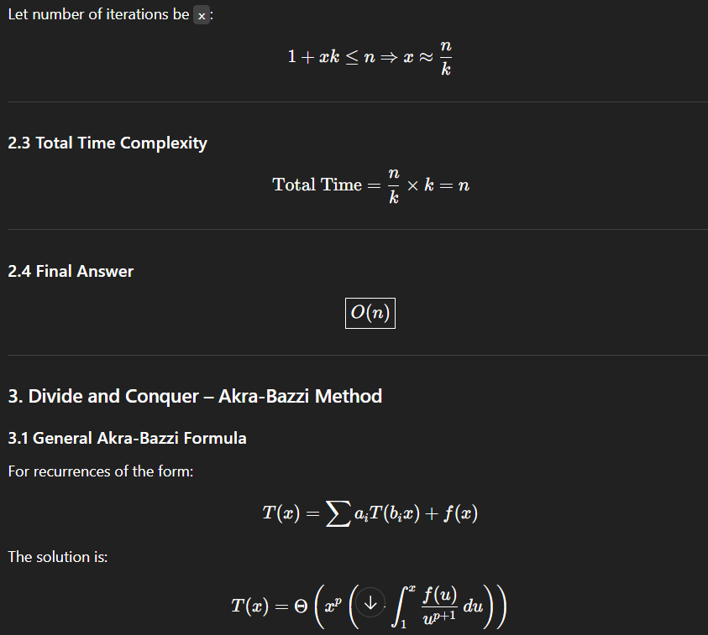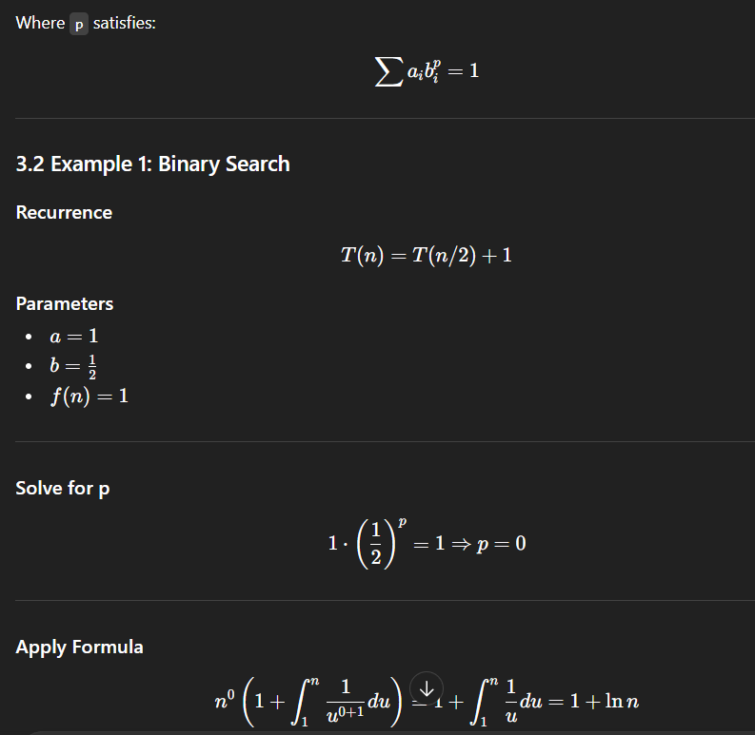
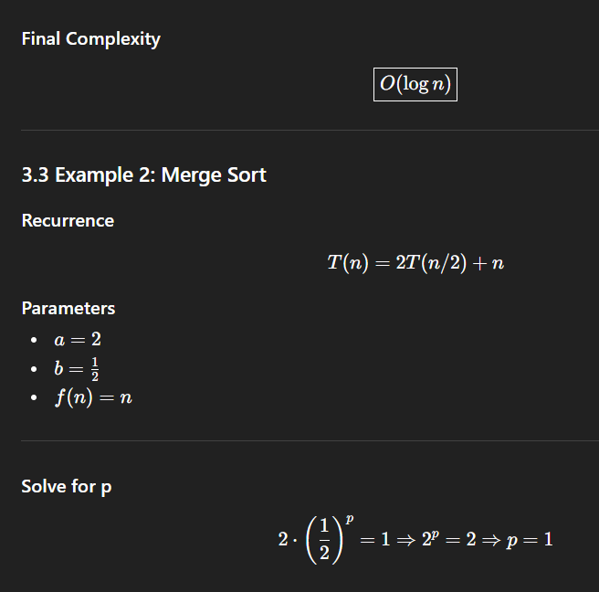

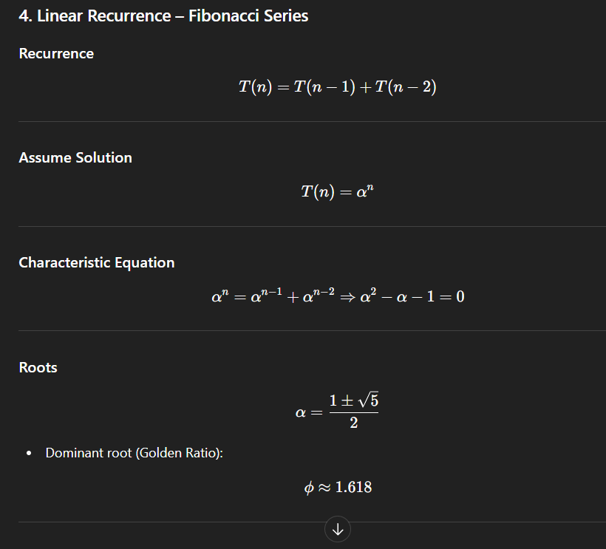
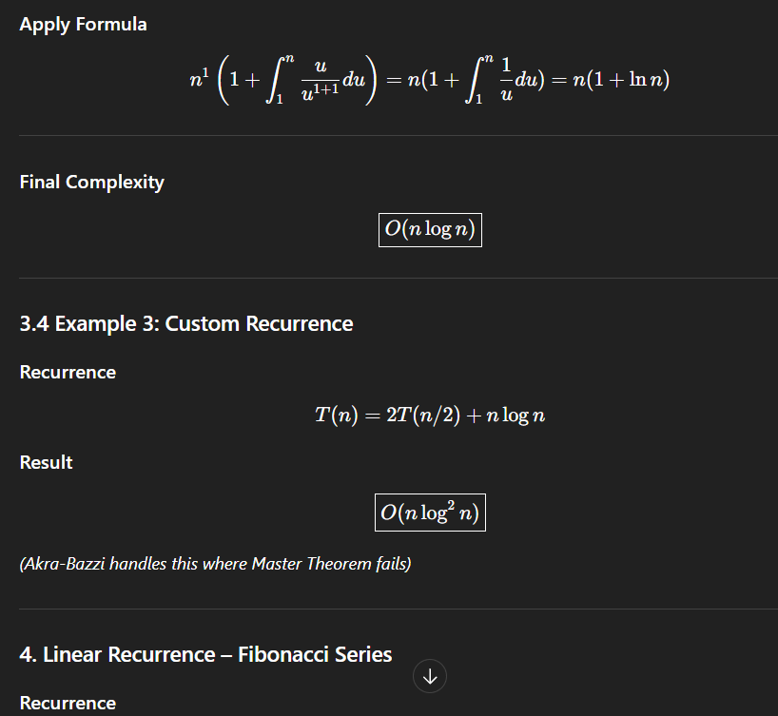
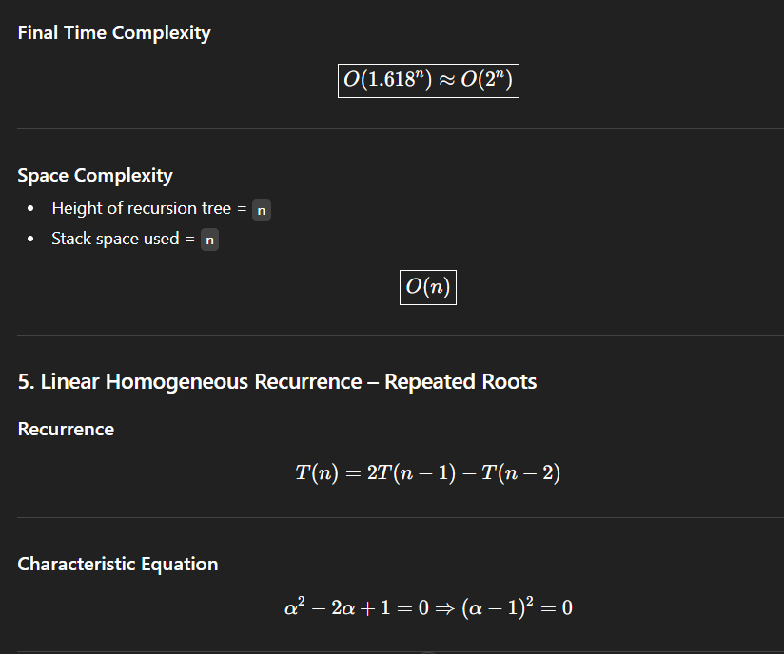
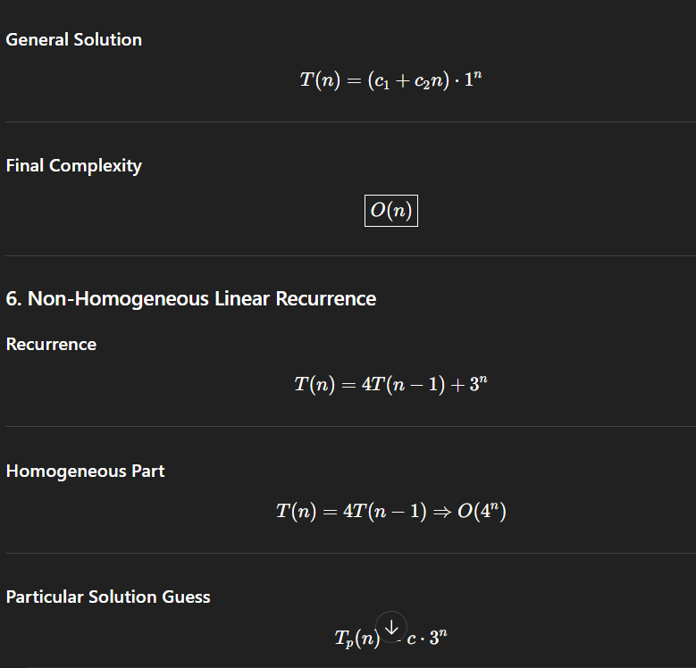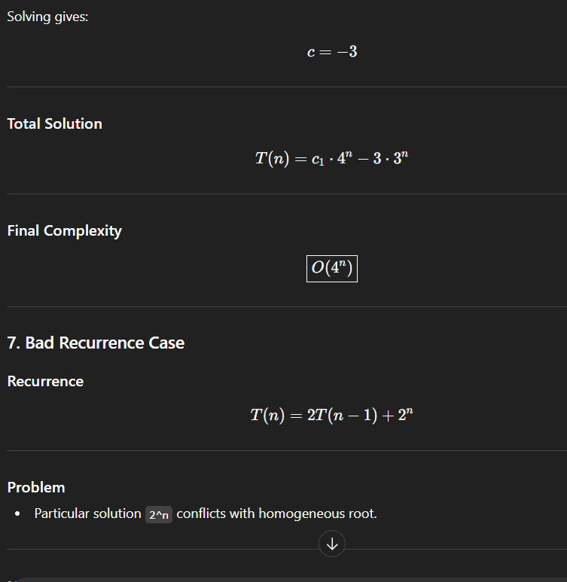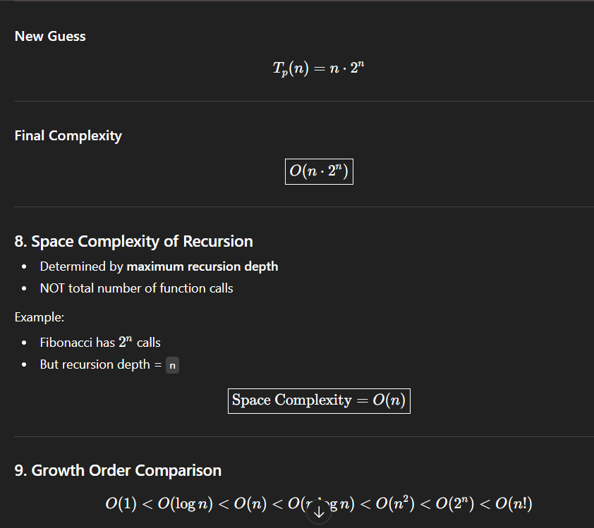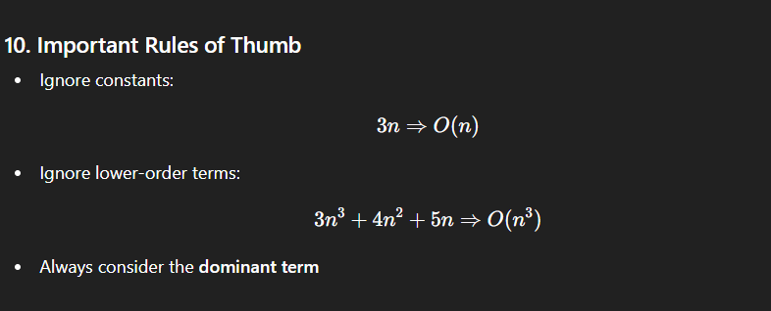

BITWISE QUICK HINTS & MEMORY SHEET

🔹 Basic Bit Checks

✅ Check last bit (odd/even)
(n & 1)
- = 1 → odd
- = 0 → even
🧠 Memory: & 1 → last bit

✅ Get ith bit
(n >> i) & 1
🧠 Memory: shift then check

✅ Set ith bit to 1
n | (1 << i)
🧠 Memory: OR sets

✅ Clear ith bit (make 0)
n & ~(1 << i)
🧠 Memory: AND with NOT

✅ Toggle ith bit
n ^ (1 << i)
🧠 Memory: XOR flips

🔹 Shift Properties

✅ Left shift
x << k = x * 2^k
🧠 Memory: << multiply

✅ Right shift (signed)
x >> k = floor(x / 2^k)
🧠 Memory: >> divide

✅ Unsigned right shift
x >>> k
🧠 Memory: fills with 0

🔹 Power of Two

✅ Check power of 2 (BEST)
n > 0 && (n & (n - 1)) == 0
🧠 Memory: power of 2 → only one set bit

✅ Alternative
(n & -n) == n
🧠 Memory: rightmost bit equals number

🔹 Count Set Bits

✅ Basic counting
while(n > 0){
count += n & 1;
n >>= 1;
}

🔥 Brian Kernighan (FAST)
while(n > 0){
n = n & (n - 1);
count++;
}
🧠 Memory: n & (n-1) removes last set bit

🔹 Rightmost Set Bit

✅ Extract rightmost set bit
n & -n
🧠 Memory: isolate last 1

✅ Remove rightmost set bit
n & (n - 1)
🧠 Memory: drop last 1

🔹 Unique Number Problems

✅ Every number twice except one
ans ^= num;
🧠 Memory: XOR cancels pairs

✅ Every number thrice except one
👉 Bit counting method
(sum of bits % 3)
🧠 Memory: mod k trick

✅ Every number k times except one
👉 Count bits at each position
👉 (sum % k)
🧠 Memory: generalized mod trick

🔹 Two Unique Numbers
If every element appears twice except two numbers:
xor = all XOR
setBit = xor & -xor
partition using setBit
🧠 Memory: split by rightmost bit

🔹 Fast Power (a^b)

✅ Binary exponentiation
while(b > 0){
if((b & 1) == 1) result *= a;
a *= a;
b >>= 1;
}
🧠 Memory:
- b & 1 → odd check
- b >> 1 → halve exponent
- square base each step

🔹 Magic Number (Very Asked)
Formula:
while(n > 0){
sum += (n & 1) * powerOf5;
powerOf5 *= 5;
n >>= 1;
}
🧠 Memory: binary → base 5 mapping

🔹 Swap Two Numbers (No temp)
a ^= b;
b ^= a;
a ^= b;
🧠 Memory: XOR swap
⚠️ Avoid in production (readability issue)

🔹 Check Power of Four
n > 0 &&
(n & (n - 1)) == 0 &&
(n & 0x55555555) != 0
🧠 Memory: power of 2 + position check

🔹 Subsets using Bitmask
Total subsets:
1 << n
Check element in subset:
mask & (1 << i)
🧠 Memory: bitmask represents subset

🔹 Important Interview Patterns

⭐ Only one set bit
→ power of 2

⭐ Remove last set bit repeatedly
→ Brian Kernighan

⭐ Need parity / odd-even
→ n & 1

⭐ Need fast multiply/divide by 2
→ shifts

⭐ Need pair cancellation
→ XOR

⭐ Need unique among k repeats
→ bit count % k

