After resampling the data, the Confusion Matrix is as follows:

The below confusion matrix represents the performance of a classification model that predicts student adaptability into three classes: "High," "Low," and "Moderate."

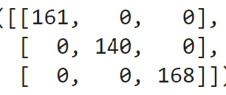

The rows of the matrix correspond to the actual classes, and the columns correspond to the predicted classes.

The diagonal values represent the true positives for each class. In other words, these are the instances that were correctly classified.

The off-diagonal values are zeros in this matrix, indicating there are no false positives or false negatives for any class. This suggests that the model made no errors in classifying any of the instances.

Here's a breakdown of the confusion matrix for each class:

**For the "High" class:**

* True Positives (TP): 161
* False Positives (FP): 0
* False Negatives (FN): 0

**For the "Low" class:**

* True Positives (TP): 140
* False Positives (FP): 0
* False Negatives (FN): 0

**For the "Moderate" class:**

* True Positives (TP): 168
* False Positives (FP): 0
* False Negatives (FN): 0

This confusion matrix indicates that the model has achieved perfect performance for this dataset. It correctly classified all instances into their respective classes, and there are no misclassifications (false positives or false negatives) for any of the three classes.

In summary, this confusion matrix shows that the model's predictions perfectly match the true classes, indicating that the model's performance is outstanding.