COAPPS

**TITLE – HUMAN RESOURCE MANAGEMENT SYSTEM**

**Presented By**

**Team Lead - P Rajeswari**

**Team Members**

**B S Karthayini**

**S Teja**

**K Dinesh Reddy**

**S Abdul Malik**

**Under The Guidance Of**

**Amyjoy Exson**

**CONTENT**

1.Abstract

2.Introduction

3.Project

4.

5.Literature Review

**ABSTRACT**

This project aims to design and develop a robust and user-friendly Human Resources Management System (HRMS) to streamline and automate various HR processes, including employee onboarding, leave management, payroll management, performance management, recruitment and application tracking, and training and development.

The system will provide a centralized platform for employees, managers, and HR professionals to access and manage HR-related information, reducing manual errors and increasing efficiency. The HRMS will also offer advanced reporting and analytics capabilities to support data-driven decision-making and ensure compliance with relevant labor laws and regulations. The system's scalability and security features will support the growing needs of the organization, enhancing employee engagement and retention, and contributing to overall organizational success.

This document provides a comprehensive overview of key areas in human resource management, including employee onboarding, leave management, payroll management, performance management, recruitment and application tracking, and training and development. It outlines policies, procedures, and best practices to effectively manage these aspects of HR, ensuring smooth operations, compliance with regulations, and fostering a positive employee experience.

**INTRODUCTION**

Python Full Stack Development :

A Comprehensive Approach to Building Dynamic Web Applications, In today's fast-paced digital landscape, building efficient and scalable web applications is crucial for businesses to stay competitive. Python full stack development offers a robust and versatile solution for creating dynamic web applications that meet the evolving needs of modern organizations. As we embark on building a Human Resources Management System (HRMS), we will leverage the power of Python full stack development to create a comprehensive and user-friendly platform.

Python, a high-level programming language, offers a vast range of libraries, frameworks, and tools that enable developers to build fast, scalable, and maintainable applications. The full stack development approach involves working with both front-end and back-end technologies to create a seamless user experience. By combining Python with popular frameworks like Django, Flask, and React, we can build a robust HRMS that streamlines human resources processes, enhances productivity, and drives business growth.

**INTRODUCTION TO PROJECT**

**Building a Human Resources Management System with Python Full Stack Development:**

Our HRMS project aims to create a centralized platform that automates various human resources functions, including employee management, payroll processing, leave management, and performance evaluation. By leveraging Python full stack development, we can create a scalable and flexible system that adapts to the evolving needs of our organization.

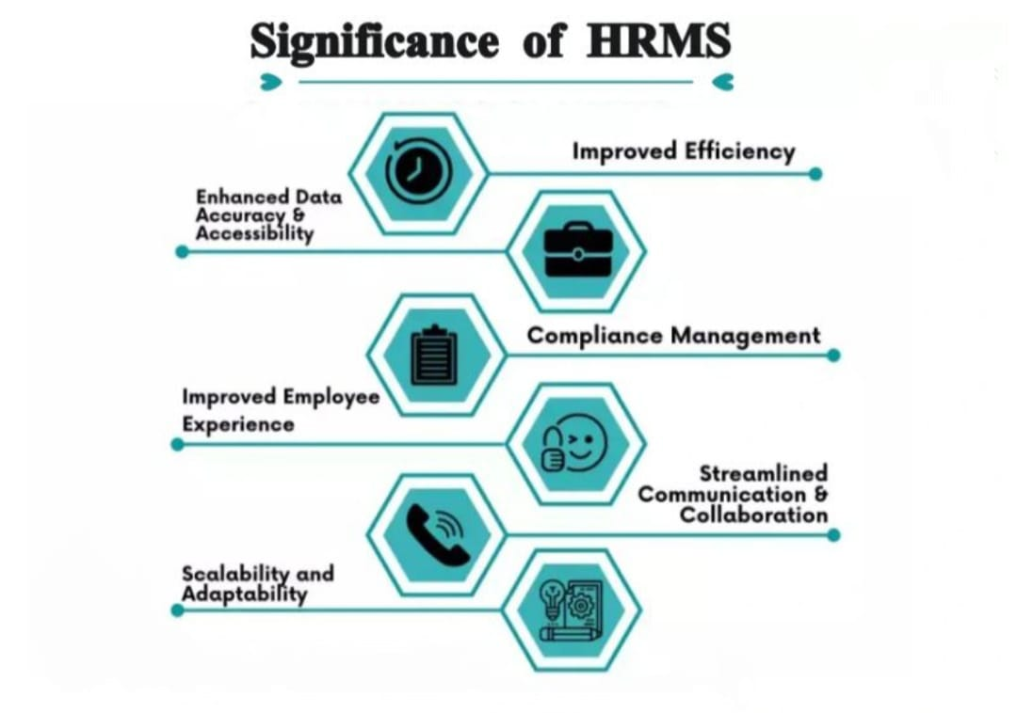

With Python, we can utilize popular libraries like NumPy, pandas, and scikit-learn for data analysis and machine learning tasks, enabling us to build predictive models and gain valuable insights into employee behavior and organizational trends. Additionally, we can utilize front-end frameworks like React and Angular to create a responsive and user-friendly interface, ensuring a seamless user experience for HR professionals, managers, and employees.

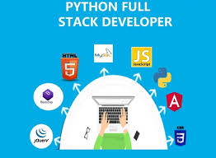

By harnessing the power of Python full stack development, we can create a cutting-edge HRMS that drives business success, enhances employee engagement, and supports strategic decision-making. In the following pages, we will delve deeper into the technical aspects of our project, exploring the architecture, design, and implementation of our Python full stack development solution.

1. **Employee Onboarding**

The employee onboarding module streamlines the process of welcoming new employees to the organization. It includes electronic forms and documents, such as tax forms and benefits enrollment, which can be completed and submitted online. The module also assigns company policies and procedures to new employees, ensuring they have access to necessary information from day one. Task management features allow HR and managers to assign and track onboarding tasks, such as scheduling meetings and training sessions. The employee self-service portal provides a centralized location for new employees to complete onboarding tasks and access important information.

**2 . Leave Management**

The leave management module simplifies the process of requesting and approving leaves. It includes various leave types, such as vacation, sick, and parental leaves, and allows employees to submit leave requests online. The module automatically checks leave balances and accrual rules, ensuring that employees do not exceed their available leave. Managers can approve or deny leave requests, and the module sends notifications to employees and HR. The calendar view feature allows teams to see leave schedules and plan accordingly. Reports and analytics provide insights into leave usage and trends, helping HR and managers make informed decisions.

**3 . Performance Management**

The performance management module enables organizations to set goals and objectives for employees. It includes performance evaluations and reviews, allowing managers to provide feedback and ratings. Employees can also provide self-assessments and receive feedback from peers. The module tracks performance metrics and ratings, providing a comprehensive view of employee performance. Development plans and recommendations help employees grow and improve. Reports and analytics provide insights into performance trends and areas for improvement.

**4.Payroll Management**

The payroll management module automates payroll processing, ensuring accurate and timely payments. It integrates with payroll software or providers, eliminating manual data entry. The module manages employee salary and benefits, including deductions and contributions. Tax compliance and reporting features ensure that the organization meets all tax obligations. Pay stubs and W-2 forms can be generated and distributed electronically. Payroll analytics and reports provide insights into payroll costs and trends, helping HR and finance teams make informed decisions.

**5 . Recruitment and Application Tracking**

The recruitment and application tracking module streamlines the hiring process. It allows organizations to post job openings and advertise them on various channels. Candidates can apply online, and their applications are tracked and filtered based on predefined criteria. The module schedules interviews and manages candidate communication. Reporting and analytics provide insights into recruitment metrics, such as time-to-hire and source-to-hire.

**6 . Training and Development**

The training and development module enables organizations to manage training programs and courses. It includes a course catalog and registration feature, allowing employees to sign up for training sessions. The module tracks employee training history and records, providing a comprehensive view of employee development. Performance-based training recommendations help employees address skill gaps. Training evaluations and feedback allow organizations to assess the effectiveness of training programs. Reports and analytics provide insights into training metrics and areas for improvement.

**LITERATURE REVIEW**

Human Resource Management (HRM) plays a vital role in organizational success. Effective HRM practices can improve employee engagement, productivity, and retention, ultimately leading to enhanced organizational performance. The advent of technology has transformed HRM, with Human Resource Management Systems (HRMS) emerging as a crucial tool for streamlining HR processes.

**1. HRM Practices and Organizational Performance**

Studies have consistently shown that effective HRM practices positively impact organizational performance (Huselid, 1995; Delaney & Huselid, 1996). HRM practices such as employee involvement, training and development, and performance management are critical for enhancing employee engagement and productivity (Guthrie, 2001; Combs et al., 2006).

**2 . Technology in HRM**

HRMS has revolutionized HRM by automating various HR processes, improving efficiency, and reducing costs (Kovach et al., 2002). HRMS can enhance employee engagement, facilitate communication, and provide valuable insights for strategic decision-making (Bhattacharya et al., 2005).

**3 . Employee Engagement and Motivation**

Employee engagement is a critical factor in organizational success (Kotter & Heskett, 1992). Strategies such as employee empowerment, recognition, and rewards can improve employee motivation and engagement (Hackman & Oldham, 1976).

**4 . Performance Management**

Effective performance management systems are essential for improving employee performance and organizational success (Armstrong & Baron, 1998). Regular feedback, goal-setting, and performance appraisal are critical components of performance management (Latham & Locke, 1979).

**5 . Recruitment and Talent Management**

Recruitment and talent management are crucial for acquiring and retaining top talent (Chambers et al., 1998). Strategies such as employer branding, social media recruitment, and talent pipelining can improve recruitment effectiveness (Sullivan, 2004).

**6 . Training and Development**

Training and development programs are essential for enhancing employee skills and knowledge (Noe & Colquitt, 2002). Strategies such as onboarding, mentoring, and leadership development can improve employee performance and retention (Baldwin & Ford)

* **CONCLUSION**

The HRMS project aimed to design and develop a comprehensive human resource management system to streamline and automate various HR processes. The system successfully integrates features such as employee management, leave management, attendance management, payroll management, and reporting.

The project demonstrates a user-friendly interface, robust functionality, and efficient data management. It enables HR personnel to manage employee data, track leave and attendance, generate payroll reports, and perform various other tasks with ease.

The system's benefits include:

* Improved data accuracy and consistency
* Enhanced employee experience
* Streamlined HR processes
* Increased productivity and efficiency
* Better decision-making through data-driven insights

The project's success is a testament to the effective collaboration between the development team, stakeholders, and end-users. Future enhancements could include integrating additional features, such as performance management, training management, and talent management, to further enhance the system's capabilities.

Overall, the HRMS project has successfully met its objectives, providing a robust and user-friendly platform for managing human resources effectively.