**ASSIGNMENT -5**

**Q : Create an ec2 instance with the ubuntu operating system, set all the required parameters such as security groups and key pair, and also do SSH with git bash to the running instance.**

**Also, install NodeJS on top of the instance and check for the version of node to cross-check if NodeJS is installed successfully.**

**Also, configure the instance with an elastic ip to show the static public ip address.**

**Also, create an S3 bucket and upload an object to it and show the object URL for reference.**

**Process:**

**Step 1:** Create an EC2 instance using ubuntu AMI

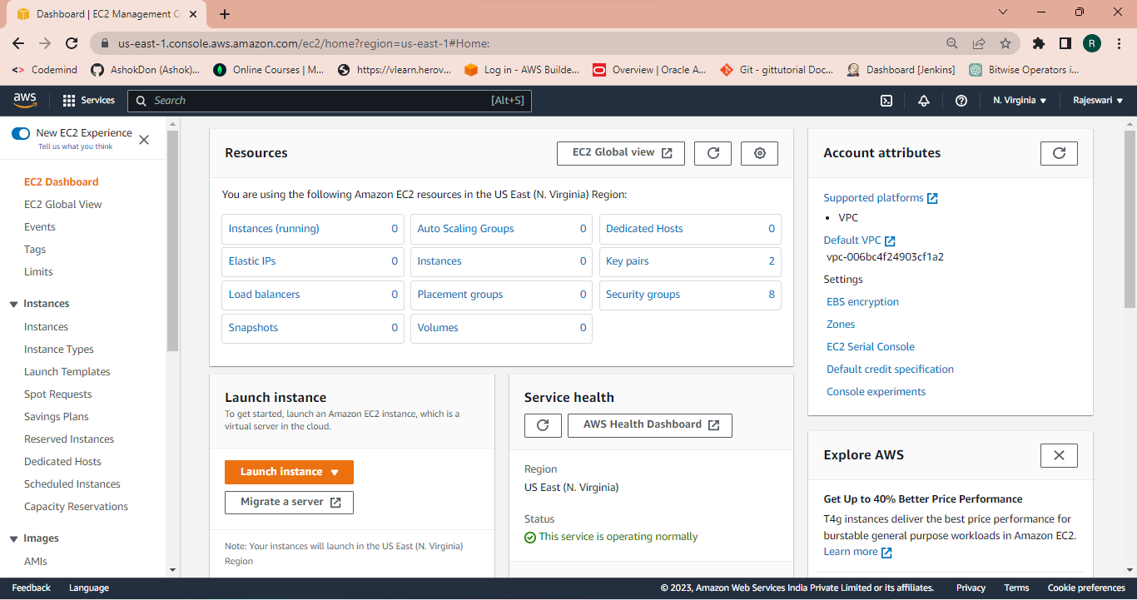

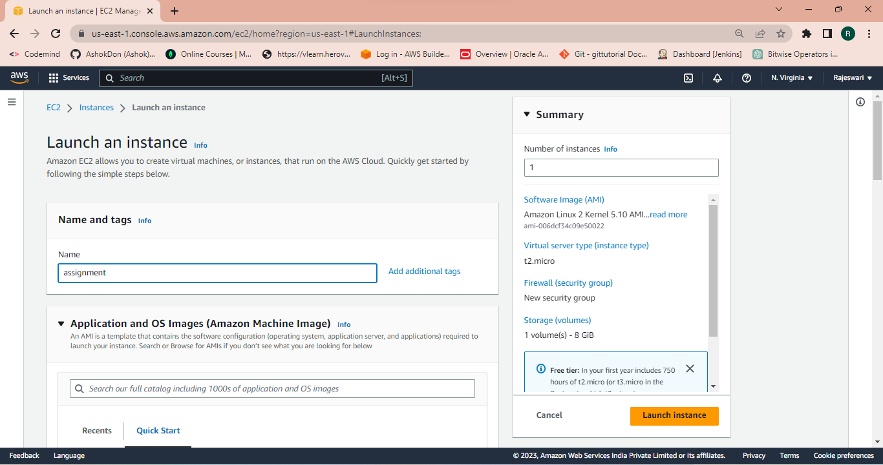

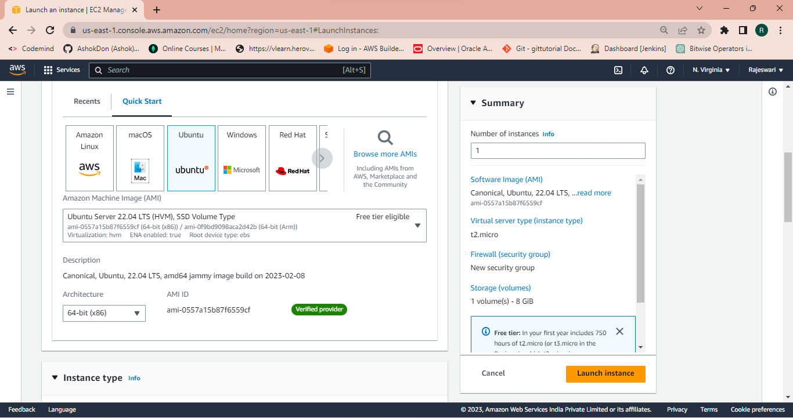

**Step 2:** Choose instance type and key pair

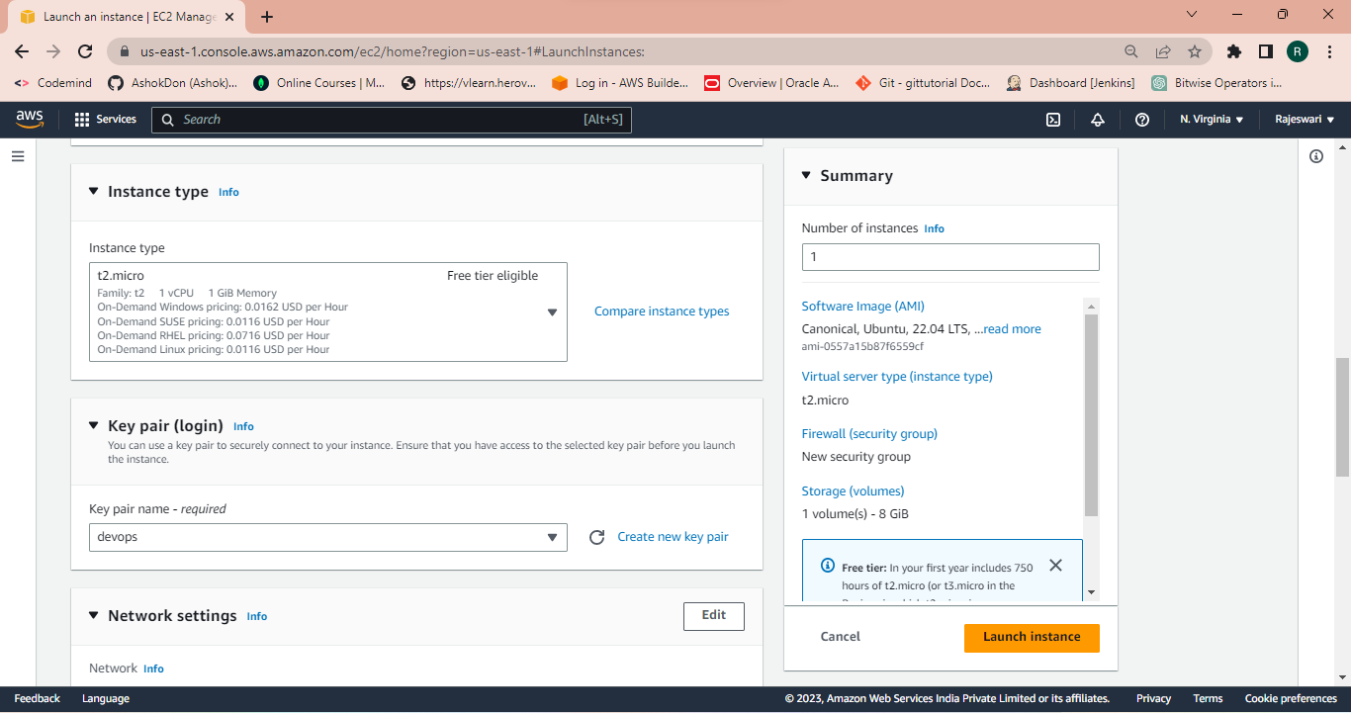

**Step 3:** Creating a security group

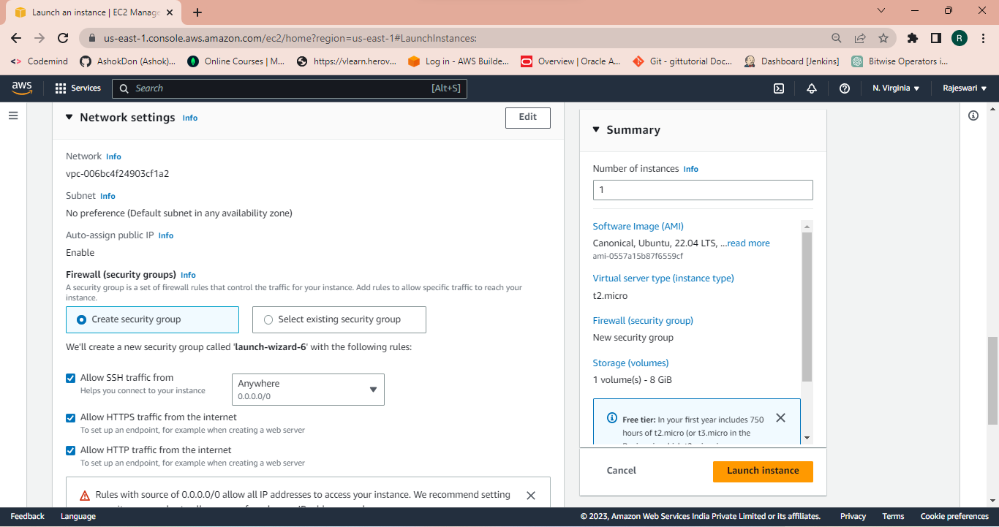

**Step 4:** Adding the User data in additional settings and launch instance.

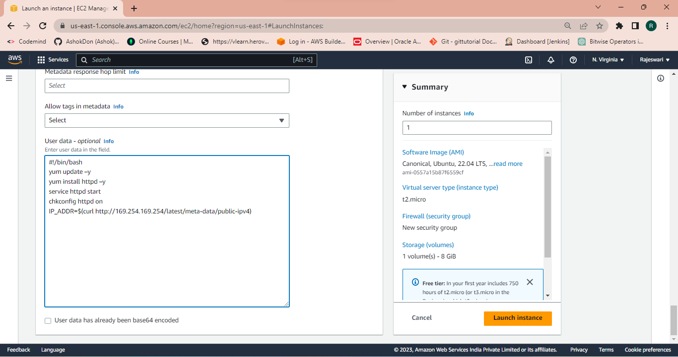

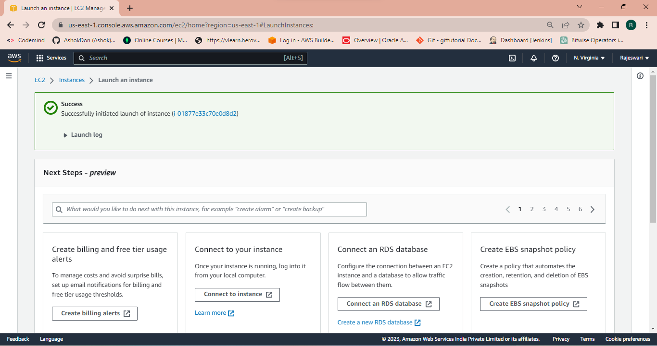  
**Step 5:** Now check the status of the instance.

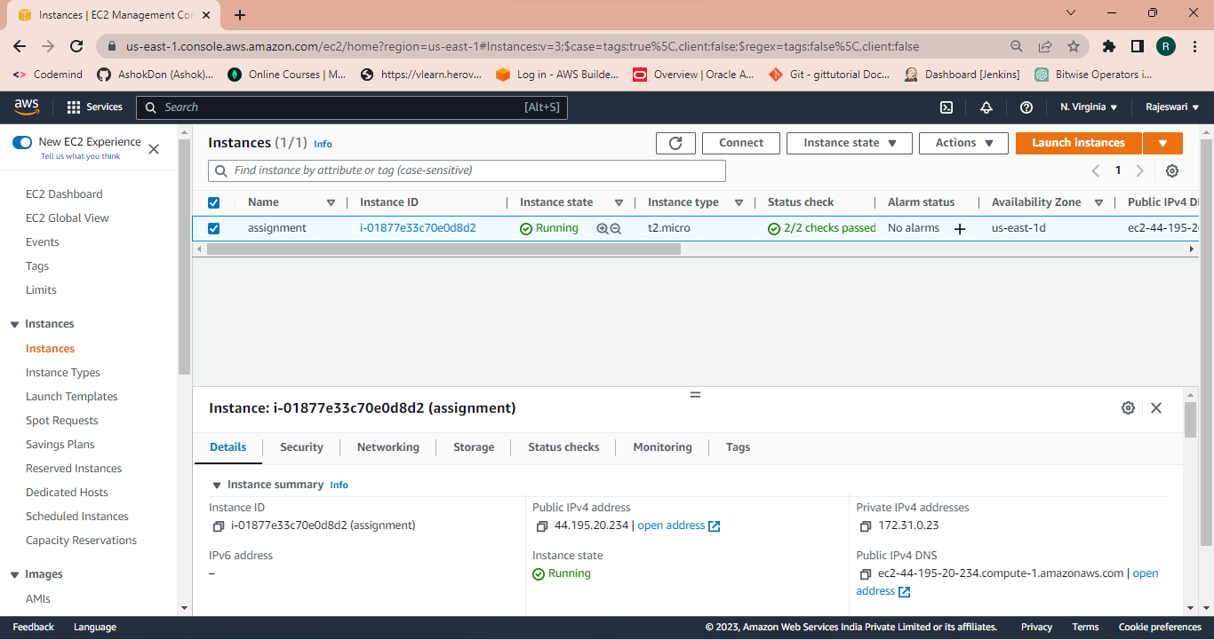

**Step 6:** Now connect EC2 instance using SSH client and copy the ssh link.

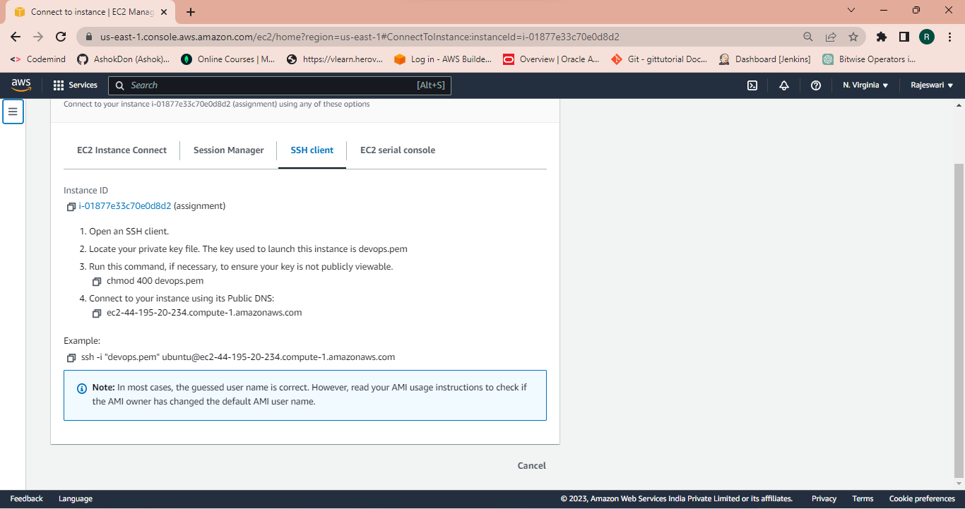

**Step 7:** Go to the git bash and open git bash cli and paste the command copied in the ssh client command. Here we see that EC2 instance is connected with git bash successfully.

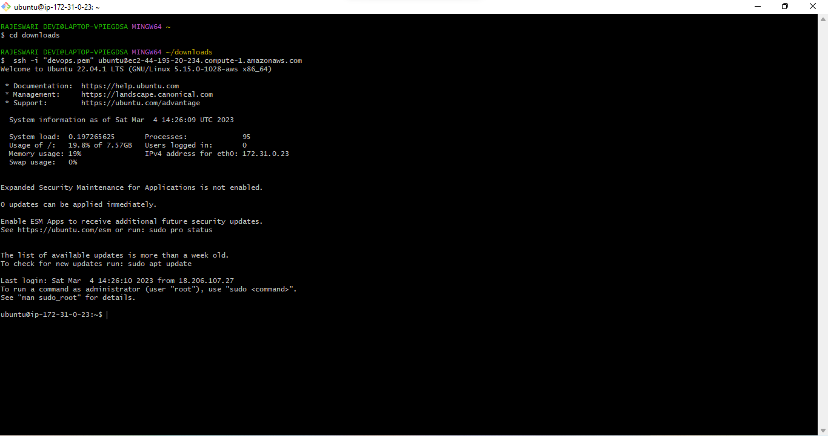

**Step 8:** To install nodejs we to update apt package manager using

the command **sudo apt update.**

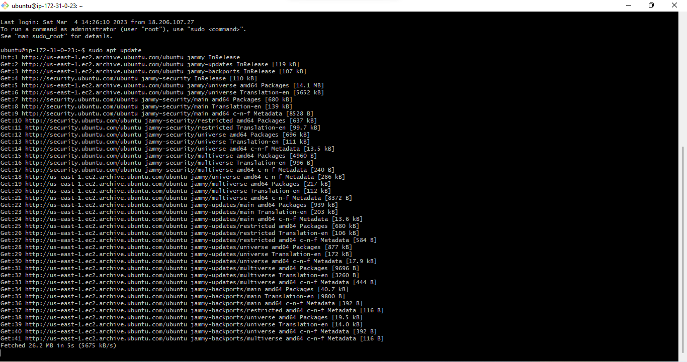  
**Step 9:** Now install the Nodejs using the command **sudo apt install nodejs**.

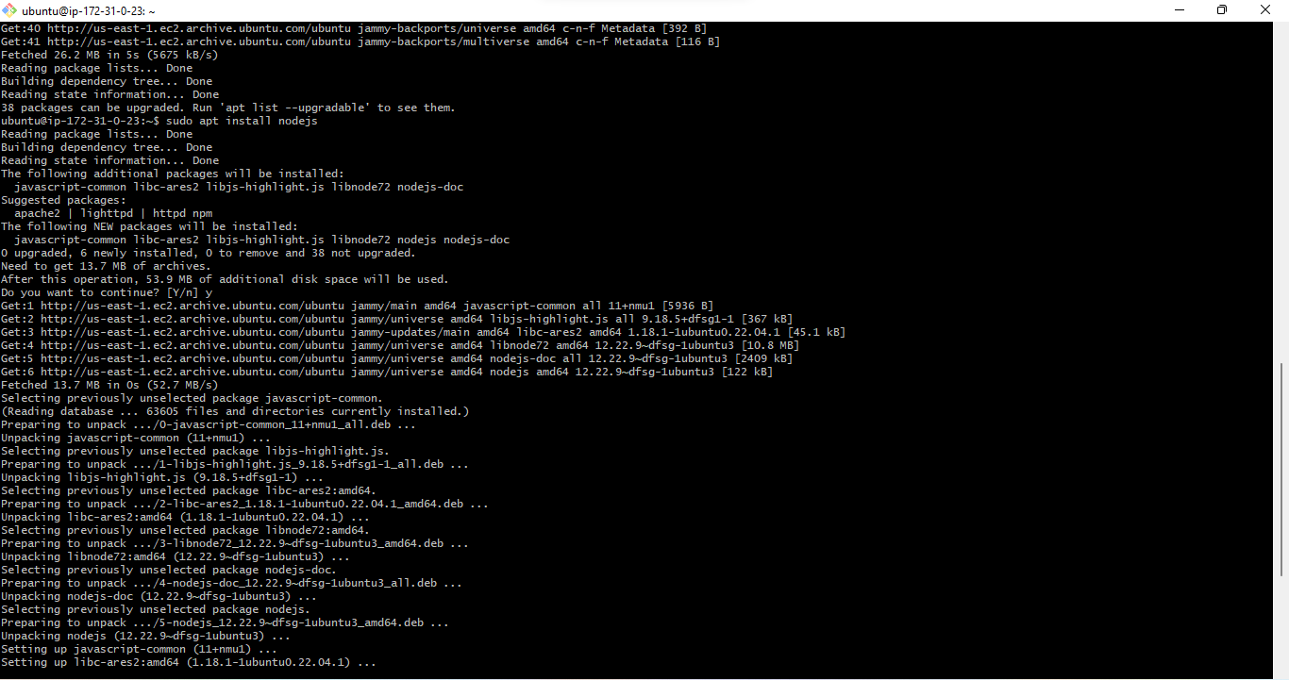

**Step 11:** After installing to check the version of the nodejs using the command **node -v.**

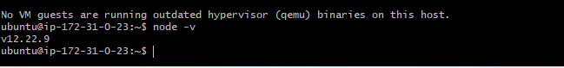

**Step12:** Now allocate Elastic IP address for instance

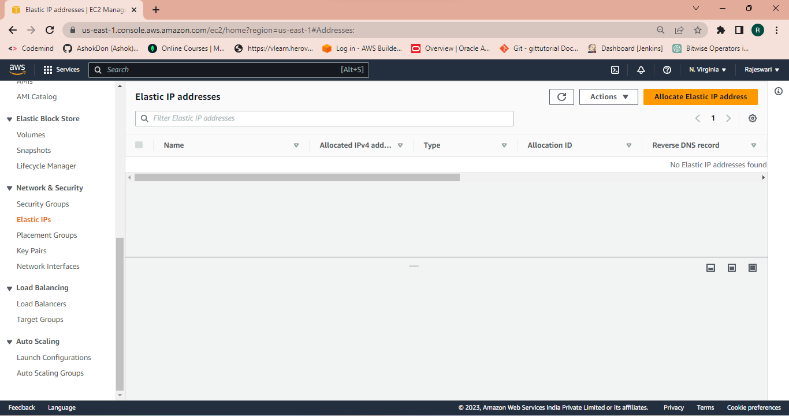

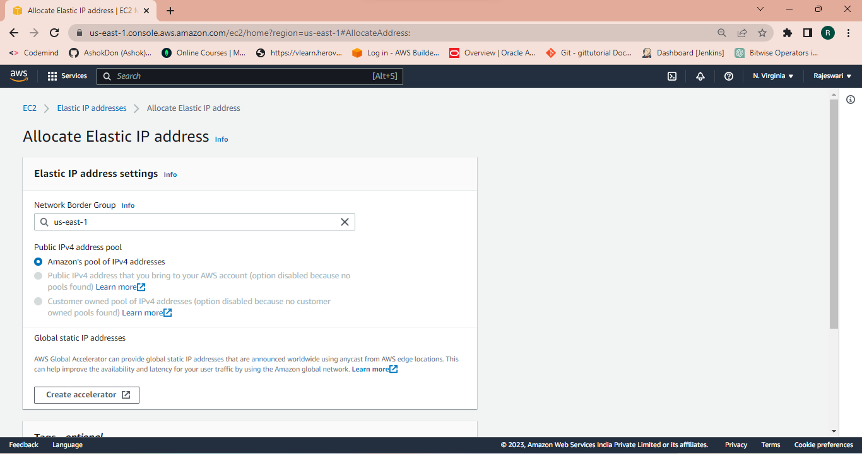

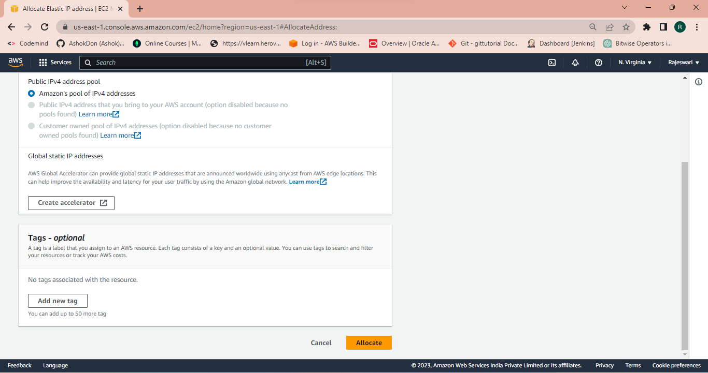

**Step 13:** Now associate with the created instance.

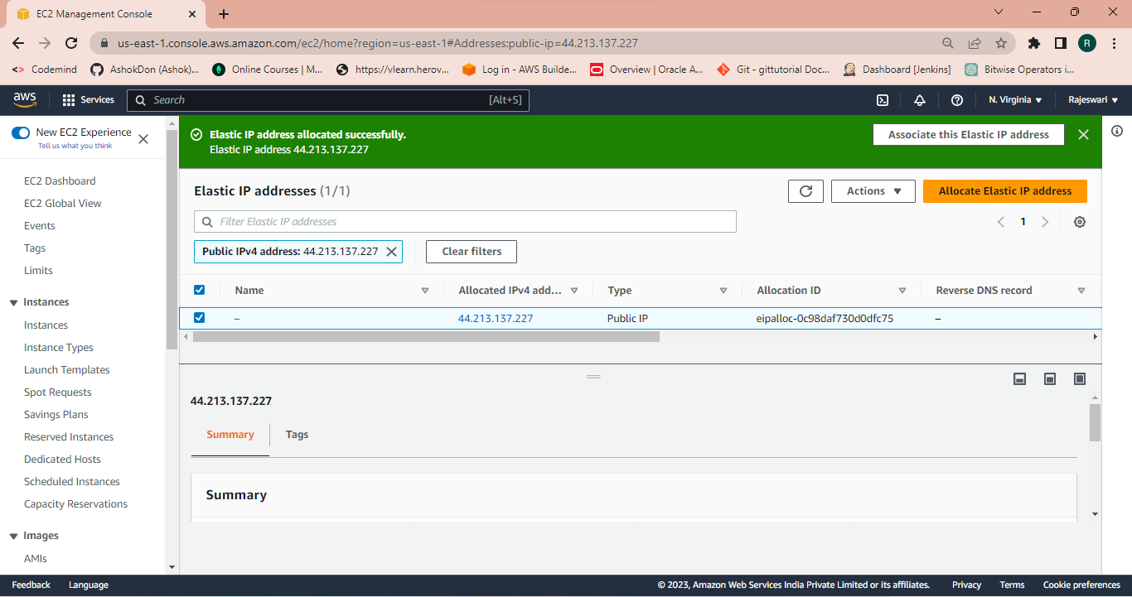

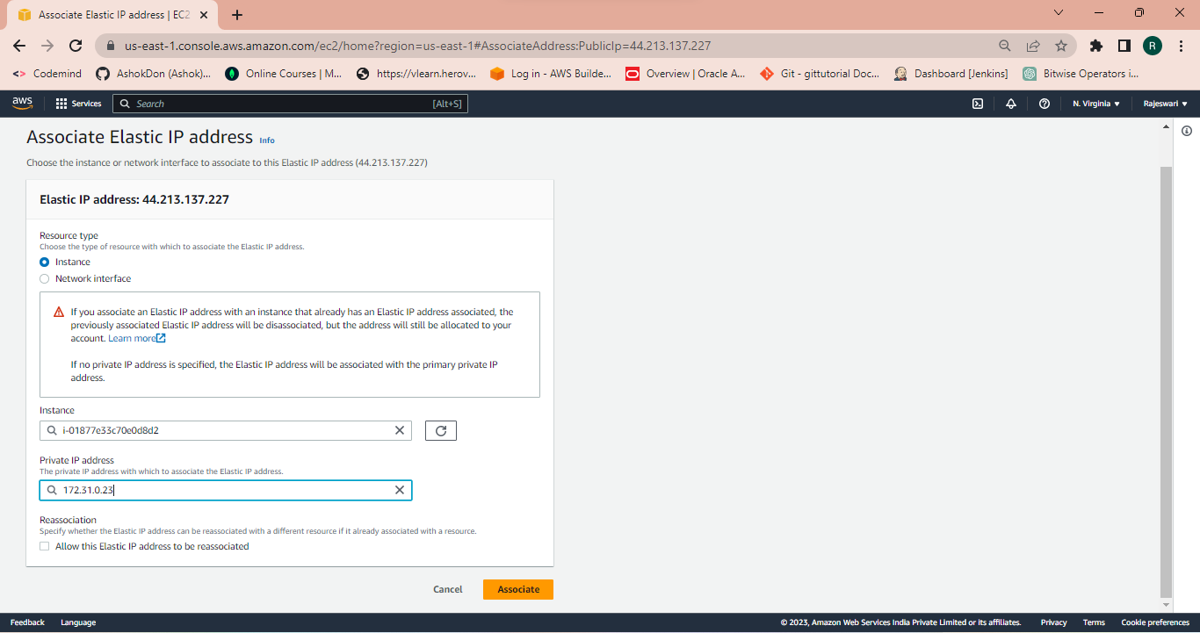

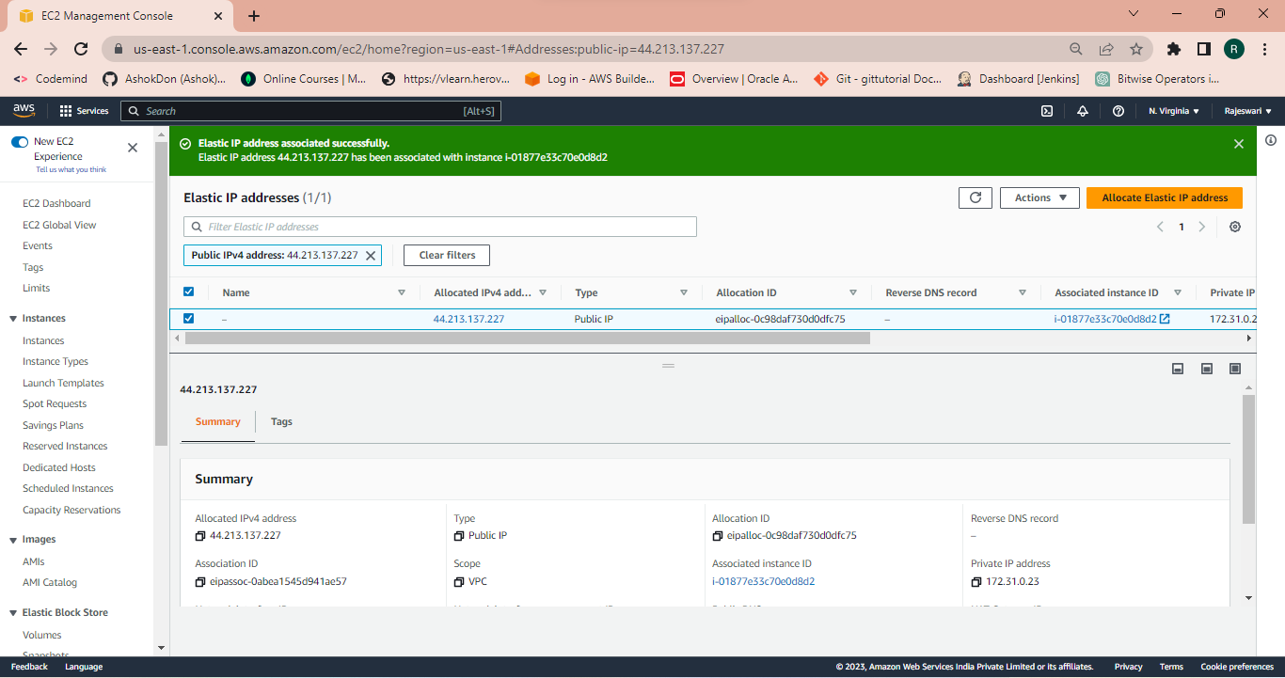

**Step 14:** Here we check that Elastic IP is created.

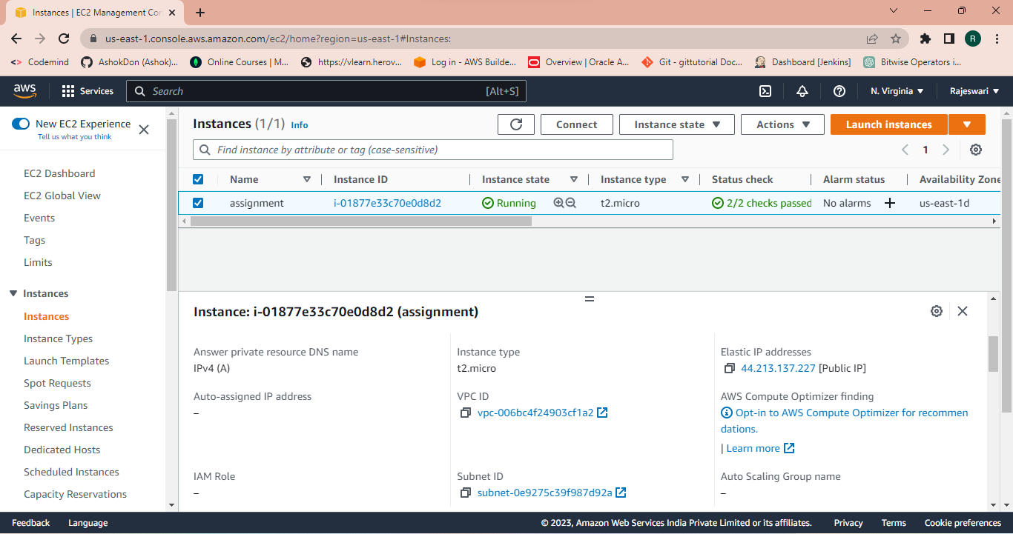 **Step 15:** Now connect an instance with the Git Bash.

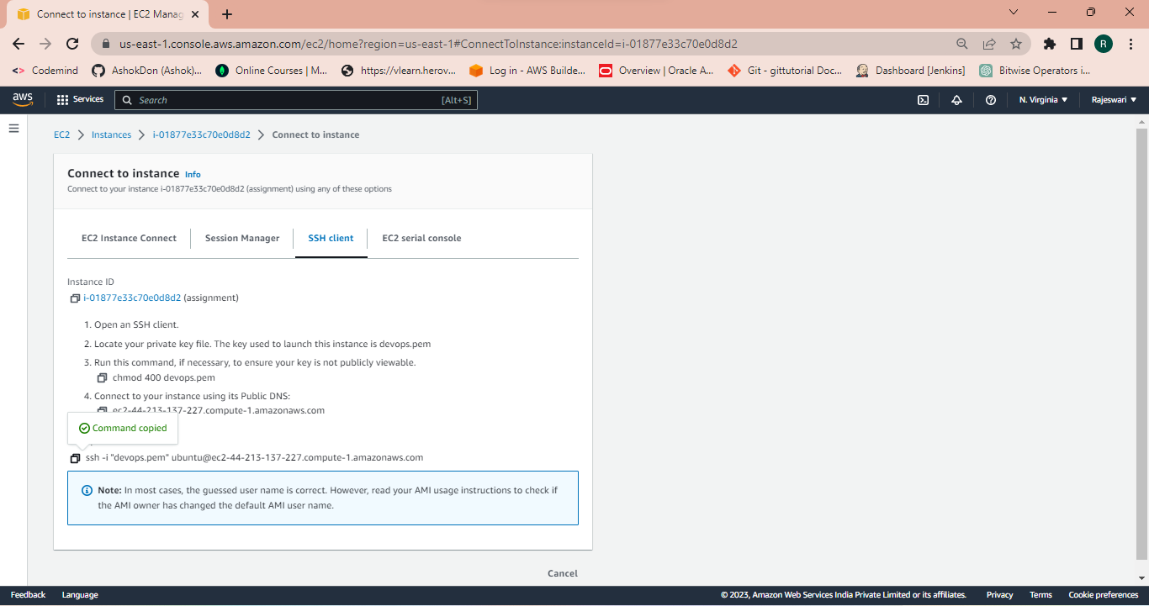

**Step 16:** Here we check that Elastic Ip address instance and configuring the IP address

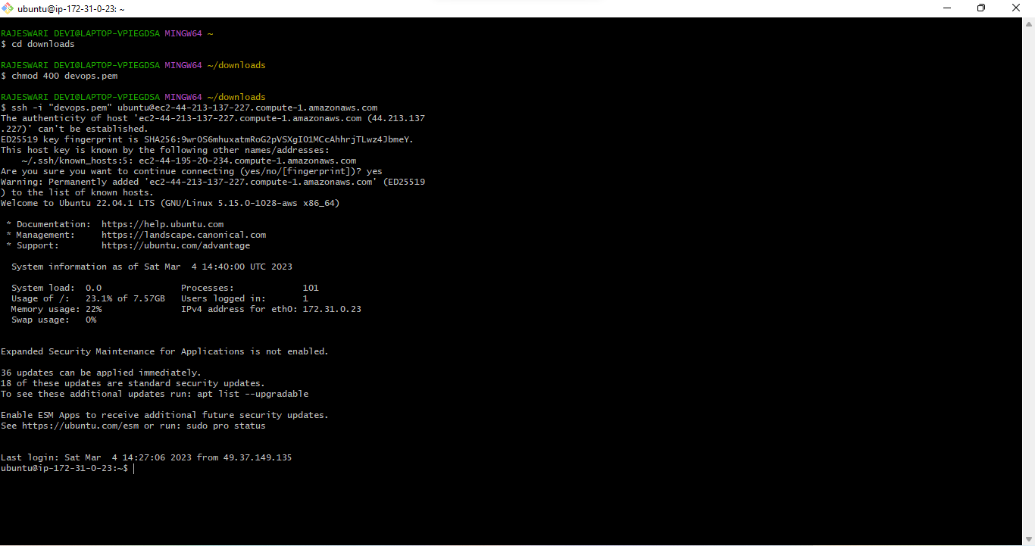

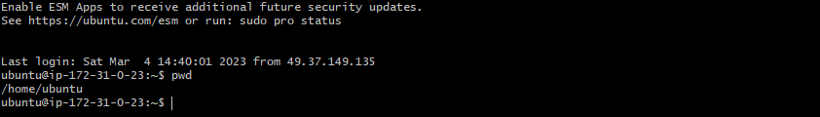

**Step 17:** Now we are creating S3 bucket

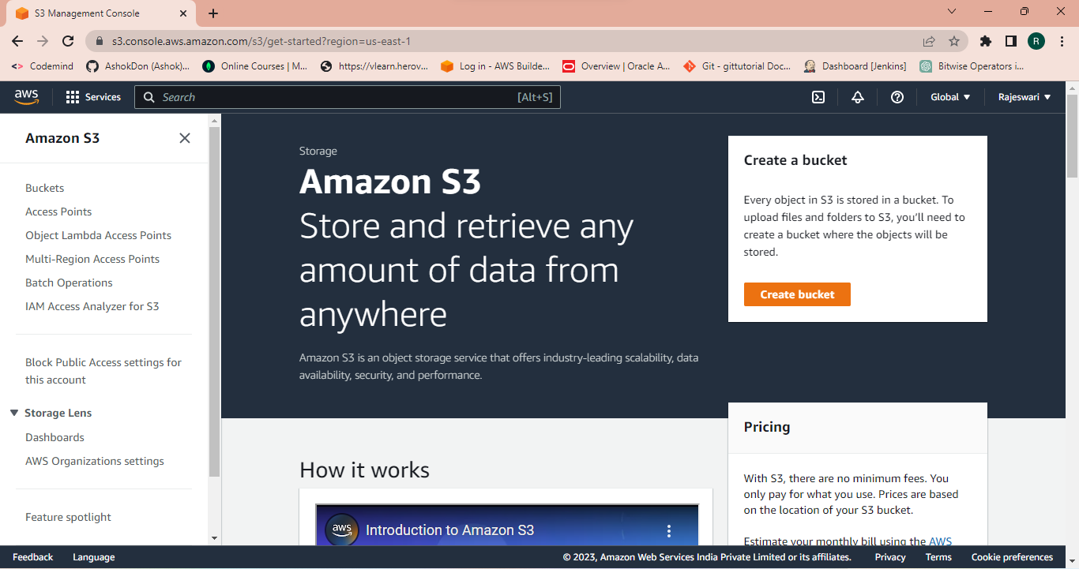

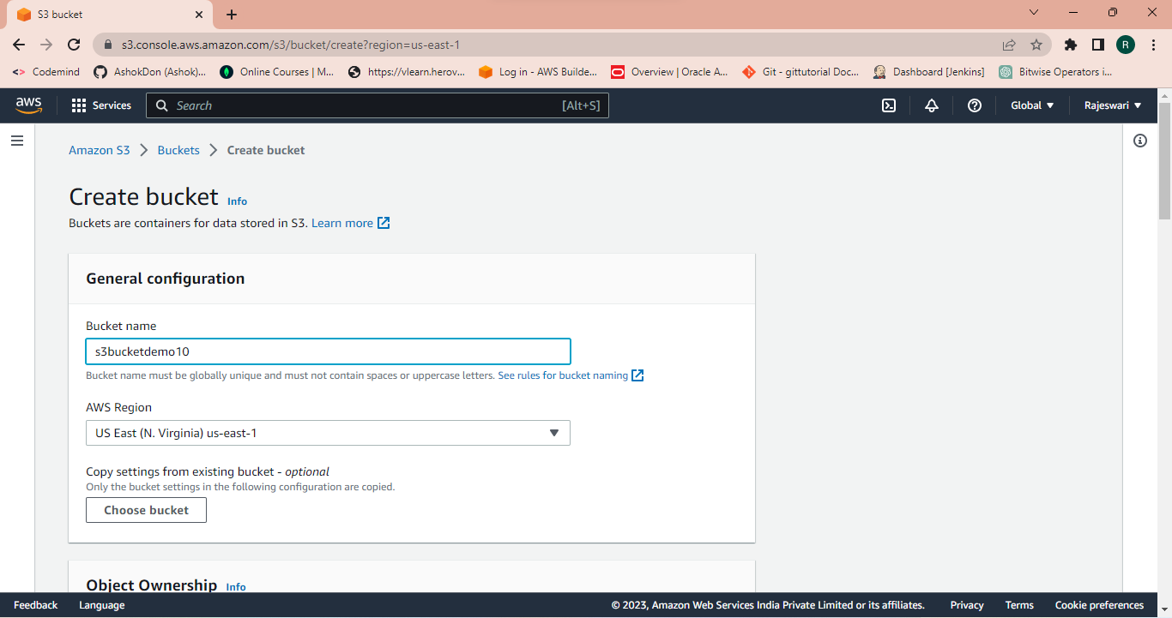

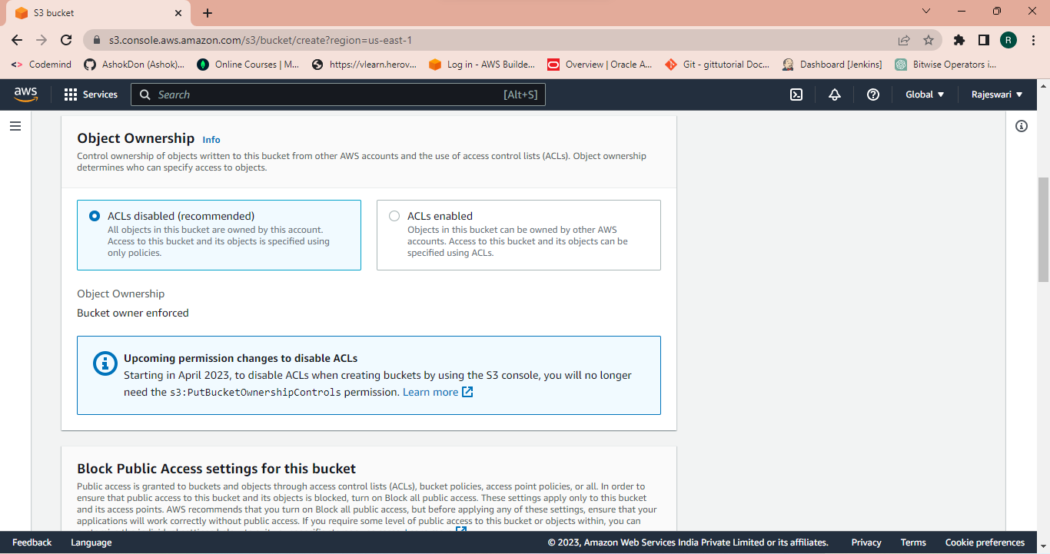

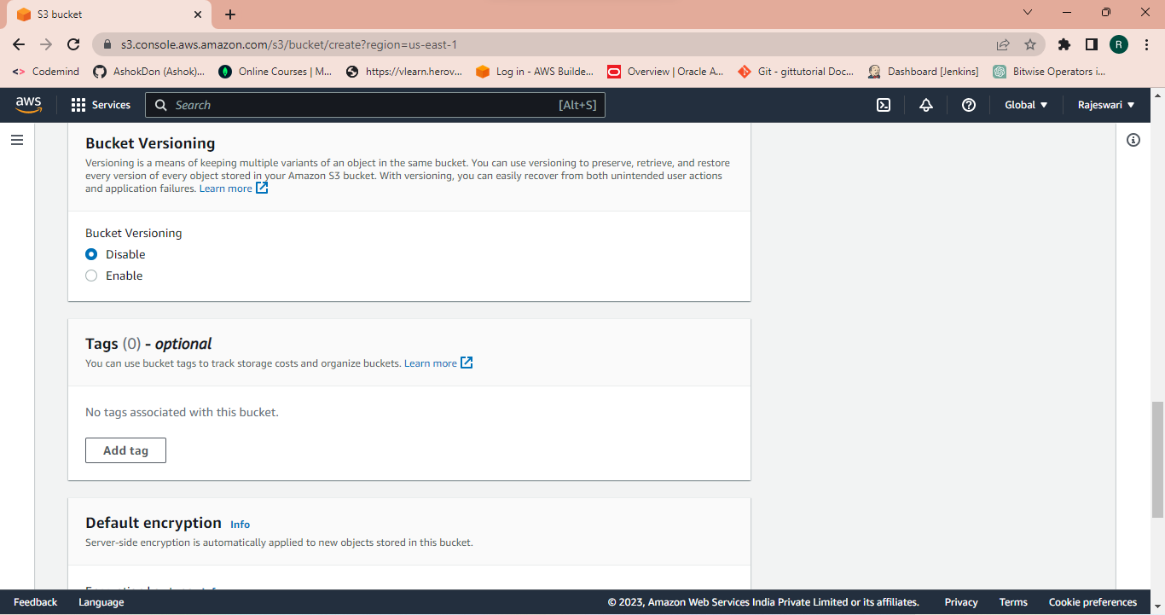

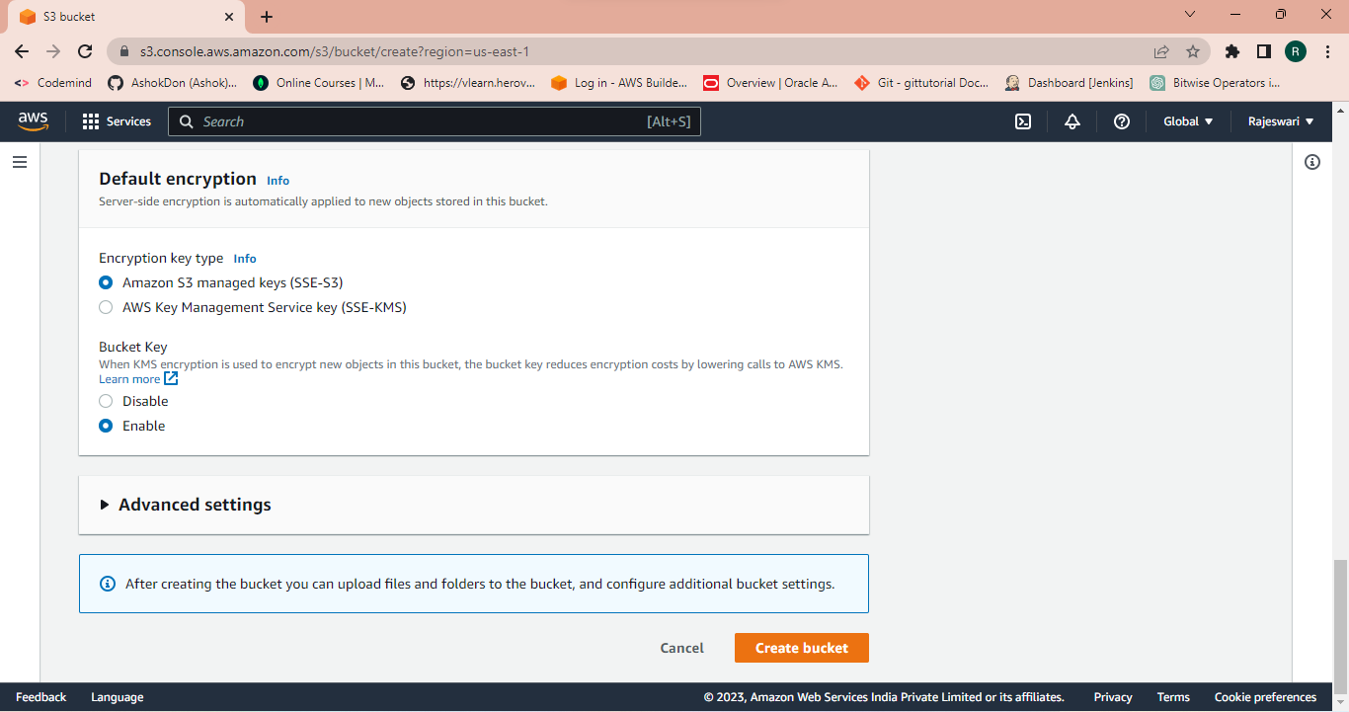

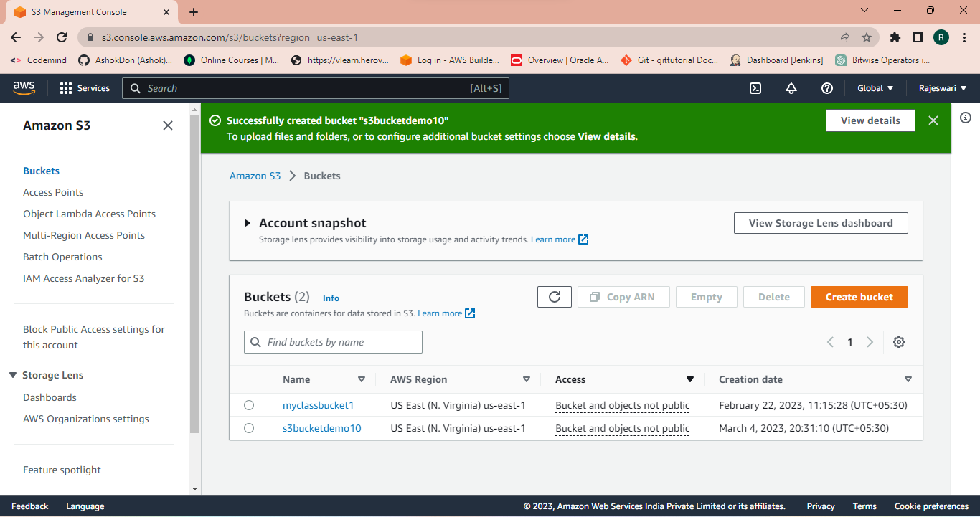

**Step 18:** Now upload a file in the bucket.

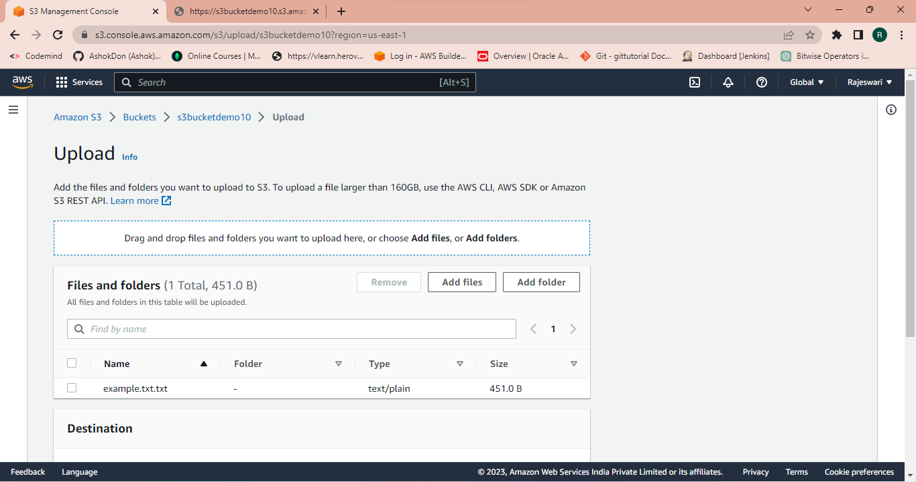

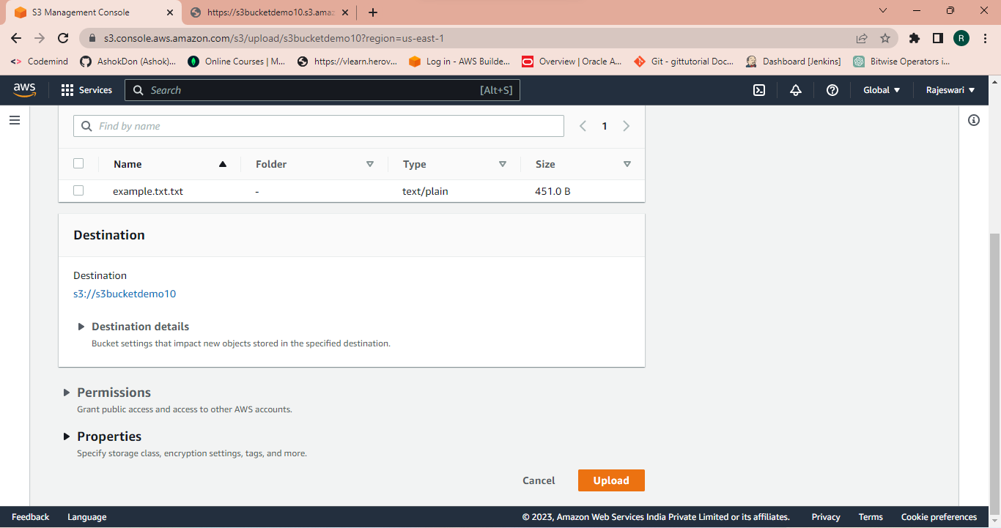

Its uploaded successfully.

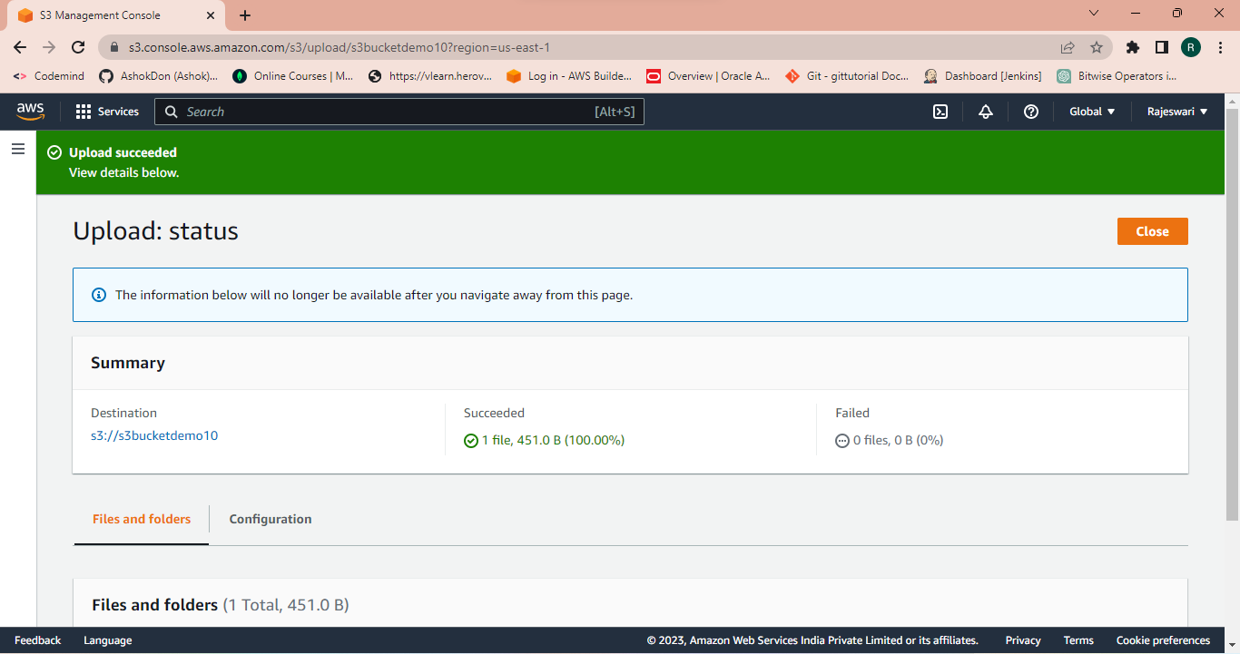

**Step 19:** Now copy the URL of the object and open in the browser.

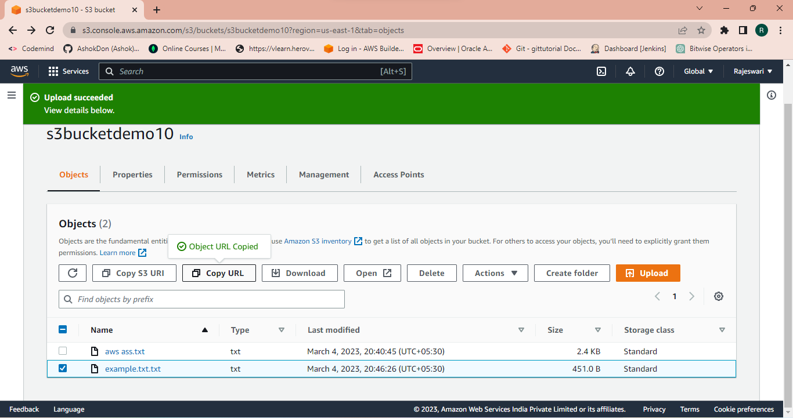

**Step 20:** Here is the link of the object and data.

https://s3bucketdemo10.s3.amazonaws.com/example.txt

