Application Deployment configuration

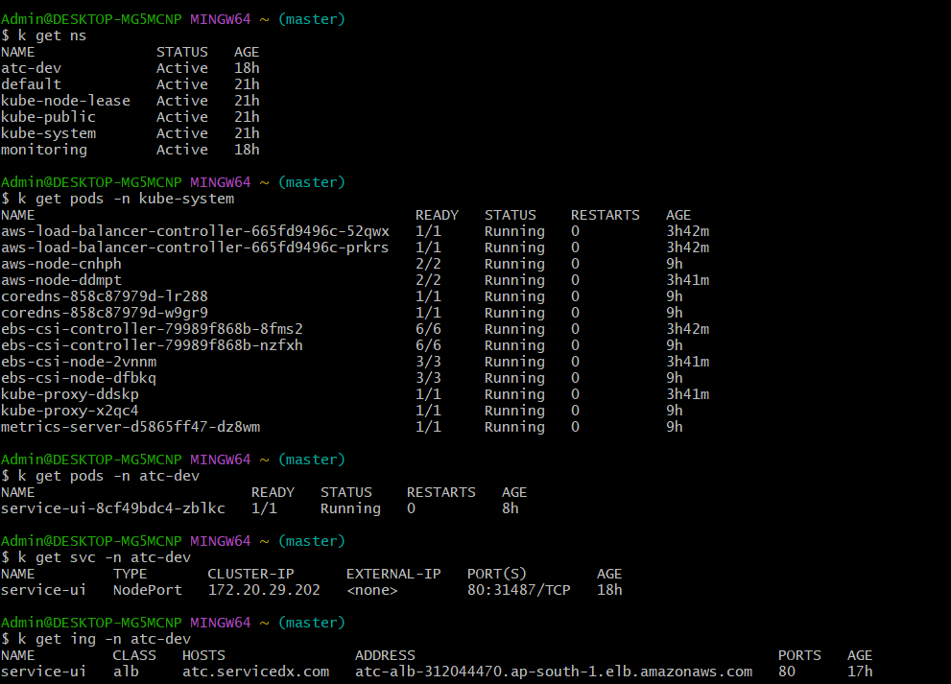

 Simple Static Web Application

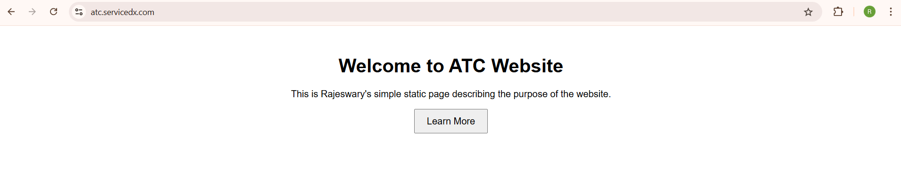

URL of the application: https://atc.servicedx.com

Monitoring Deployment configuration

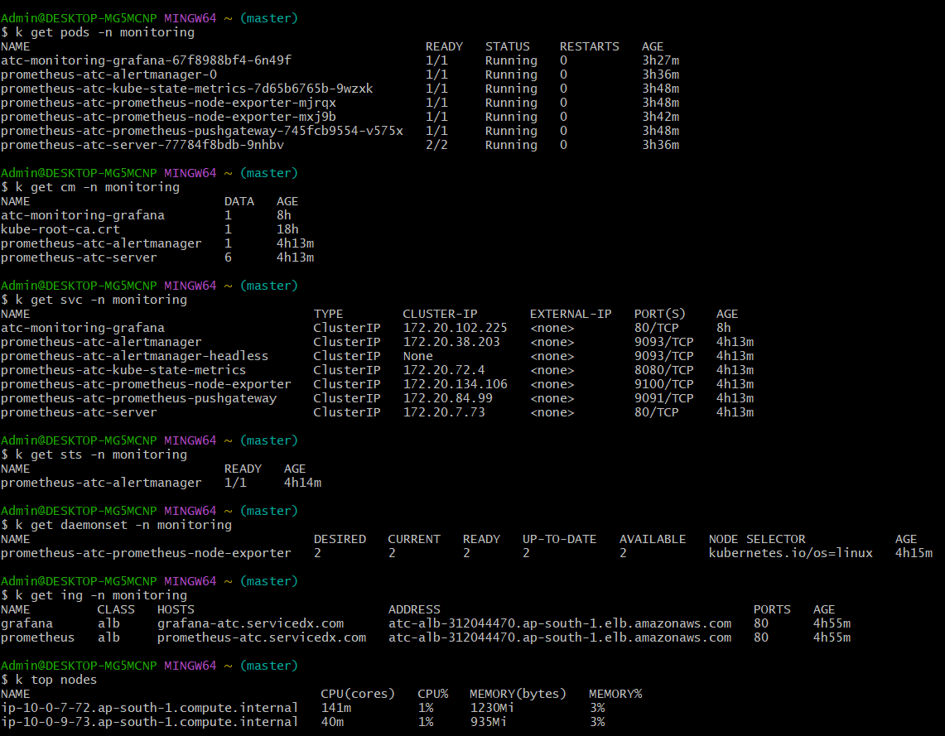

Grafana Outcome

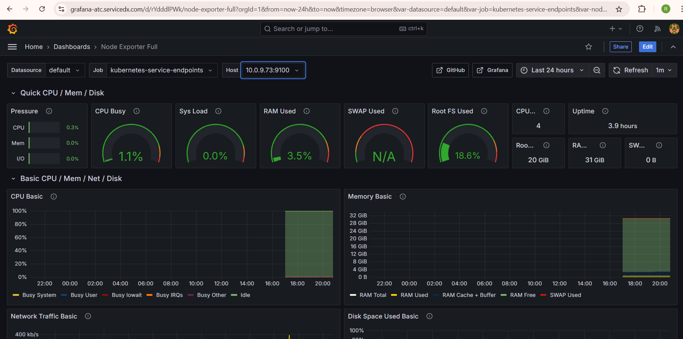

URL for Grafana application: https://grafana-atc.servicedx.com/

Prometheus Outcome

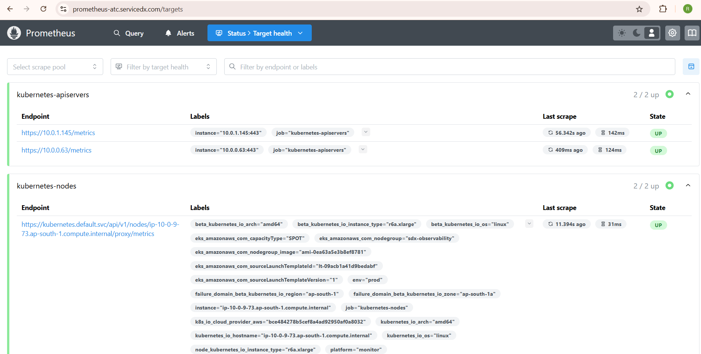

URL for Prometheus application: https://prometheus-atc.servicedx.com/