VPC configuration

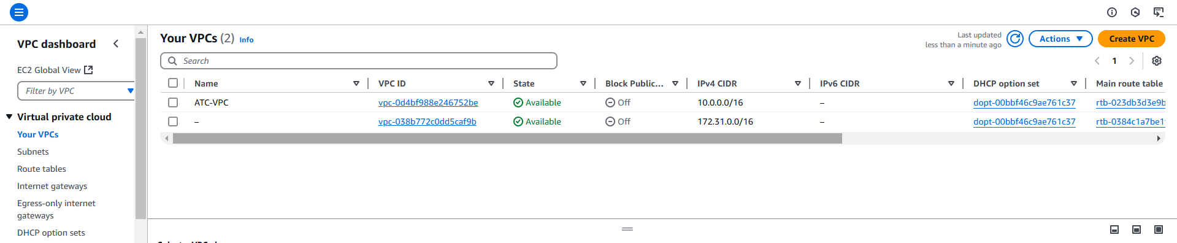

EKS configuration

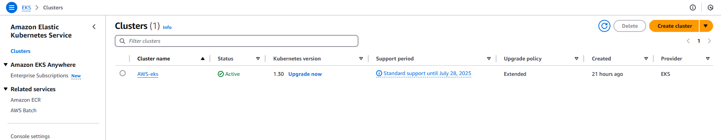

Nodegroup Configuration

