Phase 3: Development
Smart Public Restroom
Components required:
1. Automated Flush and Faucet Systems
2. Smart Toilet Seats
3. Occupancy Sensors
4. Hand Sanitizer Dispensers
5. Paper Towel and Soap Dispensers
6. Odor Control Systems
7. Smart Lighting
8. Environmental Sensors
9. QR Code or Mobile App Access
10. Emergency Alert Systems
11. Maintenance and Cleaning Alerts
12. Digital Signage
13. Toilet Seat Sanitization Systems
14. Occupancy Tracking
15. Water and Energy Efficiency Features
16. User Feedback Systems
The specific components may vary based on the restroom 's design, location,and intended user base.smart public restrooms aim to provide a more comfortable, efficient,and hygienic experience for users while facilitating maintenance and resource management for facility operators.
Purpose of project:
The purpose of this project is to enhance the user experience, improvehygiene and streamline maintenance and management.The key purpose is to ImproveHygiene,User convenience,WaterandEnergyConservation,Accessability,MaintenanceEfficiency,Sustainability,Datacollection,Improveduserexperience,ModernAesthetics,Costsavings,Publichealth,Customer Satisfaction and these are the purpose to create a more pleasant,convenient and sustainable restroom experience for users while streaming operations for facility managers.
Circuit Diagram for project:
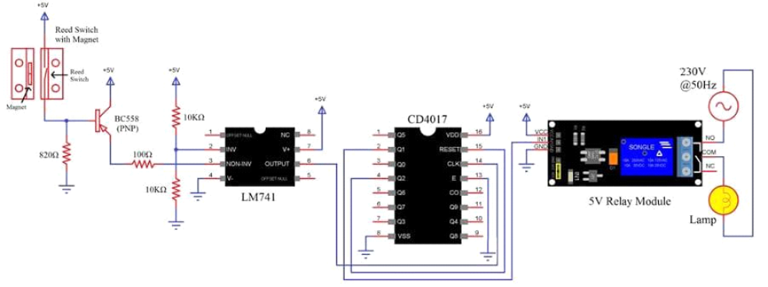

Program for smart public restroom:
1. User Interface:
Develop a user-friendly interface for selecting restroom options (e.g., men's, women's, accessible).
Implement touchless controls to minimize contact.
2. Occupancy Management:
Use occupancy sensors to monitor restroom usage.
Display real-time occupancy information on a digital sign outside the restroom.
3. Entry Control:
Use QR codes or RFID cards for secure access.
Implement automatic doors or touchless entry mechanisms.
4. Sanitization:
Integrate automatic hand sanitizers and soap dispensers.
Schedule regular cleaning and maintenance based on usage data.
5. Health Monitoring:
Add air quality sensors to monitor CO2 and humidity levels.
Alert staff if conditions are unfavorable.
6. Water Conservation:
Install smart faucets and toilets with sensors to control water flow.
Implement leak detection systems.
7. Energy Efficiency:
Use motion sensors to control lighting and ventilation.
Optimize energy consumption based on occupancy.
8. Feedback System:
Provide a way for users to rate the restroom's cleanliness and report issues.
Use this data to improve maintenance.
9. Security:
Implement surveillance cameras for security.
Secure data to protect user privacy.
10. Data Analytics:
Collect and analyze data on restroom usage and maintenance needs.
Use this data for predictive maintenance and improvements.
11. Mobile App:
Develop a mobile app for users to check restroom availability and receive notifications when it's their turn.
12. Accessibility Features:
Ensure the restroom is ADA compliant with features like accessible stalls and height-adjustable fixtures.
13. Maintenance Scheduling:
Create a system to schedule and track routine maintenance tasks.
14. Emergency Procedures:
Include safety features and protocols in case of emergencies, such as fire alarms and emergency exits.
15. Payment System:
If applicable, implement a payment system (e.g., pay-per-use or subscription-based) for premium public restrooms.
Coding :
import time

class SmartRestroom:
def _init_(self):
self.occupied = False
self.light_on = False
self.fan_on = False

def presence_detected(self):
self.occupied = True
self.turn_on_light()
self.turn_on_fan()
print("Restroom is occupied.")

def no_presence(self):
self.occupied = False
self.turn_off_light()
self.turn_off_fan()
print("Restroom is vacant.")

def turn_on_light(self):
self.light_on = True
print("Light is ON.")

def turn_off_light(self):
self.light_on = False
print("Light is OFF.")

def turn_on_fan(self):
self.fan_on = True
print("Fan is ON.")

def turn_off_fan(self):
self.fan_on = False
print("Fan is OFF.")

if _name_ == "_main_":
restroom = SmartRestroom()

while True:
presence = input("Is there anyone in the restroom? (yes/no): ")
if presence.lower() == "yes":
restroom.presence_detected()
else:
restroom.no_presence()
time.sleep(1)

