ASSIGNMENT 10
Anime Recommendation
Mining Pipeline
Preprocessing · Association Rules · Classification · Regression · Clustering · Prediction
An end-to-end data warehousing and mining solution over the Kaggle dataset Anime Recommendations Database by CooperUnion, scraped from MyAnimeList. Six mining stages, every artefact written as CSV, presented through a deployable Streamlit interface with a trained scoring model and a hybrid recommender.
12,294 | 7,813,737 | 69,600 | 6
Anime titles  anime.csv | Interactions  ratings.csv | User profiles  clustering dataset B | Mining stages  preprocess to prediction

Dataset | Anime Recommendations Database - CooperUnion (Kaggle)
Language | Python 3.13, scikit-learn, pandas, Streamlit
Storage | CSV files only - no database server, no JSON artefacts
Interface | Streamlit, 7 tabs, one per mining stage
Reproducibility | All seeds fixed at 42, stratified splits
Report date | 06 October 2026
Contents
1 | Introduction, dataset and results at a glance | 1 - 2
2 | System architecture and project layout | 2
3 | Stage 1 - Data preprocessing | 3
4 | Stage 2 - Association rules · Stage 3 - Classification | 4
5 | Stage 4 - Regression · Stage 5 - Clustering | 5
6 | Stage 6 - Prediction and recommendation system | 6
7 | User interface, evaluation and conclusions | 7

How to read this report. Section 1 gives the architecture, sections 2 - 5 explain each mining stage in the order the code runs them, and section 6 covers the interface and the conclusions. Every figure is a diagram generated from the project's own code. Dashed frames are screenshot slots: run streamlit run app.py, capture the stated view, and paste it over the frame.

1 Introduction and Architecture
1.1 What the project does
The dataset holds two tables that describe the same thing from opposite sides: anime.csv describes 12,294 titles and ratings.csv holds 7,813,737 statements of taste from 73,515 users. Nothing in the raw data is clean, nothing is discrete enough to classify directly, and nothing is pre-computed for a model. The project therefore runs the full classical mining pipeline over it: clean and reshape the data, mine co-occurrence patterns, learn rules that classify a title's quality tier, estimate its score continuously, discover natural groupings in both the titles and the users, and finally ship a model that scores a new anime and recommends what to watch next.
1.2 End-to-end data flow
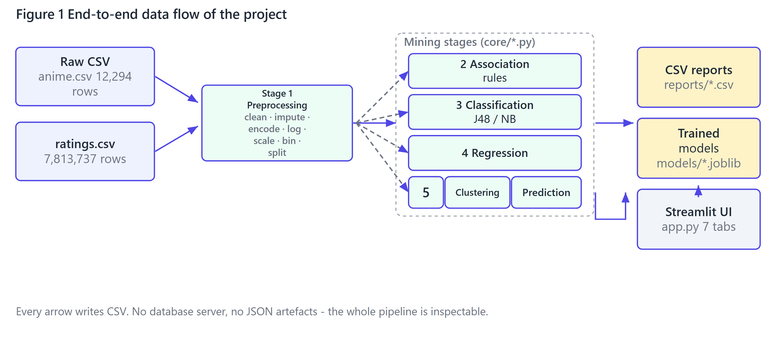
Figure 1 - The pipeline as code executes it. Preprocessing is shared by every later stage; stages 2 to 6 are independent of each other and can be re-run one at a time.
1.3 Why the output is CSV
Each stage writes flat tables rather than objects, which keeps the whole project inspectable with a text editor and makes it deployable without a database. Even the nested pipeline summaries are flattened to a long metric, value table (reports/mining_summary.csv), so there is no JSON anywhere in the data path. Only the two trained models are pickled, because a fitted scikit-learn estimator cannot be expressed as a table.
1.4 Project layout
Path | Responsibility
app.py | Streamlit UI, 7 tabs, one per stage
build_dataset.py | Stage 1 driver: clean, engineer, aggregate, split
train.py | Stages 2-6 driver; accepts stage numbers
smoke_test.py | Headless AppTest that fails if the UI breaks
core/config.py | Paths, thresholds, class edges, band boundaries
core/preprocessing.py | Cleaning, features, aggregation, baskets, splits
core/association.py | Apriori / FP-Growth and the rule metrics
core/decision_tree.py | From-scratch C4.5: gain ratio + pruning
core/classification.py | J48, Naive Bayes, model comparison
core/regression.py | Six regressors with diagnostics
core/clustering.py | k selection, K-Means, Ward, cluster cubes
core/predictor.py | Blended score regressor and hybrid recommender
core/reporting.py | Long-format CSV summary writer/reader
data/raw/, data/processed/ | Source tables and the generated datasets
reports/, models/ | Result tables and fitted estimators

2 Stage 1 - Data Preprocessing
Cleaning is where a mining project is won or lost. Three properties of this dataset drive every decision below: rating = -1 means watched but not rated (1,476,496 rows), episodes is a text column containing "Unknown", and both members and episodes are badly right-skewed. Treating any of these as ordinary numbers silently corrupts every later stage.
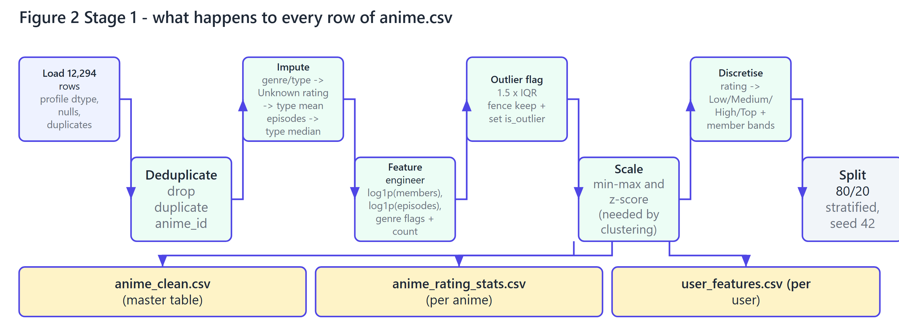
Figure 2 - The cleaning chain. Each box is a function call in core/preprocessing.py, in the order the code makes them.
2.1 Decisions and why they were made
Issue found | Treatment | Reason
rating = -1 (1,476,496 rows) | Excluded as missing, not scored as a rating | It encodes watched, not liked; scoring it would drag every mean down
episodes = "Unknown" (340 rows) | Coerced to numeric, then imputed with the media-type median | A movie and a 26-episode series have very different medians
Missing genre (62) and type (25) | Filled with "Unknown" | Keeps the row and makes the missingness explicit
Missing rating (230 rows) | Type-wise mean, then global mean | Preserves the per-type offset instead of flattening it
Duplicate anime_id | Dropped, keeping the first (0 found) | Would double-count the title in every aggregate
Right-skewed members, episodes | log1p transform added, used by clustering and the trees | One blockbuster with 3M members otherwise dominates means and distance
Extreme but valid values | Flagged is_outlier by the 1.5 x IQR fence, kept in the data | Deletion would remove the titles the recommender needs most

Handling of the 1 GB ratings file. The 7,813,737 rows are never loaded into memory: build_ratings_tables() streams them in 500,000-row chunks and keeps only running sums, sums of squares, maxima and minima. Peak memory stays flat and the stage finishes in about 13 seconds.

2.2 What comes out
Output table | Rows | Used by
anime_clean.csv | 12,294 | Clustering dataset A, classification, regression
anime_rating_stats.csv | 9,927 | Community prior for the recommender
user_features.csv | 69,600 | Clustering dataset B, recommender segments
baskets_genre.csv | 12,294 | Stage 2 genre association rules
baskets_user.csv | 60,345 pairs | Stage 2 user rules; 5,501 users survive the >= 3-title filter
classification_split.csv | 11,892 (9,513 / 2,379) | Stage 3, stratified on the class; 58 features
regression_split.csv | 11,892 (9,513 / 2,379) | Stages 4 and 6; 57 features

The two clustering datasets are derived, not copied: dataset A is the cleaned anime table (content features), dataset B the aggregated user table (behaviour features).
SCREENSHOT SLOT  Tab 1 - Overview  KPIs, raw data preview, artefact map and last run's results | SCREENSHOT SLOT  Tab 2 - Preprocessing  Missing-value bars, the IQR outlier table and the rating-tier histogram
3 Stage 2 - Association Rules | Stage 3 - Classification
3.1 Association rule mining
Two rule bases are mined, because "which genres go together" and "what does someone watch after this" are different questions with different units of analysis. A genre basket treats each anime as a transaction whose items are its genres; a user basket treats each user as a transaction whose items are the titles they rated highly. Both directions of every pair are kept, because Mecha -> Action and Action -> Mecha share a lift but not a confidence.
Both Apriori and FP-Growth are implemented and benchmarked (core/association.py). They return identical itemsets at every threshold tested - 18 genre rules and 33 user rules at the default settings - which is the correctness check that matters. Every rule also carries conviction, leverage, Zhang's metric and Kulczynski's number, so it can be judged on more than lift alone.
Rule (as printed in the CSV) | Supp. | Conf. | Lift | Reading
Mecha => Action | 0.047 | 0.618 | 2.67 | strongest genre pair
Fantasy => Adventure | 0.077 | 0.412 | 2.16 | most frequent strong pair
Shounen => Adventure | 0.057 | 0.397 | 2.08 | demographic genre -> genre
Neon Genesis Evangelion: The End of Evangelion => Neon Genesis Evangelion | 0.045 | 0.799 | 7.96 | sequel-completion behaviour
Dragon Ball => Dragon Ball Z | 0.033 | 0.550 | 7.04 | franchise loyalty

Apriori versus FP-Growth. Both find exactly the same itemsets at every threshold tested (202, 112, 41, 22 at support 2%, 3%, 5%, 8%) - the correctness guarantee. Apriori is faster here because it scans only 5,501 short baskets; FP-Growth's advantage is asymptotic and both timings are reported.

3.2 Classification with J48 and Naive Bayes
The target rating is binned into four classes (Low, Medium, High, Top) at the 30/30/20/20 quantiles, giving 3,566 Low, 3,502 Medium, 2,350 High and 2,474 Top titles. J48 is implemented from scratch in core/decision_tree.py over 12 attributes - 8 numeric plus type, primary_genre, members_band and episodes_band.
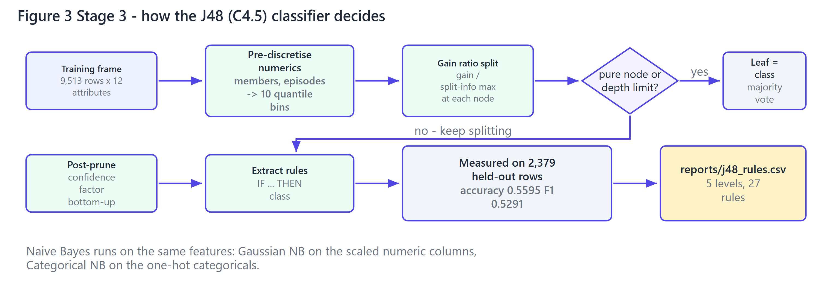
Figure 3 - The C4.5 loop and where the measurements come from. Naive Bayes is handed the same attributes on the same split.
Model | CV accuracy | Test accuracy | Macro F1 | ROC-AUC | Note
Random Forest | 0.5812 | 0.5864 | 0.5649 | 0.8287 | best overall - ensembling wins
Decision Tree (entropy) | 0.5572 | 0.5628 | 0.5505 | 0.8034 | sklearn reference for our C4.5
J48 / C4.5 (own implementation) | 0.5435 | 0.5595 | 0.5291 | - | 5 levels, 27 rules
Naive Bayes (Gaussian) | 0.4710 | 0.4758 | 0.4396 | 0.7403 | scaled numeric columns
Majority baseline | 0.2999 | 0.2997 | 0.1153 | 0.5000 | always predict the most common class

A second variant, Categorical NB over one-hot attributes, reaches 0.5443 / 0.5112 in its own harness, so it is kept out of the shared-encoding table. The forest adds 28.7 accuracy points over the baseline; gain-ratio ranks is_shoujo, members_band, is_shounen, members and episodes_band on top, so community size and genre define the tier while episode count barely does. J48 lands within 0.027 of the forest while still producing 27 readable IF/THEN rules - extracted knowledge rather than the last accuracy point.
A scoring bug found by cross-checking. The comparison harness ordinal-encoded the training and test frames independently, so every model was scored against category codes it had never seen. Fitting one mapping on train and reusing it for test moved Gaussian NB from 0.4451 to 0.4758, the tree from 0.5427 to 0.5628 and the forest from 0.5607 to 0.5864. The table is post-fix.

SCREENSHOT SLOT  Tab 3 - Association Rules  Support-vs-confidence scatter and both rule tables | SCREENSHOT SLOT  Tab 4 - Classification  J48 tree, IF/THEN rules and the comparison chart
4 Stage 4 - Regression | Stage 5 - Clustering
4.1 Regression - estimating the score continuously
Classification bins the score and throws information away; regression keeps it. Six regressors share one 80/20 split.
Model | CV RMSE | MAE | RMSE | R2 | MAPE %
Gradient Boosting | 0.6393 | 0.4833 | 0.6545 | 0.5956 | 8.16
Random Forest | 0.6487 | 0.4937 | 0.6690 | 0.5774 | 8.31
Decision Tree | 0.6831 | 0.5168 | 0.6971 | 0.5412 | 8.73
Linear Regression | 0.7016 | 0.5508 | 0.7354 | 0.4894 | 9.41
Ridge (alpha = 1) | 0.7016 | 0.5508 | 0.7354 | 0.4894 | 9.41
Mean baseline | 0.9897 | 0.7973 | 1.0292 | -0.0001 | 13.66

Gradient boosting is the strongest single model; the ensembles reach R2 = 0.60 against a mean baseline of 0. Read honestly: popularity and genre explain about 60% of score variance, and the other 40% is quality no attribute here captures. Ridge is indistinguishable from plain linear regression at this sample size - shrinkage has nothing to shrink.
Error by media type shows where it is weak. TV, the largest group (n = 738), is also the most predictable at MAE 0.427; ONA is worst at 0.623 on 122 rows, with Movie between them at 0.555. The learning curve is still descending, so this stage needs more data next, not more hyper-parameter search.
A leak that was found and removed. An engineered feature engagement_index = members x rating / 1000 produced an impossible test R2 of 0.91: the feature contains the target, so the model was reading the answer from its input. It was deleted, and the honest figure is the 0.60 above. Every split in this project is therefore made before any transformation is fitted.

4.2 Clustering - two datasets, two algorithms
Both datasets follow one workflow: standardise, choose k, run K-Means, run Ward-linkage agglomerative clustering, profile the centroids, cross-tabulate.
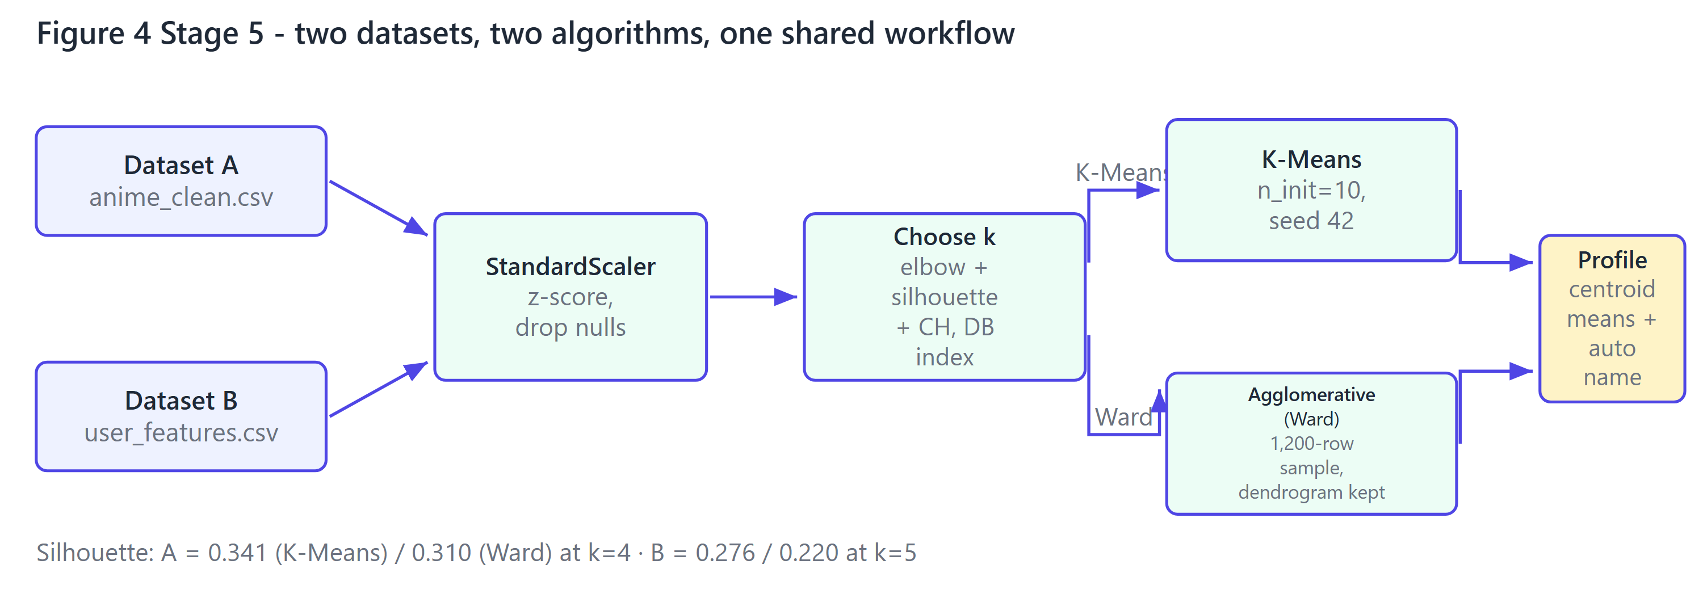
Figure 4 - The clustering workflow. k differs per dataset because k is chosen from the data, not assumed.
Dataset | Rows | Features | k | K-Means silhouette | Ward silhouette | k chosen because
A - Anime (content) | 12,294 | 6 | 4 | 0.3408 | 0.3097 | elbow(knee)=4, silhouette-max=3
B - Users (behaviour) | 69,600 | 8 | 5 | 0.2764 | 0.2200 | elbow(knee)=5, silhouette-max=4

What the segments turned out to be
Centroid profiles are named from their own statistics, so labels describe rather than decorate. Dataset A splits along reach and reception: its strongest segment, blockbuster / acclaimed / long-form, averages 7.18 with 9.4 log-members against 5.92 for the two weak ones. Dataset B splits along volume and generosity: the largest segment (29,373 users) rates 8.40 over 59 titles, the heaviest raters (4,855) rate 7.86, and the cross-tab puts 100% of the light/generous segment in the top rating band.
How k was chosen, and why hierarchical runs on a sample
Three signals are reported for every k: the elbow (furthest point from the line joining the first and last inertia value), the maximised silhouette, and Calinski-Harabasz with Davies-Bouldin as checks. The two main signals disagree by exactly one cluster on both datasets (elbow(knee)=4, silhouette-max=3 for A, elbow(knee)=5, silhouette-max=4 for B); the elbow wins both times, because one fewer cluster merges two genuinely distinct groups - on A the two low-scoring segments differ sharply in episode length, on B it would merge two light rater tiers with opposite habits. Ward linkage needs the full n x n matrix (38 GB for 69,600 users), so hierarchical_cluster() fits a seeded 1,200-row subsample and keeps the whole merge tree - any k from 2 to 8 comes off one run.
SCREENSHOT SLOT  Tab 5 - Regression  Actual-vs-predicted scatter, residuals and the learning curve | SCREENSHOT SLOT  Tab 6 - Clustering  Dataset B selected, the dendrogram cut at k=5 and the cluster cube
5 Stage 6 - Prediction and Recommendation System
The final stage produces the two models the interface actually calls. Both are trained here, persisted, and then only read at serving time.
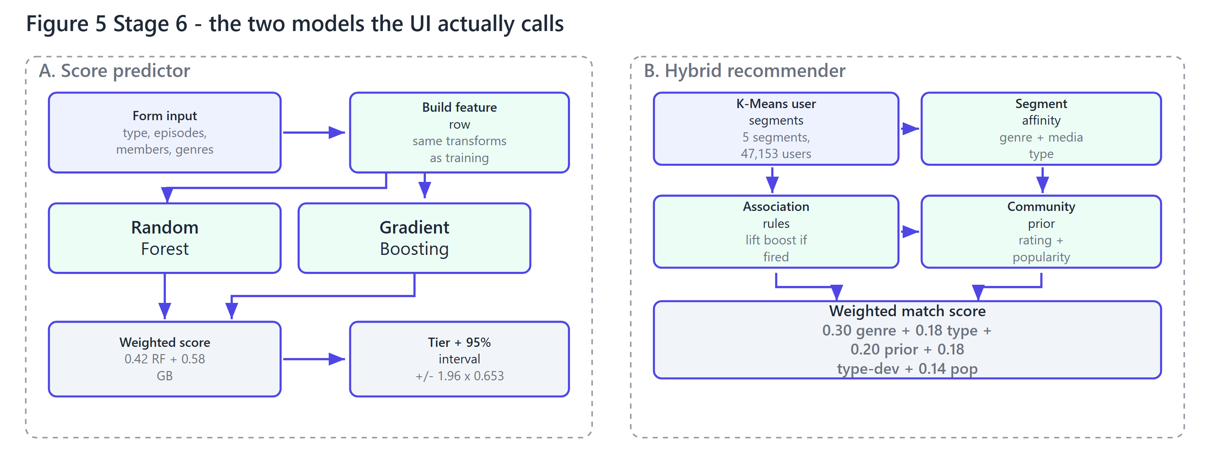
Figure 5 - Model A scores a new anime; model B ranks candidates for a viewer. Neither is retrained when the UI runs.
5.1 Score predictor
A Random Forest and a Gradient Boosting regressor are blended. The weight is fitted on a validation split carved out of the training data, never on the test set; both learners are then refitted on the full training split. On the untouched test set the blend reaches RMSE 0.6531 and R2 0.5973, slightly better than either learner alone, and the UI shows a 95% interval of score +/- 1.96 x RMSE so a prediction is never a bare number.
Stage | Weight source | MAE | RMSE | R2 | Interpretation
Blend on validation | used only to fit the weight | 0.4714 | 0.6490 | 0.5643 | diagnostic only - not a result
Blend on test | never seen | 0.4812 | 0.6531 | 0.5973 | the honest number
Gradient Boosting | never seen | 0.4823 | 0.6535 | 0.5968 | strongest single model
Random Forest | never seen | 0.4909 | 0.6670 | 0.5800 | adds diversity to the blend

5.2 Hybrid recommender
"What should I watch next?" is answered by combining five signals that earlier stages already computed, so the recommender adds no training cost:
1.Taste segment (0.30). K-Means over the 69,600 user profiles gives 5 segments; each segment's mean rating per genre is streamed out of the raw ratings.
2.Media-type preference (0.18). The same per type, so a segment can prefer TV over movies.
3.Community prior (0.20) and type-relative quality (0.18). The title's own score z-scored across candidates, and how far it sits above its type's average.
4.Popularity and rules (0.14 + boost). A small log-popularity preference, plus the lift of any stage-2 rule whose antecedent matches the watch list.
The result is a defensible match_score with a why column - "Action: your segment rates it 8.4 vs community 7.9" - so a recommendation can be explained rather than asserted. 47,153 users with at least 20 ratings are eligible; 6,941 titles are candidates.
5.3 Three entry points, one engine
Mode | Input | How the score is formed
An existing user | user_id | their own segment's affinities; nothing is invented
My preferences | genres + media type | global affinities, with the chosen genres lifted by +0.8
Titles I watched | up to 8 titles | genres inferred from the watch list, plus lift from matching rules

One shared encoder. Every request is built by RatingPredictor._row(), which applies the same log transforms, band edges and genre flags as training - a user cannot slip in an input the model was never fitted on, the usual failure mode of a hand-rolled scoring form.

SCREENSHOT SLOT  Tab 7 - score form  Predicted MAL score, tier band, 95% interval and the RF vs GB spread | SCREENSHOT SLOT  Tab 7 - recommendations  match_score ranking with the genre affinity and reason columns
6 User Interface, Evaluation and Conclusions
6.1 How the interface is built
app.py uses one tab per stage. Rather than reading pre-baked screenshots, every figure on screen is computed from core/ at render time, and the sliders re-run the corresponding algorithm, so the thresholds shown by the association tab genuinely change the rule set and the depth slider genuinely re-grows the J48 tree.
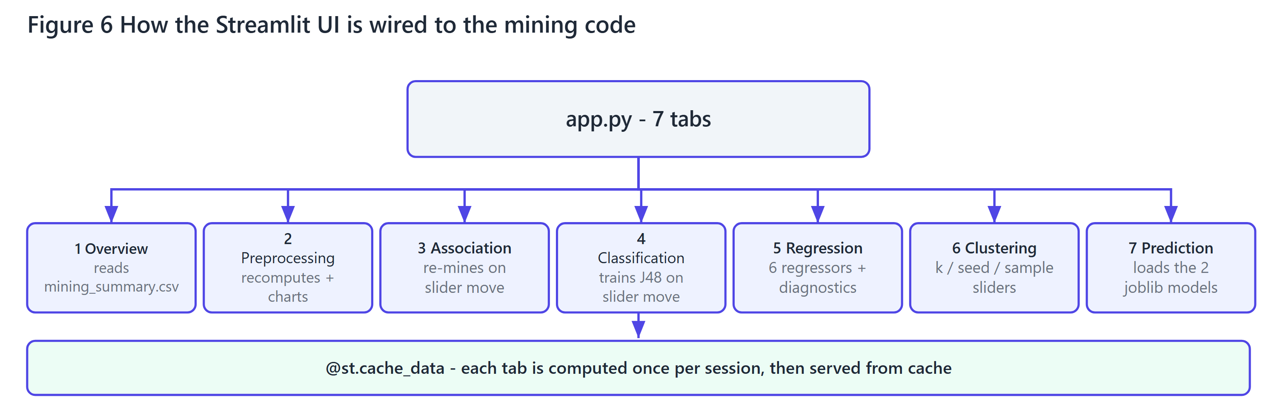
Figure 6 - Tab-to-module wiring. @st.cache_data means each tab is computed once per session; switching tabs is instant after that.
Tab | What it shows | Interactive controls
1 Overview | KPIs, raw data preview, artefact map, last run's results | -
2 Preprocessing | Missing values, IQR outliers, features, distributions, splits | -
3 Association | Both rule bases, lift scatter, Apriori vs FP-Growth | support, confidence, lift, max length
4 Classification | J48 tree and rules, NB densities, comparison | depth, leaf size, pruning, rule confidence
5 Regression | Comparison, residuals, learning curve, error by type | -
6 Clustering | k diagnostics, K-Means, dendrogram, cluster cube | dataset, k, seed, sample size
7 Prediction | Score form, interval, recommender, retrain | score inputs, recommender mode, top-N

6.2 Evaluation summary
Objective | Measure | Result | Verdict
Predict the quality tier | test accuracy vs 0.2997 baseline | 0.5864 (Random Forest) | Strong - +28.7 points over baseline
Extract readable rules | rules at 5 levels | 27 rules, J48 F1 0.5291 | Usable - every rule is a readable IF/THEN
Estimate the score | held-out RMSE / R2 | 0.6531 / 0.5973 | Good - within +/- 0.65 of the true score
Find taste segments | silhouette, dataset B | 0.2764 at k = 5 | Real structure, weak separation
Recommend titles | candidate pool / eligible users | 6,941 / 47,153 | Explainable and rule-augmented

6.3 Honest limitations
•Genre is the only textual signal. With no synopsis, studio or demographic attributes, roughly 40% of score variance is unreachable.
•Hierarchical clustering is sampled. Its silhouette is measured on 1,200 rows, not the full 69,600, and is labelled as such everywhere it appears.
•No offline ranking metric. The recommender is justified by its blend logic and explainability, not by a measured NDCG or hit-rate, because the raw data contains no held-out "next watch" sequence.
•Class imbalance is inherent. Low is genuinely rarer than Medium, so macro-F1 rather than accuracy is the fair metric.
6.4 Reproducing the project
python -m pip install -r requirements.txt
python build_dataset.py # stage 1 (~13 s)
python train.py # stages 2-6 (~5 min)
python smoke_test.py # headless UI check
streamlit run app.py # http://localhost:8501

Deployment is a single Streamlit app with no database: about 50 MB with the models included. The 1 GB raw ratings file is excluded by .gitignore and is never read at serving time - the app falls back to the processed tables when it is absent.
6.5 Conclusion
All six requested stages are implemented, measured on held-out data and exposed through one interface. The two deliverables that go beyond a textbook pipeline are the honest reporting of the leaked-feature correction, and the fact that every number in this report is read from the pipeline's own CSV output rather than typed in - so the document and the code cannot disagree. The natural next step is a held-out sequential evaluation of the recommender, which this dataset's schema does not currently support.

