

CC LAB -9

Cloud watch

• Name :HITU RAJ

• Roll no. :2005025

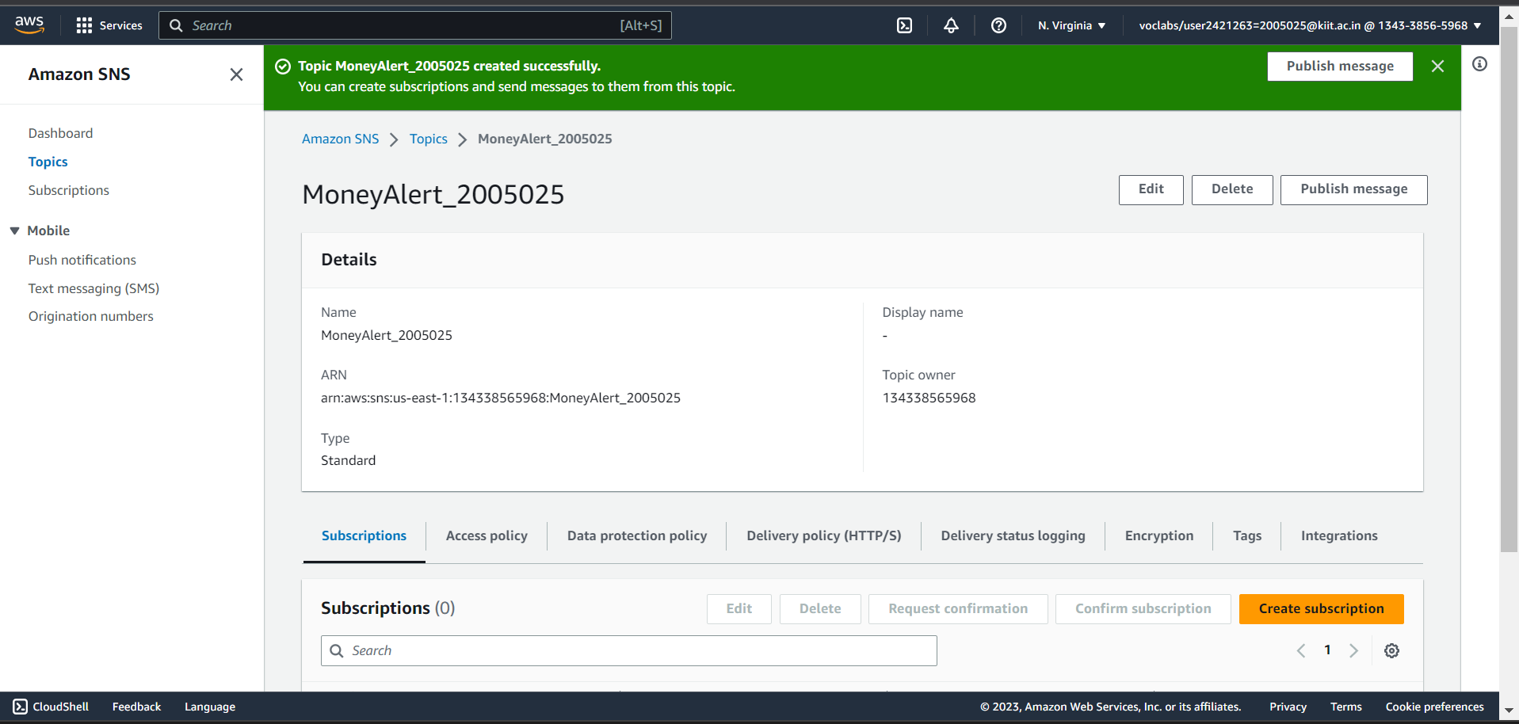• Branch :CSE-10

1.CREATING TOPIC:

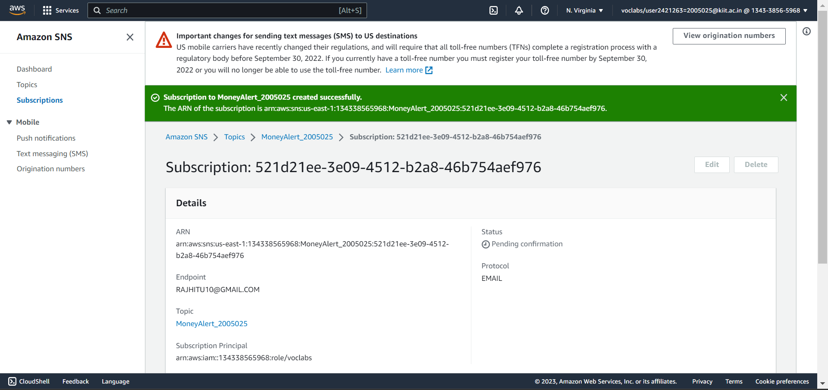2. CREATING SUBSCRIPTION AND ADDING MAIL

3.Creating alarm

