

CC LAB -10

Amazon RDS

• Name :HITU RAJ

• Roll no. :2005025

• Branch :CSE-10

­­­­­­­­

1.Creating a RDS

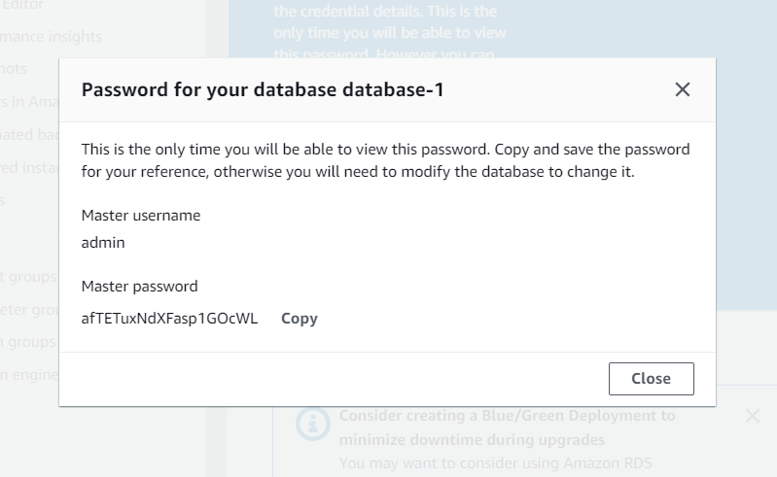

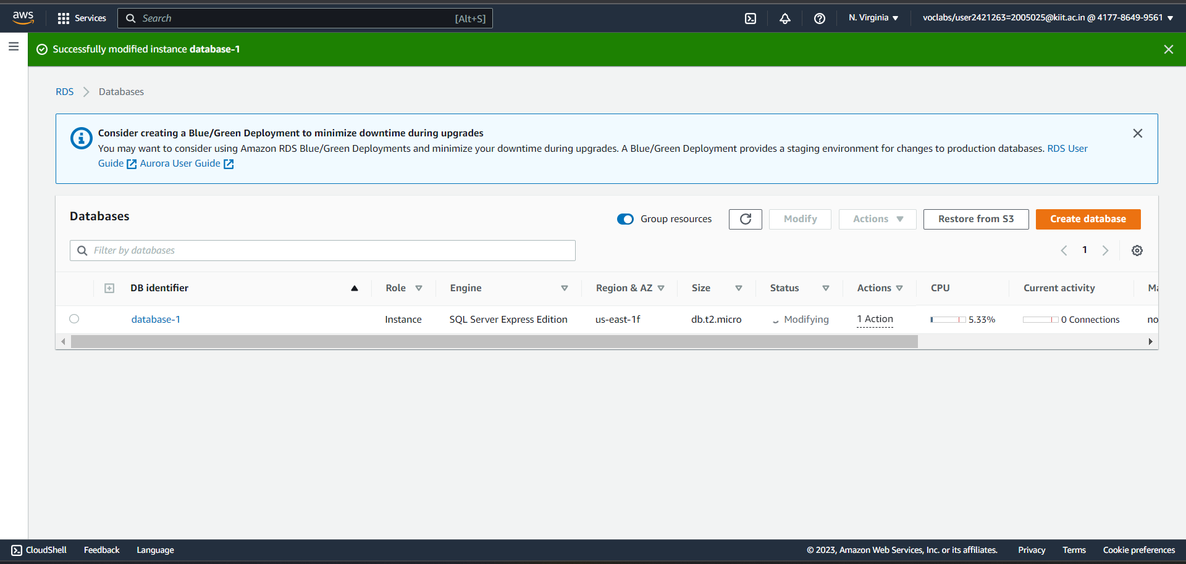2. public access to data base

3. Editing inbound rule for VPC

My IP : 103.161.223.10

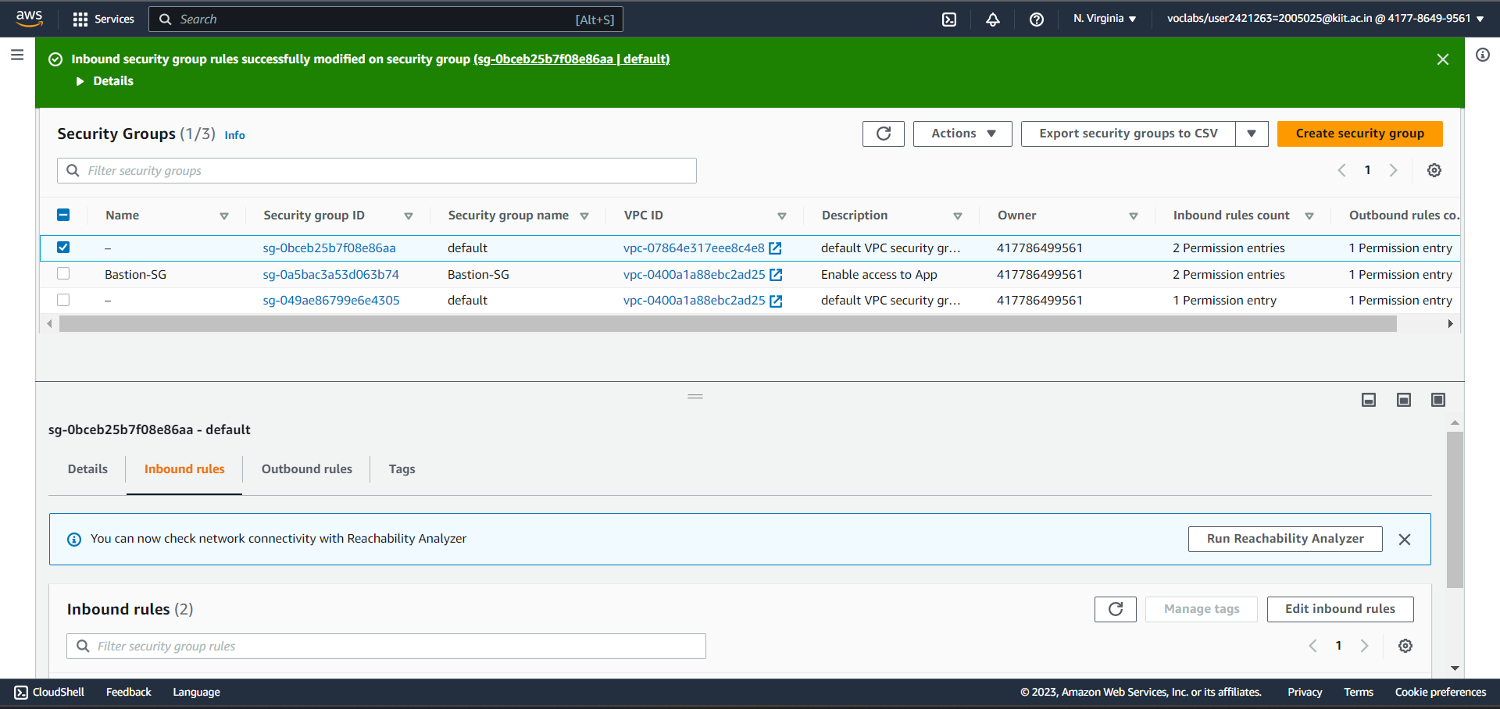

4. linking RDS

Endpoint value: 1.c4clsaexvijx.us-east-1.rds.amazonaws.com 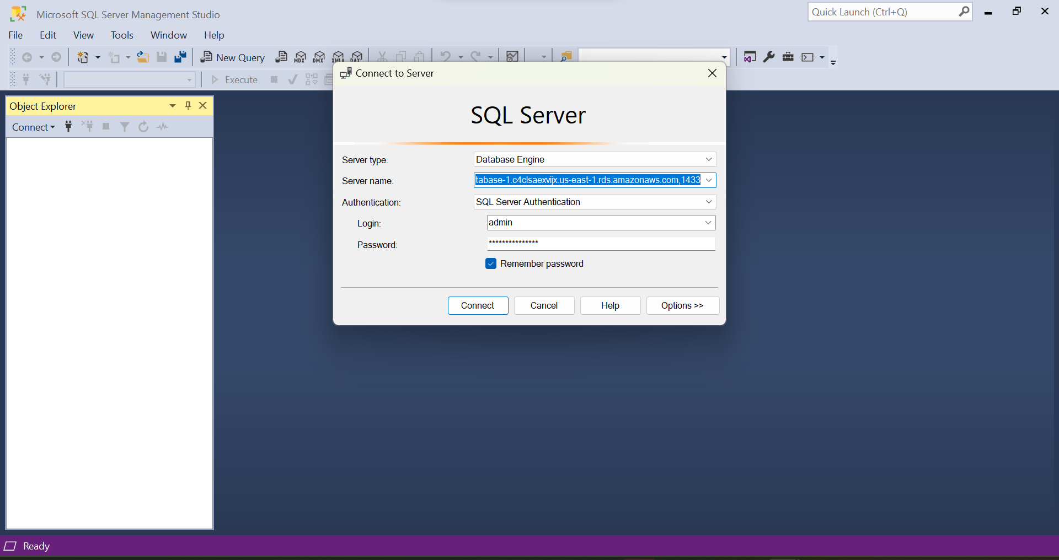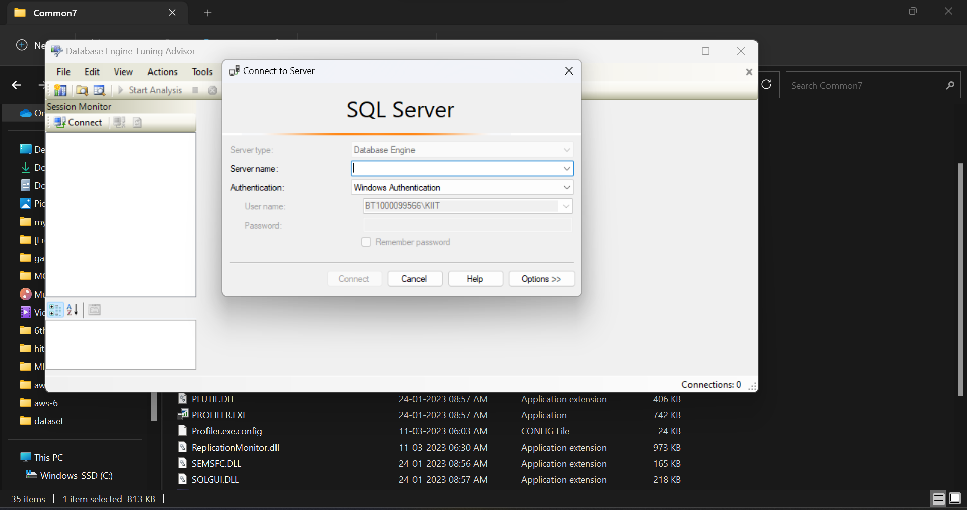

5. Connected to SQL sever Management tool

