CC LAB11

Load Balancing

• Name :HITU RAJ

• Roll no. :2005025

• Branch :CSE-10

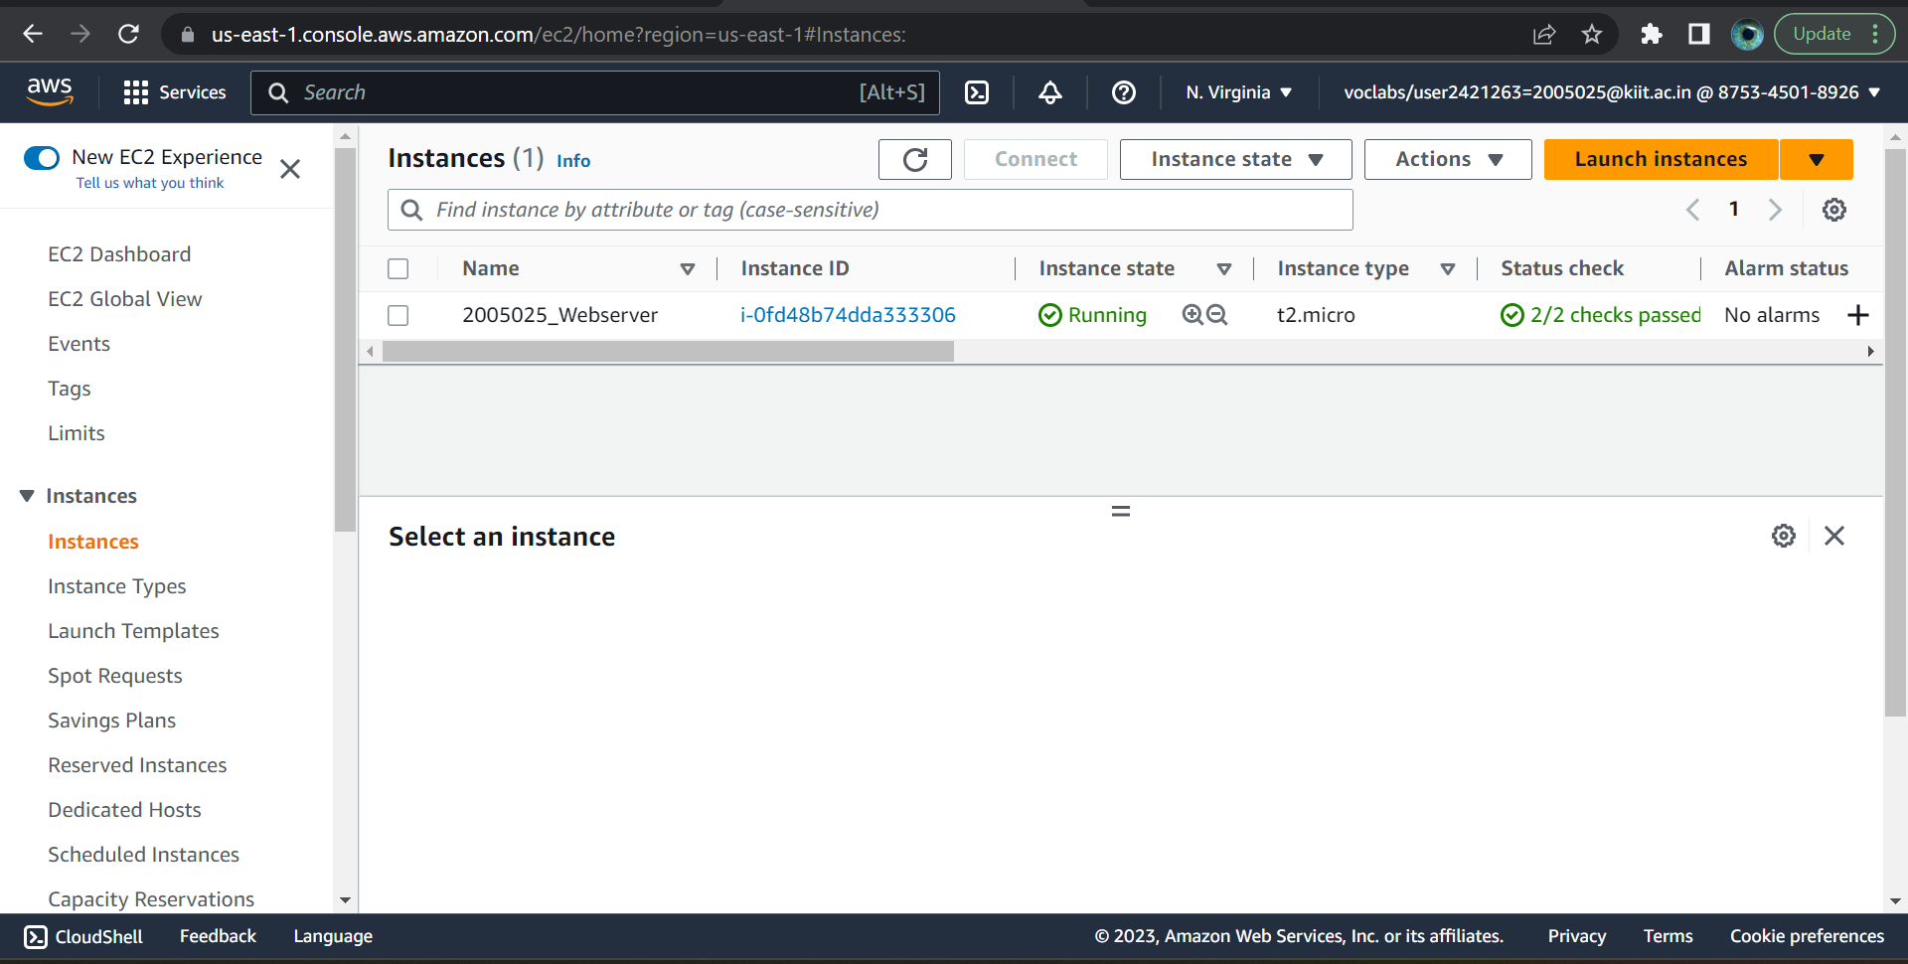1.Creating an Instance

2. Accessing the EC2 instance website1

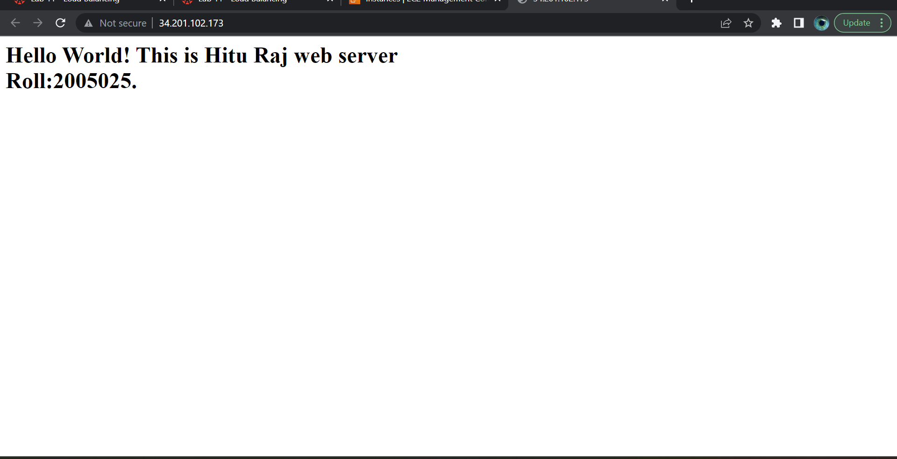

3. creating 2nd EC2 instance

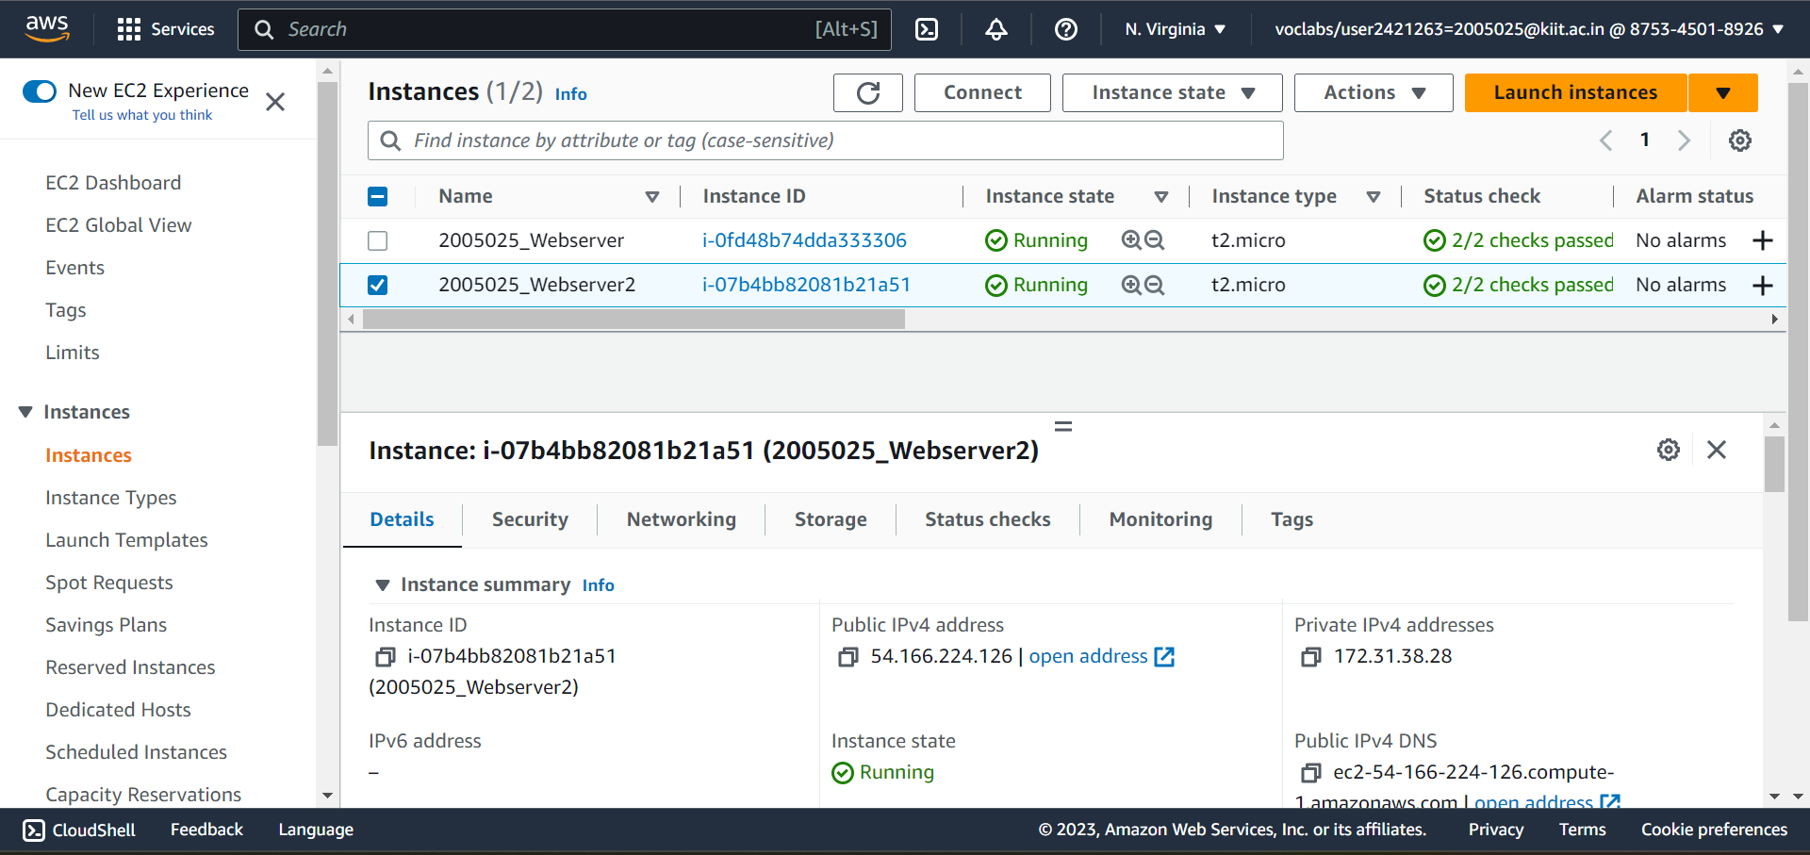

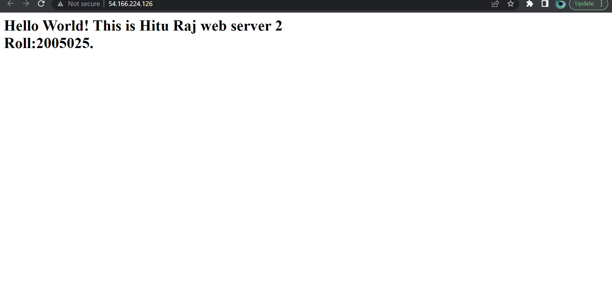4. Displaying 2nd website

5.Creating Target group

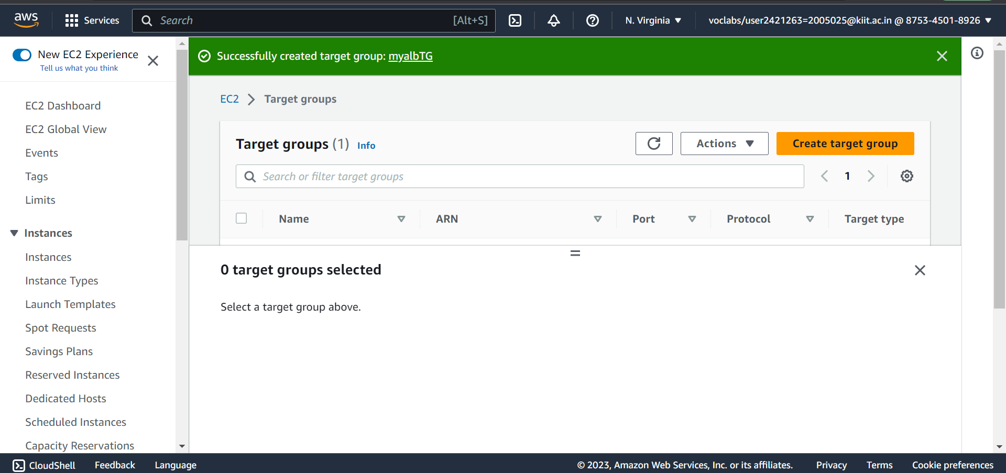

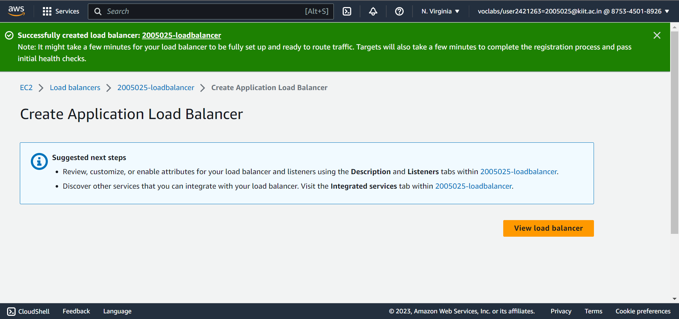6. Creating Load Balancer

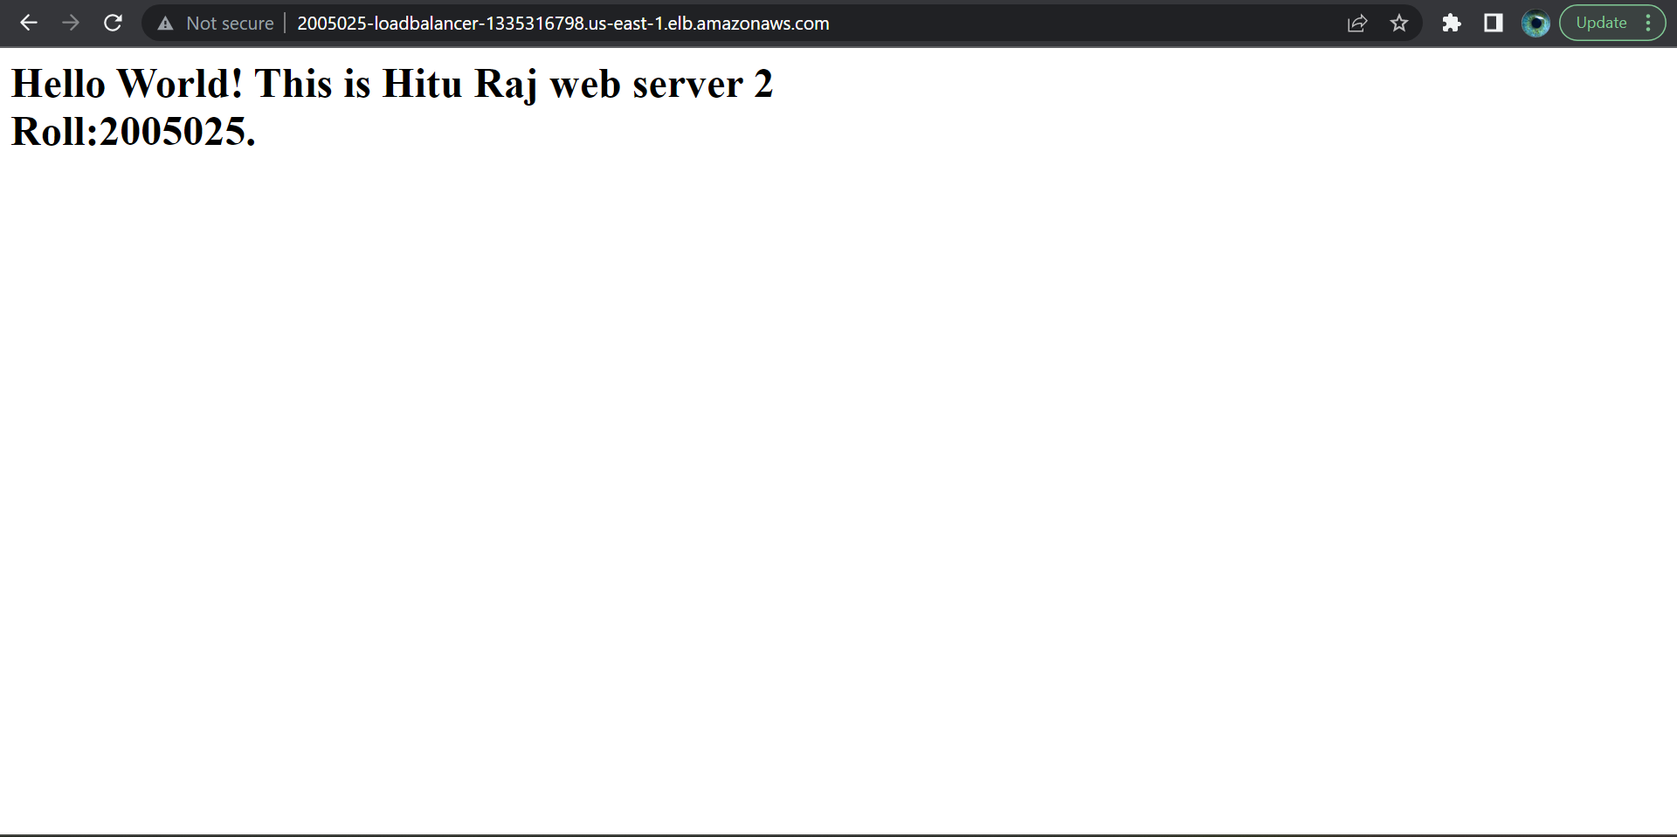7. Displaying the websites using Lod Balancer