

CC LAB 12

BeanStalk Cloud Formation

• Name :HITU RAJ

• Roll no. :2005025

• Branch :CSE-10

1.Deploying application using BeanStalk

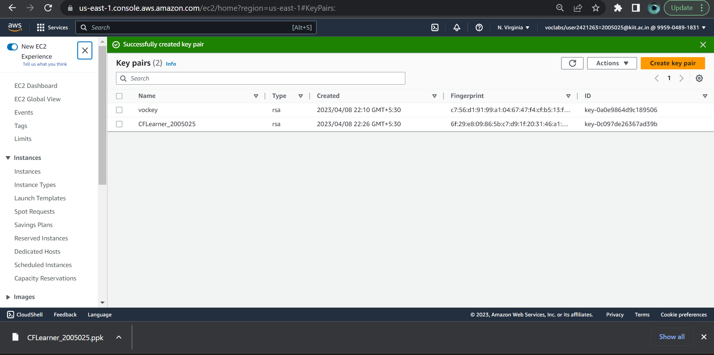2.Creating Key Pair

## 3.Deploy an application using Cloud Formation

