

CC LAB 6

EBS-Elastic Book Store

• Name :HITU RAJ

• Roll no. :2005025

• Branch :CSE-10

**Task 1. Start creating the instance and assign a name**

## 

## **Task 2. Access your EC2 instance**

## 

## **Task3. Update the security group**

## **Task 4. Test the rule**

## **Task 5. Attach an EBS volume to my EC2 instance**

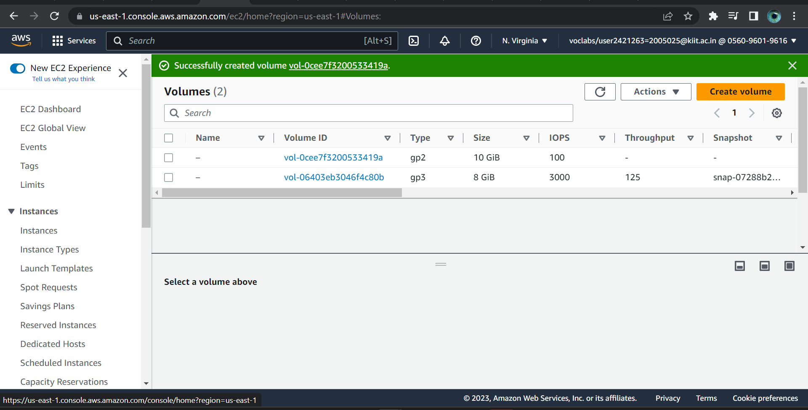

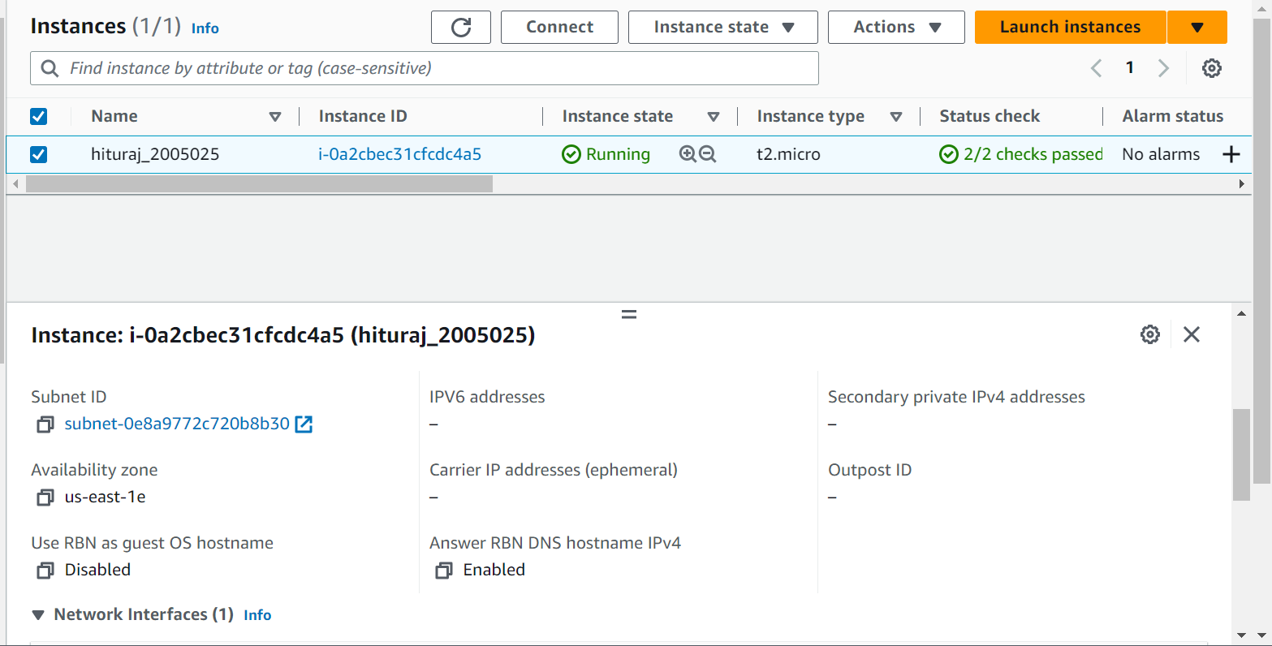

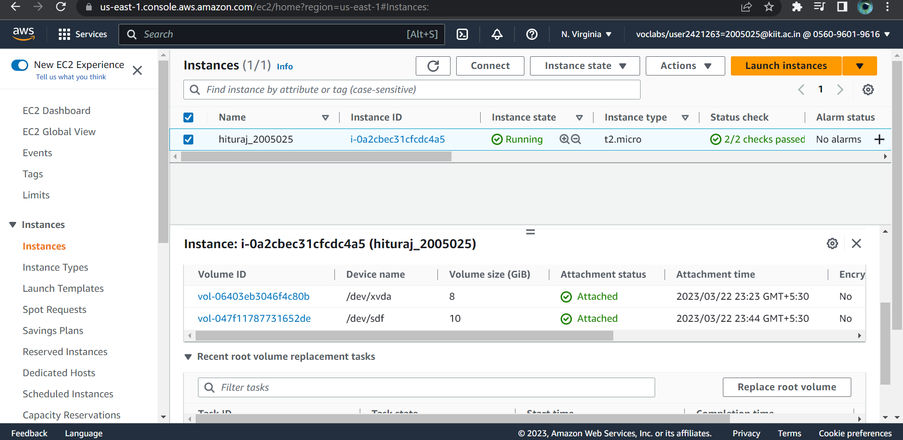**OUTPUT**