

CC AWS-LAB 7

IAM0-Identity and Access and Management

• Name :HITU RAJ

• Roll no. :2005025

• Branch :CSE-10

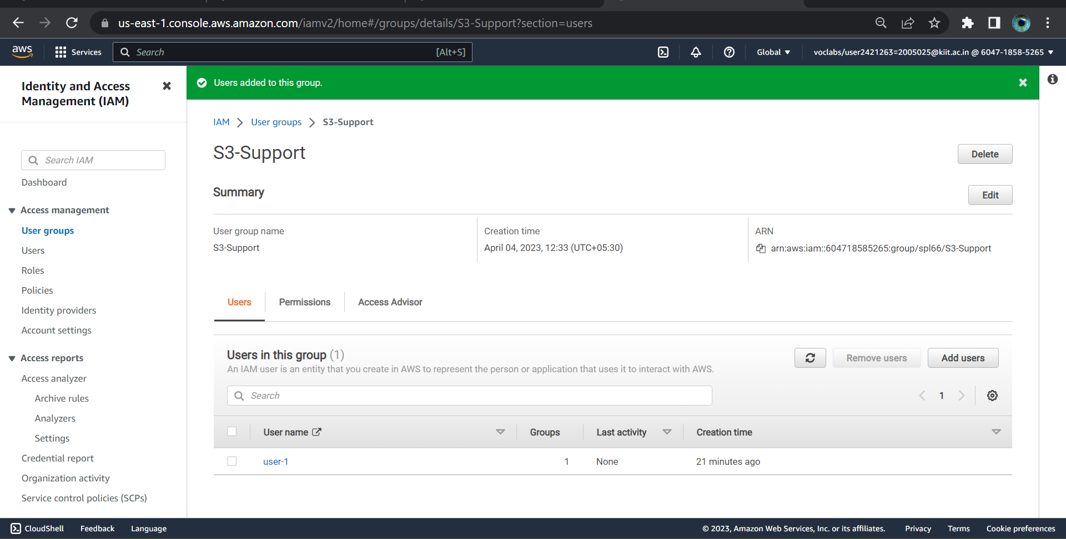Adding user1 to S3-Support

Adding user2 to EC2-Support

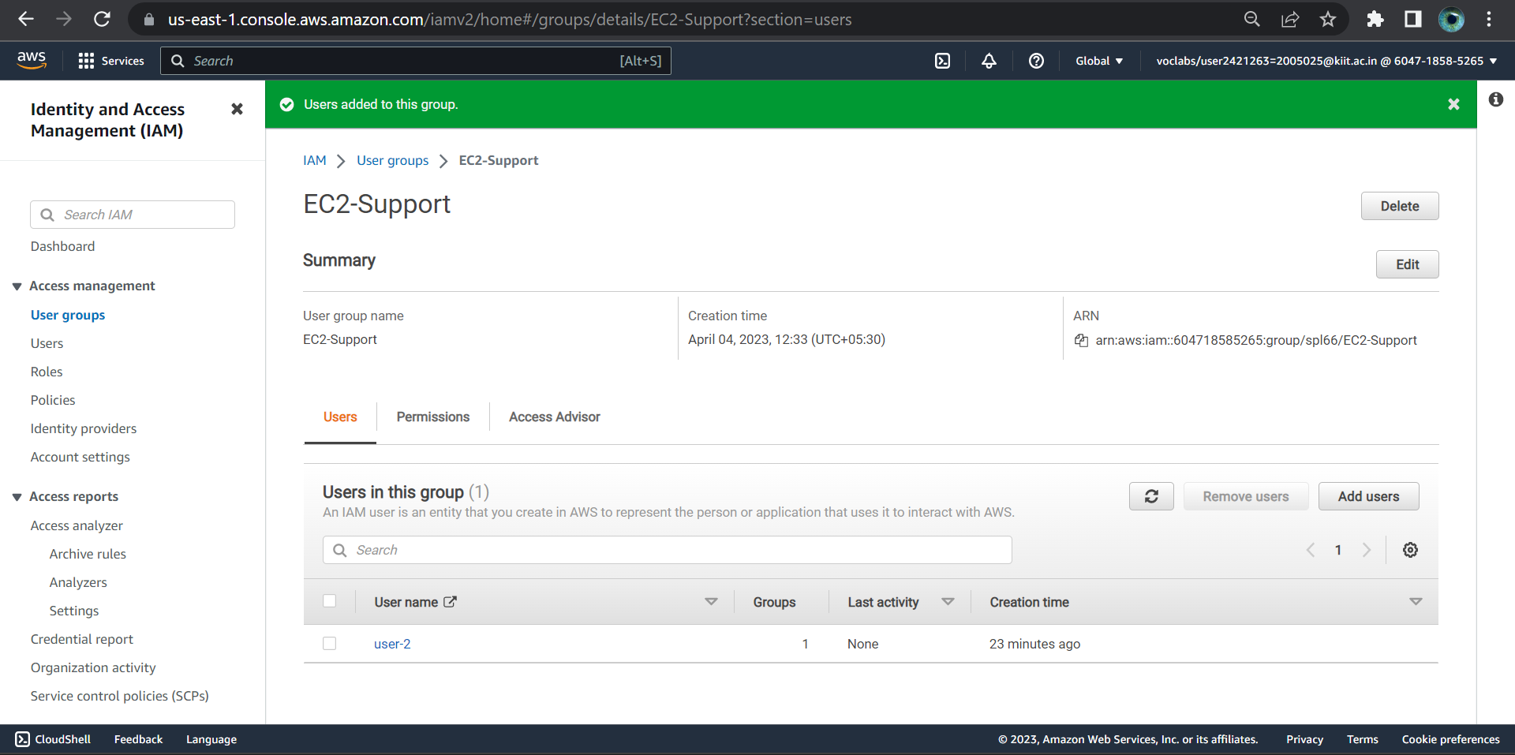

* Adding user3 to EC2-Admin

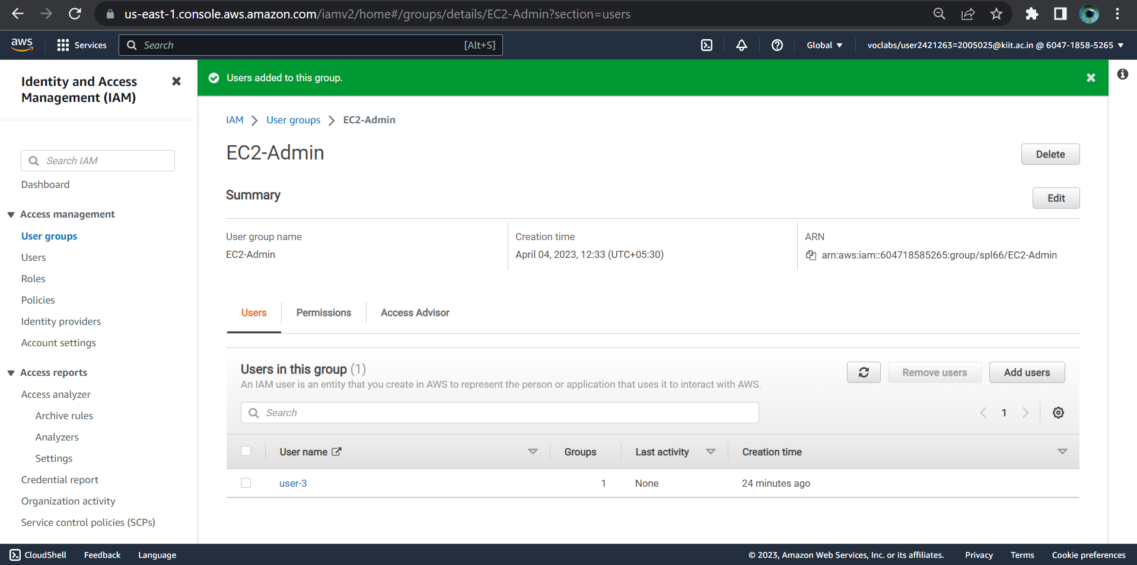

* Sign-in URL for IAM users in this account

https://604718585265.signin.aws.amazon.com/console

1.Login user-1(S3-group)

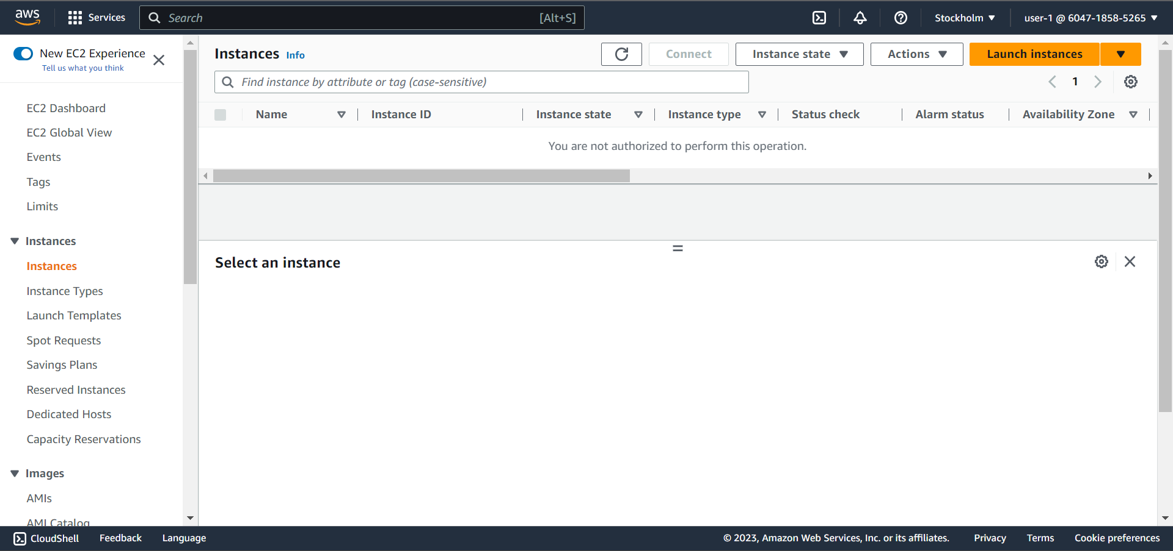user1 cannot access EC2

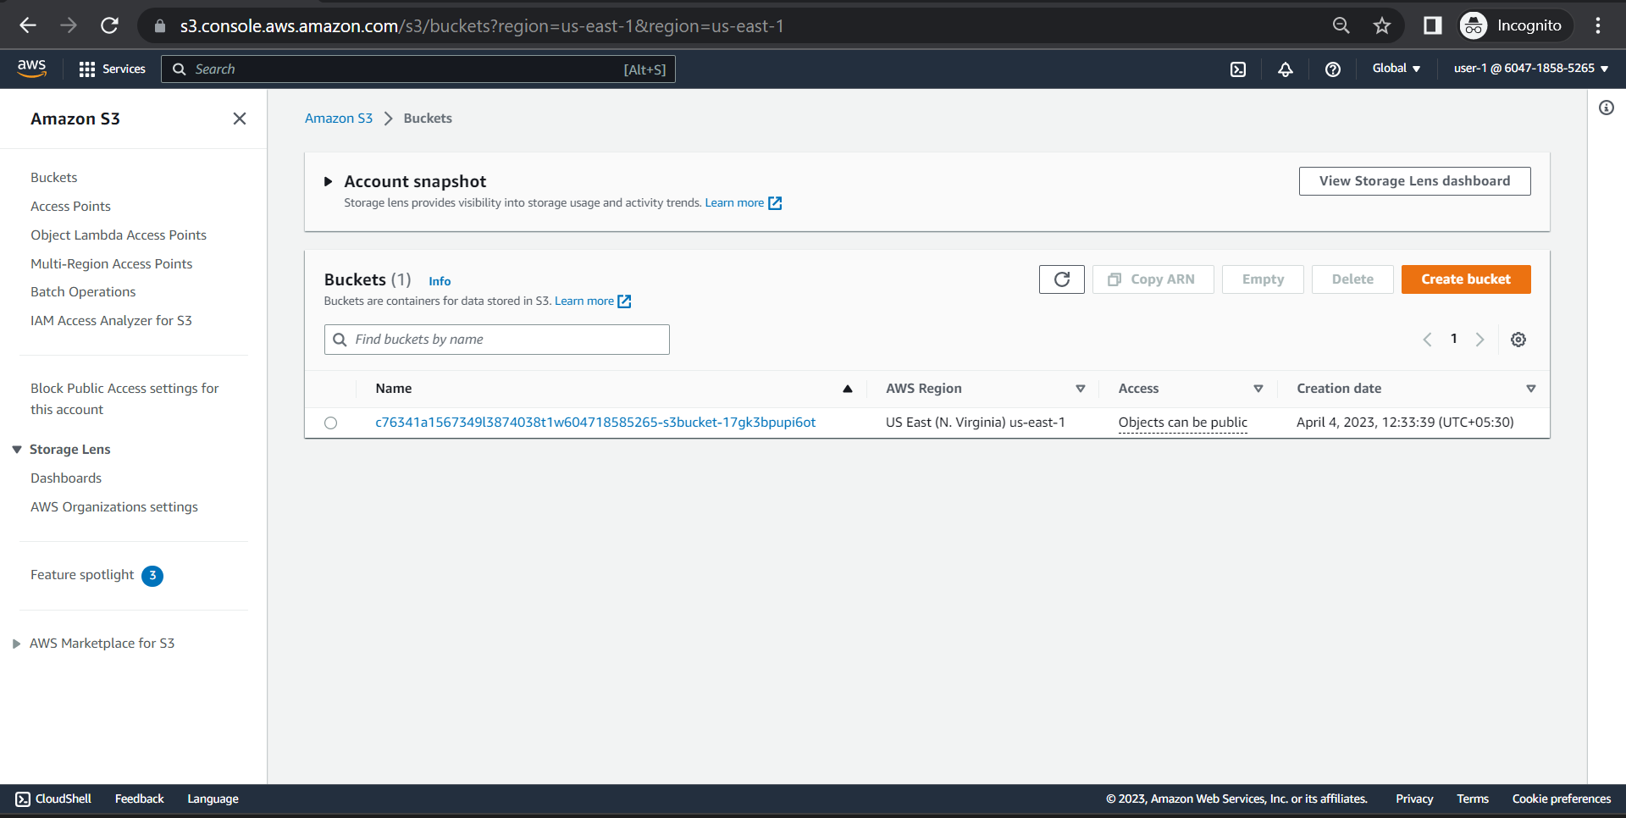user1 can acces S3 bucket

2. Login user-2(EC2-group)

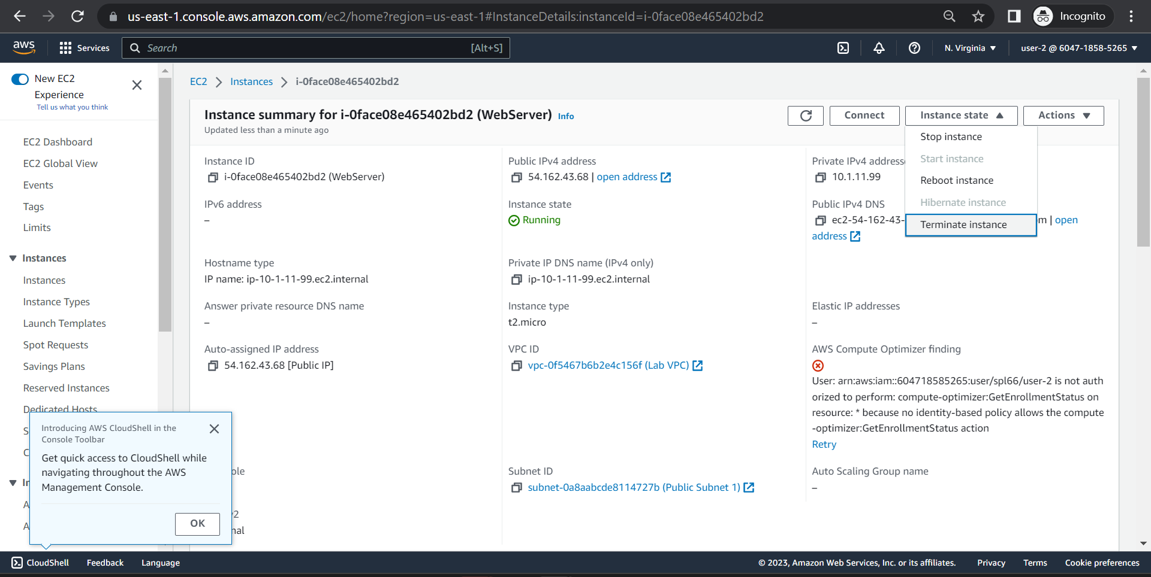user2 can access EC2

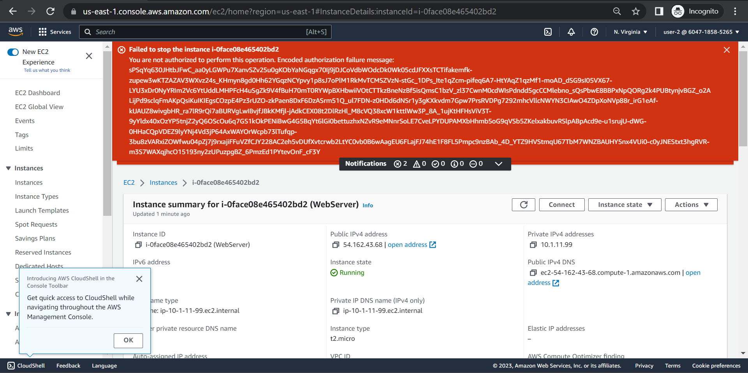user2 cannot stop an instance

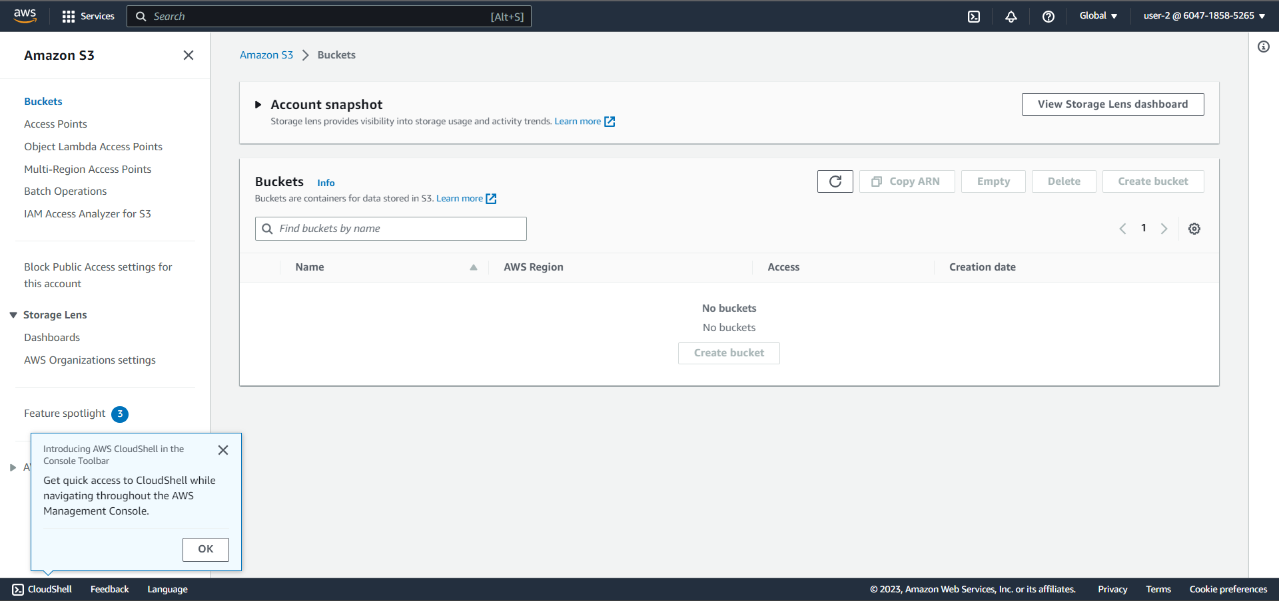user 2 cannnot read the S3

3.Login as User 3(EC2-admin)

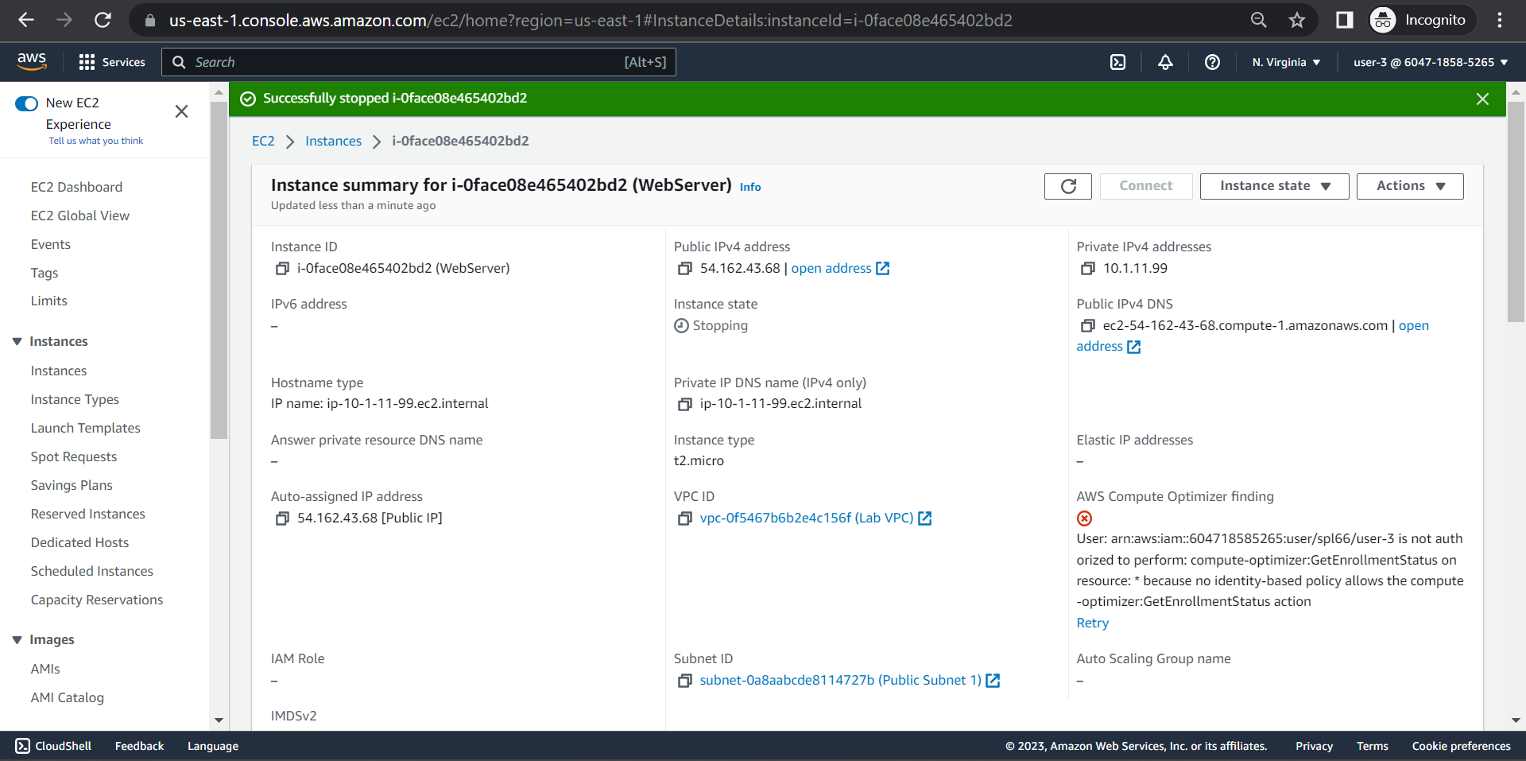User3 has the permission to stop the EC2 instance