

CC LAB 4.1 & 4.2

• Name :HITU RAJ

• Roll no. :2005025

• Branch :CSE-10

**LAB 4.1**

**EC2**

1. Create EC2 instance with the name web-server your full roll no.and security groupname with your first name.Display the result as i)your full name,ii) your roll no.

Step 1 Creating a Instance

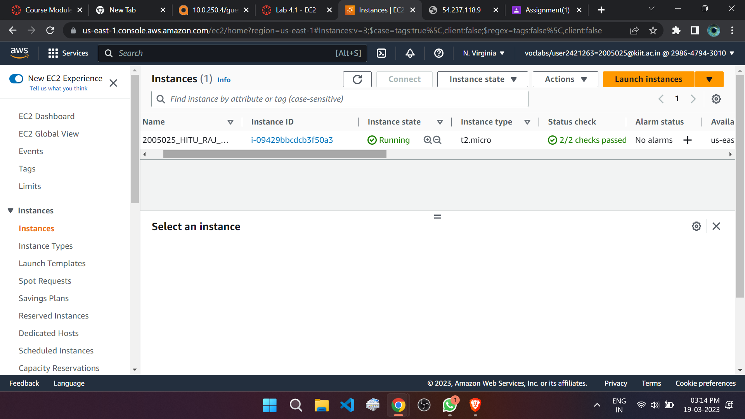

S

Step 3: Modifing a Security Group

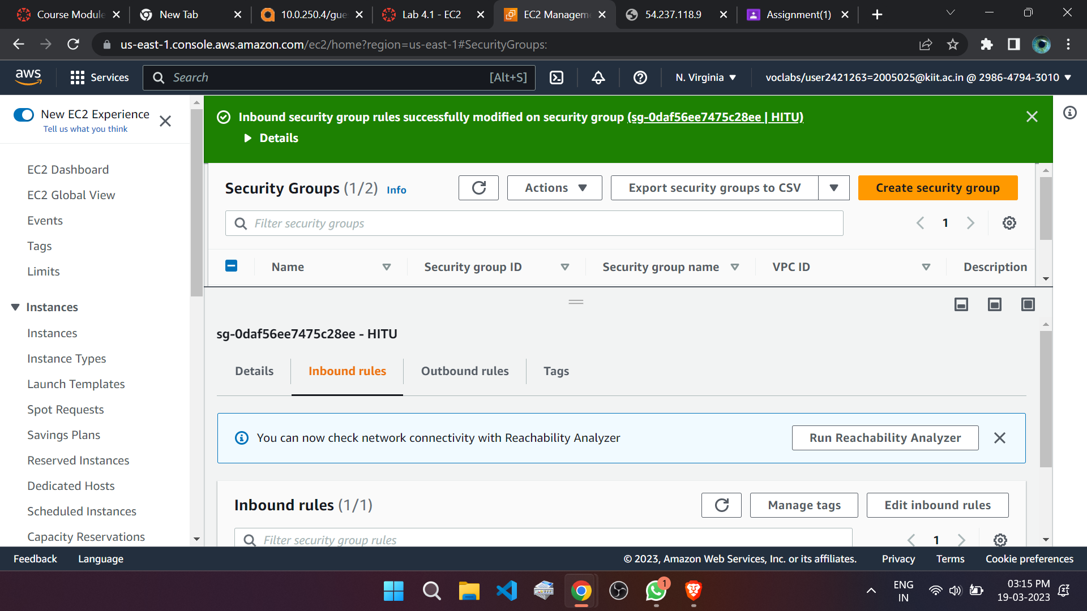

**Final Output** “Displaying Name”

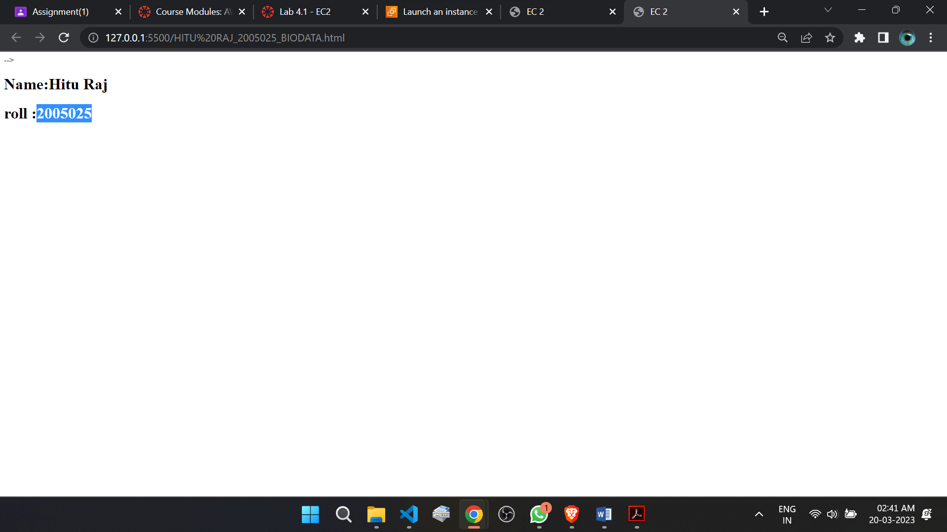

**LAB 4.2**

**S3 Bucket**

2. Design a web page to display your biodata and name of your web-page as

Bio_rollno.HTML you may use css also. Create S3 bucket with your first name and

attach the Bio_rollno.HTML to display its output in S3 bucket.

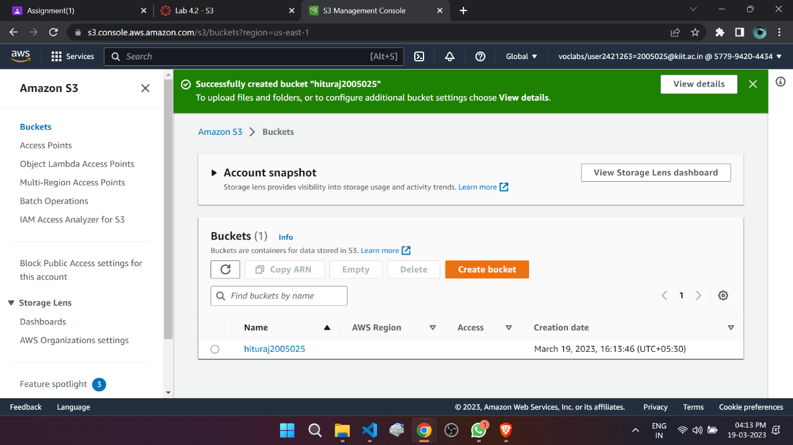Step1:Creating a S3 Bucket

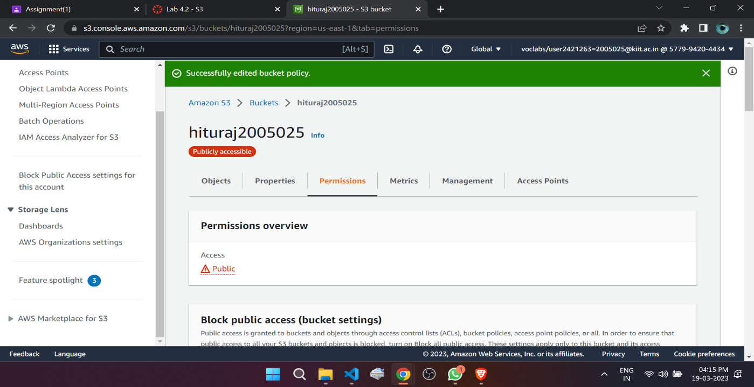Step 2:Editing the Bucket Policy

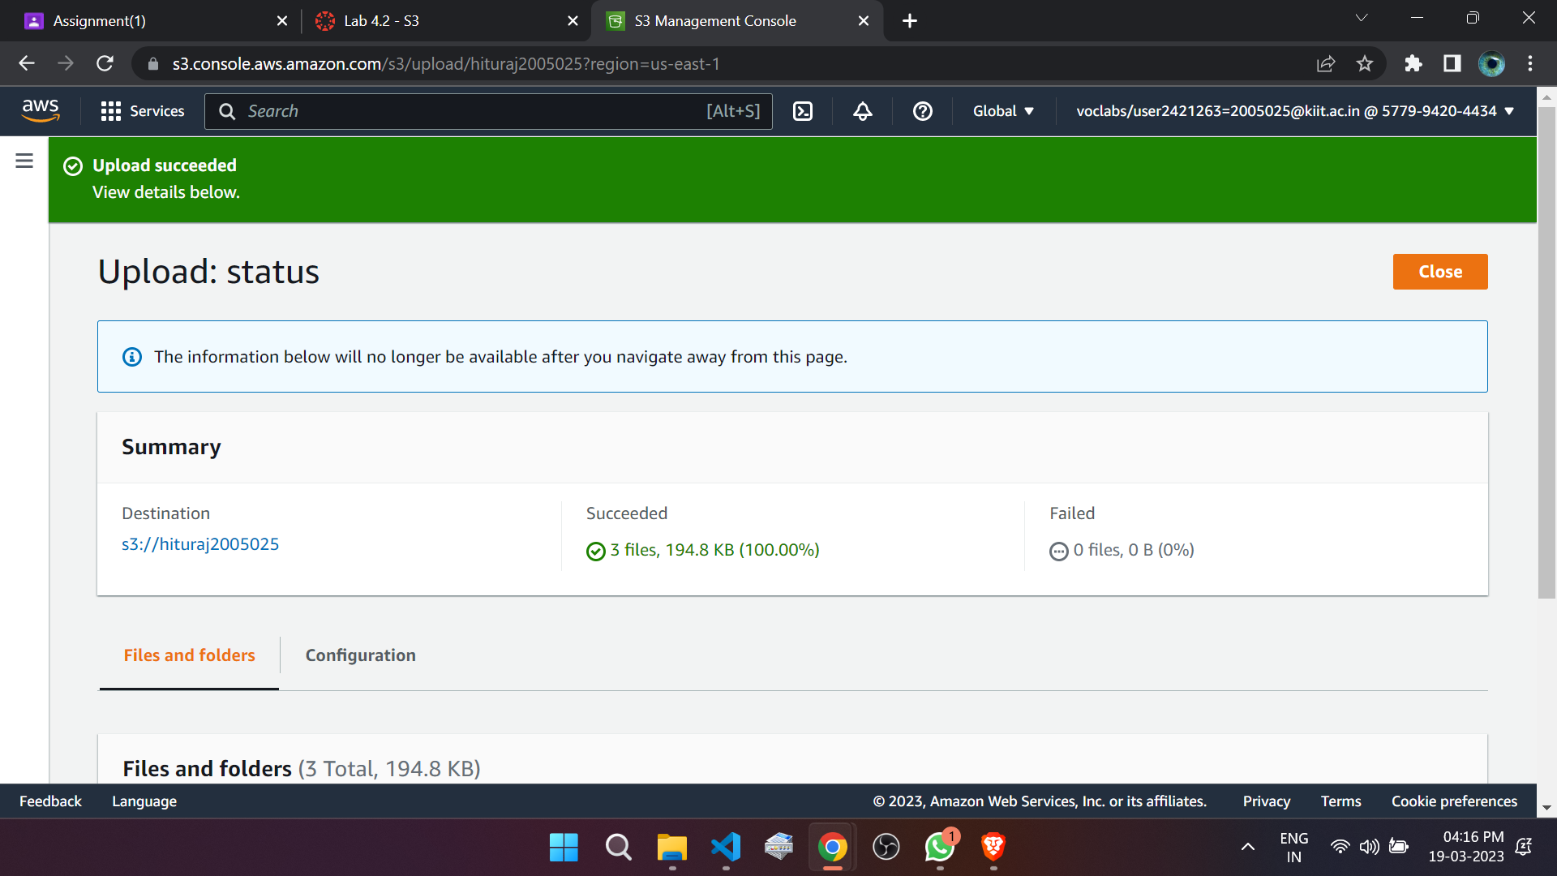Step 3: Uploading HTML AND CSS

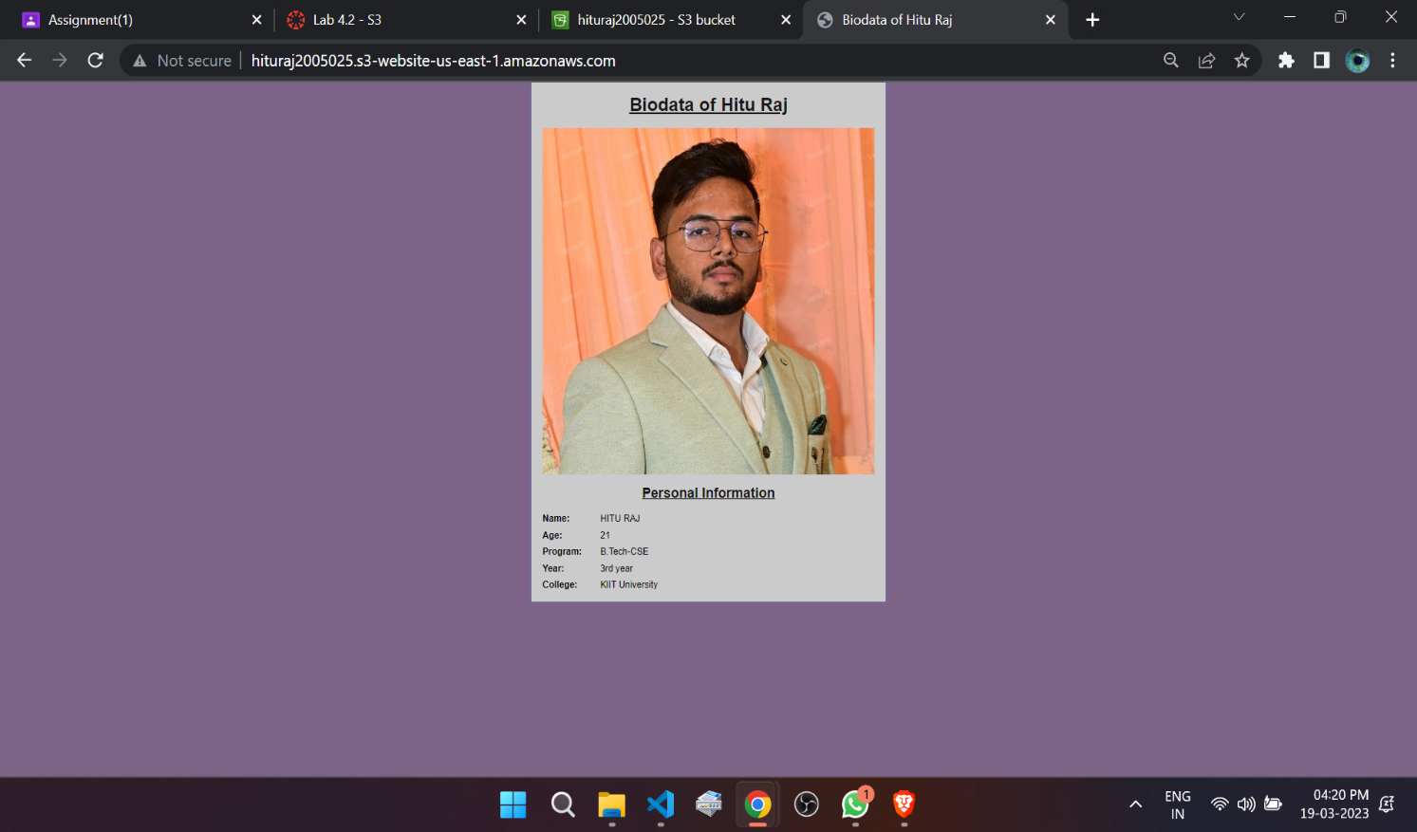OUTPUT of the “BIODATA”