|  |  |  |  |
| --- | --- | --- | --- |
| **USER** | **TROTTLE** | **ROUND ROBIN** | **EQUALLY SPREAD** |
| UB1_025 | 51.08 | 50.93 | 50.93 |
| UB10_025 | 50.66 | 50.72 | 50.7 |
| UB11_025 | 503.37 | 505.01 | 504.79 |
| UB12_025 | 503.38 | 507.35 | 505.23 |
| UB13_025 | 499.74 | 498.23 | 498 |
| UB14_025 | 503.77 | 503.2 | 501.44 |
| UB15_025 | 500.26 | 501.11 | 500.48 |
| UB16_025 | 493.96 | 494.74 | 495.3 |
| UB17_025 | 505.89 | 509.6 | 506.43 |
| UB18_025 | 497.6 | 497.92 | 498.52 |
|  |  |  |  |
| UB19_025 | 497.37 | 498.74 | 499.42 |
| UB2_025 | 50.45 | 50.32 | 50.44 |
| UB20_025 | 508.7 | 507.14 | 506.36 |
| UB21_025 | 499.57 | 497.39 | 498.22 |
| UB22_025 | 501.31 | 498.93 | 499.45 |
| UB23_025 | 498.71 | 497.91 | 496.08 |
| UB24_025 | 494.56 | 494.48 | 495.42 |
| UB25_025 | 503.87 | 503.07 | 503.93 |
| UB26_025 | 495.66 | 497.7 | 499.18 |
| UB27_025 | 502.54 | 502.03 | 500.95 |
| UB28_025 | 499.76 | 496.96 | 497.56 |
| UB29_025 | 505.54 | 504.8 | 504.69 |
| UB30_025 | 505.68 | 502.64 | 504.71 |
| UB31_025 | 198.76 | 198.16 | 199.13 |
| UB32_025 | 202.87 | 203.28 | 203.43 |
| UB33_025 | 200.58 | 200.67 | 200.58 |
| UB34_025 | 201.42 | 201.54 | 201.28 |
| UB34_026 | 200.66 | 200.92 | 199.41 |
| UB34_027 | 201.72 | 202.4 | 202.19 |
| UB34_028 | 200.81 | 201.29 | 200.24 |
| UB34_029 | 201.87 | 201.16 | 201.87 |
| UB34_030 | 200.57 | 200.29 | 200.88 |
| UB34_031 | 298.26 | 297.68 | 297.31 |
| UB34_032 | 203.3 | 203.14 | 203.93 |
| UB34_033 | 51.16 | 51.24 | 51.15 |
| UB34_034 | 50.86 | 50.99 | 50.97 |
| UB34_035 | 51.46 | 51.49 | 51.7 |
| UB34_036 | 51.49 | 51.49 | 51.61 |
| UB34_037 | 50.9 | 51.04 | 50.99 |
| UB34_038 | 50.38 | 50.42 | 50.47 |

COMPARISION TABLE

GRAPH

SUBMITETED BY:

HITU RAJ

2005025

CS-10

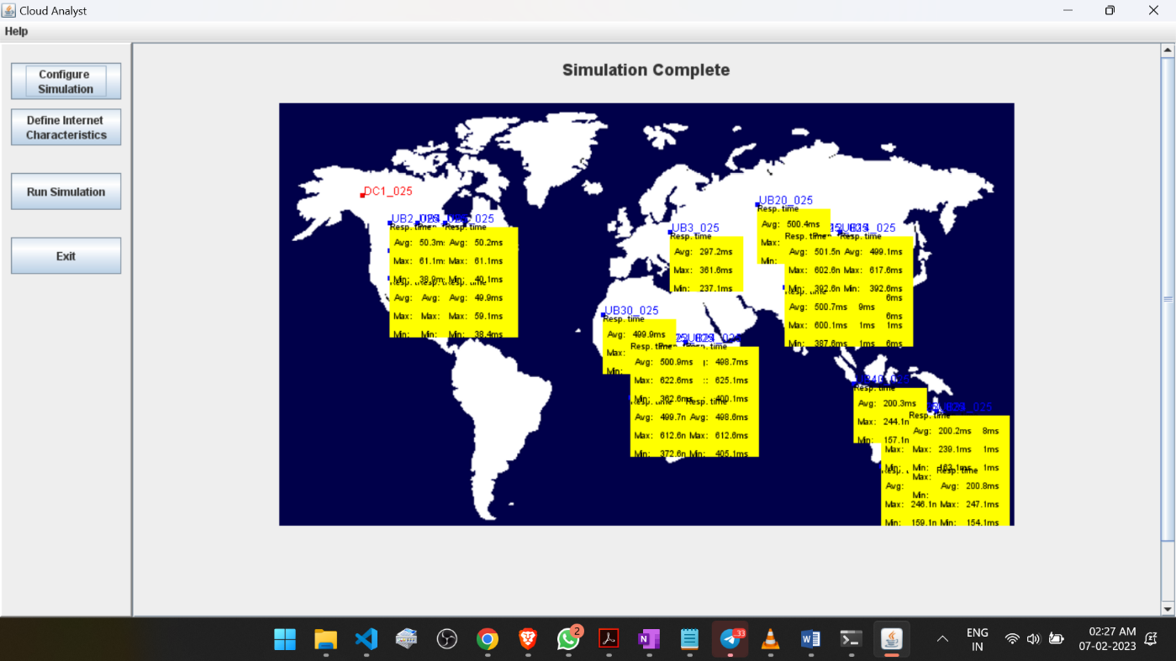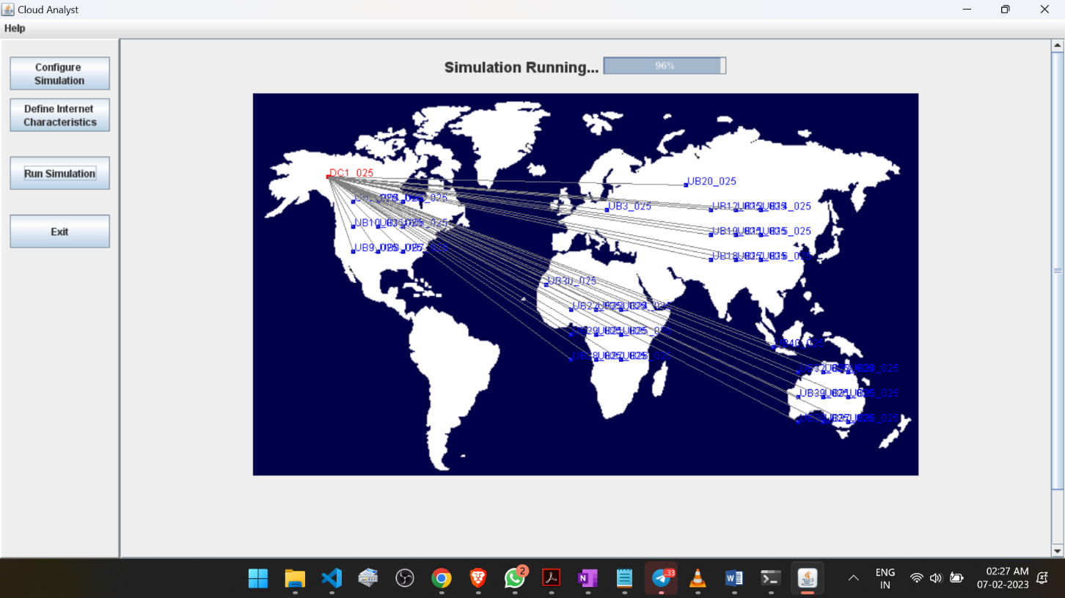STIMULATION