Results of the Simulation Completed at: 07/02/2023 02:35:15

3. THROTTLE

Overall Response Time Summary

|  |  |  |  |
| --- | --- | --- | --- |
|  | **Avg (ms)** | **Min (ms)** | **Max (ms)** |
| Overall response time: | 318.85 | 41.59 | 609.02 |
| Data Center processing time: | 1.24 | 0.02 | 2.27 |

Response Time by Region

|  |  |  |  |
| --- | --- | --- | --- |
| **Userbase** | **Avg (ms)** | **Min (ms)** | **Max (ms)** |
| UB10_025 | 50.66 | 41.96 | 57.51 |
| UB11_025 | 503.37 | 410.14 | 581.52 |
| UB12_025 | 503.38 | 396.47 | 587.84 |
| UB13_025 | 499.74 | 415.41 | 577.76 |
| UB14_025 | 503.77 | 405.20 | 594.02 |
| UB15_025 | 500.26 | 382.72 | 564.02 |
| UB16_025 | 493.96 | 396.54 | 558.82 |
| UB17_025 | 505.89 | 431.29 | 582.67 |
| UB18_025 | 497.60 | 398.82 | 581.52 |
| UB19_025 | 497.37 | 397.87 | 592.78 |
| UB1_025 | 51.08 | 43.51 | 63.76 |
| UB20_025 | 508.70 | 439.00 | 591.49 |
| UB21_025 | 499.57 | 409.02 | 609.02 |
| UB22_025 | 501.31 | 422.72 | 593.78 |
| UB23_025 | 498.71 | 416.52 | 570.16 |
| UB24_025 | 494.56 | 422.62 | 580.43 |
| UB25_025 | 503.87 | 392.66 | 575.11 |
| UB26_025 | 495.66 | 433.97 | 596.52 |
| UB27_025 | 502.54 | 427.58 | 599.02 |
| UB28_025 | 499.76 | 406.43 | 584.00 |
| UB29_025 | 505.54 | 432.59 | 577.64 |
| UB2_025 | 50.45 | 42.33 | 60.86 |
| UB30_025 | 505.68 | 416.52 | 586.54 |
| UB31_025 | 198.76 | 166.35 | 244.46 |
| UB32_025 | 202.87 | 166.52 | 236.54 |
| UB33_025 | 200.58 | 167.43 | 240.10 |

|  |  |  |  |
| --- | --- | --- | --- |
| UB34_025 | 201.42 | 175.47 | 235.46 |
| UB35_025 | 200.66 | 164.17 | 233.52 |
| UB36_025 | 201.72 | 168.19 | 234.04 |
| UB37_025 | 200.81 | 165.10 | 232.52 |
| UB38_025 | 201.87 | 154.46 | 236.52 |
| UB39_025 | 200.57 | 169.40 | 230.11 |
| UB3_025 | 298.26 | 253.38 | 346.62 |
| UB40_025 | 203.30 | 167.52 | 254.38 |
| UB4_025 | 51.16 | 44.55 | 59.01 |
| UB5_025 | 50.86 | 43.26 | 61.76 |
| UB6_025 | 51.46 | 43.30 | 59.59 |
| UB7_025 | 51.49 | 41.59 | 62.46 |
| UB8_025 | 50.90 | 42.26 | 59.14 |
| UB9_025 | 50.38 | 42.76 | 58.77 |

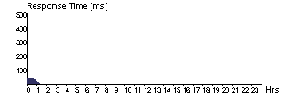User Base Hourly Response Times UB10_025

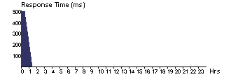UB11_025

UB12_025



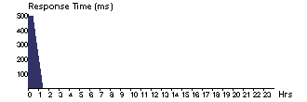UB13_025

UB14_025



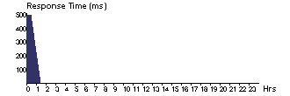UB15_025

UB16_025

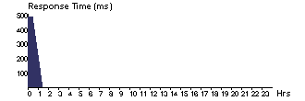

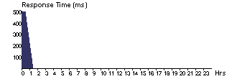UB17_025

UB18_025 UB19_025

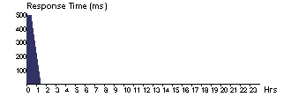

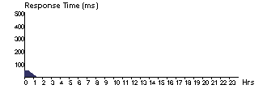UB1_025

UB20_025

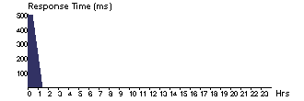

UB21_025

UB22_025 UB23_025

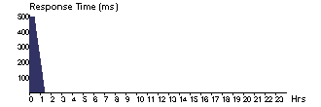

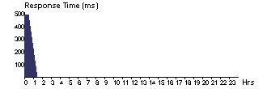UB24_025

UB25_025



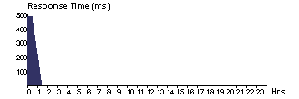UB26_025

UB27_025 UB28_025



UB29_025

UB2_025



UB30_025

UB31_025 UB32_025

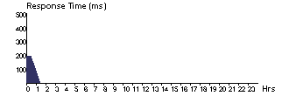

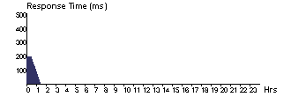UB33_025

UB34_025



UB35_025

UB36_025 UB37_025



UB38_025

UB39_025



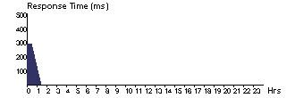UB3_025

UB40_025 UB4_025



UB5_025

UB6_025



UB7_025

UB8_025 UB9_025



Data Center Request Servicing Times

|  |  |  |  |
| --- | --- | --- | --- |
| **Data Center** | **Avg (ms)** | **Min (ms)** | **Max (ms)** |
| DC1_025 | 1.24 | 0.02 | 2.27 |

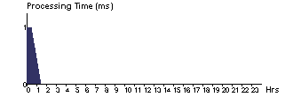Data Center Hourly Average Processing Times DC1_025

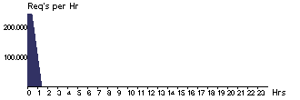Data Center Hourly Loading DC1_025

Cost

Total Virtual Machine Cost ($): 0.50

Total Data Transfer Cost ($): 2.35

Grand Total: ($) 2.85

|  |  |  |  |
| --- | --- | --- | --- |
| Data Center | **VM Cost $** | **Data Transfer Cost $** | **Total $** |
| DC1_025 | 0.50 | 2.35 | 2.85 |