

CN LAB-2

WIRESHARK

• Name :HITU RAJ

• Roll no. :2005025

• Branch :CSE-4

**1. Screenshot of Wireshark application.**

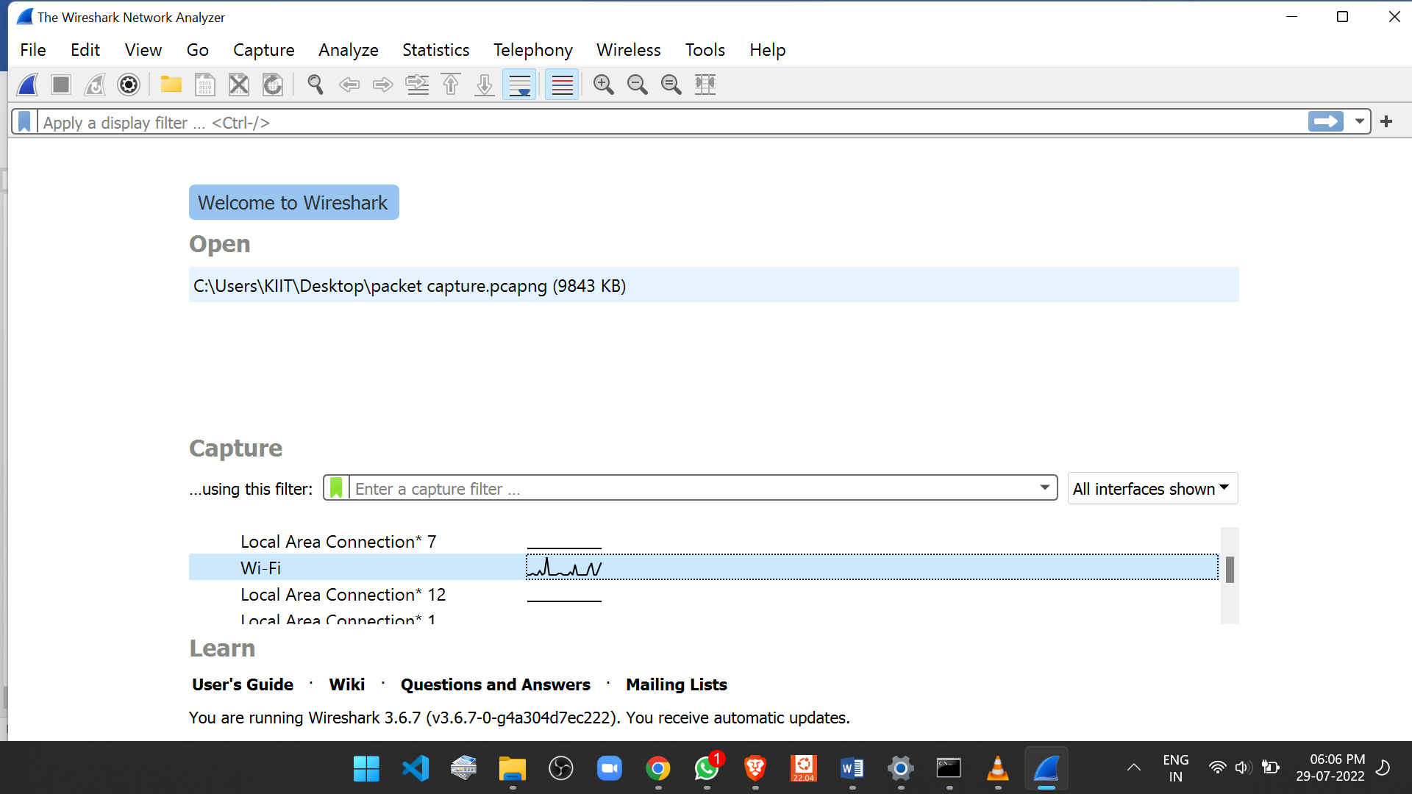

**2. Use “DNS” as a filter.**

**­­­**

**KIIT WIFI**

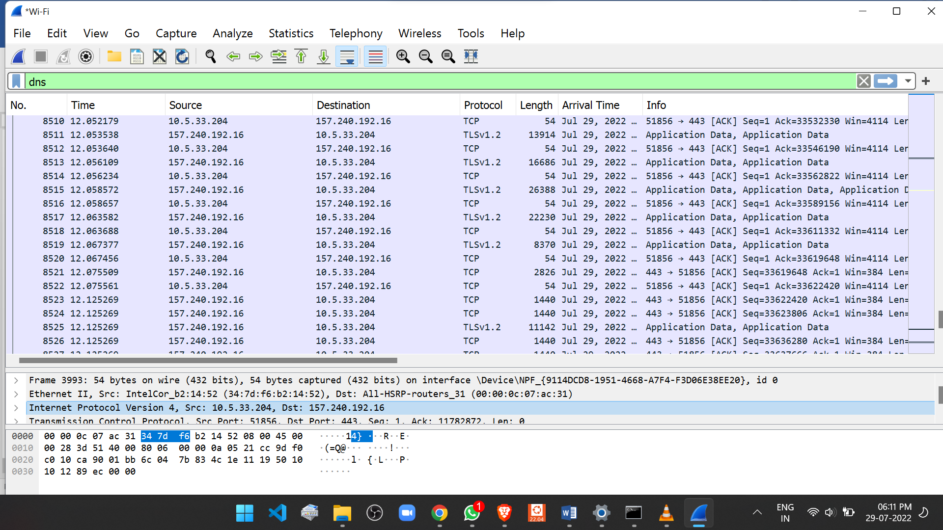

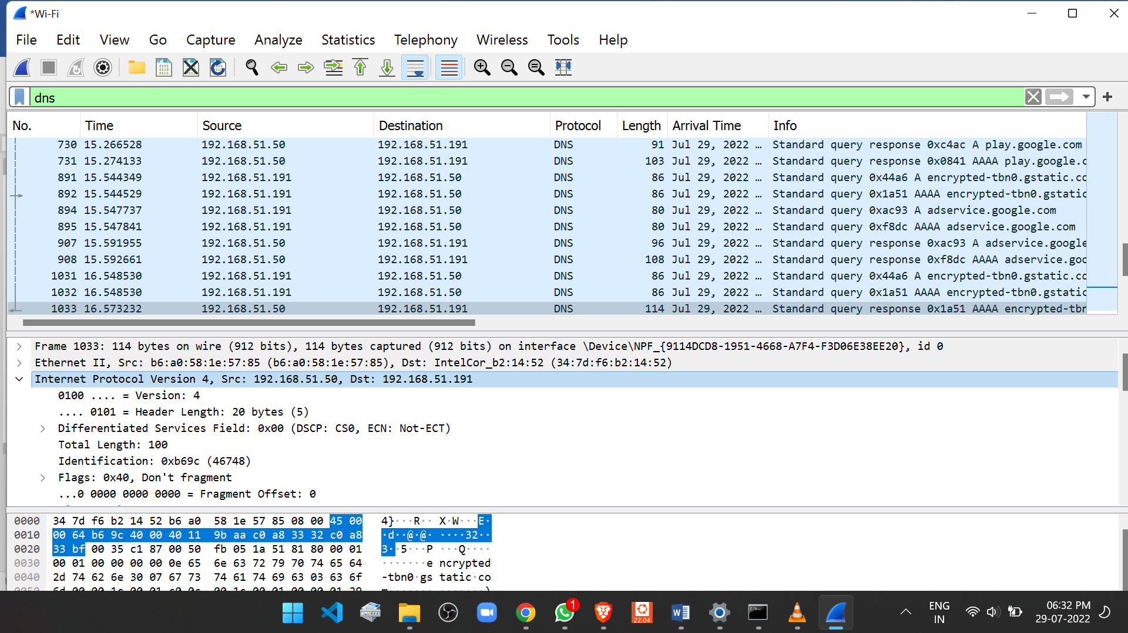**HOTSPOT**

**3.Use “port 53” as a filter.**

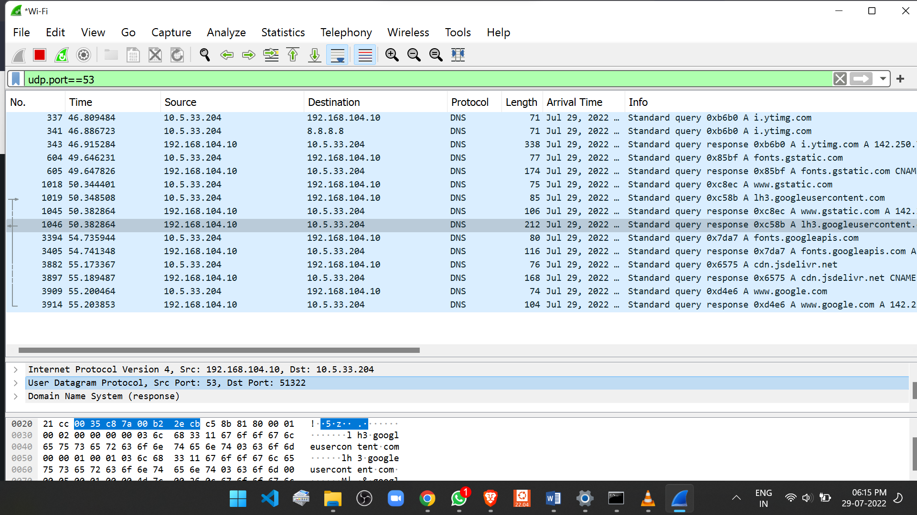**KIIT WIFI**

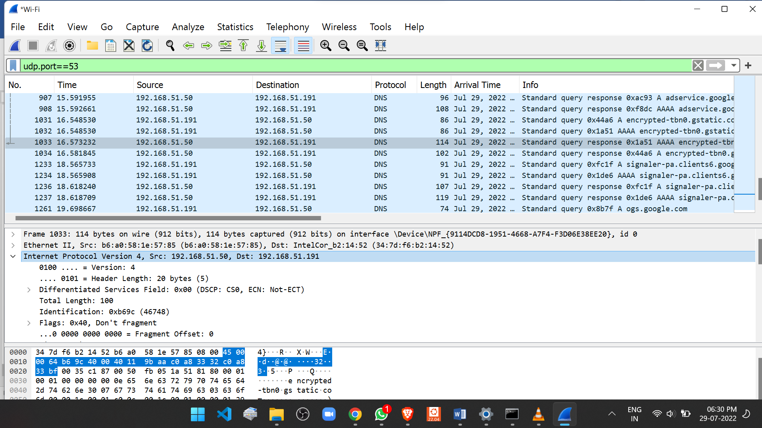**HOTSPOT**

**4. Encapsulation details screenshots.**

* 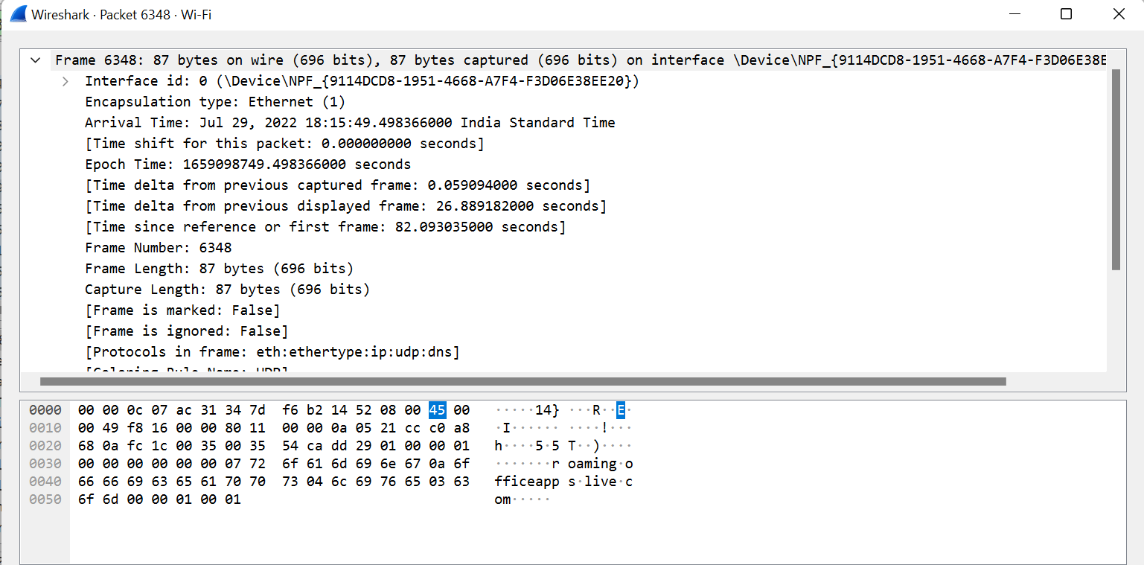**Frames**
* **Ethernet**

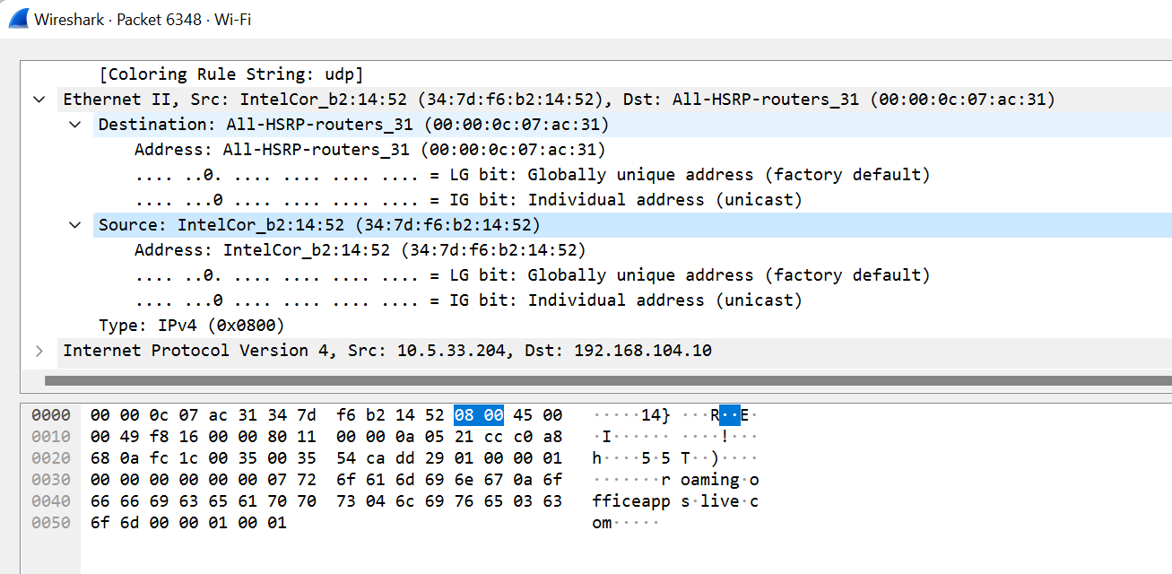

* **IP**

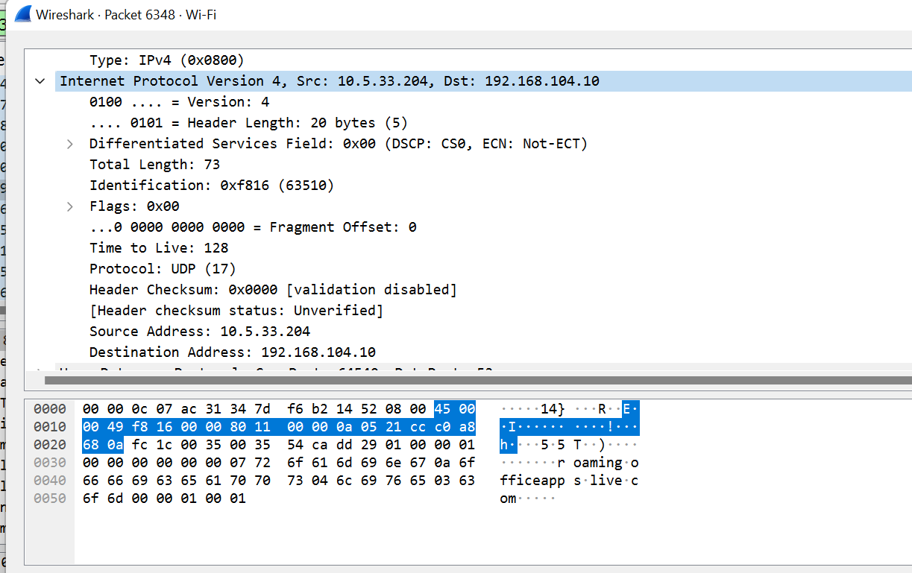

**IP SHOWING SAME AS THAT OF MY PC**

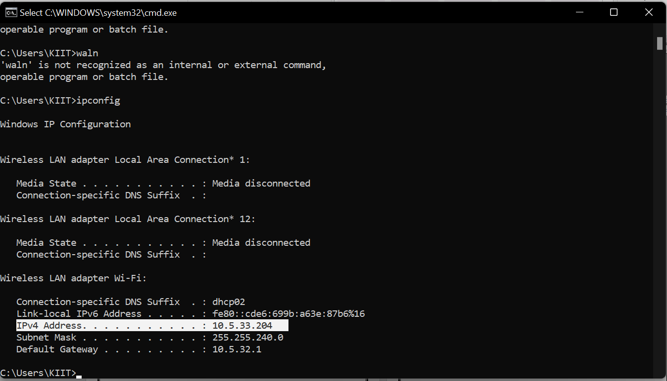

* **UDP**

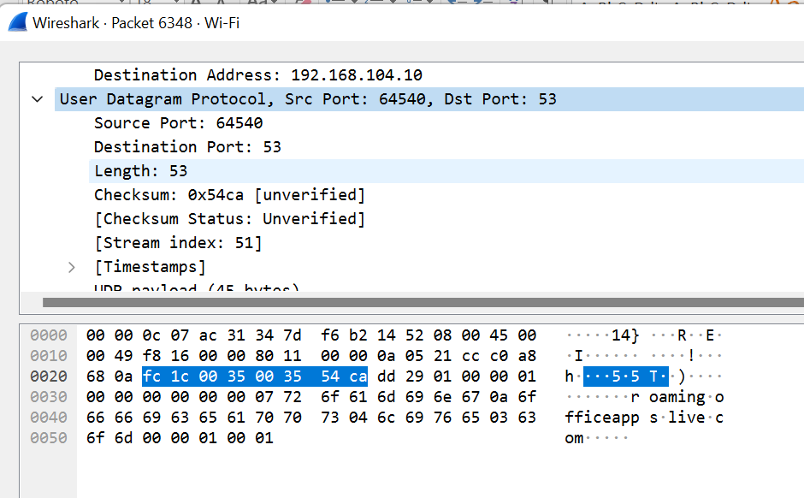

* **DNS**

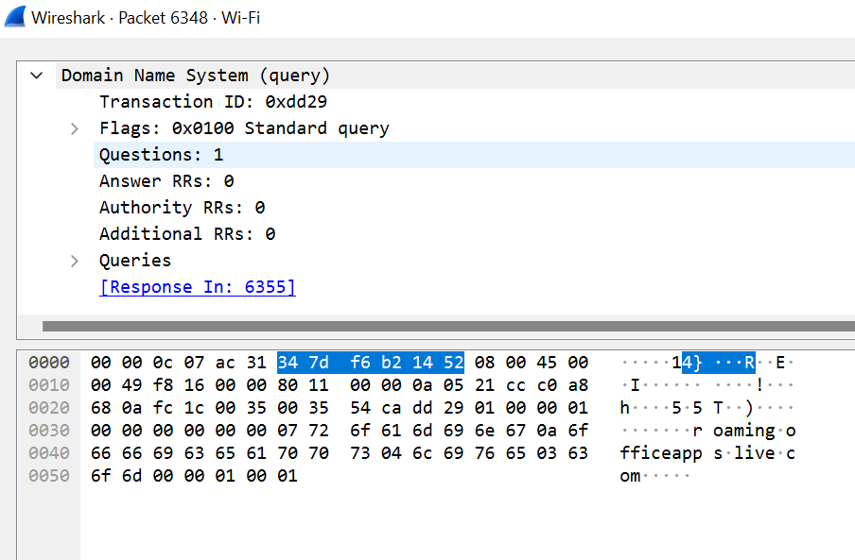

• Name :HITU RAJ

• Roll no. :2005025

• Branch :CSE-4